
Assessment 1
Title: Assessment component: Individual report on Unilever

Name: Aayushy Pradipkumar Patel
Student ID: 2503361
Module Name: Strategic Management
Module Code: LCMB7003
Lecturer’s Name: Andry Rakotovalolora
Word Count: 5000

Term 2

Executive Summary
The report gives a detailed strategic analysis of Unilever in the fast-moving consumer goods (FMCG) industry. The analysis discusses the external and internal environment the organisation is operating in, using models such as PESTEL, SWOT, VRIO, the Balanced Scorecard, the Matrix, created by Ansoff and the BCG Matrix. The analysis establishes a powerful brand name, sustainability leadership, potential to innovate and a global network of distribution as competitive advantage assets of Unilever. It also deals with such strategic issues as competitive, digital disruption, and sustainability issues. The report considers strategic options at both new business and corporate levels as well, and is guidance-based on differentiation based on sustainability and market upsurge. Thus, it can be stated that innovation, agility, and effective strategic change management are the keys to the long-term success of Unilever.

Table of Contents
Introduction 4
SECTION 1 4
1. Organisational Context and Overview 4
1.1 Introduction to Unilever 4
1.2 Mission, Vision, and Business Model 5
1.3 Industry Overview 6
1.4 Market Position & Competitors 7
2. External and Internal Environment Analysis 8
2.1 External Environment: PESTEL Analysis 8
2.2 Critical Success Factors and Strategic Challenges 11
2.3 Internal Environment 12
2.4 VRIO Framework 14
2.5 Internal Strengths and Competitive Advantage 16
3. CSR and Sustainability Objectives 17
3.1 CSR Strategy Overview 17
3.2 Alignment with Business Objectives 18
4. View of the organisation 18
4.1 Financial Perspective 19
4.2 Customer Perspective 20
4.3 Internal Business Processes 20
4.4 Learning and Growth Perspective 21
5. Strategic Choices and Implementation 22
5.1 Business-Level Strategy Options 22
5.2 Corporate-Level Strategy Options 22
5.3 Recommended Strategy 22
5.4 Change Management Evaluation 22
6. Strategic Evaluation and Recommendations 23
6.1 Strategic Evaluation Using Frameworks 23
6.2 Recommendations 25
Section 2 26
1. Reflective account (Kolb’s cycle of reflective practice) 26
Conclusion 29
References 30

Introduction
The following report is a critical analysis of the strategic management practices of Unilever, which is one of the biggest multinationals concerned with the fast-moving consumer goods (FMCG) industry. In the present volatile and competitive global business environment, organisations have to keep on changing their strategies in order to maintain a competitive advantage. The report is a strategic analysis of Unilever, a top multinational organisation that is in the FMCG sector.

SECTION 1

1. Organisational Context and Overview

1.1 Introduction to Unilever
Unilever is a multinational consumer goods producer with a rich history of innovation with an effort to simplify life (unilever.com, 2025). Established in 1929 as a result of the merger of Lever Brothers and Margarine Unie, the organisation has turned into one of the most powerful multinational corporations in the FMCG industry. Unilever is among the most geographically dispersed consumer goods companies in the world, which head office located in London (UK) and Rotterdam (Netherlands) and has operations in more than 190 countries. It enjoys a high consumer penetration and a good global presence, with approximately 3.7 billion consumers taking its products in a day. In 2025, the company reached a turnover of €50.5 billion which evidences the fact that the company is still strong and financially strong despite an unstable economic situation in the world (unilever.com, 2025).
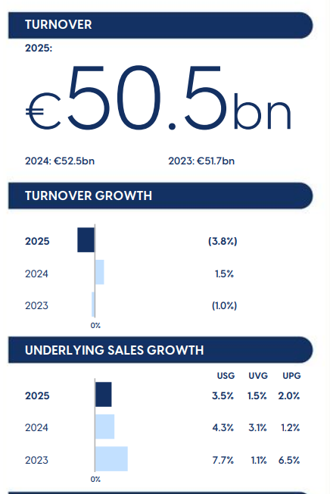
Figure 1: Performance
(Source: unilever.com, 2025)

1.2 Mission, Vision, and Business Model
Unilever's mission statement, make sustainable living commonplace, demonstrates the way Unilever has embraced the concept of incorporating sustainability into the ordinary activities of consumers (unilever.com, 2025). The vision of the organisation is to provide future sustainable growth and create a positive social and environmental impact. It has a business model that deals with Fast-Moving Consumer Goods (FMCG) and has the following key segments such as Beauty and Wellbeing, Personal Care, Home Care and Foods and refreshments (unilever.com, 2025). This diversified portfolio enables Unilever to risk balance and cater to a broad spectrum of consumer needs in the developed or emerging markets. The strategic emphasis of the company on Desire at Scale is a blend of scientific innovation, great brand equity and the profound insights of consumers to provide high-quality products to the international customers (binti Tsuraya et al. 2023).
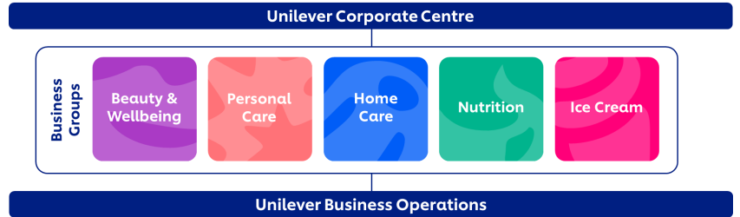
Figure 2: Business Operations
(Source: unilever.com, 2025)

1.3 Industry Overview
Fast-Moving Consumer Goods (FMCG) is a highly competitive industry with low switching costs and high price sensitivity and consumer taste change (Derqui et al. 2022). The businesses have to keep innovating in order to stay afloat, especially with digital transformation redefining the retail channels, marketing practices and consumer interaction. E-commerce, the use of information to make decisions and the increasing sustainability demands are altering the common competitive dynamics dramatically. Moreover, the FMCG market of the UK is already approximately USD 266.2 billion in 2025 and it is projected to increase to USD 405.3 billion in 2034 with strong positive growth in the long term.
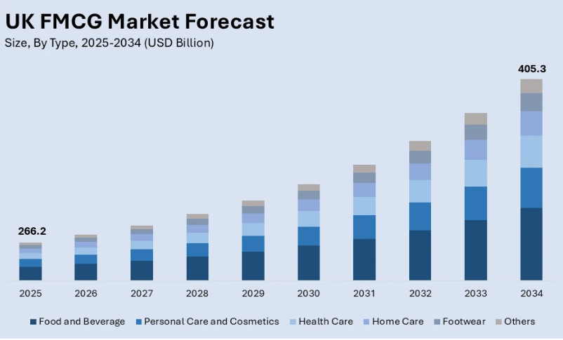
Figure 3: Industry growth
(Source: Imarcgroup, 2026)

1.4 Market Position & Competitors
Unilever has been able to establish a high position of competition in the world FMCG industry due to a range of power brands including Dove, Knorr, Lifebuoy and Hellmann's (Kang et al. 2023). The structure of Compass Organisation, which incorporates five core groups of business, improves strategic focus and accountability. The major competitors in the industry are Procter and Gamble, Nestle and Colgate-Palmolive. The ability to convert global scale with market responsiveness, presence in the emerging markets, where it makes about 59% of its turnover and the capability to enter the emerging markets (unilever.com, 2025).
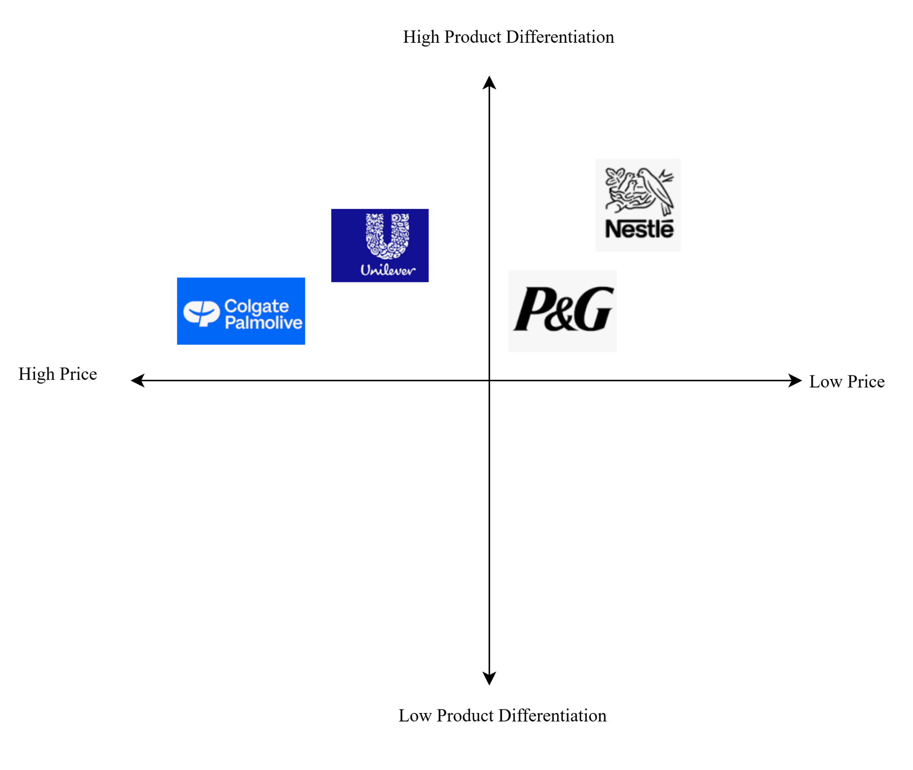
Figure 4: Competitive positioning
(Source: Influenced by Kang et al. 2023)

2. External and Internal Environment Analysis

2.1 External Environment: PESTEL Analysis
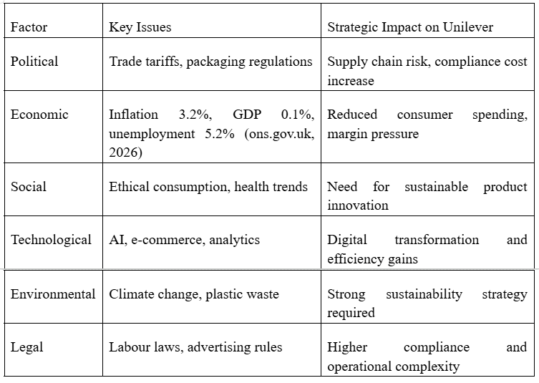
Table 1: PESTEL Analysis
(Source: Influenced by ons.gov.uk, 2026)
Political Factors
Global trade policies and tariffs, as well as geopolitical tensions, negatively impact Unilever by interfering with supply chains and raising operational expenses (Hajarath and Chaitanya, 2025). There are also regulatory pressures on the packaging waste, the use of chemicals and sustainability compliance, which are also increasing across leading markets.
Economic Factors
Macroeconomic conditions strongly impact consumer purchasing behaviour. The UK has a moderate labour market pressure with an unemployment rate of 5.2 and an employment rate of 75.1% (Nov 2025-Jan 2026). Inflation is still at 3.2 per cent (Feb 2026), and this factor decreases consumer buying capacity and heightens cost-responsiveness in the FMCG markets (ons.gov.uk, 2026). Fluctuations in the currency also pose a risk to a company that has been diversified globally such as Unilever in terms of revenue translation as well as input costs (Chaitanya Raja Hajarath, 2025).
Social Factors
The consumer behaviour is changing to health, ethical and environmentally friendly consumption (Lazaridou et al. 2024). Cruelty-free products, natural ingredients and eco-friendly packaging are in high demand. These tendencies are also in line with the sustainability-based brand positioning of Unilever especially in areas such as personal care and food products.
Technological Factors
FMCG competition is being transformed due to technological advances (George and George, 2023). Robots in the field of marketing, predictive analytics, and automated supply compressions make operations smoother and target consumers. These changes are equally affecting consumer-brand relationships as the fast expansion of e-commerce and online stores forces Unilever to enhance its omnichannel strategy.
Environmental Factors
Climate change and environmental degradation represent an important issue for FMCG firms. Unilever is under increased pressure to decrease carbon emissions, plastic waste, and enhance the use of a circular economy (de Arruda Pollice and Scarcelli, 2024). It is the focus of its sustainability commitments that is fundamentally important in terms of brand reputation and regulatory compliance.
Legal Factors
Unilever has to abide by the stringent advertising rules, consumer laws and international labour laws (de Arruda Pollice and Scarcelli, 2024). The disparities in various jurisdictions' labour laws make workforce management challenging. The regulatory examination of product claims and their impact on the environment adds to the compliance demands.

2.2 Critical Success Factors and Strategic Challenges
Critical Success Factors (CSFs)
Strong Brand Portfolio and Consumer Trust
Unilever has an excellent global brand such as Dove, Lifebuoy, and Knorr which is one of the success factors (Narayanan and Das, 2022). The recognition and loyalty of the consumers of these brands can be achieved in over 190 countries. The answer to sustaining demand in over-saturated FMCG markets is brand equity where 3.7 billion consumers use its products every day (unilever.com, 2025).
Sustainability and Ethical Positioning
Sustainability is currently an ingredient in CSF and more consumers are ready to buy ecologically responsible products (unilever.com, 2025). Unilever has incorporated its sustainability strategy within the business model, and it assists the company to compete over the long term (Narayanan and Das, 2022).
Emerging Market Strength
About 59% turnover is generated by emerging markets, which are a key success factor through geographic diversification (unilever.com, 2025). This helps Unilever to offset the downward trend in the developed economies and take advantage of the growing consumption by the middle classes in Asia, Africa and other developing countries.
Strategic Challenges
Inflation and Cost Pressure
Consumer purchasing power and logistics and the cost of raw materials are on the rise due to rising inflation (UK CPIH at 3.2% in 2026), which decreases consumer purchasing power Influenced by (ons.gov.uk, 2026). This puts a strain on the margin and compels Unilever to strike a balance between pricing approaches and affordability.
Intense Global Competition
Unilever has stiff competition with Procter and Gamble, Nestle and Colgate-Palmolive (Siddiq and Ali, 2024). These competitors are constantly investing in innovation, branding, and pricing systems, escalating the competition.
Regulatory and Sustainability Compliance
Tightening of international policies on plastic wastes, the utilisation of chemicals, and advertisement claims present challenges in compliance (Tumu et al. 2023). The inability to comply with the environmental requirements may affect brand image and limit the market.
Digital Disruption
The fast expansion of e-commerce and consumer targeting and advertisement by AI necessitates the ongoing investment in digital transformation to remain relevant in the market and efficient (Bezditnyi, 2024).

2.3 Internal Environment
SWOT Analysis
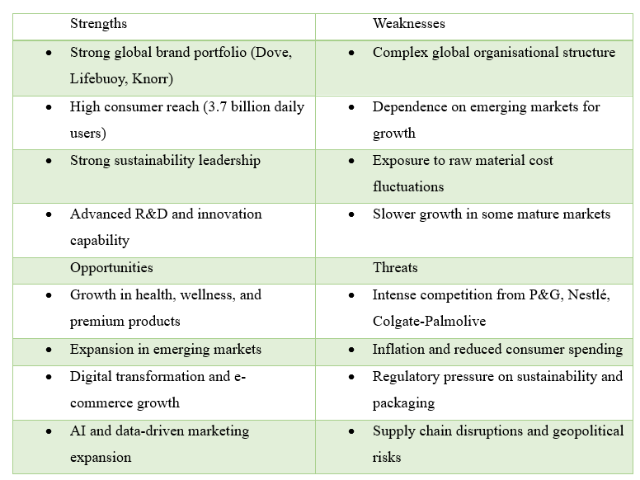
Table 2: SWOT Analysis
(Source: Influenced by unilever.com, 2025)
The SWOT analysis has pointed out that though the company is in a good position to take advantage of the chance in sustainability, digitalisation, as well as emerging markets, it has to optimise operations and become increasingly agile to offset the competitive as well as economic risks in the global FMCG industry (unilever.com, 2025).
Key Resources
Unilever has powerful tangible and intangible resources, such as its globally recognised brand portfolio (Dove, Knorr, Lifebuoy), its widespread distribution network with 190+ countries, and large financial resources (unilever.com, 2025). The high number of consumers and the market size make it a strong platform for continuous growth and positioning in the market.
Capabilities
The organisation has an advanced level of supply chain management, product innovation, and data-driven marketing capabilities (Wang, 2024). Its ability to integrate the global efficiencies and the local market attentions will empower it to differentiate products to the diverse consumer needs.
Core Competencies
Unilever has three key competencies, namely, brand management, integration of sustainability and scale of innovation (unilever.com, 2025). This has enabled it to offer differentiation in competitive markets due to its capacity to integrate high brand equity in its sustainable activities. In addition, its ability to go global with innovation and be locally relevant reinforces the competitive advantage long term (Wang, 2024).

2.4 VRIO Framework
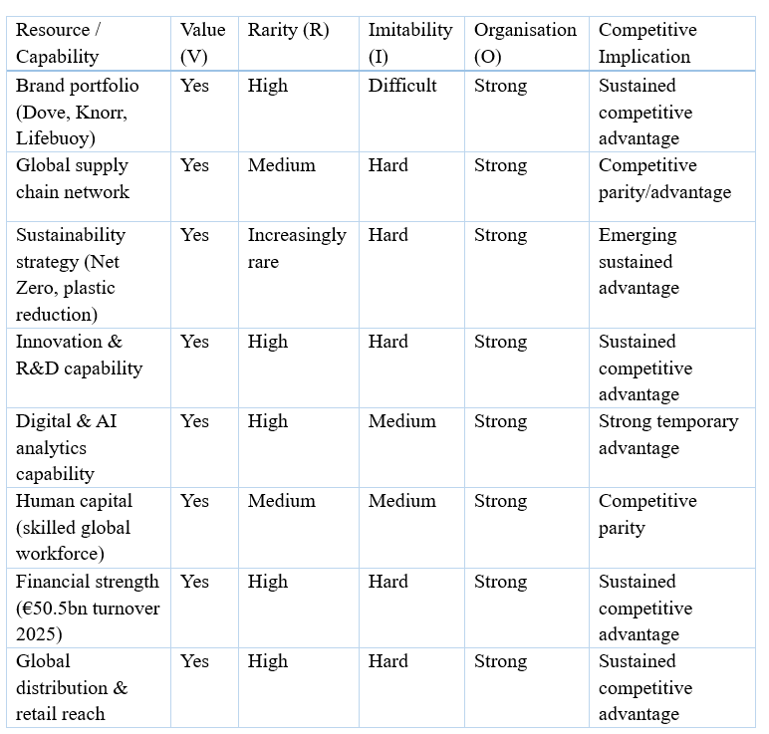
Table 3: VRIO Analysis
(Source: Influenced by unilever.com, 2025)
VRIO analysis of Unilever shows that the organisation owns numerous strategically sensitive and difficult-to-replicate resources that aid in making it sustain a competitive advantage (unilever.com, 2025). It has a strong base of long-term advantage of its global brand portfolio, consisting of power brands like Dove and Knorr, strong consumer trust, and high market differentiation. Likewise, Unilever can afford innovative development and expansion aspects in the global market because of its innovation capability and financial strength (Akter, 2025). The sustainability policy of the company is becoming rarer and more strategic, as the consumption based on ESG is turning out to be a significant trend in the market. It has also achieved unparalleled market access and scale efficiency due to its distribution network spread over 190+ countries around the world (unilever.com, 2025). But capabilities like human capital and digital analytics have a medium to high competitive advantage because they are partially imitable.

2.5 Internal Strengths and Competitive Advantage
Unilever has internal strengths, which are key to its competitive advantage in the highly saturated FMCG industry. Its strong international brand portfolio with major brands like Dove, Knorr and Lifebuoy is one of its greatest strengths (Siddiq and Ali, 2024). These brands create a good consumer confidence, emotional attachment and a high degree of repeat buyer behaviour, making it difficult to switch in a price-sensitive market. Due to this fact, Unilever is in a position to be able to control its demand even at times when there might be inflationary pressure and low consumer spending. A second strength is that it has a large global distribution network, with operations in over 190 countries and reaching an approximate population of 3.7 billion consumers per day (unilever.com, 2025). With the help of this scale, large economies of volume and cost efficiency can be achieved giving the organisation a chance to compete well with competitors like Procter & Gamble and Nestle.
The capability to enter the developed and developing markets helps in diversifying revenues and minimising geographical risk exposures. The level of innovation and R&D functioning of Unilever also makes a significant contribution to the level of its competitiveness (Laursen and Andersen, 2023). With the assistance of data-driven information and AI-based marketing tools, a rapid response to the dynamics of consumer taste, including the health-conscious and sustainable consumption patterns, could be achieved. In addition, its business model grounded in sustainability enhances the brand differentiation given that individuals prefer choosing green corporations more. The financial strength shown by a turnover of €50.5 billion in 2025 enables further investment in the marketing and innovation strategy and expansion (unilever.com, 2025).

3. CSR and Sustainability Objectives

3.1 CSR Strategy Overview
The Corporate Social Responsibility (CSR) strategy of Unilever is fundamentally ingrained into its business model, placing sustainability as a long-term value-creating option, as opposed to a side activity (unilever.co.uk, 2026). The ultimate goal of the organisation is net-zero emissions of its entire value chain by 2039, with an intermediate aim of a 50-per-cent cut in full value chain emissions (Scope 1, 2, and 3) by 2030. It also has the goal of 100% grid electricity utilisation being renewable, and alleviating environmental impact with quantifiable targets like decreasing virgin plastic consumption by 29% and 25% recycled plastic in packaging by 2025 (unilever.com, 2025). In addition, 97 per cent of the major commodities are now certified deforestation-free, which is good growth in ethical sourcing and the protection of biodiversity. The CSR strategy that Unilever has adopted shows a strong focus on respecting the interests of various stakeholders such as consumers, suppliers, governments, and local communities with regard to the Stakeholder Theory.
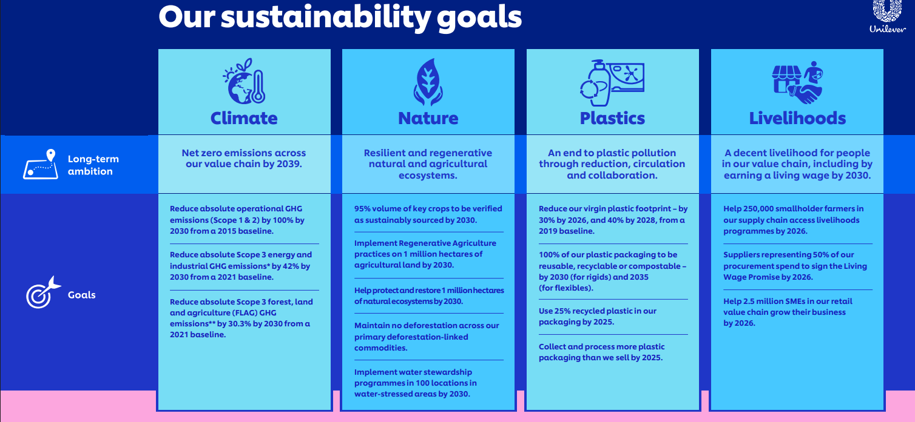
Figure 5: Sustainability goals
(Source: unilever.com, 2026)

3.2 Alignment with Business Objectives
Unilever is a company that strategically integrates CSR in its business model, which has set the sustainability objectives to be in line with the long-term business profitability and growth (unilever.co.uk, 2026). This is a manifestation of the theory of Triple Bottom Line that focuses on making a balance between economic, environmental and social performance. Sustainability is a competitive attribute which increases brand equity and consumer loyalty in more environmentally conscious markets. Sustainable sourcing and circular packaging are only a few initiatives aimed not only at minimising the environmental impact but also enhancing operational and risk management. Through the incorporation of CSR in its value chain, Unilever generates both long-term value and enhances stakeholder relationships and positioning in the market (Modreanu et al. 2022).

4. View of the organisation
Balanced Scorecard (Kaplan and Norton, 1992) is a systematic tool that could be used to assess how Unilever transforms its strategic vision into quantifiable performance results in both financial and non-financial aspects. It facilitates the comprehensive evaluation of the process of creating value, based on customers, internal processes and organisational learning.
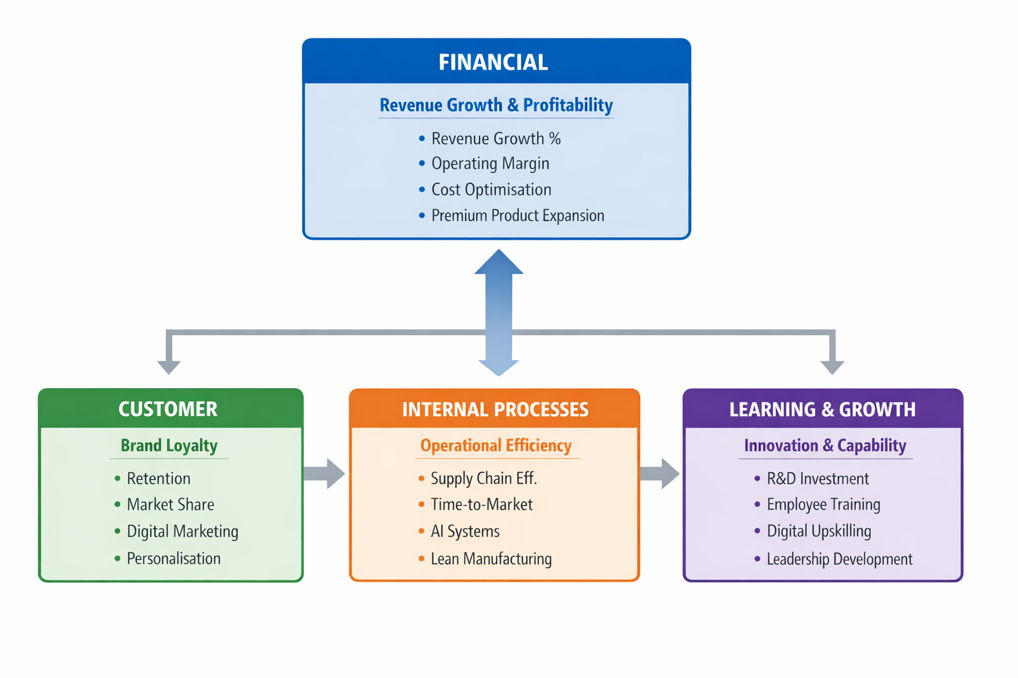
Figure 6: Balanced Scorecard
(Source: Influenced by Kaplan and Norton, 1992)

4.1 Financial Perspective
Objective: Revenue Growth & Profitability
To deliver long term revenue growth and enhanced overall profitability by maximising the performance of its product portfolios, increasing high-margin product groupings and lowering its cost performance throughout the global operation.
KPIs
Important key performance indicators are the percentage increase in revenues and operating margin (Lee, 2023).
Targets and Initiatives
Unilever aims at realising long-term growth of revenue in the mid-single-digits ahead of safeguarding growth by tactical plans like cost minimisation programmes and reorganisation of the failing product lines. One key strategic move will be the growth of higher category products under Beauty and Wellbeing and Personal Care, where better margins will be obtained based on value-based pricing. Brands like Dove Premium and TRESemmé are good examples of successful premiumisation strategies that enhance profitability (Ahmed, 2024). In 2025, the turnover amounted to a massive €50.5 billion with a surprise backing of underlying sales growth of 3.5 % and an operating margin of 20.0%, which was an improvement in operational efficiency of the company despite currency and market pressures (unilever.com, 2025).

4.2 Customer Perspective
Objective: Improve Brand Loyalty
The purpose is to increase the amount of customer loyalty and brand equity by providing innovative, high-quality and sustainable products in response to changing consumer needs.
KPIs
The main measures of the indicators are customer retention rate and international market share of major categories.
Targets and Initiatives
Unilever intends to gain loyalty through the digital marketing transformation strategy and the customised consumer engagement strategy. As an illustration, AI analytics-based data-driven campaigns can enable brands such as Dove and Lifebuoy to target particular groups of consumers with messages that resonate with them. Also, product differentiation and localised innovation are displayed in terms of region-specific skincare and nutrition products that enhance emotional bond to the brand and enhance retention.

4.3 Internal Business Processes
Objective: Operational Efficiency
To enhance operational efficiency through the optimisation of world supply chains, cost reduction in production and speed of time to market in the production of new products.
KPIs
Important KPIs will cover efficiency of the supply chain, inventory turnover and time-to-market of new products (Lee, 2023).
Targets and Initiatives
Unilever is betting hard on AI-powered supply chain systems to capitalise on demand prediction, asset minimisation, and logistics effectiveness (Jayawardana, 2025). As an illustration of an application of digital twin technology, in certain manufacturing facilities, flow optimisation in production can be achieved through digital twin technology. Lean manufacturing activities are also carried out in all the international facilities to minimise the operation inefficiencies and enhance sustainability performance.

4.4 Learning and Growth Perspective
Objective: Innovation and Capability Development
To strengthen the organisational capability through investment in employee development, digital transformation and research and development.
KPIs
The important indicators are the percentage of R&D investment on revenue and the hours of training of employees (Jayawardana, 2025).
Targets and Initiatives
Unilever focuses on leadership development programmes and digital upskilling to equip employees to meet AI-enabled change (Mann and Mann, 2025). The company has also continued to invest heavily in R&D to facilitate innovation on sustainable products, like plant-based foods and environmentally friendly packaging solutions. Developing sustainability and digital analytics training programmes improves employees' competencies and maintains a connection with strategic objectives.

5. Strategic Choices and Implementation

5.1 Business-Level Strategy Options
Cost Leadership
Unilever can partially adopt a cost leadership strategy as it has a massive global scope and scope for economies of scale. The company operates in more than 190 countries, boasting a turnover of more than 50 billion euros (2025) and sources efficiently across the globe, enjoys economies of scale in buying in large quantities, and has integrated supply chains. These benefits make decreasing unit prices and remaining competitive in price-sensitive FMCG markets a bit easier.
Differentiation
Unilever needs a more appropriate strategic option to explore differentiation. The company enjoys a good brand worldwide with its products like Dove, Lifebuoy and Knorr, which enables it to market them on the basis of quality, trust and emotional branding. Along with this, sustainability as a differentiator is also a strategic strength since more and more consumers are demanding morally responsible and green products. The company's efforts by Unilever to minimise its plastic consumption and accomplish 97 per cent deforestation-free sourcing enhance Unilever's competitive differences in an already competitive FMCG industry. This will help improve customer loyalty and enable premium pricing techniques, increasing long-term profitability.

5.2 Corporate-Level Strategy Options
Diversification
Unilever can also explore other related areas like health and wellness and functional nutrition products (Narayanan and Das, 2022). This diversification is in line with the international consumer trend towards healthier lifestyles and preventive health consumption. Diversifying into high-value nutrition and working with functional foods helps the organisation lessen its reliance on the main low-margin FMCGs.
International Expansion
Additionally, its globalisation, especially in such developing sectors like India, Brazil and Southeast Asia, continues to be a core focus in Unilever's growth program (Luo and Tung, 2025). These countries provide great prospects because of increased disposable income, urbanisation, and the increase in population. Having distributed products to local tastes and prices, Unilever can become both global and local at the same time, which is in line with a transnational approach. Nonetheless, the firm is also susceptible to political, economic and regulatory dangers associated with expansion into the emerging markets.

5.3 Recommended Strategy
A combined strategy of sustainability-based differentiation and focused growth in high-growth emerging markets is the ideal strategic road map that Unilever should take (Luo and Tung, 2025). Sustainability helps enhance brand value, customer trust, and regulatory compliance, and expansion to the developing economies enables continued growth in revenue. Such a two-fold approach is in line with changing consumer demands and the world population demographic patterns; it guarantees profitability and sustainability in the business.

5.4 Change Management Evaluation
Unilever has been making good headway in digital transformation, and this is especially with AI-enabled supply chain systems, predictive analytics and the growth of e-commerce (Tatarchenko, 2025). Such programs have enhanced efficiency in operations and sensitivity to consumer demand. Also, its sustainability transformation is quite developed, and its major accomplishments include a 29 per cent decrease in the consumption of virgin plastic and involvement in the integration of 25 per cent recycled plastic (unilever.com, 2026). Nonetheless, change management issues in global subsidiaries have not been overcome based on cultural differences, different regulatory contexts and resistance to change. Unity in terms of sustainability and digitisation in a variety of markets is not an easy challenge. There might also be gaps in capabilities in embracing modern technologies in some regions. Despite these problems, Unilever is prepared with the well-organised model of “Compass Organisation” which facilitates more efficiency in the alignment and accountability which helps in smoother strategic execution of the ground operations globally (unilever.com, 2026).

6. Strategic Evaluation and Recommendations

6.1 Strategic Evaluation Using Frameworks
Ansoff’s Matrix
Market Penetration
Unilever is strengthening its bases in the existing markets by engaging in intensive marketing, brand extensions, and competitive pricing strategies (Telakowiec, 2024). Its old brands like Dove and Lifebuoy are able to penetrate deeper, utilising brand loyalty and distribution strengths.
Product Development
The organisation is also proactive in creating sustainable and innovative product lines, such as biodegradable packaging and plant-based alternatives (Telakowiec, 2024). This is an indicator of a robust product development process in line with the changing consumer tastes of products, favouring environmentally conscious products.
Market Development
Unilever has successfully moved to new markets like India and Africa through product innovation and adaptation to local product requirements and sensitivity to price (van Heurn, 2025). This localisation policy increases the availability and spurs the expansion of promising areas.
Diversification
Further diversification is related to the move of the company into health and wellness segments since the new products enable it to access new areas of revenue and leverage existing competitive competencies in research and development and branding (van Heurn, 2025).
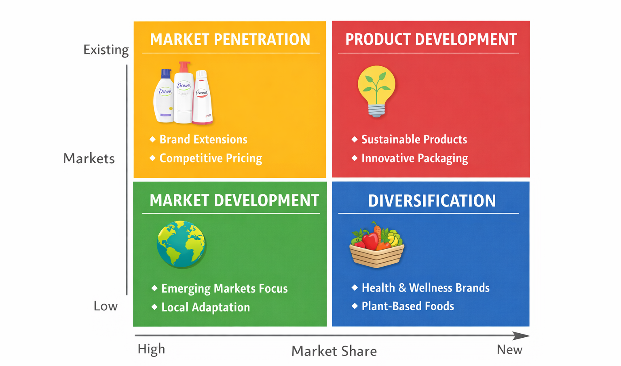
Figure 7: Ansoff’s Matrix
(Source: Influenced by Telakowiec, 2024)
BCG Matrix
Unilever has a portfolio that portrays a good balance of Stars, Cash Cows, and Question Marks. Older brands such as Dove are cash cows, as they bring a steady cash flow, whereas newly developed sustainable product brands are Star products that can grow significantly (Tserenbat et al. 2024). There are also newer health-oriented products that are Question Marks, and will have to make additional investments to see whether it would make long-term work. This is a diversified portfolio which helps in risk management but must be consistently prioritised on strategy (Tserenbat et al. 2024).
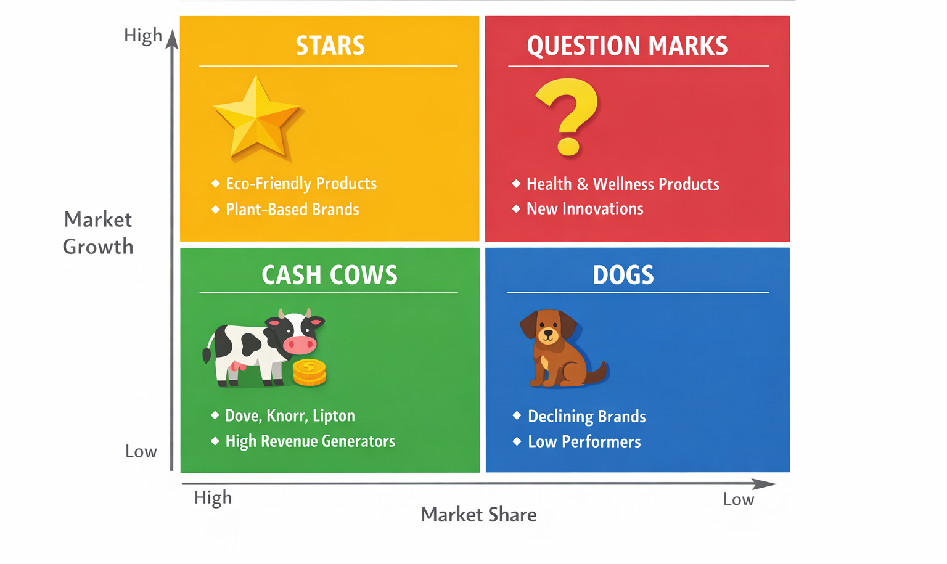
Figure 8: BCG Matrix
(Source: Influenced by Telakowiec, 2024)

6.2 Recommendations
Recommendation 1: Accelerate Sustainable Innovation
To enhance its differentiation approach, Unilever must maximise investments in sustainable product development, especially on biodegradable materials and low-carbon substitutes (Buri and Kiss, 2025).
Justification
This is in line with the Resource-Based View (RBV), in which distinctive resources like innovation in sustainability generate an inimitable competitive advantage (El Nemar et al. 2025). Indeed, such strategies have proven to be valuable over time, as seen with successful brand equity developed by companies such as Patagonia due to their sustainability leadership.
Recommendation 2: Enhance Digital Transformation Capabilities
It is advised that the company increase its adherence to artificial intelligence, data analysis, and e-commerce solutions to enhance consumer and business interactions and optimise work processes (Bezditnyi, 2024).
Justification
Dynamic Capabilities Theory means that organisations are required to keep up with the ever-evolving environments through the incorporation of new technologies into the organisation. Companies such as Amazon are a good example of how digital transformation results in responsiveness and competitive position in the global markets (Agustian et al. 2023).
Recommendation 3: Strengthen Presence in Emerging Markets
Unilever needs to further invest in the emerging economies by producing products that are less expensive, locally differentiated and reinforcing the distribution channels (Kormakova et al. 2023).
Justification
This strategy adapts the Market Development strategy of Ansoff and helps to achieve long-term growth by geographical expansion. Localisation and accessibility have been instrumental in companies like Nestlé, which have been able to capitalise on the emerging markets to increase revenues (Kormakova et al. 2023).

Section 2

1. Reflective account (Kolb’s cycle of reflective practice)
Concrete Experience
During the first step, I was involved in compiling and analysing a lot of secondary data concerning Unilever. I researched its organisational structure, mission, vision and business model to learn its strategic base in the FMCG industry. I also examined its external and internal environment based on frameworks, namely, PESTEL, SWOT and VRIO. In this level, I was ordered to work with various strategic tools, such as the Balanced Scorecard, the Matrix of Ansoff and the BCG Matrix. By specialising in the creation of value at Unilever by innovation, sustainability and global expansion, I narrowed in on this area of interest (Jayawardana, 2025). I also explored industry-level issues of digital transformation, sustainability pressures, and competitive rivalry. Synthesising the theory of academic knowledge with real practice in organisations was one of the most crucial things in my experience. I had made sure that every strategic tool was directly reinforced in the operations of Unilever as opposed to the implementation in isolation. This contributed to my developing a more realistic, practical sense of strategic management (Chaitanya Raja Hajarath, 2025).
Reflective Observation
Throughout the analysis undertaken, I noted that Unilever's strategic position is very complicated, as it is globally diversified and has a wide range of products. I also learned that sustainability could not be an important corporate social responsibility campaign, but a core strategic centre that controls the decision-making process of branding, product development, and market development (Chaitanya Raja Hajarath, 2025). This change in perception made me recognise sustainability as a business strategy and not a single business function. I also understood that various strategic frameworks had different yet complementary points of view. To be more exact, PESTEL analysis made me realise that there are external forces, including regulatory changes, environmental issues and economic risks which should not be ignored, whereas the VRIO analysis demonstrated internal competencies such as brand equity, potential to innovate and ability to find new means of distribution throughout the world. But at first, I had to find ways of relating these isolated analyses into a whole, consistent strategic narrative. The other notable observation was the tension that seems inherent in the strategy of Unilever between global consistency and local responsiveness. This was more visible, especially in the developing world, where adjustment to the consumer localisation preferences is vital but has to be in line with the global brand identity. Also, I estimated that, as a theory like the Resource-Based View or the Dynamic Capabilities Theory is of great use, it is necessary to interpret and think critically about the theoretical framework that the theory needs to be applied to real-life organisations (El Nemar et al. 2025).
Abstract Conceptualisation
This process helped me gain a greater insight into the workings of strategic management theories in practice. I got to know that competitive advantage does not develop as a result of any single factor but rather through a combination of a set of inner as well as external capabilities. According to the Resource-Based View, I came to comprehend that the brand portfolio and innovation strength of Unilever are advantageous, unique, and impracticable, thus long-term advantages (El Nemar et al. 2025). This enabled me to go beyond an analysis of the surface and critically assess the reasons some resources are important to work on. The Dynamic Capabilities Theory made me realise that organisations have to keep changing, constantly by getting innovative, digital and learning in organisations. It was especially pertinent to the digital and sustainability transitions of Unilever. Personally, I also understood the significance of the Matrix of Ansoff, which helped me to understand how growth strategies like the development of markets and diversification are applied in practice. On the same note, the Balanced Scorecard assisted me in recognising the collaboration between financial and non-financial measurements of performance to determine strategic success. I learned how to relate theory and practice, which contributed to enhancing the depth of my analysis in significant ways (El Nemar et al. 2025).
Active Experimentation
In the future, I will use the knowledge I gained in this assignment in both school and employment environments by becoming more analytical and critical of strategic analysis. Instead of merely expounding on strategic frameworks like PESTEL, SWOT, VRIO or the Balanced Scorecard, I will dwell on the meaning of how and why organisations employ these tools to aid decision-making in real-life situations (El Nemar et al. 2025). This shift will allow me to go beyond the surface level and have more insightful and practical strategic arguments. I also plan to improve my skills in combining various frameworks into one coherent analysis. An example of this is that I will incorporate external environmental analysis and internal capability analysis to yield more balanced and comprehensive strategic information. This combination will enable me to have a deeper concept of the interplay between external influence and internal capabilities in shaping organisational strategy (van Heurn, 2025).
In my future research, I will be more focused on the correlation between theoretical terminology like sustainability, digital transformation, and competitive advantage and real organisational practices. This will enable me to critically evaluate the effectiveness of organisations in their strategies to meet changing market conditions (Bezditnyi, 2024). To construct a more critical and nuanced argument, I will also concentrate on the identification and assessment of strategic tensions, including the trade-off between cost efficiency and sustainable investment. More so, I will manage my scholarly writing by working on logical flow, minimising repetition and easing transition between various analytical sections of the writing.

Conclusion
Thus, the present report has critically examined the strategic position of Unilever to analyse its internal possibilities, external environment and its strategic direction. The analysis has identified a strong brand portfolio, leadership in sustainability and global coverage as major sources of competitive advantage for the company.

References
Agustian, K., Mubarok, E.S., Zen, A., Wiwin, W. and Malik, A.J., 2023. The impact of digital transformation on business models and competitive advantage. Technology and Society Perspectives (TACIT), 1(2), pp.79-93.
Ahmed, M., 2024. The Impact of Workforce Diversity on Organizational Performance: A Case Study of Unilever. iRAPA International Journal of Business Studies, 1(1), pp.18-33.
Akter, S., 2025. Cross-cultural management and its impact on international corporate success-a case study of Unilever Plc.
Bezditnyi, V., 2024. The Impact of Artificial Intelligence on Business Model Transformation in E-Commerce. Research Corridor Journal of Engineering Science, 1(1), pp.143-170.
binti Tsuraya, H., Endayani, L., Zahda, F.M., Utami, I.S. and Jayadi, U., 2023. Unilever Company Work Model. International Journal of Economics, Management and Accounting (IJEMA), 1(1), pp.7-14.
Buri, Z. and T Kiss, J., 2025. Case Study of Unilever's Zero-Emission Target Realization.
Chaitanya Raja Hajarath, K., 2025. Geopolitical Trade Tensions and Their Strategic Impact on Global Supply Chains. Available at SSRN 5295693.
de Arruda Pollice, F.F. and Scarcelli, M., 2024. Purchasing and supply management journey into unilever’s circular economy strategy. In A Systemic Transition to Circular Economy: Business and Technology Perspectives (pp. 161-173). Cham: Springer International Publishing.
Derqui, B., Fayos, T. and Occhiocupo, N., 2022. The virtuous cycle of trust. Unveiling clues to successful innovation in the Fast Moving Consumer Goods industry. European Journal of Innovation Management, 25(6), pp.1036-1056.
El Nemar, S., El-Chaarani, H., Dandachi, I. and Castellano, S., 2025. Resource-based view and sustainable advantage: a framework for SMEs. Journal of Strategic Marketing, 33(6), pp.798-821.
George, A.S. and George, A.H., 2023. FMCG's digital dilemma: The consequences of insufficient IT expertise in the fast-moving consumer goods industry. Partners Universal International Innovation Journal, 1(3), pp.46-69.
Hajarath, K.R. and Chaitanya, K., 2025. Geopolitical trade tensions and their strategic impact on global supply chains. International Journal of Global Innovations and Solutions, 2(2).
Imarcgroup, 2026. UK FMCG Market Report by Type. Available at: https://www.imarcgroup.com/uk-fmcg-market [Accessed on: 10/4/2026]
Jayawardana, P.W., 2025. The Impact of Artificial Intelligence on Supply Chain Optimization in FMCG Industry.
Kang, J., Lee, S. and Choi, S., 2023. Asymmetric Vacillation in the FMCG Industry: A Case Comparison of Procter & Gamble and Unilever. Administrative Sciences, 13(8), p.187.
Kaplan, R. and Norton, D. 1992. The Balanced Scorecard—Measures That Drive Performance. Harvard Business Review, 79.
Kormakova, I., Kruhlyanko, A., Peniuk, V., Ursakii, Y. and Verstiak, O., 2023. Actual strategies for businesses penetrating foreign markets in the modern economy: Globalisation aspect. International Journal of Professional Business Review: Int. J. Prof. Bus. Rev., 8(5), p.117.
Laursen, L.N. and Andersen, P.H., 2023. Resource and supplier interaction in network innovation governance: the case of innovating at Unilever. Journal of business research, 156, p.113465.
Lazaridou, D., Mattas, K., Tsakiridou, E. and Yercan, M., 2024. Consumption patterns for healthy and environmentally friendly food choices: An overview of contemporary issues. Value chain dynamics in a biodiverse environment: Advances in biodiversity, sustainability, and agri-food supply chain development, pp.61-75.
Lee, C.C., 2023. Analyses of the operating performance of information service companies based on indicators of financial statements. Asia Pacific Management Review, 28(4), pp.410-419.
Luo, Y. and Tung, R.L., 2025. A multipolar geo-strategy for international business. Journal of International Business Studies, 56(7), pp.821-829.
Mann, S. and Mann, S., 2025. Human resource development in the digital era: Talent management and skill enhancement. In Immersive Technology for the Gig Economy: Transformative Business Practices (pp. 381-408). IGI Global Scientific Publishing.
Modreanu, A., Andrișan, G.N., Sârbu, A.M. and Grădinaru, C., 2022. Corporate Social Responsibility, a Strategic Tool for Sustainable Value Creation: A Case Study of Unilever’s Sustainable Living Plan. In BASIQ International Conference (pp. 575-582).
Narayanan, S. and Das, J.R., 2022. Can the marketing innovation of purpose branding make brands meaningful and relevant?. International Journal of Innovation Science, 14(3-4), pp.519-536.
Narayanan, S. and Das, J.R., 2022. Can the marketing innovation of purpose branding make brands meaningful and relevant?. International Journal of Innovation Science, 14(3-4), pp.519-536.
ons.gov.uk, 2026. Employment. Available at: https://www.ons.gov.uk/ [Accessed on: 10/4/2026]
Siddiq, S. and Ali, T., 2024. Advertising spend and its impact on FMCG profitability (A case study of Unilever and Procter & Gamble). Journal of Marketing & Management, 15(1).
Tatarchenko, Y.M., 2025. Digital transformation of international business: the impact of artificial intelligence on the competitiveness of companies.
Telakowiec, A., 2024. How Bonduelle and Unilever manage price image for perceived value. In Pricing Decoded (pp. 133-142). Routledge.
Tserenbat, U., Lee Alm, D. and Kusche, F., 2024. Why Longevity Wins-The Dove Blueprint for Long-Term Marketing Success. LBMG Strategic Brand Management-Masters Paper Series.
Tumu, K., Vorst, K. and Curtzwiler, G., 2023. Global plastic waste recycling and extended producer responsibility laws. Journal of Environmental Management, 348, p.119242.
unilever.co.uk, 2026. Leading in the next era of corporate sustainability. Available at: https://www.unilever.co.uk/sustainability/#:~:text=Fewer%20things%2C%20done%20better%2C%20with,Livelihoods [Accessed on: 10/4/2026]
unilever.com, 2025. Annual report. Available at: https://www.unilever.com/files/unilever-annual-report-and-accounts-2025.pdf [Accessed on: 10/4/2026]
unilever.com, 2025. Unilever Sustainability Statement 2025. Available at: https://www.unilever.com/files/unilever-sustainability-statement.pdf [Accessed on: 10/4/2026]
unilever.com, 2026. Our sustainability goals. Available at: https://www.unilever.com/files/our-sustainability-goals.pdf [Accessed on: 10/4/2026]
van Heurn, F.A., 2025. Frugal Innovation: Business Opportunities and Challenges for Multinational Corporations in Emerging and Developing Markets.
Wang, H., 2024. Supply Chain Analytics for Sustainable Operations: a case study on Unilever's GHG emissions.

