

Assessment 1 – Reading Task Template
PART 1: Upload your photo of your A3 in-class notes here:
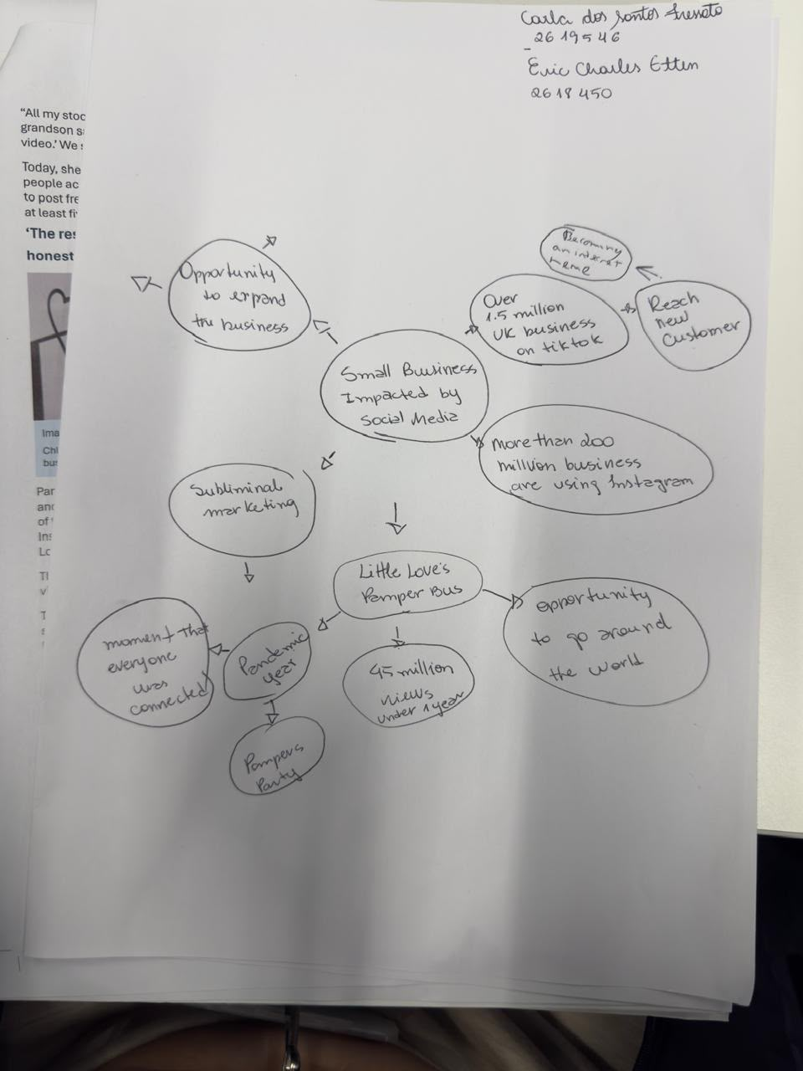
PART 2:
- Answer every question below in 1-3 full sentences.
- Use your own words. Do not use generative AI to answer these questions.
- Include a specific detail from the text when asked.
REMINDER
- The main idea is the overall message of the whole text.
- A key point helps to explain the main idea.
- A specific detail or example from the text shows that the key point is true.

- What is the main idea of the whole text?

The main idea is about how social media helps and impact small business, how the business grows after posting videos or photos on social media. They reach more clients; they could promote own products and become more popular.

- What is one key point that supports the main idea, and which specific example from the text shows this?
One key point is that social media helps reach a lot of people quickly by using TiktTok, Instagram or Facebook. For example: Chloe posted video of their children pamper parties on TikTok, Instagram and Facebook, the business has racked up about 45 million views in under a year.

- What is a different key point that supports the main idea, and which specific example from the text shows this?

Another different key point is when customers share posts, leave a review or recommend it for others; this also can reach people from far away. For example, people travel 3 hours to buy a burger at Honywood Sandwich Shop after a customer posted and girls fly from Cyprus to buy prom dresses at Krystalls Butique.

- Which part of the text do you think is most important, and why?
I think the most important part is that social media helps small business grow without needing spend much money on advertising, even with a limited budget they can become successful just by using social media.

Reflection:
- What did you find difficult in this task (including in-class components), and why was it difficult?
I felt a bit nervous about making Mind maps because it is hard when we worked in groups/pairs and we have different ideas; I would like to improve working in groups.
In addition, one thing that I found it difficult is to identify points that support the main idea of the whole context. The article shows several business and personal experiences, so it was important to understand the overall message rather than focus on every detail. I also found challenging it to organise my thoughts and express my opinions clearly during the class activities.

- What helped you with this difficulty, and how did it help you?
Reading the text again helped me understand the main ideas. Comparing the texts and discussing the topic in class helped me to consider different perspectives and organise my ideas more clearly, which made me feel more confident when answering the questions.

