Social Epidemiology and Public Health
Development

Student Name: Tank Shivangi
Student Number: 2530748
Lecturer: Muhammad Aliyu
Submission Date: Aug 19, 2026
Word Count: 2671

Table of Contents

TASK 1: Health Inequalities Among the Elderly Population in the United Kingdom 5
1. Introduction 5
2. Contextual Background and Underlying Factors 5
2.1 Disease and Illness Rates 5
2.2 Social Issues 6
3. National Response to Reduce Health Inequalities in the Elderly Population 7
3.1 The Care Act 2014 and Its Role in Addressing Elderly Health Inequalities 7
3.2 The NHS Long Term Plan and Ageing Well Programme 7
4. Organisations That Support the Elderly Population 8
4.1 Age UK: Goals, Achievements, and Role in Reducing Health Inequalities 8
4.2 Centre for Ageing Better: Goals, Research, and Advocacy 8
5. Conclusion 8
TASK 2: An Epidemiological Analysis of Blood Cancer in the London Borough of Tower Hamlets 9
1. Introduction 9
1.1 Definition of Blood Cancer and Its Social, Cultural, and Health Consequences 9
1.2 Global and UK Incidence and Prevalence of Blood Cancer 10
1.3 The Target Population: Tower Hamlets (3 P’s.) 12
2. Key Determinants and Risk Factors of Blood Cancer 13
2.1 Genetic Environmental Risk Factors 13
2.2 Environmental Risk Factors 13
2.3 Occupational Lifestyle-Related Risk Factors 13
2.4 Lifestyle-Related Risk Factors 13
3. Epidemiological Studies and Health Needs Assessment 14
3.1 Application of Epidemiological Study Designs to Identify At-Risk Groups 14
3.2 Health Needs Assessment of the Target Population in Tower Hamlets 14
4. Public Health Measures to Contain, Manage, and Reduce Blood Cancer 15
4.1 Prevention Strategies 15
4.2 Health Protection Measures 15
4.3 Health Promotion Initiatives 15
5. Monitoring and Surveillance of Blood Cancer Incidence 16
5.1 Cancer Registry Data and the National Cancer Registration and Analysis Service 16
5.2 Local Surveillance Systems and Public Health England Fingertips 16
6. Public Health Impact of Blood Cancer on the Specified Population 16
6.1 Short-Term Consequences on Morbidity and Quality of Life 16
6.2 Long-Term Consequences on Mortality and Life Expectancy 17
7. Proposed Health Intervention Programme 17
7.1 Design of the Intervention Programme 17
7.2 Evaluation of the Proposed Intervention's Acceptability and Effectiveness 17
8. Strengths and Weaknesses of the Epidemiological Approach 17
8.1 Strengths and Advantages of the Approach 17
8.2 Assumptions, Limitations, and Insufficiencies 18
Reference List 19
Task 1 19
Task 2 20

TASK 1: Health Inequalities Among the Elderly Population in the United Kingdom

1. Introduction
One of the demographic groups that have been increasing at a fast rate in the United Kingdom is the elderly population, which is delineated as adults aged 65 years and above. According to Age UK (2026), it is indicated that the number of pensioner population will ensure an increase up to 12.7 million by the year 2026 and over 13 million by 2030 (GOV.UK, 2026). The diverse interplay of biological ageing, limited socio-economic capacity, structural ageism, and limited access to responsive healthcare services means old people experience disproportionate risks of health inequalities. The report discusses key health inequalities faced by the elderly in the UK, national responses to them and how two supporting charities have contributed towards this work.

2. Contextual Background and Underlying Factors

2.1 Disease and Illness Rates
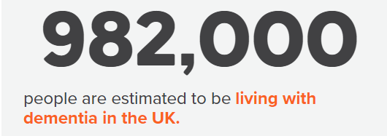
Figure 1: Number of People in Dementia
(Source: Alzheimer’s Research UK, 2025)
Dementia: Older adults are disproportionately impacted by dementia, in the UK, it is estimated that 982,000 individuals will live with dementia in 2024, increasing to 1.01 million in 2025, and is expected to grow to 1.4 million in 2040 (Alzheimer’s Research UK, 2025).
Cardiovascular Disease: Another significant number of ill health is cardiovascular disease, 5.9 million individuals in England live with CVD and the prevalence increases sharply above 60 years old with nearly 8% of the population developing coronary heart disease (British Heart Foundation, 2026). The death rates are high: adults over 75 years of age have the most excess winter mortality rates, and the age group above 90 years have the highest rates overall.

2.2 Social Issues
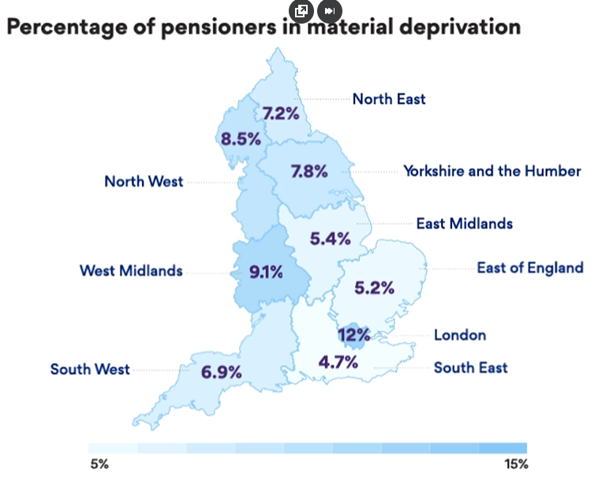
Figure 2: Percentage of Pensioners in Material Deprivation
(Source: Ageing Better, 2025)
In the UK, an estimate of 940,000 individuals aged 65 and above will experience loneliness, and this number will soar to 1.2 million in 2034 (Age UK, 2025). The rate of older people in poverty is remaining high with some 1.9 millennium aged living in poverty; the elderly increasing at 21 among those 85 years or older (Ageing Better, 2025). These problems are exacerbated by housing and fuel poverty, and in 2022/23, End Fuel Poverty Coalition (2025) projects 4,950 excess winter deaths due to cold and damp homes and is disproportionately affecting older women aged 85 and above.

3. National Response to Reduce Health Inequalities in the Elderly Population

3.1 The Care Act 2014 and Its Role in Addressing Elderly Health Inequalities
A historic law, the Care Act 2014, which has consolidated the law on adult social care in England, places statutory responsibilities on local authorities to advance individual wellbeing, avoid the onset of care requirements, and offer individualised support (GOV.UK, 2024). In the case of older adults, the Act put in place universal eligibility over all adults who are at risk of abuse and lawful carer rights of adults who are not paid. It forms the basis of the existing social care system but is still yet to be fulfilled. In 2025, the King funds (2025) states that elected unmet need is on the increase with 2.6 million over 50 year-olds being unable to obtain the required care (AGE UK, 2025).

3.2 The NHS Long Term Plan and Ageing Well Programme
Ageing Well is a priority in the NHS Long Term Plan (2019) and its successor, the 10 Year Health Plan for England 2025, where it aims to include better community-based services, primary and social care in one, and the new Frailty and Dementia Modern Service Framework (AGE UK, 2025). Anticipatory care in care homes, urgent community response teams that bring care to homes within two hours, and social prescribing are some of the programmes of Ageing Well (NHS UK, 2025). These policies will prevent hospitalisation of frail elders to prevent hospitalisation of frail elderly and the broader social determinants of later life health inequality.

4. Organisations That Support the Elderly Population

4.1 Age UK: Goals, Achievements, and Role in Reducing Health Inequalities
In 2009, after the merging of Age Concern and Help the Aged, Age UK, the largest UK charity to support the elderly, was created. Its objectives entail successful later life by championing pensioner poverty, loneliness, and social care reform (AGE UK, 2026). In 2025, its national advice line provided advice and support to more than 6,000 older individuals who needed help applying benefits, revealing more than 36 million pounds in missing support and a mean of 5,900 per person. also Age UK provides innovative research on loneliness under the English Longitudinal Study of Ageing and lobbies the government over the automatic uptake of Pension Credit (The Independent, 2026).

4.2 Centre for Ageing Better: Goals, Research, and Advocacy
The Centre for Ageing Better is a charity, independent foundation that is aimed at making later life a better one. It publishes the annual report, State of Ageing, which becomes the official statistical source information on ageing in England (Centre for Ageing Better, 2025). Its aims are to address the issue of ageism, facilitate age-friendly jobs and enhance homes through the network of the National Home Improvement Agency. In 2025, the Centre spearheaded the Age Without Limits campaign that aims to dispel negative stereotypes about older adults, and collaborated with policy-makers to inform the future national approach to ageing.

5. Conclusion
The elderly face a wide range of health inequalities in the UK, such as an imbalance in dementia, cardiovascular disease, and excess mortality, alongside embedded social inequalities, such as loneliness, poverty, and fuel poverty. They are not random or unavoidable; these inequalities represent failures in the program of social care, housing, and income protection that build up over a lifetime. Nation-wide actions like the Care Act 2014 and NHS Long Term Plan promote valuable frameworks but are undermined by poor implementation and long-term underfunding. Charities such as the Age UK and the Centre of Ageing Better are very essential in the generation of evidence, advocacy and service delivery. To diminish the health inequalities in older adults, it is important to invest in prevention and universal funding of social care, auto-benefit claims and age-sensitive practices throughout the systems.

TASK 2: An Epidemiological Analysis of Blood Cancer in the London Borough of Tower Hamlets

1. Introduction

1.1 Definition of Blood Cancer and Its Social, Cultural, and Health Consequences
Blood cancer is a general term used to refer to malignancies of the blood, bone marrow, and lymphatic system that are primarily leukaemia, lymphoma, and myeloma (Saha et al., 2024). It has significant health effects and implications such as anemia, immunosuppression and death as well as social and cultural effects such as high cost of long term treatment, caregiver stress and the cultural stigma of cancer among some minority ethnic groups (AMERICAN SOCIETY OF HEMATOLOGY, 2024).

1.2 Global and UK Incidence and Prevalence of Blood Cancer
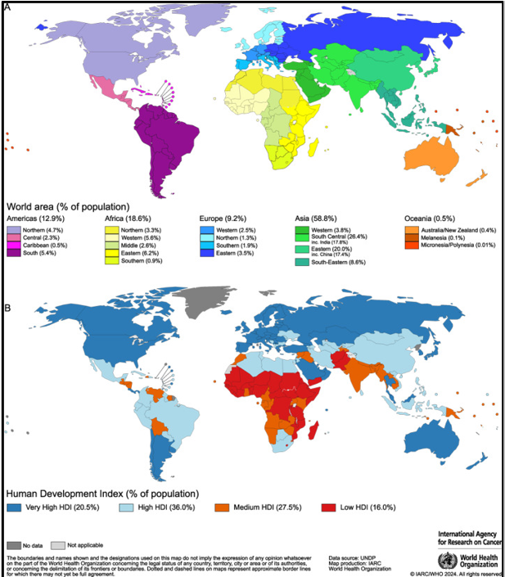
Figure 3: Global maps present (A) 20 areas of the world and (B) the four‐tier HDI.
(Source: Sung et al., 2026)

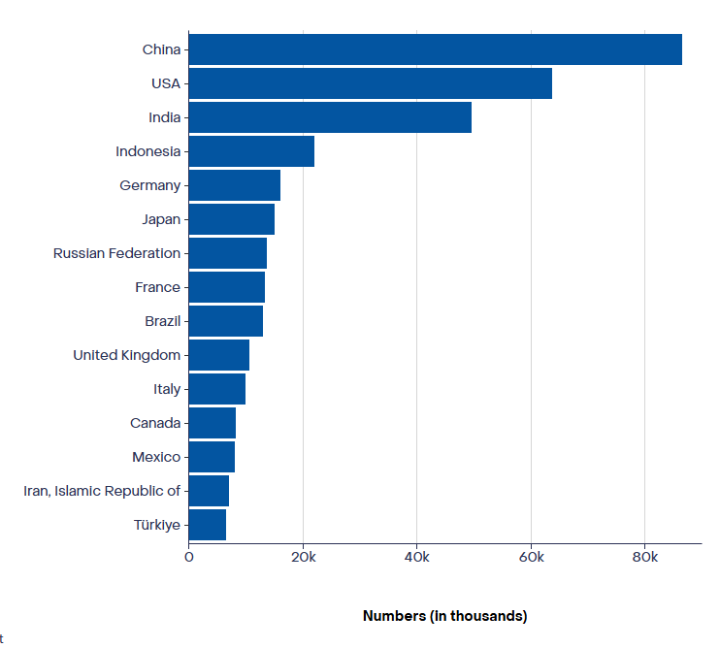
Figure 4: Blood Cancer Absolute numbers, Incidence, Both sexes
(Source: Cancer today, 2026)
Global: GLOBOCAN 2024 estimates globally 20.6 million new cancer cases annually, of them exponentially haematological malignancies. Global cancer heterogeneity requires a delicate strategy in national and regional efforts in cancer control, but in the first session, the role of primary prevention against cancer must take center stage that involves greater efforts to control tobacco use, prevent infections and reduce alcohol usage and excess body weight and mount physical activity.
United Kingdom: In the United Kingdom, leukaemia alone causes around 9,900 new cases per annum with 39 percent being diagnosed in individuals aged 75 years and above (Sung et al., 2026). According to Blood Cancer UK (2026), the number of individuals living with blood cancer in the UK currently stands at more than 310,000.

1.3 The Target Population: Tower Hamlets (3 P’s.)
Tower Hamlets is a populated borough in London, which has a population density of 331,886 people and has a median age of 30.6 years. It documents extreme deprivation, a prevalent ethnic background, and a quintupled growing 3564 cohort initially exposed to chronic illness (Gov.UK and ONS, 2026). The local response of health authorities to blood cancer is based on the 3 Ps framework of Prevention, Protection, and Promotion, which are succinctly summarised below.
Table 1: Application of the 3 Ps Framework to Blood Cancer in Tower Hamlets
The 3 P's | Application to Blood Cancer in Tower Hamlets
Prevention | Changing the intensity of risk factors: quitting smoking programmes, occupational exposure risk management (benzene, ionising radiation), weight loss via the borough Healthy Weight Declaration (Tower Hamlets council, 2026).
Protection | Vaccinating immunocompromised patients, infection prevention after transplant, safety of blood transfusion via NHS Blood and Transplant, protecting vulnerable patients.
Promotion | Community education to the Bangladeshi and Somali community, GP education on symptom recognition, culturally sensitive Bengali and Somali materials, outreach via mosques (Healthwatch, 2026).

2. Key Determinants and Risk Factors of Blood Cancer

2.1 Genetic Environmental Risk Factors
Blood cancer is multifactorial. Inherited mutations in TP53 gene, as well as Down syndrome and Fanconi anaemia, can greatly predispose people to leukaemia and lymphoma of all ages (Elghetany, Patnaik and Khoury, 2024).

2.2 Environmental Risk Factors
Some of the known environmental risks are the presence of ionising radiation and the viral infections announced as Epstein-Barr virus and human T-lymphotropic virus associated with particular types of lymphoma. Tower Hamlets is at a further risk because of the congested cities and the industrial legacy in the area in addition to the quality of housing, which is a specific risk factor in east London (Aguayo et al., 2021).

2.3 Occupational Lifestyle-Related Risk Factors
Exposures to benzene, formaldehyde, and pesticide remain as predetermined risks especially those in the construction, manufacturing and cleaning industries concentrated in the industrial districts of east London (Iqbal, 2026).

2.4 Lifestyle-Related Risk Factors
Risks increase because of tobacco use, obesity and a history of chemotherapy and at Tower Hamlets there is high smoking and obesity among South Asian communities. The incidence of male AML is also 11 percent in the most deprived quintile of England (Cancer Research UK, 2025).

3. Epidemiological Studies and Health Needs Assessment

3.1 Application of Epidemiological Study Designs to Identify At-Risk Groups
The UK blood cancer incidence by age, sex, and geography is the most granular data available through cross-sectional studies through the Haematological Malignancy Research Network (Cancer Research UK, 2025). Exposure to benzene, and ionising radiation has been found to be significant aetiological agents in case-control studies. Prospective cohort studies, and the UK Biobank, in particular, allow the test of interactions between genes and the environment in terms of ethnicity. Randomised controlled trials are used to test novel therapies such as CAR-T cell therapy, but their extrapolation to a wide range of populations has been noted to be a limitation (Sterner and Sterner, 2021).

3.2 Health Needs Assessment of the Target Population in Tower Hamlets
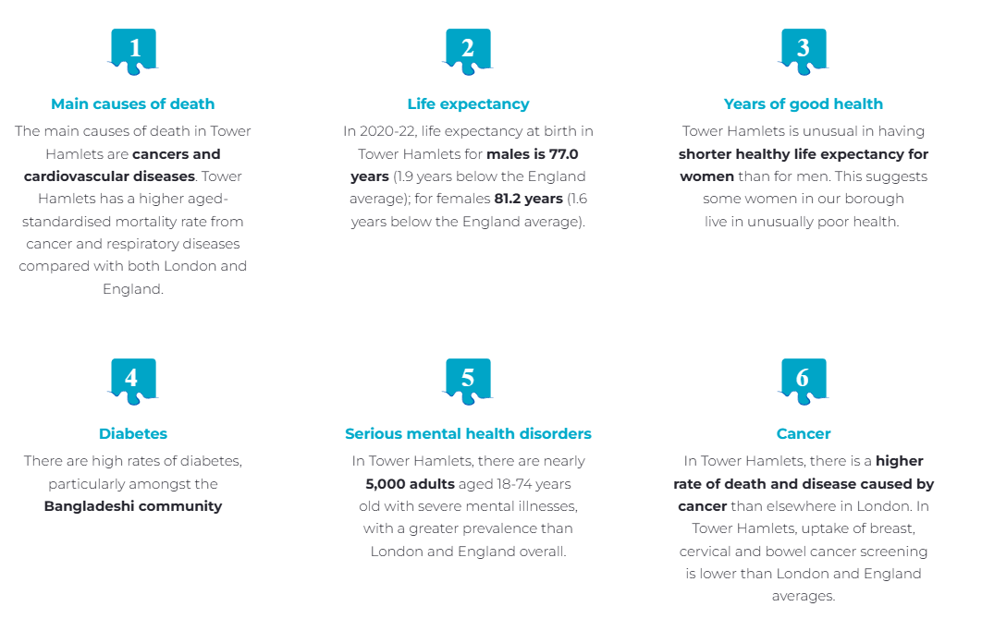
Figure 5: Health Need Assessment in Tower Hamlet
(Source: Tower Hamlets Together, 2026)
Cancer death and morbidity is higher in Tower Hamlets than in wider London and England, and cancer is the leading cause of premature death in the borough and male life expectancy remains at just 77.0 years (1.9 years below the England average) - the December 2025 OHID Mortality Profile confirmed an increase of 9 per 100,000 in the male under-75 mortality rate in Tower Hamlets in 20212023 (OHID, 2025). This burden is further worsened by screening uptake, where in 2023 only 49% of women aged 25-49 years attended cervical screening and 46% of women attended breast screening when invited which is significantly lower than the national target of 80% and bowel cancer screening has not yet met the target of 80 in North East London (Healthwatch Tower Hamlets, 2025).

4. Public Health Measures to Contain, Manage, and Reduce Blood Cancer

4.1 Prevention Strategies
Primary prevention is about reducing risk which is modifiable: the COSHH 2002 benchzene monitoring in the workplace, the Tobacco and Vapes Bill 2025 to reduce tobacco consumption, and the Healthy Weight Declaration employed by Tower Hamlets Council to reduce obesity. The NHS Long Term Plan includes a target to diagnose 75% of cancer at stage 1 or 2 by 2028 (under secondary prevention) (The BLK Team, 2024).

4.2 Health Protection Measures
Medical safety includes prevention of infection in immunocompromised patients, safety of the national blood bank (NHS Blood and Transplant) and vaccination of vulnerable groups. The Tower Hamlets Public Health commissions had focused on activities such as the rates being vaccinated against influenza and pneumococcal vaccination among the older people, and stricter post-transplant infection measures by monitoring through the Royal London Hospital haematology unit (Wallace, 2025).

4.3 Health Promotion Initiatives
The health promotion of Tower Hamlets incorporates community-based strategies such as Blood Cancer UK's campaign to raise awareness of leukaemia, called Spot Leukaemia, which has used culturally relevant resources such as Bengali and Somali literature, faith-based interventions through mosques, and general practitioner (GP) education on early signs and symptoms. The programme known as Primary Care Networks is a peer support network and social prescribing that minimizes psychosocial burden in the process of treatment (Hanafiah and Bertotti, 2026).

5. Monitoring and Surveillance of Blood Cancer Incidence

5.1 Cancer Registry Data and the National Cancer Registration and Analysis Service
Data on cancer registries is accessible via the National Disease Registration Service (NDRS), run by NHS England, which offers detailed statistics on haematological malignancy using the Get Data Out programme to capture ICD-10 data and sub-regional and demographic data (Digital.nhs.uk, 2025).

5.2 Local Surveillance Systems and Public Health England Fingertips
The Office of Health Improvement and Disparities (OHID) Fingertips portal offers interactive data with local levels on cancer incidence, mortality, and screening uptake reported on Tower Hamlets census area. Complementary local surveillance incorporates Barts Health NHS Trust Cancer Board audits London Cancer Alliance quality standards, which are real-time sources of intelligence to inform commissioning.

6. Public Health Impact of Blood Cancer on the Specified Population

6.1 Short-Term Consequences on Morbidity and Quality of Life
Short-term outcomes of blood cancer are chronic fatigue, prolonged immunosuppression that results in long hospitalization, and morbidity of treatment due to radiation and chemotherapy. The Tower Hamlets has a longer haematology length of stay than the rest of London, putting a strain on the Royal London Hospital. Cultural stigmatization and language barriers put patients at risk of anxiety and depression (Blood Cancer UK, 2026).

6.2 Long-Term Consequences on Mortality and Life Expectancy
The consequences in the long-term are the decreased lifespan with annual deaths due to leukaemia in the UK averaging at around 5,000 and expected to decrease by 13 percent by 2038-40 (Cancer Research UK, 2025). The life expectancy of men in Tower Hamlets stands at 77.0 years, lower than the England average, and cancer is a major cause of this, as well as other main cord casualties such as secondary malignancies and cardiotoxicity secondary to anthracycline.

7. Proposed Health Intervention Programme

7.1 Design of the Intervention Programme
The intervention will be a Community-Based Early Detection and Support Programme on Blood Cancer in Tower Hamlets, which will include culturally sensitive awareness raising, in Bengali, Somali, and English; the special GP training in symptom recognition and referral. A peer support hub, which will be located on the Barts Health outpatients; and will be integrated into the social prescribing scheme of the borough in line with the NHS Long Term Plan (Tower Hamlet, 2026).

7.2 Evaluation of the Proposed Intervention's Acceptability and Effectiveness
The evaluation design is a mixed-methods design (measuring process, outcome, and impact) using a difference-in-differences design between London boroughs matched to evaluate the effectiveness of using GP referrals as a process indicator (GP referrals) versus initiating screening on behalf of healthcare providers (campaign reach and clinic attendance) versus initiating screening as a process (stage at diagnosis) versus initiating screening as an outcome (one-year survival and patient-reported experience), and qualitative interviews and modelling the cost-effectiveness (Glover et al., 2025).

8. Strengths and Weaknesses of the Epidemiological Approach

8.1 Strengths and Advantages of the Approach
The methodology relies on quality UK cancer registry data using NDRS and HMRN, which guarantees close ascertainment of cases, and demographic description. Routine surveillance, epidemiological studies and local health needs assessment triangulation are supportive factors in enhancing validity. The culture preparedness and health equity are strengthened through community involvement in the design of interventions (Roman et al., 2025). The mixed methods analysis embodies both quantitative and lived experience needed to translate policy and make commissions.

8.2 Assumptions, Limitations, and Insufficiencies
Limitations are based on the use of cancer registry data that could be insufficient in reflecting the minority groups since there was a mismatch in coding. There might be assumptions of constant GP referral behaviour and constant population denominators in that case, that are not true because of the high population churn in Tower Hamlets (Tower Hamlet, 2025). Small-area estimates have large confidence intervals and short periods of evaluation might not reflect long-term benefits in survival. Before generalisation the transferability of the intervention to non-London settings needs to be researched more.

Reference List

Task 1
Age UK (2025) AGE UK’S NEW REPORT SHOWS ‘YOU ARE NOT ALONE IN FEELING LONELY’, Age UK. Available at: https://www.ageuk.org.uk/latest-press/articles/age-uks-new-report-shows-you-are-not-alone-in-feeling-lonely/ (Accessed: August 12, 2026).
AGE UK (2025) Care in Crisis | Age UK, Ageuk.org.uk. Available at: https://www.ageuk.org.uk/our-impact/campaigning/care-in-crisis/ (Accessed: August 14, 2026).
AGE UK (2026) history | age international, Ageinternational.org.uk. Available at: https://www.ageinternational.org.uk/who-we-are/history/ (Accessed: August 14, 2026).
Ageing Better (2025) Financial Security | The State of Ageing 2025, Centre for Ageing Better. Available at: https://ageing-better.org.uk/financial-security-state-ageing-2025 (Accessed: August 15, 2026).
Alzheimer’s Research UK (2025) Prevalence and incidence, Dementia Statistics Hub. Available at: https://dementiastatistics.org/about-dementia/prevalence-and-incidence/ (Accessed: August 16, 2026).
British Heart Foundation (2026) The CVD challenge in England, British Heart Foundation. Available at: https://www.bhf.org.uk/for-professionals/healthcare-professionals/data-and-statistics/the-cvd-challenge/the-cvd-challenge-in-england (Accessed: August 16, 2026).
Centre for Ageing Better (2025) The State of Ageing in 2025. Available at: https://ageing-better.org.uk/sites/default/files/2025-03/The-State-of-Ageing-2025-interactive-summary.pdf (Accessed: August 14, 2026).
GOV.UK (2024) Care Act 2014 . Available at: https://www.legislation.gov.uk/ukpga/2014/23/pdfs/ukpga_20140023_en.pdf (Accessed: August 16, 2026).
GOV.UK (2026) Over 12 million pensioners to receive £575 State Pension boost, GOV.UK. Available at: https://www.gov.uk/government/news/over-12-million-pensioners-to-receive-575-state-pension-boost (Accessed: August 15, 2026).
NHS England (2024) NHS Long Term Plan, NHS. Available at: https://www.england.nhs.uk/long-term-plan/ (Accessed: August 12, 2026).
NHS UK (2025) UK government web archive, Nationalarchives.gov.uk. Available at: https://webarchive.nationalarchives.gov.uk/ukgwa/20250506042058/https://www.longtermplan.nhs.uk/areas-of-work/ageing-well/ (Accessed: August 13, 2026).
The Independent (2026) Some older people ‘skipping showers or meals to make ends meet financially’, Newswav. Available at: https://newswav.com/article/some-older-people-skipping-showers-or-meals-to-make-ends-meet-financially-A2601_9dDXl2 (Accessed: August 16, 2026).

Task 2
Aguayo, F., Boccardo, E., Corvalán, A., Calaf, G.M. and Blanco, R. (2021). Interplay between epstein-barr virus infection and environmental xenobiotic exposure in cancer. Infectious Agents and Cancer, 16(1). doi:10.1186/s13027-021-00391-2. (Accessed: August 11, 2026).
AMERICAN SOCIETY OF HEMATOLOGY (2024) Blood cancers, www.hematology.org. Available at: https://www.hematology.org/education/patients/blood-cancers (Accessed: August 11, 2026).
Blood Cancer UK (2026a) Blood Cancer UK | Facts and Information about Blood Cancer, Blood Cancer UK. Available at: https://bloodcancer.org.uk/news/blood-cancer-facts/ (Accessed: August 13, 2026).
Blood Cancer UK (2026b) Blood Cancer UK | Living well with mantle cell lymphoma, Blood Cancer UK. Available at: https://bloodcancer.org.uk/understanding-blood-cancer/lymphoma/mantle-cell-lymphoma/living-well-mantle-cell-lymphoma/ (Accessed: August 14, 2026).
Cancer Research UK (2025) All cancers combined incidence statistics, Cancer Research UK. CRUK. Available at: https://www.cancerresearchuk.org/health-professional/cancer-statistics/statistics-by-cancer-type/all-cancers-combined/incidence (Accessed: August 16, 2026).
Cancer Research UK (2026) Leukaemia (all subtypes combined) mortality statistics, Cancer Research UK. Available at: https://www.cancerresearchuk.org/health-professional/cancer-statistics/statistics-by-cancer-type/leukaemia/mortality (Accessed: August 15, 2026).
Digital.nhs.uk (2025) welcome to zscaler directory authentication, Digital.nhs.uk. Available at: https://digital.nhs.uk/ndrs/data/data-outputs/cancer-data-hub/cancer-registration-statistics (Accessed: August 12, 2026).
Elghetany, M.T., Patnaik, M.M. and Khoury, J.D. (2024) “myelodysplastic neoplasms evolving from inherited bone marrow failure syndromes / germline predisposition syndromes: back under the microscope,” Leukemia Research, 137, p. 107441. Available at: https://doi.org/10.1016/j.leukres.2024.107441.
Gov.UK and ONS (2026) How health has changed in your area - Office for National Statistics, www.ons.gov.uk. Available at: https://www.ons.gov.uk/peoplepopulationandcommunity/healthandsocialcare/healthandwellbeing/articles/howhealthhaschangedinyourarea2015to2021/2023-06-16#E09000030 (Accessed: August 15, 2026).
Hanafiah, A.N. and Bertotti, M. (2026) “Navigating the national rollout: examining primary care network link workers and the integration of local social prescribing models in Redbridge,” Primary health care research & development, 27, p. e76. Available at: https://doi.org/10.1017/S1463423626101443.
Healthwatch (2026) Tower Hamlets GP Care Group Launches Ground Breaking Somali Health Website, Healthwatchtowerhamlets.co.uk. Available at: https://www.healthwatchtowerhamlets.co.uk/news/2025-02-06/tower-hamlets-gp-care-group-launches-ground-breaking-somali-health-website (Accessed: August 11, 2026).
Iqbal, M. (2026) Global Workplace Chemical Risks Estimated to Rise by About 67 Percent in 2026, Sdsmanager.com. SDS Manager. Available at: https://sdsmanager.com/us/chemical-hse-news/global-workplace-chemical-risks-estimated-to-rise-by-about-67-percent-in-2026/ (Accessed: August 15, 2026).
Roman, M., Ali, S., Ibrahim, N., Dobbs, T. D, Hutchings, H. and Whitaker, I.S. (2025) “Automated data collection in cancer care: state of play among registries in the United Kingdom and Europe,” Health Information Management Journal, 55(1), pp. 123–131. Available at: https://doi.org/10.1177/18333583251378962. (Accessed: August 15, 2026).
Saha, S., Ghosh, S., Ghosh, S. and Nandi, S. (2024) “A comprehensive review on unravelling the complexity of blood cancer,” International Journal of Pharmaceutical Sciences Review and Research, 84(3). Available at: https://doi.org/10.47583/ijpsrr.2024.v84i03.020. (Accessed: August 14, 2026).
Sterner, R.C. and Sterner, R.M. (2021) “Car-t cell therapy: current limitations and potential strategies,” Blood Cancer Journal, 11(4), pp. 1–11. Available at: https://www.nature.com/articles/s41408-021-00459-7
Sung, H., Filho, A.M., Laversanne, M., Ferlay, J., Siegel, R.L., Soerjomataram, I., Jemal, A. and Bray, F. (2026) “Global cancer statistics 2024: globocan estimates of incidence and mortality worldwide for 34 cancers in 186 countries,” CA: A Cancer Journal for Clinicians, 76(4). Available at: https://doi.org/10.3322/caac.70090. (Accessed: August 13, 2026).
The BLK Team (2024) The role of preventive care in reducing long-term healthcare costs, BLK Assistance. Available at: https://blk-assistance.com/the-role-of-preventive-care-in-reducing-long-term-healthcare-costs/ (Accessed: August 13, 2026).
Tower Hamlet (2025) Introductory evidence pack. Available at: https://www.towerhamlets.gov.uk/Documents/One-TH/Evidence-Pack-1-Introduction.pdf (Accessed: August 14, 2026).
Tower Hamlet (2026) Cancer: Diagnosis and Treatment | Tower Hamlets Connect, Towerhamletsconnect.org. Available at: https://www.towerhamletsconnect.org/information-and-advice/conditions-and-disabilities/cancer/cancer-diagnosis-and-treatment/ (Accessed: August 15, 2026).
Tower Hamlets council (2026) Cancer, www.towerhamlets.gov.uk. Available at: https://www.towerhamlets.gov.uk/lgnl/health__social_care/public_health/cancer.aspx (Accessed: August 14, 2026).
Tower Hamlets Together (2026) The challenge, www.towerhamletstogether.com. Available at: https://www.towerhamletstogether.com/the-challenge (Accessed: August 15, 2026).
Cancer today (2026) Who.int. Available at: https://gco.iarc.who.int/today/en/dataviz/bars?mode=population&key=total&cancers=36&populations=100_104_108_112_116_12_120 (Accessed: August 14, 2026).
Glover, R.E. et al. (2025) “A mixed methods protocol for an impact and implementation evaluation of the pharmacy first services for management of common conditions in England,” International Journal of Pharmacy Practice, 33(2). Available at: https://doi.org/10.1093/ijpp/riaf004. (Accessed: August 18, 2026).
Healthwatch Tower Hamlets (2025) Experiences of cancer screening services in tower hamlets, Healthwatchtowerhamlets.co.uk. Available at: https://www.healthwatchtowerhamlets.co.uk/report/2024-07-22/experiences-cancer-screening-services-tower-hamlets (Accessed: August 15, 2026).
Office for Health Improvement and Disparities (2025) Mortality profile: Statistical commentary december 2025, GOV.UK. Available at: https://www.gov.uk/government/statistics/mortality-profile-december-2025-update/mortality-profile-statistical-commentary-december-2025 (Accessed: August 18, 2026).
Wallace, A. (2025) “Recent immigrant children a profile of new arrivals to U.S. schools,” Open GLAM, 2. Available at: https://doi.org/10.21428/74d826b1.b1ae638e. (Accessed: August 18, 2026).

