
Student name: | MD TUHIDUL ISLAM TUHIN | Student ID number: | 2425623
Programme: | MSc Engineering Project Management, MSc Industrial Engineering
Module: | Project Management
Module code: | ACHA7025
Lecturer: | Andrew Thorn | Internal Verifier: | Kelvin Lake

Table of Contents
Introduction 4
2. Essential Principles of Project Management 4
2.1 Project Governance 4
2.2 Project Life Cycle 5
2.3 Scope Management 6
2.4 Time and Schedule Management. 6
2.5 Cost Management 7
2.6 Risk Management 7
2.7 Quality Management 7
2.8 Communication Management 7
3. Case Study Analysis – SWOT and PESTLE 8
3.1 SWOT Analysis 8
3.2 PESTLE Analysis 9
4. Enhancing Organisational Structure and Communication 10
4.1 Current Structural Issues 10
4.2 Suitable Organisational Structure 10
4.3 Advancing communication with Growers and Transports 11
4.4 Quality Control Technology 11
5. Moving to new premises: Feasibility 12
5.1 Operational Feasibility 12
5.2 Financial Feasibility 12
5.3 Market Feasibility 12
6. Analysis of Leadership Style and Project Success 13
6.1 Leadership Issues in the Relocation Project 13
6.2 Relevant Leadership Styles 13
6.3 Preferred Leadership Style 13
6.4 Leader Influence on Project Results 14
7. Conclusions and Recommendations 14
References 15

Introduction
The small producer company is known for focusing on the apple mix with a wide variety of supplementary fruit, including strawberries, blueberries, kiwi, and bananas (Sansavini et al., 2004). The company provides two UK supermarkets of significant size currently, and its operation is based on a small business unit, which has seen its demand increase rapidly. This expansion has put much strain on its small production capacity, and its third supermarket has shown interest in stocking its products. Although this is a powerful business prospect, the company is currently experiencing business operations problems, especially in its supply chain. Late shipments, poor random quality of fruits, and collection delays by the growers are becoming even more prevalent. These problems have been attributed to poor communication habits, a lack of a proper organizational framework, and a lack of control by the management. To address these obstacles, the directors are considering the possibility of moving to a bigger industrial plant to serve more and produce new product lines like coconut water, child juices, healthy soups, and yoghurt-based beverages. Such a growth needs to be studied in a systematic assessment using the principles of project management in order to make sure that the relocation is workable, sustainable, and corresponds to the strategic aims. Fundamentals of project management are used in this report to evaluate the situation of the company. It will consist of a PESTLE/SWOT analysis, an analysis of the governance and communication systems, and a discussion of the ways the use of technology could help coordinate the supply chain (Ispandiari et al., 2025). The report further takes into consideration leadership styles that can have an impact on the success of the relocation and expansion project, allowing the directors to make effective decisions.

2. Essential Principles of Project Management

2.1 Project Governance
The relocation and expansion project needs strong project governance that will guide the process. Having a clear governing structure is a certainty in that the process of making decisions, reporting, and accountability stays the same across the project. In this case, the three directors who are the legislators of strategy, funders, and makers of significant amendments will form a Project Board (Bashir & Abdelhakim, 2023). A Project Manager is expected to supervise day-to-day activities, coordinate and communicate, as well as organize suppliers, contractors, and internal teams. Governance should also include provided roles, time-based reporting to avoid unplanned changes which may degrade cost, time, or quality.
Role | Responsibilities
Project Board (Directors) | Strategic oversight, budget approval, and key decision-making
Project Manager | Daily coordination, reporting, risk, and stakeholder management
Operations Lead | Workflow design, production process coordination
Supply Chain Lead | Communication with growers, transport coordination, and scheduling
Quality Lead | Hygiene compliance, product testing, supermarket standards

2.2 Project Life Cycle
Stage | Application
Feasibility | Assess relocation need, capacity requirements, product expansion potential, and financial viability.
Design | Facility layout, equipment specification, production flow planning
Procurement | Select contractors, purchase machinery, and acquire supply chain software (Prabhu, 2020).
Build | Fit-out, machinery installation, utilities setup, compliance inspections
Transition | Staff training, supply chain alignment, testing, and phased relocation

2.3 Scope Management
Scope management sets up the scope of the project and cuts scope creep. The scope of relocation involves the choice of the new location, the design layout of the facility, the installation of production and storage systems, the implementation of communication technology and the transfer of the operation (Badiru, 2011). The product development is to cover research, testing and preparation to launch new products like coconut water, children's juices, soups, and yoghurt beverages. The biggest risk is related to scope creep and especially to the added features or product concepts being introduced in the course of the project.

2.4 Time and Schedule Management.
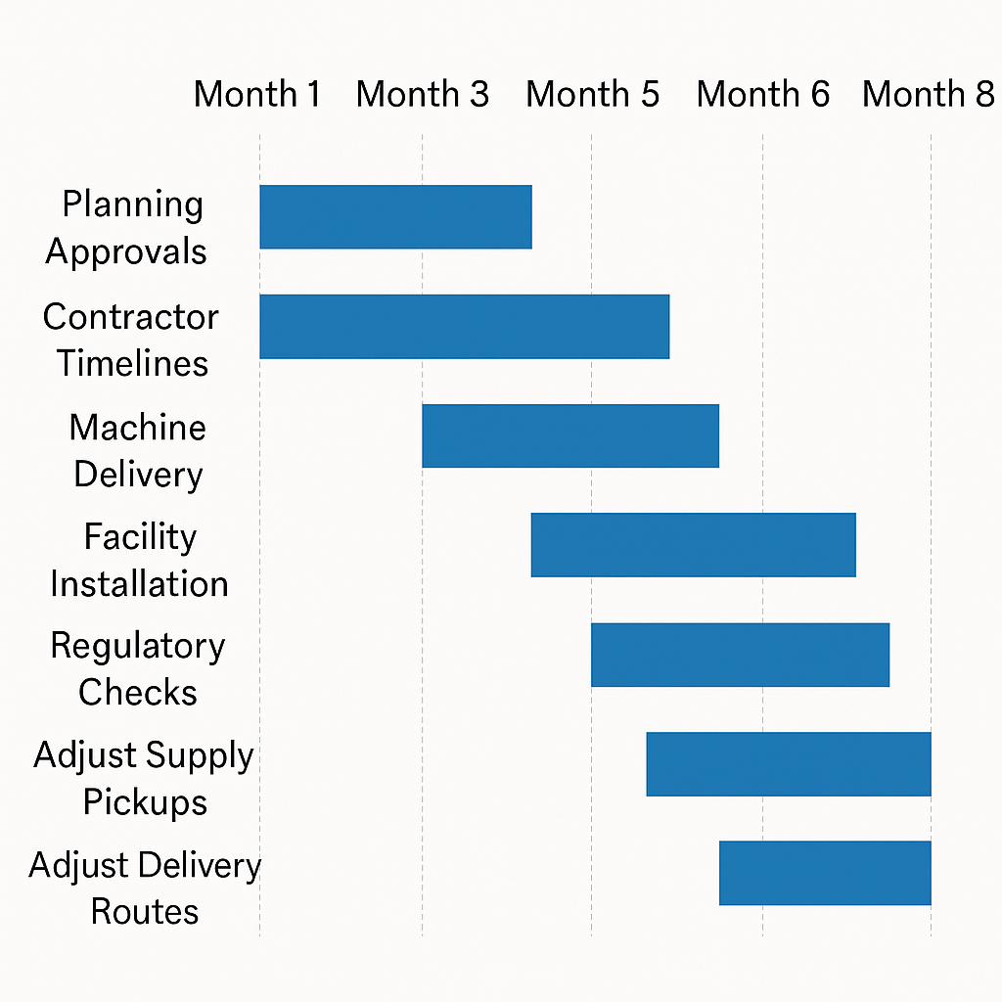
Time management is a necessity since, during relocation, no production can be done. Significant schedule tasks consist of permission to plan approvals, timetable of contractors, machine deliveries, installation of facilities, and regulatory inspections. Refrigeration systems, blending machines and packaging machinery lead times should be incorporated into the schedule (Wadzwanya, 2017). The use of tools such as Gantt charts and critical path analysis will aid in finding the key tasks and preventing delays.

2.5 Cost Management
Moving requires a large amount of investment. The capital expenses are the cost of acquisition or leasing the facility, the cost of acquisition of new machinery, the cost of installing storage and quality-control systems and the cost of IT infrastructure (Blampied et al., 2023). Other operational expenses are the utilities, high transport expenses, training, staff recruitment, and maintenance of facilities. There should be a set cost base with contingency funds to address inflation, delay of machinery or disruption in the supply chain.

2.6 Risk Management
The project risks affecting the project development are in the form of supply bottlenecks among the growers, technology implementation delays, employees being reluctant to new processes, and the unpredictable demand for new products. The other risks are the delay in construction, machinery, and compliance (Sholarin & Awange, 2016). Each risk probability and impact should be assessed with a risk register, and mitigation measures must be implemented as backup suppliers, gradual implementation of latest technology and training of staff.

2.7 Quality Management
The quality of products must be supported during a change of facilities. The management of quality should be done in terms of handling of fruits, the cleanliness of production, the temperatures and packaging. The new product lines demand more verifications, such as allergen controls and microbiological tests (Juricek, 2014). Audits and quality checks are to be conducted to meet the compliance with the HACCP standards and the requirements of supermarkets.

2.8 Communication Management
One of the major flaws of the present operation is communication. A communication matrix in PMBOK must specify the recipient of information, information flow and information format. Efforts could be reinforced by using digital tools, including supplier portals, shared delivery schedules, and automated transport notifications and by using cloud-based documents, which will reduce errors and missed deliveries (Prabhu, 2020).

3. Case Study Analysis – SWOT and PESTLE

3.1 SWOT Analysis
Strengths | Weaknesses | Opportunities | Threats
Strong and rising demand | Limited production capacity due to a small facility | New supermarket showing interest | Supply chain disruption from growers and transport companies
Relationships with major UK supermarkets | Poor communication with suppliers and transport partners | Ability to introduce new product lines | Competitors are launching similar healthy drinks (Srdjevic et al., 2012)
Loyal and experienced fruit growers | Missed deliveries are affecting product quality (Widodo et al., 2019) | Growth in UK health-focused consumer trends | Inconsistent fruit supply caused by weather and EU import issues
Positive perception of product quality | Lack of a clear organisational structure
The company has strengths that can be used to provide a firm ground for growth. The good relationship with the supermarkets and high demand show that the brand is a trusted one and, in a position, to lead in the market of healthy drinks. The stability of supply is also found by the loyal growers, and this is helpful in the development of new lines of products, including coconut water and juices that are designed to serve children.
Nevertheless, the weaknesses are high and need immediate management intervention. The low size current makes the facility limit production and affects the company to serve the increasing demand (Haniffa et al., 2022). Lack of communication between the company and growers and the transport providers has already led to late deliveries and variation in the quality of the fruit. These concerns point to the fact that the organisation's structure is no longer effective in a fast-growing business, making it more vulnerable to operations. There is a high growth potential in the external opportunities. Even higher.

3.2 PESTLE Analysis
PESTLE analysis informs about the broader external environment that the relocation and expansion plans are subject to.
Political Factors: The availability and price of fruits are directly influenced by political factors like UK policies in agriculture, post-Brexit importation policies, and agricultural subsidies (Eierle et al., 2022). The European fruit regulations that are required to be followed in the importation of the fruits may bring about delays or more paperwork, which may interfere with supply during the peak seasons.
Economic Factors: A Major role in expansion is the state of the economy. There is inflation that has escalated the price of fruit, fuel, packaging, and utilities, making the overall operation costs higher. There are also increased fuel costs, which are increasing transport costs because of increased fuel costs affecting the collection of the fruit with the growers, as well as delivery to the supermarkets.
Social Factors: The consumer behavior is particularly good towards penetrating new product lines. Customers in the UK are turning health-conscious and becoming more interested in natural drinks, nutritional products among children and drinks that are rich in low sugar content. This trend in society tags a need for coconut water, children's juices, and yoghurt drinks (Srdjevic et al., 2012). Concurrently, consumers are demanding transparency, sustainability, and quality, which need to be sustained by the company at the time of relocation.
Technological Factors: Technology presents useful possibilities to enhance production and communication. Fruit processing can also be accelerated with the help of automation. Delivery is also checked according to the supply chain, with real-time delivery data and inventory level. Sensors can be used to enhance the temperature of storing fruits to prevent any spoilage and quality problems. As a method of mitigating missed deliveries and coordination failures that are experienced by the company, the integration of digital communication facilities would be appropriate.
Legal Factors: The company must abide by the food safety laws, such as the HACCP laws and the supermarket standards. The relocation will attract regulatory health checks, hygiene licenses and compliance with the health and safety legislation (Haniffa et al., 2022). Non-compliance with the legal requirements would slow down the project or lead to fines.
Environmental Factors: Such forces as the environment affect the consumer expectations and operations. Environmental and social metrics promote waste reduction, carbon mitigation, and enhanced energy efficiency by the companies. The new plant would have to dispose of waste in a responsible manner, and it should have a low environmental footprint (Eierle et al., 2022). Fruit supply is also subject to weather conditions and variability in climate, and therefore, monitoring of the environment is necessary in planning supplies to the supply chain.

4. Enhancing Organizational Structure and Communication

4.1 Current Structural Issues
The company is now working under an informal structure whereby three directors are the leaders and most of the operations are handled collectively by them. This informal structure was acceptable when the business was starting off well; however, it is no longer applicable in a fast-growing organization supplying big supermarkets (Morris et al., 2006). Lack of a clear chain of command gives the decision-making process slow and not consistent, particularly where quick action is needed to respond to supply chain impacts or delivery problems (Arab & Muneeb, 2019). No formal departments and managerial duties are provided, creating duplication of efforts, loss of clarity regarding responsibility, and little check towards the major areas of operation.
4.2 Suitable Organizational Structure
It should have a functional organizational structure as it is suggested to group activities according to the business's core business functions, which will form well-defined lines of responsibility and effective operations. The structure is one that fits well in an expanding manufacturing company and promotes accountability vertically, as well as the ability of specialists. The top control would be the Board or the CEO, who would entail strategic direction and supervise key decision-making like facility relocation, product expansion, and investing in technology. An operations Manager is expected to take care of production processes, workflow structure, personnel, and equipment needs (Chión et al., 2020). The Supply Chain Manager would look into relations with growers, transporting suppliers, and distributors, whereby communication would be maintained and delivery performance kept. A Quality Manager would be entrusted with the hygienic standards, consistency of the product, compliance with food safety and the needs of the supermarket.

4.3 Advancing communication with Growers and Transports
The process of communication between the company, growers, and transport providers needs to be improved to minimize missing deliveries and guarantee that the quality of the fruit stays the same. A supply chain management system like ERP, SAP Business One or some other cloud-based technology would allow real-time visibility of the order, stock data, delivery schedule, and supplier performance. These systems enable everyone to share information effectively, dropping the occurrence of errors and communication breakdowns in communication (Yahaya et al., 2018). GPS-based planning would also enable real-time tracking of transport progress, which would help the company address the delays promptly. Instant messaging, document sharing, and prompt updates within the teams would be supported by mobile communication applications, including Slack, Microsoft Teams, or company-specific portals. The joint inventory and forecasting platform would help the growers to plan the exact level of harvests and delivery based on the actual demand level, to speak, drop shortages or overstocking.
4.4 Quality Control Technology
Technology will be of immense help in enhancing quality control throughout the increased production plant. Temperature monitoring IoT sensors would help in tracking the conditions of the fruits kept in stock and while in transit to preserve the food and minimize spoilage. Tracking would be enhanced through the application of barcode scanning systems that tracked the origin, batch number, and status of quality of every delivery of fruits (Badiru, 2011). The quality indicators could be represented as real-time digital dashboards, including hygiene compliance scores, machine performance, time of delivery, and wastage. Such dashboards would enable managers to spot issues early enough and take corrective measures.
5. Moving to new premises: Feasibility

5.1 Operational Feasibility
Operation feasibility investigates the capability of the company to accommodate higher production in a bigger plant. The existing location is not large enough to suit the increasing demand or add new product lines, and it has no space to provide the workflow layout, storage, hygienic zoning, and use of modern equipment (Holopainen, 2022). By transferring to a bigger industrial unit, the company would be able to organize the production spaces in a more methodical manner, decrease bottlenecks, enhance adherence to hygiene, and implement updated technologies like automatic processors or high-quality control systems.

5.2 Financial Feasibility
Financial feasibility is concerned with the possibility of rewards being higher than the relocation costs. The relocation will cause a large capital outlay including renting or owning a proper space, fit-out, equipment modernization, refrigeration changes, storage facilities, and digital supply chain solutions. Other financial implications involve employee training, hiring new positions and changing the transport allocation during the transition period (Shen et al., 2010). The first investment outlay is quite expensive, but the financial performance in the future is very bright. A bigger facility will allow higher volume of production, better economies of scale and more efficient processes that may be more profitable.

5.3 Market Feasibility
Market feasibility evaluates the viability of the business environment for the intended expansion. The market environment enjoys prospects because of increased consumer demand for health-conscious beverages and healthy alternatives. The new product lines, like cocoa water, juices for kids, soups, and yoghurt beverages, adhere to the emerging high social trends in the UK. The expansion of the healthy product assortments by supermarkets is actively expanding, and these augers well with long-term collaborations (Westland, 2006). Nonetheless, the company should also not forget the threat of rivalry with the well-known brands and new healthy beverage makers.

6. Analysis of Leadership Style and Project Success

6.1 Leadership Issues in the Relocation Project
The relocation and expansion project is associated with a few leadership issues that should be effectively addressed. The company is also changing its structure from a less informal system of two or three directors to a more complex form having departments. This change demands the leaders to lead the staff through corporate transformation, define the responsibilities, and instill confidence in innovative procedures (Aziz et al., 2022). Furthermore, coordination of growers, transport providers, contractors, and internal teams is also part of the project, and hence communication and stakeholder management are extremely important.

6.2 Relevant Leadership Styles
The company may be backed by different leadership styles that are able to meet its changing requirements. Transformational leadership is especially pertinent since it is aimed at motivating the staff, gaining trust, and promoting innovation. The style would aid staff to appreciate the vision of the relocation, encourage them to learn new processes and create a positive attitude towards the change. It is also significant in situational leadership because the various phases of the project need dissimilar leadership behaviours (McLeod, 2021). As an illustration, in the planning and construction stages, a more instructive style might be required to create clarity and adherence, but in the transition phase, the instructive style is likely to induce psychological staff aids via a coaching style approach.

6.3 Preferred Leadership Style
An integrated leadership approach, which involves both transformational leadership, situational leadership and participative leadership, are recommended. The general vision and inspiration needed to highlight a successful relocation and product expansion would be offered through transformational leadership (Jiang, 2014). It would help the personnel in realizing the strategic rationale behind the change, encourage new product development, and enhance adherence to new quality and communication requirements.

6.4 Leader Influence on Project Results
Good leadership will have a direct impact on the success of the project. Good leadership enhances communication networks and, therefore, coordination with growers, transport providers, and internal teams will be easy. It also lessens confusion and opposition during the adoption of recent technology or a new operational position (Arfanaldy, 2025). An embracing leadership approach which allows participation and transparent communication can minimize mistakes, enhance motivation and advocate a culture of quality and continuous betterment.

7. Conclusions and Recommendations
The analysis writes down that the company owns a high potential in the market but has serious operational, structural and communication challenges. The possibility of moving to a bigger facility exists and has distinct benefits of capacity, workflow, and diversifying products. It will involve an organized project management strategy to organize the suppliers, control the risks and quality of the product (Krog & Govender, 2015). The organizational structure, adoption of technology, and communication systems must be improved to support the process of growth and prevent the recurrent problem with deliveries. Leadership will also be vital in achieving the transition of staff, enhancing collaboration, and supporting strategic goals congruence.
Strategic Recommendations
- Introduce a professional governance structure on PRINCE2 principles.
- Use a functional or matrix organizational structure that has specific roles.
- Implementation of supply chain communication technology; ERP and real-time tracking.
- Offer necessary staff and supplier training on new systems and processes.
- Carry out gradual out-of-process relocation to reduce discontinuity of production.

References
Arab, Z., & Muneeb, A. (2019). Effective communication as a strategy for enhancing organizational performance. Management, 2(1), 1-19.
Arfanaldy, S. R. (2025). Effective Leadership Styles in Project Management: A Literature Analysis of Their Impact on Project Success. International Journal of Multidisciplinary Approach Research and Science, 3(02), 652-665.
Aziz, R. A., Jaapar, M. H., Yusop, W. S., Singh, B., Murukaya, G., Benedict, J. S., ... & Senathirajah, A. R. B. S. (2022). Leadership in project management: A study of the relationship between leadership styles and project success. Res Militaris, 12(4), 1900-1907.
Badiru, A. B. (2011). Project management: Systems, principles, and applications. CRC Press.
Bashir, S., & Abdelhakim, H. (2023). Using project management principles to improve research projects. Pharmaceutical Journal, 310(7972).
Blampied, N., Buttrick, R., Jucan, G., Piney, C., Stevens, C., Violette, D., & Max Wideman, R. (2023). In search of project management principles. Project management journal, 54(6), 588-606.
Chión, S. J., Charles, V., & Morales, J. (2020). The impact of organisational culture, organisational structure and technological infrastructure on process improvement through knowledge sharing. Business Process Management Journal, 26(6), 1443-1472.
Eierle, B., Hartlieb, S., Hay, D. C., Niemi, L., & Ojala, H. (2022). External factors and the pricing of audit services: A systematic review of the archival literature using a PESTLE analysis. Auditing: A Journal of Practice & Theory, 41(3), 95-119.
Haniffa, H. M., Muzaffar, W. W., Kemala, D., Ismail, F. F. N., Tan, W. E., & Manaf, N. A. (2022, August). Analysing the viability of carbon capture and storage technology via SWOT/PESTLE analysis: Case study in Malaysia. In AIP Conference Proceedings (Vol. 2610, No. 1, p. 040001). AIP Publishing LLC.
Holopainen, T. (2022). Feasibility of In-house vs. Outsourced Project Management in Public Facility Implementation.
Ispandiari, A. R., Fauzi, I., Yustina, N., & Qonita, Z. (2025). Integrating Pestle and Swot for Advancing Sustainable Inland Waterway Transportation: Insights from West Java, Indonesia. Communications-Scientific Letters of the University of Zilina, 27(2), A1-A12.
Jiang, J. (2014). The study of the relationship between leadership style and project success. American Journal of Trade and Policy, 1(1), 51-55.
Juricek, J. (2014). Agile project management principles. Lecture Notes on Software Engineering, 2(2), 172.
Krog, C., & Govender, K. (2015, October). Servant leadership and project management: Examining the effects of leadership style on project success. In European Conference on Management, Leadership & Governance (pp. 201-210). Academic Conferences International Limited.
McLeod, S. (2021). Feasibility studies for novel and complex projects: Principles synthesised through an integrative review. Project Leadership and Society, 2, 100022.
Morris, P. W., Jamieson, A., & Shepherd, M. M. (2006). Research updating the APM body of knowledge, 4th edition. International Journal of Project Management, 24(6), 461-473.
Prabhu, T. L. (2020). Project Management: Fundamental Principles of Project Management (Vol. 1). Nestfame Creations Pvt Ltd..
Sansavini, S., Donati, F., Costa, F., & Tartarini, S. (2004). Advances in apple breeding for enhanced fruit quality and resistance to biotic stresses: new varieties for the European market. Journal of fruit and ornamental plant research, 12(Spec. ed. 2), 13-52.
Shen, L. Y., Tam, V. W., Tam, L., & Ji, Y. B. (2010). Project feasibility study: the key to successful implementation of sustainable and socially responsible construction management practice. Journal of cleaner production, 18(3), 254-259.
Sholarin, E. A., & Awange, J. L. (2016). Environmental project management: principles, methodology, and processes. Springer.
Srdjevic, Z., Bajcetic, R., & Srdjevic, B. (2012). Identifying the criteria set for multicriteria decision making based on SWOT/PESTLE analysis: a case study of reconstructing a water intake structure. Water resources management, 26(12), 3379-3393.
Wadzwanya, F. C. (2017). Managing small and medium enterprises using project management principles (Doctoral dissertation, Cape Peninsula University of Technology).
Westland, J. (2006). The project management life cycle: a complete step-by-step methodology for initiating, planning, executing & closing a project successfully. Kogan Page Limited.
Widodo, A. K., Mahachandra, M., Widhiyaningrum, M. R. T., & Tahqiqi, R. (2019). Formulating a Strategic Management of Social E-Commerce through a Combination of SWOT and PESTLE Analysis: Case Study. In Proceedings of the International Conference on Industrial Engineering and Operations Management Bangkok.
Williams, M. (2008). The principles of project management. EAS. IN.
Yahaya, M., Al-Khawlani, M. A. A., Suleiman, M. S., & Usman, U. M. Z. (2018). Organizational structure and an effective communication: the moderating effect of transformational leadership. International Journal of Scientific and Technology Research, 7(11), 4-9.

