

International Business LCMB7014

Ted Baker International Business in Turkey
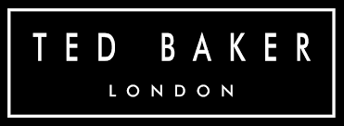

Student Name: Rehan Farooqui
Student Number: 2223935
Lecturer: Dr Hossein Shokri
Submission Date: 21st August 2023

Table of Contents
Introduction 2
Company Background 2
Company’s Objectives and Strategies 3
Countries’ Specifications 4
Home Country 4
Host Country 4
External Analysis 6
A Comparative PESTEL Analysis 7
Industry Five Forces 9
Market Analysis 10
Host Country Analysis 12
Country’s National Diamond 12
Country Business Risks 14
Internal Analysis 16
Global value chain 16
SWOT analysis 17
International Strategies 18
Entry Modes 20
Corporate Social Responsibility 21
Conclusion 22
References 23

Introduction
The term International Business can be termed as the global or transnational exchange of products, services, technology, capital, and knowledge across national borders (Cavusgil et. al., 2014). In a nutshell, international business entails the exchange of products and services between two or more nations. In the following report, the company's internationalisation strategy will be described using various analytic frameworks that consider management-particular factors, industry-specific factors, as well as country-specific factors.
In addition, examples will be used to facilitate comprehension of the organisation of resources and capabilities in marketing, operations, HRM, etc. Along with a critical analysis of the company's entrance mode into the target market, the method of entering various nations will be discussed. In addition to a conclusion, the consideration of country/industry/market factors about the business's exposure to risk should accompany the justification of the management's various strategic decisions.

Company Background
The company chosen for the completion of the current report is Ted Baker, the British high-street clothing retail firm famous for suits, shirts, along with the dresses. Ted Baker was founded in the year 1988 and is headquartered in Glasgow, Scotland. The company was owned by Authentic Brands Group, after their €211 Million acquisition in the year 2022 as the company has over 500 shops as well as concessions around the globe (Crunchbase, 2023). The official website of the company is accessible through < https://tedbakercroatia.com >.
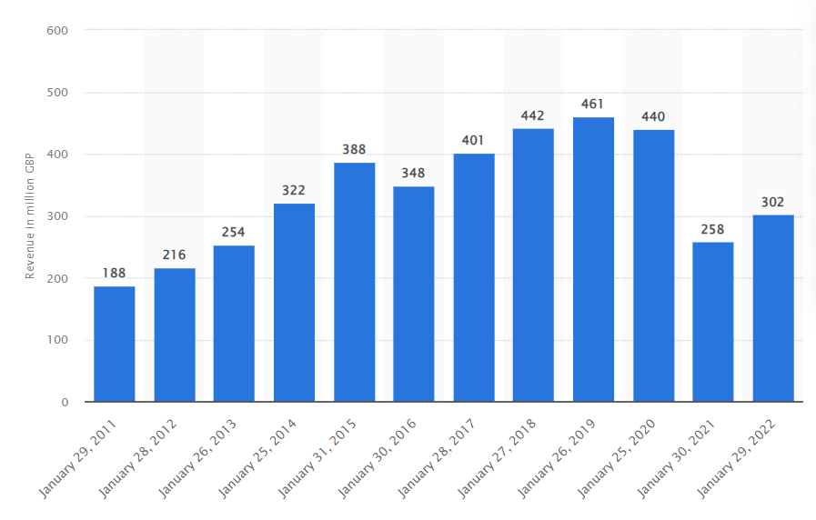
Figure 1: Retail revenue of Ted Baker worldwide from the financial year 2010/11 to the financial year 2021/22, 2023
Source: Statista, 2023
With the help of the above graph, the depiction has been made about the overall revenue of Ted Baker from the period of 2011 to 2022 where the financial performance of the company is not stable and changes in both the increment and decrement ways (Statista, 2023). The founder of Ted Baker was Ray Kelvin who deals in the fashion industry and the products offered by the company to their customers are ready-to-wear, footwear, accessories, and home wear for meeting the needs and requirements of the project appropriately. Also, apart from the stores of Ted Baker, there are some other stores where the products have been offered by the company to their customers such as John Lewis Partnership and House Fraser.

Company’s Objectives and Strategies
The description of objectives and strategies of Ted Baker is stated as under:
Ted Baker’s Objectives
- To create a culture of trust
- To reduce the environmental influence
- To empower conscious consumption by providing customers more sustainable choices (Ted Baker, 2023)
Ted Baker’s Strategies
To Make a Digital-First Approach to Becoming a True Global Omnichannel Business.

Countries’ Specifications
The main country specifications of the home country of Ted Baker is the UK and the chosen host country is Turkey. The specific discussions related to both countries have been provided in the report as under:
Home Country (UK)
The alterations in consumer behaviour, a rise in the proportion of retail sales conducted online, and difficult economic circumstances are among the factors that are reshaping the way retailers do business and interact with their clientele (Retail sector in the UK, 2021). The economic production of the retail industry in year 2020 was £97.0 billion, showing 5.2% of the overall economic result of the UK as well as a decrease of 2.5% from 2019. There were 3.0 million jobs in the retail industry in 2019 (Retail sector in the UK, 2021).
The amount of goods sold at retail formations in the United Kingdom was approximately to be £437 billion in 2020, that was 0.6% less than in 2019. As a result of lockdown limitations, many retail businesses that were not important to the community were forced to shut down after the COVID-19 pandemic broke out in March 2020. This resulted in a significant drop in retail sales. Retail sales improved to pre-pandemic phases by June year 2020 before falling slightly again as not essential retail practices closed over the winter (Retail sector in the UK, 2021). The resumption of operations at not essential retail establishments contributed significantly to the robust recovery of sales in April 2021.
Host Country (Turkey)
The pandemic happened by the coronavirus has led to these difficulties by speeding trends like greater internet buying and adding economic challenges via limitations (Turkey’s Retail Sector Note, 2023). Using statistics as well as more current studies on the industry, this briefing paper offers an overview of the present condition of the retail industry in the United Kingdom. Sometimes, as a result of the availability of data, the figures solely pertain to Great Britain. This briefing does not contain any information about government policy on the retail sector since it is exclusively concerned with the retail sector (as opposed to the wholesale sector) (Turkey’s Retail Sector Note, 2023). The economic production of the retail industry in 2020 was £97.0 billion, presenting 5.2% of the overall economic result of the UK as well as a decrease of 2.5% from in year 2019.
As a result of lockdown limitations, many retail businesses that were not important to the community were forced to shut down after the COVID-19 pandemic broke out in March 2020 (Turkey’s Retail Sector Note, 2023). This resulted in a significant drop in retail sales. The resumption of operations at non-essential retail establishments contributed significantly to the robust recovery of sales in April 2021.
According to International Trade Administration, (2023), The Republic of Turkey is the 20th highest nominal gross domestic product (GDP) as well as the 11th largest GDP based on the buying power parity. The statistics of the Government of Turkey (GoT) estimations, the Turkish economy grew 11% in the year 2021, 9.2% up from the year 2020. The market size of Turkey is roughly estimated at $906 billion according to World Bank.
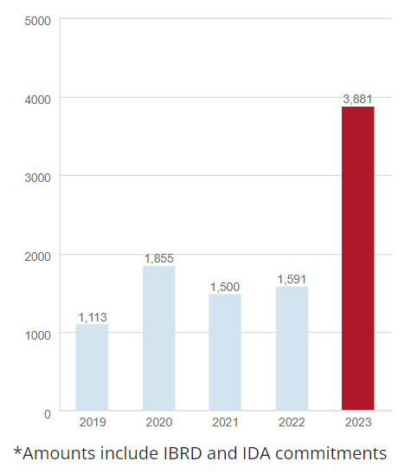
Figure 2: Turkey: Commitments by Fiscal Year (in millions of dollars), 2023
Source: The World Bank, 2023
The political, legal, and economic factors are supportive in terms of businesses expanding in the Turkish market. A stable political and legal environment along with the growing pace of the GDP of the Turkish market makes the business environment suitable for the companies to expand. However, the infrastructural aspects are not good in that the investments required will help Ted Baker in ensuring its successful growth and development in the new marketplace.

External Analysis
The external environment is evaluated with the help of tools such as PESTLE Analysis. The following tool makes use of six various factors like political, economic, social, technological, legal, and environmental aspects as the base to comment on the effectiveness and market situation of an organisation (Christodoulou and Cullinane, 2019). The application of the following analysis has been made in the markets of the UK and Turkey which have been discussed further in the report as under:

A Comparative PESTEL Analysis
The PESTLE Analysis of the UK and Turkey
External Drivers | PESTLE - UK | PESTLE – TURKEY
Political Factors | Political Stability – Opportunity  Brexit Impact – Opportunity and Threat  Vibrant Political Culture – Opportunity  Maintenance of Good Political Relations – Opportunity (Thomas et al., 2021) | Suitable Geopolitical Location for International Trade and Commerce – Opportunity  Political Instability – Threat  Challenges Due to Differences in EU Standards and Regulations – Threat  Human Rights Concerns Impacting on Businesses – Threat
Economic Factors | Highly Developed and Market-Based Economy – Opportunity  Leading Financial Centres – Opportunity  High Disposable Income of Customers – Opportunity  High Inflation – Threat  Major Destination for Luxury and Boutique Shopping – Opportunity (Akman, 2020) | Diverse Economy – Opportunity  High Inflation – Opportunity  Large and Young Workforce Turkish’s Labour Market – Opportunity  Trade Policy and Relationship with Global Markets – Opportunity and Threat  Focus on Attraction of Foreign Investment and Economic Liberalisation – Opportunity  Challenges Due to Regulations and Bureaucratic Red Tape – Threat
Social Factors | The current Population is 68.7 Million – Opportunity  High Influence due to the Concept of Social Class – Opportunity  Existence of Different Races and Religions – Opportunity  Existence of Inequality – Threat  Major Destinations for International Students – Opportunity | Population approximates 86 million people – Opportunity  48.3% population is under 30 – Opportunity and Threat  Existence of Cultural Diversity – Opportunity and Challenge  Gender Roles and Relations – Opportunity and Challenge  Involvement of Women in Informal and Low-Paying Jobs – Challenge
Technological Factors | Most Technologically Advanced Countries in the World – Opportunity  Technological Infrastructure Offers Entrepreneurs Unlimited Opportunities – Opportunity  High Level of Internet Connectivity – Opportunity | Investments in Technology Infrastructure – Opportunity  Funded by Start-ups and Tech Companies – Opportunity  Investment in R&D – Opportunity
Legal Factors | Advanced Legal System as well as Strong System of Civil Liberties – Opportunity  Major World Leader in Human Rights along with Civil Liberties – Opportunity and Threat | Intellectual Property Protection – Opportunity  Improvement in the IP Laws and Regulations – Opportunity and Threat  Trademarks and Patents – Opportunity  Labour Laws – Opportunity and Threat
Environmental Factors | Economic Activities Impact on Environment and Business Working Due to Strict Regulations – Opportunity and Threat | Impact of Negative Economic Activities Such as Air Pollution – Threat  Impact of Employee Health and Wellness Challenges – Threat  Limited Supply of Freshwater Resources – Threat

Industry Five Forces
Porter’s Five Forces Model has been propounded by Michael E. Porter, who stated five different forces used with the purpose to state the competitiveness and profitability existing in the industry (Baxter, 2019). The implementation of Porter’s Five Forces Model in the clothing market of the UK has been provided in the report as under:
Factors | Porter - UK
Bargaining Power of Customers | It is termed as the power that buyers wield over the market as well as how much potential they hold rely on the presence of alternatives held by the consumer. Customers have a diverse selection of options present to them while shopping through us since there are a lot of different companies competing for their business (Amelia et al., 2019). A client has the choice to go with Blackberry, Van Heusen, Louis Phillipe, or another brand like that. Because of this, consumers can exert some type of control over the cost charged by these firms; thus, the negotiating potential of consumers is rather strong.
Bargaining Power of Suppliers | This represents the influence that the market has over its suppliers, and it is directly proportional to the number of providers who are currently active within the industry. Because there is already so much supply in the clothes market, there is a very high total number of providers (Abalkhail, 2019). Instead, several companies have adopted a backward integration strategy and begun working on their back-end systems. The negotiating strength of the suppliers is reduced as a result of the fact that the brands have established relationships with their groups of suppliers (Ruan, Sang and Zeng, 2022).
Threat of New Entrants | It is a measure of how straightforward it is for a brand-new business or one that is already well-established to break into a certain market, in this example the clothes market. If we evaluate the sector, we find that there are no big obstacles that must be overcome to join it; the only obstacle is the fact that this industry requires significant financial investment (HALİFE, 2020). It is necessary to have financial resources to set up the equipment needed to manufacture garments, and the fashion sector operates with significant levels of debt and trade receivables. As a direct consequence of this, the level of competition is moderate.
Threat of Substitutes | There are very few instances in which the availability of alternatives and the danger that they provide to the garment business are both present (EKMEKÇİ, 2019). Although there is constant flux in the tendencies of the fashion industry and the availability of inexpensive apparel from the unorganised sector, none of these factors offers a significant danger to the industry. As a result, the competition from other products is minimal (Jaiswal, 2021).
Competitive Rivalry | It is one of the most important factors that determine a company's level of competitiveness within the sector. The level of rivalry within the business is very strong because the number of companies in the market is increasing and there is an availability of apparel brands that are both reasonably priced and well-established (Baxter, 2019). Due to this, Blackberry is going to have to place a greater emphasis on and spend more money on, advertising while still providing a distinct product to the specialised market it serves.

Market Analysis
The United Kingdom's apparel as well as footwear market rates third. After China and the United States, the United Kingdom's clothing along with footwear market is the third largest in the globe at $70.7 billion. The United States has the largest clothing and footwear market. Approximately 45 billion pounds are spent by British customers on apparel and textiles.
This number has steadily risen over the past decade, as well as despite the epidemic eradicating 10 billion pounds, it will continue to rise. The pandemic-affected online enterprises improved. In 2020, apparel and footwear sales crested at 31% (UK fashion industry data, 2023). The fashion as well as textile industries annually contribute approximately £20 billion to the British economy.
The largest UK retailers are Primark, Next, George, Arcadia, TK Maxx, JD, Tesco, Debenhams, as well as John Lewis (Global Data, 2023). Other national competitors include Next, George, and Arcadia. England, Wales, as well as Scotland employ 500,000 people in the fashion and textiles industries. There are 88,000 people employed in manufacturing, 62,000 in wholesale, and 413,000 in retail.
In year 2020, there were 34,045 fashion along with the textile businesses in United Kingdom, including 30,035 retailers, 8,825 wholesalers, as well as 8,245 producers. The UK fashion and textile industries are dominated by small and medium-sized businesses (UK fashion sector statistics, 2023). 90% of retail, 85% of wholesale, and 80% of manufacturing are micro markets with nine or fewer employees. Between 2005 and 2020, the number of British garment manufacturers rised by 13% to 4,005 (Global Data, 2023).
It reversed a years-long decline caused by a lack of investment and lower manufacturing alternatives in other countries. Multiple factors contributed to the decline. The United Kingdom's apparel and textile exports decreased from £9.7 billion in 2019 to £8.9 billion in 2020. The United Kingdom exported 6.8 billion pounds of textiles in 2019, an increase from the 6.3 billion pounds exported in 2020 (UK fashion industry data, 2023).
In 2020, the United Kingdom imported 19.7 billion pounds worth of clothing, down from 20.2 billion pounds in 2019. Despite this decline, imports of apparel increased by 32% from 2008 to 2020 (UK fashion industry data, 2023). The valuation of EU apparel exports increased fourfold between 2008 and 2017.

Host Country Analysis
Country’s National Diamond (Turkey)
The following model discusses the factors that offer a competitive advantage for one national economy or business over the other (Cullen, 2020). Some of the main factors considered are related to firm strategy, structure as well as rivalry, related industries, demand conditions and factors conditions. The application of Porter’s Diamond Model in Turkey has been provided as under:
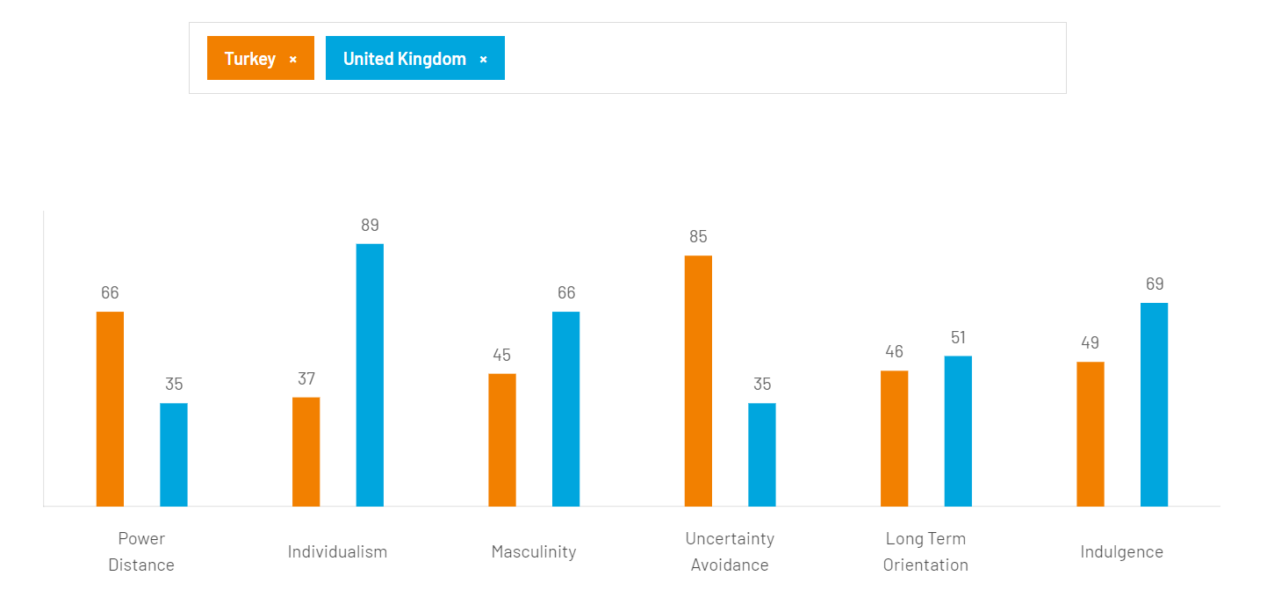
Figure 3: Hofstede's Cultural Dimension Model, Turkey, and UK, 2023
Source: Hofstede Insights, 2023
Power and Distance Index
Due to Turkey's high score (66), the following traits may be used to characterise its style: The ideal supervisor is a father figure who guides a hierarchical, dependant, and sometimes inaccessible organisation. The managers rely on their superiors and rules. The workers expect job instructions (Cullen, 2020). Control and a formal approach towards administrators are anticipated. Information is filtered and communicated circuitously. The father is the family patriarch, and the others submit to him.
UK's PDI of 35 is among the lowest worldwide. This suggests most Britons live in an egalitarian society (Cullen, 2020). This highlights one of British culture's fundamental contradictions between birth rank and the deeply held conviction that one's birthplace should not restrict their ability. Fair play underpins the idea that everyone should be treated equally.
Individualism Vs Collectivism
The Turkish collectivism score is 37. Individuals belong to in-groups (families, communities, or organisations) that care for one another in exchange for allegiance, so "We" is essential. Communication is indirect, and group harmony is maintained by avoiding open conflicts. In a partnership, morality always surpasses task completion. It takes time to establish trust. There may be a rise in nepotism. Typically, business feedback is indirect (Cullen, 2020).
The United Kingdom has one of the highest Individualist scores at 89, trailing only Australia along with the United States. The British are reserved and independent. Children are encouraged early on to think independently and determine their life's purpose as well as contribution to society. Personal satisfaction results in contentment. As Britain's prosperity has increased over the previous decade, unrestrained consumerism, along with a strengthening of the 'ME' culture have been addressed.
Masculinity Vs Femineity
Turkey is female and receives a 45. This suggests that the culture values and promotes soft skills such as accord, equality, and compassion for the disadvantaged. The key to avoiding conflicts in your personal and professional life is to find common ground. Turks spend their leisure time socialising with family, clan, and acquaintances (Beydilli and Kurt, 2020). Status is displayed, but it is driven by a high PDI. At 66, Britain's culture is masculine and success-oriented. Strangers are perplexed by the apparent contradiction among British modesty and understatement as well as its success-focused values. To comprehend the British, it is essential to read between the lines. Not every phrase means what it says. In contrast to Feminine cultures such as Scandinavia, British citizens live to work and have ambitious performance objectives.
Uncertainty Avoidance Index
Turkey scores 85 on this dimension, indicating a need for laws and norms. People utilise several rituals to reduce anxiety (Özdemir, Malatyalı and Sakallı, 2023). With frequent allusions to “Allah”, they may sound religious to visitors, yet they are generally established social practices designed to reduce stress.
At 35, the UK has a low Uncertainty Avoidance score, meaning they are content to wake up to a blank day and change plans as new information becomes present. Despite their low UAI, the British are comfortable with confusing circumstances and use the phrase ‘muddling through’. British society has few norms, yet those that exist are followed (the most renowned of which is the love of queuing) (Khan et al., 2022). Planning horizons will also shorten. Most significantly, a highly individualistic and inquiring country is creative and innovative. This is shown in society's humour, strong consumption of new and inventive things, and quick, creative businesses such as advertising, marketing, as well as financial engineering.
Long Term Orientation Vs Short-Term Orientation
Since Turkey's intermediate score of 46 falls in the middle of the spectrum, it is not feasible to conclude that the nation has a dominant cultural preference. It is not possible to identify a dominant favourite in British culture through a score of 51 on this dimension, which is considered an intermediate phase.
Indulgence
Due to Turkey's intermediate score of 49, it is impossible to define a quality that corresponds to this dimension for the nation. A score of 69 shows that the culture of the United Kingdom may be categorised as Indulgent (Cullen and Archer-Brown, 2020). People who live in cultures with a high score for Indulgence are crucially willing to give in to their impulses and desires when it comes to entertaining themselves and having fun. They have a positive outlook on life and a tendency to consider optimistically. In addition, they place a greater emphasis on their leisure time, are free to act as they see fit, and are free to spend their money as they see fit.
Country Business Risks (Turkey)
The main business risks which can be faced in the market in Turkey are stated in the report:
Economic Volatility
Inflation, currency depreciation, and sky-high interest rates are just some of the economic woes Turkey has faced in recent years (Turner et al., 2021). Because of their effects on both consumer spending and manufacturing expenses, these variables may reduce your apparel company's bottom line. Following a robust expansion of 11% in 2021, Turkey's economy is projected to see a deceleration in 2022 mostly as a result of significant escalations in energy costs and interruptions in the availability of essential commodities due to the ongoing conflict in Ukraine. Turkey relies on Russia for the importation of over 30% of its natural gas, in addition to roughly 20% of the metals and chemicals necessary for its domestic industry.
Labour Issues
The intricacies of labour legislation and relations in Turkey might be seen as multifaceted. It is crucial to prioritise adherence to labour rules, effectively address staff concerns, and foster positive employee relations to mitigate any disruptions and legal complications (Stallkamp and Schotter, 2021).
Intellectual Property Concerns
It is important to safeguard one's clothing designs, trademarks, and other forms of intellectual property. The enforcement of intellectual property rights in Turkey exhibits variability and necessitates the implementation of appropriate legislative measures to mitigate unauthorised use or counterfeiting (Voss et al., 2019).
Cultural and Consumer Preferences
It is important to comprehend and accommodate the cultural and consumer preferences of the local population. If one fails to appropriately adjust their goods and marketing techniques, it may result in diminished demand or a dearth of customer interest.
Political and Regulatory Environment
Regulations, trade laws, and tariffs in Turkey may be subject to change due to the country's unstable political situation. Supply chains and company operations are vulnerable to disruption from political instability and abrupt policy changes. As the next elections in June 2023 get nearer, there is a potential for an escalation in societal division (George et al., 2019). Nevertheless, it is important to note that this should not pose a significant risk to the political stability of the nation. In recent times, Turkey has taken steps to mend its diplomatic ties with the United Arab Emirates (UAE), transcending previous regional sources of conflict. In November 2021, bilateral cooperation agreements were signed by both nations including several domains such as commerce, energy, and ecology (Voss et al., 2019). According to several media sources, Saudi Arabia, Egypt, and Israel have reportedly undertaken measures to establish a novel degree of diplomatic engagement with Turkey. It is anticipated that these enhancements would have mutually beneficial economic impacts.
Market Competition
The Turkish apparel sector has a high level of competitiveness, as both domestic and global brands actively compete to secure their respective market shares (George et al., 2019). The differentiation of goods and the establishment of a strong brand identity are of paramount importance to effectively distinguish oneself within the market.

Internal Analysis

Global value chain
- Global Production
According to the information gained through Fibre2Fashion, (2023), it has been stated that the estimated share of Turkey in the global production of clothing products is around 3.4 per cent as well as the clothing industry known as the seventh largest supplier in the world along with the third largest supplier in the European Union (Dobos-Nagy, 2021).
- Global Marketing
The textile and apparel sector has been the backbone of the Turkish economy for the past two decades, playing an important role in the development of industrialization and the process of market orientation. During the 1980s, this industry was the most important contributor to the global economy, and its capacity to acquire real currency through exports made a substantial contribution to the economy. Turkey has a long-standing, varied, and contemporary textile and garment sector that has contributed to its economic and industrial growth. It is one of the world's largest textile and garment exporters since it can produce everything from raw materials to completed goods. Turkey's textile and garment sector thrives due to its talented and flexible labour. Turkey's unique position between Europe and Asia helped the sector flourish (Voss et al., 2019). This allows Turkish companies to successfully export to established Western markets due to short lead times. Flexible manufacturing procedures allow the sector to quickly boost production runs, enhancing these competitive advantages (Egels‐Zandén and Alexander, 2020). The textile industry has remained one of the country's most significant economic contributors. In the 1990s, it was also one of the fastest-growing industries, with an average annual growth rate of 12.2%, compared to the aggregate 5.2% annual growth rate of the Turkish economy. More than 50 billion dollars were invested in the industry over a period of five to ten years, bringing the total investment in the sector to over 150 billion dollars
- Global HRM
Turkey has a long-standing, varied, and contemporary textile and garment sector that has contributed to its economic and industrial growth. It is one of the world's largest textile and garment exporters since it can produce everything from raw materials to completed goods. Turkey's textile and garment sector thrives due to its talented and flexible labour. Turkey's unique position between Europe and Asia helped the sector flourish (Voss et al., 2019). This allows Turkish companies to successfully export to established Western markets due to short lead times. Flexible manufacturing procedures allow the sector to quickly boost production runs, enhancing these competitive advantages

SWOT analysis
The term SWOT Analysis relates to the evaluation and analysis of strengths, weaknesses, opportunities, and threats that impact the working of an organisation (Benzaghta et al., 2021). The application of the following analysis on Ted Baker has been provided in the report as under:
Strengths and Weaknesses
Strengths | Weaknesses
- Consistency Due to Automation | - Ineffective Demand Forecasting
- Successful Mergers and Acquisitions | - High Attrition Rate in Workforce
- Strong Distribution Network | - Issues in the Integration of Culture
- Good Returns on Capital Expenditure | - Gaps in the Product Range
- High Skilled Workforce | - Requirement of Investment in Research and Development
- Strong Dealer Community | - Ineffective Financial Planning
- Successful Track Record of Developing New Products
Opportunities and Threats
Opportunities | Threats
- Positive Impact of New Taxation Policy | - Changes in Customer Needs and Preferences
- Economic Up stick and Increment in Spending | - Rising Cost of Raw Material
- Opening of New Markets Due to Government Agreement | - Increasing Trend Towards Isolationism in the American Companies
- New Customers from Online Channel | - Imitation of Counterfeit and Low-Quality Products
- New Environmental Policies | - Intense Competition

International Strategies
The main strategies that can be implemented by Ted Baker in terms of international strategies have been reported as under:
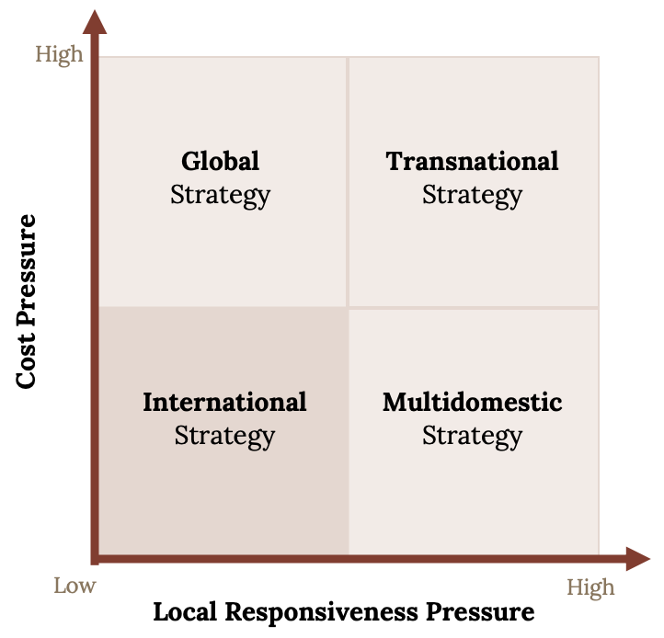
Figure 4: Internationalisation Strategies, 2023
Source: Business Jargon, 2023
Multi-Domestic Strategy
To meet local requirements in each market, a multinational corporation loses efficiency. MTV customises its programming in dozens of countries, including New Zealand, Portugal, Pakistan, and India, as opposed to imposing its American-made programming on audiences worldwide (Stallkamp and Schotter, 2021).
Global Strategy
A global approach prioritises efficiency over market-specific requirements. This strategy is opposed to multi-domestic. A global strategy accentuates economies of scale by delivering the same commodities and services in each country, despite minor product and service modifications in certain areas.
Transnational Strategy
A multinational corporation seeks a balance between domestic and international strategies. This company seeks to combine efficacy with native preferences in various countries (Turner et al., 2021). McDonald’s and KFC worldwide use the same brands and menu items. These businesses also accommodate native tastes.

Entry Modes
The possible entry modes for Ted Baker to enter the market in Turkey are as under:
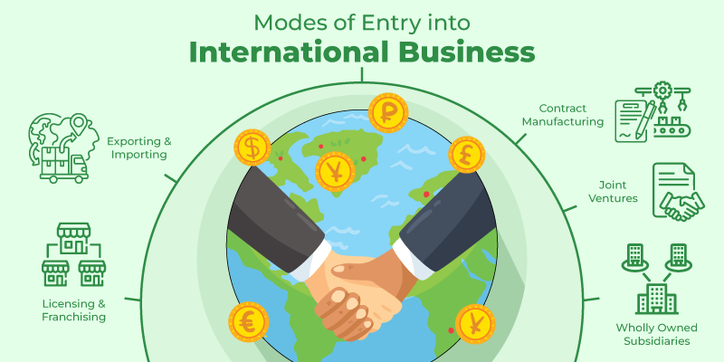
Figure 5: Entry Modes for International Market, 2023
Source: Research Gate, 2023
Direct Exporting
The products or services directly offered in the new markets for selling are stated as Direct Exporting. After establishing a sales programme, many companies seek representation from agents and/or distributors to expand their presence in a particular market (Gankema, Snu and van Dijken, 2019).
Licensing
Under the provisions of a licencing agreement, one company grants another company the right to use its product or service. This is a highly complex type of business transaction. It is a particularly advantageous strategy if the vendor of the licence already has a substantial market share in the industry (Salmon and Tordjman, 2020). There are two categories of licences: production licences and marketing licences.
Franchising
Although franchising is more prevalent in North America, it is gaining popularity as a method for significantly expanding market share in other regions of the world. If a business has a proven business model (such as a restaurant chain) that can be easily replicated in other locations, franchising is a viable option for them (Sharma et al., 2020).
Partnering
When entering new international markets, the formation of strategic alliances is not only highly recommended, but in some regions of the world (such as Asia) may be required. On the surface, various types of partnerships may appear quite distinct, ranging from simple co-marketing agreements to complex strategic alliances for production (Sharma et al., 2020).
The most suitable way of expansion for Ted Baker in the new market of Turkey will be Franchising so that the business will be costing much and will have an idea about how the market is going to be for the company in the future.

Corporate Social Responsibility
The term Corporate Social Responsibility (CSR) refers to the strategy taken by companies to make improvements in their profits along with taking an active involvement in directing their positive social role in the world (Dent and Randall, 2021). The depiction of some of the main CSR of Ted Baker has been provided as under:
Environment
Ted is a distinguished member of the Green 500. In July 2010, Ted received the Green 500 Ethical Conduct Platinum Award (Dent and Randall, 2021). In addition, they have partnered with MADE-BY, an internationally recognised and approved benchmarking organisation, which examines Ted's apparel from fibre through the manufacturing process and monitors the workers' conditions.
Sustainability
Ted Baker's products are durable because they do not use disposable apparel. Ted's traditional designs are crafted of high-quality materials and can be worn year-round (Baker and Powell, 2020). As part of their MADE-BY initiative, they aim to increase the proportion of sustainable fibres, such as Organic Cotton and Tencel, within our collections.
Animal Welfare and Endangered Species
Ted Baker supports 'fair' trade and requires all animal-derived products to be sourced from animals treated to the highest standards and by animal welfare laws. The OIE Animal Health Codes are strictly enforced for their suppliers (George et al., 2019). Ted Baker will never use CITES or IUCN-listed endangered species in their products.

Conclusion
With the help of information presented in the above sections, the conclusion relates to the importance of business analysis and evaluation which states the good position of Ted Baker in the current market. However, there always exist certain levels of issues in both the existing and new markets. As stated above, the following report focuses on the expansion of Ted Baker in the new market of Turkey, the report stated the effectiveness of the market using different tools and techniques such as PESTLE, SWOT, Porter’s Five Forces, Value Chain, Entry Strategies along with other ways to understand the market of Turkey and UK both to have an understanding about the new environment whether it will be good to expand or not. The report concludes with the suitability of the expansion of business in Turkey. However, there are certain issues related to political, market and cultural factors that impact negatively on the business performance using appropriate strategies, it will become possible to ensure successful expansion of business in the market of Turkey for Ted Baker.

References
Abalkhail, T.S., 2019. Entry and expansion strategies for Burberry in Oman by applying Porter's Five Forces model. Indian Journal of Marketing, 49(1), pp.25-35.
Akman, M.K., 2020. Defence Management and PESTLE analysis. Ante Portas–Security Studies, 1(14), pp.93-102.
Amelia, D., et al., 2019. A Study of Clothing Industry Competitiveness with Porter’s Five Force Approach in Kabupaten Agam Central Industry (A Preliminary Study of Ampek Angkek, Banuhampu, Sungai Puar). KnE Social Sciences, pp.169-185.
Baker, T. and Powell, E.E., 2020. Founder identity theory. The psychology of entrepreneurship, pp.164-181.
Baxter, G., 2019. A strategic analysis of Cargolux Airlines International's position in the global air cargo supply chain using Porter’s Five Forces Model. Infrastructures, 4(1), p.6.
Benzaghta, M.A., et al., 2021. SWOT analysis applications: An integrative literature review. Journal of Global Business Insights, 6(1), pp.55-73.
Beydilli, E.T. and Kurt, M., 2020. Comparison of management styles of local and foreign hotel chains in Turkey: A cultural perspective. Tourism Management, 79, p.104018.
Cavusgil, S.T., Knight, G., Riesenberger, J.R., Rammal, H.G. and Rose, E.L., 2014. International business. Pearson Australia.
Christodoulou, A. and Cullinane, K., 2019. Identifying the main opportunities and challenges from the implementation of a port energy management system: A SWOT/PESTLE analysis. Sustainability, 11(21), p.6046.
Crunchbase. 2023. Ted. [Online]. Available Through: < https://www.crunchbase.com/organization/ted> (Accessed: 04th July 2023).
Cullen, U. and Archer-Brown, C., 2020. Country-specific sociocultural institutional factors as determinants of female entrepreneurs' successful sustainable business strategies within the context of Turkey and the UK. In Entrepreneurial Opportunities: Economics and Sustainability for Future Growth (pp. 7-36). Emerald Publishing Limited.
Cullen, U., 2020. Sociocultural factors as determinants of female entrepreneurs’ business strategies. Journal of Entrepreneurship in Emerging Economies, 12(1), pp.144-167.
Dent, E.B. and Randall, C., 2021. Moral re-armament: toward a better understanding of the society-corporation relationship before the emergence of “corporate social responsibility”. Journal of Management History, 27(3), pp.389-408.
Dobos-Nagy, E., 2021. The Promise of Sustainability and the Pandemic? How Hungarian Fashion Production Companies Could Gain Better Position in the Global Supply Chain Due to Re-location Tendencies. Environmental, Social and Economic Sustainability in the Light of the (Geo) Political Challenges of Our Age. Budapest: Corvinus University of Budapest, Corvinus Geographia, Geopolitica, Geooeconomia, pp.180-205.
EKMEKÇİ, Y.A.D., 2019. Factors influencing competitive advantage of sports clubs in Turkey. Trakya Üniversitesi Sosyal Bilimler Dergisi, 21, pp.79-91.
Fibre2Fashion. 2023. Textile & Apparel Industry in Turkey. [Online]. Available Through: < https://www.fibre2fashion.com/industry-article/9/textile-and-apparel-industry-in-turkey> (Accessed: 06th August 2023).
Fibre2Fashion. 2023. The growing dimensions of Turkish textile & clothing. [Online]. Available Through: < https://www.fibre2fashion.com/industry-article/7416/the-growing-dimensions-of-turkish-textile-and-clothing#:~:text=With%20an%20estimated%20share%20of,largest%20supplierto%20the%20European%20Union.> (Accessed: 06th August 2023).
Gankema, H.G., Snu, H.R. and van Dijken, K.A., 2019. The internationalisation process of small and medium-sized enterprises: An evaluation of the stage theory. In Entrepreneurship and SME Research (pp. 185-197). Routledge.
George, G., et al., 2019. Inclusion and innovation: A call to action. Handbook of inclusive innovation, p.1.
Global Data. 2023. United Kingdom (UK) Apparel Market Size and Trend Analysis by Category (Clothing, Footwear, Accessories), Retail Channel, Supply Chain, Consumer Attitudes and Themes, Key Brands and Forecast, 2021-2026. [Online]. Available Through: < https://www.globaldata.com/store/report/uk-apparel-market-analysis/> (Accessed: 24th July 2023).
HALİFE, H., 2020. Analysis of competitiveness of Turkish textile sector based on the Porter’s Diamond Model. Stratejik Yönetim Araştırmaları Dergisi, 3(1), pp.27-49.
International Trade Administration. 2023. Turkey – Country Commercial Guide. [Online]. Available Through: <https://www.trade.gov/country-commercial-guides/turkey-market-overview> (Accessed: 20th July 2023).
Jaiswal, L., 2021. Choice of Response Strategy Adopted by Indian Private Higher Education Institutions Collaborated with Foreign Education Institutions: Applying Porter’s Five Force Model. Education Quarterly Reviews, 4(2).
Khan, I.U., et al., 2022. Exploring the effects of culture on acceptance of online banking: A comparative study of Pakistan and Turkey by using the extended UTAUT model. Journal of Internet Commerce, 21(2), pp.183-216.
Knitting Industry. 2023. Textiles Intelligence. Prospects for Turkey’s textile and clothing industry 2021. [Online]. Available Through: <https://www.knittingindustry.com/prospects-for-turkeys-textile-and-clothing-industry-2021/> (Accessed: 04th August 2023).
Oka, C., Egels‐Zandén, N. and Alexander, R., 2020. Buyer engagement and labour conditions in global supply chains: The Bangladesh accord and beyond. Development and Change, 51(5), pp.1306-1330.
Özdemir, F., Malatyalı, M.K. and Sakallı, N., 2023. Anti-refugee attitudes towards Syrian people living in Turkey: Culture dimensions and motivational personal dispositions. International Journal of Intercultural Relations, 94, p.101809.
Retail sector in the UK. 2021, 25th May. House of Commons Library. [Online]. Available Through: <https://researchbriefings.files.parliament.uk/documents/SN06186/SN06186.pdf> (Accessed: 11th July 2023).
Ruan, T., Sang, D. and Zeng, Q., 2022, July. Research on ZARA’s Business Environment and Marketing Strategies in China. In 2022 2nd International Conference on Enterprise Management and Economic Development (ICEMED 2022) (pp. 659-672). Atlantis Press.
Salmon, W.J. and Tordjman, A., 2020. The internationalisation of retailing. The Retailing Reader, 364.
Sharma, P., et al., 2020. Managing uncertainty during a global pandemic: An international business perspective. Journal of business research, 116, pp.188-192.
Stallkamp, M. and Schotter, A.P., 2021. Platforms without borders? The international strategies of digital platform firms. Global Strategy Journal, 11(1), pp.58-80.
Statista. 2023. Retail revenue of Ted Baker worldwide from financial year 2010/11 to financial year 2021/22. [Online]. Available Through: <https://www.statista.com/statistics/505910/ted-baker-revenue-worldwide/> (Accessed: 04th July, 2023).
Ted Baker London. 2023. [Online]. Available Through: < https://tedbakercroatia.com/ > (Accessed: 06th July 2023).
Ted Baker. 2023. Working Together to Make Better Choices. [Online]. Available Through: <https://www.tedbaker.com/row/info/sustainability> (Accessed: 20th July 2023).
The World Bank. 2023. Overview. The World Bank in Turkiye. [Online]. Available Through: <https://www.worldbank.org/en/country/turkey/overview> (Accessed: 20th July 2023).
Thomas, P.J.M., et al., 2021. A PESTLE analysis of solar home systems in refugee camps in Rwanda. Renewable and Sustainable Energy Reviews, 143, p.110872.
Turkey’s Retail Sector Note. 2023. Flanders Investment & Trade. [Online]. Available Through: <https://www.flandersinvestmentandtrade.com/export/sites/trade/files/news/621140422142946/621140422142946_1.pdf> (Accessed: 10th July 2023).
Turner, D., et al., 2021. STRIDE-II: an update on the Selecting Therapeutic Targets in Inflammatory Bowel Disease (STRIDE) Initiative of the International Organization for the Study of IBD (IOIBD): determining therapeutic goals for treat-to-target strategies in IBD. Gastroenterology, 160(5), pp.1570-1583.
UK fashion industry statistics. 2023. Fashion United. [Online]. Available Through: <https://fashionunited.uk/uk-fashion-industry-statistics> (Accessed: 22nd July 2023).
Voss, H., et al., 2019. International supply chains: compliance and engagement with the Modern Slavery Act. Journal of the British Academy, 7(s1), pp.61-76.

