Thorbjørn Ravnaas Kristiansen (P151226 / 1651093) February 2017

University of Wales, Trinity St. David
Investigating the Noise-filtering Capabilities of the Sallen-Key Topology
BEng Computer Systems and Electronics

Contents
Abstract 3
Introduction 4
Background 5
Method 6
Circuit design 6
Theoretical principles and mathematics 8
Octaves and roll-off 11
Earlier designs 13
Conclusion 15
References 16
Bibliography 16

Abstract
This report will investigate the operational principles of a Sallen-Key topology active filter by separating a desired signal from 2 noise components. The numbers dictating these values came from the authors student number (1651093). The simulation program Proteus 8 for Windows was used to simulate these conditions, as well as adding components to a fictional circuit. The active signal was a 93kHz sinewave, and the noise had frequencies of 165kHz and 10kHz. Experimentation with adding several filters to achieve the correct response gave a final attenuation of -30.3dB on the 165kHz noise component, and an attenuation of -38.3dB on the 10kHz noise component. It was discovered that separating frequencies with a bigger net distance from each other was a less intricate task to complete than to separate frequencies spaced close together. The goal was to keep the desired signal at a gain of 0dB. The result concluded with an attenuation of -9.96mdB and was considered satisfactory. The roll-off rates were 84dB/octave for the low-pass filters and 18dB/octave for the high-pass filters.
Some irregularities with the simulation software Proteus gave a skewed result on the final output gain. More research is needed to determine if this is a simulation artefact or an inherent effect of cascading operational amplifiers.

Introduction
Signal filtering is vital for any electronic system relying on precise frequencies. For efficiency reasons, multiplexing is a common technique used to carry multiple signals over the same medium. This requires a way to separate the desired signal from the rest of the spectrum. Electromagnetic interference is also a considerable problem for some applications, since this can severely deteriorate the signal to the point of unintelligibility. Filtering is the process of isolating (and, in some cases, amplifying) desired frequencies and attenuating the undesired frequencies considered as noise to produce a clean output signal[1].
This report will examine the filtering technique known as the Sallen-Key topology. The principle of operation will be explained by the usage of analogue analysation plots and frequency attenuation measurements from a simulated circuit built in the virtual circuit simulation program Proteus 8 on a Windows 10 platform. The theoretical mathematics will also be discussed.

Background
The Sallen-Key filter topology was first described by R.P. Sallen and E.L. Key in 1955. This filter topology came into existence because of the impracticalities of using cumbersome and large inductors in filtering circuits at low frequencies. This design approach allows for a sharper cut-off while maintaining the lower complexity of the overall design, and it can also provide gain, something a passive circuit cannot. [2]. It relies on a design approach that usually replaces the inductive components (L) with operational amplifiers (op-amps)[3]. One of the main disadvantages for active filter circuit is the need for an external power supply. Passive circuits do not need external power to operate, and this lowers the overall complexity compared to an active design[4]. Because of the emphasis on transistor technology in op-amps, active filters can be made substantially smaller[4].

Method

Circuit design
The circuit was built utilising Proteus, an electronics simulation program by Labcenter Electronics. A low-pass and a high-pass Sallen-Key filter was created to ultimately create a band-pass filter. The chosen frequencies for filtering were:
- 93kHz signal
- 10kHz low frequency noise (LF)
- 165kHz high frequency noise (HF)
The desired specification was a -30dB attenuation for both the LF noise and the HF noise. The output goal was a 0dB gain on the signal frequency. As the LF noise is considerably closer to the signal frequency than the HF-noise, it will require less filter stages to reach the required -30dB relative gain difference, as seen in figure 1. The signal and noise voltages were set at 0.2VRMS, and the power supply voltage for the op-amps was a +/- 15VDC supply. The high-pass filters were composed of one second order filter and one first order filter. The need for high-pass filtering was substantially lower than the need for low-pass filtering. All in all, this specific circuit is a 17th order band-pass filter. The circuit itself consists of an LM741 op-amp, resistors and capacitors. These components determine the cut-off frequency as well as the output gain. After all the components were chosen and the result was close to satisfactory, the components were adjusted to standard values[5] and the circuit was again adjusted to meet the specification.

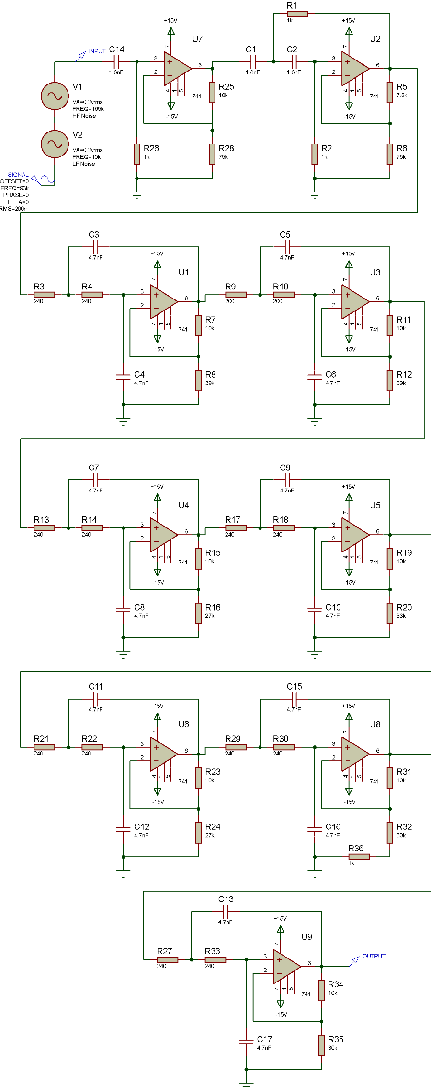
Figure 1 - Proteus circuit diagram

Theoretical principles and mathematics
The design of the bandpass filter relies on a set of mathematical equations to determine component values, cut-off frequency, gain, Q-factor (quality factor) etc. An educated guess must be made on what cut-off frequency is needed at the very start of the design process. Thereafter, a sensible capacitor value was chosen to determine the cut-off frequency, as there are less standardised capacitor values than there are resistor values. Capacitor values are usually relatively small (in the nano-Farad (nF) range), so a 1nF capacitor was chosen. This initial value allows for the equation $fc=\frac{1}{2πRC}$ to be transposed as $R=\frac{1}{2πfcC}$ to find the resistor values. This relies on a previously chosen cut-off frequency. The values chosen for this filter was a high-pass cut-off at 90kHz and a low-pass cut-off at 150kHz. This gives the equation for the low-pass filter:
$$R=\frac{1}{2π{150×}^{{10}^{3}}×1^{{10}^{-9}}}$$
This results in an approximate resistor value of 1kΩ. The process is repeated for the high-pass filter, which gives the equation:
$$R=\frac{1}{2π{90×}^{{10}^{3}}×5^{{10}^{-9}}}$$
This gives a resistor value of approximately 350Ω. Notice that the capacitor value has changed in the second equation. This is due to discoveries made when adjusting the circuit in Proteus. The filters were designed individually, and the 1nF capacitor used for the low-pass filter did not give the desired frequency response for the high-pass filter. After the component values were determined, the first revision of the circuit was put together. Originally, the circuit consisted of two second-order filters. This did not give an adequately sharp response to achieve the -30dB relative attenuation the filter needed to meet specifications. This will be discussed later in the report. As a result of this, more filters were needed to bring the frequency response slope to a satisfactory incline. After the desired frequency response was achieved, the gain needed to be adjusted so that the 93kHz signal was resting on the 0dB line (no amplification or attenuation). The gain is given by the following equation:
$$A=\left(1+\frac{R2}{R1}\right)$$
Here, $A$is gain and $R2$and $R1$are the top and bottom resistors that make up the potential divider which sends feedback to ground and the negative terminal of the op-amp. See figure 2.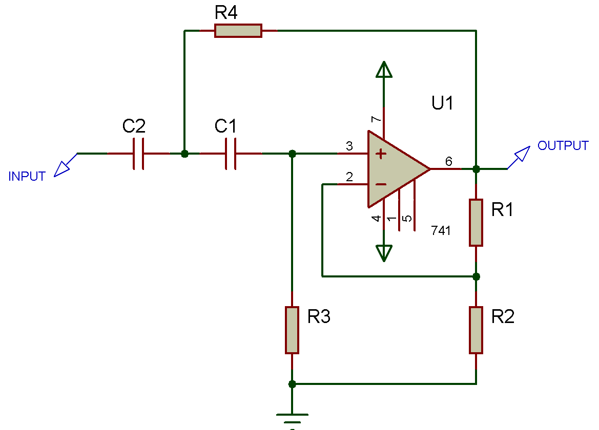
Figure 2 - Example low-pass filter
This overall filter design (figure 1) gives a frequency response signature with the following gain measurements:
- 93kHz @ -9.96mdB
- 10kHz @ -38.3dB
- 165kHz @ -30.3dB
The desired signal frequency (93kHz) gets attenuated by 9.96mdB, which is miniscule and close enough to disregard. As can be seen in the frequency analysis plot (figure 3), the slope of the trace is much flatter on the low frequency spectrum. This is a direct result of how many high-pass filters are in use compared to the amount of low-pass filters. This makes the bandwidth wider, as the Q-factor gets smaller. A small Q-factor results in a less sharp response outline, and to increase the Q-factor, more low-pass filters are needed.

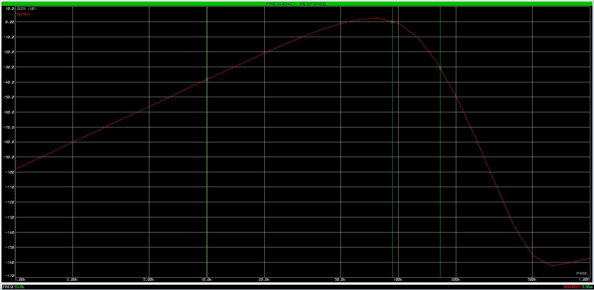
Figure 3 - Frequency analysis plot
The bandwidth is given by the difference between the frequencies at the -3dB points. Therefore, it can be said that:
$$Bw={F_{higher}-F}_{lower}$$
Thus, the calculated Q-factor is given by: $$Q=\frac{fr}{Bw}$$
Here, $fr$ is the desired frequency (93kHz) and $Bw$ is the bandwidth (59.7kHz). This gives a calculated Q of 1.55, which is a relatively poor-performing filter. This is easily improved by adding more filters to alter the low-frequency side of the spectrum, making the “slope” steeper on the frequency response graph. To further illustrate how the circuit performs, an analogue analysis was performed using the built-in tool in Proteus. As seen in figure 4, the red trace is the input to the first filter. This waveform contains the high and low frequency noise as well as the desired signal. As it is a composite waveform, it needs filtering to isolate the desired signal frequency. The green trace is the output waveform, the blue trace is the raw input signal and the red trace is the composite waveform. Interestingly, the green output trace sits on a DC level approximately 66mV higher than the input trace. The frequency response analysis would suggest otherwise, as the output signal is attenuated by -9.96mdB. A possible explanation could be that since the circuit has so many op-amps that sits on a DC level, some transistor leakage will happen. This, in turn, will cascade down the circuit and produce a slight DC-bias on the output. This is merely a hypothesis, as the frequency response analysis does not correlate with the analogue analysis in Proteus.

Octaves and roll-off
Each filter stage has 2 poles (RC-networks), except for the first high-pass filter. Each pole in a filter of this topology gives a 6dB roll-off for each octave. An octave is a doubling of frequency[6]. Cascading filter stages will give an additive roll-off effect, so for the low-pass filter with 14 poles, an 84dB roll-off is observed per octave. This can also be measured in decades. This was considered unfeasible for the frequency spectrum in this report. For reference, each pole will give a 20dB/decade roll-off[7].

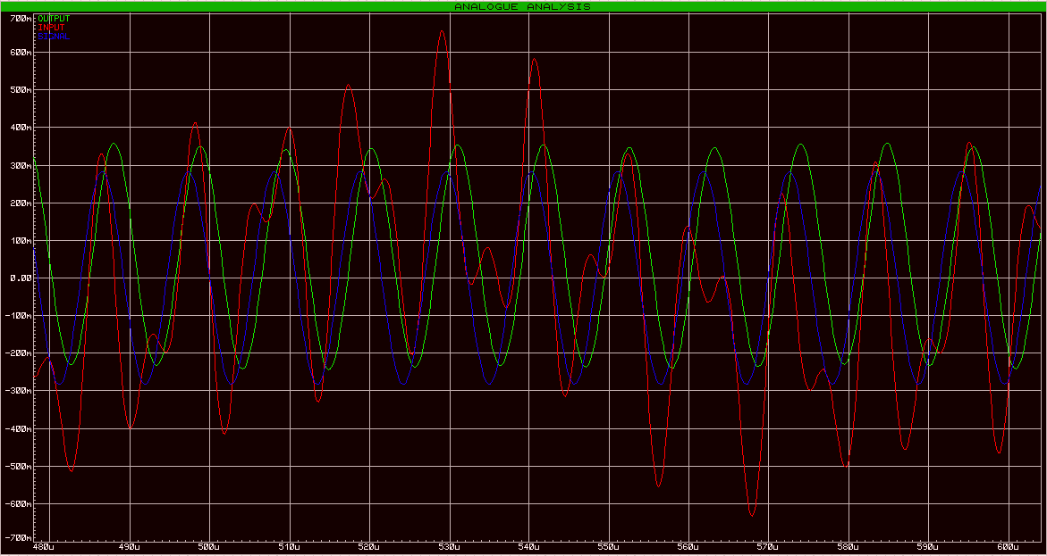
Figure 4 - Analogue analysis plot

Earlier designs
In order to reach the desired goal of 0dB gain on the 93kHz frequency component and -30dB on the noise frequencies, the design went through numerous iterations before the final goal was met. The main alteration between iterations was the addition of more filters to increase the dB/decade attenuation on the high-frequency noise. The first iteration of the circuit design can be seen in figure 5. The component ID’s are to be disregarded. 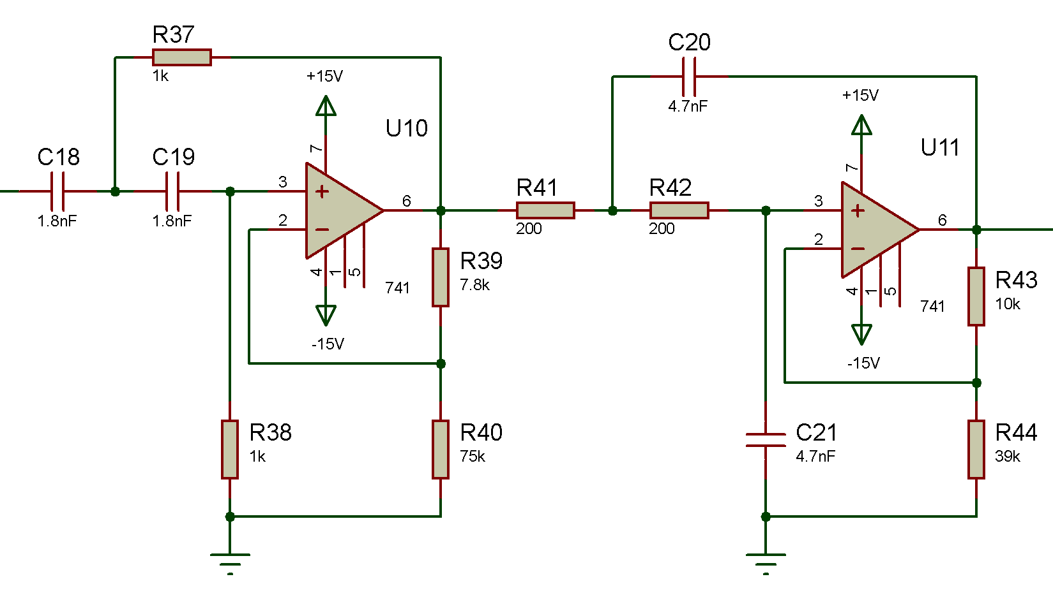
Figure 5 - 1st iteration of circuit
This did not satisfy the requirements of the circuit, as seen in figure 6. The roll-off is not steep enough, so the filter needs more stages. The gain is not vital to illustrate this, as the relative difference between the noise and the signal is too small to create an efficient filter.
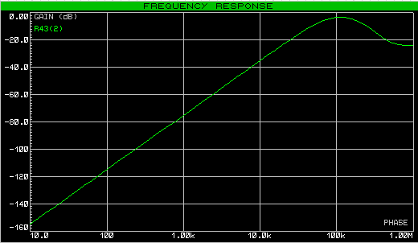
Figure 6 - Frequency response analysis for 1st circuit design iteration
The iterations after this added more and more filter stages, until a desirable response was achieved.
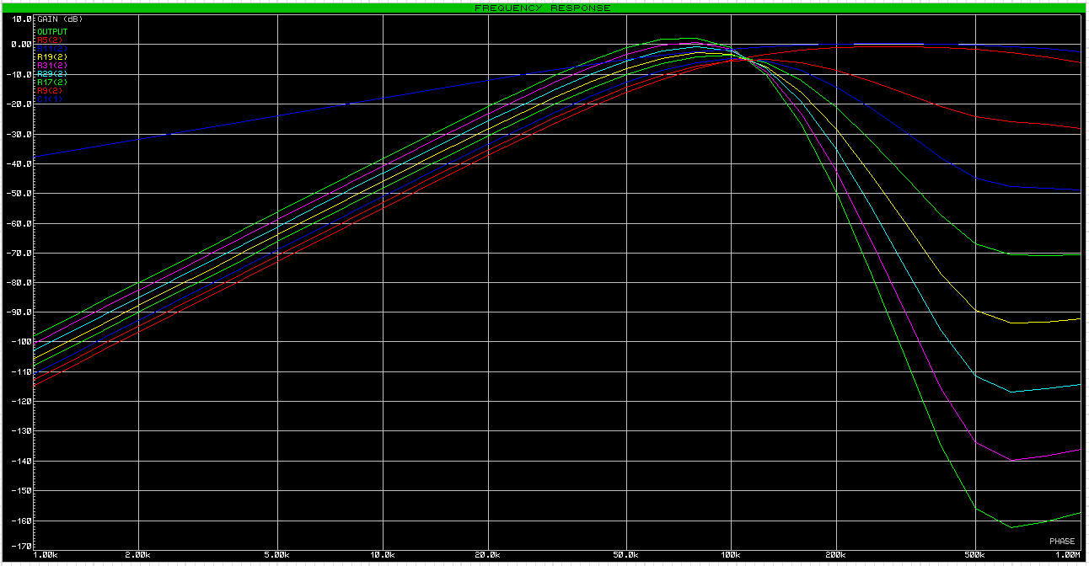
Figure 7 - Frequency response comparison between design iterations
The top blue trace in figure 7 is the output from the first order high-pass filter at the beginning of the circuit. The following traces marks a new added second order low-pass filter with the same topology (Sallen-Key). Note that the gain changes randomly with each iteration. This is because the filter was designed with response curve as a focus, and the gain was fine-tuned at the end of the design process by changing resistor values across the entire design to achieve a satisfactory response. Each trace will then reflect its specific gain rather than a logical increase with each filter-layer incrementation. This screenshot is a composition of a frequency response analysis of figure 1, but with added voltage probes on each stage to produce a combined graph.

Conclusion
A Sallen-Key filter is a capable, albeit simple composition of discreet components and transistor-based devices such as an op-amp. Cascading several stages of this filter will produce a more aggressive response, and this is a relatively easy way to achieve the desired roll-off rate before or after the cut-off point. According to the findings in this experiment, a 17th order filter was enough to attenuate the noise components to -30dB while maintaining a gain of 0dB on the signal component.
This was achieved by manipulating the roll-off rates of the individual filters. One first order filter has a 6dB/octave roll-off, which makes the total roll-off for the 3rd order high-pass filter 18dB/octave. For the 14th order low-pass filter, the roll-off is 84db/octave. Because the cut-off frequency for both filters were relatively close, the combined attenuation gave a -38.3dB attenuation on the 10kHz noise and a -30.3dB attenuation on the 165kHz noise.
More research is needed to investigate the irregularities in amplitude difference between the input and output signal.

References
[1] K. Lacanette, “A Basic Introduction to FiltersÐActive, Passive, and Switched-Capacitor.” National Semiconductor, 1991.
[2] R. P. Sallen and E. L. Key, “A practical method of designing RC active filters,” IRE Trans. Circuit Theory, vol. 2, no. 1, pp. 74–85, Mar. 1955.
[3] P. Horowitz and W. Hill, The Art of Electronics. Cambridge University Press, 2015.
[4] H. Akagi, “Modern active filters and traditional passive filters,” Bull. POLISH Acad. Sci. Tech. Sci., vol. 54, no. 3, 2006.
[5] “Standard Resistor Values | E3 E6 E12, E24, E48 Series | Electronics Notes.” [Online]. Available: https://www.electronics-notes.com/articles/electronic_components/resistors/standard-resistor-values-e-series-e3-e6-e12-e24-e48-e96.php. [Accessed: 08-Feb-2018].
[6] “Butterworth Filter Design with a Low Pass Butterworth.” [Online]. Available: https://www.electronics-tutorials.ws/filter/filter_8.html. [Accessed: 08-Feb-2018].
[7] A. Eck, “The influence of operational amplifier parameters on embedded applications - ProQuest,” ECN, vol. 43, no. 12, p. 52, 1999.

Bibliography
“Second-Order Sallen-Key Filters.” [Online]. Available: http://www.d.umn.edu/~htang/ece3235_doc_F10/Active_Filter_Summary.pdf. [Accessed: 08-Feb-2018].
“Digital Filter Terminology - dspGuru.” [Online]. Available: https://dspguru.com/dsp/reference/filter-terminology/. [Accessed: 08-Feb-2018].
P. Horowitz and W. Hill, The Art of Electronics. Cambridge University Press, 2015.

