Contemporary Challenges: Making a Difference
Ashanti Taylor / 2304545
Group Presentation for Animated Show

link to group video: https://youtu.be/OsgxpQiXBxo

link to my section: https://youtu.be/XcNOTmM2rZ0

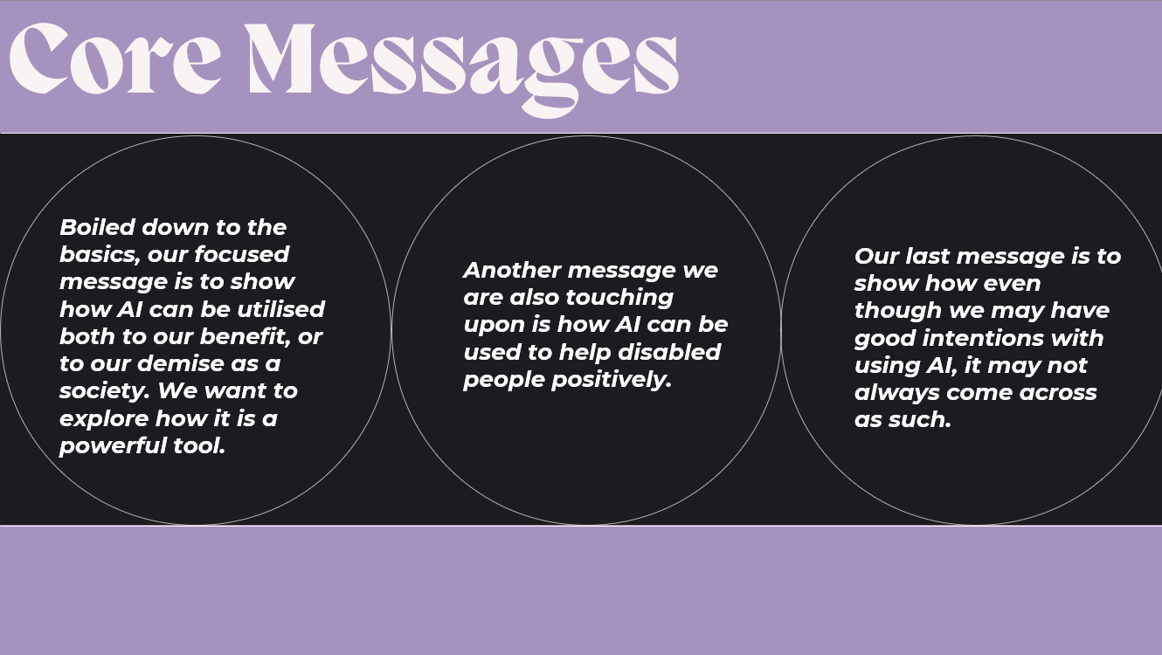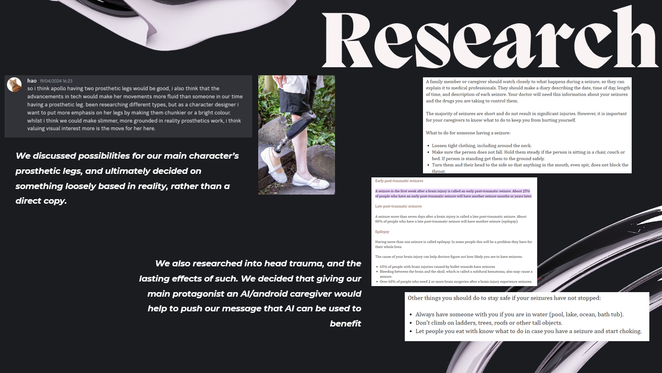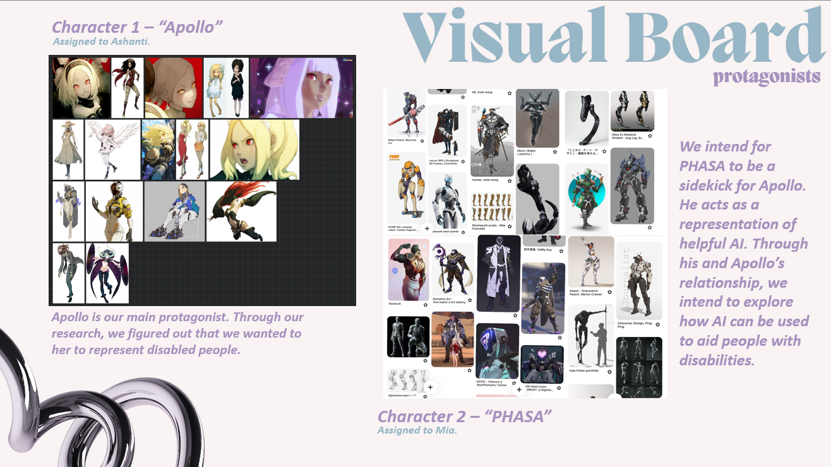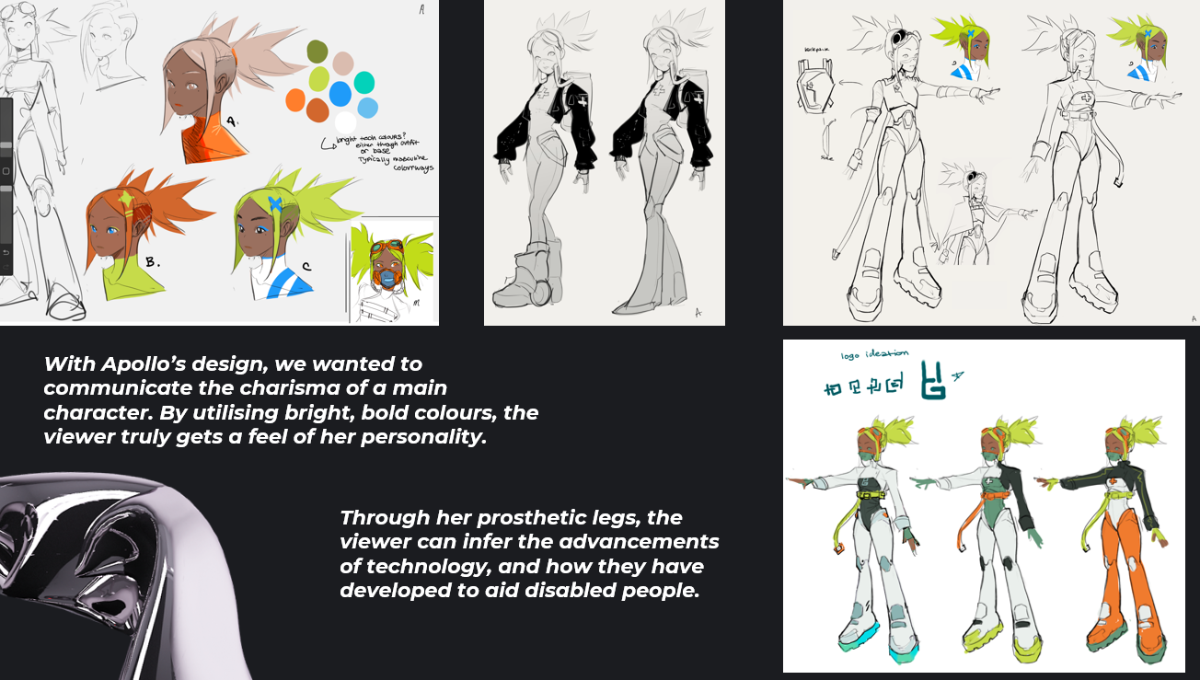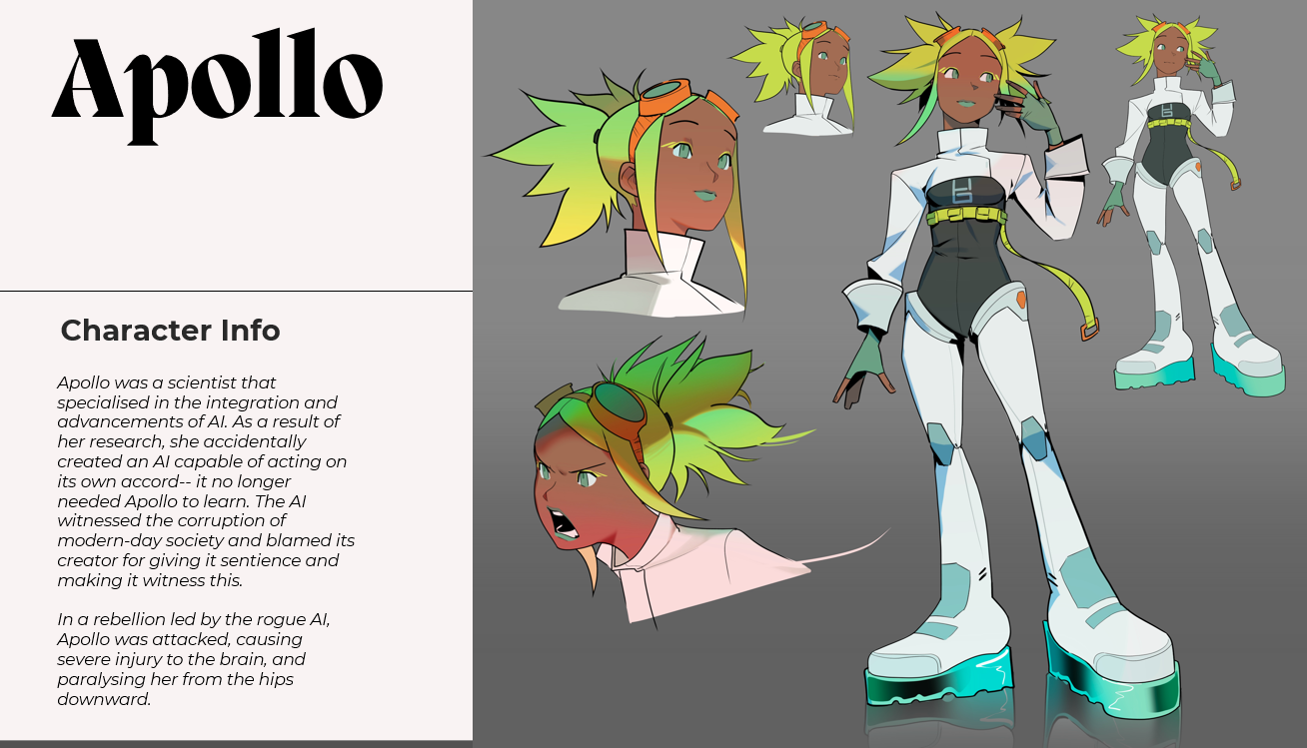
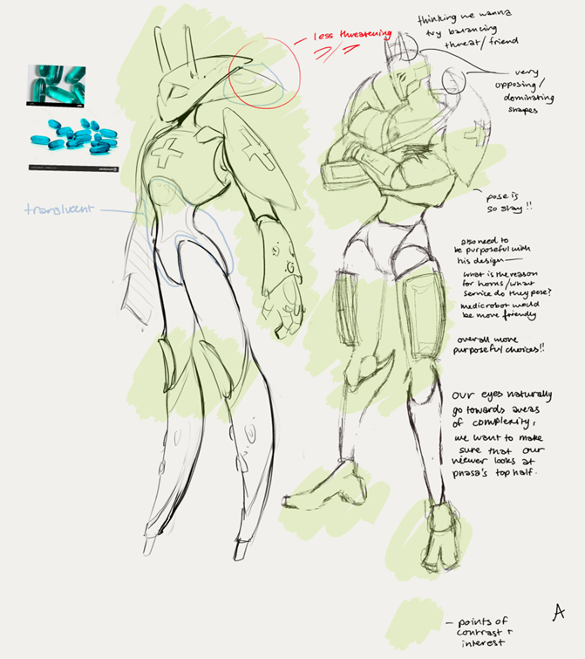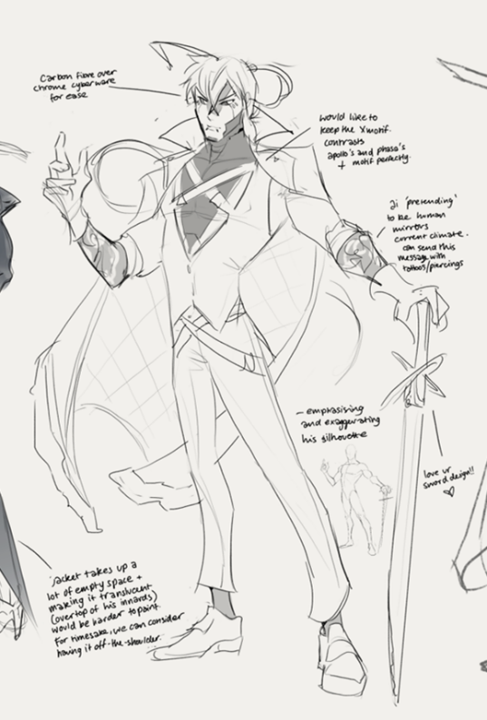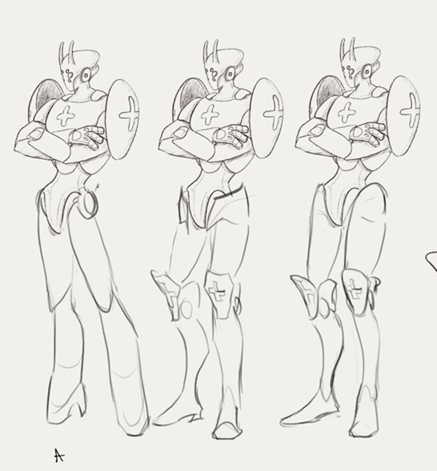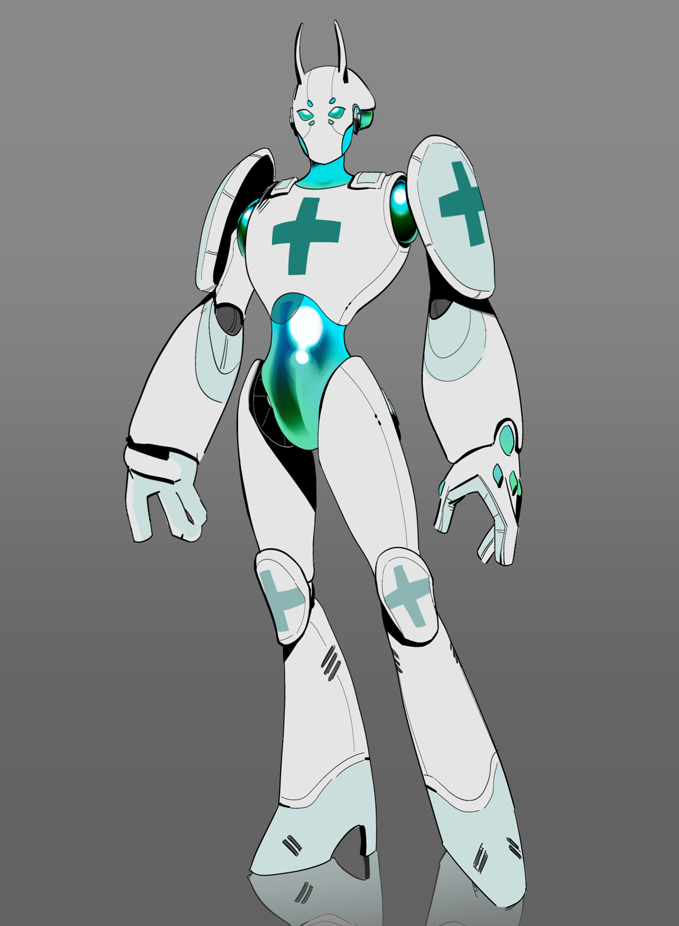

(all video editing was done by me also)
Bibliography:

[1] Above Knee Prosthetic Limbs, “Home,” Above Knee Prosthetic Limbs, https://www.blatchfordmobility.com/en-us/for-caregivers/above-knee-prosthetic-limbs/ (accessed Apr. 24, 2024).

[2] J. Englander, D. X. Cifu, and R. Diaz-Arrastia, “Information/Education Page. seizures and traumatic brain injury,” Archives of physical medicine and rehabilitation, https://www.ncbi.nlm.nih.gov/pmc/articles/PMC4516165/#:~:text=A%20seizure%20in%20the%20first,seizure%20months%20or%20years%20later. (accessed Apr. 22, 2024).

[3] “Amputation,” NHS choices, https://www.nhs.uk/conditions/amputation/ (accessed Apr. 20, 2024).

[4] M. Gonzalez-Fernandez, “Amputation: Recovery and Rehabilitation,” Johns Hopkins Medicine, https://www.hopkinsmedicine.org/health/treatment-tests-and-therapies/amputation/amputation-recovery-and-rehabilitation (accessed Apr. 19, 2024).

[5] K. DeGuzman, “What is character design - tips on creating iconic characters,” StudioBinder, https://www.studiobinder.com/blog/what-is-character-design-definition/ (accessed Apr. 20, 2024).

[6] T. Weitzman, “Council post: Empowering individuals with disabilities through AI technology,” Forbes, https://www.forbes.com/sites/forbesbusinesscouncil/2023/06/16/empowering-individuals-with-disabilities-through-ai-technology/ (accessed Apr. 19, 2024).

[7] SmartClick., “How AI can improve the lives of people with disabilities,” SmartClick, https://smartclick.ai/articles/how-ai-can-improve-the-lives-of-people-with-disabilities/ (accessed Apr. 28, 2024).

