

Title = Human Resource Management 1
Student Name Alexander. A. Adesuyi
Student ID= 2126827.
Lecturer Name=Mushfiqur Rahman.

TABLE OF CONTENT

- EXECUTIVE SUMMARY. 3
- INTRODUCTION. 3
- THE IMPACT OF EXTERNAL AND INTERNAL FACTORS ON UK LABOUR MARKET. 3
  - EXTERNAL ENVIRONMENT FACTORS 4-6
  - INTERNAL FACTORS 6-7
- THE CURRENT STATE OF LABOUR MARKEK IN UK 7-8
- LABOUR SUMMARRY TABLE 8-10
- THE EMERGING CHANGES IN HRM STRATEGIES, POST COVID AND POST BREXIT. 10-13
  - PRE COVID AND BREXIT HRM ACTIVITIES
  - POST-COVID and BREXIT HR STRATEGY.
- CONCLUSION. 13
- REFERENCE. 13-15

1 Executive Summary
The COVID-19 turmoil has changed many organizations plan. Brexit has made it difficult for low-wage business to recruit staff, there set of challenges with the new immigration policy set out by the government to address the shortages. (Chinadaily.com.2022) Also, the external and internal environmental factors also affected organisations on many multidimensional levels. The work, workplace, and the workforce restructuring are the HR most challenges.

2 Introduction
The report is based on UK current labour market, emerging post covid and Brexit HR strategies. The research method was a review of the research findings from scientific literature and business on impact of post Covid and Brexit human resource management strategy.

3 The impact of external and internal factors on UK labour market, post Covid and post Brexit HR strategy.
The role of HRM in organisation is underlined by the complex and dynamic nature of environment under which organisation is function. The impact of external such as PESTLE (Political, Economic, Socio/Cultural, Technological, Legal,) and internal environmental factors (Organisation/Corporate culture, Action of Competitors, Operational Strategy, Financial Strategy), have made the role of HR management increasingly more important in organisation undertakings. HR activities has changed since pandemic.
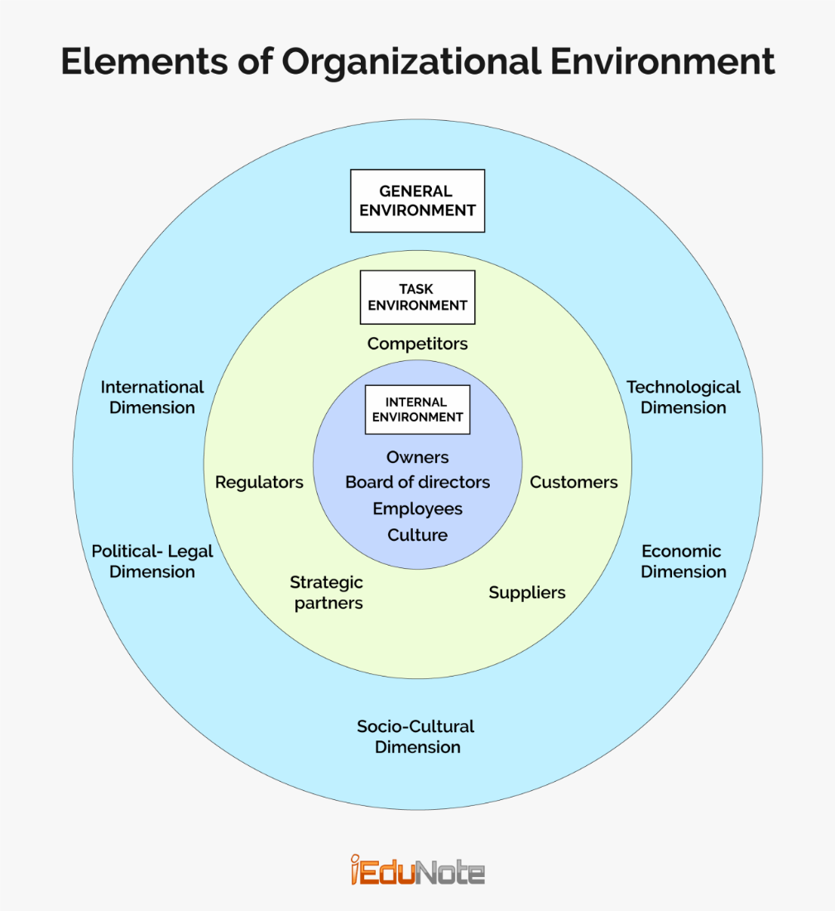
https://i0.wp.com/www.iedunote.com/img/1529/factors-of-internal-and-external-organizations-environment.png
3.1 External Environment PESTLE.
Pestle is an external factor that organisation or HRM have no influence or control over it. The Impact of external factors could be favourable or unfavourable to the organisation.
- Political Factor, Government policy, political instability and global trade affecting the organisations operation, Unions, working hours etc for example, minimum wage increasement from £8.50 to £10.44, post immigration law and new migration regulations and employment law about EU workers and sponsorship scheme. But before EU workers were allowed to work without restrictions. As a result of current conditions this factor on staffing, is unfavourable to organisation (CIPD,6. 2021).
- Economic Factor, pre Covid and Brexit era, UK economy was strong, stable and employer enjoyed cheap labour. Post Covid and Brexit era, high inflation (12%), Brexit and impact of global economy has weakened UK economy and future trade restrictions in Europe is uncertain. This move has affected business profit margin. Therefore, Economic Factor is unfavourable now because its directly affected organisation recruitment, employees' wages, learning and develop of their staff to meet customer's demand. Therefore, human resource (HR) policies and strategies changed in the affirmative way. Mello (2013) there economic trends that influences organisation achievement such as unemployment rate.
- Socio/culture, the national characteristics related may transferring to the business life such as Consumer trends/ tastes, work life balance, buying habits, Lifestyle factors, Career attitudes. Government Working from Home during pandemic and societal engagement has become workplace norm but before Covid and pandemic, Staff were not alone to work from. it was hundred percent on-site or office job. These changes affected HR management activities. Some local regional demographic labour markets are demanding for above living wages to work in retail business. Therefore, this factor is favourable to employees and may be favourable to some businesses while unfavourable to other in terms of staff shortage (CIPD,6. 2021).
- Technology Factor, Application of HRM modern technology has evolve and favourable impacted HR in UK with the use of recruiting software and other HRM digital software, hence efficient and effective talent source, recruitment and resource planning, labour forecasting, etc. Before pandemic and Brexit, most of HRM recruiting were conducted face to face, Time consuming and a lot of papers work which has changed since covid and post covid era. “Tiwari and Saxena (2012) pointed out that, technology provides new methods for HRM practices (Genc, 2014a).”

- Legislation/Regulation, Employment law, Common law, Local labour law, Health and safety regulations affecting organisation human resource management such as Compliance with the Modern Slavery Act particularly important for retail. Human resource management policies should be by legal necessities. This factor is unfavourable because of restrictions on EU migrants. The current post Brexit immigration restriction and compliance law have direct impact on the employers in term of skilled and low skilled employees needed to fill vacant post and cost involved. Pre-Covid and Brexit era, employer enjoyed cheap labour and supply exceeds demand in labour market (CIPD,6. 2021).

- Environmental Factor Restrictions imposed by UK governments such as Sustainable resources and corporate social responsibility affecting organizations because most of UK staff are concerned about planet therefore, they prefer to working in such business environment. Therefore, HRM need to show such employees that they are committed to environmental sustainability. But a Little attention was placed on this factor before pre- Covid and Brexit era. This factor is favourable to HRM that promoting eco-friendly business at this time of labour shortage. The price of goods jump-up as ethically source and environmentally conscious shoppers increases. (CIPD,6. 2021).

3.2 Internal Factors are factors which organizations has control over it if professionally managed (Armstrong and Taylor, 2020). Organisation Internal Factors can also analyse using SWOT or Porter's Five Forces. Porter’s five forces is a method using by organisations to analysis operating environment of a competition of a business. SWOT stand for strengths, weaknesses, opportunities, and threats and change the existing strategies. They are factors that affect HRM with in organisation and its business environment including following,
- Organisation /Corporate Culture. Internal factor such as Organizational/Corporate culture reflects the set of methods to achieve purposes and requires the restructure of principles, rules, departments, simply mindset in an institution. Therefore, human resource strategy or implementation must fit-in to organizational strategy including work force planning. A change of Leadership such as directors, new management or new team leader, the new management may lead to a change in the organization culture. Obviously, new management would have innovative ideas, concepts and they would try their best to implement them. Work culture will change as the new director or management also would want staff to adapt to their style of working and ideologies (Holbeche, 2009).
- Organisation Structure, Business acquisitions and international markets expansion required strategic realignment. Therefore, any changes will alter the managerial structures of an organisation, Organisation or business cannot avoid changes in strategic management. Organisation will make changes existing strategy and develop new strategy that align with the missions and goals of the organisation.
- Actions of Competitor occur when rival organisation increases their wages or salaries and better work conditions to attract skilled staff. Other organisations will react effectively by offer improve wages, employees support programs and so on. Currently, employers are offering high wage and attractive benefits due to labour shortage in UK. Pre-Brexit and Covid, employers bargaining power was high, employers can easily replace worker as supply exceeds demand.
- Operational strategy. New market entrants may pressurise current organisations market share. This in turn result to change in organisation operational strategy. change in operation of organisation with affect the level of workforce directly. Product diversification or Line extension may require modern technology, department, or marketing promotion strategy. Introduction of digital and other technology system may require fresh staff training, fewer staff as the case of remote/ Work from Home. Pre-Covid era business operations was stable, work or task were carried out 100% on site compared to post Covid and Brexit remote or hybrid working.
- Financial Strategy, Monetary loss, bankruptcy, market fluctuations may lead to organisation restructuring. When an organisation experiences losses, it does not give rewards and appraisals or reducing workforce. The decision to reduce cost (Cost Leadership) by outsourcing training would result in change to learning and development also demoralised staff. Pre – Covid Brexit era, organisation income and profits stable because of strong economy but now companies are struggling financially in terms of labour and production cost due to weak economy and labour shortage. As income and profits fluctuate so the level of workforce.
4 The current state of labour market in UK.
The early retirement and end of EU citizen free movement mostly affected the labour Market in the UK. There high vacancy rates in various occupations across the economy, some of business are having recruitment difficulties. Although their improvement in pay package, but no evidence to suggest that the Brexit has increased wages across the board because the immigration system does not allow low -wage industries to recruit from non-EU (The Migration Observatory, 2022). The businesses that suffered as result of lockdowns are now eager to recruit because their staff have moved on to other jobs. Before, supply of Recruitment agencies workers to some organisation only takes few days’ notices but these days they need months. According to Indeed recruitment, the food-preparation and service sector job posting since February 2020 increase by 72% and a twice in warehouse positions. There were 72% drop in the average number of applications per job posting between April 2021 to May 2022 according to a social networking called LinkedIn (The Economist, 22AD). “According to the Bank of England,” this was a result of the number of inactive people increase since the beginning of the Covid. Others are something else or sick or not yet recover; the shortage of NHS staff may have affected shortage of workers due to people wait months for treatment. Fall in the number of people in the labour market was because of reduction in the EU migration. Since Brexit, labour demand grows much faster than labour supply since the pandemic. Labour market are see growth of nominal wages and some upward pressure on inflation. The recent increases in inflation are the result of global energy crisis and price of goods (Powell, Francis-Devine, and Clark, 2022). “According to office of national statistic UK report,” From August to October 2022, job vacancies dropped by 46,000 on the quarter to 1,225,000. Some businesses are now reporting holding back recruitment due to economic pressures (www.ons.gov.uk, 22AD). (Employment) total of 32.75M people were employed between June-August 2022 in UK. The employment rate of people between 16-64 in work was 75.5%. Between June-August 2022, the number people were employed on a full-time basis was 24.61M and 8.14M people were on a part-time job. The number of full-time employees between June-August was 873,000 above pre-pandemic. In June to September 2022, the number of UK job vacancies dropped on the quarter to 1.25 million in July-September 2022, but vacancies were at 450,000 greater than the pre-pandemic quarter of January-March 2020. The numbers of women were in work in June-August 2022 was 15.64 million, while 17.11M men were activity working. The total number of young people between 16-24yrs unemployed in June-August 2022 was 372,000. Going by the history, the levels of unemployment young people are still low. Due to the reason that more young people are pursuing university qualifications. From April-June 2022, all non-UK national's employment rate was 75.3%, against 75.4% for UK. EU citizens employment rate was 81.8%, against 68.8% for non-EU citizens. Between the final quarter of 2019 and the first quarter of 2022, the employment rate of people 55-64yrs fell by 1.8%. The Ons survey suggested that a slow economy could loosen labour market and high inflation plus squeezed real incomes may push some people back to work (www.ons.gov.uk, 22AD).

5 Labour Summary Table
Table 1: July to September 2022 (Office for National Statistics, 2022).
 | Level or Rate | Change on  earlier  three-month  period | Change on  year | Change since  December 2019 to  February 2020
Employment  (000s, aged  16 years  and above) | 32,739 | -52 | +148 | -334
Employment rate  (Aged 16 to 64  years) | 75.5% | 0.0pp | +0.1pp | -1.1pp
Unemployment  (000s, aged  16 years  and above) | 1,224 | -69 | -227 | -140
Unemployment  rate  (Aged 16 years  and above) | 3.6% | -0.2pp | -0.7pp | -0.4pp
Economically inactive (000s, aged 16 to 64 years) | 8,999 | +108 | +198 | +629
Economic  inactivity rate  (Aged 16 to 64  years) | 21.6% | +0.2pp | +0.4pp | +1.4pp
Total weekly  hours  (millions) | 1,038.9 | -4.2 | +9.6 | -13.3
Redundancies  (000s, aged 16  years and above) | 75 | +21 | -29 | -31
Redundancy rate  (Per thousand,  aged 16 years  and above) | 2.7% | +0.7pp | -1.1pp | -1.2pp
Source: Office for National Statistics – Labour Force Survey

6 The emerging changes in Human Resourcing Strategies in the post Covid, post Brexit environment.

Strategic HR management is an idea which combined human
resource management activities with an Organisation's general strategic planning and implementation (Armstrong, 2011).
6.1 Pre Covid and Brexit HRM activities
Pre Covid-HR department traditional roles was workforce planning, recruiting, produce the employee handbook training employees based on long-term goals and help employees reach the company’s best goals. Labour market favourable to the employers in all sectors in UK. Employment and economy grew year by year because of free movement of goods and European citizens that came to work in UK without restriction, immigration check and barriers, until year 2016 after UK voted to leave European Union Community and Economic Area.
6 .2 Post-COVID and Brexit HR strategies
Since UK exit of European Union in year 2020 as result of political and economic decision, employment and workforce has changed. Virtually all business sectors are facing with problem of staff recruitment and retention best suited staff needed for their vacant post in some areas of economic sectors such as domestic workers, warehouse, hospitality, health, and social sectors, etc. Also, the size of Global pandemic “Covid 19” on all organizations and industries around the globe including UK were same but different impact. during the pandemic, a lot of people lost their job were minimal as result of furlough payment., the labour market. Organisations digital capabilities has been an enabler that HRM are using to connect with people online during pandemic and post pandemic in UK. As a result of unended Covid 19, HR department has developed post -Covid and Brexit strategies that align with organisations changing environment, work, workforce, and workplace. The following are the emerging changes in HR strategies in the post Covid and post Brexit.
- Competitive wage and Employee Branding, as result of tight labour market organisations is increasing the wages and salaries, or improve work conditions, offer better social support programs and so on; which also is reacted effectively. Organisations are responded, in terms of satisfying the employees expectations, to keep them as a member of company (Pilbeam,2010). As we can see, the organisations source of competitive advantage and differentiation focus is the HRM. So, unique, and well organised HR can be a valuable competitive advantage in any organisation (Barney, 1991; Barney, 1995; Barney & Wright, 1997).
- Remotely Working Environment, Technological factor changed human resource management of organisation as we are experiences during pandemic and post Covid 19. Because of global pandemic, some employees are not free to work in the workplace for health reason as this resulted in rapid shift to remote work from home, HRM as has strategically set up common ground to help those employees to continue supporting their organisation from home with the aid of digital resources. Technology has made it possible to improved human resource functions such as selection, recruitment, educating, training, performance app. On contrary, organisation may need qualified workers that will use newly technology, and this will increase personnel spending. According to Bingöl (2006), technological developments require flat organizational structures to allow highly qualified personnel show their creativeness (Genc, 2014b).
- Staff Health and Wellbeing, During Covid pandemic period, a lot of people were, emotionally, mentally stress and financially depressed. These circumstances have direct effected organisation productivity and employee morale at work and as a result HRM in every organisation have made health and safety a priority. Some organisation invested more in well-being last year. Some organisations have offers health and counselling support to their employee both at work and remotely. HRM are now creating awareness of health and wellbeing support packages available to the staff because most of the employees are still not taking advantage of these free offer.
- Flexible/Hybrid work, the new trend of flexible/Hybrid work has been introduced by HRM in some organisation to accommodate and strengthen those staff are studying, that yet to recover from pandemic or employee living in a far distant to support their organisation at agreed time or days. Provision of flexible/hybrid work has help organisation mitigate labour shortage in some sector. On the other hand, the expectations for working flexible increased by 75% and any attempt by any company to reverse back to a fully on-site arrangement might result to reduction in their workforce by 39%. Workplace and organisation culture redesigned around employees-driven flexibility to accommodate the present labour outlook.
- Talent Management, The UK current highly skilled specialist's shortage with international and intercultural experience has become a challenge after Brexit and post Covid. HR department has adapted to rapidly changing in labour market, most organisation is strategically reskilling and upskilling their employees to prepare them for new jobs, career changes—and advancing within their current career tracks. HR are reskilled and upskill programs mostly targeting employees’ skills building in critical analysis and problem solve, decision making, leadership and data management, etc, in the post-pandemic era. Agrawal et al. (2020) pointed that the skill building should be focused on four areas: digital, higher cognitive, social, and emotional adaptability and resilience.
- Digitalisation and Automation, Defilippi (2002) suggests that technology alters the roles of human resource. Organisations are investing in digital workplace that enhances HR analytics and automation. HR modern technologies notable change roles within HR since COVID appeared, as majority of recruitment and selection practices were provided by e-bots or ATS (application tracking system). HR modern technologies are key enabler for video interview, reference check and better delivery of HR services. some employers who depend on EU workers before and are now ineligible to recruit from overseas are starting to adjust by turning to automation to reduce their need for EU workers. HR modern technologies are example of operational strategy (internal factor) and in some cases can be negative effect in terms of staffing and financial strategy.
- Redesign Culture and workplace, Redesign have direct impact on financial and operational strategy (internal factors). Because some employees are working remotely, some organizations realized that the physical space, offices, car parking are no longer needed anymore. The employers redesign workplace for the employees that agreed to work in the office, hence more efficient, serves the unique needs of teams better and reduced overhead costly. Organisation culture, engagement and rules concerning content and place of work during COVID-19 changed including guidelines on social distance, sanitations, business travel and the use of common spaces like kitchens or recreation areas.
- Contingency and Workforce planning, Labour market becoming competitive because of unended Covid 19, post Brexit Shrinking labour market and customer preference. HR are strived by strategy workforce contingency planning that informs good business decision and optimised ability. Part of HR operational strategy including outsourcing
- Redefined compensation and Benefit, Compensation and benefit factor are very crucial, both in the recruiting and retention of staff in post Covid and Brexit. Because Covid 19 changed employee lifestyles dictated new needs and reshaped the way business operating, some employers have adopted new HR strategy. Some organisations HR has redesigned their compensation and benefits to meet the needs of current and future employees, including benefits related to mental condition, more cash support staff relocation or redeployment. Also, non- financial benefits are added including dedicated Childcare and family support services, employee helpline aid. All these implies that compensation and benefits area will affect financial strategy (Internal factor) by lost revenue and increased costs.

7 Conclusion,
Post Covid and Brexit labour market is more difficult to recruit and keep staff. Therefore, post pandemic strategy require competencies from managers and employees, so re-skilling and re-training are the approaches to mitigate skilled staff shortage.

Reference:
www.ons.gov.uk. (22AD). Labour market overview, UK - Office for National Statistics. [online] Available at: https://www.ons.gov.uk/employmentandlabourmarket/peopleinwork/employmentandemployeetypes/bulletins/uklabourmarket/november2022#:~:text=The%20most%20timely%20estim [Accessed 22 Dec. 2022].

https://migrationobservatory.ox.ac.uk/press/brexit-exacerbated-labour-shortages-in-the-uk-but-is-not-the-only-cause/
PESTLE factsheet (cipd.co.uk)
Environmental Factors Affecting Human Resources Management Activities of Turkish Large Firms, International Journal of Business and Management; Vol. 9, No. 11; 2014 ISSN 1833-3850 E-ISSN 1833-8119 Published by Canadian Center of Science and Education.
Holbeche, L. (2009). Aligning human resources and business strategy. Amsterdam; Boston: Butterworth-Heinemann.

Mello, J.A. (2013). Strategic Human Resource Management. Florence, Ky: Cengage.
Pilbeam, S. (2010). People Resourcing and Talent Planning: HRM in Practice. 4th ed. Harlow, England. Pearson Prentice Hall.
Genc, K.Y. (2014a). Environmental Factors Affecting Human Resources Management Activities of Turkish Large Firms. International Journal of Business and Management, 9(11). doi:10.5539/ijbm. v9n11p102.
Defilippi, R. J. (2002). Organizational Models for Collaboration in New Economy. Human Resource Planning, 25(4), 7–18
Armstrong, M. (2011). Armstrong’s handbook of strategic human resource management. London: Kogan Page.
Armstrong, M. and Taylor, S. (2020). Armstrong’s handbook of human resource management practice. 15th ed. London, United Kingdom; New York, Ny: Kogan Page.

Re-vision of Future Trends in Human Resource Management (HRM) after COVID-19 Authors: Sylwia Przytula, Gabriela Strzelec, Katarzyna Krysińska-Kocienski Journal of Intercultural Management, ISSN 2080-0150, e-ISSN 2543-831X
Migration Observatory. (n.d.). Brexit exacerbated labour shortages in the UK but is not the only cause. [online] Available at: https://migrationobservatory.ox.ac.uk/press/brexit-exacerbated-labour-shortages-in-the-uk-but-is-not-the-only-cause/.
(Accessed: December 22, 2022).
郭蓉 (22BC). Fewer EU citizens moving to Britain. [online] global.chinadaily.com.cn. Available at: https://global.chinadaily.com.cn/a/202208/16/WS62fafb83a310fd2b29e726f6.html [Accessed 16 Aug. 2022].

The Economist. (22AD). Britain’s labour market is straining to recover from the pandemic. [online] Available at: https://www.economist.com/britain/2022/07/07/britains-labour-market-is-straining-to-recover-from-the-pandemic.
Powell, A., Francis-Devine, B. and Clark, H. (2022). UK Labour Market Statistics. commonslibrary.parliament.uk. [online] Available at: https://commonslibrary.parliament.uk/research-briefings/cbp-9366/
Barney, J. (1991). Firm Resources and Sustained Competitive Advantage. Journal of Management, 171, 99-120
Barney, J. B., & Wright, P. M. (1997). On Becoming a Strategic Partner: The Role of Human Resources in Gaining Competitive Advantage. Human Resource Management, 37(1), 31–46.

