

What is the Police Force’s role in safeguarding children and how effective is partnership policing to achieve this in the UK?

By Rhian Goldby
ID: 2236212
BSc (Hons) Professional Policing January 2023

Word Count: 7809

Declaration
This work has not previously been accepted in substance for any degree and is not being concurrently submitted in candidature for any degree.
Signed: Rhian Goldby
Date: 06/10/25

Statement 1:
This dissertation is being submitted in partial fulfilment of the requirements for the degree of BSc Professional Policing
Signed: Rhian Goldby
Date: 06/10/25

Statement 2:
This dissertation is the result of my own independent work/investigation, except where otherwise stated.
Other sources are acknowledged by footnotes giving explicit references. A bibliography is appended.
Signed: Rhian Goldby
Date: 06/10/25

Statement 3:
I hereby give consent for my dissertation, if accepted, to be available for photocopying and for interlibrary loan, and for the title and summary to be made available to outside organisations.
Signed: Rhian Goldby
Date: 06/10/25
Statement 4:
I hereby give consent for my dissertation, if accepted, to be available on the university’s IT system to those who have consent to use the system.
Signed: Rhian Goldby
Date: 06/10/25

Abstract
This dissertation discusses the effectiveness of the child protection system. It concentrates upon the role of police, within the multi-agency approach to safeguarding children, and additionally considers the roles of other professionals within this context.
The study aims to provide a deeper understanding of the importance of effective partnership working and to address common misconceptions held by police officers regarding the authority and responsibilities of social workers—especially in relation to the removal of children from harmful environments. In doing so, it seeks to highlight both historical and recent failings within the child protection system, drawing on evidence from child practice reviews and a range of published literature.
To support this investigation, a comprehensive review of academic sources, policy documents, legislation, and relevant media (such as documentaries) was undertaken. Additionally, primary data was collected through surveys with professionals in the field, including police officers, public protection officers, and children’s social workers. The findings reveal significant gaps in the current child protection system, as well as in police officers’ understanding of the legal powers held by social workers, which may influence frontline decision-making and affect the overall effectiveness of multi-agency safeguarding efforts.

Acknowledgements
I would like to begin by expressing my heartfelt thanks to my foster siblings. Your experiences and presence in my life have profoundly influenced my motivation to pursue this area of research. You have inspired my commitment to making a difference in the lives of children who rely on the protection and support of police and social services. I am deeply grateful for the perspective you have given me.
I would also like to sincerely thank my colleagues in both the police and social care sectors for their valuable time and willingness to participate in this research. Your contributions have been significant, and the findings have offered significant insight into current practices. I am committed to sharing these outcomes—where possible—within South Wales Police to support the ongoing development of informed, effective safeguarding practices.
Lastly, and by no means least, I extend my heartfelt thanks to my family and friends. Your unwavering support throughout this journey has meant everything to me. During the long hours of research and the moments of self-doubt, your encouragement has been a constant source of strength. I am immensely proud to have reached this milestone, and I could not have done so without you.

Table of Contents
Chapter 1 -Introduction………………………………………………………………..Page 8

Chapter 2 – Literature Review
2.0 Introduction………………………………………………………………………..Page 11
2.1 Exploration of the effectiveness of child protection in the UK……………………Page 11
2.2 The roles of partner agencies in relation to safeguarding children in the UK……. Page 15
2.3 Effect on children when removed from neglectful situations……….…………….Page 17
2.4 Conclusion………………………………………………………………………...Page 18

Chapter 3 – Research Methodology
3.0 Introduction………………………………………………………………………...Page 20
3.1 Research Approach………………………………………………………….……...Page 20
3.2 Primary Research Method……………………………...…………………………..Page 21
3.3 Analysis of Results…………………………………………...…………………….Page 22
3.4 Ethical Concerns……………………………………………...…………………….Page 22
3.5 Conclusion………………………………………………………………………….Page 23

Chapter 4 – Analysis of Results
4.0 Introduction……………………………………………..……………...…………..Page 24
4.1 General findings of the Questionnaire……………………………………..……….Page 24
4.2 Partner agencies perspectives ……………………………………………….……..Page 25
4.3 Improvements to effectively safeguard children……………………………...……Page 26
4.4 Conclusion………………………………………………………………...………..Page 27

Chapter 5 – Conclusion
5.0 Overall Summary……………………………………………..…………………….Page 28
5.1 Summary of Key Findings………………………………………………………….Page 28
5.2 Unresolved Questions………………………………………………………………Page 30
5.3 Limitations of the Study…………………………………………………...……….Page 31

Appendix
Bibliography………………………………………………………………..…………..Page 32
Questionnaire…………………………………………………………………..…...…..Page 36
Ethics Form……………………………………………………………………...……..Page 50

Chapter 1 - Introduction
This empirical research study aims to investigate the current issues surrounding the police forces' role in safeguarding children and the effectiveness of partnership policing in achieving this in the United Kingdom. The core of safeguarding children is the child protection system. Child protection is entirely about taking action; in the context of safeguarding and promoting children’s welfare, to protect specific children who are suspected to be suffering, or likely to suffer, significant harm, whether this occurs inside or outside of the home, including online. (Children’s Social Care National Framework; 2023)
To determine an appropriate conclusion around this topic, the researcher has created four different objectives which are the following; a) explore the effectiveness of child protection, b) analyse the role of partner agencies to safeguard children, c) investigate if police are taking on a social services role when dealing with the welfare of children, and d) the impact on children when removed from neglectful situations. Through providing these objectives, the researcher can explore all topics and key concerns without them being overshadowed throughout the study.

This research topic was chosen as it holds deep personal significance for the researcher. Through the experience of having foster siblings who were repeatedly failed by partner agencies, the researcher witnessed first-hand the consequences of systematic shortcomings within child protection. This personal connection instilled a strong motivation to investigate the effectiveness of the child protection system, to understand areas which need improvements and to explore how it can be strengthened to ensure that the vulnerable children receive the appropriate protection and care required.

To successfully conclude the issues surrounding this topic area, the researcher will explore literature, which highlights these key issues from a historical point of view and compare these views to the current issues. An example of this is research which had been conducted by Vangen et al (2003), states that to successfully safeguard children in societies located in the United Kingdom, partnership organisations must collaborate. This is due to the ideology that each partnership organisation, such as child social work, youth services, et cetera, can transfer knowledge amongst one another to ensure all aspects of child safeguarding are accomplished. Despite this, researchers Adam Crawford and Xavier L’Hoiry (2017) stated that to successfully conquer issues relating to child safeguarding, emergency services and their collaborative agencies must exhaust all conceivable solutions, ahead of time, upon investigating and understanding the key issues surrounding safeguarding. However, this is not how the police force and their collaborative agencies are conducting their investigations today. As a result of these issues, the researcher has concluded that through investigating these areas and producing alternative routes to improve child safeguarding, police forces across the United Kingdom may refer to this thesis.

Through applying previous studies and literature, the researcher will also conduct primary research using a questionnaire. The researcher will create this questionnaire based on the gaps in the literature. This will allow the researcher to create research which is relevant and appropriate for the thesis. The researcher will distribute the questionnaire to a variety of public service sectors which are primarily responsible for responding to child safeguarding issues in the United Kingdom. To ensure that all participants are comfortable answering challenging questions in their fields of work, the answers will remain anonymous to ensure that participants are completely transparent without fear of exposure. Therefore, the data collected will provide enhanced quality and more accurate representations of the current issues surrounding child safeguarding in the United Kingdom.

The next section of this thesis will include a discussion and findings section. During this section of the thesis, the researcher will analyse the findings from the questionnaire and identify where key issues lie to conclude appropriate interventions for future investigations. In order to appropriately analyse whether these future interventions will be successful, the researcher will critically assess their effectiveness and whether more improvements need to be made before successful implementations.

The remainder of this study will then provide an overall conclusion, to answer the topic question; What is the Police Force’s role in safeguarding children and how effective is partnership policing to achieve this in the UK? The conclusion will integrate the study’s findings to respond to the primary research questions, examine each objective systematically, and provide a reflective and evidence-based assessment of the overall effectiveness of the child protection system.

Chapter 2 – Literature Review
2.0 Introduction
This chapter will provide an overview and analysis of the available literature regarding the topic of child protection, including: its effectiveness; the roles of police officers and partner agencies when dealing with the welfare needs of children who are at risk; and the removal of children from neglectful situations. It aims to provide an analysis of the most relevant research, from a variety of academic resources.
This chapter will, more specifically, focus upon the current literature surrounding the following four objectives: a) explore the effectiveness of child protection, b) to critically analyse the roles of partner agencies in safeguarding children, c) investigate whether police are fulfilling the role of social services, when responding to the welfare needs of children, and d) analyse the impact, on children, of removal from neglectful situations. This literature analysis will provide the basis for a robust exploration of these objectives and subsequently support evidence-based conclusions.
The literature referred to reflects the police role in safeguarding children, and effectiveness of partnership policing in the same. It consists of academic literature, published between 1980 and 2025, available through the University’s online platform of scholarly resources, alongside literature obtained from reliable sources, covering the same time frame. This will ensure that the literature reviewed is current, reliable and relevant.

2.1 Exploration of the effectiveness of child protection in the United Kingdom.
The Children Act, 1989 specifies that Police are primarily responsible for investigating criminal offences involving child abuse. It also sets out the responsibilities of Police officers to establish when children need to be immediately safeguarded, in cases where they are imminently at risk of significant harm. Despite this, His Majesty’s Inspectorate of Constabulary (2015) (HMIC) states that the prosecution of a perpetrator may not always serve the public interest. Example cases include those whereby the perpetrator is very young, has a learning disability, or where other aspects of the case reduce the realistic prospect of conviction. As a result of this, police powers are provided for within Section 46 of the Children Act (1989), and can be enforced by officers, allowing a child to be removed from their guardian in circumstances where there is “reasonable cause to believe that a child would otherwise be likely to suffer harm” within the care of said guardian. Under these circumstances, policing powers provide for two routes of intervention to ensuring a child’s safety, as follows:
- Removing a child to suitable accommodation and keeping him there; or
- Take such steps as are reasonable to ensure that the child’s removal from any hospital, or other place, in which he is then being accommodated is prevented (Children Act, 1989).
These routes can safeguard a child for up to 72 hours, without a court order, although it is legislated that the police must take responsibility in ensuring that these children are provided with appropriate accommodation for the duration of their stay (GOV.UK; 2014).
The effectiveness of child protection in the UK Police force has previously been explored in studies, which have highlighted the positive and negative aspects of utilising police powers. Historically the child’s experience of this has, in practice, been considered negatively, as the following statement; released by the Whiteley Child Protection Unit (WCPU;1972) describes:
“If a complaint about child neglect was taken seriously, then the kid would be interviewed in the station and probably even pass their abuser in the corridor. The front desk would often put complaints off by suggesting that these types of allegations could lead to all sorts of family problems.”
This statement indicates that historically, Police officers, who had a duty of care to protect children, had used their authority as a deterrent in preventing children from making complaints about their experiences of abuse.
Literature also suggests that child abuse, and the responsibility of safeguarding children, had historically, fallen upon female officers within the force, and that blame was largely placed upon the child’s mother. Researchers Brown and Heidensohn, (2000) describe this as having been due to a male ideology that child abuse was “all to do with mothering and kids”. However, modern policing increasingly identifies that mothers are not solely responsible for keeping their children safe, and much work has been undertaken to raise awareness that safeguarding children is ‘everybody’s business’. According to the Working Together to Safeguard Children (2023) guidance: ‘all police officers and other police employees, are well placed to identify early when a child’s welfare is at risk and when a child may need protection from harm’. It is also acknowledged that the responsibility for promoting children’s welfare lies within families, communities, and across multiple partner agencies (HM Government; 2023).
In 2021, Singh, S critically analysed the gendered dimensions regarding the disproportionate blame of mothers, when considering Section 5 Domestic Violence, Crime and Victims Act 2004 - the offence of ‘causing or allowing a child to die’. Essentially, this offence is applicable when a child has died, and a clear perpetrator cannot be identified. This offence enables the prosecution to hold individuals to account, when they may not have been directly violent towards the child; however, they had failed to protect him/her. Collected data suggests that women are convicted, at a higher rate than men, for this offence. Furthermore, Singh argues that Section 5 disproportionately criminalises women, targeting those who have experienced domestic abuse. Ultimately, they suggest that Section 5 should only be used in circumstances where all lines of enquiries have been explored to identify the perpetrator of harm to the child.
Further case studies share examples of child deaths, for which blame cannot be attributed to the mother. One such case is that of Semina Halliwell; a 12-year-old female who completed suicide following an incident of sexual assault, perpetrated by an older male. Lawrie, E (2025), documented through the BBC that Semina sought police assistance, advising them that she was raped. Semina was supporting a prosecution; however, she was advised that approximately 18 months could pass before the courts would determine the charges, and that it could come down to ‘her word against his’.
During this process, Semina was reported to have experienced hateful comments, online bullying and physical abuse by fellow students in her school. From the time her allegation was reported, Semina contacted police over 100 times, reporting incidents of bullying and harassment. Semina’s mother also requested support when identifying a concerning decline in Semina’s mental health, however this was never actioned. She reported that Semina would express suicidal ideation, and sought assistance from partner agencies, as the ‘trained professional(s)’ in these circumstances, requesting support for Semina. Sadly however, Semina overdosed, and an inquest was held into her death. Gill, A (2025) published a BBC article explaining that the inquest determined that Semina Halliwell’s death was not preventable, as it was not known what her intentions were. Semina’s mother made a statement to the coroner stating: "I believe it was as a consequence of these agencies' failures, that my precious daughter is no longer with me." She further expanded that she felt Semina was not believed regarding the allegation she had made and that Semina might still be alive if more support were offered to her.
Ultimately, there were multi-agency failings stemming from this approach: with police focussing solely upon the investigation, and social services providing no support for the victim. When Semina initially withdrew her complaint, no protection or safeguarding measures were provided by the police.
Furthermore, this study also details that Semina’s school relied on COVID-19 measures to safeguard Semina, and did not implement adequate protection from the perpetrator. They failed to raise their concerns to police and social services when Semina’s indecent image was being shared within the school, and this was not reported, as it should have been. Semina’s mental health worker remained absent, despite being aware of Semina’s deteriorating mental health, and Semina’s numerous attempts to contact them, however this contact was not returned.
Although not directly involved in the case of Semina, one police officer had reportedly expressed concerns regarding the failed safeguarding for Semina, however it is understood that no further action was taken when this was raised. The officer has since, reportedly left the force, owing to retaliation faced for exposing these failings, which suggests a toxic culture surrounding ‘whistleblowing’ (Legallens, 2025).
The Children’s Commissioner for England (2024) states that there are significant numbers of sexual abuse victims who are children, yet are required to navigate their way through traumatic criminal justice proceedings, without the opportunity to access specialist support services. It is estimated that 92% of children who are subjected to sexual abuse, do not receive support from specialist agencies, and that police do not refer them to such agencies. The Commissioner audited data from every police force in England and Wales, to ascertain the number of referrals which had been submitted to support children who were victims of crime. This audit identified that many police forces do not collect this data, and the findings showed that between 2022-2023, there were approximately 102,000 recorded incidents involving child victims, however, notably, there was no documented evidence of referrals to support services. In the cases where referrals have been made to advocacy support, most of the victims do not receive any additional support and are expected to navigate the criminal proceedings alone.
A national review of 576 child protection cases found that over one-third were inadequate, revealing systemic weaknesses in police handling of vulnerable children (HMIC; 2015).
The aforementioned literature would suggest that historically, and more recently, there have been many failings within the Police role in child protection. Furthermore, it identifies that there remains a need for better referral pathways to assist children to navigate the criminal justice system, and to receive specialist support, as victims of abuse.

2.2 The roles of partner agencies in relation to safeguarding children in the United Kingdom.
In 2021, the National Society for the Prevention of Cruelty to Children (NSPCC) defined the child protection system as a framework with 3 key elements, ultimately to identify children who are at risk of harm; take action to protect those children; and prevent further abuse occurring. The NSPCC explain that each nation’s system may vary, although they each share the same principles. Sidebotham, P. et al, (2016) explains that the key effectiveness to safeguarding children depends on how efficient the multi-agency workers approach is.
Throughout the course of a child’s development, both the child and their family are likely to engage with a diverse range of services including education, health and social care. Therefore, it is imperative that practitioners engage effectively, in multi-agency collaboration, to develop a holistic understanding of the child’s circumstances. Such coordinated approaches are central to safeguarding frameworks, ensuring that interventions are conducted in a timely manner and respond to the needs of the child at risk.
Baginsky, M (2022) analyses the effectiveness of safeguarding, within a school setting, considering the frequent exposure and trust developed between teachers and students, in a safe setting. Baginsky, M explains that school plays a crucial role in recognising signs of abuse and neglect in children. Schools are expected to intervene to provide early support, and to refer to partner agencies, however this is not always straightforward. Schools and local authorities often have differing views of the ‘threshold’ for social services and police intervention. It was also found that teachers can be hesitant to make referrals, which might damage the trust and rapport built with the child and the parents.
Often, schools will submit referrals to the Multi-Agency Safeguarding Hub (MASH) to share safeguarding concerns. When a MASH referral is submitted, the urgency of the referral is assessed, considering whether immediate action is required. The MASH provision combines staff from various agencies, including: police, social services, education and health, and intends to effectively safeguard children (Care Learning, 2024). One possible outcome from a MASH referral is the commencement of a Section 47 investigation (S47). Where immediate concerns are highlighted for a child, their parents may not be advised of the S47. Information will be gathered to assess the risk to the child and whether any criminal offences have occurred. If so, the police and social services will conduct a joint S47, and interview the children, without parents being present. Following a S47, the outcomes could include: a strategy meeting, arrest of the parents, removal of a child, or safety plans being implemented with parents, whilst the investigation continues (West Berkshire Council, 2024).
The Children Act 1989, dictates that social services have a duty to promote the welfare of children, by intervening when they suspect a child is at risk, and initiating joint investigations, such as S47. Social workers have a significant responsibility for safeguarding children, often following the four key elements: Prevention, Protection, Support and Partnership. Social services are central to safeguarding children; including assessing a situation to ascertain whether police involvement is necessary (Leaf Care, 2024). A common misconception is that social services have power to remove a child from a situation which poses an immediate risk. However, this is not possible without a Court Order, unless there is parental consent for the child to be accommodated under Section 76 (S76) of the Social Services and Well-being (Wales) Act 2014. Owing to this, social services often contact police for assistance, to exercise emergency police powers, in removing an ‘at risk’ child, when parents do not consent to S76 (Legislation, 2014).
An example of failings in relation to partnership working is the case of Logan Mwangi. Logan was a 5-year-old boy, who was tragically murdered in July 2021, by his mother, stepfather and 14-year-old stepsibling. Logan suffered 56 external injuries, alongside catastrophic internal injuries. The reviewed evidence determined these injuries were non-accidental. At the time, Logan’s mother contacted police, reporting Logan as missing. However, this has since been proven as an attempt to conceal the death of Logan (ITVX, 2025).
A Child Practice Review of Logan’s death was conducted by the Cwm Taf Morgannwg Safeguarding Board and was published in November 2022. The review highlighted multiple failings from the services involved with Logan. Logan had been taken to hospital in 2020, with a broken shoulder and other injuries, including bruising. The paediatric consultant deemed these injuries to be accidental and no referrals were made to police or social services; this was deemed to be a significant missed opportunity to safeguard Logan. Later, in March 2021, Logan’s name was (along with that of his half-sibling) was placed on the child protection register, under the categories of physical and emotional harm. During this period of registration, Logan was seen by a GP, for treatment of a burn to his neck, however no child protection referral was made. In May 2021, Logan’s name was removed from the child protection register, and the family disengaged with social services. Just two months later, Logan was pronounced dead after being found in a river near to his home address (Child Practice Review Report, 2022).
Ashif (2025) also discusses that the review highlighted systematic failures and missed opportunities to protect Logan. For example, that a social worker visited Logan, shortly before his death, however; were told that Logan had COVID-19, and could not be seen, they left without seeing or hearing Logan. Essentially, this was considered a systematic failure in managing risk. Pearson (2022) explored the organisational barriers to information sharing, highlighting it as inefficient between agencies, and ineffectiveness to support decision making, in this case. Ashif (2025) and Pearson (2022) each highlight that the information sharing systems are inefficient in sharing multiagency information; creating a barrier between partner agencies where risks are known.
This literature highlights the significance of multi-agency approaches to safeguarding children, and the importance of information-sharing between all agencies. In the case of Logan Mwangi, it is clear that there were failures in communication between key agencies, and errors in practice, which might have served to prevent his untimely death.

2.3 Establishing the effect on children when removed from neglectful situations
This section will discuss the predominant reasons for children being removed from their parent’s care, and the effect that removal can subsequently have on children. The National Association for Children (2022) informs that neglect is the most frequent reason for children entering the care system; stating that neglect causes 64% of children to be removed from their parent’s care. Neglect is defined as ‘the continuous failure to provide for a kid's basic requirements. A child may be abandoned without adequate clothing, housing, supervision, insufficient medical attention, no food or in a dirty environment’ (NSPCC, 2024).
Children who experience abuse or neglect may be removed from their families, and accommodated by the Local Authority. There are advantages and disadvantages to this. Children removed from guardians, require this for their own safety, to prevent them from experiencing further abuse, with the aim of providing them with better opportunities in life (NSPCC Learning, 2025). However, care-experienced children frequently suffer with long term psychological issues. For example, the National Centre for Social Research (2025) suggests that being a care-experienced child in the UK, increases the risk of death by suicide, nine-fold, when compared with those who are do not have care experience.
Similarly, HM Inspectorate of Probation (2023) explores the connections between care-experienced children, sexual exploitation, and involvement in criminal activity. It found that the likelihood of sexual exploitation for care-experienced children is six-times higher than those without care experience. In addition, care-experienced children are 33% more likely to receive a youth justice caution or conviction, between the ages of 10-17, compared to 4% of those who are not. These statistics identify a high need for care-experienced children to receive preventative support in relation to these issues, and this can be provided through early intervention programmes. These are multi-agency programmes which target young people, who are either displaying offending behaviour, or are identified as being at risk of offending, and offers guidance and support, to reduce the likelihood of them committing crimes (Thompson, K. 2021).
Sadly, the literature here highlights that a balance is necessary between the safeguarding of children, and the harm which may impact a child, once he/she enters the care system.

2.4 Conclusion
The available literature on child protection within policing suggests that historically, and more recently, there have been systemic failings by Police, in the role of child protection. It identifies that better referral pathways are necessary, to assist children who are identified as victims of abuse.
In respect of multi-agency approaches to safeguarding children, it is apparent that there is a need for better information-sharing processes between all agencies. It has been highlighted those failures in communication between key agencies, and missed opportunities in practice, can lead to tragic consequences for children who are the victims of abuse.
However, the literature also highlights that balance is necessary, when responding to issues of child protection, as literature also informs that there are significant consequences for care-experienced children. Such consequences include that care-experienced children are disproportionately represented in statistics for suicide; child sexual exploitation; and entry into the criminal justice system. For these issues, early intervention is essential to reduce the risk of further harm being experienced by the child.

Chapter 3 - Research Methodology
3.0 Introduction
This thesis discusses the following question, what is the police force’s role in safeguarding children and how effective is partnership policing to achieve this in the UK? To appropriately address, and effectively answer this question, the thesis has generated four objectives. They are as follows; a) Explore the effectiveness of child protection; b) Analyse the roles of partner agencies to safeguard children; c) Investigate if police are taking on a social services role when dealing with the welfare of children and d) Analyse the impact on children when removed from neglectful situations. In effort to address the thesis question and objectives, this dissertation will utilise the abundant literature available to gain academic understanding of these topics. Furthermore, to effectively address some of the objectives, further investigation via surveys will be utilised to gain frontline staff and key workers viewpoints on the matter. Via these methods, appropriate conclusions can be drawn.

3.1 Research approach
This thesis research approach will involve both qualitative and quantitative methods. Quantitative research includes statistics and data to identify patterns and will assist in ascertaining if results are correct. It does not primarily involve feelings and opinions (Taylor, 2024). Additionally, this thesis will also utilise qualitative data, Hassan (2024) states that this method allows the researcher to generate comprehensive insights into human experiences behaviours and interactions, through detailed examination. This dissertation will include a range of literature to gain a wider understanding of the current academic surrounding safeguarding children and the partnership policing approach. It will involve different schools of thought, which will benefit this dissertation to compare the points made by academic researchers, whilst also obtaining the viewpoints of frontline staff who must effectively safeguard children daily. The advantages of this mixed approach will help understand the current schools of thought regarding the safety of children, whilst also obtaining an understanding of the academic thinking. As well as allowing this dissertation to critically examine safeguarding measures, it evaluates the effectiveness of the child protection system. The quantitative method approach will provide validity to this study, and it will allow the arguments presented to be substantiated within an academic research context, therefore providing credibility to this dissertation.
In contrast, there are limitations to this approach which the researcher must alleviate to produce an exhaustive thesis. A significant limitation of the mixed approach is that the quantitative approach may not capture the nuanced perspectives, thoughts and feelings of frontline staff, such as police officers, social workers and child protection investigation officers. Consequently, the findings risk reflecting the views of researchers rather than those on the frontline who are directly engaged in the safeguarding of children. Furthermore, the reliability of data may be compromised by it’s potential to become outdated. Frequently, legislation and policies are reviewed, often annually, and changes are introduced which could affect the earlier findings, which would be less applicable to current practice. To ensure continued relevance, results will be critically analysed against the most recent legislation and policies with caution. The researcher also recognises that there is potential for gaps between numerical data and the professional experiences of frontline employees regarding safeguarding children, which will be acknowledge throughout this dissertation.

3.2 Primary research method
This dissertation will include a data collection method, namely the ‘Survey Method’. Survey research refers to the process of gathering information from a selected group of individuals by obtaining their responses to a series of structured questions (Ponto, 2015). This form of research will be used to target frontline police officers, social workers and child protection investigation officers to collect primary data which; will assist in addressing the objectives highlighted in this thesis. It will allow the researcher to understand their knowledge and thoughts surrounding the child protection system, acknowledging their perspectives on the issues and will evaluate what needs to be altered to ensure a more effective system to safeguard children. By implementing the survey method, this will generate a qualitative data analysis from individuals whose professional responsibilities centre on safeguarding children in critical situations. This will provide the researcher with an indication of how effective the child protection system is and how effective partnership policing is. A key limitation is that this method relies on qualitative rather than quantitative data, the findings are susceptible to the influence of participants’ personal perspectives. For instance, responses may reflect professional biases, such as police constables expressing negative opinions about social services, which could create biased findings through this research. Additionally, an uneven distribution of responses across participant groups could lead to overrepresentation of specific viewpoints. As a result of this, there is a risk of compromising the reliability and validity of the results and limiting the findings.

3.3 Analysis of results
In this dissertation, the researcher is using the mixed method approach, namely qualitative and quantitative data research methods. To analyse the qualitative data obtained, the researcher will be utilising the thematic analysis approach. In this dissertation, thematic analysis will be employed to systematically identify, analyse and interpret patterns within the qualitative research collected. This approach allows for a structured exploration of participants’ perspectives and experiences, enabling the researcher to have an overview of frontline applications regarding safeguarding children. By highlighting reoccurring patterns across the data obtained, thematic analysis provides a stern framework to understand the complex qualitative information and to maintain a clear understanding of the thesis (McLeod, 2024).
Throughout this study, the researcher will also utilise descriptive analysis to summarise the information obtained. Hassan (2024), states that descriptive analytics is an approach within data analysis which allows researchers to examine current trends and patterns. By summarising raw data, it facilitates the researcher to place complex information into meaningful insights. Often, descriptive data will utilise graph charts. This dissertation will seek to utilise graph charts to analyse both qualitative and quantitative data which is found. Although descriptive data analysis is an advantage as it can be used for both qualitative and quantitative research, there are limitations for the researcher to acknowledge. A limitation of graph charts is that sometimes, they may be difficult to understand and follow. Therefore, the researcher must critically detail the findings that are shown in the graph to produce a simplistic understanding of the information obtained.

3.4 Ethical concerns
Throughout this dissertation, there are numerous ethical considerations which need to be discussed to ensure a successful thesis. To begin, this dissertation discusses sensitive topics due to the nature surrounding the safeguarding of children. In this dissertation, there will be topics which discuss child abuse, failings of partnership agencies regarding the safeguarding of children, and participants may become triggered by the questions asked. In the survey produced by the researcher, there are questions relating to the effectiveness of the child protection system and the main reasons as to why the professionals encounter children at risk. Ultimately, this could cause trauma to resurface for a participant if they have ever encountered such failings regarding the safety of children, or traumatic incidents which they have attended involving children at risk. Ultimately, this could lead to mental health concerns, such as post-traumatic stress disorder (PTSD). Although, Naser (2024) explains that the likelihood of a survey question resurfacing trauma for a participant is low, they explain that the questions should be typically framed to be open to interpretation, meaning the participant is not forced to recall incidents which would resurface trauma. Surveys are designed to collect information from a group of individuals, it is not intended to elicit memories but created for the purpose of gathering information. The researcher who generated this survey ensured that participants rights and dignity were respected. This was achieved by placing a disclaimer at the beginning of the survey detailing the sensitive nature of the topic and advising participants how the collected data would be used. Also, by allowing participants to remain anonymous this respects their dignity and personal opinions are protected. Furthermore, this dissertation will only focus on case studies which are in the public domain, to ensure that there are no data protection breaches by also ensuring that the professionals and children at risk involved rights are protected.

3.5 Conclusion
In conclusion, this dissertation has sought to address a sensitive area of study, taking careful consideration of ethical standards to ensure that moral principles were balanced throughout the research process. The study critically evaluates the advantages and limitations of different approaches, identifying the most appropriate and relevant methods for data collection and analysis. Therefore, these methods have enabled the development of conclusions that respond to the researchers aims and objectives. Ultimately, this dissertation contributes to a comprehensive understanding of safeguarding of children in relation to partnership policing.

Chapter 4 – Findings/Results
4.0 Introduction
This chapter of the dissertation will present and critically examine the results of the research undertaken, providing an analysis of key findings from statistical evidence and questionnaire data. Subsequently, the research obtained will contribute to addressing the overall aims of this dissertation; which are the following: a) explore the effectiveness of child protection, b) to critically analyse the roles of partner agencies to safeguard children, c) investigate if police are taking on a social services role when dealing with the welfare of children and d) analyse the impact on children when removed from neglectful situations.
Therefore, this thesis will systematically address each research objective, with the purpose of creating appropriate conclusions for each aim.

4.1 General findings of the Questionnaire
In relation to the general findings of the questionnaire produced, participants were asked a series of questions regarding their knowledge of partnership agencies, their opinion of the effectiveness of the child protection systems and their understanding of safeguarding children. Overall, participants agreed that the term ‘safeguarding children’ means to mitigate the risk posed to the child, ensuring that the children at risk are safe from harm and promoting their wellbeing. Heziej, M (2021) defines safeguarding children as “the action that is taken to promote the welfare of children and protect them from harm”. Therefore, suggesting that participants understood what it means to safeguard children and the reasoning behind it.
The research method obtained 20 responses in total, consisting of responses from: 50% frontline police officers, 40% social workers and 10% child protection investigation officers. Each participant was asked to define their role when dealing with children at risk, each response explains that their core focus is the safety of the children. Police officers state that they investigate criminal offences and address any immediate concerns for children, whereby they can utilise protection orders under Section 46 of the Children Act (1989). Furthermore, social workers detail that their role is to complete ongoing assessments of the child’s safety to identify any risks and act when necessary. Social services are required to create safety plans for the children involved, offer support to the families and decide if a child protection investigation needs to be considered.

The child protection system is currently facing challenges due to lack of funding and resources, whilst facing an increasing demand (Early Intervention Foundation, 2018). Participants of the questionnaire were asked for their opinion on how effective the child protection system is. The results have been generated into a graph, which show the percentages of participants answers.

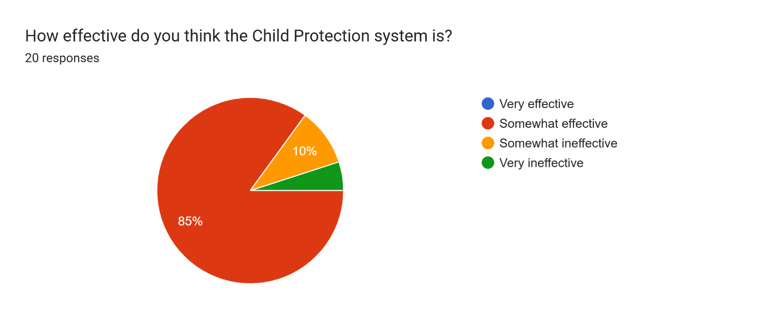
This research suggests that agencies believe that there are improvements to be made regarding the child protection system. Ultimately, there was not a single participant who stated that the system was very effective, therefore suggesting that there is need for development in the system.

4.2 Partner agencies perspectives
The purpose of the questionnaire was to assess the extent to which professionals understood the roles and responsibilities of each other and their knowledge of partner agencies powers when it relates to safeguarding children. The participants provided broadly consistent responses, indicating that they perceived the role of the police in safeguarding children as primarily investigating suspected abuse and the right to exercise powers to remove children from their home, in cases of serious neglect or immediate risk to their safety. Whereas social services have been understood to have an ongoing responsibility for safeguarding following police intervention, including providing support for families and managing risk through the implementation of support plans. Overall, the findings suggest that participants demonstrated a partial understanding of the respective roles of their partner agencies in relation to safeguarding children. Essentially, each agency bears a crucial responsibility to safeguard and protect children. Police officers are expected to undertake a similar role to social services as they all aim to achieve the same objective. Police often collaborate with professionals from the local authority to ensure the safety and welfare of children, specifically in instances involving abuse or neglect (Official Government Website, 2016).

On the other hand, this thesis will argue that the findings suggest a lack of knowledge regarding the roles and responsibilities of key safeguarding agencies. Notably, most frontline police officers who completed the questionnaire expressed the belief that social services have the authority to remove children from neglectful environments. Evidently, this is a common misconception, as social services cannot legally remove a child from their home without either a court order or guardian’s consent (Hopkins Solicitor’s, 2024). Furthermore, all participants who identified as frontline police officers indicated uncertainty or held the belief that social services possessed the authority to remove a child from a neglectful environment. In contrast, every participant acknowledged that the police have the legal authority to enact such a removal. This discrepancy highlights a significant gap in the understanding of the roles and powers of partner agencies. Such misunderstandings may contribute to misplaced expectations and operational inefficiencies, potentially delaying effective safeguarding interventions.

4.3 Improvements to effectively safeguard children
Participants were asked if police are the most appropriate agency to safeguard children, to allow for their views to be expressed. Most participants state that police are efficient when initially responding to incidents and investigating any criminal offences, but social services take primacy in long-term safeguarding of children.
However, participants suggested improvements to effectively safeguard children, the most common improvement being communication between services and understanding each other’s roles. It is suggested by participants that there should be easier pathways for partner agencies to be able to get in contact and for safeguarding officers to be 24/7 to provide guidance to police officers at a scene when they are unsure what the appropriate action is to take, as removing the child is not always the most appropriate action. As discussed, removing a child from a situation they are used to can have a detrimental impact on their mental health and can be a traumatic experience. Therefore, joint training with police and social services would be beneficial to facilitate effective partnership policing (College of Policing, 2023).

4.4 Conclusion
In conclusion, this thesis highlights the limited understanding that partner agencies have of one another’s roles and responsibilities. The findings suggest the need for internal training and guidance to create more efficient partnership policing. Moreover, the research targets the necessity of reviewing the current child protection system, which appears to function with significant inefficiencies. Improvements could be achieved through the implementation of joint workshops, training programmes and shared knowledge at multi-agency collaborations. Without any improvements, it is likely that misconceptions and unrealistic expectations will persist, ultimately undermining the effectiveness of safeguarding practice.

Chapter 5 – Conclusion
5.0 Overall Summary
In conclusion of this dissertation, it is important to return to the research question: What is the Police Force’s role in safeguarding children and how effective is partnership policing to achieve this in the UK? This question has been explored through gathering data, and it is apparent that there is a significant gap in the child protection system. Failings to effectively safeguard children have led to child deaths, and it is also evident that care-experienced children are 33% more likely to become involved in criminal activity, by comparison to their peers who are not care-experienced. Research clearly suggests that partnership policing in the UK does not effectively safeguard children, as information is not consistently, or adequately shared between partner-agencies, which has resulted in significant missed opportunities to effectively safeguard children. Upon gaining views from individuals in the public service sector, it was evident that there was a lack of understanding of one another’s roles, and that partnership working was not effective. Therefore further training and more appropriate joint-working was required.

5.1 Summary of Key Findings
To summarise the relevant data, it is important to return to the objectives of this thesis which are: a) explore the effectiveness of child protection, b) to critically analyse the roles of partner agencies to safeguard children, c) investigate if police are taking on a social services role when dealing with the welfare of children and d) analyse the impact on children when removed from neglectful situations. To begin, this thesis explored the effectiveness of child protection system, identified the failings in the system but also examined how the system had improved over the years. In 1972, a statement was released suggesting that child victims of abuse were encouraged not to voice their experiences, but this has developed over the years to encourage children to come forward to tell their stories. However, literature suggests that when children voice their abuse, they are left to navigate the proceedings alone and no support is offered. Ultimately, this is a failing of the child protection system, as safeguarding of victims who are children is not addressed. As a consequence of this, Semina Halliwell took her own life due to the lack of support, which some researchers claim could have been prevented if safeguarding was sufficiently addressed. Overall, literature suggests that the child protection system needs development to prevent missing opportunities to safeguard children in future circumstances, and to prevent reoccurring failures discussed in the case of Logan Mwangi.

Secondly, the aim to analyse the roles of partner agencies in relation to safeguarding children was examined and literature suggests that each agency has specific roles to effectively safeguard children. Literature and professionals state that the police force’s role when safeguarding children, is to investigate any criminal matters and to hand on the long-term safeguarding plans to social services. Participants of the questionnaire state that police are the most appropriate agency to initially deal with safeguarding children, however any long-term safety plans should be addressed by social services. Literature suggests that the effectiveness of partner agencies responses to safeguarding children entirely depends on their working strategy and how efficiently information is progressed between multi-agencies. Essentially, each agency has a common goal to effectively safeguard children, however they need to work together to be able to achieve this.

Furthermore, the researcher has investigated whether police officers are expected to take on a social services role when addressing safeguarding with children. Although there is limited literature surrounding this topic area, literature does state that police take on a similar role to social services when safeguarding children; as police are held to a standard to investigate criminal offences, but initial responders are also expected to provide initial safeguarding to children at risk. Whereas social services are required to provide the ongoing safety plans with children, whether this is with the family’s involvement or to effectively safeguard and support the children who are in the care system.

Lastly, this thesis analysed the impact on children when they are removed from neglectful situations. The literature surrounding this topic has controversial viewpoints, some literature states that there is a positive impact on those who are removed from the abusive environment as they will no longer be susceptible to harm, therefore reducing further psychological trauma. On the other hand, the National Centre for Social Research (2025) states that children removed from their guardians’ care are 9 times more likely to be subject to death by suicide than those who have never been involved in the care system. Literature also suggests that those who experience the care system are more susceptible to engaging in criminal activity or likely to become victims of exploitation, as they lack a consistent role model. The absence of a dependable role model limits their ability to develop a clear understanding of appropriate conduct. Individuals who participated in the research method, namely a questionnaire, also gave conflicting views on the impact of children when removed from neglectful situations. The consensus was that it is somewhat positive for the child to be removed from the situation, however some participants acknowledged that children may suffer mental harm because of the traumatic experience, therefore, in agreement with the literature surrounding this topic area.

5.2 Unresolved Questions
Although this dissertation has explored various aspects of the child protection system, one key issue remains unresolved. Specifically, in addressing the objective of analysing the roles of partner agencies, it became evident that social services do not possess the legal authority to remove a child from their home without either parental consent or a court order. This raises an important question: Why are such powers not granted to social services? This question remains unanswered, as current research does not offer a definitive explanation. It is unclear why social workers lack emergency removal powers similar to those held by police constables, particularly given that social services are the lead agency for safeguarding children. In light of this, the researcher recommends that a review of social services’ statutory powers be considered, with the aim of enabling them to act independently in safeguarding children where no criminal offences are identified. Additionally, this study highlights a widespread misconception that social workers can remove children from a home without consent of the guardians. This misunderstanding appears to extend to police and other partner agencies, resulting in operational inefficiencies and misplaced criticism towards social services. Primary research revealed that frontline police officers often expressed frustration at the perceived inaction of social services, despite acknowledging a lack of understanding of their actual legal powers. This indicates a need for improved inter-agency education and training, to ensure all safeguarding partners have a clear understanding of each other’s roles and limitations, thereby fostering more effective collaboration.

5.3 Limitations of the study
Although this research has offered insights into the child protection system, it is important to acknowledge several limitations. Firstly, the primary research focused on a limited number of professionals, specifically frontline police officers, social workers, and child protection investigation officers. As a result, the perspectives gathered represent only a small portion of the agencies involved in safeguarding, and the findings may not be fully applicable to other local authorities or further child protection professionals across the UK.
Additionally, the study was subject to time constraints, which limited the opportunity for a more in-depth, long-term analysis. This meant it was not possible to observe how the system evolves over time or to identify any ongoing improvements or persistent issues that might emerge.
Access to data also presented a challenge due to ethical and confidentiality concerns. The researcher was restricted to using publicly available case studies to ensure compliance with data protection regulations. However, this reliance on high-profile cases—many of which focused on system failures—meant the research lacked a balanced view, as positive examples of effective multi-agency collaboration are less likely to receive media attention or be documented in the public domain.
Despite these limitations, the research makes a valuable contribution to understanding both the strengths and weaknesses of the current child protection system in the UK. It also lays the groundwork for further study into how partnership working can be improved to better protect children at risk.

Bibliography.
Ashif, (2025) The tragic case of Logan Mwangi. Available at: The Tragic Case of Logan Mwangi: A Story of Loss and Systemic Failure - Londondays (Accessed on: 30/09/2025)
Baginsky, M et al (2022) Protecting and Safeguarding Children in Schools. Bristol. (Accessed on: 30/09/2025)
Care Learning (2024). What Are Multi-Agency Safeguarding Hubs (MASH)? Available at: What are Multi-Agency Safeguarding Hubs (MASH)? – Care Learning (Accessed on: 30/09/2025)
CHILD PRACTICE REVIEW REPORT (2022) Cwm Taf Morgannwg Safeguarding Board Extended Child Practice Review CHILD T Circumstances resulting in the Review. Available at: Child Practice Review CTMSB 04-2021 Child T Final Report - EMBARGOED (Accessed on: 30/09/2025)
Children’s Commissioner of England (2024) Thousands of child abuse victims forced to navigate criminal justice system without support. Available at: Thousands of child abuse victims forced to navigate criminal justice system without support | Children's Commissioner for England (Accessed on: 30/09/2025)
College of Policing (2023) Partnerships. Available at: Partnerships | College of Policing (Accessed on: 01/10/25)
Early Intervention Foundation (2018). Improving the effectiveness of the child protection system. Available at: Improving the effectiveness of the child protection system: Overview | Early Intervention Foundation (Accessed on: 01/10/25)
Garrett, P.M. (2004) Talking Child Protection. Journal of Social Work. Available at: Talking Child Protection - Paul Michael Garrett, 2004 (Accessed on: 30/09/2025)
Gill, A. (2025). Southport girl’s overdose death not preventable by authorities, coroner concludes. Available at: Southport girl's overdose death not preventable by authorities, coroner concludes - BBC News (Accessed on: 30/09/2025)
GOV et al (2018) Evidence of effective child protection systems in practice. Available at: 400_Evidence_of_Effective_Child_Protection_Systems_in_Practice.pdf (Accessed on: 03/09/2025)
Gov.uk (2014) Children Act 1989. Available at: Children Act 1989 (Accessed on: 03/09/2025)
Hassan, M. (2024) Qualitative Research. Available at: Qualitative Research - Methods, Analysis Types and Guide (Accessed on: 08/09/25)
HM Government (2023) Working Together to Safeguard Children 2023: A guide to multi-agency working to help, protect and promote the welfare of children. Working together to safeguard children 2023: statutory guidance (Accessed on: 30/09/2025)
HM Inspectorate of Probation (2023). Children with care experience. Available at: Children with care experience – HM Inspectorate of Probation (Accessed on: 01/10/2025)
HMIC (2015) In harm’s way: The role of the police in keeping children safe. Available at: in-harms-way.pdf. (Accessed on: 03/09/2025)
Hopkins Solicitors. (2024). Can Social Services remove my child from my care? Available at: Can Social Services remove my child from my care? (Accessed on: 01/10/25)
Huziej, M. (2021). What is the definition of safeguarding children? Available at: Definition of safeguarding children | Six key principles, relevant legislation (Accessed on: 01/10/25)
Lawrie, E. (2025). Semina Halliwell: The funny, kind, 12-year-old who took a fatal overdose. Available at: Semina Halliwell: The funny, kind, 12-year-old who took a fatal overdose - BBC News (Accessed on: 30/09/2025)
Leaf Care (2024) Safeguarding Children: Roles and Responsibilities of Health and Social Care Professionals. Available at: Safeguarding Children: Roles and Responsibilities of Health and Social Care Professionals - Leaf Complex Care (Accessed on: 30/09/2025)
Legallens.org.uk. (2025). The Systemic Failures That Led to the Tragic Death of 12-Year-Old Semina Halliwell. Available at: The Systemic Failures That Led to the Tragic Death of 12-Year-Old Semina Halliwell – Legal Lens (Accessed on: 30/09/2025)
Legislation.gov.uk. (2014). Social Services and Well-Being Act 2014. Available at: Social Services and Well-being (Wales) Act 2014 (Accessed on: 06/10/25)
McLeod, S. (2024) Thematic Analysis. Available at: Thematic Analysis: A Step by Step Guide (Accessed on: 08/09/25)
Munro, E. (2005) Improving practice: Child protection as a systems problem. Children and Youth Services Review. Available at: Improving practice: Child protection as a systems problem - ScienceDirect (Accessed on: 30/09/2025)
Naser, M. (2024) Mandatory Questions in Surveys. Available at: Mandatory Questions In Surveys - SmartSurvey (Accessed on: 08/09/25)
National Association for Children. (2022). The common thread in child removal – neglect not abuse. Available at: The common thread in child removal – neglect not abuse (Accessed on: 30/09/2025).
National Centre for Social Research. (2025). New report reveals long-term outcomes for UK care-experienced children. Available at: New report reveals long-term outcomes for UK care-experienced children | National Centre for Social Research (Accessed on: 01/10/2025)
National Society for the Prevention of Cruelty to Children (2021). Child protection system in the UK. Available at: Child protection system in the UK | NSPCC Learning (Accessed on: 30/09/2025)
NSPCC (2024) Neglect. Available at: Neglect is also Child Abuse: Know All About It | NSPCC (Accessed on: 30/09/2025)
NSPCC Learning. (2025). Children in care (looked after children) Available at: Children in care (looked after children) | NSPCC Learning (Accessed on: 01/10/2025)
Official Government Website (2016) Safeguarding children and vulnerable adults. Available at: Safeguarding children and vulnerable adults (Accessed on: 02/10/25)
Pearson, C. (2022). Systemic failings lead to death of Logan Mwangi. Available at: Systemic failings lead to death of Logan Mwangi (Accessed on: 30/09/2025)
Ponto, J. (2015) Understanding and Evaluating Survey Research. Available at: Understanding and Evaluating Survey Research - PMC (Accessed on: 08/09/25)
Redmond, T. et al (2023) How we can protect the protectors: learning from police officers and staff involved in child sexual abuse and exploitation investigation. Available at: Frontiers | How we can protect the protectors: learning from police officers and staff involved in child sexual abuse and exploitation investigations (Accessed on: 30/09/2025)
Sidebotham, P. et al (2016) Pathways to harm, pathways to protection: a triennial analysis of serious case reviews 2011 to 2014 Final report. Available at: Triennial Analysis of SCRs 2011-2014 - Pathways to harm and protection (Accessed on 30/09/2025)
Singh, S. (2021). Punishing Mothers for Men’s Violence: Failure to Protect Legislation and the Criminalisation of Abused Women. Feminist Legal Studies. Available at: Punishing Mothers for Men’s Violence: Failure to Protect Legislation and the Criminalisation of Abused Women | Feminist Legal Studies (Accessed on: 30/09/2025)
Taylor, L. (2024) What is Quantitative Research? Available at: What is Quantitative Research? Methods and Types with Examples (Accessed on: 08/09/25)
The Murder of Logan Mwangi (2025) ITVX, 4 March. (Accessed on: 04/09/2025)
Thompson, K. (2021). How successful are early interventions in reducing violent crime? Available at: How successful are early interventions in reducing violent crime? – ReviseSociology (Accessed on: 01/10/2025)
West Berkshire Council (2024). What to Expect: Child Protection Investigations. Available at: What to Expect: Child Protection Investigations (Section 47 Enquiries) - West Berkshire Council (Accessed on: 30/09/2025)
Working Together to Safeguard Children (2023) Working together to safeguard children 2023. Available at: Working together to safeguard children 2023: statutory guidance (Accessed on: 06/10/25)

Primary Research – Questionnaire.
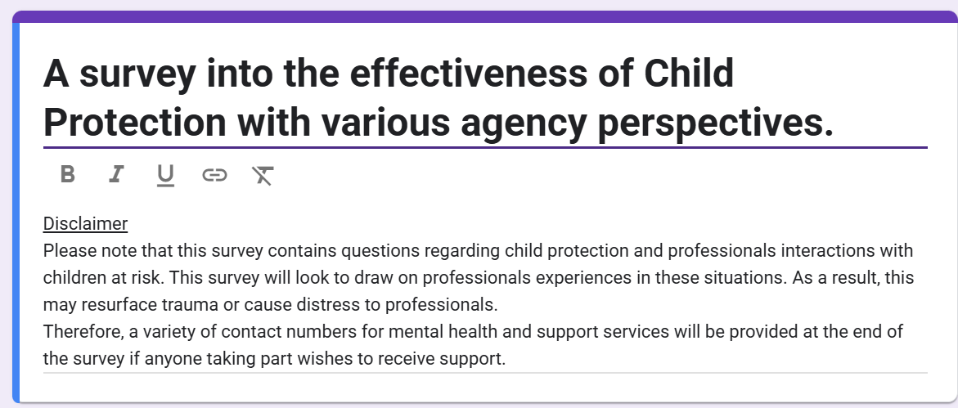

Question 1:
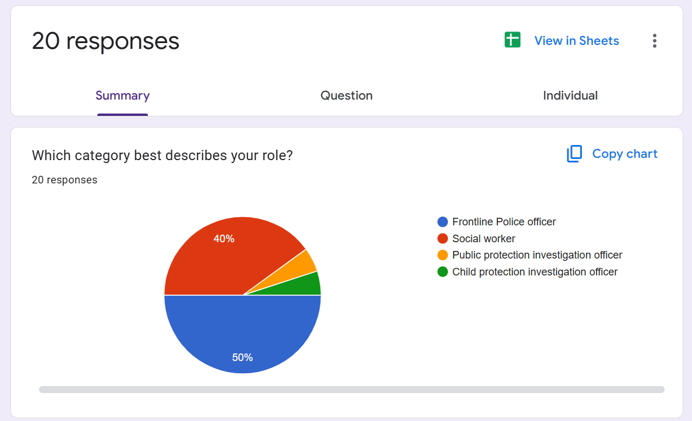

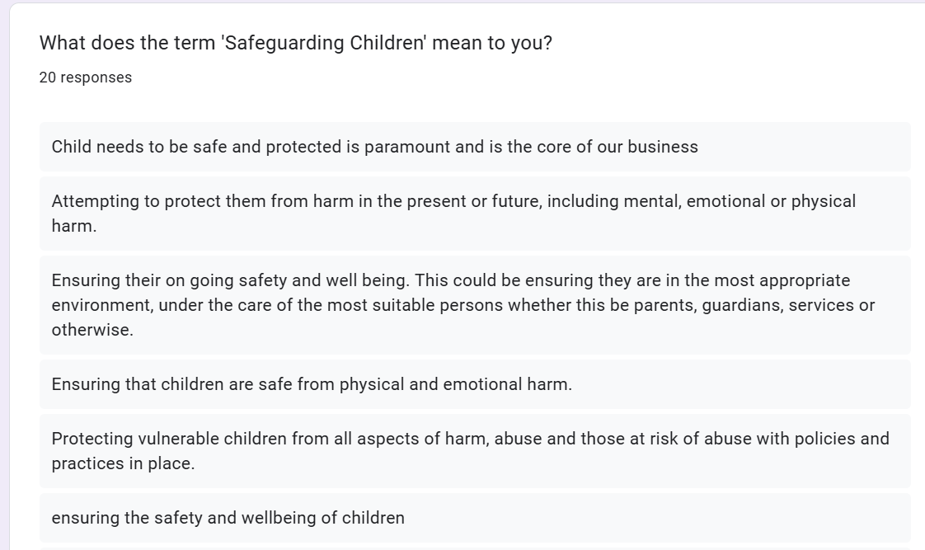
Question 2:

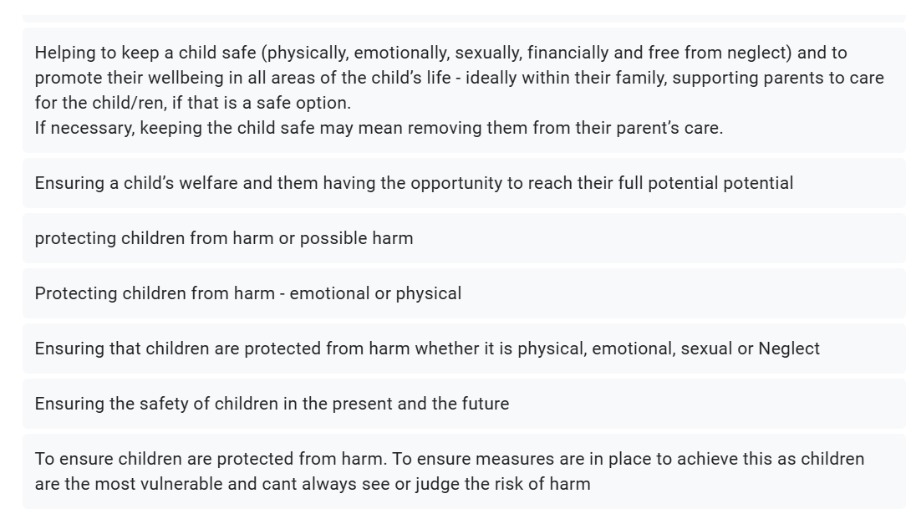

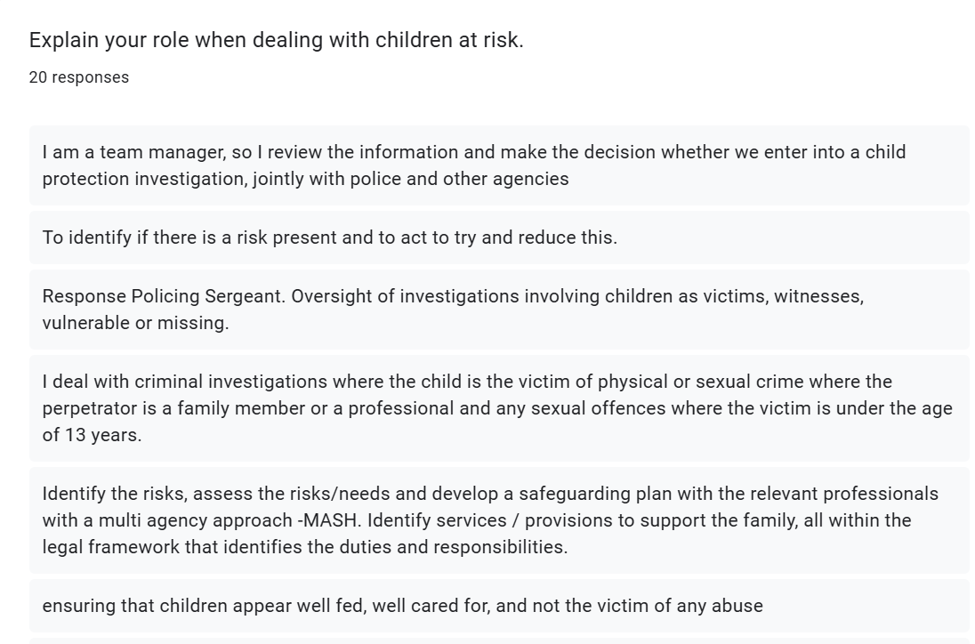
Question 3:

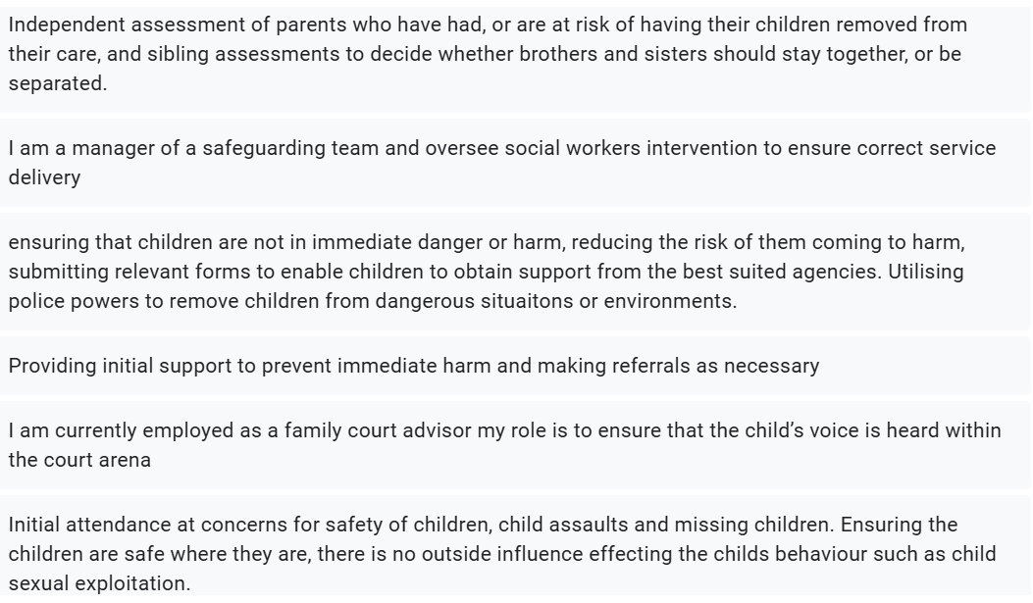

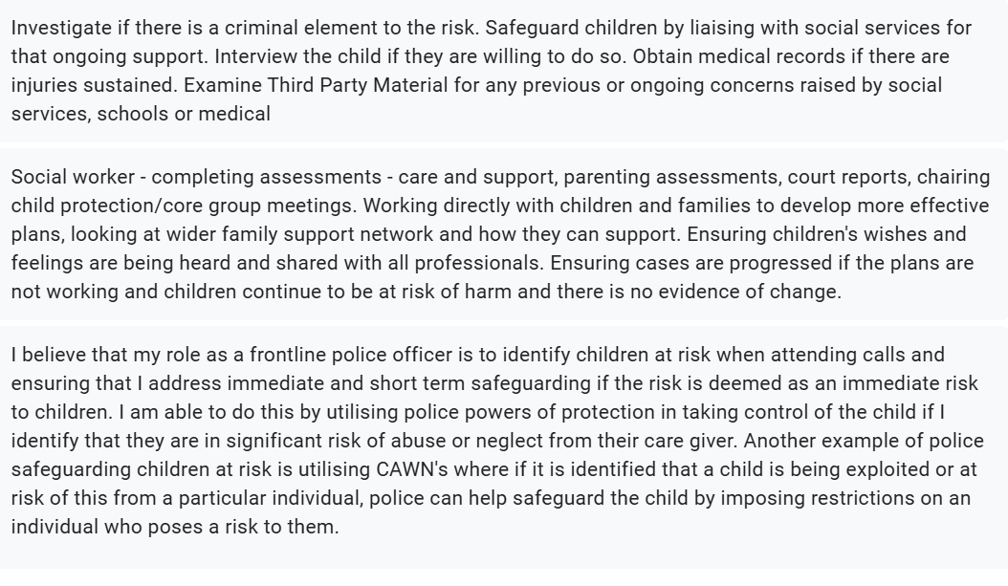

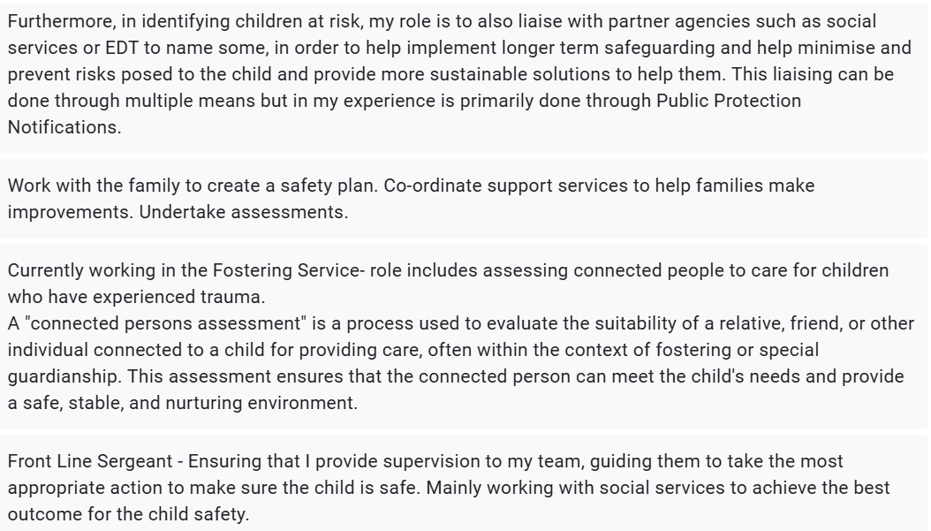

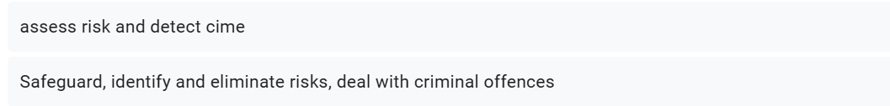

Question 4:
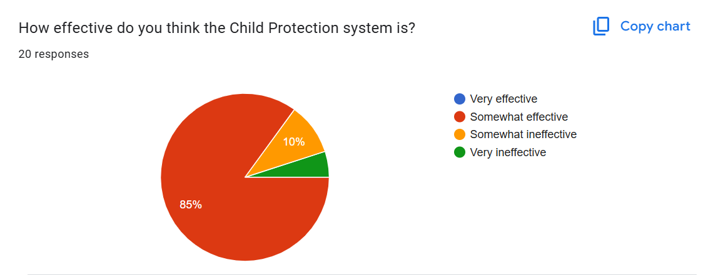

Question 5:
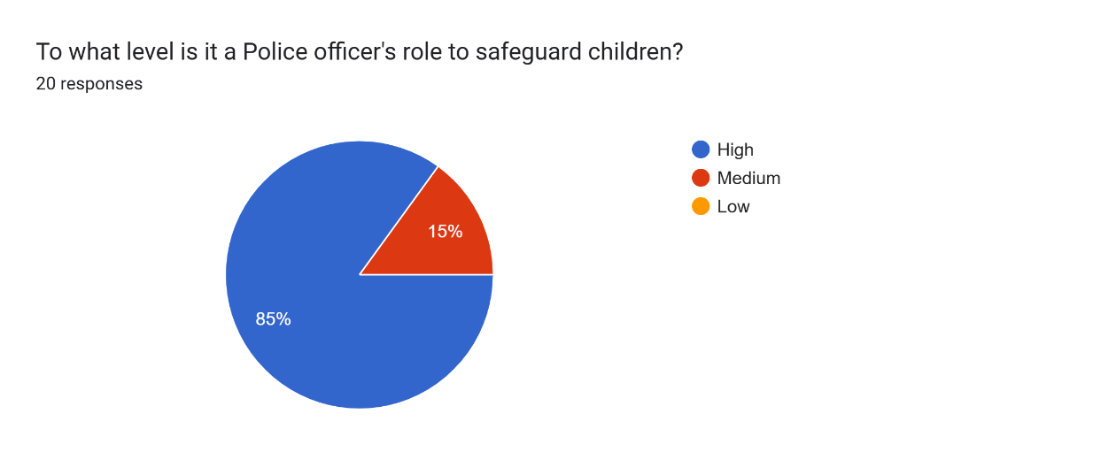

Question 6:
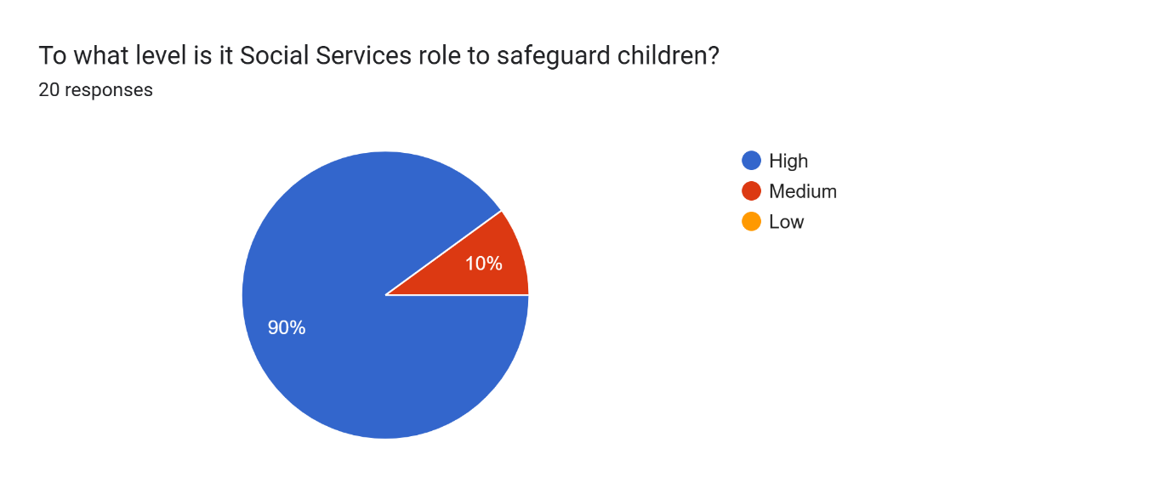
Question 7:
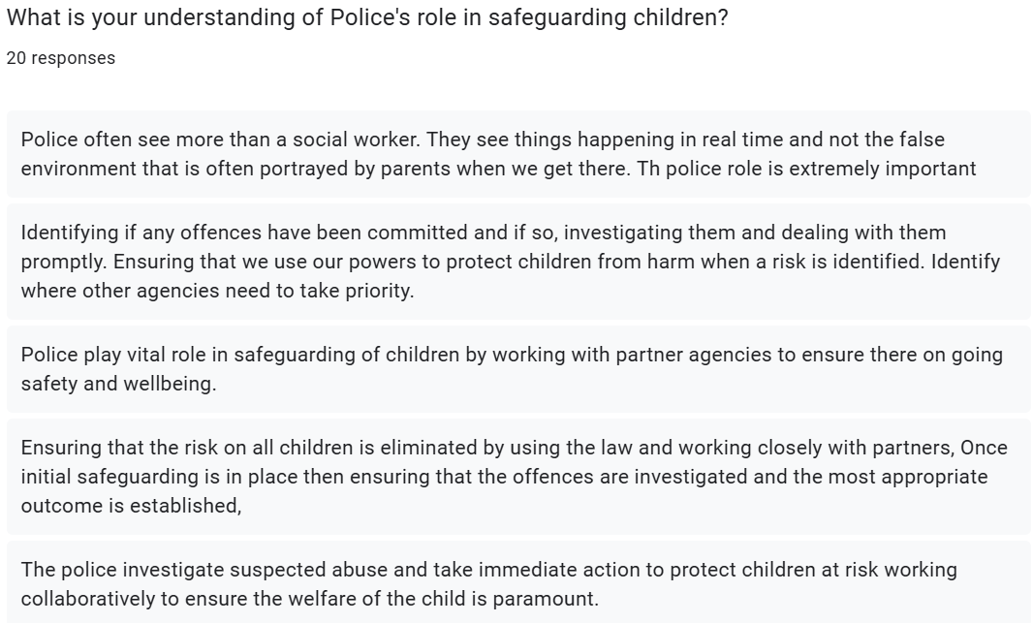
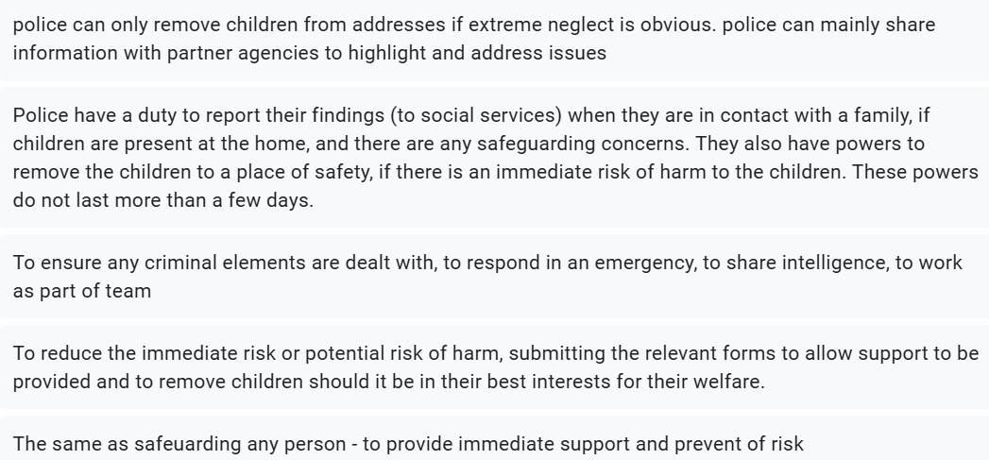
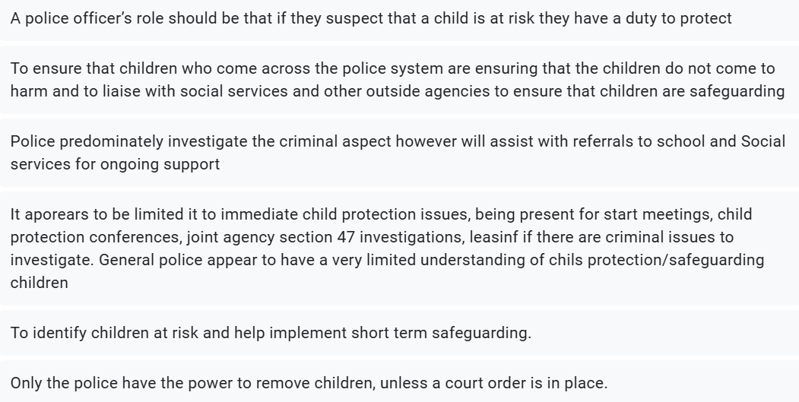
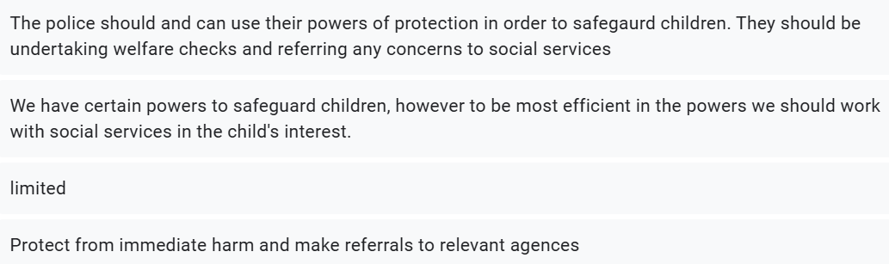

Question 8:
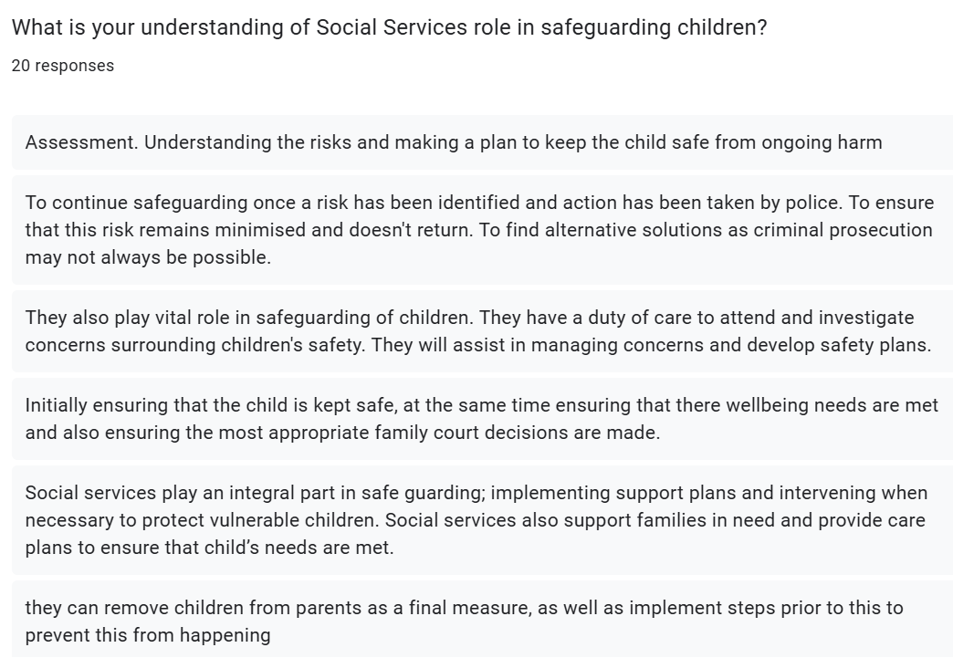
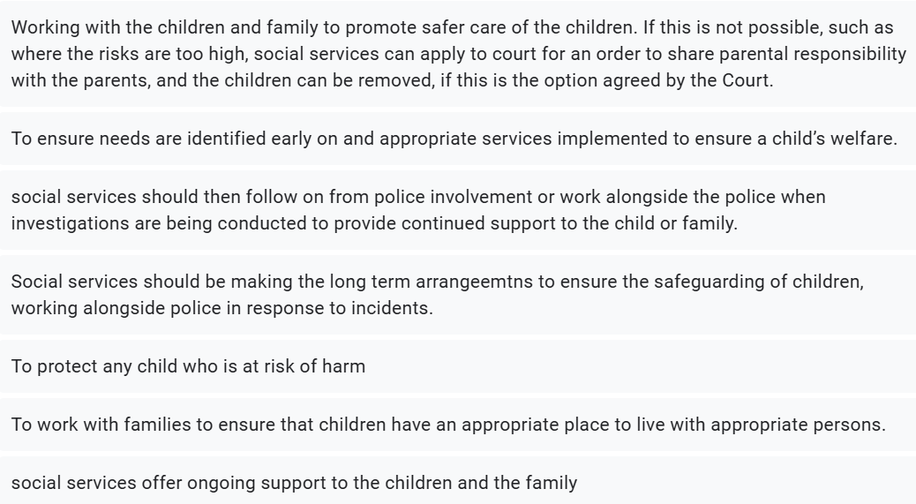
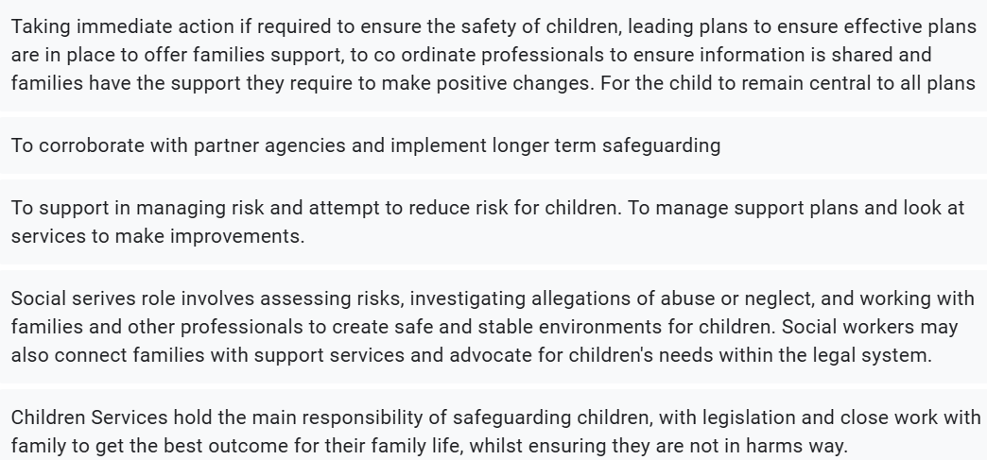


Question 9:
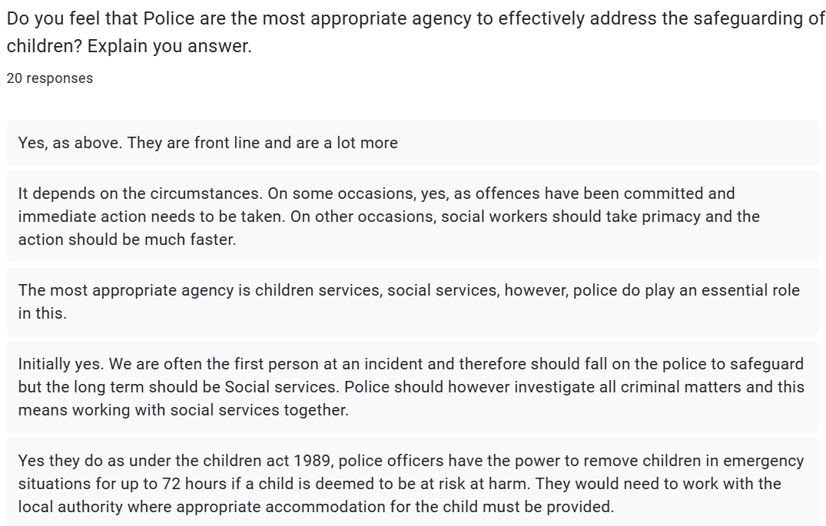
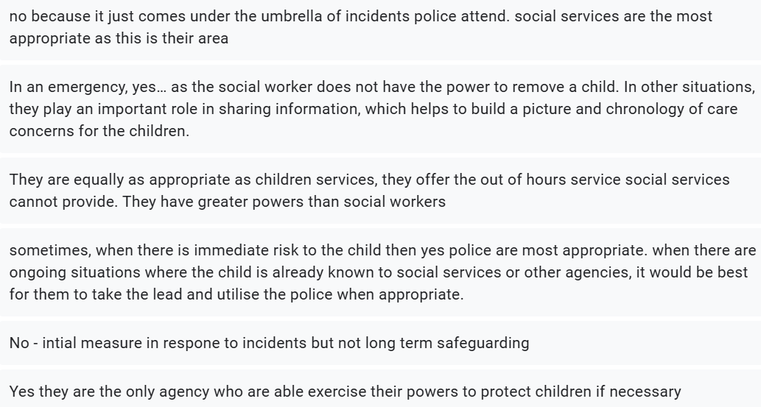
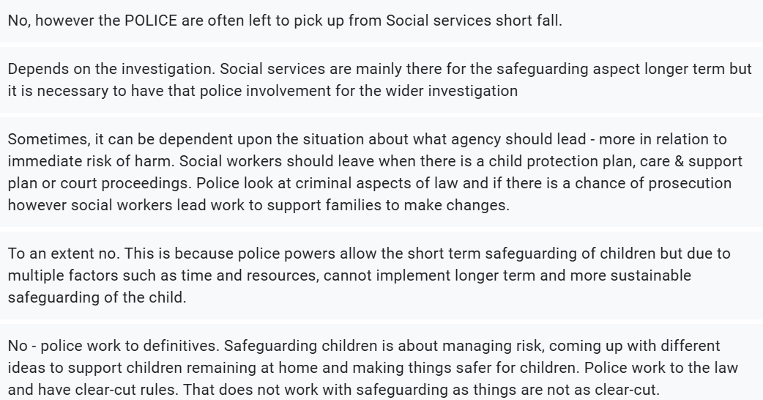
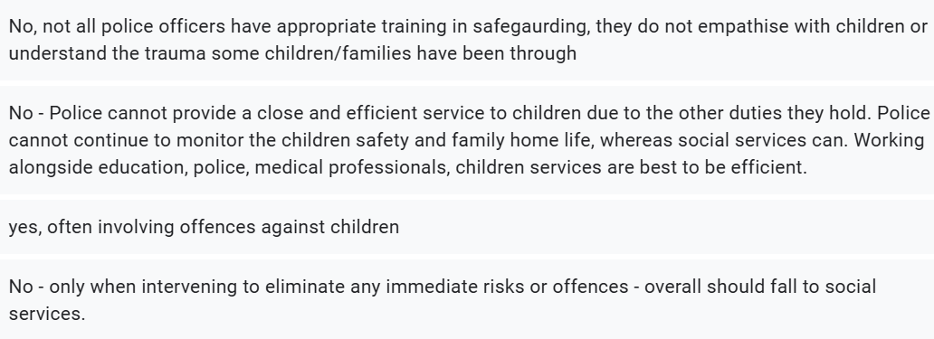

Question 10:
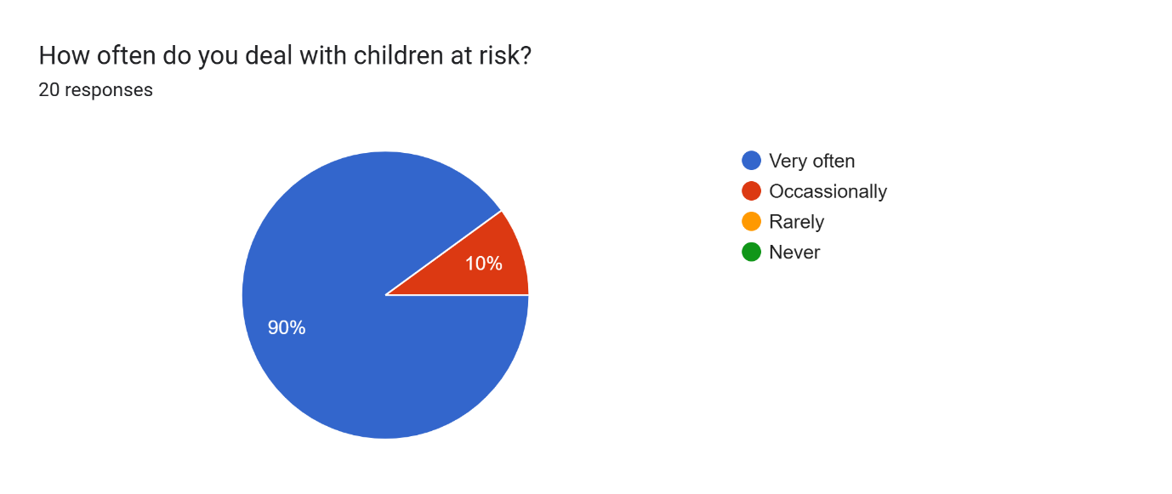

Question 11:
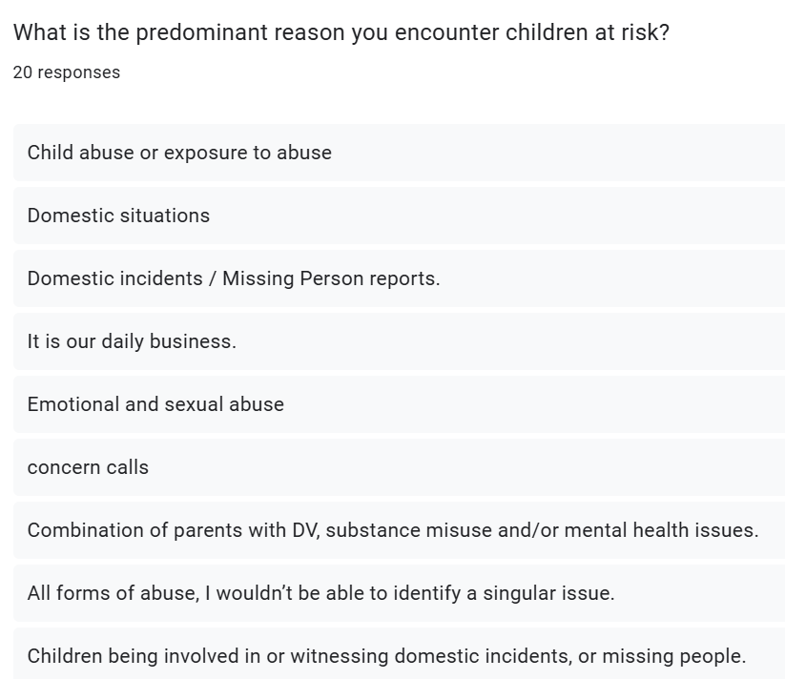
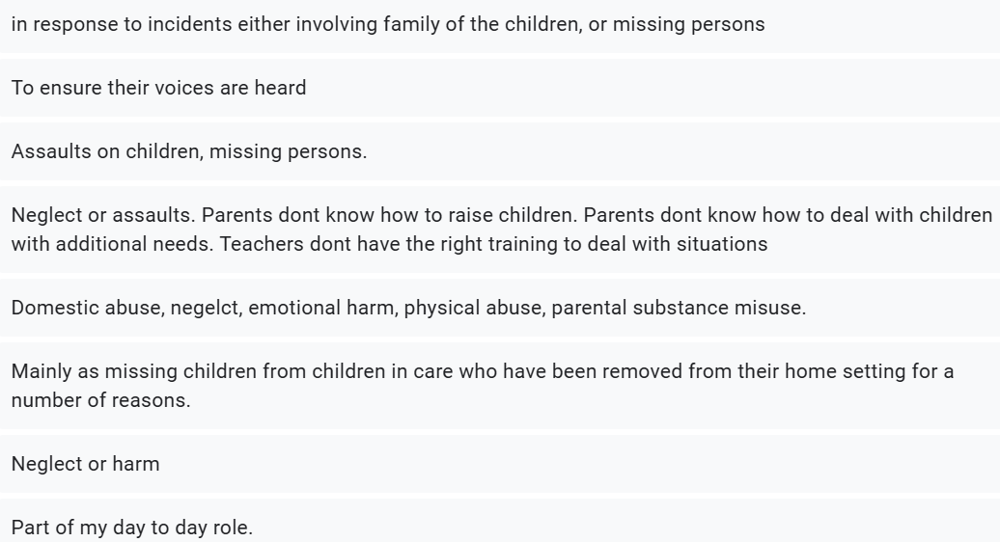
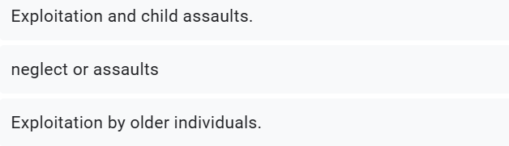

Question 12:
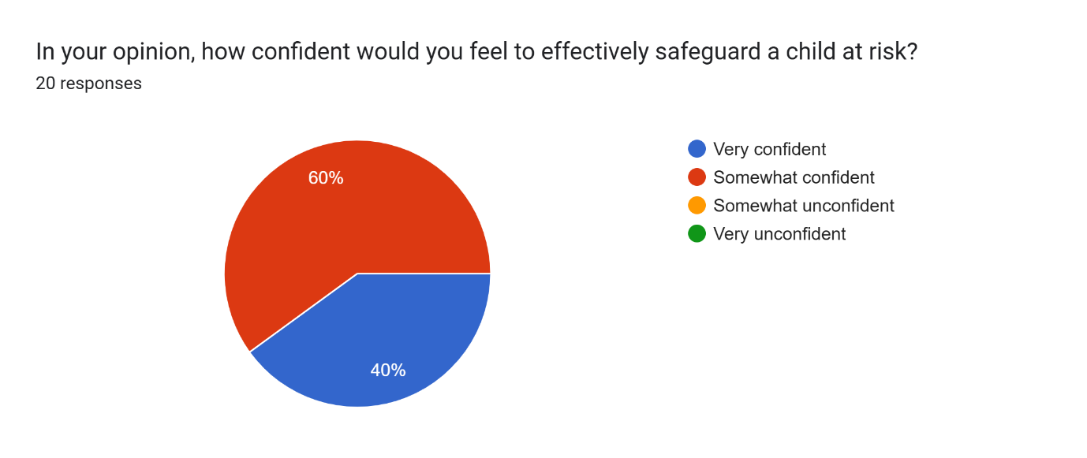

Question 13:
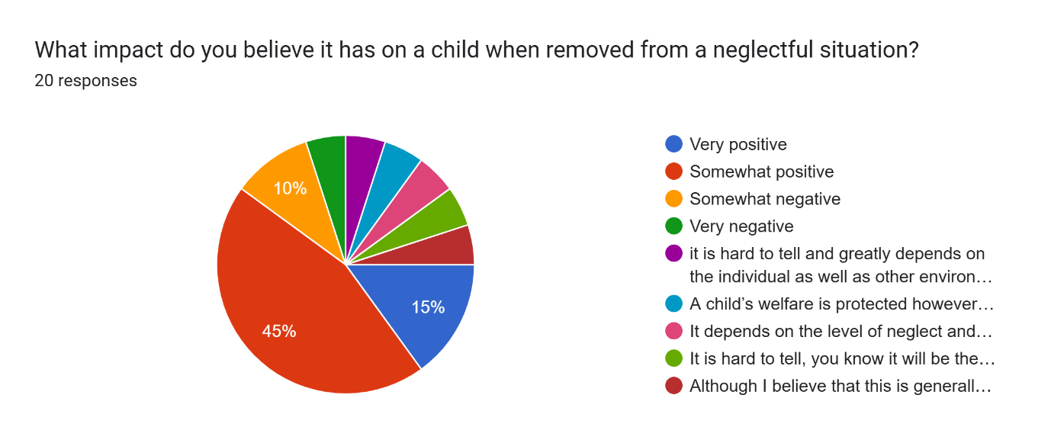
Question 14:
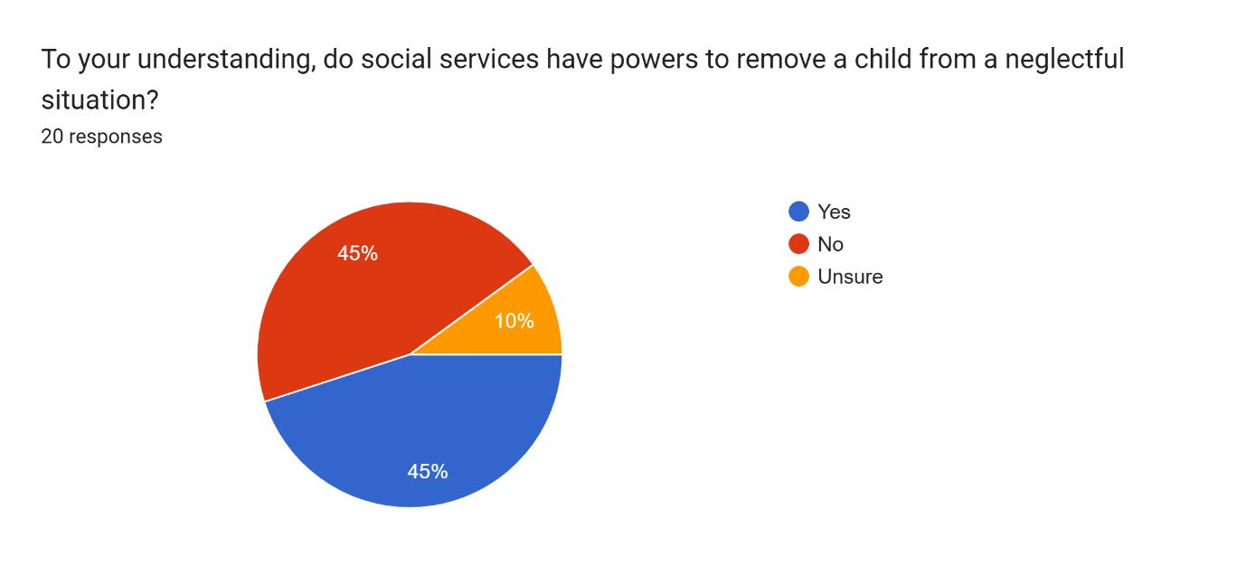
Question 15:
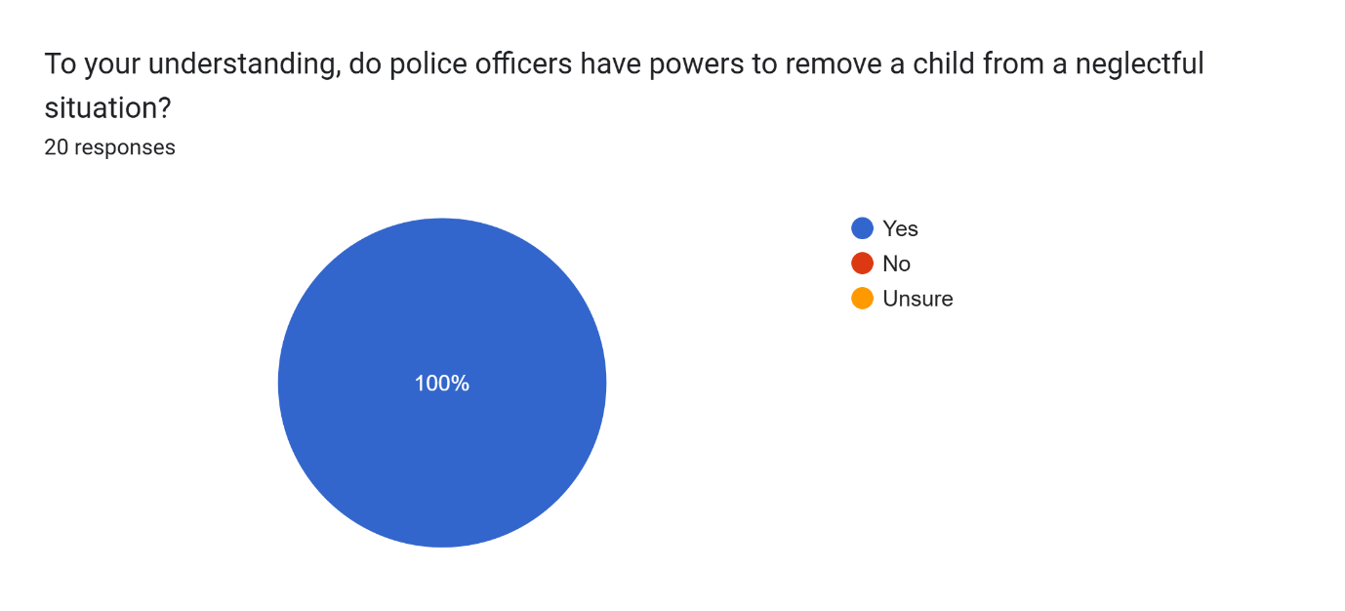Question 16:
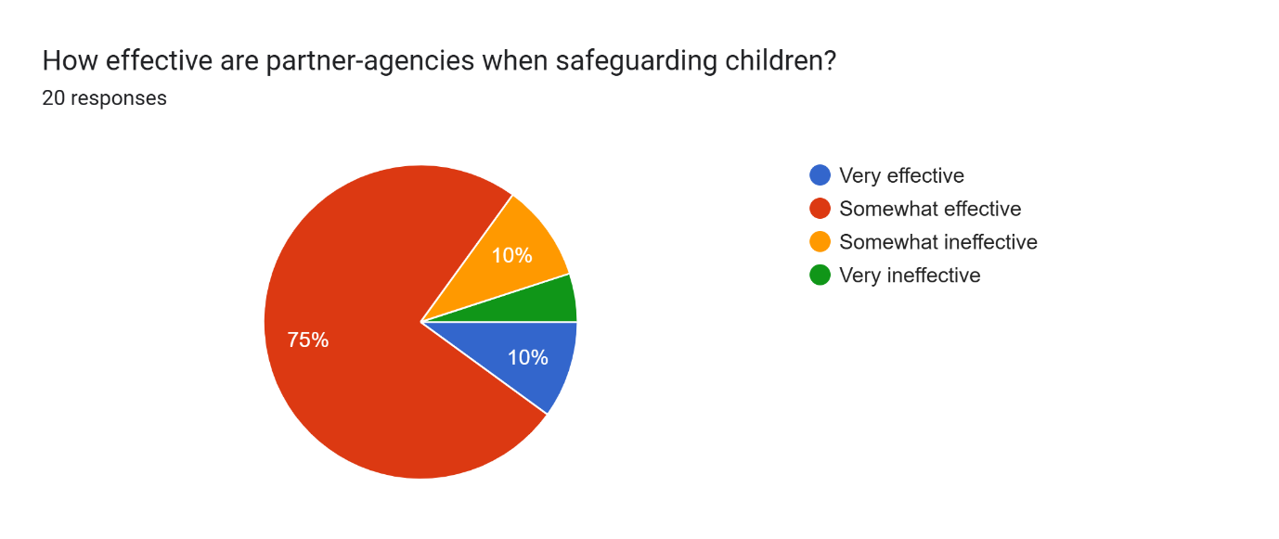

Question 17:
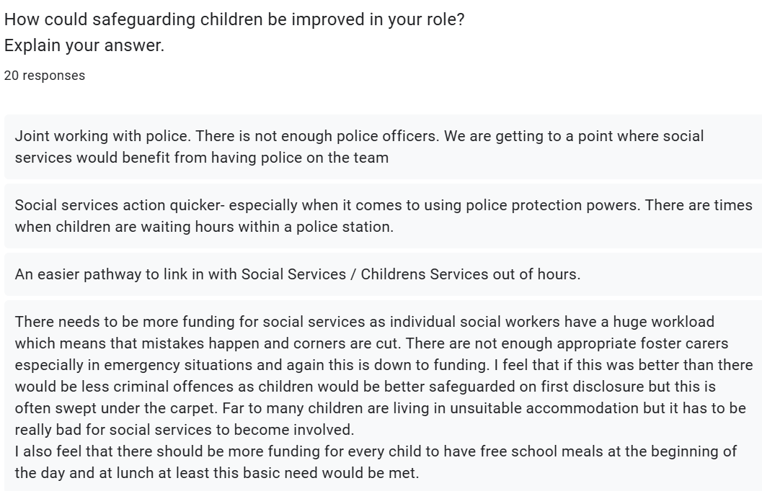
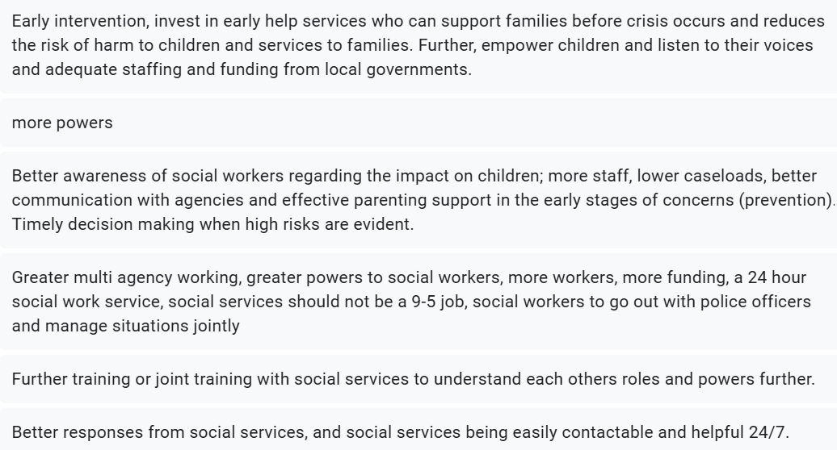
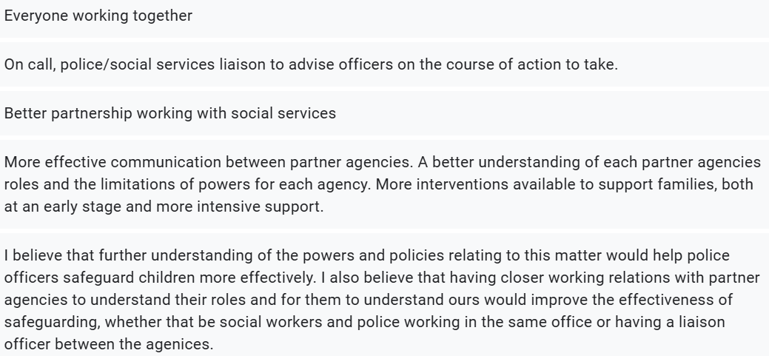

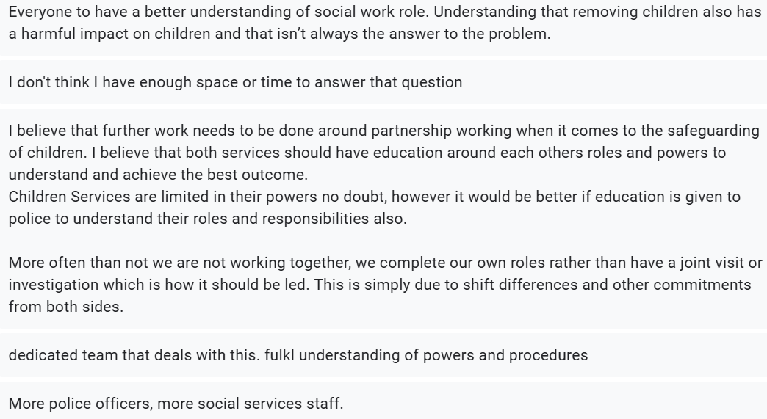

Ethics Form.
APPLICATION FOR ETHICAL APPROVAL

RESEARCH STUDENTS
This form is to be completed by the student within SIX months for full-time students and TWELVE months for part time students, after the commencement of the research degree or following progression to Part Two of your course.

Once complete, submit this form via the MyTSD Doctoral College Portal at (https://mytsd.uwtsd.ac.uk).

This document is also available in Welsh.

RESEARCH STAFF ONLY
All communications relating to this application during its processing must be in writing and emailed to pgresearch@uwtsd.ac.uk , with the title ‘Ethical Approval’ followed by your name.

STUDENTS ON UNDERGRADUATE OR TAUGHT MASTERS PROGRAMMES should submit this form (and receive the outcome) via systems explained to you by the supervisor/module leader.

In order for research to result in benefit and minimise risk of harm, it must be conducted ethically. A researcher may not be covered by the University’s insurance if ethical approval has not been obtained prior to commencement.

The University follows the OECD Frascati manual definition of research activity: “creative work undertaken on a systematic basis in order to increase the stock of knowledge, including knowledge of man, culture and society, and the use of this stock of knowledge to devise new applications”. As such this covers activities undertaken by members of staff, postgraduate research students, and both taught postgraduate and undergraduate students working on dissertations/projects.

The individual undertaking the research activity is known as the “principal researcher”.

Ethical approval is not required for routine audits, performance reviews, quality assurance studies, testing within normal educational requirements, and literary or artistic criticism.

Please read the notes for guidance before completing ALL sections of the form.

This form must be completed and approved prior to undertaking any research activity. Please see Checklist for details of process for different categories of application.

SECTION A: About You (Principal Researcher)
1 | Full Name: |  | Rhian Goldby
2 | Tick all boxes that apply: |  | Member of staff: | ☐ | Honorary research fellow: | ☐
 | Undergraduate Student | ☒ | Taught Postgraduate Student | ☐ | Postgraduate Research Student | ☐

3 | Institute/Academic Discipline/Centre: | University Wales Trinity Saint David
4 | Campus: | Swansea
5 | E-mail address: | 2236212@uwtsd.ac.uk
6 | Contact Telephone Number: | 07577777290
 | For students:
7 | Student Number: | 2236212
8 | Programme of Study: | BSc (Hons) Professional Policing Practice
9 | Director of Studies/Supervisor: | Jane Davies

SECTION B: Approval for Research Activity
1 | Has the research activity received approval in principle?  (please check the Guidance Notes as to the appropriate approval process for different levels of research by different categories of individual) |  | YES | ☒ | NO | ☐
 |  |  |  |  | Date
2 | If Yes, please indicate source of approval (and date where known): Approval in principle must be obtained from the relevant source prior to seeking ethical approval | Research Degrees Committee |  | ☐
2 |  | Institute Research Committee |  | ☐
2 |  | Other (Rhian Goldby) |  | ☒ | 23/02/2025

SECTION C: Internal and External Ethical Guidance Materials
 | Please list the core ethical guidance documents that have been referred to during the completion of this form (including any discipline-specific codes of research ethics, location-specific codes of research ethics, and also any specific ethical guidance relating to the proposed methodology). Please tick to confirm that your research proposal adheres to these codes and guidelines. You may add rows to this table if needed.
1 | UWTSD Research Ethics & Integrity Code of Practice | ☒
2 | UWTSD Research Data Management Policy | ☒
3 | [List any other relevant documents here] | ☐

SECTION D: External Collaborative Research Activity
If there are external collaborators then you should gain consent from the contact persons to share their personal data with the university. If there are no external collaborators then leave this section blank and continue to section E.
1 | Institution
2 | Contact person name
3 | Contact person e-mail address
4 | Is your research externally funded? |  | YES | ☐ | NO |  | ☐
5 | Are you in receipt of a KESS scholarship? |  | YES | ☐ | NO |  | ☐
6 | Are you specifically employed to undertake this research in either a paid or voluntary capacity? | Voluntary | YES | ☐ | NO | ☐
7 |  | Employed | YES | ☐ | NO | ☐
8 | Is the research being undertaken within an existing UWTSD Athrofa Professional Learning Partnership (APLP)? | If YES then the permission question below does not need to be answered. | YES | ☐ | NO |  | ☐
9 | Has permission to undertake the research has been provided by the partner organisation? | (If YES attach copy)  If NO the application cannot continue | YES | ☐ | NO |  | ☐

Where research activity is carried out in collaboration with an external organisation
10 | Does this organisation have its own ethics approval system? | YES | ☐ | NO | ☐
 | If Yes, please attach a copy of any final approval (or interim approval) from the organisation (this may be a copy of an email if appropriate).

SECTION E: Details of Research Activity
1 | Indicative title: | What is the Police Force’s role in safeguarding children and how effective is partnership policing to achieve this?
2 | Proposed start date: | 23/03/2025 | Proposed end date: | 06/10/2025
Introduction to the Research (maximum 300 words per section)
Ensure that you write for a Non-Specialist Audience when outlining your response to the points below:
- Purpose of Research Activity
- Proposed Research Question
- Aims of Research Activity
- Objectives of Research Activity
Demonstrate, briefly, how Existing Research has informed the proposed activity and explain
- What the research activity will add to the body of knowledge
- How it addresses an area of importance.
3 | Purpose of Research Activity  In my personal life I have had experience with children in care and undertaking the role to safeguard them. This has come in the form of fostering two young children who were removed from their home to safeguard them and placed in our care.  Furthermore, from this experience it has inspired my career path to go into child protection due to witnessing the failings of safeguarding children in the first instance. This topic is worthy for an undergraduate dissertation due to the reasons mentioned above as well as the current research and reports which indicate that the current system in place needs to be revised in order to safeguard children more effectively.  On 18th November 2024, the children’s commissioner for the UK government stated, “My new report tells these children’s stories, revealing a stark failure of the children’s social care system”, when referring to children under Deprivation of Liberty orders. (Children’s Commissioner for England, 2024). In addition, a report from HMICFRS in February 2024 heavily criticised the metropolitan police in their interactions and dealings with children at risk of exploitation, as well as missing children (HMICFRS, 2024).  These recent reports demonstrate that there is a need for the revision and restructuring of how police and partner agencies approach safeguarding children as currently there is a large failure resulting in children suffering the effects.  (this box should expand as you type)
4 | Research Question  What is the Police Force’s role in safeguarding children and how effective is partnership policing to achieve this within the UK?  (this box should expand as you type)
5 | Aims of Research Activity  This dissertation will study police forces roles in safeguarding children and the effectiveness of current partnership policing in achieving this. This will be done by looking at the current issues faced by police forces and identifying where the current failings are.  (this box should expand as you type)
6 | Objectives of Research Activity  1. Explore the effectiveness of child protection  2. Analyse the roles of partner agencies to safeguard children  3. Investigate if police are taking on a social services role when dealing with the welfare of children  4. Impact on children when removed from neglectful situations  (this box should expand as you type)
Proposed methods (maximum 600 words)
Provide a brief summary of all the methods that may be used in the research activity, making it clear what specific techniques may be used. If methods other than those listed in this section are deemed appropriate later, additional ethical approval for those methods will be needed. You do not need to justify the methods here, but should instead describe how you intend to collect the data necessary for you to complete your project.
7 | Throughout this dissertation, two main survey methods will be utilised in order to conduct research into this topic. The first being through study and analysis of literature both academic and quantitative data which will be taken from experts and government studies.  This will provide this dissertation with credible sources and evidence for the points made within and the suggestions made to improve police forces effectiveness when safeguarding children. The second method to be used will be a questionnaire that will focus on serving police officers, social workers and other professionals within this field.  This will be to gain an understanding of the current issues faced by frontline staff and to highlight the current knowledge of powers and policies that are possessed by each agency in relation to safeguarding children. These methods of research are best suited to this dissertation as it will allow me to collect primary data from professionals who specialise in safeguarding children whilst has simultaneously analysing this data against the academic research that this dissertation will study.  This study will look at research from the following professions:  Response officers: This dissertation will seek the perspective of frontline officers in order to gain their understanding of powers and policies regarding safeguarding children, their knowledge what it means to safeguard a child and their views on the effectiveness of partnership policing in relation to safeguarding children.  Social workers: This dissertation will seek the perspective of social workers to expand on the viewpoints and experiences of safeguarding children, to not have a police force orientated approach. Furthermore, to allow this dissertation to obtain a partner agency’s perspective on this matter to analyse the effectiveness of multi-agency cooperation in safeguarding children.  Public Protection investigation officers: This dissertation will seek the perspective of investigators in public protection who are officers who specialise in safeguarding children. Therefore, their opinion would be sought as they would be considered experts in this field and their role is the principal of this study. This would allow the dissertation to collect primary data and perspectives from individuals who frequently work alongside partner agencies and the children at risk.  I will contact these agencies directly via email and request for the survey to be disseminated to the teams.  (this box should expand as you type)
Location of research activity
Identify all locations where research activity will take place.
8 | I am currently stationed in Fairwater however I will not limit my research to just this area and I will look to expand my research to South Wales and the rest of the UK for a broader sampling strategy.  (this box should expand as you type)
Research activity outside of the UK
If research activity will take place overseas, you are responsible for ensuring that local ethical considerations are complied with and that the relevant permissions are sought. Specify any local guidelines (e.g. from local professional associations/learned societies/universities) that exist and whether these involve any ethical stipulations beyond those usual in the UK (provide details of any licenses or permissions required). Also specify whether there are any specific ethical issues raised by the local context in which the research activity is taking place, for example, particular cultural and/or legal sensitivities or vulnerabilities of participants. If you live in the country where you will do the research then please state this.
9 | Not applicable  (this box should expand as you type)

10 | Use of documentation not in the public domain: Are any documents NOT publicly available? | NO | ☒
10 |  | YES | ☐
11 | If Yes, please provide details here of how you will gain access to specific documentation that is not in the public domain and that this is in accordance with the current data protection law of the country in question and that of England and Wales.  (this box should expand as you type)

 | Does your research relate to one or more of the seven aims of the Well-being of Future Generations (Wales) Act 2015? | YES | NO
12 | A prosperous Wales | ☐ | ☒
13 | A resilient Wales | ☐ | ☒
14 | A healthier Wales | ☐ | ☒
15 | A more equal Wales | ☐ | ☒
16 | A Wales of cohesive communities | ☐ | ☒
17 | A Wales of vibrant culture and thriving Welsh language | ☐ | ☒
18 | A globally responsible Wales | ☐ | ☒
19 | If YES to any of the above, please give details:
 | (this box should expand as you type)

SECTION F: Scope of Research Activity
 | Will the research activity include: | YES | NO
1 | Use of a questionnaire or similar research instrument? | ☒ | ☐
2 | Use of interviews? | ☐ | ☒
3 | Use of focus groups? | ☐ | ☒
4 | Use of participant diaries? | ☐ | ☒
5 | Use of video or audio recording? | ☐ | ☒
6 | Use of computer-generated log files? | ☐ | ☒
7 | Participant observation with their knowledge? | ☐ | ☒
8 | Participant observation without their knowledge? | ☐ | ☒
9 | Access to personal or confidential information without the participants’ specific consent? | ☐ | ☒
10 | Administration of any questions, test stimuli, presentation that may be experienced as physically, mentally or emotionally harmful / offensive? | ☐ | ☒
11 | Performance of any acts which may cause embarrassment or affect self-esteem? | ☐ | ☒
12 | Investigation of participants involved in illegal activities? | ☐ | ☒
13 | Use of procedures that involve deception? | ☐ | ☒
14 | Administration of any substance, agent or placebo? | ☐ | ☒
15 | Working with live vertebrate animals? | ☐ | ☒
16 | Procedures that may have a negative impact on the environment? | ☐ | ☒
17 | Other primary data collection methods. Please indicate the type of data collection method(s) below. | ☐ | ☒
 | Details of any other primary data collection method:  (this box should expand as you type) | ☐ | ☒
If NO to every question, then the research activity is (ethically) low risk and may be exempt from some of the following sections (please refer to Guidance Notes).

If YES to any question, then no research activity should be undertaken until full ethical approval has been obtained.

SECTION G: Intended Participants
If there are no participants then do not complete this section, but go directly to section H.

 | Who are the intended participants: | YES | NO
1 | Students or staff at the University? | ☒ | ☐
2 | Adults (over the age of 18 and competent to give consent)? | ☒ | ☐
3 | Vulnerable adults? | ☐ | ☒
4 | Children and Young People under the age of 18? (Consent from Parent, Carer or Guardian will be required) | ☐ | ☒
5 | Prisoners? | ☐ | ☒
6 | Young offenders? | ☐ | ☒
7 | Those who could be considered to have a particularly dependent relationship with the investigator or a gatekeeper? | ☐ | ☒
8 | People engaged in illegal activities? | ☐ | ☒
9 | Others. Please indicate the participants below, and specifically any group who may be unable to give consent. | ☒ | ☐
 | Details of any other participant groups:  Social workers and police officers who have worked within the field that this dissertation will form its basis on. This will be done with their consent.  (this box should expand as you type) | ☒ | ☐

Participant numbers and source
Provide an estimate of the expected number of participants. How will you identify participants and how will they be recruited?
10 | How many participants are expected? | 10 social workers  10 PPU staff  20 police officers  (this box should expand as you type)
11 | Who will the participants be? | Social Workers  Police officers  Public protection officers  (this box should expand as you type)
12 | How will you identify the participants? | I will ask colleagues of different levels of experience and service in order to gain a wide sampling framework of the views and opinions of police officers in safeguarding children.  (this box should expand as you type)

 | Information for participants: | YES | NO | N/A
13 | Will you describe the main research procedures to participants in advance, so that they are informed about what to expect? | ☒ | ☐ | ☐
14 | Will you tell participants that their participation is voluntary? | ☒ | ☐ | ☐
15 | Will you obtain written consent for participation? | ☐ | ☐ | ☒
16 | Will you explain to participants that refusal to participate in the research will not affect their treatment or education (if relevant)? | ☐ | ☐ | ☒
17 | If the research is observational, will you ask participants for their consent to being observed? | ☐ | ☐ | ☒
18 | Will you tell participants that they may withdraw from the research at any time and for any reason? | ☐ | ☐ | ☒
19 | With questionnaires, will you give participants the option of omitting questions they do not want to answer? | ☒ | ☐ | ☐
20 | Will you tell participants that their data will be treated with full confidentiality and that, if published, it will not be identifiable as theirs? | ☐ | ☐ | ☒
21 | Will you debrief participants at the end of their participation, in a way appropriate to the type of research undertaken? | ☐ | ☐ | ☒
22 | If NO to any of above questions, please give an explanation
 | (this box should expand as you type)

 | Information for participants: | YES | NO | N/A
24 | Will participants be paid? | ☐ | ☒ | ☐
25 | Is specialist electrical or other equipment to be used with participants? | ☐ | ☒ | ☐
26 | Are there any financial or other interests to the investigator or University arising from this study? | ☐ | ☒ | ☐
27 | Will the research activity involve deliberately misleading participants in any way, or the partial or full concealment of the specific study aims? | ☐ | ☒ | ☐
28 | If YES to any question, please provide full details
 | (this box should expand as you type)

SECTION H: Anticipated Risks

Outline any anticipated risks that may adversely affect any of the participants, the researchers and/or the University, and the steps that will be taken to address them.

If you have completed a full risk assessment (for example as required by a laboratory, or external research collaborator) you may append that to this form.
1 | Full risk assessment completed and appended? |  | Yes | ☐
1 |  |  | No | ☒
2 | Risks to participants  For example: sector-specific health & safety, emotional distress, financial disclosure, physical harm, transfer of personal data, sensitive organisational information
 | Risk to participants:  (this box should expand as you type) | How you will mitigate the risk to participants:  (this box should expand as you type)
3 | If research activity may include sensitive, embarrassing or upsetting topics (e.g. sexual activity, drug use) or issues likely to disclose information requiring further action (e.g. criminal activity), give details of the procedures to deal with these issues, including any support/advice (e.g. helpline numbers) to be offered to participants. Note that where applicable, consent procedures should make it clear that if something potentially or actually illegal is discovered in the course of a project, it may need to be disclosed to the proper authorities
 | (this box should expand as you type)
4 | Risks to the investigator  For example: personal health & safety, physical harm, emotional distress, risk of accusation of harm/impropriety, conflict of interest
 | Risk to the investigator:  (this box should expand as you type) | How you will mitigate the risk to the investigator:  (this box should expand as you type)
5 | University/institutional risks  For example: adverse publicity, financial loss, data protection
 | Risk to the University:  (this box should expand as you type) | How you will mitigate the risk to the University:  (this box should expand as you type)
6 | Environmental risks  For example: accidental spillage of pollutants, damage to local ecosystems
 | Risk to the environment:  (this box should expand as you type) | How you will mitigate the risk to environment:  (this box should expand as you type)

 | Disclosure and Barring Service
 | If the research activity involves children or vulnerable adults, a Disclosure and Barring Service (DBS) certificate must be obtained before any contact with such participants. | YES | NO | N/A
7 | Does your research require you to hold a current DBS Certificate? | ☐ | ☐ | ☒
8 | If YES, please give the certificate number. If the certificate number is not available please write “Pending”; in this case any ethical approval will be subject to providing the appropriate certificate number.

SECTION I: Feedback, Consent and Confidentiality

1 | Feedback  What de-briefing and feedback will be provided to participants, how will this be done and when?
I will inform participants that I will be able to send a link for my final dissertation after it has been marked. This will be for them to review but only after the dissertation has been completed and marked.
I will also invite participants to send them a link for the results or provide a brief for what has been written so they can view the results.

(this box should expand as you type)
2 | Informed consent  Describe the arrangements to inform potential participants, before providing consent, of what is involved in participating. Describe the arrangements for participants to provide full consent before data collection begins. If gaining consent in this way is inappropriate, explain how consent will be obtained and recorded in accordance with prevailing data protection legislation.
At the start of the survey, I will complete a disclaimer that has to be recognised by the participant. This will state that any information they provide will not be shared outside of this dissertation and no personal identifiable information will be asked or required to be filled out.

(this box should expand as you type)
3 | Confidentiality / Anonymity  Set out how anonymity of participants and confidentiality will be ensured in any outputs. If anonymity is not being offered, explain why this is the case.
I will not be looking to acquire their name or any personal identifiable information in this matter and will only be asking for their role as part of my study.

(this box should expand as you type)

SECTION J: Data Protection and Storage

 | Does the research activity involve personal data (as defined by the General Data Protection Regulation 2016 “GDPR” and the Data Protection Act 2018 “DPA”)? | YES | NO
1 | “Personal data” means any information relating to an identified or identifiable natural person (‘data subject’). An identifiable natural person is one who can be identified, directly or indirectly, in particular by reference to an identifier such as a name, an identification number, location data, an online identifier or to one or more factors specific to the physical, physiological, genetic, mental, economic, cultural or social identity of that natural person. Any video or audio recordings of participants is considered to be personal data. | ☐ | X
 | If YES, provide a description of the data and explain why this data needs to be collected:
2 | (this box should expand as you type)
 | Does it involve special category data (as defined by the GDPR)? | YES | NO
3 | “Special category data” means sensitive personal data consisting of information as to the data subjects’ –  (a) racial or ethnic origin,  (b) political opinions,  (c ) religious beliefs or other beliefs of a similar nature,  (d) membership of a trade union (within the meaning of the Trade Union and Labour Relations (Consolidation) Act 1992),  (e) physical or mental health or condition,  (f) sexual life,  (g) genetics,  (h) biometric data (as used for ID purposes), | ☐ | X
 | If YES, provide a description of the special category data and explain why this data needs to be collected:
4 | (this box should expand as you type)

 | Will data from the research activity (collected data, drafts of the thesis, or materials for publication) be stored in any of the following ways? | YES | NO
5 | Manual files (i.e. in paper form)? | ☐ | ☒
6 | University computers? | ☒ | ☐
7 | Private company computers? | ☐ | ☒
8 | Home or other personal computers? | ☒ | ☐
9 | Laptop computers/ CDs/ Portable disk-drives/ memory sticks? | ☒ | ☐
10 | “Cloud” storage or websites? | ☐ | ☒
11 | Other – specify: | ☐ | ☐
12 | For all stored data, explain the measures in place to ensure the security of the data collected, data confidentiality, including details of backup procedures, password protection, encryption, anonymisation and pseudonymisation:
I will be writing my dissertation on my work laptop however will be regularly emailing my dissertation to my personal email for storage.

(this box should expand as you type)

 | Data Protection
 | Will the research activity involve any of the following activities: | YES | NO
13 | Electronic transfer of data in any form? | ☐ | ☒
14 | Sharing of data with others at the University outside of the immediate research team? | ☐ | ☒
15 | Sharing of data with other organisations? | ☐ | ☒
16 | Export of data outside the UK or importing of data from outside the UK? | ☐ | ☒
17 | Use of personal addresses, postcodes, faxes, emails or telephone numbers? | ☐ | ☒
18 | Publication of data that might allow identification of individuals? | ☐ | ☒
19 | Use of data management system? | ☐ | ☒
20 | Data archiving? | ☐ | ☒
21 | If YES to any question, please provide full details, explaining how this will be conducted in accordance with the GDPR and Data Protection Act (2018) (and any international equivalents, where appropriate):
 | (this box should expand as you type)
22 | List all who will have access to the data generated by the research activity:
Just myself and I will hold it in line with Data Protection guidance.

(this box should expand as you type)
23 | List who will have control of, and act as custodian(s) for, data generated by the research activity:
Just myself and I will hold it in line with Data Protection guidance.

(this box should expand as you type)
24 | Give details of data storage arrangements, including security measures in place to protect the data, where data will be stored, how long for, and in what form. Will data be archived – if so how and if not why not.
Any data that I do collect I will maintain until the completion of my dissertation as I will not have any need to retain this information after this. I will keep it secured on my laptop device which only I have access to and is password protected.

(this box should expand as you type)
25 | Please indicate if your data will be stored in the UWTSD Research Data Repository (see https://researchdata.uwtsd.ac.uk/ ). If so please explain. (Most relevant to academic staff)
Not applicable

(this box should expand as you type)
26 | Confirm that you have read the UWTSD guidance on data management (see https://www.uwtsd.ac.uk/library/research-data-management/) | YES | ☒
27 | Confirm that you are aware that you need to keep all data until after your research has completed or the end of your funding | YES | ☒

SECTION K: Declaration
The information which I have provided is correct and complete to the best of my knowledge. I have attempted to identify any risks and issues related to the research activity and acknowledge my obligations and the rights of the participants.

In submitting this application I hereby confirm that I undertake to ensure that the above named research activity will meet the University’s Research Ethics and Integrity Code of Practice which is published on the website: https://www.uwtsd.ac.uk/research/research-ethics/
1 | Signature of applicant: | Rhian Goldby | Date: 24/02/2025

For STUDENT Submissions:
2 | Director of Studies/Supervisor: |  | Date:
3 | Signature: |  | Date:

For STAFF Submissions:
4 | Academic Director/ Assistant Dean: |  | Date:
5 | Signature: |  | Date:

Checklist: Please complete the checklist below to ensure that you have completed the form according to the guidelines and attached any required documentation:
☒ | I have read the guidance notes supplied before completing the form.
☒ | I have completed ALL RELEVANT sections of the form in full.
☒ | I confirm that the research activity has received approval in principle
☐ | I have attached a copy of final/interim approval from external organisation (where appropriate)
☐ | I have attached a full risk assessment (where appropriate) ONLY TICK IF YOU HAVE ATTACHED A FULL RISK ASSESSMENT
☒ | I understand that it is my responsibility to ensure that the above named research activity will meet the University’s Research Ethics and Integrity Code of Practice.
☒ | I understand that before commencing data collection all documents aimed at respondents (including information sheets, consent forms, questionnaires, interview schedules etc.) must be confirmed by the DoS/Supervisor, module tutor or Academic Director.

RESEARCH STUDENTS ONLY
Once complete, submit this form via the MyTSD Doctoral College Portal at (https://mytsd.uwtsd.ac.uk).

RESEARCH STAFF ONLY
All communications relating to this application during its processing must be in writing and emailed to pgresearch@uwtsd.ac.uk , with the title ‘Ethical Approval’ followed by your name.

STUDENTS ON UNDERGRADUATE OR TAUGHT MASTERS PROGRAMMES should submit this form (and receive the outcome) via systems explained to you by the supervisor/module leader.

