
University of Wales Trinity Saint David

Assignment 2 – Flicker & Flame’s Handmade Candles
Business plan

Module Name: Entrepreneurship
Module Code: LCBB5001

Student Name: Pavlinka Todorova Veleva
Student Number: 2028165

Lecturer Name: Nishi M Ramsurrun
Date: 07.12.2022

Table of Contents

Business description 3
Industry analysis 4
Threat of new entry 4
Threat of substitutes 4
Bargaining power of customers 5
Bargaining power of suppliers 5
Competitive Rivalry 5
Operations and Management Team 6
Operations 6
Management team 8
Marketing 8
Product 9
Price 10
Promotion. 11
Place 12
Financials 13
Source of funds 13
Use of funds 13
Research Methods 14
References 16

Business description

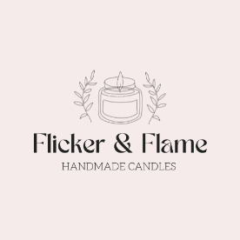
Flicker & Flame’s Handmade Candles is a new business, aiming to launch from 2023, it is owned and operated by Pavlinka Veleva as a Sole Proprietorship. This legal status is the most commonly used, most inexpensive and it does not need to be registered as a business entity. Also, the owner is the person who has full control over the business and decisions. Another advantage is that the profit is earned as personal income, so the owner does not have to pay any special income taxes. However, there are disadvantages as well such as the owner having to perform all the activities through the business and having to rely on their own resource of funding. If the company has a failure, the owner has the liability for it. (KHANNA, 2020) The firm is operating online through website.
The company produces and sells scented candles with a traditional, collaborated, and festive scents, and also Personalized candles – client’s preferences with different colors, sizes, and containers. Flicker & Flame is using coconut wax and cotton wicks. The container choice is dependent on the color and scent. Unlike to our competitors we are trying to use only eco materials no matter is that going to affect the end price– we prefer quality than quantity.
The mission of Flicker & Flame is simple – “No matter what happens, always love yourself and your life”. We stopped on this statement after passing through the Covid-19 Pandemic. The company wants to put a note of relief in rushed people’s world with our coconut wax scented candles. We want to remind our customers that they are doing well and to stop for a moment to find peace in its soul. Our hand-poured and well-scented candles bring a sense of comfort and a warm feeling into clients' lifetimes. (Carpenter, 2017)
Flicker and Flame aim to improve people’s quality of life – in terms of sleep, relieve stress, put a romantic note in the interior, or just a small help for meditation and relaxation. Another main priority for the firm is to expand its market and deliveries up to Europe, also the company intends to develop stronger relationships with more suppliers.
Our target market includes both – commercial (restaurants, bars, and hotels) and household sectors – men and women between 30-50 years. The study says that men prefer to buy a candle with stronger scent, dark color with a solid container and women are attracted to gentle scents with glass containers. Also, younger auditory prefers to buy a candle online, while older prefers the tangible experience before buying. (Balen, 2022).

Industry analysis

In 1990 Michael E. Porter has created his model called Porter’s Five Forces which identifies and analyzes five competitive forces. This analysis can help the companies to determine the industry’s structure, the level of competition, weaknesses, and strengths of it. The model is most frequently used to fix a corporate strategy and to enhance company’s long-term profitability. (Mahesh P Bhaskar, 2019)

Threat of new entry – Moderate to high is the component which should be evaluated to prevent company’s risk. As the threat is considered every new company which appears on the market or an already existing one.
As a new company, Flicker&Flame is faced with a moderate level of threats in the candle industry, because of the low level of entry, not much-specialized knowledge required, and low R & D expenses. Also, we are not too well-known name on the market, because of our new appearing in the industry market.

Valuable | Rarerity | Inimitable | Organized
X | Not really – but it is customized | X | Democratic type of leadership

Threat of substitutes –Relatively high is the component which shows the availability of similar to us product, which can be bought from another brand for less amount.
Nowadays, in the candle industry, there are many competitors striving to hold the same high level of quality as ours, but they try to offer a lower price to attract the customers. That makes our work more difficult and faces a threat for us. We have to pay attention to produce the most efficient product in order to succeed. If we do not allow the customers to switch to the new industry players, they will be out of the market as a result of paying high costs without making any profit. To prevent our customers to switch off to other candle store and producers, we improved loyalty scheme and create a customer relationship management (CRM) where our customers journey is analyzed from the moment they initiate interest in our products – personal accounts which store bonus points made after a purchase. Also, we made sure that we keep our business on track by constantly developing new ventures, which are based on customers' preferences and reviews.

Bargaining power of customers – medium level has the component which shows the pressure from customers on the business in terms of quality, price, and better customer service.
The customer’s power is medium because there are a lot of candle companies, so the customer can choose which one suits it perfectly. Our professionalism and the customer service we offer to make people feel close to their preferences, so it is more likely to choose us instead of our competitors. On other hand, switching costs are very low and candles are not an essential product, however since we are nearing to Christmas, candles could be a gift idea, hence reaching out to meet customer demand and satisfaction will help the company sustain for a competitive business advantage.

Bargaining power of suppliers – High level has the component which refer to how much pressure can supplier put on the companies by raising their prices or even lower their quality, by the restrictions of raw materials they can provide and the accessibility of where the supplier is located.
The Bargaining power of suppliers for the company is high, because Wax Company’s, packaging’s, transportation’s price constantly is going up due to inflation. If we have to switch to another supplier because of some reason, it will cost a lot for the company which will impact our production, quality, and the price. Thus, the company is dependent on one supplier – Wax CO.

Competitive Rivalry

This table shows the intensity of competition between the companies in candle making industry:

Name of competitor | Differentiation
Yankee Candles | What can impress a customer more than an outsider looking at the first second? – The beauty of the hand decorated jars. We superior Yankee’s Candles with creativity.
Jo Malone | We superior Jo Malone’s candles with a cheaper price, but the same quality.
Diptyque Candles | Based on reviews from Google on their official website, we superior Diptyque Candles with better quality customer service – our primary purpose is to communicate with the buyers through the whole process and after that to take their feedback.

Operations and Management Team

Operations – a wide range of activities used in day-to-day operations or in long-time period to run the company with the purpose of earning money. It is also called the transformation some input into output, having a certain quality level. (N. Suresh, 2009)
The operation of making candles is a fun DIY project, which satisfies with its process and mainly the end result. The supply and equipment which we are using for candle-making process contain:
- Candle-making Coconut wax;
- Cotton wicks;
- Fragrance oil (depends on what scent is the order);
- Silicone spatula;
- Staines steel container;
- Thermometer;
- Stove/ Hot plate;
- Wick holder;
- Container/jar;
Our official supplier is Wax CO Company, which is England based company for candles wax, wicks, and oils.
The production place is having an address: 20 Neville Road, London, E7 9QX.
Because of our online shop, we cannot sell the candles directly to the customers. The postage of the end product is usually made through the local Post Office. The postage is included in the price and all we need is the customer’s address. We inform our buyers that the delivery will be made in the next 3-4 working days.

The candle business process involves the following steps:
- Step 1 – Clean the surface which you are going to use and cover it with a newspaper or towel to make sure you will keep it clear.
- Step 2 – Measure the right amount wax – fill the container with wax, then double it. This will give you the exact amount of wax.
- Step 3 – Melting Process – put the wax into the stainless-steel container on the hob. Leave it around 10-15 minutes, stirring frequently.
- Step 4 – Put scent – once your wax is ready put a few drops of the fragrance oil, depending how strength you want to be.
- Step 5 – Attach the wick – stick the wick for the container’s bottom.
- Step 6 – Look at the wax’s temperature, once gets 140℃ pour it slowly into the jar and leave a little bit wax for later to fill the jar up.
- Step 7 – Secure the wick with the wick holder to prevent swaying into the wax.
- Step 8 – Leave the candle around four hours on room temperature and cut the wick.

Generating revenue:
Our mission is to generate revenue by selling new and innovative scented candles different from our competitor’s. The product range is wide and constantly developed.
We genuinely believe that the Economy of scale is a benefit for our revenue by reducing the average cost of production. The total cost will increase as well as our output, hence our revenue. That will help to satisfy of customer’s preference for a price, but still the same quality. (Lipsey, 2000)
To emphasize on customer relationship management, we endeavor to provide AI support therefore our website provides 24/7 customer service chat, allowing our customers to ask their questions at any time of the day, whether it is after working hours or after it. People prefer this Artificial intelligence, because of the immediately respond. Also, we believe that the chat can be more productivity than one person who is staying all day on the phone.
Selling products through our friends and family’s recommendation is taking an important part of our promotion company. We are able to expand our business growing from sustainable growth

Prevent loss:

We are trying to develop Lean Management through our company which will help us to our future improvements and Eliminating the waste – sometimes an order could be cancelled, so we have the idea to double-melt the wax and use it for other order, which will cut our cost of waste.
We are removing all the intermediates, who are buying our product and after that sell it more expensive, because our brand is one and unique, we put the price, we produce the candles, no one else cannot do it.

Management team

Name | Skills | What do they bring to the firm
Strategical level – CEO – Pavlinka Veleva | Time management, managing people, researched-based steps and learning skill | Prioritizing the steps through Eisenhower Matrix, supporting the staff, constantly exploring the newest trends.
Tactical level – Marketing and Advertisement – Maria Etova | Selling skill, Communication skill, Detail-oriented, Customer service skill | Ability to understand the market, sell the right products on the right place, hence increasing the revenue, Manage the team, looking at all the opportunities, Satisfying the customers by answering their questions.
Operation level – General Production –Alexandrina Marinova | Dedication to the process, Company loyalty, Responsibility, Organized | Day to day operations such as accepting the goods from the supplier, unpacking, candles making, posting the orders, placing a new orders to the supplier.

Marketing

The marketing mix, also called Four P's is an analysis that helps companies to develop effective strategies in order to business growth, especially when the products are new for the business. This analysis makes a brighter understanding of the customer’s demand and needs. The classification was launched in 1960 by E. Jerome McCarthy - a marketing professor and author. For the analysis, each component – Product, Price, Promotion, and Plane can be examined independently, but in real-life situations, they are going altogether. Every company strives to have better 4Ps composition, which basically leads to high customer satisfaction. (BAKER, 2003)

Product – the offered products of our company are Handmade Scented Candles in many different sizes such as 50ml, 150ml and 250ml; colors such as red, blue, and white; containers such as jars, tins, and bubble cubes; and many lost-lasting scents: traditional fragrance such as Vanilla, Lavender, Sandalwood and more; collaborated scents such as Sandalwood/Rose, Lemon/Peppermint, Mint/Lavender and more; and many festive scents for example for Halloween – Pumpkin Spice, Christmas – Cinnamon and Personalized candles – client’s preferences with different colors, sizes, and containers. Candles are commonly used in household as a part of the interior for making cozy, romantic and relieved environment as well as in the commercial market.
We try to attract our customers with bio-coconut wax, cotton wicks, differentiated and modern scents, and especially hand-decorated jars. Flicker & Flame is using high-quality coconut wax, which can hold the aroma 50% longer than the paraffin one and burns slower and cotton wick which guarantees a clear burn and throws 35% more fragrance into the room.
We rely on our customer’s feedback because many of our collaborations in mixed scents are inspired by their preferences and desires. Flicker&Flame also think that the customers are the moving power in the company’s growing.
The candles of Flicker&Flame are individually wrapped with three layers – first tissue, second paper, and third bubble wrap. This protection is needed to isolate the candle of any outside smells. Once this is done it is time for the box made from eco-friendly materials, tailored with the size of the jar, container, or the tin.
Here are some of our products from the Christmas section, which we expect to be the most frequently bought candles in December

Hand-designed Christmas jars:
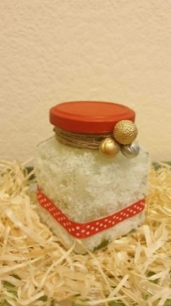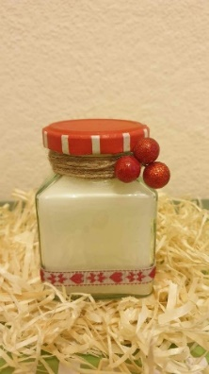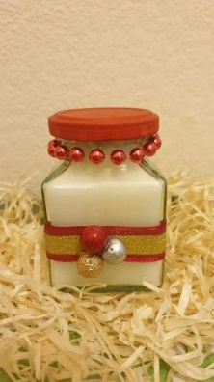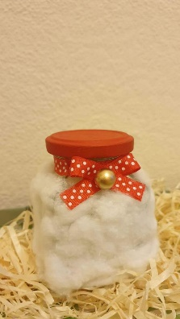

Small and Medium tins with scented wax and Bubble Scented cube:
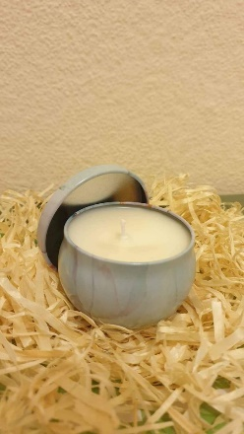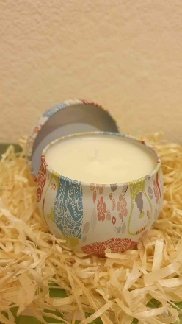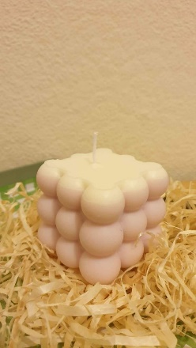

Price – the price is linked with the amount which customers are ready to pay, perceived value, target market, supply cost, seasonal discounts, and competitor’s price. In order to calculate the end price per unit, we stopped on three things –supplies, equipment, and bills.
Each candle to be produced will cost 7,40£ total cost: 3£ for raw materials, 0,40£ for packaging, 0,40£ for delivery, and 3,60£ for fixed cost such as rent, bills and monthly loan payment.
Our market price will be from 14,99£ for candles in tin, 19,99£ for bubble candles, up to 24,99£ for hand-decorated candles, in terms of the size, is it colorful or not, is there one or more scents and is it decorated by hand. We expect profit of approximately 10£ per item.
Our target market is businesses and households – men and women in 30-50 age group. We believe that they are willing to spend this amount of money for candle, based on our survey (see research point).
Our company use the 99p psychological pricing strategy – an strategy used to encourage our clients to think on emotional level rather than a logical one. The strategy is illusion for the customers – they are most likely to buy product priced 14,99£ than 15,00£, that is because they are focused on the big domination rather than the smaller one. This trick is also known such as ‘oldest retail trade’. (Rao, 2009)
Second model which we also use is price skimming - we set higher prices in our introductory period to capitalize on sales and to maximize profit. As the business expand its sizes, the product price will drop down.
The last model used is bundle pricing – allow us to sell cheaper a few products together, also we put small gift to attract our clients. This helps us to remove old candles and to raise customer’s value perception.

Promotion – marketing event with a purpose of direct impact on the behaviour of the firm’s customer. (Robert C. Blattberg, 2010) The core element in promotion for our firm is to communicate with the customer to make sure that they need our candles and also they are priced appropriated. The factor ‘Promotion’ reaches our audience online with advertising and sales promotion.

Advertising – form of paid communication between the firm and the customer. We believe that advertising is the best form to engage potential clients and to maintain a good level in the marketing environment. We use different social media platforms such as:

- Facebook – along with pictures, this is the platform for making giveaways to our customers, which help us to build brand awareness and gain new followers. This media gives us the youngest audience – students.

- Instagram – We are doing beautiful pictures of our candles and post it on this platform to interact the customers. Also, for all of our truly fans we put a videos Behind-the-scenes of our working process to increase their curiosity and faithfulness to the brand.
- Pinterest – one of the largest platforms for finding home interior – absolutely our distinction and the pillar in the marketing strategy.
- Etsy – another fast-growing platform for maker merchant and DIY hustlers.
Our website:
www. Flicker&Flame.com
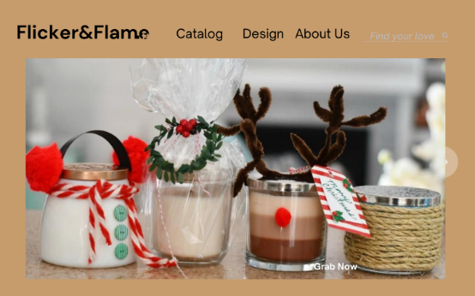

Sales promotion – short term sales, appropriate for brand switchers. Sales promotions are focused to grab the attention of the new clients and rewarding our existing ones.
We expect to make most revenue before the biggest holidays such as Eastern, Halloween and Christmas, thus mean this time at the year is the most suitable for maintaining good advertising and sales promotion.
We are ready to give a 10% discount for everyone’s first purchase, free postage for orders over 50£ and 15% off the end price for everyone who bring their friend in our website as a customer. Also, there are some of our bigger limited offers.



Place – Putting the product in different platforms will help us to promote it and reach bigger amount of people, who are willing to buy. Among with the pictures, we put the best advantage of our candles which attract our clients and cover their expectations. Our products will be available online in different platforms:
- Website – www.Flicker&Flame.com - ( not currently operational);
- Market place in Facebook;
- Instagram;
- Etsy;
We are trying to ensure the three aspects of availability:
- The right place – availability of all our products at all the time in all platforms;
- The right time – The period before Christmas when candle-lovers are seeking for a gift is the perfect when we have the chance to reach bigger profit.
- The right quality – we are looking for full satisfying our customers with exclusive eco-materials and high quality wax and wicks.
Our business uses Direct Chanel of Distribution - Exclusive Distribution – we sell directly to the customers; we manage our own logistic system and resources. The firm is focused on building customers loyalty through different elements of the brand.
Seasonal hit – Before Christmas form 10-15 of December we will offer our candles in the Covent Market, London.

Financials

Source of funds – for the starting of my business, I needed 15,000£. I brought money from three places:
- Personal investment – I put 5,000£ investment in my business. These money were my savings for the last year.
- Love money – My family lend me 5,000£ to help me to make my dream true. They do not have any interest on it. Their own rule is to give them back, once my business passed through the tough period at the beginning (a year after I started, or even more).
- Government loan – I applied for 5,000£ start-up loan from the government. After I have done the business plan, I sent it to the government, they approved my request and paid me the amount with a 6% interest rate. The plan is this loan to be repaid in eleven months, because of the interest I have to repay around 5,300£ - ten monthly payments of 500£ and one payment of 300£.

Use of funds

 | Month 1 | Month 2 | Month 3 | Month 4 | Month 5 | Month 6
Revenue | 5,000£ | 7,500£ | 7,500£ | 7,000£ | 7,000£ | 8,000£
Fixed Costs | Rent – 300£  Salary – 2,000£  Loan repayment – 500£  Total: 2800£ | Rent – 300£  Salary – 2,000£  Loan repayment – 500£  Total: 2800£ | Rent – 300£  Salary – 2,000£  Loan repayment – 500£  Total: 2800£ | Rent – 300£  Salary – 2,000£  Loan repayment – 500£  Total: 2800£ | Rent – 300£  Salary – 2,000£  Loan repayment – 500£  Total: 2800£ | Rent – 300£  Salary – 2,000£  Loan repayment – 500£  Total: 2800£
Variable Costs | Raw materials – 750£  Packaging – 100£  Delivery cost – 100£  Bills – 100£  Total: 1,050£ | Raw materials – 900£  Packaging – 120£  Delivery cost – 130£  Bills – 150£  Total: 1,300£ | Raw materials – 900£  Packaging – 120£  Delivery cost – 130£  Bills – 150£  Total: 1,300£ | Raw materials – 820£  Packaging – 110£  Delivery cost – 120£  Bills – 140£  Total: 1,190£ | Raw materials – 820£  Packaging – 110£  Delivery cost – 120£  Bills – 140£  Total: 1,190£ | Raw materials – 1,000£  Packaging – 140£  Delivery cost – 160£  Bills – 170£  Total: 1,470£
Profit | 1,150£ | 3,400£ | 3,400£ | 3,010£ | 3,010£ | 3,730£

Research Methods

To better understand the market, I have done research within the class with a six-question survey. That helped me to collect and analyze data for people’s behavior, product preferences, and industry trends. This questionnaire helped us to plan our strategies for production in the future – steps that will save us additional costs and risks. The target group was men and women between 20 and 50.
People who took part of the survey were three men and eight women.
Here is the template of the survey:

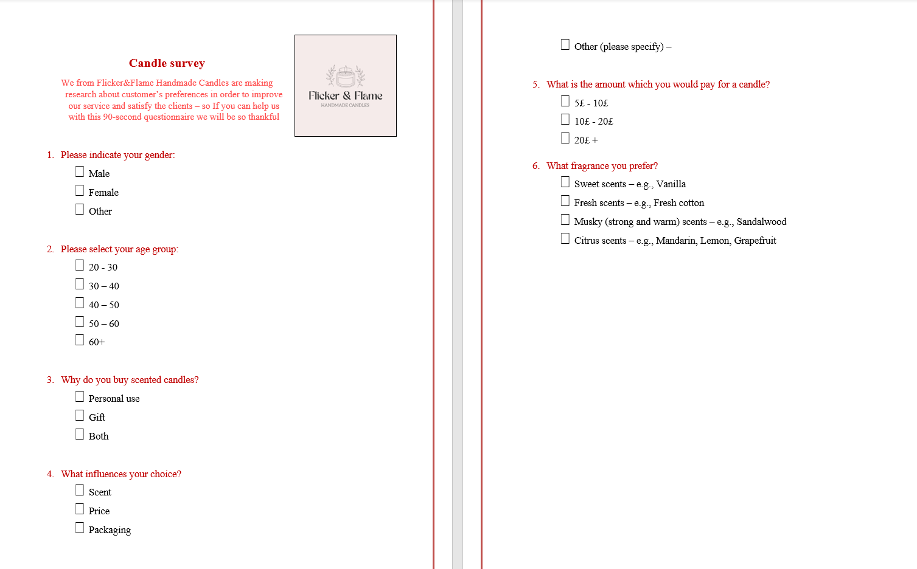

Here is the result:
Our survey says the Male group between 30-40 years prefers to buy candles for gifts and personal use, but the choice is mainly influenced by the scent. They would spend 20£+ on a candle with a Musky scent – strong and warm.
The survey says Female group between 20-40 years prefer to buy candles for gift and personal use, but the choice is mainly influenced by the scent and the price – 4 of 8 would spend around 5-10£ per candle, the other 4 would spend 10-20£ per candle with Sweet or Fresh Scent.
Based on the questionnaire men are willing to pay higher prices for strong-scented candles and women are willing to pay a bit less for fresh and sweet-scented candles.
The tendency shows that people getting more influenced by the price due to the inflation problems nowadays.
Learned lesson: we have to use the best scents along with the good price.

References

BAKER, M. J. (2003). The Marketing Book. Oxford: Butterworth-Heinemann.
Balen, L. (2022, 01 27). The Target Market for Candles: Who Buys and Why! Retrieved from Amplifyxl: https://amplifyxl.com/target-market-for-candles/
Bruce R. Barringer, R. D. (2019). Entrepreneurship. Successfully launching new ventures, 6th edition. Harlow: © Pearson Education Limited.
Carpenter, S. (2017). Art of Candle Making Business startup. Newport: Valencia Publishing House.
Justin G. Longenecker, C. W. (2008). Small Business Managament, Launching and Growing Entrepreneurial Ventures. Mason: The Thomson Corporation.
KHANNA, R. (2020). FASTSTART Your Business. Quebek: RONIKA KHANNA.
Lipsey, R. G. (2000). ECONOMIES OF SCALE IN THEORY AND PRACTICE. Vancuver: Simon Fraser University.
Mahesh P Bhaskar, S. P. (2019). JARDCS - Porter's Five Forces Model. International Journal of Physics, 14.
N. Suresh, S. A. (2009). Operations Management. New Delhi: New Age International (P) Ltd.
Norman M. Scarborough, J. R. (Essex). Essentials of Entrepreneurship and Small Business Management, 8th Edition. 2016: Pearson Education Limited.
Rao, V. R. (2009). Handbook of Pricing Research in. Cheltenham: Edward Elgar Publishing Limited.
Robert C. Blattberg, R. B. (2010). SALES PROMOTIO. Oxford: Oxford University Press.

