Research, build, and deploy a Virtualised Enterprise network
Aleksandr Badger
University of Wales, Trinity Saint David
Swansea, Wales
2308404@student.uwtsd.ac.uk

Table of Contents
Task 1 3
Hypervisor 3
Type 1 & Type 2 Hypervisor’s 3
IP Addressing 4
Routing 6
Network Services 7
Task 2 8
Hypervisor 8
Windows Server and Client 9
Linux Server and Client 11
Mixed 13
Task 3 16
Deployment and Testing 16
Personal Reflection 17

Task 1

Hypervisor

Type 1 & Type 2 Hypervisor’s
A type 1 hypervisor can directly operate and have access to the system resources, running directly on the host system or “bare metal”, and can allocate resources to virtual machines (VMs) without additional privileges, one example of a type 1 hypervisor is Proxmox [1][2].
A type 2 hypervisor will be installed on top of an operating system as an application and relies on the OS to access hardware resources and admin need, one example of a type 2 hypervisor is Oracle VirtualBox [1][2].
Due to the topology and their minimal services at this point in time, a type 2 hypervisor will suffice. This will be easier to setup due to only needing a software on an OS, the topology also requires very few resources to operate, with a maximum of 13gb of memory and 120gb of storage, which is a comparatively small amount and can still allow for more devices to be added, therefore system resources and performance isn’t an issue.
Furthermore, due to there being two Windows and Debian devices, there are few varying operating systems, both of which are compatible with the same hardware and hypervisor. While a type 1 hypervisor can do this, it is more appropriate to use on a large-scale setup with varying operating systems and more advanced security needs, when compared to a type 2 hypervisor. A type 1 hypervisor also requires more advanced knowledge due to being essentially its own OS, whereas even a non-technical person can use a type 2 hypervisor.

IP Addressing
IP Addressing assigns each device on a network with a unique identifier, this allows routers and switches to send and receive packets from and to the intended device. Without this, switches and routers wouldn’t be able to correctly send the data where it is needed [3][4].
There are two type of IP address’, there are IPv4 addresses and IPv6 addresses. An IPv4 address is a 32-bit number that is written in a dotted decimal form for human readability such as 192.168.0.1, each number being four bytes [3][4].
The network portion of an address is managed by the subnet mask, which can allow for more devices on a single network and is usually identified by a /24 (or intended size) by an address, and can look like this 255.255.255.0 (this indicates the unique identifier for this machine is the last octet. This is called subnetting[3].
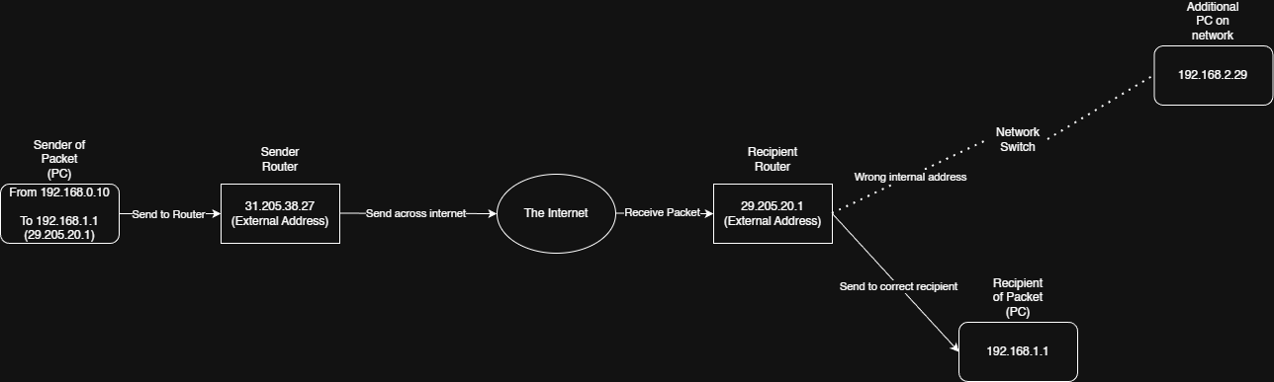
Figure 1: Network Diagram Topology Example
Subnetting separates an IP address into smaller networks by adjusting the length of the network portion, which allows for more use of the limited IPv4 spaces. This can also be used to create smaller, separate subnets on the same network, which can be useful when needing to isolate devices, such as a guest network for visitors and a private network for internal users.
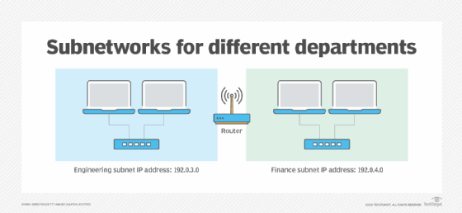
Figure 2: TechTarget Subnetting Diagram [5]
An IPv6 address uses a 128-bit hexadecimal number, as this allows for far more address spacing and hierarchical addressing, such as 3001:0da8:75a3:0000:0000:8a2e:0370:7334. Theses addresses are more common when large scale systems are needed, such as the global internet (external networks) as there are limited IPv4 addresses, however internal networks still use IPv4 as they are only limited to the number of devices locally [4].

Routing
Routing is the network layer process that controls how data packets are forwarded between different networks. Routing protocols allow routers to make forwarding decisions by using a routing table that maps the destination addresses on the network, these may contain information such as IP addresses, MAC addresses and more. These are maintained either via manual configuration or through automated protocol exchanges, that can adapt to the network. Routers control how network traffic moves between segments, therefore accurate routing is necessary for peak performance and reachability across networks [6].
Static routing is where manually configured routes are used, this allows for predictability and security, as only known/accepted devices are added, however this means that it does not respond automatically to any changes in the network, which makes it unsuitable for a large scale or constantly changing network, but acceptable for small scale topologies where control and simplicity are more emphasized [7].
Dynamic routing is where routing protocols exchange routing information automatically, this allows routers to rediscover networks and devices when a failure occurs, this helps improve scalability, as devices are automatically assigned and added, and creates down-time protection as it can reconfigure itself, however this is at the cost of network complexity and potential security risks [7].
For the topology’s setup, a static route would be better. This is due to the small network size, with manually assigned IP addresses. Furthermore, the static routing will ensure consistent connectivity between Debian and Windows Servers and their respective clients, this allows for a more secure, simple network, which is exactly what this topology needs [7][8].

Network Services
A VPN is a virtual private network, which provides secure and encrypted communications across the internet by mimicking another network. VPN’s protect data by encapsulating and protecting packets by using methods such as encrypted tunneling, which often use the IPSec and SSL/TLS protocols, to allow site-to-site and remote-access connectivity. Best practices for VPN usage include strong encryption algorithms, monitoring network traffic and using zero-trust architecture [9].
The Dynamic Host Configuration Protocol (DHCP) allows for a server or router to automatically assign an IP address, subnet masks, default gateways and DNS servers, to any connecting devices. This allows for reduced IP address conflicts and supports scalability. Best practices for DHCP include using a relay agent which allows for one single DHCP server across large networks and documenting reasoning for address allocation and their addresses [9][10].
Active Directory Domain Services (AD DS) unifies authentication, authorisation and management of users across a domain. Useful features of AD are the management of security groups, which allows you to create and assign permissions for a necessary group, group policy enforcement, which allows all users to have the same policies applied automatically to devices and centralized user management i.e. user creation, password reset, add user to a group [10].
Certificate Authorities (CAs) can issue, validate and revoke digital certificates that links identities to cryptographic keys, this forms the foundation of Public Key Infrastructure (PKIs). CAs allow for secure authentication, encryption and digital signatures. Best practices for CAs are using certificate revocation methods and performing audits regularly to ensure integrity and trustworthiness [10].

Task 2

Hypervisor
A type 2 hypervisor has been used for this topology. This is due to the limited resources available, as a type 1 hypervisor would require a completely separate host machine, or a cloud machine which usually cost money to use. Furthermore, there are computers available with high specifications that can meet the requirements to setup and run the enhanced topology with ease from the University.
Alongside the previous listed reasons in Task 1, which are ease of use, as I also have prior experience using type 2 hypervisors. The enhanced topology in Assignment 2 also allows me to know that the complexity of the network itself will not expand, therefore a type 2 hypervisor will suffice as there are no extra resources necessary in the future. Furthermore, there are a plethora for open-source free to use type 2 hypervisors, which effectively reduces the cost of this setup to nothing, due to machines being provided.
Overall, due to the simplicity of the network topology including enhanced, the cost of setup and maintenance, ease of use due to interfaces and the lack of expansion necessary in the future, the type 2 hypervisor is the obvious choice for this setup.

Windows Server and Client

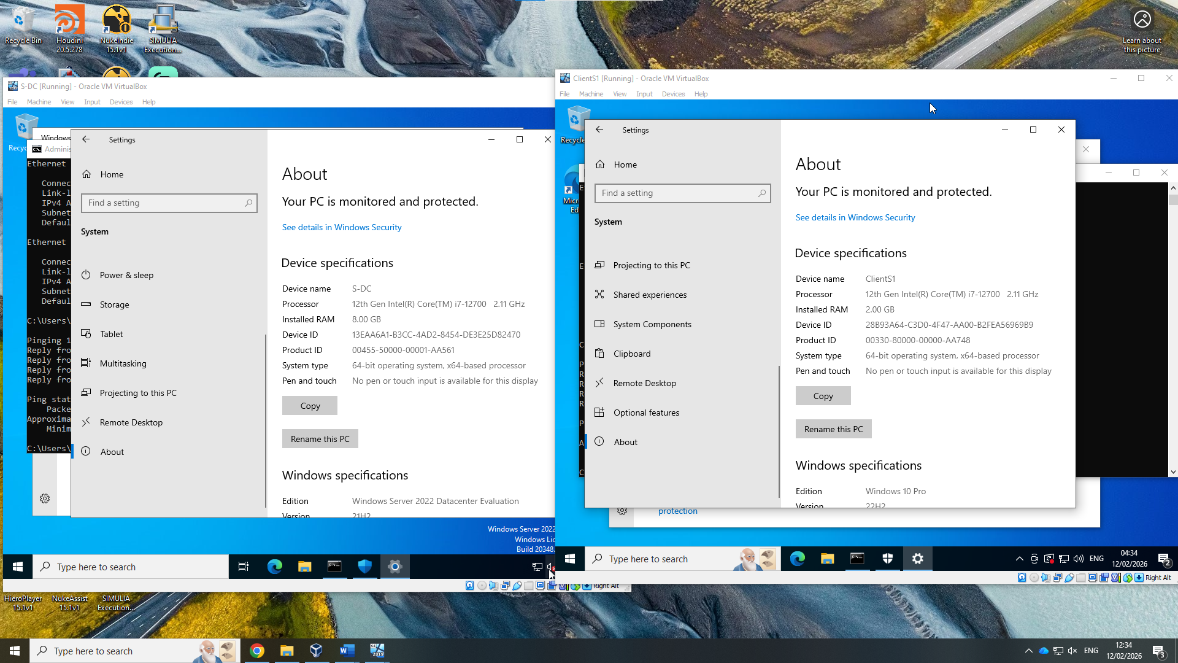
Figure 3: Server and Client name

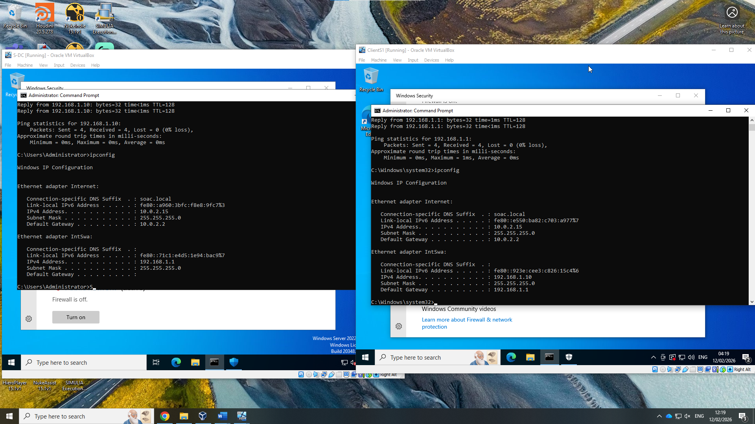
Figure 4: IP addresses
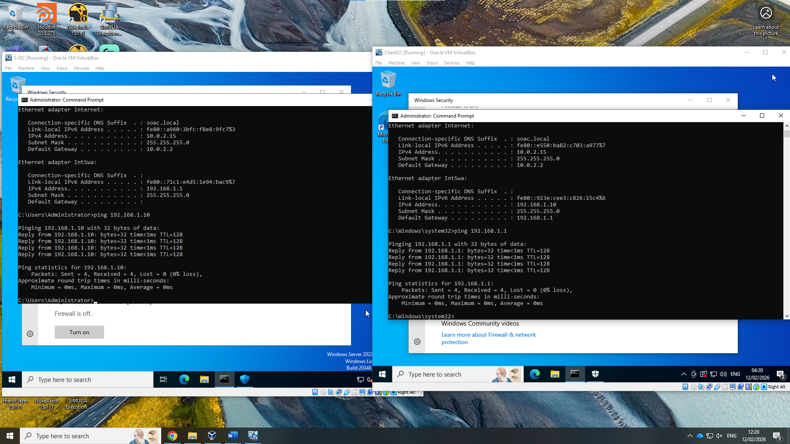
Figure 5: Ping command

Linux Server and Client
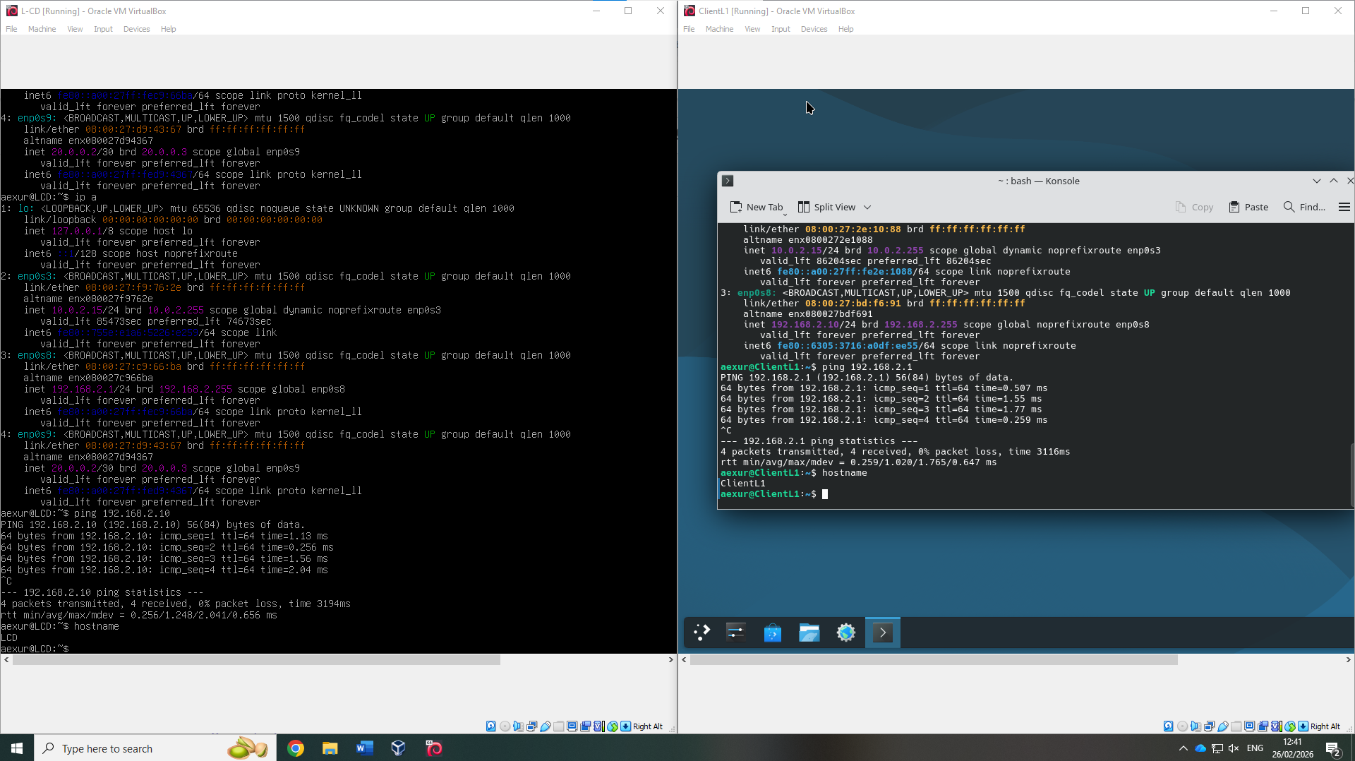
Figure 6: Server and Client names

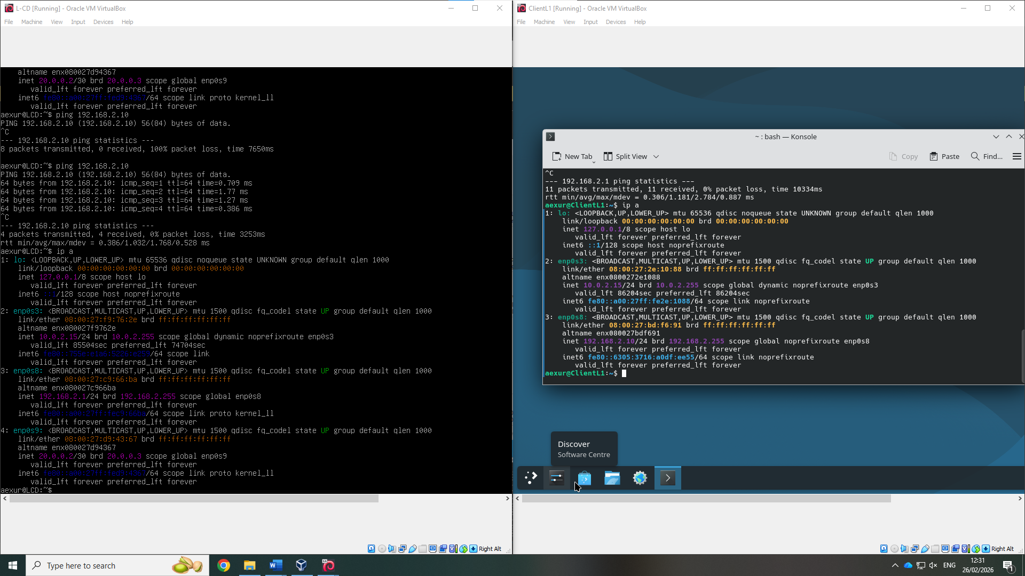
Figure 7: IP addresses
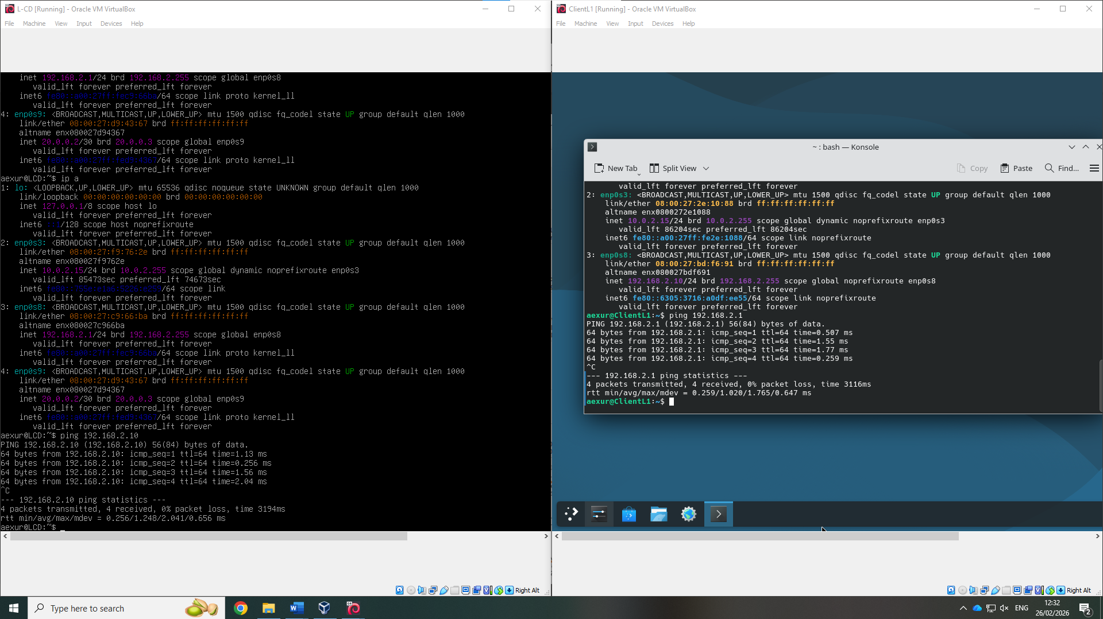
Figure 8: Ping command

Mixed
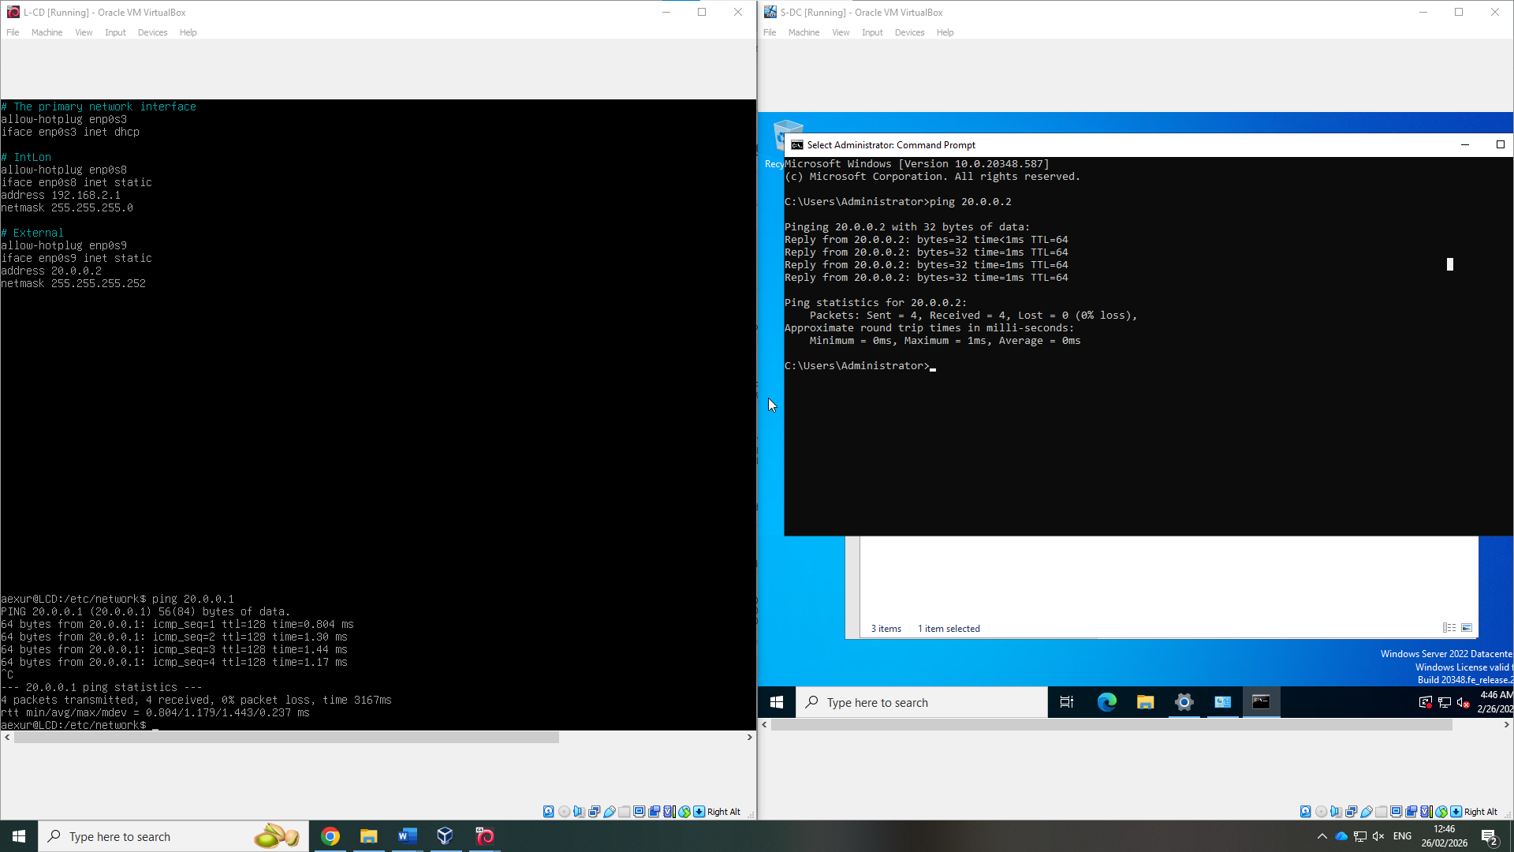
Figure 9: Ping Debian server and Windows Server
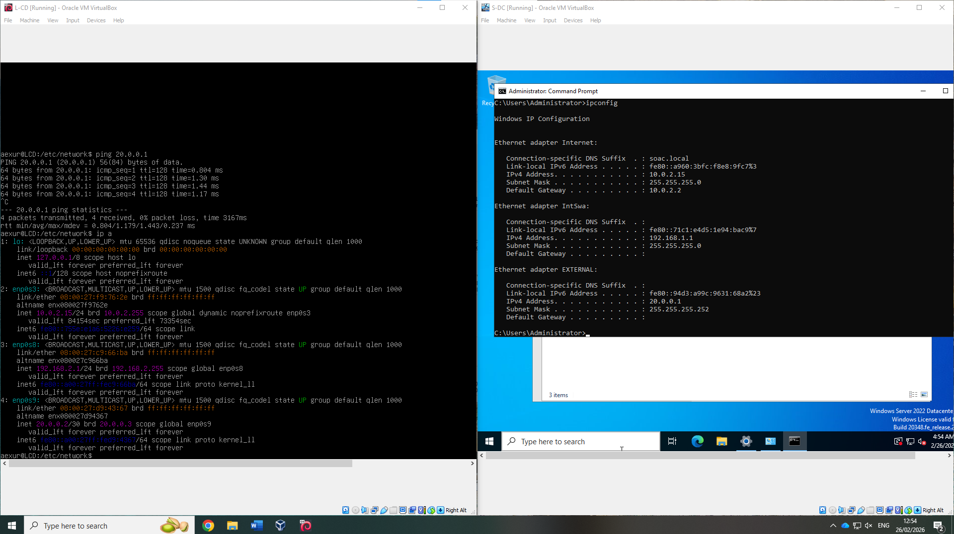
Figure 10: Debian and Window Server Networks
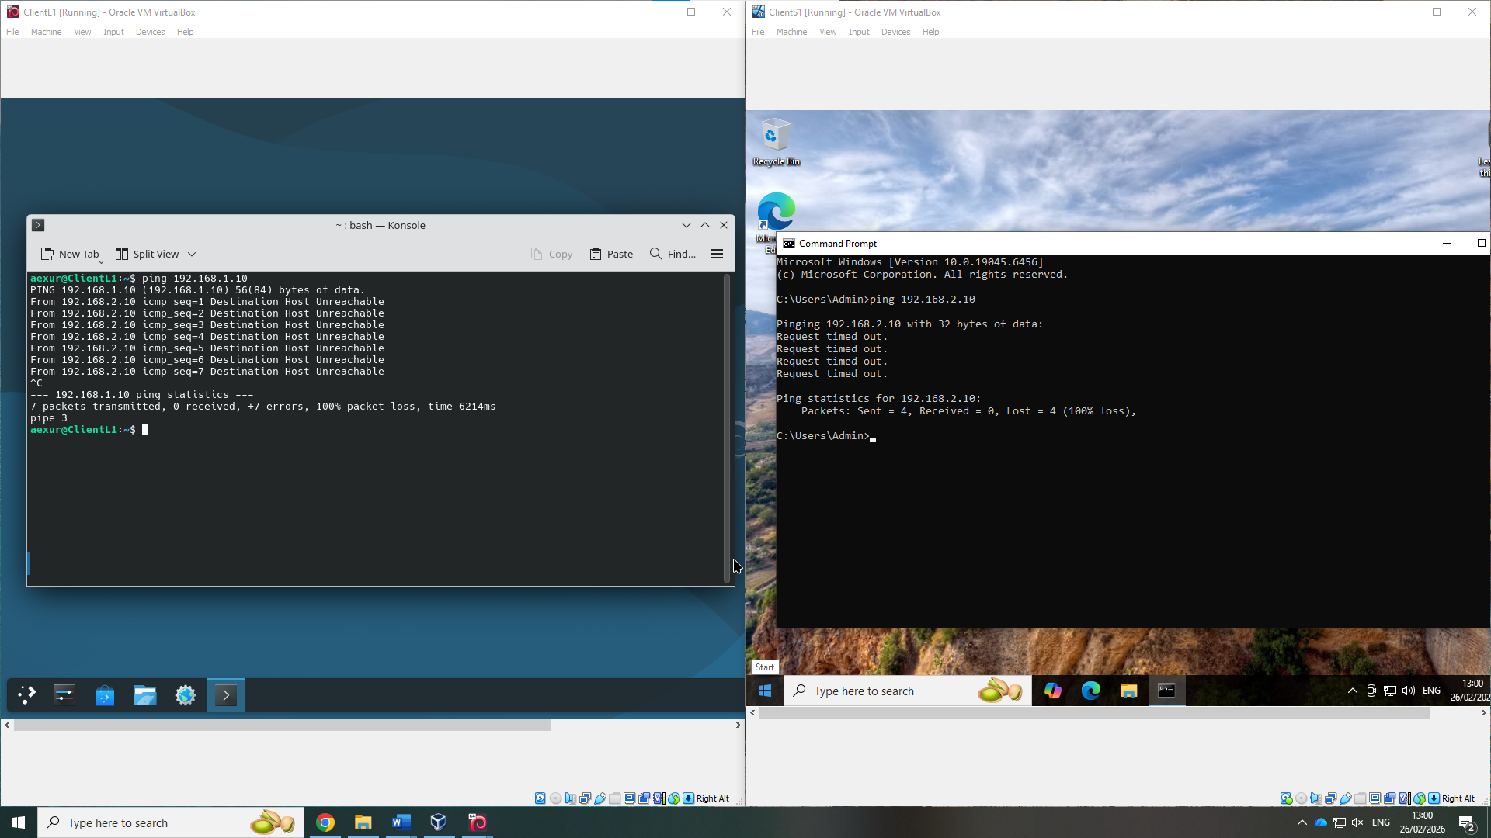
Figure 11: Ping Debian Client and Windows Server

Task 3

Deployment and Testing
The only issue faced during the deployment and testing were the Windows Server and Client originally could not ping each other, this was due to a firewall issue. To fix this, both firewalls were disabled, so that they could detect one another. It is important to note that this is not a permanent solution to this problem.

Personal Reflection
This project gave me practical insight on how to develop, build and deploy a virtualised network with differing operating systems. Assigning multiple networks to multiple machines, including separate connecting networks, was a new experience that I quickly learnt with ease. Outside of this, learning how to setup a Debain Server and apply a manual IP address and networks manually via the CLI was a new experience.
Despite this, I have had previous experience using Windows Servers, clients and Linux clients, alongside Type 2 hypervisor experience in both personal and professional environments, which made this experience smooth and enjoyable.
Overall, this helped to strengthen my already existing networking capabilities, especially in a virtualised environment, compared to the physical one I am accustomed to. Furthermore, I did gain a deeper understanding of the differing types of virtualisation and when they are necessary.

