
BMIH6002
Hotel Placement – Managing Food and Beverage Operations
Reflective Learning Log
Student ID: 2121358

Table of Contents
Introduction 2
Section 1: Reflection on Experience and Personal Development (Gibbs' Reflection Model) 2
Section 2: Critical Analysis of Work-Based Skills and Technical Knowledge 3
Section 3: Reflection on Organisational Issues 4
Conclusion and Action Plan 5
References 6

Introduction
Offering a variety of services to suit a wide range of guest tastes, Delta Hotels by Marriott Bristol City Centre's food and beverage business is extensive and includes fine dining, casual dining, and event catering. The hotel has a range of British and international dishes, and it is dining areas can host weddings and corporate functions in addition to smaller, more private parties. My main learning goals for my placement in the food and beverage department are to: build supervisory abilities; improve communication and teamwork; comprehend the technical components of food service; and solve organisational challenges to increase operational efficiency.

Figure 1: Delta Hotel (Source: Booking, 2022)

Section 1: Reflection on Experience and Personal Development (Gibbs' Reflection Model)
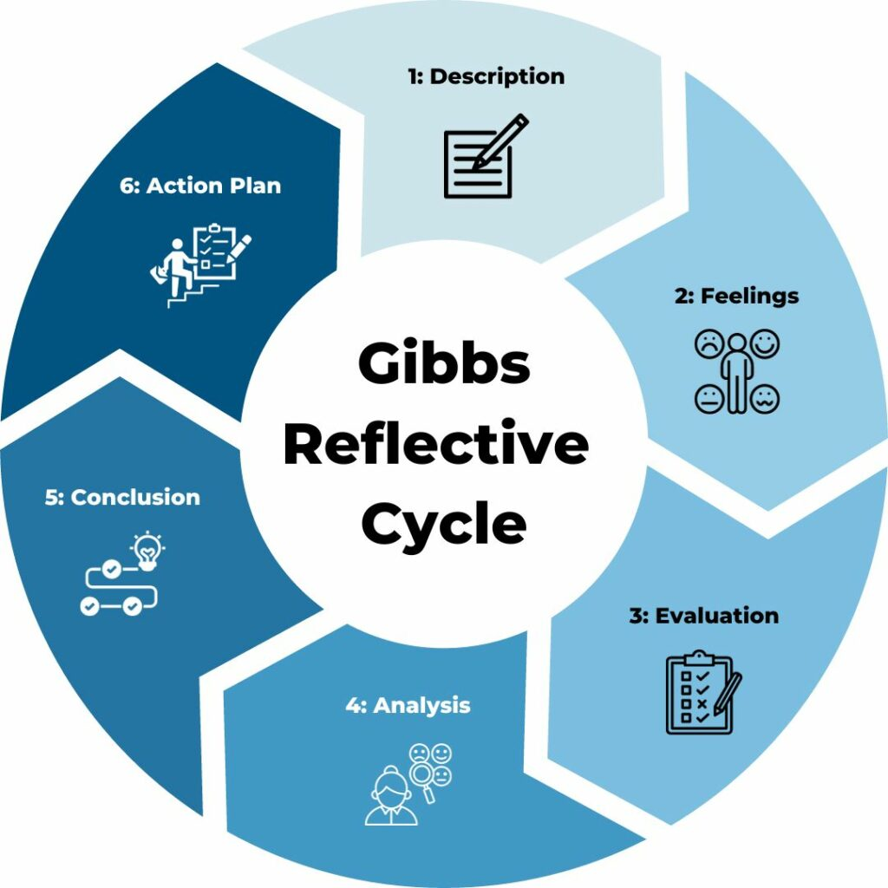
Figure 2: Gibbs' Reflection Model (Source: TSW Training, 2020)
The six-stage Gibbs Reflection Model is a framework for methodically reviewing events, promoting in-depth investigation of learning and growth, and organising for upcoming enhancements. Description, Feelings, Evaluation, Analysis, Conclusion, and Action Plan are the stages (ASET, 2017).
Description: I shadowed a supervisor in the food and beverage department, where I was responsible for staff supervision, guest relations, and coordination with the culinary crew. I also took part in the organisation and implementation of the event. I had to be ready for changing needs and obstacles, such as customers' requests on high-traffic service during peak hours or a lack of staff.
Emotions: I was first anxious about taking on the supervising job, but with time, I became more assured. I felt more capable of handling duties toward the end, particularly when it came to overseeing guest service and settling conflicts under duress. One night, a guest complained about delayed service, which the service provider saw needed fast attention and proper terminology.
Evaluation: I was able to solve problems, work under pressure, and communicate more effectively after the event. Nonetheless, it proved difficult to oversee employee schedules and guarantee timely task completion during peak times. I learned how crucial leadership and teamwork are to keeping things running smoothly (Jones et al., 2016).
Analysis: I gained important abilities in time management, teamwork, and communication. I was able to employ the academic understanding I had gained from hotel management studies to effectively assign work and coordinate between the restaurant staff and kitchen staff. Setting priorities for tasks became essential to avoiding service interruptions and preserving client happiness (Johnston et al., 2012). I ordered other hotel necessities after a large number of visitor orders and low supplies.
Conclusion: I learned from this experience that effective leadership in the food and beverage industry necessitates flexibility, good communication, and the capacity to act quickly under pressure. I came to understand how crucial it is to keep team members motivated and to deal with problems head-on to preserve service quality. Using Maslow's Need Hierarchy theory, I found that supporting and recognizing staff for handling pressure boosts productivity, especially during delays or high guest requests.
Action Plan: Going ahead, I want to strengthen my leadership abilities by actively participating with the team in high-pressure scenarios and pursuing more supervisory positions. By proactively addressing guest concerns and devising techniques to foresee prospective challenges, I aim to improve my problem-solving abilities. To maintain high standards of guest service during peak service periods, I will also concentrate on optimising staff schedule management.

Section 2: Critical Analysis of Work-Based Skills and Technical Knowledge
- Work-Based Skills:
The Food and Beverage department needs strong teamwork, communication, and task-management abilities to maintain high guest service standards. Orders are delivered on time and accurately when restaurant staff and kitchen staff collaborate seamlessly, which is made possible by effective cooperation. During my working experience, I realised that teamwork reduces mistakes and time wastage, something that is very important during peak periods. As the need of the visitors had to be met without overwhelming the employees, task prioritisation was very crucial and, thus, management of tasks was also crucial.They impacted customer satisfaction in a way because a well organised manpower was able to attend to the needs of the customers with a lot of efficiency and focus (Walker, 2021).
- Technical Knowledge:
Understanding inventory systems, quality control procedures, and complaint handling are among the technical skills needed to preserve operational efficiency (Johnston et al., 2012). For example, during my placement I learned how to monitor stock, ensure that it was ordered on time so that there would not be shortages in the store. Besides, I got practical experience in receiving complaints from the visitors using a systematic approach to ensure that visitors’ concerns were addressed and within the due time. Dealing with these complaints taught me a good lesson that one has to balance between fixing a problem and being sympathetic to customers in order to maintain service quality and visitor satisfaction. The most notable example was when guests needed stocks quickly and suppliers needed to be informed. The timely and effective resolution of this challenge required resource management theories in line with JIT inventory management, which attempts to meet demand without significant storage costs.
- Relevance to Guest Service:
The standards of guest service are closely related to both technical knowledge and work-based abilities. A better coordinated and responsive service is the result of effective communication and teamwork, which enhances the entire visitor experience. Similar to this, being well-versed in technical areas like quality assurance and inventory control guarantees that the business's operational side operates efficiently and experiences as few service interruptions as possible. By gaining these abilities and technical know-how, I helped the hotel uphold its strict guidelines for visitor pleasure, making sure visitors had a great time the entire time (Vallen & Vallen, 2014).

Section 3: Reflection on Organisational Issues
- Identify a Problem:
One organisational problem I saw during my placement was a personnel shortfall at busy times, especially in the evening when the volume of guests was highest. The food and beverage department frequently found it difficult to maintain effective service, which led to higher wait times for customers and more strain on the current workforce. Staff morale was also harmed by this problem since they were overworked and less productive in their jobs, which influenced service delivery (Potter, 2015). One night, a staff shortage caused late service and angry clients. The following recurrence showed how the Human Capital Theory's workforce planning measures might help employees perform well during busy times.
- Impact on Operations:
The general visitor experience was directly impacted by the staffing shortfall. There was not enough staff, so customers had to wait longer for their orders, which made them unhappy and made complaints. Furthermore, the overworked employees were unable to provide the required degree of attentiveness, which had a detrimental impact on the quality of the services (Jones et al., 2016). The staff's performance in the kitchen was also affected by this problem, as they had to handle several duties at once, which resulted in mistakes during the processing and delivery of orders. In Herzberg's Motivation-Hygiene Theory, lack of assistance is a hygiene issue that lowers worker satisfaction and productivity under pressure.
- Suggestions for Solutions:
To solve the personnel shortage, I suggest putting in place a more adaptable scheduling system that coincides with periods of high demand. Changing shift patterns to guarantee that there are more employees available throughout peak times and perhaps providing cross-training to staff members to enable them to assist in various capacities as required could be part of this. More effective personnel allocation would also be possible with the introduction of improved workforce planning systems that foresee busy periods based on historical data. Applying pertinent concepts, such as Herzberg's Two-Factor Theory, can help increase employee motivation and job satisfaction by making sure workers have enough support during their shifts (Fallon & Rutherford, 2010). By implementing these adjustments, the department may improve employee productivity and visitor happiness, which would result in more efficient operations.

Conclusion and Action Plan
Key Insights:
During my Food and Beverage department shadowing experience, I gained a great deal of insight into the value of technical expertise, teamwork, and communication in providing excellent guest service. I gained important job-related skills like effectively handling assignments under time constraints and enhancing restaurant staff and kitchen staff communication. I also developed a greater comprehension of technical procedures such as quality control, inventory management, and complaint handling, all of which are essential to guarantee operational effectiveness and customer happiness (Hagg, 2013).
Future Action Plan:
Going forward, I want to keep honing my leadership abilities by looking for other chances to oversee and lead groups in comparable high-stress situations. To ensure smoother operations, I will concentrate on honing my capacity to encourage and assist employees during periods of high service demand. To improve my capacity to address organisational difficulties, I also plan to take additional training in F&B management, specifically in areas like staff planning and guest service techniques. I hope to acquire a well-rounded skill set by expanding on the theoretical and practical information I have learned from this placement, which will help me succeed in the hospitality sector and eventually assume leadership positions (Cavallar, 2017).

References
ASET (2017) Good Practice Guide for Workbased and Placement Learning in Higher Education. Sheffield: ASET.
Cavallar, G. (2017) The rights of strangers: Theories of international hospitality, the global community and political justice since Vitoria. London: Routledge.
Fallon, M. & Rutherford, D. (2010) Hotel Management and Operations. London: Wiley.
Hagg, E. (2013) Internship Guide: Work Placements Step by Step. 5th ed. The Hague: Eleven International Publishing.
Johnston, R., Clark, G. & Shulver, M. (2012) Service Operations Management: Improving Service Delivery. 5th ed. London: Pearson.
Jones, P., Hillier, D. & Comfort, D. (2016) ‘Sustainability in the hospitality industry: Some personal reflections on corporate challenges and research agendas’, International Journal of Contemporary Hospitality Management, 28(1), pp. 36-67.
Kanfer, R., Frese, M. & Johnson, R.E. (2017) ‘Motivation related to work: A century of progress’, Journal of Applied Psychology, 102(3), pp. 338.
Potter, C. (2015) ‘Leadership development: An applied comparison of Gibbs’ Reflective Cycle and Scharmer’s Theory U’, Industrial and Commercial Training, 47(6), pp. 336-342.
Vallen, G.K. & Vallen, J.J. (2014) Check-In Check-Out: Managing Hotel Operations. 9th ed. Harlow: Pearson Education Limited.
Walker, J.C. (2021) Introduction to Hospitality. 8th ed. Harlow: Pearson Education Limited.

