
Master of Business Administration

Module Name: Marketing Management
Module Code: LCMB7024

Assessment component 1: Marketing Environment Analysis

Lecturer’s Name:
Laila Maazouz
Dian Mayasari

Work Count:2497

Student Name: Panchal Avani Dilipbhai
Student ID: 2527582

Table of Contents
1. Introduction 3
2. Task 1: Critical Analysis of the Macro Marketing Environment 4
2.1 Macro Marketing Environment 4
2.2 Analysis of Macro Factor 1: Technological Factors 5
2.2.1 Impact on Apple (Pioneer Organisation) 5
2.2.2 Impact on Samsung (Follower Organisation) 6
2.3 Analysis of Macro Factor 2: Economic Factors 6
2.3.1 Impact on Apple (Pioneer Organisation) 6
2.3.2 Impact on Samsung (Follower Organisation) 7
3. Task 2: Strategic Responses of Pioneering and Follower Organisations 7
3.1 Pioneering Organisation’s Strategic Responses (Apple) 7
3.2 Follower Organisation’s Strategic Responses (Samsung) 9
4. Conclusion 10
5. References 12

1. Introduction
This report aims to critically analyse the macro marketing environment and its influence on strategic marketing management within the global smartphone industry. It focuses on two major organisations: Apple Inc. as a pioneering firm and Samsung Electronics as a follower firm. These companies operate in a highly dynamic and competitive industry characterised by rapid technological innovation, strong brand competition, and evolving consumer preferences.
The global smartphone industry is one of the largest and fastest-growing sectors, with an estimated market value of approximately $642.64 billion in 2.26, projected to reach over $1129.19 billion by 2034, reflecting a compound annual growth rate (CAGR) of around 7.3% (Fortune Business Insights, 2022).
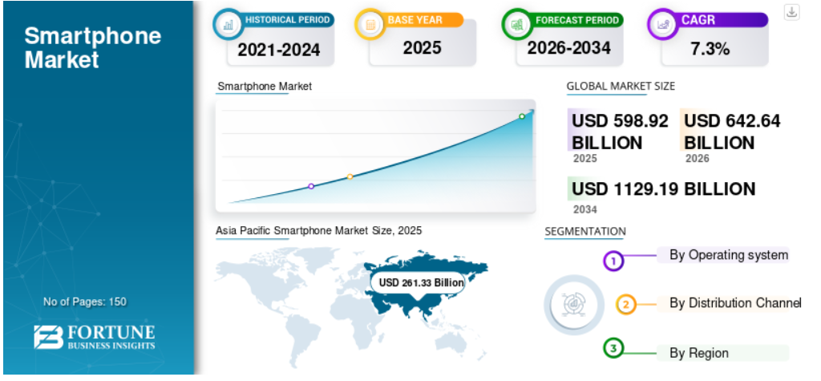
Figure 1: Smartphone Marker Size
(Source: Fortune Business Insights, 2022)
The competitive landscape is dominated by a few key players, particularly Apple and Samsung, which together account for a significant share of the global market. For instance, Apple held around 20% global market share in 2025, slightly ahead of Samsung at 19%, highlighting intense rivalry at the top (Jain, Mishra and Pathak, 2025). Additionally, in 2024 both firms collectively represented approximately 44% of the global smartphone installed base, reinforcing their dominance in the industry (Diaconescu, 2026).
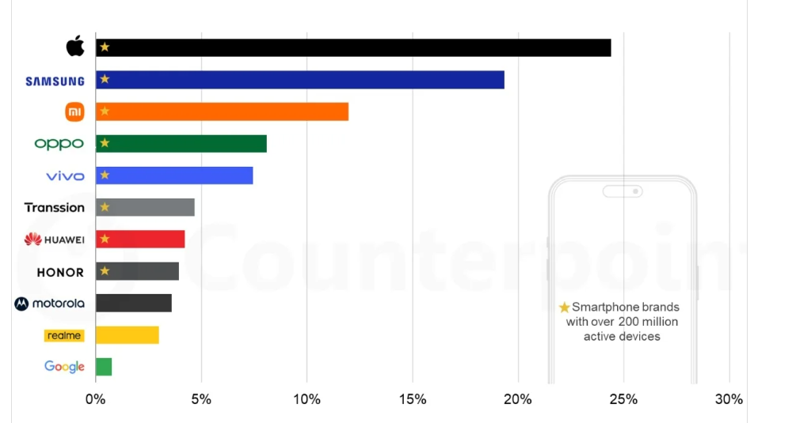
Figure 2: Apple & Samsung
(Source: Diaconescu, 2026)

Analysing the macro marketing environment is crucial for organisations as it helps identify external opportunities and threats that influence strategic decisions. Tools such as the PESTLE framework enable firms to evaluate factors such as technological innovation and economic conditions, which are particularly significant in this industry due to rapid digital transformation and fluctuating consumer purchasing power.
This report is structured into two main tasks. Task 1 critically examines two macro-environmental factors—technological and economic and their impact on Apple and Samsung. Task 2 evaluates the strategic responses of both organisations using relevant frameworks such as Porter’s Generic Strategies to assess how they sustain competitive advantage in a rapidly evolving market.

2. Task 1: Critical Analysis of the Macro Marketing Environment

2.1 Macro Marketing Environment
The macro marketing environment refers to external forces that influence organisational performance but remain beyond direct control. The PESTLE framework is widely used to analyse these forces, encompassing Political, Economic, Social, Technological, Legal, and Environmental factors. This framework enables organisations to systematically identify opportunities and threats arising from the external environment and align their strategies accordingly (Qawasmeh et al., 2025).
In the context of the global smartphone industry, two macro factors have been selected for analysis: technological and economic factors. These factors are particularly relevant due to the industry’s dependence on rapid innovation cycles and sensitivity to global economic conditions. The smartphone market is highly technology-driven, with advancements such as 5G, artificial intelligence (AI), and foldable devices shaping competition and consumer expectations. At the same time, economic conditions significantly influence consumer purchasing power, especially for premium-priced products such as Apple’s iPhones.
The factors are strategic as they have a direct influence on the demand, pricing strategy, and competitive positioning. For example, smartphone shipments have increased at a pace of approximately 2 percent in 2025, which listed a moderate improvement but also reflected sensitivity to the market to economic changes (Reuters , 2026). In addition, the presence of a small number of large competitors Apple at approximately 20 percent and Samsung with 19 percent market share reveal the tight competition that has been fuelled by the technological capabilities and strategic flexibility (Hardwick, 2026).

2.2 Analysis of Macro Factor 1: Technological Factors

2.2.1 Impact on Apple (Pioneer Organisation)
Technological advancement represents a significant opportunity for Apple as a pioneering organisation. Apple’s strategy is heavily centred on innovation, enabling it to differentiate its products through design, ecosystem integration, and proprietary technologies such as iOS and custom chipsets. This innovation-driven approach has contributed to its leadership position, with Apple achieving approximately 20% global market share in 2025, the highest among competitors (Reuters , 2026).
Technological innovation is also a factor that enhances the competitive edge of Apple as it helps to offer a high price and brand loyalty. To illustrate, the success of iPhone 17 series, and ongoing implementation of new features like AI based capabilities and superior processors have led to the expansion of high-value segments. Moreover, Apple enjoys the advantage of ecosystem integration, which makes switching more costly to consumers and improves customer loyalty.
Nevertheless, a rapid change of technology is also a threat, and it demands the constant investment in research and development (R&D). A lack of innovation leadership might decrease differentiation and undermine the competitive advantage. Nevertheless, Apple is well-equipped to withstand market competition because it has considerable financial resources and innovation abilities, which makes it very flexible.

2.2.2 Impact on Samsung (Follower Organisation)
In the case of Samsung, the technological aspects have offered it opportunities as well as challenges. Being a follower organisation, Samsung follows the approach of quick adaptation and diversification. In contrast to Apple, Samsung deals in many different prices and is utilizing technological progress, like foldable smartphones and devices powered by AI, to keep up with the competition. This flexibility has helped Samsung to be in a solid market position with an estimated market share of about 19 percent in the world in 2025 (Hardwick, 2026).
Samsung’s ability to quickly integrate emerging technologies allows it to compete effectively with Apple, particularly in innovation areas such as foldable devices and display technology. For example, Samsung’s investment in foldable smartphones has created a niche market segment where it currently leads.
Nonetheless, Samsung is more vulnerable than Apple since the company is dependent on diversification of products and stiff competition among Android platform. There is a threat of substitution and competition of prices due to the existence of numerous rivals providing similar technologies. This makes the competitive advantage of Samsung to be rooted more in operation efficiency and innovation pace than in product ecosystems.
Samsung is also very competitive in terms of market, though less dominant in the high end segment as Apple. Its strategy is that of a follower, as it is responsive and covers the markets instead of going innovative.

2.3 Analysis of Macro Factor 2: Economic Factors

2.3.1 Impact on Apple (Pioneer Organisation)
Economic factors present both opportunities and threats for Apple. On one hand, rising disposable incomes and premiumisation trends have supported growth in high-end smartphones, with global average selling prices reaching a record $356 in 2024, reflecting increased demand for premium devices (Counterpointresearch, 2024). This benefits Apple, whose strategy focuses on high-margin products.
However, economic uncertainty and inflation pose a significant threat. Smartphone demand is highly sensitive to economic conditions, with global shipments previously declining by over 4% during periods of economic slowdown as consumers delayed upgrades (Mallick, 2026). Nevertheless, the excellent brand loyalty and ecosystem have enabled Apple to sustain the demand even during declines, which are used to sustain the competitive advantage through high price and consumer retention.

2.3.2 Impact on Samsung (Follower Organisation)
For Samsung, economic factors represent a greater challenge due to its exposure across multiple price segments. Rising component costs and inflation have increased device prices by up to 15–40% in some markets, reducing affordability and weakening demand, particularly in the budget segment (Kumari, 2025). This makes Samsung more vulnerable compared to Apple.
Nonetheless, Samsung has a high level of flexibility as it has a wide product range at different prices, thus being able to cater to both the premium and mid-end markets. However, its dependence on price sensitive consumers makes it more susceptible to the economic crunch.
In terms of market position, Samsung remains competitive but faces margin pressures and stronger competition, particularly in emerging markets where economic conditions heavily influence purchasing decisions.

3. Task 2: Strategic Responses of Pioneering and Follower Organisations

3.1 Pioneering Organisation’s Strategic Responses (Apple)
Apple, as a pioneering organisation, adopts a highly focused and innovation-driven strategy to respond to external challenges such as technological disruption and economic uncertainty. Its strategic response can be effectively analysed using Porter’s Generic Strategies, particularly differentiation strategy (Islami, Mustafa and Latkovikj, 2020).
The differentiation of Apple relies on innovation, system integration, and high-quality branding. In contrast to the competitors, Apple provides a well-integrated ecosystem (iPhone, iOS, Mac, Apple Watch), which makes users experience better and makes switching more expensive. This approach helps Apple to have a high level of customer loyalty and be able to command high prices. This achievement is evidenced by the fact that despite their smaller share in the world smartphone units, Apple controls close to 82 percent of smartphone profits throughout the world (Richter, 2023).
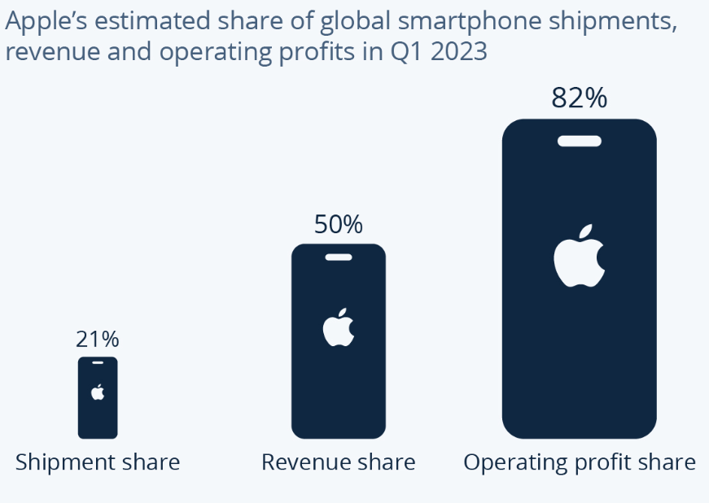
Figure 3: Apple Profit Share
(Source: Richter, 2023)

In addition, Apple responds to changes in technology by heavily investing in proprietary technology such as custom chipsets (e.g. Apple silicon) and artificial intelligence-based features. Apple is not a first mover but a late mover and its technologies are fully realized and matured, and is not as risky as it has remained at the forefront of the pack when it comes to innovation. By doing so, Apple is able to enjoy a long term competitive advantage without necessarily bearing a lot of the cost of experimentation.
Due to economic pressure, Apple has a premium pricing approach, and its target markets comprise segments with high incomes where premium prices do not affect demand much. This is specifically successful in the developed markets like the United States and Europe where consumers are not reluctant to spend more on brand value and quality (Pattuglia and Amoroso , 2023). Moreover, the company has expanded its sources of revenue by providing services like iCloud, Apple Music and the App Store thus minimizing its dependence on hardware sales and maximizing recurring revenue.
However, Apple’s strategy also presents risks. Its heavy dependence on the iPhone, which contributes around 50–60% of total revenue, exposes the company to market saturation and declining upgrade cycles . Moreover, its premium pricing limits accessibility in price-sensitive markets such as India and Africa (Counterpointresearch, 2024b) .
Overall, Apple’s strategic response demonstrates strong alignment with Porter’s differentiation strategy. By focusing on innovation, brand equity, and ecosystem control, Apple maintains a sustainable competitive advantage and industry leadership, particularly in profitability rather than volume.

3.2 Follower Organisation’s Strategic Responses (Samsung)
Samsung is a follower organisation which follows a more flexible and adaptive approach in order to be competitive in the world of smartphones. It has a strategy that is consistent with the Porters Generic Strategies wherein it has integrated cost leadership and differentiation in various segments.
In comparison with Apple, Samsung is a company with a large product scope, producing smartphones of various price points, starting with low-end models and going to the flagship. This will help Samsung secure a bigger and more varied customer base, especially in the new markets where affordability is one of the major determinants. For example, Android gadgets (Samsung included) hold a world market share of about 71-72 percent, versus iOS at an estimated 27-28 percent. This indicates good positioning on Samsung in mass-market segments (Sharma, 2023).
Samsung’s strategic response to technological change is based on rapid adoption and first-mover experimentation. The company has been a leader in innovations such as foldable smartphones, giving it a temporary competitive advantage in niche segments. The foldable smartphone market is projected to grow by 20% in 2026, with Samsung currently leading this category (Son and Kim, 2022). This demonstrates Samsung’s ability to exploit emerging technological opportunities quickly.
Also, Samsung enjoys the advantages of vertical integration as it manufactures most important components like displays and semiconductors in-house. This will offer cost benefits, supply chain management and operational efficiency enabling Samsung to react better in the event of external shocks like geopolitical tensions and supply shortages.
Nevertheless, there are limitations in the strategy of Samsung as well. It has a highly diversified product range which diminishes brand exclusivity and brand differentiation as it does to Apple. Samsung can find it difficult to compete technically and profit as much as Apple in the high-end segment because of challenges in the brand loyalty and profitability. Samsung can be a leader in terms of the shipment volumes or be a leader in certain segments, nevertheless, Apple remains a leader in profit margins and customer retention (Appreciate, 2026).
The Samsung strategy is competitive and displays a follower strategy, which is orientation-oriented towards scale and adaptability. It is responsive to external forces by diversification of its product, several segmentation of markets and quick adaptation to new technology. This helps Samsung to have a high presence in the world with a market share estimated to be 19 percent as it competes closely with Apple.

4. Conclusion
This report has critically examined the macro marketing environment and its influence on the strategic positioning of Apple as a pioneer organisation and Samsung as a follower in the global smart phone industry. The results of Task 1 illustrate that macro-environmental forces, especially technological, economic, political and social forces are dominant in influencing competitive forces. The most influential factor was the technological development because it gave both the innovational opportunities and the threats of the quick obsolescence. Another factor that had a great impact was economic conditions, as they influenced consumer purchasing power and demand patterns in the various market segments.
The analysis has shown that Apple is a pioneer innovator by exploiting its technological opportunities on the basis of continuous innovation, integration of ecosystems, and excellent brand differentiation. This assists the firm to remain at high-quality prices and profitability. Instead, Samsung is a more flexible and responsive organization, which responds to the same external forces diversifying their products, ensuring it keeps its costs down, and adapts quickly to the new technologies. Whereas Apple still keeps on leading the pack in terms of profitability and brand loyalty, Samsung is able to compete in terms of the magnitude and reach of the market.
Task 2 also demonstrated that there is close relationship between the strategic responses and the market position of any organisation. Differentiation strategy has helped Apple to develop long term competitive advantage compared to the hybrid approach which has helped Samsung to be responsive and resilient in a highly competitive environment.
In general, the report highlights that environmental scanning is necessary in order to identify external opportunities and threats. With the changes present in macro-environment, organisations with marketing strategies that are consistent with changes are in a better position to maintain competitive advantage. Strategic adaptability and exploiting core competences is important in dynamic businesses like smart phones in order to survive in the long-run.

5. References
Appreciate (2026). Apple vs Samsung: Who Is Winning the Smartphone War in 2026? [online] appreciate. Available at: https://appreciatewealth.com/blog/apple-vs-samsung-smartphone-wars [Accessed 19 Mar. 2026].
Counterpointresearch (2024a). GLOBAL SMARTPHONE MARKET 2024. [online] Counterpointresearch.com. Available at: https://counterpointresearch.com/en/insights/global-smartphone-market-2024 [Accessed 19 Mar. 2026].
Counterpointresearch (2024b). iPhone Hits Record 50% Revenue Share on US, India and Emerging Markets; China Risks Remain. [online] Counterpointresearch.com. Available at: https://counterpointresearch.com/en/insights/iphone-hits-record-50-revenue-share-on-us-india-and-emerging-markets-china-risks-remain [Accessed 17 Mar. 2026].
Diaconescu, A. (2026). Apple leads the smartphone market in active devices, Samsung is also in the one-billion club. [online] PhoneArena. Available at: https://www.phonearena.com/news/apple-leads-smartphone-market-in-active-devices-samsung-second-place_id178086 [Accessed 19 Mar. 2026].
Fortune Business Insights (2022). Smartphone Market Size, Share | Forecast, 2028. [online] Fortune Business Insights. Available at: https://www.fortunebusinessinsights.com/industry-reports/smartphone-market-100308 [Accessed 19 Mar. 2026].
Hardwick, T. (2026). Apple Tops 2025 Smartphone Market With 20% Share, 10% Growth. [online] MacRumors. Available at: https://www.macrumors.com/2026/01/12/apple-tops-2025-smartphone-market. [Accessed 19 Mar. 2026]
Islami, X., Mustafa, N. and Latkovikj, M.T. (2020). Linking porter’s generic strategies to firm performance. Future Business Journal, [online] 6(1), pp.1–15. doi: https://doi.org/10.1186/s43093-020-0009-1.
Jain, S., Mishra, V. and Pathak, T. (2025). Global Smartphone Shipments Grew 2% YoY in 2025; Apple Emerged as Market Leader. [online] Counterpointresearch.com. Available at: https://counterpointresearch.com/en/insights/global-smartphone-shipments-grew-2-percent-YoY-in-2025. [Accessed 16 Mar. 2026]
Kumari, N. (2025). From Phones to Laptops: The Real Reason Electronics Are So Expensive Now. [online] Bisinfotech. Available at: https://www.bisinfotech.com/the-real-reason-electronics-are-so-expensive-now/ [Accessed 19 Mar. 2026].
Mallick, S. (2026). Mobiles may ring less louder this year: Shipments expected to contract by 4% on-year due to rising prices. [online] The Economic Times. Available at: https://economictimes.indiatimes.com/industry/cons-products/electronics/mobiles-may-ring-less-louder-this-year-shipments-expected-to-contract-by-4-on-year-due-to-rising-prices-of-parts-and-forex-shocks/articleshow/127649120.cms?from=mdr [Accessed 19 Mar. 2026].
Pattuglia, S. and Amoroso , S. (2023). ORGANIZING THE MARKETING ACTIONS AROUND PREMIUM PRICE IN TECHNOLOGICAL BRANDS: THE CASE OF APPLE. [online] Available at: https://www.hu.ac.ae/images/pdf/sbj/2019-1/Article2.pdf. [Accessed 19 Mar. 2026]
Qawasmeh, F.M., Qawasmeh, E.F., Daoud, M.K., Alfityani, A. and Maali, H. (2025). The Impact of Environmental Analysis on Business Strategy: A Qualitative Approach. Advances in Science, Technology & Innovation, pp.345–353. doi: https://doi.org/10.1007/978-3-031-90558-2_43.
Reuters (2026). Apple leads global smartphone market with 20% share in 2025, says Counterpoint. Reuters. [online] 12 Jan. Available at: https://www.reuters.com/business/media-telecom/apple-leads-global-smartphone-market-with-20-share-2025-says-counterpoint-2026-01-12/. [Accessed 17 Mar. 2026]
Richter, F. (2023). Infographic: Apple in the Smartphone Market: Win Where It Matters. [online] Statista Daily Data. Available at: https://www.statista.com/chart/29925/apples-share-of-the-global-smartphone-market/?srsltid=AfmBOopGgYvvkFxYrifTAPmYRh73dAHWaNznTbLNM3WbCZAecqfKIpKP [Accessed 19 Mar. 2026].
Sharma, D. (2023). iPhone vs Android Users: Key Differences in Behavior - Adapty.io. [online] Adapty. Available at: https://adapty.io/blog/iphone-vs-android-users/?utm_source=chatgpt.com&rsid=bb4ca214-7374-46f7-8ea4-c703f0b3a371 [Accessed 18 Mar. 2026].
Son, I. and Kim, S. (2022). Supply Chain Management Strategy and Capital Structure of Global Information and Communications Technology Companies. Sustainability, [online] 14(3), p.1844. doi: https://www.mdpi.com/2071-1050/14/3/1844.

