

Case Study on Obesity in the UK

Name: Zaheed ullah

ID: 1814933
Lecturer name :Rebecca kavanagh

Table of Contents
Introduction 2
A brief account on the rising concern of Obesity 2
Causes of obesity 3
Adversity of obesity 4
Strategies for managing obesity in the UK 5
Conclusion 7
References 8

Introduction
In recent years, obesity has been one of the major concerns for leaders around the world. Many kinds of adverse health complications are associated with obesity, which makes the person incapable of performing his day-to-day task in an organised manner. For this very reason, obesity is considered one of the most complex diseases that include excessive amounts of body fat. In context to this, the following assessment will highlight the various aspects of Obesity and its impact on humans. In addition to this, the following assessment will also discuss the management strategies in context to social learning theory, attitude and the theory of planning behaviour by presenting the case study scenario of the UK.

A brief account on the rising concern of Obesity
According to Klarin et al. (2017), obesity or being overweight is an abnormal or excessive accumulation of fat that eventually risks the health of a person. A person having a Body Mass Index of 25 is accounted as overweight and the one who is over 30 is obese. This particular issue has now become the prevailing epidemic proportions with about 4 million individuals being dead each year. The report has been presented by the global burden of diseases in 2017. Celis-Morales et al. (2017) stated that rates of overweight and obesity have been significantly growing in the case of adults and children. For instance, the Health Survey of England 2019 has estimated that about 28.0% of adults in England are victims of obese (Zhu et al., 2020). Further, the survey also reveals that men are more prone to get overweight or obese than that of women (68.2% of men, 60.4% of women). According to Lloyd et al. (2018), people at the age of 45-75 are more likely to get overweight or obese.
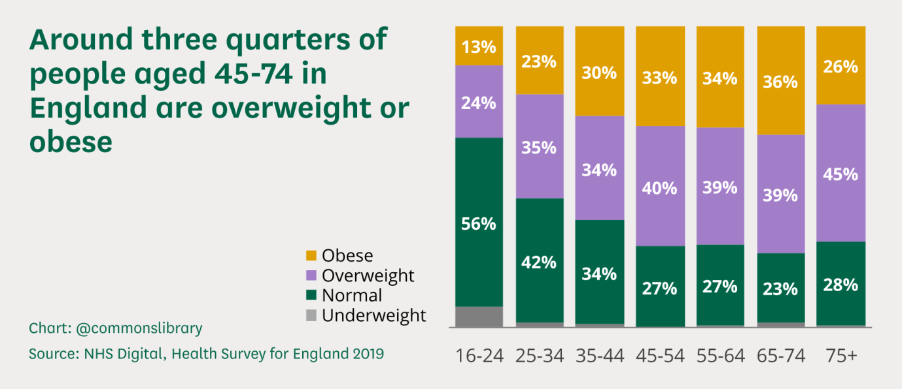
Figure 1: Impact of Obesity
(Source: Baker, 2021)
The above graph reveals that within the most deprived locations of England, the prevalence of excessive weight gain is 9% higher than in the least deprived locations (Rauber et al., 2021). About 9.9% of reception age children that is between the age of 4-5 are obese where 13.1% are overweight (Burgoine et al., 2018). In context to this, the survey report shows that the children living in the deprived arrears have a higher chance of being obese where 6.7% of the children between the ages of 2-5 years are from least deprived areas (Peters et al., 2021). On the other hand, about 13.9% of the children at the age of 10-11 are from the least deprived areas (Burgoine et al., 2018). Considering this, it can be noted that obesity is not just a cosmetic concern rather it has become a medical problem, which has increased the risk of other diseases and health problems such as specific types of cancer, high blood pressure, heart attack, diabetes and many more.

Causes of obesity
According to Robinson et al. (2021), Obesity is generally caused by eating too much and moving too little. For instance, if a person consumes items with high-energy content, especially fats and sugars but fails to burn down the sugars by doing physical exercise or activities then most of the surplus energy gets stored by the body as fat. On average, a person needs 2,500 calories each day for maintaining a healthy weight. Similarly, women on the other hand need 2,000 calories to perform average physical activities for 2,000 calories. Yates et al. (2020) argued that one of the main reasons for obesity or being overweight is due to lack of participation of the people for doing physical activity, as a result of which the calories consumed by them is being stored as excess body fat.
Yates et al. (2020) argue that obesity does not develop overnight. It happens gradually over time as the result of disturbed lifestyle choices and poor diet. For instance, the consumption of fast food that contains high fats and sugars increased the risk of obesity. About 165% of the UK's total population consumes fast food regularly (Liberali et al., 2020). Consumption of too much alcohol is another major reason for obesity as it contains many calories, because of which people drinking too much alcohol are often overweight. Apart from this drinking soft drinks or sugary drinks is another major concern for local authorities in managing the growing number of obesity in the country. Apart from this, lack of physical activity is another major factor that leads to obesity. There are individuals whose job involves sitting at a desk for most of the time in a day. Further, they also rely on cars then switching to walking or cycling (Hu et al., 2020). In terms of relaxation, people prefer to watch TV, Browse intent and play games on the internet rather than indulging themselves in regular exercise. If a person is not active enough then it is very much likely that they would not use the energy provided to them through the food they eat, because of which gets stored as extra energy within the body of a person.
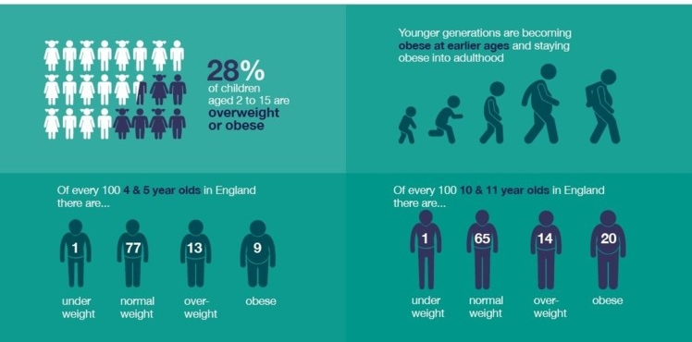
Figure 2: Increasing prevalence of Obesity in UK
(Source: Hu et al., 2020)
However, some rare genetic conditions cause obesity such as Prader Willi Syndrome. Apart from this, many medical conditions contribute to obesity or weight gains. For instance, an example is the underactive thyroid gland or hypothyroidism, in which the thyroid gland of a person fails to produce enough hormones (Yoon et al., 2020). Similarly, Cushing's syndrome is considered a rare disorder that often causes the overproduction of steroid hormones leaving the person to get overweight. In terms of management, if these conditions are properly diagnosed and treated then the peon would be able to lose weight.

Adversity of obesity
In context to the above discussion, it can be noted that obesity is the most complex health issue that results due to the combinations of causes and people’s factors such as behaviour and genetics. In terms of behaviours, it can be related to their physical activity, inactivity, poor dietary habits, excessive medications, unmanaged lifestyle and many more. Otterbach et al. (2021) stated that Obesity is a very serious issue not just in the UK but also around the globe because it is connected with poor mental health outcomes and reduction in the quality of life. Apart from this, obesity is closely related to diabetes, heart diseases, stork and some specific types of cancer.
According to the reports of the NHS, obesity is related to several further health complications and is likely to develop within an individual. These issues with this health would prevent them from performing their day-to-day tasks that would eventually make them dependent (Mohammadbeigi et al., 2018). For instance, they are likely to feel breathless while doing any activity. Apart from this, their snoring and sweating are likely to increase, because of which they would be deprived of good sleep making them feel tired all the time. They would also feel some tremendous pain in their joints and back pain, which would eventually lower their confidence and self-esteem or often be isolated from the rest of their communities. All these incapability and isolations often associated the individual with serious psychological problems that would not just affect their relationship but would also affect their professional life. This would eventually lead them to the great depression. According to Alsabieh et al. (2019), a person with obesity is likely to have an increased risk of developing many potentially serious health conditions such as type 2 diabetes, high blood pressure, high cholesterol, asthma, metabolic syndrome, breast cancer and bowel cancer. Further, it is also necessary for people to realise that there is no quick fix to obesity.
On the other hand, there are various programs but it takes time and commitment for getting the best result (Younas et al., 2021). In situations, healthcare professionals play a very important role, as they would provide them with encouragement and motivation to achieve their weight loss goals. Further, keeping regular monitoring of the weight of an individual is the major challenge that is required in the process of losing weight. However, it is also the fact that the gene you inherit from your parents would significantly affect the amount of body fat that can be stored by each person (Casas et al., 2020). In context to this, it can be stated that genetics plays a major role as efficiently the body is converted to food than into energy and the way it regulates their appetite as well as the way, through which a person burns down their calories.

Strategies for managing obesity in the UK
The social learning theory was initially proposed by Albert Bandura where it gave his major emphasis on observing, modelling and imitating the behaviour, attitude and emotional relation of a person. In response to the growing numbers of obesity, the government has announced a scheme for minimising the prevalence of obesity. In accordance with these measures or schemes, NHS England aims to support a wider range of populations for losing weight (Younas et al., 2021). Further, the legislation in the UK has made it compulsory to add calorie labelling on menus for all food and drinks in cafes, restaurants, bars and takeaways. In addition, the authorities have also banned the promotion of foods that have high fat, salt and sugar. The authorities aim to ban the product that is sold out with an offer of buy one get one free. The amendments in the laws have also currently been banning the commercials ads promoting high-fat content food items on televisions and various online platforms before 9 am, avoiding the crucial timing when the children are most likely to be exposed to those advertisements (Machado et al., 2020).
The UK has the highest number of levels of obesity, because of which there have been many governmental strategies aiming to address those issues. The various health risks associated with obesity have been brought into more focus due to the situations of the Covid-19 pandemic around the Globe (Yin et al., 2020). Further, the studies also reveal that in comparison to one with a healthy weight, those overweight or obese individuals are at higher risk of being hospitalised and would eventually need more intensive treatment in the case of Covid-19. This also puts them at a higher risk of dying. In context to this, it is very necessary to reduce the level of overweight and obesity. Furthermore, it is also the responsibility of locals to corporate with NHS and helps them cope with the ongoing effect of Covid-19 and eventually fight together to minimise the risk of Covid-19 on obese people.
The abrupt rise in obesity in recent years has been directly related to the major change within the environment and the way they live (Alsabieh et al., 2019). This has been increased due to many factors, which has been making people more and more dependent on all their daily tasks. For instance, the development of technologies and transportations has led to many transformations in the world that significantly increased gross productivity and profitability. However, it is also the fact that this same advancement has made people more dependent on gadgets in all their day-to-day life. In today's scenario, no one would even imagine his or her world without a smart phone or internet connection. In order to tackle obesity effectively, the authorities in the UK will require major changes within the environment they live in (Yates et al., 2020). They will have to be aware of people regarding the lucrative looking foods items and products that have a very high fat content. Considering this, it can be noted that tackling obesity effectively will require many changes that will make it easier for people to improve their quality of life.

Conclusion
The discussion above clearly points out that obesity has become the new pandemic for not just the UK but also other parts of the world. Obesity is regarded as a serious condition because individuals with these conditions are more likely to develop other serious health issues such as diabetes, asthma cancer, heart issues and many more, which can lead to death. In response to this particular issue, the authorities in the UK have implemented many laws and orders for minimising the rate of obesity in the nations. However, it is also the fact that this would require time, due to which they must handle it patiently and with clear guidelines.

References
Alsabieh, M., Alqahtani, M., Altamimi, A., Albasha, A., Alsulaiman, A., Alkhamshi, A., Habib, S.S. and Bashir, S. (2019). Fast food consumption and its associations with heart rate, blood pressure, cognitive function and quality of life. Pilot study. Heliyon, 5(5), p.e01566.
Baker, C. (2021). Obesity Statistics. [online] House of Commons Library. Available at: <https://commonslibrary.parliament.uk/research-briefings/sn03336/> [Accessed 22 July 2021].
Burgoine, T., Sarkar, C., Webster, C.J. and Monsivais, P. (2018). Examining the interaction of fast-food outlet exposure and income on diet and obesity: evidence from 51,361 UK Biobank participants. International Journal of Behavioral Nutrition and Physical Activity, 15(1), pp.1-12.
Casas, R., Castro Barquero, S. and Estruch, R. (2020). Impact of sugary food consumption on pregnancy: a review. Nutrients, 12(11), p.3574.
Celis-Morales, C., Lyall, D.M., Guo, Y., Steell, L., Llanas, D., Ward, J., Mackay, D.F., Biello, S.M., Bailey, M.E., Pell, J.P. and Gill, J.M. (2017). Sleep characteristics modify the association of genetic predisposition with obesity and anthropometric measurements in 119,679 UK Biobank participants. The American journal of clinical nutrition, 105(4), pp.980-990.
Hu, Z., Tylavsky, F.A., Kocak, M., Fowke, J.H., Han, J.C., Davis, R.L., LeWinn, K.Z., Bush, N.R., Sathyanarayana, S., Karr, C.J. and Zhao, Q. (2020). Effects of maternal dietary patterns during pregnancy on early childhood growth trajectories and obesity risk: The CANDLE Study. Nutrients, 12(2), p.465.
Klarin, D., Emdin, C.A., Natarajan, P., Conrad, M.F. and Kathiresan, S. (2017). Genetic analysis of venous thromboembolism in UK Biobank identifies the ZFPM2 locus and implicates obesity as a causal risk factor. Circulation: Cardiovascular Genetics, 10(2), p.e001643.
Liberali, R., Kupek, E. and Assis, M.A.A.D. (2020). Dietary patterns and childhood obesity risk: a systematic review. Childhood Obesity, 16(2), pp.70-85.
Lloyd, J., Creanor, S., Logan, S., Green, C., Dean, S.G., Hillsdon, M., Abraham, C., Tomlinson, R., Pearson, V., Taylor, R.S. and Ryan, E. (2018). Effectiveness of the Healthy Lifestyles Programme (HeLP) to prevent obesity in UK primary-school children: a cluster randomised controlled trial. The Lancet Child & Adolescent Health, 2(1), pp.35-45.
Machado, P.P., Steele, E.M., Levy, R.B., da Costa Louzada, M.L., Rangan, A., Woods, J., Gill, T., Scrinis, G. and Monteiro, C.A. (2020). Ultra-processed food consumption and obesity in the Australian adult population. Nutrition & diabetes, 10(1), pp.1-11.
Mohammadbeigi, A., Asgarian, A., Moshir, E., Heidari, H., Afrashteh, S., Khazaei, S. and Ansari, H. (2018). Fast food consumption and overweight/obesity prevalence in students and its association with general and abdominal obesity. Journal of preventive medicine and hygiene, 59(3), p.E236.
Otterbach, S., Oskorouchi, H.R., Rogan, M. and Qaim, M. (2021). Using Google data to measure the role of Big Food and fast food in South Africa’s obesity epidemic. World Development, 140, p.105368.
Peters, S.A., MacMahon, S. and Woodward, M. (2021). Obesity as a risk factor for COVID‐19 mortality in women and men in the UK Biobank: comparisons with influenza/pneumonia and coronary heart disease. Diabetes, Obesity and Metabolism, 23(1), pp.258-262.
Rauber, F., Chang, K., Vamos, E.P., da Costa Louzada, M.L., Monteiro, C.A., Millett, C. and Levy, R.B. (2021). Ultra-processed food consumption and risk of obesity: a prospective cohort study of UK Biobank. European journal of nutrition, 60(4), pp.2169-2180.
Robinson, E., Boyland, E., Chisholm, A., Harrold, J., Maloney, N.G., Marty, L., Mead, B.R., Noonan, R. and Hardman, C.A. (2021). Obesity, eating behavior and physical activity during COVID-19 lockdown: A study of UK adults. Appetite, 156, p.104853.
Yates, T., Razieh, C., Zaccardi, F., Davies, M.J. and Khunti, K. (2020). Obesity and risk of COVID-19: analysis of UK biobank. Primary care diabetes, 14(5), pp.566-567.
Yin, X., Chen, Y., Lu, W., Jin, T. and Lin, L.I. (2020). Association of dietary patterns with the newly diagnosed diabetes mellitus and central obesity: a community based cross-sectional study. Nutrition & Diabetes, 10(1), pp.1-9.
Yoon, S.R., Fogleman, S.K., Kim, H., Lee, K.E. and Kim, O.Y. (2020). Breakfast Intake Effect on the Association between Fast-Food Consumption and the Risk of Obesity and Dyslipidemia in Korean Adults Aged 20–39 Years Based on the Korea National Health and Nutrition Examination Survey IV 2013–2014. Clinical nutrition research, 9(2), p.107.
Younas, B., Khalid, W.A. and Hassan, M.U. (2021). Fast Food Consumption and Increased Caloric Intake Leading to Obesity a Survey among Pakistani Teenagers. Systematic Reviews in Pharmacy, 12(5), pp.169-170.
Zhu, Z., Guo, Y., Shi, H., Liu, C.L., Panganiban, R.A., Chung, W., O'Connor, L.J., Himes, B.E., Gazal, S., Hasegawa, K. and Camargo Jr, C.A. (2020). Shared genetic and experimental links between obesity-related traits and asthma subtypes in UK Biobank. Journal of Allergy and Clinical Immunology, 145(2), pp.537-549.

