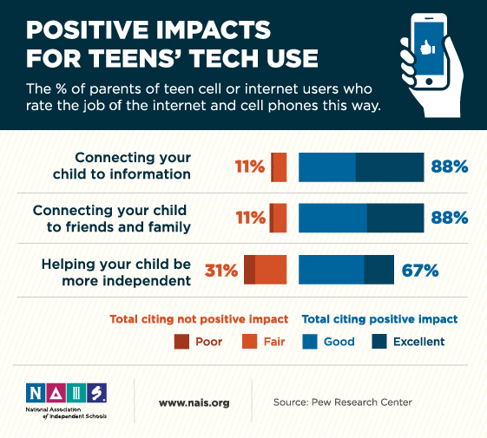
The digital world of a youth’s culture provides a great understanding and account of the major generational differences one sees in an educational environment. A students’ peer culture is likely to be a vital source of skills when mesured up to digital media competence. However, Bourdieu (1977) argues that the dominant classes govern and manipulate the ‘rules’ of the educational field for youths. He explains his findings by suggesting that the cultural competences regarded by said dominant classes are expected and solely provided to “privilaged youth during their childhood”. (Rafalow, 2016, p. 43). Minority and poor children come from a different background to those of the dominant class and therefore, as expected, develop alternate beliefs, practices and styles which, unsurprisingly, do not meet the “rules” of the educational field.

A stereotypical youth, nowadays, often behaves in a contradictory manor, e.g. whilst he/she can be selfish, deviant and irrational, they can also be engaged, tolerant and extremely creative – all at once. The youth culture is largely labelled and characterized as the “generation ‘x’” simply due to the effects of concerned expressions from adults about “the nature and trajectories of social groups” (Wortham, 2010, p. 2). In his article ‘Youth Cultures and Education’, Wortham clearly addresses the importance for educators to understand and attend to all circulating accounts of youth. He explains how these accounts provide a structure of attitudes and, in many cases, the policies of which the youth culture is influenced by. Is it possible, by taking such misleading details of youth for granted, educators may fail to understand their culture and young people will be subject to counterproductive treatment. However, an attempt to understand their views can provide a cooperation between student and educator and in time create a successful workplace.

Youth culture is often represented as the ‘generation x’ or ‘the digital age’. The Twenty-First Century has outlined the major generational differences in technology and the influence social media platforms such as Instagram and Facebook have on youth culture today.

Youth Cultures and Digital Technologies in Education

Internet and Youth Culture
The crisis facing many educators across the globe today is one that many can and will relate to. Youths or young people are facing a pressure to divert away from social media platforms and the use of the internet in social situations. Why? Many educators, parents and adults are anxious of the influence platforms such as Facebook and Instagram are having on the youths of the Twenty-First Century. Influencers on these platforms, some may argue, are projecting a false way of living along with an image many youths are desperate to fit. Adolescents absorbed in these lifestyles are living in what some may call a postmodern youth culture, which is indistinguishably shaped by televsion, social media and the information society. An article discussing postmodern youth culture in Australia claims that school curriculums are no longer exciting or stimluating for adolescents with these digital values. (Tinning & Fitzclarence, 2012)

Literature surrounding the subject of internet and youth culture suggests different views regarding the role of technology in society. The major perspectives include technological determinism.
- Technological Determinism
- Innovative force with a thorough prerogative for children and young people.
- “Net-generation” and “digital natives” – adolescents who experienced childhood during the expansion of the internet and had been “immersed in a media-rich environment.” (Mesch, 2011)
Educational relationship
- Information is thought of and processed differently compared to past generations.
- Experimentation is more gratifying and very likely.
- Dependent on information technologies when inquiring studies and experimental research.
- Eager to master multimedia skills required by certain projects and/or professions.
ARGUMENT: The internet has established a generation whom possess a more sophisticated view and knowledge of skills by the utilisation of information technologies. This generation of youth culture have learnt to express learning supported values from their own experiences and the creation of a culture in a digital space, with specific learning and social preferences.

Heading 1

Bibliography
Frechette, J. & Williams, R., 2016. Media Education for a Digital Generation. 1st Edition ed. New York: Routledge.
Mesch, G. S., 2011. The Internet and Youth Culture. The Hedgehog Review, pp. 50-60.
Rafalow, M., 2016. Disciplining Play: Education and Youth Culture in the Twenty-First Century. p. 43.
Tinning, R. & Fitzclarence, L., 2012. Postmodern Youth Culture and the Crisis in Australian Secondary School Physical Education. Quest, 44(3), pp. 287-303.
Wortham, S., 2010. Youth Cultures and Education. Review of Research in Education, 02 11.

