

Combustion Emissions, CALCULATIONS AND MAPPING FOR EFFICIENCY
Powertrain and Sustainability

February 22, 2018
Bernadette marie gray
P141311

Contents

1.0 Introduction 2
2.0 Mapping 3
2.1 Drive Cycle, NEDC 3
2.2 Maps 4
2.2.2 Lambda 4
2.2.2.1 Lambda Data 4
2.2.2.2 Lambda 3D Map 5
2.2.3 Equivalence Ratio 6
2.2.3.1 Equivalence Ratio Excel Data 6
2.2.3.2 Equivalence Ratio 3D Map 7
2.2.3.3 Flame Speed 7
2.2.3.4 Justification for Lambda and Fuel Equivalence Ratio Data 8
2.2.4 Ignition Timing 9
2.2.4.1 MBT Timing - Maximum Brake Torque Timing 9
2.2.4.2 Knock 9
2.2.4.3 Ignition Timing Map 10
2.2.4.4 Strategy for Knock Protection, Fuelling and Starting 11
3.0 Reducing NOx and Hydrocarbons for the NEDC cycle 12
4.0 Analysis of 1.2Litre GDI Turbo 13
4.1 Hardware Limit and Knock Limit 13
4.2 Burn/Flame Duration 13
4.3 Fuelling Strategies 15
4.4 BSFC 15
5.0 Appendix 17
5.1 Fuel Injectors 17
5.2 Engine Efficiency 19
6.0 List of Figures, Tables, Equations 21
7.0 References 22

1.0 Introduction

In this report engine maps have been created on a Naturally Aspirated engine, the vehicle assumed to be used is an Audi A3, 1.6ltre. The vehicle needed to meet the emissions cycle by using different values of lambda to achieve the desired fuel equivalence ratio. The maps created are for fuel consumption, ignition timing and a strategy for knock protection and cranking and taking into consideration temperatures at high loads.
From carburettors to fuel injection, fuelling strategies in modern technologies have never been better or cleaner, so society and the government think. Since the Volkswagen scandal of the defeat device a new drive cycle has been introduced, a random test cycle.
With stricter European Legislations and a new drive cycle, World Light-Vehicle Test Procedure being introduced in September 2018, stricter laws and growing technology means tighter emissions for vehicles.
The New European Drive Cycle, NEDC full test starts with four repetitions of the urban drive cycle over approximately 200 seconds. The cycle is showing city conditions using low load and low exhaust gas temperature and an extra urban drive cycle, with a more aggressive and high-speed mode.
Using the type of base maps in this report, alongside an intelligent ECU, fuelling strategies can be manipulated to suit these test conditions to meet the current legislations for emissions.
This report is presenting the correlation between mapping and how it is tuned to achieve the correct timing for ignition, to then have the best power with still stricter emissions.

2.0 Mapping

2.1 Drive Cycle, NEDC
800RPM has been used as the starting point for the RPM, this is because the engine is idling (uk-air.defra, n.d.).
Figure 1 is showing the section of the table which is used for the NEDC drive cycle, this information is known as it has been completed from another report by the author. During the emissions cycle, the vehicle is only run at part load at lower RPM’s, the use of Lambda 1 has been used at low load, low RPM to meet the fuelling requirements of the legislation. Figure 1 is showing the Engine Torque on the left-hand side, in response to the RPM, on the top of the table. This section will discuss the benefits and reasoning of using different lambda or fuel equivalence ratio settings and ignition for different loads and RPM. Figure 2 is from a previous report carried out on the NEDC drive cycle, and it is showing the maximum RPM the vehicle can
Figure 1 Drive Cycle Highlighted

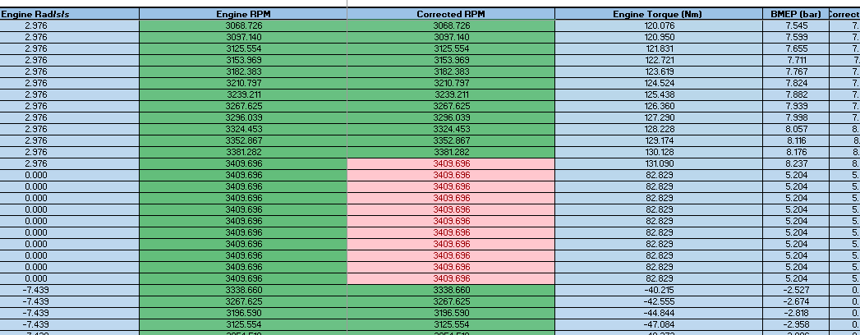
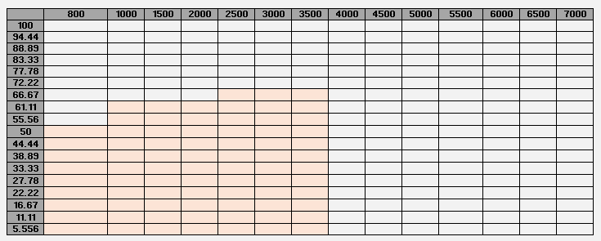
Figure 2 Drive Cycle Maximum Calculated RPM

2.2 Maps

2.2.2 Lambda
$$Lambda \left(λ\right)=\frac{AFR}{AFR_stoich}$$
Lambda is the ratio of the actual Air:Fuel Ratio to the stoichiometric Air:Fuel Ratio, 14.7:1 (EngineeringToolBox, n.d.). Stoichiometric combustion is the ideal combustion where all the reactants in the air and fuel have mixed with limited dissociation of the molecules. With any unburned molecules in the exhaust, it emits C,H₂ and CO, this means the combustion is uncomplete. To ensure that the engine is mapped efficiently at different temperatures and loads and to meet the drive cycle, lambda has been used against load and rpm range and been altered to achieve best fuel consumption and emissions.

2.2.2.1 Lambda Data
With air deficiency, lambda is less than 1, indicating a rich mixture. Enriching can help protect engine from overheating, reducing exhaust gas temperatures as fuel is only being converted to CO.
“Maximum engine output results at Lambda = 0.85 to 0.95” (Reif, 2014)
With air surplus, lambda is more than 1, indicating a lean mixture, the excess air is characterised by reduced fuel consumption. The maximum value for lean lambda is dependent on engine. If it is too lean, the mixture will no longer be ignitable. At higher RPM’s the temperature will be increasing adding extra fuel will be reducing the temperature.
Table 1 IsoOctane Reactants and Products
C₈H₁₈ + 12.5 (O₂ + 3.76N₂) | => => => | 8 CO₂ + 9 H₂O + 47N₂
Equation 1 Mass of IsoOctane
$$FMass=8 ×12+18 ×1=114 g/mol IsoOctane$$

Adding mass to the combustion products lowers the temperatures as the air and fuel mixture has become diluted.

Equation 2 Ideal Gas Law
$$T=\frac{PV}{nR}$$

Where:
P | Pressure
V | Volume
R | Universal Gas Constant
n | No of Moles

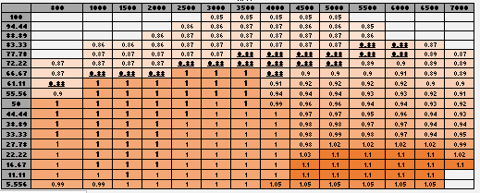
Figure 3 Lambda Excel Data

2.2.2.2 Lambda 3D Map

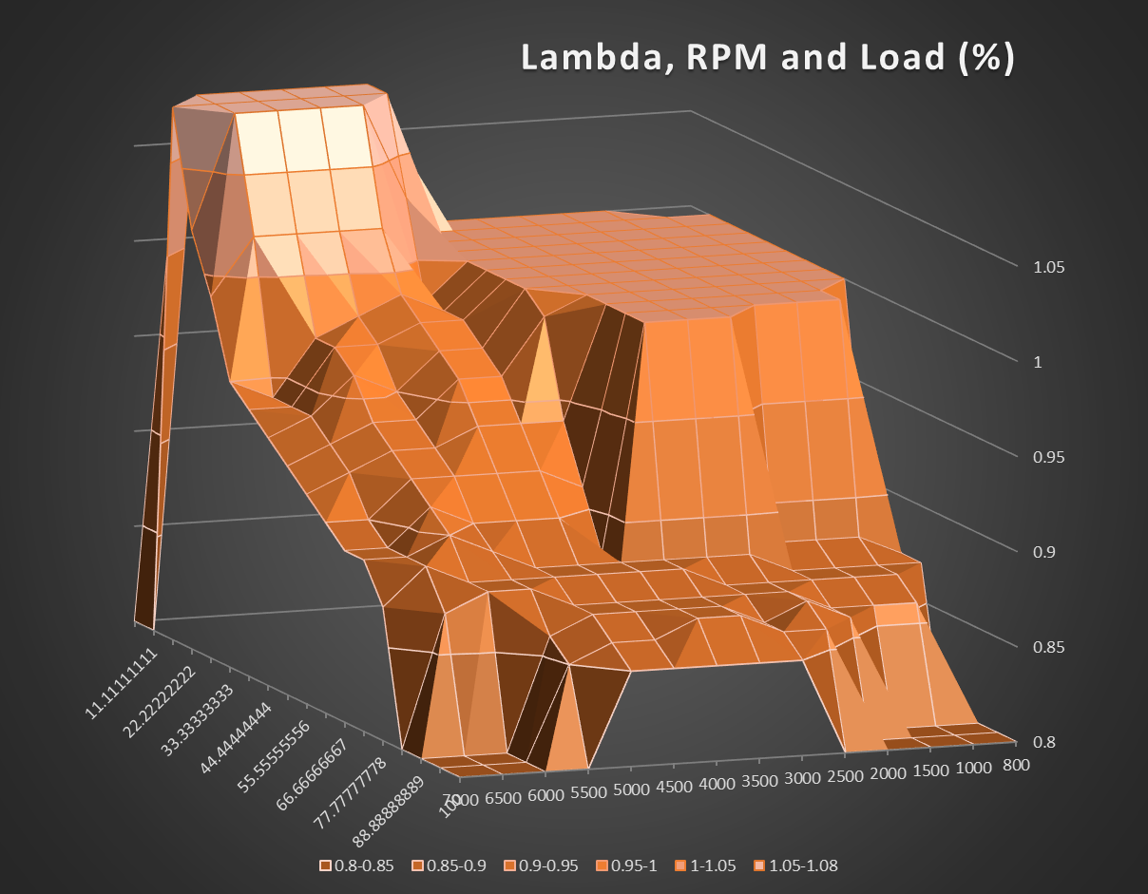
Figure 4 Lambda Map

2.2.3 Equivalence Ratio

Equation 3 Fuel Equivalence Ratio
$$Ф \left(Equivalence Ratio\right)=\frac{1}{λ \left(Lambda\right)}$$
$$Ф \left(Equivalence Ratio\right)=\frac{1}{0.78}=1.28=28\% Rich$$
The equivalence ratio is the ratio of actual fuel to air ratio divided by the theoretical fuel to air ratio, the theoretical ratio is the stoichiometric ratio. If the equivalence ratio is less than 1 it is a lean mixture, when the equivalence ratio is greater than 1 it is a rich mixture.

2.2.3.1 Equivalence Ratio Excel Data
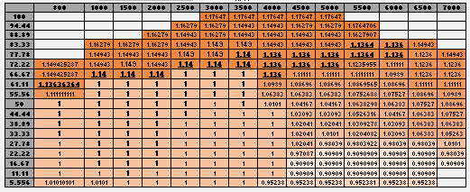
Figure 5 Equivalence Ratio Excel Data

2.2.3.2 Equivalence Ratio 3D Map
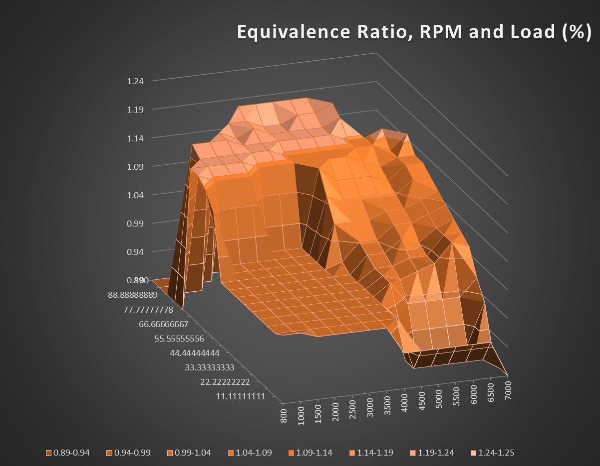
Figure 6 Equivalence Ratio Map

2.2.3.3 Flame Speed

Equation 4 Laminar Flame Speed
$$S_{l},0= B_{m}+B_{λ} {\left(\frac{1}{λ}-\frac{1}{λ_{m}}\right)}^{2}$$
Where:
Bm | 26.3 (cm/s)
B λ | -84.7 (cm/s)
λm | Air Fuel Equivalence Ratio, where Bm is max = (0.88)

For IsoOctane to achieve the maximum power, 0.88 is used for lambda (Reif, 2014).
Lean patches are not good for flame speed, running rich means that it won’t take as long for flame speed to move as they are cold. The maximum average flame speed is to avoid lean patches by running rich (McDonald, 2018). As the molecules get bigger the speed gets slower, therefore it must warm up ahead of the flame to burn faster and smaller molecules burn faster as they have higher random velocity and feed flame faster. The less air and fuel in the cylinder, the lower the flame speed will be. As you have less fuel it will burn slower, so you lean off to Lambda=0.85.

2.2.3.4 Justification for Lambda and Fuel Equivalence Ratio Data
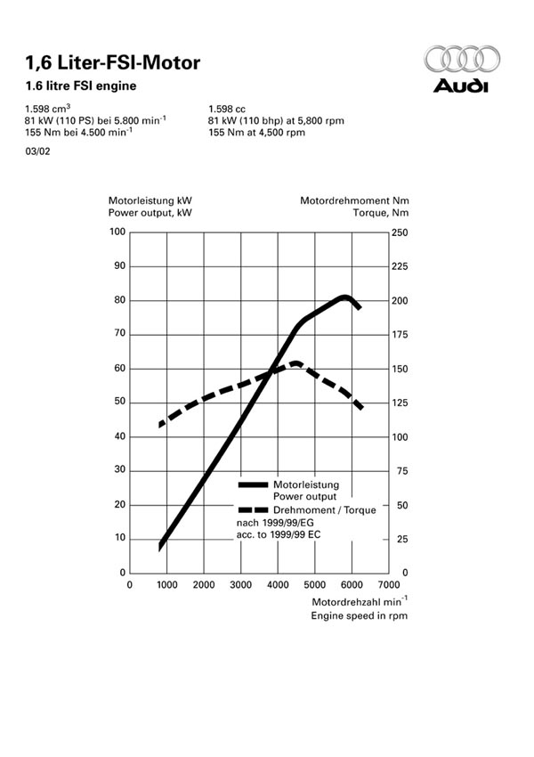
Due to the fuel equivalence ratio and the lambda being in relation to one another analysis is being completed in one section. As stated in the brief, the mapping needs to emit power but keep to the drive cycle standards. The lambda circled is showing that at legal testing it is 1 where the fuel consumption is important, this is the drive cycle section as mentioned in the first section.
Figure 7 Audi Power Range
To protect the catalysts, exhaust gas treatment with a 3-way catalyst convertor can only convert all three pollutants mentioned above at Lambda = 1 (Reif, 2014).
Spark ignited engines achieve the lowest fuel consumption at constant engine output at 20 to 50% air surplus, Lambda = 1.2 to 1.5 (Reif, 2014) this can be seen at low load and high RPM.
The smaller circle is showing that at higher RPM, lambda is between 0.8-0.88 this is to achieve the power range. Figure 7 was used to find where to input the most power, this was used at mostly 3500-4500RPM as will be the useable power of the engine.
At low load and low RPM, the fuel mixture is slightly rich, this is due to having low air speed at idle, that the intake can experience fuel drop out.
The bottom row is showing the overrun when the engine goes from high RPM to low load and down to low RPM. Leaning the fuel at low load and high rpm gives a desirable popping noise, due to unburned fuel igniting on the overrun.
At high RPM, the engine will be experiencing high temperatures, applying a rich lambda at high RPM will cool off the valves and the temperature to limit knock.

2.2.4 Ignition Timing
As combustion does not complete instantly, and the volume is changing, ignition timing is critical for combustion to achieve the most useful work. Igniting the mixture early, the pressure can increase due to the heat from the flame before TDC and would generate negative work. If the mixture isn’t ignited on time, the heat release process is not efficient enough to emit enough torque (Guoming., 2003).
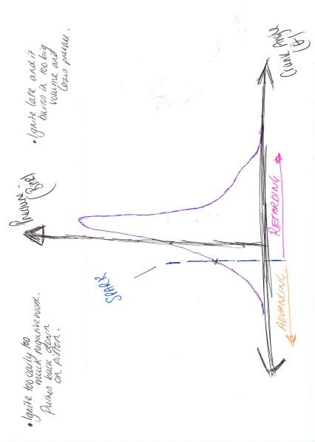
Figure 8 Ignition Timing on A Pressure vs Angle Graph

2.2.4.1 MBT Timing - Maximum Brake Torque Timing
MBT timing for an internal combustion engine can also be called minimum spark timing for the best torque, or maximum brake torque. Unless the engine is limited by engine knock or emission standards then MBT timing will need to be in operational conditions. In this case, it has been inputted for mid-range use of RPM and mid load. Traditionally, MBT timing for an engine will be determined by completing a spark sweep process that requires a substantial amount of time to obtain MBT calibration. Based on research, the peak cylinder pressure occurs around 15° after top dead centre, ATDC, at MBT timing. The 50% of mass fraction burned point occurs between 8-10° ATDC when MBT timing is achieved. By combining the combustion process and the cylinder volume it will achieve the best torque output (Guoming., 2003).

2.2.4.2 Knock
Knock is the name given to the noise transmitted through the engine structure. It is spontaneous ignition that happened ahead of the propagation flame. There is an extreme rapid release of pressure from the flame and pressure waves of high amplitude spread across the chamber. There is also a type of knock which occurs on a hot surface, it can happen before spark or after. A flame develops on an overheated service or deposits in the chamber, creating a pressure wave (Fouzi, 2015). In an engine with pinging, the flame front can be 12 times as faster than normal (peugeotlogic, n.d.). This causes an excessive increase of pressure and temperature inside the combustion chamber, the higher temperatures will cause the unburned mixture to self-ignite and then accelerate the combustion process further. The second combustion is what causes the pinging noise in the engine. These vibrations are picked up by knock sensors, and the ignition timing is retarded until the knock is no longer detected.

2.2.4.3 Ignition Timing Map
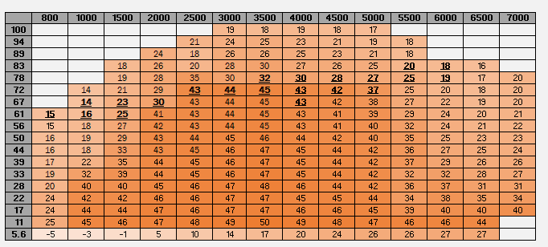
Figure 9 Ignition Timing Map

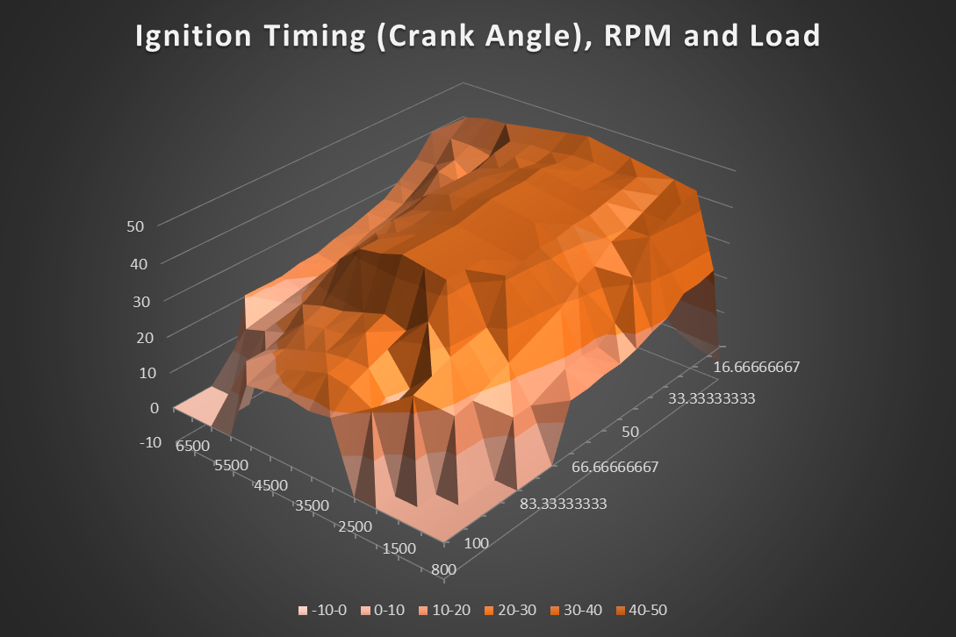
Figure 10 Ignition Timing 3D Map

The engine used has 2 valves per cylinder, compared to a 4 valve cylinder the ignition will be more advanced than a 3 due to less efficiency engine chamber design (Walker, 2008).
The ignition map has been separated into different sections for different applications, Low Load/Cruising/ High Load/Overrun. As the RPM increases from 800RPM to 3000RPM the flame will not be in correlation to the speed, so the ignition has been advanced. Above 3000RPM the temperature rises, and the laminar flame speed keeps pace with RPM and burn duration stays constant.
The minus numbers in the table are representing the crank angle at 3 degrees after top dead centre, the ignition has been well retarded from MBT to keep the idle speed under control and to stop the engine overrunning. On deceleration, retarding the ignition will give smoother engine braking, and it will give the exhaust popping noise.
Due to the slower combustion at light loads the ignition has been advanced. When lift off accelerator and less air is in the cylinder. With a low crank angle, the ignition can suddenly be retarded, this can be to torque curve or avoid detonation. The Audi A3 at light loads has an advance of 40-47° in the 2500RPM-4500RPM and mid load region, this is for responsiveness and economy.
The ignition timing begins to retard at high load and high RPM to limit any knock in the engine, at high RPM and low-mid load it has also been retarded as the power begins to decrease. At the peak power, (in bold) the ignition has been advanced to 35-40°.

2.2.4.4 Strategy for Knock Protection, Fuelling and Starting
When mapping for cold starting, the cranking enrichment has to decay away. The engine is now running on warm enrichment, the temperature is cooled. Influencing the temperature can depend on advancing the ignition as this helps to increase cold idle rpm, making the engine run smooth.
The right cold running mixture at idle is to have less enrichment and increased engine speed, the higher the engine rpm the higher the air speed, so less droplets of fuel are wasted, which creates a richer mixture (Walker, 2008).
Figure 11 Cold starting, Enrichment, Temperature and Ignition Data

To avoid soot and unburned hydrocarbons condensation occurs when either the air/walls are cold. The % extra over the injection opening times in the main base map – warm up correction map. For the ignition, you add the number in the table to the base map, there is a lot of fuel drop out with low air speed.
Cold Start: The engine requires extra fuel when starting due to condensation, if the car doesn’t start right away it can flood the spark plugs, the starting map is to ensure that the enrichment is only for a few cycles and ten back to the base map. At starting the air flow is minimal, with fuel injection the system controls the air by bypassing the closed throttle.
Warm start: A warm engine helps promote fuel vaporization, the engine can benefit from a small proportion of enrichment. The fuel injection system will be able to detect from sensors whether this is needed.
Hot Start: At higher temperatures, it is dangerous, ensuring a thermostat reading is correct the and working over 75° it will have calculated to use the region on the far right.
The ignition values will be added to the ignition base map for the designated temperatures to ensure that the chamber is not near detonation.

3.0 Reducing NOx and Hydrocarbons for the NEDC cycle

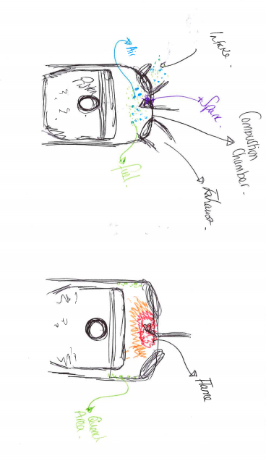
High hydrocarbons are normally caused by an engine misfire caused by worn spark plugs, loose spark plug wires, incorrect ignition timing and/or lean air-fuel mixture. During a misfire, the unburned hydrocarbons will be pushed out the cylinder by the piston on the exhaust stroke. High hydrocarbons is normally caused by an excessively rich air/fuel mixture. A fouled spark plug doesn’t ignite the mixture, if the temperature is too low, the cylinder walls are not hot enough, so the fuel is easily vaporized and condensed. The flame is quenched out when it reaches the sides and the cooler parts on the chamber. This is called the quench area (Halderman, 2006).
Figure 12 Quench Area in Chamber

If the ignition is too advanced, there is too much negative work and the fuel and air rich patches will burn outside and have unburned molecules inside the patch as it doesn’t ignite (Halderman, 2006).
NOx occurs mostly under high load, due to the combustion pressure increasing and the temperature. Accelerating a vehicle onto a motorway is an example of high NOx due to the high load transmitted. At steady throttle and light loads, ignition timing is advanced, this can result to high NOx. As the engine temperature is higher, the peak temperature inside combustion results to more dissociation of the molecules. Adding EGR lowers the temperatures and dilutes the intake air into the cylinder (Halderman, 2006).

4.0 Analysis of 1.2Litre GDI Turbo

Attachment Figure 1: Ignition Timing
Attachment Figure 2: Exhaust Lambda
Attachment Figure 3: PMax Average
Attachment Figure 4: Angle of PMax
In this section graphs have been used from a 1.2Litre GDI Turbo to analyse the effects of all the mentioned variables above.

4.1 Hardware Limit and Knock Limit
The hardware limit is put in place to prevent any damage happening to the engine, for this engine, the limit is 140BAR, (Hancock, 2008) in relation to limiting the knock in the engine.
Looking at Attachment Figure 1 and 3, the pressure is in relation to the ignition. PMax is occurring at 3500RPM and at 3000BMEP, 3 BAR. BMEP, is another way of presenting load of an engine. As the hardware limit is 140BAR, the ignition has been retarded heavily to 3.3°BTDC at full load from 17.6° at part load at 4000RPM. The pressure increases from 81.7BAR to 118.8BAR. Ignition retarding is being used as a means of knock limit, to prevent any high temperatures occurring and detonation. When the ignition is being retarded on the map, the pressure can be too high which can cause excessive compression resulting to autoignition. At high load the turbo can not run MBT timing hence dramatic retarding.

4.2 Burn/Flame Duration
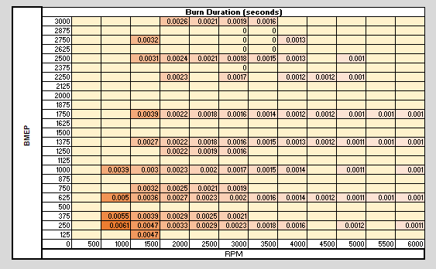
The burn duration was taken by adding the ignition timing angle to the PMax Angle on the graphs. The angle was then converted into seconds. At lower RPM’s the flame speed has slowed down, (Audi example) Figure 13, resulting to ignition advance as seen in Attachment Figure 1. The flame speed increases at higher RPM therefore the burn duration decreases. the flame front consists of two regions, preheat zone and a reaction zone. Optimum spark advance and extreme cyclic variations limit engine operation. Fastest burning cycles with an over advanced spark timing have high tendency to knock, slowest burning cycles with retarded spark timing are likely to burn incompletely. Ensuring a perfect burn, will generate a clean flame to convert chemical energy into mechanical.
Figure 13 Burn Duration for 1.2L GDI
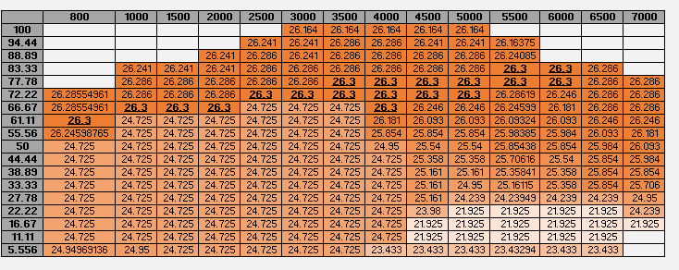
Figure 15 Flame Speed for Audi A3

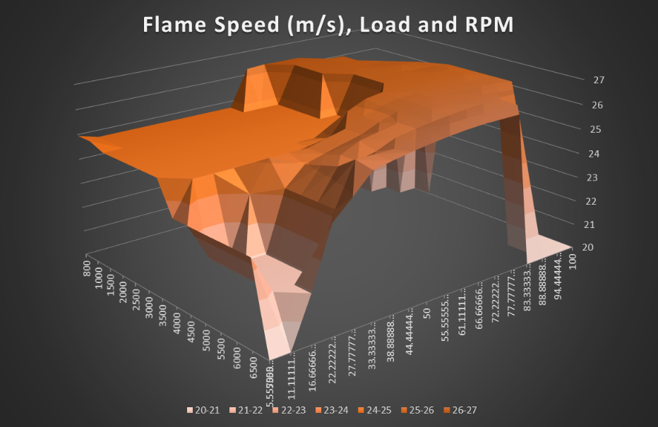
Figure 14 Flame Speed Audi A3 3D Map

4.3 Fuelling Strategies
At high RPM and High BMEP, the Lambda graph, Attachment Figure 2, has a rich patch showing a range of 0.92 – 0.98, this is indicating that the engine is running slightly hot. Having a rich mixture is less likely to ignite As it is a turbocharged engine, the lambda values are higher than the Audi, which is naturally aspirated. When the engine is over fuelled and added EGR it makes harder for spontaneous flame to propagate, lean mixture is also less explosive. At low RPM, the unburned zone is waiting longer in time for the flame to approach therefore it is more likely for knock. At 1000RPM the engine is running 0.99 Lambda at the lowest load this is because it is not hot enough to burn the soot of the spark plugs, hence why it is lean.

4.4 BSFC

Equation 5 Calculations used to calculate BSFC
$$1 Kg of fuel has energy=44x{10}^{6}Joules$$
$$1 gm of fuel has energy=44x{10}^{6}Joules$$
$$Energy Effiency η=0.3$$
$${Useful}/{Flywheel work out of 1gm worth of fuel=η x Fuel Enrgy }$$
$$Mechanical Energy Porduced=\frac{1000J}{Sec}for 3600 Seconds, 1Kw Hour=3.6x{10}^{6}Joules$$
$$BSFC=Actual Grams x η x useful work$$
$$BSFC=\frac{Actual Grams used for 1Kw for 1Hr}{η x Useful Work }$$

Equation 6 Power Kw
$$Power \left(Kw\right)= BMEP x Engine Displacement x\frac{RPM}{120}$$
$$Fuel Flow \left({kg}/h\right)=\frac{Air Flow \left({kh}/h\right)}{AirFuelRatio x Lambda (1)}$$
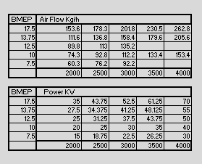
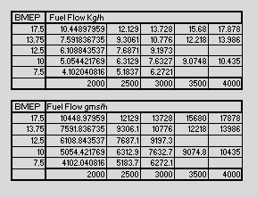
Figure 16 Values from Above Calculations

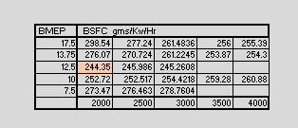
Figure 17 BSFC Values

After using the calculations above the BSFC. Brake Specific Fuel Consumption is a measure of the fuel efficiency of fuel that is burned and produces power and torque, from chemical to kinetic motion. At 2000 RPM and with a load of 12.5BMEP the fuel efficiency is at its lowest. This could be due to the lambda running at 1 during this period, Attachment Figure 2, with an efficient ignition timing.
In real life situations when carrying out these tests, it will be on a dyno with real live data and power/torque curves will be generated. Unfortunately this could not be achieved therefore the values that are in this are from assumptions and static data.

5.0 Appendix

5.1 Fuel Injectors
The method used in modern cars for fuelling are fuel injectors, either in a direct injection, port injection, multi and sequential. Fuel injectors are controlled electronically to enable precise fuelling strategies for every cylinder, working in milliseconds.
When designing fuel injectors for production vehicles, the smaller the nozzle on the injector Figure 2. The duty cycle is the time the injector is open for, this duty cycle varies for each RPM. At high RPM and full throttle the fuel injector will open for longer, and at lower RPM with lower volumetric efficiency, low load, the duty cycle is reduced.
https://www.dieselnet.com/tech/diesel_fi_pro.php

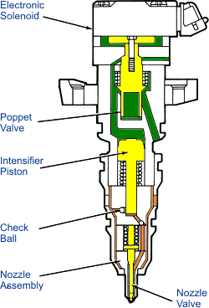
Figure 18 Fuel Injector
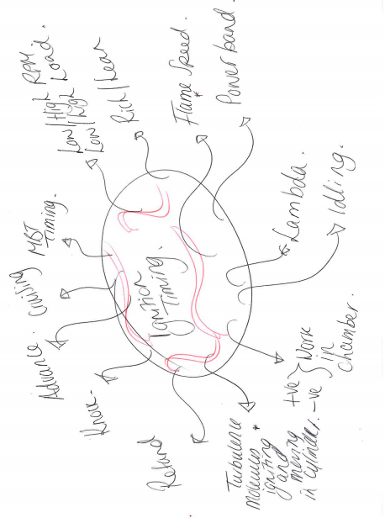
Figure 19 Ignition Timing Brainstorm

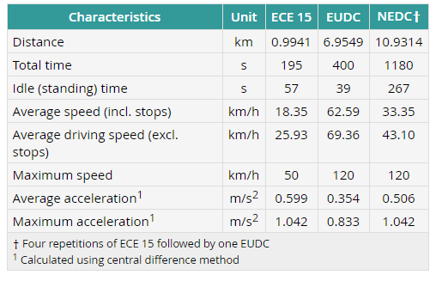
Figure 20 NEDC Drive Cycle (DieselNet, n.d.)

5.2 Engine Efficiency
$$Work Done (W)=Qin-Qout$$
Equation 7 Work Done
Where:
Qin: Heat in
Qout = Heat out

The work done in the cycle is the difference between how much heat goes into a cycle and how much is released out. The cycle efficiency can also be calculated by using the work done.

$$ɳ= \frac{W}{Qin}= \frac{Qin-Qout }{Qin}$$
$$\frac{Qin}{Qin}= \frac{Qout}{Qout} , ɳ=1- \frac{Qout}{Qin}$$
$$ɳ (cycle efficiency)=1- \frac{1}{CR^{ˠ-1}}$$
Equation 8 Cycle Efficiency Derivation
Where:
CR: Compression Ratio
ɣ (Gamma) : 1.2 -1.4. Ratio of Specific Heats

Gamma is a number that is dependable on the state of a gas. Gamma appears in many fluid equations including the equation relating to pressure, temperature and column during a simple compression and expansion process. The value of gamma just depends on the state of the gas (Hall, 2015). Gamma is related to specific heat.
$$ɣ=1+\frac{R}{CV } = \frac{Cp}{Cv}$$
Equation 9 Gamma

$$Cp=Cv+R$$
Where:
CV: Specific Heat at Constant Volume
R : Gas Constant
Cp: Specific Heat at Constant Pressure
Equation 10 Constant Pressure
Cp is the heat required to raise the temperature of 1kg of gas to 1Kelvin at a constant pressure

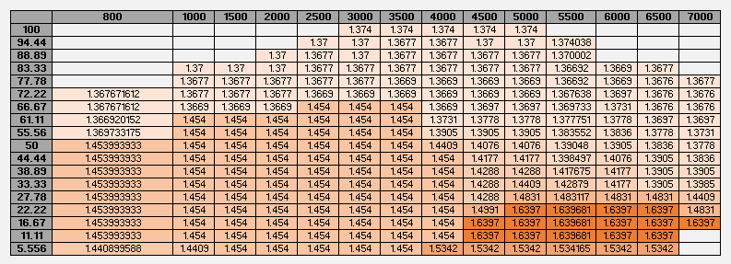
Figure 21 Burn Duration for Audi A3

6.0 List of Figures, Tables, Equations

Figure 1 Drive Cycle Highlighted 3
Figure 2 Drive Cycle Maximum Calculated RPM 3
Figure 3 Lambda Excel Data 5
Figure 4 Lambda Map 5
Figure 5 Equivalence Ratio Excel Data 6
Figure 6 Equivalence Ratio Map 7
Figure 7 Audi Power Range 8
Figure 8 Ignition Timing on A Pressure vs Angle Graph 9
Figure 9 Ignition Timing Map 10
Figure 10 Ignition Timing 3D Map 10
Figure 11 Cold starting, Enrichment, Temperature and Ignition Data 11
Figure 12 Quench Area in Chamber 12
Figure 13 Burn Duration for 1.2L GDI 13
Figure 14 Flame Speed Audi A3 3D Map 14
Figure 15 Flame Speed for Audi A3 14
Figure 16 Values from Above Calculations 15
Figure 17 BSFC Values 16
Figure 18 Fuel Injector 17
Figure 19 Ignition Timing Brainstorm 18
Figure 20 NEDC Drive Cycle (DieselNet, n.d.) 18
Figure 21 Burn Duration for Audi A3 20

Equation 1 Mass of IsoOctane 4
Equation 2 Ideal Gas Law 4
Equation 3 Fuel Equivalence Ratio 6
Equation 4 Laminar Flame Speed 7
Equation 5 Calculations used to calculate BSFC 15
Equation 6 Power Kw 15
Equation 7 Work Done 19
Equation 8 Cycle Efficiency Derivation 19
Equation 9 Gamma 19
Equation 10 Constant Pressure 19

7.0 References

DieselNet. (n.d.). Emissions Test Cycle. Retrieved from www.dieselnet.com: https://www.dieselnet.com/standards/cycles/ece_eudc.php
EngineeringToolBox. (n.d.). Stoichiometric Combustion . Retrieved from engineeringtoolbox.com: https://www.engineeringtoolbox.com/stoichiometric-combustion-d_399.html
Fouzi, M. S. (2015). Combustion and Fuel Characteristics .
Guoming., Z. (2003). MBT Timing Detection and it's Closed Loop Control Using In-Cylinder Pressure Signal. SAE International.
Halderman, J. (2006). Automotive Fuel and Emissions Contrl. New Jersey: Pearson Education .
Hall, N. (2015, May 05). Specific Heats . Retrieved from grc: https://www.grc.nasa.gov/www/k-12/airplane/specheat.html
Hancock, D. (2008). New 3 Cylinder 1.2l Advanced Downsizing Technology Demonstrator. Michigan: SAE Technical Paper Series.
McDonald, M. (2018, Jan 22). Lecture Notes . Swansea.
peugeotlogic. (n.d.). www.peugeotlogic.com. Retrieved from Engine Pinging: http://www.peugeotlogic.com/info/info1.htm
Prosbat, C. O. (1989). Bosch Fuel Injection Management. Massachusetts: Robert Bently Inc.
Reif, P. D.-I. (2014). Bosch Automotive Handbook. Stuttgart: RobertBosch .
uk-air.defra. (n.d.). Appendix 2. Retrieved from uk-air.defra.gov.uk: https://uk-air.defra.gov.uk/assets/documents/reports/cat15/0408171324_Appendix2Issue3toPhase2report.pdf
Walker, D. (2008). Engine Management. Somerset : Haynes.
Walsh, M. (1996). Air Pollution from Motor Vehicles . Washington: The International Bank.

https://www.parkers.co.uk/audi/a3/hatchback-2003/16-3d/specs/
http://citeseerx.ist.psu.edu/viewdoc/download?doi=10.1.1.541.9753&rep=rep1&type=pdf
http://www.formula1-dictionary.net/map_fuel.html
https://books.google.co.uk/books?id=jcikAgAAQBAJ&pg=PA442&lpg=PA442&dq=hardware+limit+engine&source=bl&ots=5GQOor2xyz&sig=gJR8UjIQap9jtS-8BMXxDLPlFZQ&hl=en&sa=X&ved=0ahUKEwjV3qOiqbXZAhWKC8AKHWTxDmgQ6AEIODAD#v=onepage&q=hardware%20limit%20engine&f=false
https://www.audi.co.uk/glossary/f/fsi.html
http://www.eng-tips.com/viewthread.cfm?qid=378251
https://www.epa.gov/sites/production/files/2016-10/documents/std-car-camry-2.4l-engine-mapping-process2016-06-20.pdf
https://books.google.co.uk/books?id=Hqsyv_KD0lgC&printsec=frontcover#v=onepage&q&f=false
https://www.carfolio.com/specifications/models/car/?car=109549

