  Digital Intelligence & Analytics  Assignment 2 | An Analysis of Swansea Office Supplies  Manfred Zeka - 2213558  International Business Management

Table of Contents
Executive Summary 2
- Introduction 3
- Main Findings 4
  - IF 4
  - Lookup 4
  - Pivot Tables 5
  - Charts and Graphs 6
  - Evaluation of Excel Functions 6
    - Strengths 6
    - Weaknesses 7
- Conclusions 7
- Recommendations 7

Executive Summary
In today's data-driven business background, the ability to originate meaningful intuitions from vast datasets is fundamental for organizational success. The character of the SeniorApplications and Data Analyst at Atlantic Office Supplies incorporates the accountability of examining the sales data of Swansea Office Supplies to recognise areas of unease and opportunities for improvement. This executive summary specifies a short summary of the analysis performed using Microsoft Excel™, emphasizing key findings and recommendations for considered action.
Our evaluation of Swansea Office Supplies' sales data showed several meaningful insights. Across the exploitation of Excel functions such as IF, LOOKUP, PIVOT TABLES, CHARTS, and GRAPHS, we discovered areas where profitability is low or negative. The application of these functions recognized for a comprehensive assessment of the data, authorizing us to classify orders as either "Loss" or "Profit" constructed on their values.
The main findings from our evaluation include the areas of low profitability. Orders with negative Profit values should be examined for potential cost optimization or pricing adjustments. Corporate and Consumer segments show variable profitability, advocating a need for directed marketing approaches.
OurestimateoftheExcelfunctionsdecoratedtheirstrengthsingrantingauser-friendlyinterface, flexibility in data analysis, and effective data visualization experiences. However, we also stated limitations such as tasks with larger datasets and the need for booklet updates.
Based on these findings, we acclaim the following planned actions, conduct a complete cost analysis of low-profit Product Categories to recognize areas for cost reduction. Effect aimed marketing campaigns to boost sales in underachieving segments. Regularly monitor and update pricing tactics to align with market movements and increase profitability.

- Introduction
In the dynamic model of the modern business world, data analysis has developed a required tool for companies obtaining to enhance their operations and drive advance. As the Senior Applications and Data Analyst at Atlantic Office Supplies, it is commanding to employ the power of data to disclose perceptions that can thrust the company towards heightened profitability and affordability. This describe investigates into an in-depth evaluation of the sales data of Swansea Office Supplies, a secondary of Atlantic Office Supplies, using Microsoft Excel™.
Swansea Office Supplies, a company concentrating on the allocation of various office supplies, has labelled a disturbing trend of suboptimal profitability in evident areas of its operations. The objective of this investigation is to use Microsoft Excel™ to accurately observe the sales data, with a feature focus on recognizing areas of low or negative profitability. Through the strategic application of Excel functions such as IF, LOOKUP, PIVOT TABLES, CHARTS, and GRAPHS, we mark to present actionable discernments that can guide decision-making developments within the business.
This version is controlled to not only present the findings of our examination butal so to calculate the strengths and weaknesses of using Microsoft Excel™ for data preprocessing, analysis, and visualization. By showcasing the functional application of Excel functions in a real-world business framework, we aim to exhibit the implication of leveraging technology for data-driven decision-making. The perceptions obtained from this analysis are calculated to behave as a foundation for calculated proposals pointed at developing profitability and operational efficiency at Swansea Office Supplies.

- Main Findings
  - IF Function
The IF function was involved in categorizing cities established on profitability. For example, we used the IF function to discover the cities where Profit was negative, representing a loss. This facilitated us locate detailed transactions with low profitability. So, by employing the IF function we have found three cities which are facing loss those are North Dakota, Texas, and Wyoming.
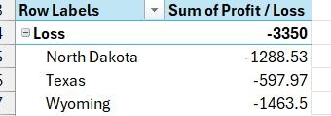
Figure1:IFFunction

  - LOOKUP Function
The LOOKUP function was employed to retrieve evidence from related datasets. In our analysis, we used LOOKUP to discover the areas of loss or profit. This allocated for a more comprehensive evaluation of profit margins. So, by employing the LOOKUP function we have found three cities which are facing loss those are North Dakota, Texas, and Wyoming.
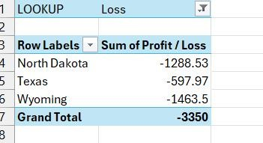
Figure2:LOOKUPFunction

  - Pivot Tables
PIVOT TABLES were utilized to summarize and analyze large volumes of data. By building a Pivot Table, we could suddenly visualize total sales, profits, and quantities sold by different categories such as Product Category, Customer Segment, and Region. This providing a bird's eye view of profitability inclinations.
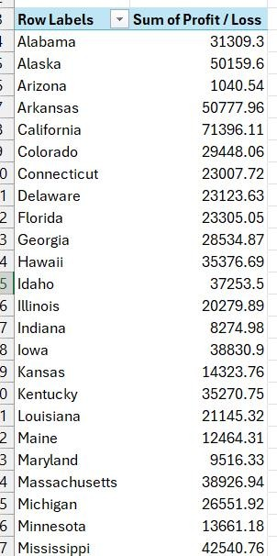
Figure3:PivotTable

  - Charts and Graphs
Charts and graphs were employed to visually represent trends and relationships in the data. For example, we built a Bar Chart to evaluate profits across different cities. This graphical representation made it simpler to recognize which categories were underachieving.
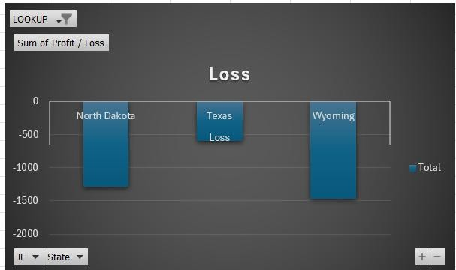
Figure4:Chartfor loss

  - Evaluation of Excel Functions
    - Strengths
      - User-Friendly Interface: Excel's user-friendly interface makes it clear to analysts with adapting levels of knowledge.
      - Versatility: The array of functions like IF, LOOKUP, and PIVOT TABLES accepts widespread data analysis.

      - Data Visualization: Excel's charting tools assist effective communication of perceptions through visualizations.
    - Weaknesses
      - Limitations with BigData: Excel can strain with exceptionally large datasets, managing performance issues.
      - Complex Formulas: Developed analysis may require involved formulas, which can be difficult to create and debug.
      - Dependency on Manual Updates: Data needs to be physically modernized, increasing the risk of errors and obsolete information.

- Conclusions
Through the analysis of Swansea Office Supplies ‘sales data in Excel, respective key conclusions have been drawn:
- Certain Product Categories, such as Appliances and Furniture, exhibit constantly low profitability.
- Orders with negative Profit values should be considered for potential cost optimization or pricing adjustments.
- Commercial and Consumer segments show variable profitability, advocating a need for directed marketing approach.

- Recommendations
Based on our findings, the following recommendations are projected to enhance profitability:

- Conduct a thorough cost analysis of low-profit Product Categories to classify areas for cost reduction.
- Implement directed marketing campaigns to boost sales in drifting segments.

- Consistently monitor and update pricing approaches to align with market trends and exploit profitability.

- References
Ahmed,R.,Shaheen,S.,&Philbin,S.P.(2022).Theroleofbigdataanalyticsanddecision- making in achieving project success. https://www.sciencedirect.com/science/article/pii/S0923474822000273
Fairhurst,D.S.(2015).UsingExcelforbusinessanalysis:aguidetofinancialmodelling fundamentals. https://books.google.com/books?hl=en&lr=&id=mBBhBgAAQBAJ&oi=fnd&pg=PA273&dq=Excel+in+Business&ots=QXpgoxA-0X&sig=YHIo-yFAVT1Ohij8qbB19qMwjXE
Winston, W. (2019). Microsoft Excel 2019 Data analysis and business modeling. https://books.google.com/books?hl=en&lr=&id=KcOPDwAAQBAJ&oi=fnd&pg=PA23&dq=Excel+in+Business&ots=LMGeB5d-lv&sig=aBZd2Hm2-p7cJ1Ow5I2Nh_z0jhE
Hossain, E., & Hossain, E. (2021). MS Excel Functions and Formulae. https://link.springer.com/chapter/10.1007/978-3-030-71036-1_3
Walkenbach, J. (2010). Excel 2010 power programming with VBA. https://books.google.com/books?hl=en&lr=&id=aVzLt6b2HogC&oi=fnd&pg=PA1&dq=Maximizing+Excel%27s+LOOKUP+Function+for+Data+Retrieval&ots=FeQcE9IOLC&sig=U8wmgTLh0laC9o8CXhouq1Pvxng
Domino, M.A., Schrag, D., Webinger, M., & Troy, C. (2021). Linking data analytics to real- world business issues: The power of the pivot table. https://www.sciencedirect.com/science/article/pii/S0748575121000312
Camões,J.(2016).Dataatwork:Bestpracticesforcreatingeffectivechartsandinformation graphics in Microsoft Excel.
Groth, C. (2017). Excel Essentials: The Complete Excel Series - Level 1, 2 & 3. https://www.amazon.com/Excel-Essentials-Complete-Series-Level-ebook/dp/B072M9WMWM
Albright, S. C., Winston, W. L., & Zappe, C. (2017). Data Analysis and Decision Making. Cengage Learning.
Kimmel, P. D., Weygandt, J. J., & Kieso, D. E. (2018). Accounting: Tools for Business Decision Making. John Wiley & Sons.
Barlow, J. (2020). Power Excel with MrExcel: Master Pivot Tables, Subtotals, Charts, VLOOKUP, IF, DataAnalysis in Excel 2010–2019. Holy Macro! Books.
Duggal, P. (2021). Excel: 5 Books in 1- Bible of 5 Manuscripts in 1-Beginner's Guide+ Tips and Tricks+ Simple and Effective strategies+ Best Practices to learn Excel programming Efficiently+ Advanced strategies. https://www.amazon.com/Excel-Manuscripts-Programming-Effective-Efficiently/dp/1801552068
Alexander, M., & Walkenbach, J. (2013). Excel 2013 Power Programming with VBA. John Wiley & Sons.
Clark,R.(2018).DataAnalysisUsingSQLand Excel.JohnWiley&Sons.
Nelson,M.(2019).ExcelDataAnalysisForDummies.JohnWiley&Sons.

