
Student Name: Harsh Narendrakumar Barot
Student Id:2521393
Programme: Master of Business Administration
Module: Marketing Management
Module code: LCMB7024
Module Teacher: Laila Maazouz Taonga Kaonga Sobere-Snithers
Assignment Title: Marketing Environment Analysis: The Case of BHP
Word Count: 2686
Submission Date: 24-07-2026

Table of Contents
1. Task 1: Marketing Environment Analysis 3
1.1 Introduction to BHP and the Lower-Carbon Transition 3
1.2 Analysis of two external marketing environment actors influencing its transition toward lower-carbon products 3
1.2.1 One external factor: Natural Environmental actor analysis 3
1.2.2 Economic actor analysis on lower-carbon products of BHP 7
1.3 Conclusion: Key Opportunities and Challenges 10
2. Task 2: Strategic Growth and Competitive Positioning 10
2.1 Strategic Problem and Growth Objective 10
2.2 Critical Application of the Ansoff Matrix and Justification of the Selected Growth Strategy 11
2.3 Recommended Strategy 12
2.4 Competitive Advantage Through Differentiation 13
2.5 Implementation Requirements for lower-carbon business model 14
2.6 Strategic Risks and Mitigation 14
2.7 Conclusion 15
3. Critical Reflection on AI Usage 15
3.1 AI Tools and Tasks Performed 15
3.2 Tool Disclosure 16
3.3 Critical Evaluation of AI Output 16
3.4 Contribution Analysis 17
3.5 Ethical and Professional Implications 17
References 18

1. Task 1: Marketing Environment Analysis

1.1 Introduction to BHP and the Lower-Carbon Transition
BHP is an Australian resources company that plays a crucial role in connecting mining with the global energy transition through its steelmaking coal, iron ore, and copper operations. According to Kotler et al. (2024), the natural and economic environments act as external forces that influence customer value, costs, and competitive opportunities. For BHP, achieving a lower carbon footprint means they need to blend operational decarbonisation with genuine support for their customers in reducing emissions throughout the value chain.

1.2 Analysis of two external marketing environment actors influencing its transition toward lower-carbon products

1.2.1 One external factor: Natural Environmental actor analysis
Global steel and mining industry carbon pricing competitiveness to mitigate climate change
Figure 1: H2-DRI-EAF Emission-Related Costs
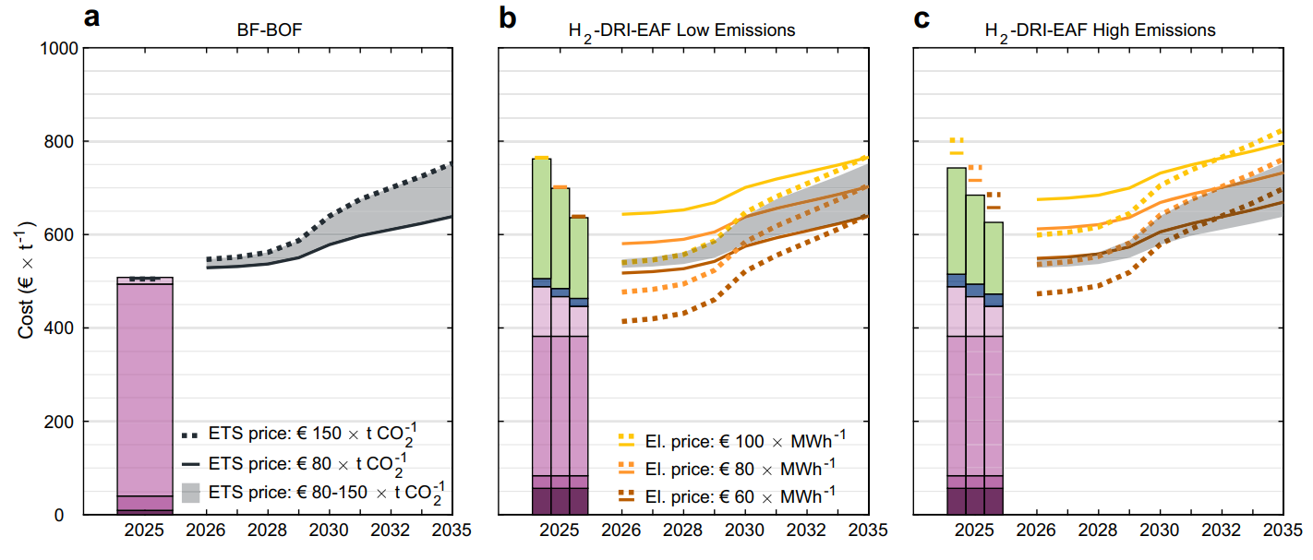
(Source: Johnson et al., 2025)
Mining currently accounts for 4-7% of the world's total greenhouse gas emissions (Reuters, 2025). Europe generates varying H2-DRI-EAF emission-related costs for mining (Johnson et al., 2025). The effect of carbon pricing is to alter the relative cost of production of the various routes by adding a cost to production and pushing up the market value of the verifiably lower-emission input. While the EU Emissions Trading System and Carbon Border Adjustment Mechanism are driving green-steel markets, these markets can be undermined by uneven international prices, which can lead to carbon leakage, and producers in stricter jurisdictions (Johnson et al., 2025).
Climate policy and GHG emissions strategy in the mining sector
The Safeguard Mechanism (declining emissions baselines) applies to large-scale industrial installations in Australia. Safeguard Mechanism Credit units traded around A$38 per tonne in 2025, which had resulted in a slight abatement signal for Australian investments in projects focused on mining. (Clean Energy Regulator, 2025a; Clean Energy Regulator, 2025b)
Carbon emission challenges and investors’ partnership towards net zero carbon emission strategy of BHP
Figure 2: BHP Scope 1&2 Emissions
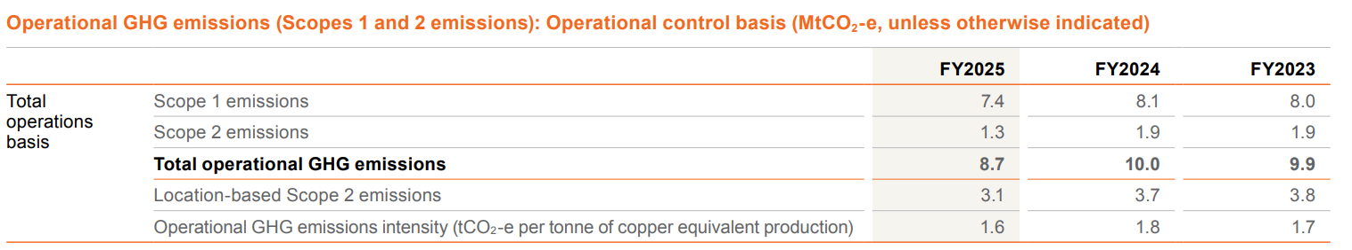
(Source: BHP, 2025a)
Energy and diesel are BHP's primary natural environment concern, as these directly affect carbon operating costs. The energy consumption in FY2025 was 133 Petajoules (PJ), out of which 28 Petajoules (PJ) was from renewables. Market-based Scope 1 emissions were 7.4 MtCO2-e, and Scope 2 emissions were 1.3 MtCO2-e (BHP, 2025a). Electricity-focused emissions were reduced through renewable power purchasing. The significance of battery-electric haulage is highlighted by the fact that at certain open-pit mines, truck fleets can account for up to 80% of emissions (Yu et al., 2024). The trials BHP is conducting with investors, like Caterpillar, Komatsu and CATL, therefore, could limit carbon and fuel-price exposure.
Emissions targets of BHP with scope 3 action plan
Figure 3: BHP Scope 3
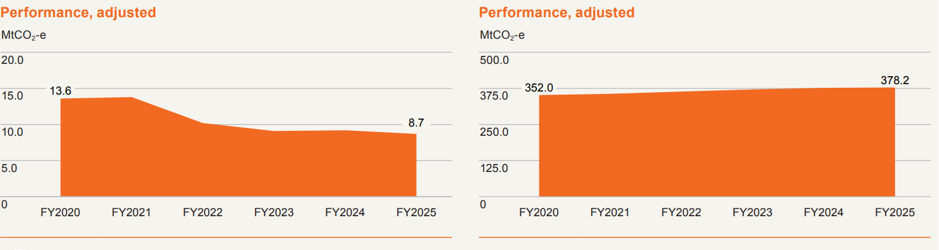
(Source: BHP, 2025a)
BHP's operational emissions-focused reduction goal is to achieve a minimum 30% reduction by FY2030, and a 2050 net zero target. The formal target is measured against a 126.9 MtCO2-e carbon budget (BHP, 2025a). By FY2025, for Scope 3 emissions, BHP had 378.2 MtCO2-e, of which 318.2 MtCO2-e were associated with processing sold products. However, partnerships with steelmaking companies, alongside the NeoSmelt pilot electric-smelting-furnace, can have an impact on the adoption of technology (BHP, 2024a; BHP, 2025b). For product-market relevance, iron-unit emissions intensity was 50% lower than conventional blast furnace-related production using BHP ores (BHP, 2025c).
BHP climate transition action plan in the last 3 years
The climate transition plan has turned into a test for investors and the government. The shareholders provided advisory-led support of 92%, but in 2026 reporting, some of the Pilbara renewable projects were delayed or cancelled (BHP, 2024a; Knaus and Morton, 2026). Clear milestones with goals are therefore crucial.
Roadmap of global steel and mining sector decarbonisation targets and goals by 2050
Figure 4: Decarbonisation Roadmap
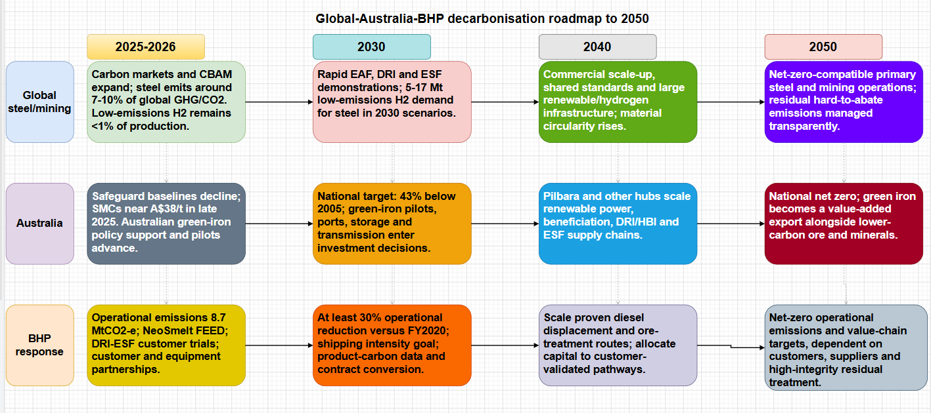
(Source: Self-developed)
The roadmap connects the dots between the tightening global carbon-focused markets, Australia’s ambitious 43% emissions-reduction target, and BHP’s operational strategies. The reasoning makes sense to start with small-scale pilots before moving to larger commercial applications, and BHP’s goal of a 30% operational reduction by FY2030 serves as a solid benchmark for progress. Still, challenges like hydrogen shortages and the slow readiness of technology pose significant risks to successful execution (BHP, 2024; IEA, 2025).
Climate engagement policy highlights addressing carbon pricing strategies of BHP
BHP's climate-policy principles are in alignment with Paris-aligned policy, low-cost abatement, and carbon pricing, and the internal carbon-price protocol is applied to project appraisal (BHP, 2025d). Better external prices would enhance clean project-centric economics.

1.2.2 Economic actor analysis on lower-carbon products of BHP
Cost-competitiveness in production of low-carbon products throughout the global mining industry
From an economic point of view, lower-carbon products are competing on the basis of quality of the ore, availability of energy, and policy support (IEA, 2025).
Mining sustainability to create a net-zero economy
Green steel will be achieved at prices below AUD$500 per tonne by 2030 and under AUD$750 per tonne by 2050, assuming optimal wind and solar power, electrolysers and infrastructure (Wang et al., 2023).
Figure 5: Green Steel Prices
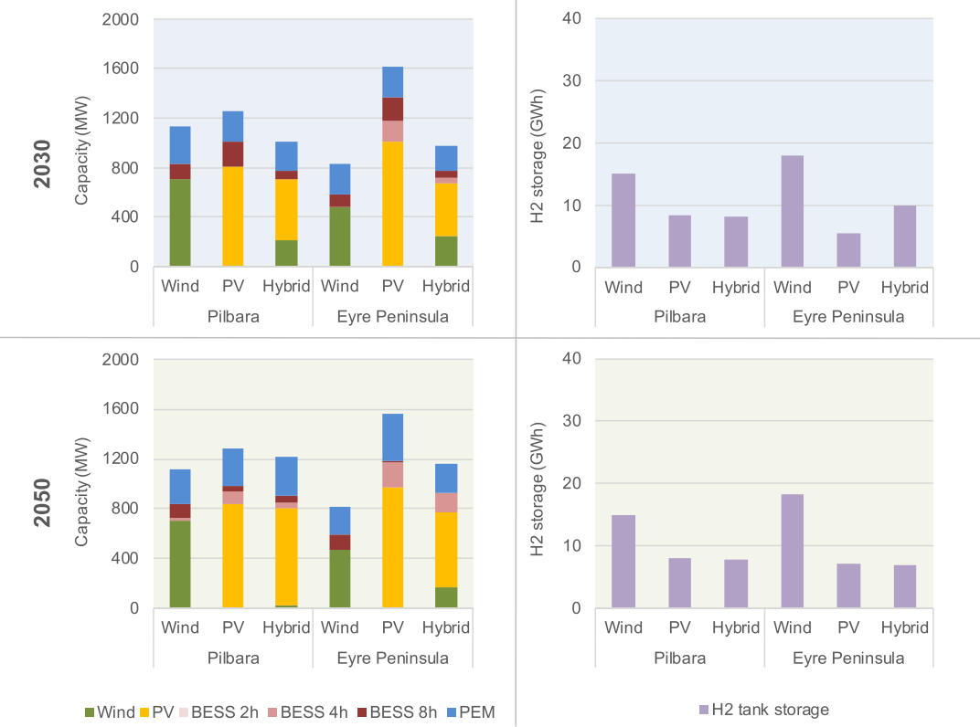
(Source: Wang et al., 2023)
Energy-based cost volatilities and carbon pricing strategies of BHP
Green hydrogen is currently 2-5 times costlier than fossil fuels, and the overcapacity in the steel industry forces BHP to reduce the incentive to pay green premiums (OECD, 2025a).
Investment in good-quality iron ore production and hydrogen-based energy capital cost analysis
This is a chance for BHP's Pilbara ore, but many deposits are not suitable for use in conventional hydrogen-DRI, which prefers higher-grade ore, and require beneficiation or electric-smelting solutions (BHP, 2024a).
Cost analysis on financing of decarbonised supply chain operations of BHP
BHP is currently estimating up to US$4 billion in investments and commitments in the next decade by FY2030 for operational decarbonisation, with diesel displacement-focused investments (BHP, 2024a). NeoSmelt has been allocated $19.8 million by ARENA to cover front-end engineering on the first stage of its process, which involves using gas to reduce iron ore into iron (BHP, 2025b). Renewable generation, safe DRI/HBI storage, and charging network-related investments must also be financed (OECD, 2025b; Algers et al., 2025).
Figure 6: Cost Analysis on Financing
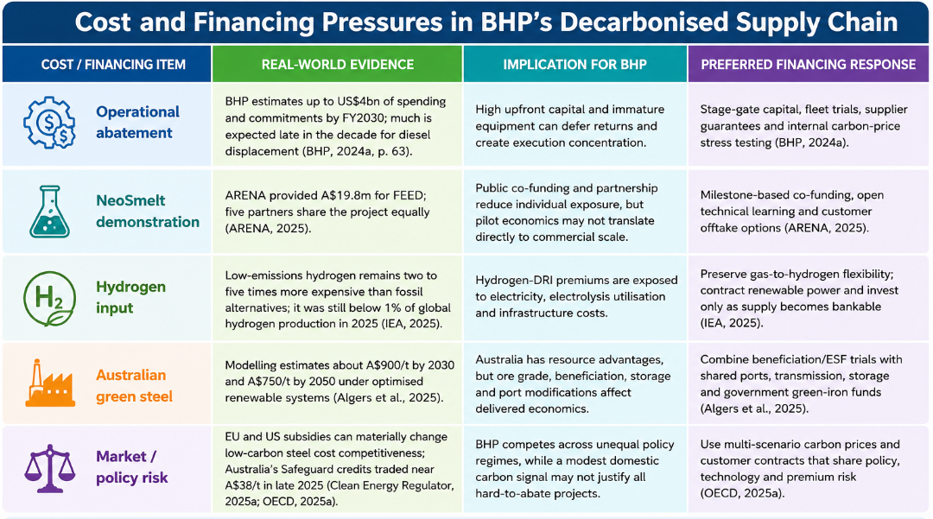
(Source: Self-developed)
BHP's GHG emission calculations: Operational scope 1 and 2 emissions
The commercial emphasis is underlined with scope calculations where operational emissions decreased by 13% between FY2024 and FY2025 (BHP, 2025c; BHP, 2025e).
BHP's value chain-based GHG emissions calculation: Scope 3 emissions
Figure 7: BHP value chain GHG Emissions
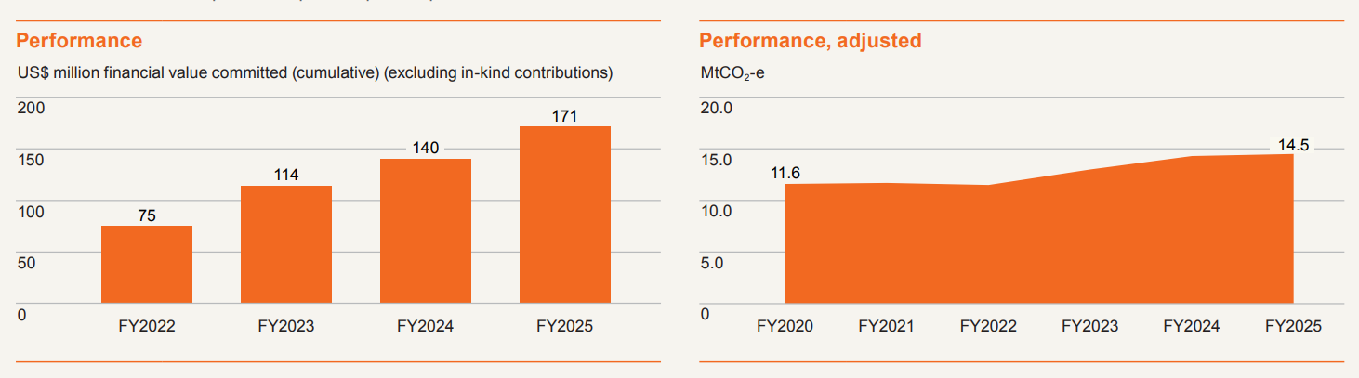
(Source: BHP, 2025a)
Despite falling off Scope 1 and Scope 2, value chain-based Scope 3 increased slightly to 14.5 MtCO2-e (BHP, 2025a). Implementing decarbonisation therefore needs to be translated into added value in global demand through product quality, traceability and customer co-investment.

1.3 Conclusion: Key Opportunities and Challenges
BHP can transform Australian renewable solutions into lower carbon iron-ore outcomes and improved market access-focused opportunities through scale and partnerships. The economic credibility is its major challenge, as Scope 3 is becoming the dominant option, and green hydrogen is still prohibitively expensive. The opportunity is greatest when there is verified emissions reduction, and superior ore performance and shared infrastructure reduce customers' overall transition cost.

2. Task 2: Strategic Growth and Competitive Positioning

2.1 Strategic Problem and Growth Objective
The issue for BHP is whether their iron ore and mining-focused ventures will be attractive when economic value is placed on embedded carbon by customers, regulators and financiers. The ambition is to achieve and build long-term partnerships with steel producers and to validate pathways to reduce emissions by incorporating BHP ores (BHP, 2025d). The goal is focused and disciplined decarbonisation to ensure Pilbara competitiveness. It should also ensure that decarbonisation-based expenditure is not an unrecovered cost by ensuring that there is a linkage between the technical performance and the customer's avoided carbon and compliance liability.

2.2 Critical Application of the Ansoff Matrix and Justification of the Selected Growth Strategy
Ansoff Matrix classifies the various growth options as market penetration, market development, product development and diversification based on the state of product and market (Puyt, Antoniou and Caputo, 2024). Market penetration will be a viable funding option for transition-focused investments. However, for market penetration, the existing ore sales into the market might further drive up blast furnace exposure. The selective market development should be targeted at those steelmakers who are exposed to carbon prices or Scope 3-focused commitments (Borchardt et al., 2025). However, while the potential market development might be carbon-constrained, the freight and ore-grade markets are more constrained. Again, if Australian green-iron economics and infrastructure advance, diversification should be considered an actual option. However, diversification into green iron carries some manufacturing and hydrogen risk for BHP.
Thus, product development is the best primary strategy. In this regard, BHP needs to tailor its current portfolio of iron-ore products and services, along with existing technical expertise, to existing customers in the steelmaking industry by means of ore blending, electric smelting furnace-focused compatibility, pellet and DRI trials, and evidence of emissions. The selection will be appropriate because the customer base is already in place, and the lower carbon-focused solution has been new or significantly improved.
Figure 8: Ansoff Matrix
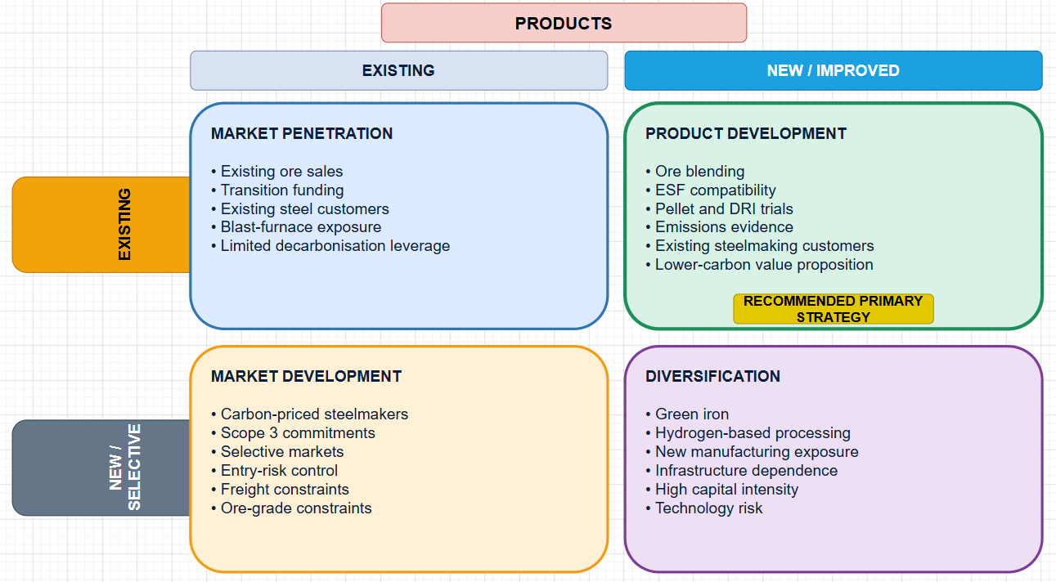
(Source: Self-developed)

2.3 Recommended Strategy
BHP should develop a platform for a green product called Pilbara Transition Iron Solutions and not sell one product until commercial technologies have been developed. This platform would have three levels. In the short term, optimisation of blast furnaces will improve fuel-ore-focused mixtures and fuel-ore trials to minimise fuel intensity and emissions. Second, BHP would ramp up the readiness of DRI-electric-smelting furnaces, advance the pellet trials, and partner with Asian steelmakers via NeoSmelt. Third, it would pave the way for hydrogen-based ironmaking by finding renewable electricity and hydrogen sources, albeit with a claim to near-zero performance until lifecycle proof can be provided. Pilbara ores are typically too dilute to meet the ore grade requirement of conventional hydrogen-DRI processes (BHP, 2025a). So, electric smelting and beneficiation are considered key strategic enablers instead of sustainability initiatives.
The model should include multi-year contracts and premiums related to justifiable results. It understands that at present, generating green hydrogen is 2-5 times more expensive than using fossil fuels and that overcapacity in steel markets lowers the pricing leverage (OECD, 2025a). BHP should focus on customers who have been identified as being exposed to the EU carbon-focused regime, net zero-focused commitments, and green procurement. This will have a positive impact on willingness to pay for avoided compliance costs.
Figure 9: Recommended Strategy
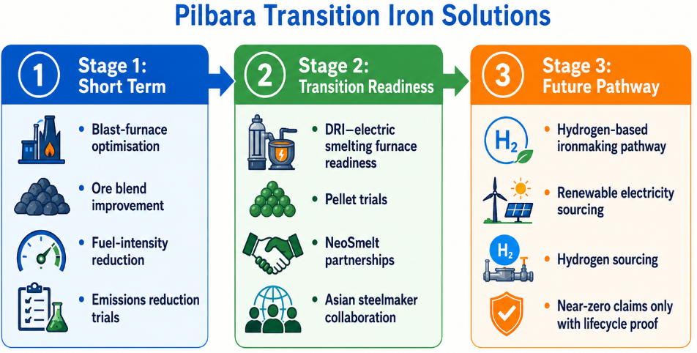
(Source: Self-developed)

2.4 Competitive Advantage Through Differentiation
Differentiation should be based on a system of capabilities that competitors cannot copy within a short time. BHP will bring together the relationships, logistics and capital to the Pilbara. The benefit would be not a low-carbon ore-focused claim, but rather a lower risk of transition due to customer focus. When furnace redesign and Scope 3 reporting are required, verified footprints can help minimise uncertainty. Learning and standards influence is achieved through partnership with firms with approximately 20% of global steel production (BHP 2024a). Independent lifecycle assurance would also help to prevent confusion between abatement measured by customers and reductions or offsets predicted.
Differentiation will be lost, however, if it is possible to process lower-grade ores to lower emissions without beneficiation compared to process emissions-focused levels for higher-grade ores. There is pressure from higher-grade Simandou supply, and concerns about the suitability of Pilbara (Financial Times, 2025). BHP is therefore competing on solution-focused performance and total delivered economics. Knowledge of the ore-treatment-focused process and reliable delivery to customers would further enhance the durability.

2.5 Implementation Requirements for lower-carbon business model
To implement, a governed portfolio is needed. BHP needs to set product-focused baselines, publish boundaries, and relate capital-related approval to returns and abatement. Top priorities for operations will be renewable electricity, diesel-focused displacement, and methane measurement. Priorities for the customers will be NeoSmelt-focused design, pellet and DRI trials, and beneficiation-focused studies. Commercial teams need to break customers down into segments based on technology and carbon exposure. However, customer contracts must bear the technological risks, energy-price, and carbon-accounting-focused uncertainty separately, so that BHP need not bear them alone.
Laboratory, customer validation, industrial trial, and contract should be followed by funding. BHP's £4 billion of planned investment in capacity is the right figure, but the public should be entitled to learn across the industry (BHP, 2024a). The governance should incorporate external assurance, board-focused oversight and project disclosure. Operational MtCO2-e, tonnes trialled, renewable share, contracted volumes and capital returns are some key indicators.

2.6 Strategic Risks and Mitigation
Risks can be technology-related delays, high hydrogen-focused costs, carbon policy-based variability, inadequate customer premiums, stranded beneficiation, greenwashing claims, and infrastructure assets. Mitigation should be done in stages, with multiple technology-focused pathways, conservative claims, co-funding, and premiums based on verified outcomes. BHP needs to test sensitivity to the hydrogen, electric and carbon prices, as subsidies can change. One early path is not as desirable as flexibility.
Figure 10: Strategic Risks and Mitigation
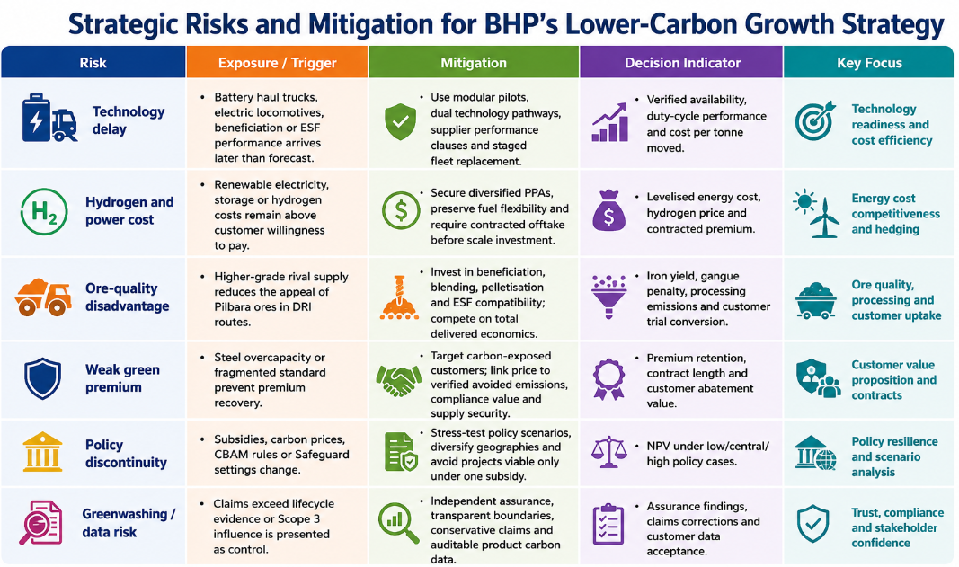
(Source: Self-developed)

2.7 Conclusion
Selective market development is an effective approach to balance growth, climate-focused relevance and execution-related risk for BHP, and should be supported by product development. A transition-solutions platform can protect Pilbara ore and transform the collaboration into a contract. Getting it right requires demonstrating emissions and economic value, and revealing allocation of capital regularly to the lower-carbon-focused commitment.

3. Critical Reflection on AI Usage

3.1 AI Tools and Tasks Performed
ChatGPT was used to find more recent academic and professional sources, compare carbon-focused pricing, hydrogen cost and emissions-based evidence, to check calculations, and for grammar review. It also checked word counts and generated keywords for the headings. Only creative production, proofreading, and drafting-focused support has been provided, as stated in the AI acknowledgement. In this regard, ChatGPT has been used to summarise and compare the industry and company reports. Any grammatical mistakes have been detected and corrected using proofreading. Again, the keywords for the images have been developed with the help of the AI tool.

3.2 Tool Disclosure
The search-focused shortlists, questions and source-related shortlists were produced based on research. It did not take the place of document-oriented reading. I opened up the sources through the AI-focused search tool and recorded the publication date, author, page-related evidence and URLs before final submission. After analysis, proofreading was used to enhance grammar and consistency with the correct Harvard referencing-focused conventions. Illustrations were created in an original fashion from cited information with no third party claimed. Overall, the contents and the information about the company reports or the industrial evidence were noted down by me and used in the report in my own words.

3.3 Critical Evaluation of AI Output
All material claims were verified with full reports, official webpages or articles, not AI-focused summaries. The emissions for FY2025 were reconciled with the BHP Annual Report and methodology. Carbon prices were checked against the Clean Energy Regulator, and hydrogen-cost claims were checked against OECD and journal evidence. Reductions were made in operation, and recomputation of Scope 3-focused shares is independent. Hallucinations were found when draft-focused outputs confused targets with achieved reductions, or when drafts considered Scope 3 as directly controllable, or drew the conclusion that Pilbara ore was always suitable for hydrogen DRI. Both of them were corrected with conflicting evidence. The test for each claim was whether the claim continued to be accurate if definitions, baselines, organisational boundaries, and uncertainty-focused statements were added back.

3.4 Contribution Analysis
AI pulled and redacted evidence, but final determinations were my own. I picked BHP, focused on the natural and economic players, selected product development, analysed the benefits and drawbacks, and made my decision based on the evidence that changed my mind. I dismissed unsubstantiated statements and linked evidence with value, competitiveness and risk.

3.5 Ethical and Professional Implications
While AI can speed up analysis, it may also reflect bias and create false references and greenwashing. There needs to be disclosure, verification, respect for copyright, confidentiality and human accountability in ethical use. The three elements of the environment-focused claim in the context of professional marketing are specificity, measurability and assurance. This is especially important for climate-related marketing, as a lack of clarity can lead the public, regulators, investors, and impacted communities to believe something different than what is actually being conveyed. AI must complement, rather than substitute judgment, and not create it or take away accountability.

References
Algers, J., Gong, J., Nykvist, B. and Åhman, M. (2025). ‘Competition and climate policy in the steel transition: Comparing costs and subsidies in the US and the EU’, Energy Policy, 198, 114507. Available at: https://doi.org/10.1016/j.enpol.2025.114507 (Accessed: 10 July 2026).
BHP (2024a). ‘Climate Transition Action Plan 2024’. Melbourne: BHP. Available at: https://www.bhp.com/-/media/documents/investors/annual-reports/2024/240827_bhpclimatetransitionactionplan2024.pdf (Accessed: 10 July 2026).
BHP (2025a). ‘Annual Report 2025’. Melbourne: BHP. Available at: https://www.bhp.com/investors/annual-reporting/annual-report-2025 (Accessed: 10 July 2026).
BHP (2025b). ‘NeoSmelt welcomes Federal Government support and signs two new participants’, 13 June. Available at: https://www.bhp.com/news/media-centre/releases/2025/06/neosmelt-welcomes-federal-government-support-and-signs-two-new-participants (Accessed: 10 July 2026).
BHP (2025c). ‘Value chain GHG emission reductions.’ Available at: https://www.bhp.com/sustainability/climate-change/value-chain-ghg-emission-reductions (Accessed: 10 July 2026).
BHP (2025d). ‘Direct climate policy advocacy’. Melbourne: BHP. Available at: https://www.bhp.com/-/media/project/bhp1ip/bhp-com-en/documents/sustainability/2025/250819_directclimatepolicyadvocacy.pdf (Accessed: 10 July 2026).
BHP (2025e.) ‘BHP GHG Emissions Calculation Methodology 2025’. Melbourne: BHP. Available at: https://www.bhp.com/-/media/documents/investors/annual-reports/2025/250819_bhpghgemissionscalculationmethodology2025.pdf (Accessed: 10 July 2026).
Borchardt, M., Pereira, G., Milan, G., Pereira, E., Lima, L., Bianchi, R. and Scavarda do Carmo, A. (2025). ‘Are sustainable supply chains managing Scope 3 emissions? A systematic literature review’, Sustainability, 17(13), p.6066. Available at: https://www.mdpi.com/2071-1050/17/13/6066/pdf. (Accessed: 10 July 2026).
Clean Energy Regulator (2025a). ‘Safeguard Mechanism’. Australian Government. Available at: https://cer.gov.au/schemes/safeguard-mechanism (Accessed: 10 July 2026).
Clean Energy Regulator (2025b). ‘Australian environmental markets: September quarter 2025’. Australian Government. Available at: https://cer.gov.au/markets/reports-and-data/quarterly-carbon-market-reports/quarterly-carbon-market-report-september-quarter-2025/australian-environmental-markets (Accessed: 10 July 2026).
Financial Times (2025). ‘Australia’s iron ore riches challenged by green steel and African rival’, 26 October. Available at: https://www.ft.com/content/f9d4d34f-7402-46bb-a9ff-4e1c0f8393e0 (Accessed: 10 July 2026).
International Energy Agency (IEA) (2025). ‘Global Hydrogen Review 2025’. Paris: IEA. Available at: https://www.iea.org/reports/global-hydrogen-review-2025 (Accessed: 10 July 2026).
Johnson, Constantin, Max Åhman, Lars J. Nilsson, and Zhenxi Li (2025). ‘Emerging green steel markets surrounding the EU emissions trading system and carbon border adjustment mechanism’, Nature Communications, 16, p.9087. Available at: https://www.nature.com/articles/s41467-025-64440-9.pdf (Accessed: 10 July 2026).
Knaus, C. and Morton, A. (2026). ‘Former top BHP economist urges tougher government policies to push miners to decarbonise’, The Guardian, 10 July. Available at: https://www.theguardian.com/business/2026/jul/10/former-bhp-economist-carbon-price-emissions (Accessed: 10 July 2026).
Kotler, P., Armstrong, G., Harris, L.C. and He, H. (2024). ‘Principles of marketing’. 19th edn. Harlow: Pearson. https://www.pearson.com/nl/en_NL/higher-education/subject-catalogue/marketing/kotler-principles-of-marketing-19ed.html
OECD (2025a). ‘Hydrogen in steel: Policy options for decarbonising the steel industry’. OECD Science, Technology and Industry Policy Papers. Paris: OECD Publishing. Available at: https://www.oecd.org/content/dam/oecd/en/publications/reports/2025/03/hydrogen-in-steel_f4d15f8d/7e2edc69-en.pdf (Accessed: 10 July 2026).
OECD (2025b). ‘Green iron opportunities in Australia’. Paris: OECD Publishing. Available at: https://www.oecd.org/en/publications/green-iron-opportunities-in-australia_bbd1e2b8-en.html (Accessed: 10 July 2026).
Puyt, R.W., Antoniou, P.H. and Caputo, A., (2024). ‘The Ansoff archive: Revisiting Ansoff's legacy and the holistic approach to strategic management’. Strategic Change, 33(6), pp.513-518. Available at: https://onlinelibrary.wiley.com/doi/pdfdirect/10.1002/jsc.2600 (Accessed: 10 July 2026).
Reuters (2025). ‘Digging to zero? Inside the race to decarbonise mining’, 7 May. Available at: https://www.reuters.com/sustainability/decarbonizing-industries/digging-zero-inside-race-decarbonise-mining-2025-05-07/ (Accessed: 10 July 2026).
Wang, C., Walsh, S.D.C., Weng, Z., Haynes, M.W., Summerfield, D. and Feitz, A. (2023). ‘Green steel: Synergies between the Australian iron ore industry and the production of green hydrogen’, International Journal of Hydrogen Energy, 48(83), pp. 32277-32293. Available at: https://doi.org/10.1016/j.ijhydene.2023.05.041 (Accessed: 10 July 2026).
Yu, G., Ye, X., Ye, Y., Huang, H. and Xia, X. (2024). ‘Optimal decarbonisation pathway for mining truck fleets’, Journal of Automation and Intelligence, 3(3), pp. 129-143. Available at: https://doi.org/10.1016/j.jai.2024.03.003 (Accessed: 10 July 2026).

