Cognitive Predictors of Mnemonic Discrimination in Young Adults: A Domain-Based Approach

Candidate Number: 9183K
Supervisor: Helena Gellersen
Word Count: 7000
Word Limit: 7000

Abstract
Mnemonic discrimination (MD)—the ability to distinguish between highly similar experiences—is increasingly used as a behavioural marker of pattern separation and a candidate early marker of Alzheimer’s pathology. Pattern separation is a hippocampal process thought to reduce interference between overlapping memory representations, facilitating the formation of distinct traces. Numerous MD tasks have been designed to provide behavioural measures targeting pattern separation processes, yet there is limited empirical evidence establishing whether variations of MD tasks measure a common unitary construct. Moreover, cognitive predictors of MD performance in young adults remain poorly characterised, with most studies examining predictors in isolation, which limits understanding of their relative importance. This study addresses both gaps in a sample of 66 healthy young adults aged 19-32. Seven MD tasks were administered, along with neuropsychological tasks measuring performance across five cognitive domains: episodic memory, executive function, perception, attention and crystallised intelligence. The latent structure of MD tasks revealed two factors reflecting the measurement method conventionally used in each task—Corrected Hit Rate, including tasks using corrected hit rate and accuracy indices, and Discriminability, comprising tasks using Lure Discrimination Index and d’. Critically, these factors were predicted by different cognitive domains: attention dominated Corrected Hit Rate, while episodic memory dominated Discriminability, providing converging evidence that MD tasks are not interchangeable. These findings underscore that outcome measure selection is a critical methodological consideration, with implications for which MD tasks should be used as markers of hippocampal dysfunction.

- Introduction
  - Pattern Separation
The ability to distinguish between highly similar experiences is fundamental to everyday memory function, and has been widely attributed to a hippocampal computational process known as pattern separation (Bakker et al., 2008). Pattern separation refers to the orthogonalisation of similar or overlapping inputs into distinct memory representations (Stark et al., 2013), which is critical for the formation of high-fidelity episodic memories. Mnemonic discrimination (MD) has been proposed as a proxy of pattern separation (Stark et al., 2019). MD tasks are designed to assess whether overlapping inputs have been encoded as distinct memory representations, though the extent to which MD tasks purely index pattern separation remains debated (Stark et al., 2019).
Functional neuroimaging findings demonstrate that the dentate gyrus (DG) subfield of the hippocampus is consistently activated during MD tasks (Bakker et al., 2008). This structure shows high sensitivity to subtle stimulus changes across perceptual, spatial and sequential dimensions (Bakker et al., 2008; Azab et al., 2013), and there is compelling evidence that DG activation supports the neural computation of pattern separation (Berron et al., 2016). The CA3 subfield of the hippocampus is thought to preferentially support the opposing process of pattern completion, but the balance with separation is dynamically modulated by the degree of similarity between inputs and stored representations (Yassa & Stark, 2011). Both pattern separation and completion are fundamentally involved in MD tasks, as successful discrimination is thought to rely on a ‘recall-to-reject’ strategy, whereby an original memory is retrieved via pattern completion before pattern separation identifies the mismatch (Stark et al., 2013).
The hippocampal subfields supporting pattern separation are highly vulnerable to decline, leading to a pathological bias toward pattern completion with age-related decline (Yassa & Stark, 2011). This neural shift manifests behaviourally as a consistent pattern of MD performance declining with age (Toner et al., 2009; Stark et al., 2013), providing a sensitive proxy for hippocampal change. Traditional recognition memory is comparatively preserved with age and during early stages of hippocampal decline, making MD tasks a unique, valuable early marker for preclinical mild cognitive impairment and Alzheimer’s disease (Stark et al., 2019). As the neural structures supporting pattern separation are among the first regions affected by tau pathology in Alzheimer's disease (Berron et al., 2019), MD tasks may be able to detect subtle hippocampal changes earlier than traditional neuropsychological tests. The MDT has been evidenced to effectively predict both cognitive status and amyloid burden in older adults (Kim et al., 2023), reinforcing its potential as a digital biomarker for early Alzheimer's pathology. However, realising this clinical potential requires a more thorough understanding of the cognitive underpinnings of MD performance in healthy populations.
  - Mnemonic Discrimination Tasks
The clinical relevance of pattern separation measures has led to increasing interest in tasks that can accurately capture this phenomenon. The Mnemonic Similarity Task (MST), designed by Kirwan and Stark (2007), was developed specifically to tax pattern separation processes. Critically, the inclusion of lure stimuli—items that are perceptually similar but not identical to previously encoded targets—places strong demands on the hippocampal pattern separation system, as successful lure rejection requires the formation of distinct non-overlapping memory representations. Since its development, the MST paradigm has been adapted into several variants employing different test formats and outcome measures, including forced choice (FC) and ‘yes/no’ (Y/N) recognition formats, objects and scenes stimuli, and continuous recognition paradigms, reflecting growing interest in characterising MD across diverse experimental approaches. The manipulation of lure similarity, which determines the precision of pattern separation required for successful discrimination, remains central to all variants.
    - Limitations of MD Tasks as Measures of Pattern Separation
Although MD tasks serve a valuable purpose in predicting hippocampal-dependent memory function and detecting early cognitive decline, they are not process-pure measures of pattern separation and inevitably reflect a combination of cognitive processes. Trelle et al. (2017) argue that MD performance is substantially confounded by reinstatement-based ‘recall-to-reject’ strategies at the test phase.
Furthermore, preliminary high-resolution fMRI evidence adds complexity to current interpretations of MD results: DG activation may not be fully attributable to pattern separation, as hippocampal computations may shift dynamically based on factors such as stimulus domain and similarity, meaning successful MD performance may reflect the ability to flexibly shift between separation and reinstatement strategies rather than pattern separation alone (Gellersen et al., 2026). Critically, object and scene stimuli may engage qualitatively different hippocampal strategies, with objects primarily recruiting pattern separation and scenes recruiting reinstatement-based mechanisms (Gellersen et al., 2026), suggesting the stimulus category used may affect which cognitive processes are targeted. This further challenges the assumption that MD tasks provide a uniform index of pattern separation.
Additionally, MD tasks inherently draw on episodic memory, attention and perception processes (Stark et al., 2019; Amer & Davachi, 2023). For example, high perceptual discrimination ability may inflate MD performance by enabling detection of subtle feature differences at a perceptual level, making perceptual and mnemonic contributions difficult to disentangle (Gellersen et al., 2021). More broadly, Stark et al. (2019) emphasise that behavioural tasks cannot directly isolate neural processes and therefore the MST should not be considered a direct measure of pattern separation. Nevertheless, neuroimaging and lesion data support that accurate MD performance is highly dependent on the DG (Kirwan & Stark, 2007; Kirwan et al., 2012), and findings are consistent with computational predictions of pattern separation. The cortico-hippocampal pattern separation (CHiPS) framework proposes that successful MD performance depends on the frontoparietal control network regulating sensory input to the hippocampus, supporting controlled attention and interference resolution to facilitate pattern separation in the DG (Amer & Davachi, 2023), providing a theoretical basis for understanding why individual differences in non-mnemonic cognitive processes systematically predict MD performance. Isolating the unique contribution of pattern separation from co-occurring cognitive processes and strategies remains a methodological challenge which the present study aims to address.
    - Can MD Tasks Be Compared?
A fundamental methodological challenge in the MD literature is the absence of a standardised outcome measure, which raises the question of whether performance on different MD paradigms can be meaningfully compared. The variants of MD tasks differ substantially in their test formats, encoding conditions, stimulus materials, and outcome measures, which is likely to place differential demands on participants. Most studies employ a single MD task, limiting cross-paradigm comparisons and the generalisability of findings, a limitation acknowledged by Gellersen et al. (2021). Aggregating findings across studies using different tasks risks conflating distinct constructs under a single label of MD ability. The heterogeneity of outcome measures—LDI, d’, corrected hit rate, and FC accuracy—presents a further obstacle for comparison, as these indices make distinct assumptions about how response bias should be handled, meaning direct standardisation across paradigms is not appropriate, as equivalent underlying ability may be expressed differently depending on which index is applied.
It has not yet been empirically established whether these indices are psychometrically equivalent representations of underlying pattern separation ability, or whether they capture partially distinct variance. The present study addresses this gap by administering seven MD tasks within the same sample, providing an empirical basis for whether MD tasks can be treated as interchangeable measures of a common underlying ability.
  - Cognitive Predictors of Mnemonic Discrimination
Given that MD tasks reflect a combination of cognitive processes beyond pattern separation, individual differences in MD performance may be driven by a range of cognitive abilities. The present study examines five cognitive domains as candidate predictors, selected based on their theoretical links to the cognitive demands of MD and established roles in hippocampal-dependent memory function.
Episodic memory ability represents the most theoretically motivated predictor of MD performance and has been extensively studied due to its shared reliance on the hippocampus to encode and retrieve distinct memory representations (Stark et al., 2013), with some conceptualisations positioning MD as a core component of episodic memory function (Ngo et al., 2020; Yassa & Stark, 2011). Successful discrimination of similar memories requires the same high-fidelity encoding and strategic retrieval processes that support detailed episodic recall (Kirwan & Stark, 2007). Research consistently demonstrates that performance on traditional neuropsychological tests of episodic memory predicts MD task success (Stark et al., 2010), a relationship underpinned by shared hippocampal neural substrates.
Executive function has been implicated in MD performance through its role in strategic retrieval and cognitive control during encoding. Working memory capacity supports the maintenance of stimulus details during encoding, facilitating the formation of higher-quality representations (Cohen et al., 2012), while cognitive control processes are central to the strategic ‘recall-to-reject’ retrieval process and postretrieval monitoring demands (Trelle et al., 2017). Executive function has been shown to contribute more strongly to Y/N than FC recognition formats, consistent with greater strategic retrieval demands of this format (Gellersen et al., 2021). Jensen et al. (2023) further demonstrated that executive function was the most important predictor of lure discrimination in older adults, dominating both episodic memory and visual acuity, suggesting the role of prefrontal-mediated processes may be underappreciated in studies focusing on hippocampal contributions. The relationship between executive function and MST performance has been replicated in older adult samples, however no significant relationship has been observed in young adult samples (Qian et al., 2025).
Perceptual discrimination ability is another highly relevant candidate predictor due to the substantial overlap between the demands of MD tasks and perceptual similarity judgements. The perceptual ability to detect subtle feature differences is required for successful lure rejection, consequently MD failures may partly stem from impairments at the perceptual stage. The capacity for high-ambiguity perceptual discrimination has been established as a primary predictor of MD performance, especially in FC formats, with subtle individual differences in perceptual sensitivity detectable even within healthy young adult samples (Gellersen et al., 2021).
Attention has also been proposed as a predictor of MD performance, given that encoding quality is highly dependent on attentional engagement. Superior sustained attention may support the formation of more detailed memory traces, facilitating subsequent lure discrimination. Wahlheim et al. (2024) demonstrated that attentive encoding was associated with more correct lure rejections, target hits, and false alarms, indicating that multiple cognitive processes influence MD performance rather than pattern separation alone. However, Vanderlip et al. (2026) found that attention performance did not predict oMST performance after accounting for age, leaving the independent contribution of attention unresolved.
Crystallised intelligence has received relatively limited investigation as a predictor of MD in the literature, but may contribute to the formation of richer memory encodings. It also serves as a proxy for cognitive reserve, which is associated with resilience to hippocampal decline (Stern, 2002; Belleville et al., 2021). Additionally, Ngo et al. (2020) found a significant positive correlation between MD and verbal intelligence.
  - The Present Study
Despite these theoretical links, several methodological and conceptual issues constrain the interpretability of existing MD findings. While age-related decline in MD ability is well-established, substantial inter-individual variability also exists in healthy young adult populations (Stark et al., 2023; Gellersen et al., 2024), yet there is limited empirical research focusing on these populations. The MD literature is also largely based on the unexamined assumption that all MD tasks target the same underlying construct; verification of this assumption is necessary before findings can be meaningfully compared. If MD tasks do not measure a unitary construct, the prevailing interpretation of MD tasks as a behavioural index of pattern separation may need reconceptualisation. Empirical investigation has been weighted toward episodic memory, with non-mnemonic predictors comparatively underexamined, and limited research modelling a range of predictors simultaneously. This makes it difficult to determine the unique contribution of each domain after accounting for shared variance. Modelling multiple domains simultaneously is necessary to determine whether MD tasks primarily reflect pattern separation or are better understood as multi-determined behavioural outcomes.
The present study will simultaneously examine five domain composites—episodic memory, executive function, perception, attention and crystallised intelligence—as predictors of MD performance within a young adult sample. First, the latent factor structure of seven MD tasks will be examined to empirically test the unexamined assumption that MD tasks measure a common underlying construct. Second, the cognitive domain predictors of MD performance will be identified to explore whether other cognitive processes can explain the inter-individual variability observed; the relative importance of cognitive predictors will be quantified via dominance analysis to enable direct comparisons of predictor contributions.
H1: All MD tasks will load onto a single latent factor, reflecting a unitary pattern separation construct.
H2: Episodic memory will be the strongest cognitive domain predictor of MD performance, given its established role in hippocampal-dependent encoding and retrieval of distinct memory representations.

- Methods
  - Participants
A total of 66 young adults, aged 18-35, participated in this study (M = 22.6, SD = 4.2). 25 participants were male (37.9%), 37 were female (59.1%) and 2 participants selected ‘Other/Prefer not to say’. All participants were fluent in English and had normal or corrected-to-normal vision and hearing. Exclusion criteria included a history of neurological or psychiatric conditions, psychoactive medication, and uncontrolled medical conditions that could impair cognitive function, which was confirmed through brief online eligibility screening. Visual acuity and cognitive impairment screening further confirmed no participants required exclusion. Data were obtained from an ongoing collaborative dataset collected across two sites: University of Cambridge and University of California, Irvine. I personally collected data from 14 participants, with the remaining participants recruited and tested by other researchers. Protocol was standardised to ensure comparability across sites. All participants provided informed consent and received financial compensation at the rate of £10 or $15 per hour. Ethical approval was obtained from the Cambridge Psychology Research Ethics Committee.
Sample size was determined by data availability within an ongoing collaborative dataset. The present young adult sample of 66 fell slightly below the sample size target due to time constraints. A sensitivity analysis for the primary multiple regression analyses (5 predictors, α = .05, power = .80) indicated the study was adequately powered to detect effects of f² = 0.213 (R² = .176). Both models exceeded this, confirming adequate power to detect effects of the magnitude observed. However, a sample of 93 participants would have been required to detect conventional medium effects (f² = 0.15), representing a limitation of the present study.
  - Procedure
2.2.1 Mnemonic Discrimination Tasks
Seven computerised MD tasks were administered across two testing sessions, covering a range of paradigms and outcome measures. The order of MD tasks was randomised for each participant to minimise potential order effects and to help control for effects of fatigue and practice across sessions. The key characteristics of all seven MD tasks are summarised in Table 1.
The traditional version of the Mnemonic Similarity Task (MST), designed by Kirwan and Stark (2007), involves an incidental encoding phase, followed by a recognition memory test (Figure 3). In the test phase, participants were required to identify targets (repetitions), foils (completely novel images), and lures (similar, but not identical to targets). The canonical measure used for this task is the Lure Discrimination Index (LDI), used to isolate genuine pattern separation ability from any bias to respond ‘similar’ overall.
The FC MST (Huffman & Stark, 2017) adapted the original paradigm by presenting targets and lures simultaneously. The test phase involved three FC test formats, in which a target was presented alongside an unrelated foil, a corresponding similar lure, or a lure object from a different pair. This FC format was developed to eliminate individual differences in decision criterion. Performance was measured by accuracy averaged from each trial type, as the FC format is considered to inherently control for response bias (Huffman & Stark, 2017).
An alternative MDT test format was designed by Trelle et al. (2017), starting with an intentional encoding phase, followed by Y/N and FC responses. This design aims to disentangle two distinct cognitive contributions to MD—strategic retrieval and representational quality—which drive successful Y/N and FC performance respectively (Trelle et al., 2017; Gellersen et al., 2021). This study therefore retained both formats using Gellersen et al.’s (2021) modification (Figure 1) to allow examination of whether recognition format influences MD’s latent factor structure. A discriminability index (d’) was calculated for both formats, allowing response bias to be separated from perceptual sensitivity.
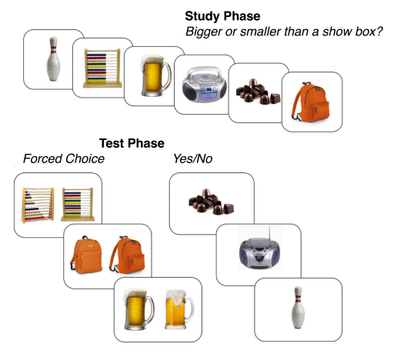
Figure 1
Forced Choice and Yes/No Test Formats of the MDT
Note. 200 pairs of images of everyday objects were shown, divided equally between the two test formats. The procedure began with a practice block of all phases, where participants received explicit instructions and feedback on responses before the test block, thus participants were aware of the upcoming memory requirements before the test phases and making the encoding phase intentional. The encoding phase required participants to make a relative size judgement for the objects presented. Stimulus presentation was standardised to 3 seconds during encoding. In the test phase, stimuli were presented until participants responded. In the forced choice test phase, participants were shown a studied target and similar lure and instructed to select the ‘old’ one. In the Yes/No test phase, participants were shown a single image (target or lure) and decided if it is ‘old’ or ‘new’. Reprinted from Gellersen et al. (2021).

Berron et al. (2018) developed novel objects and scenes MDTs using an old/new recognition format (Figure 2). The usage of objects and scenes in this paradigm aims to examine whether MD generalises across stimulus categories, motivated by converging evidence that objects and scenes engage partially distinct neural substrates (Berron et al., 2018; Gellersen et al., 2026). The primary index used for this task is corrected hit rate, which was calculated separately for both stimulus types by subtracting false alarm rate from hit rate.
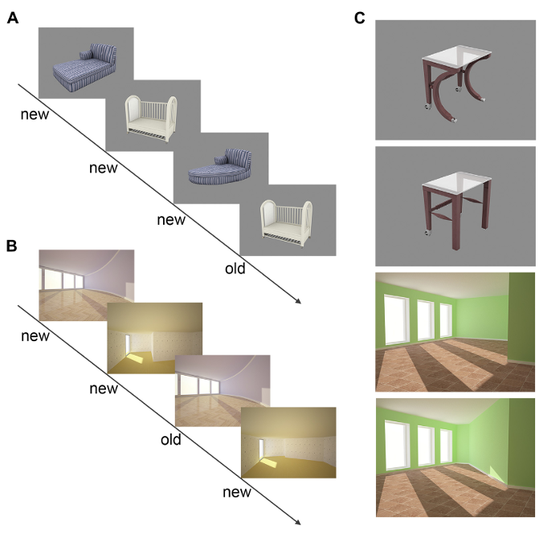
Figure 2
Examples of Stimuli Used in Objects and Scenes MDT
Note. Stimuli comprised everyday indoor objects presented on a neutral grey background and empty indoor scenes. Each stimulus was presented for 3s, with the response window ending immediately after. Stimuli were separated by a fixation star, and interstimulus intervals ranged from 0.6s to 4.2s. Stimuli were presented in sequences of four images, with the first two being novel images and the following two being repeats or lures, allowing a shorter retrieval delay. 56 of each trial type were administered for both objects and scenes, totalling 224 trials for each participant. Lures adapted shape and geometry features of objects and scenes to isolate spatial features. Reprinted from Berron et al. (2018).

The Optimised MST (oMST) introduced a continuous recognition memory format, in which encoding and test phases are integrated, allowing more efficient administration of the MST while maintaining sensitivity to age and strong correlations with performance in the original MST (Stark et al. 2023). This version also used LDI as the outcome measure (Stark et al., 2023).
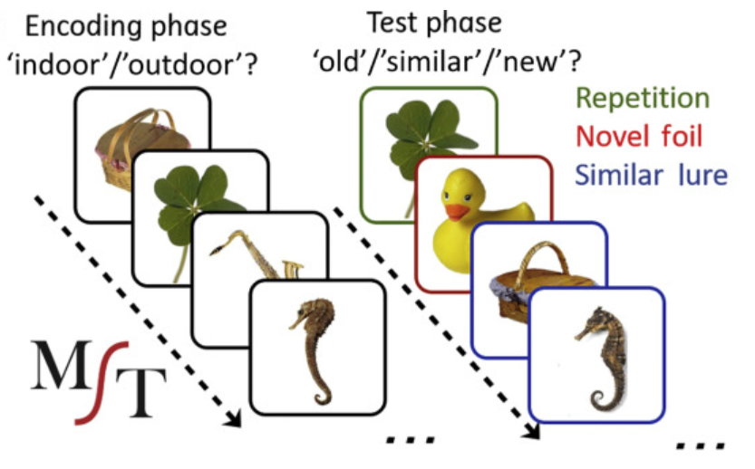
Figure 3

Examples of Stimuli Used in the Original MST
Note. Coloured boxes are not used during the actual task administration. Similar images of objects were used as stimuli in the FC version (Huffman & Stark, 2017) and oMST (Stark et al., 2023), with different test formats. The original and FC MST involve the same incidental indoor/outdoor encoding phase. The original MST and oMST employ the ‘old’/’similar’/’new’ test format, while the FC MST instructed participants to select the exact image they had previously studied. Reprinted from Stark et al. (2019).

Table 1
Summary of Mnemonic Discrimination tasks

Task | Stimuli | Encoding Task | Test Format | Outcome Measure | Trials
MST LDI ¹ | Everyday objects | Indoor/outdoor judgement | Old/similar/new | LDI | 128
FC MST ² | Everyday objects | Indoor/outdoor judgement | FC (target vs foil/lure) | Accuracy | 105
MDT FC d’ ³ | Everyday objects | Size judgement | FC (target vs lure) | d’ | 100
MDT Y/N d’ ³ | Everyday objects | Size judgement | Yes/no | d’ | 100
MDT objects ⁴ | Everyday objects | Passive viewing | Old/new | Corrected hit rate | 112
MDT scenes ⁴ | Indoor scenes | Passive viewing | Old/new | Corrected hit rate | 112
oMST LDI ⁵ | Everyday objects | Continuous recognition | Old/similar/new | LDI | 128

Note. ¹Kirwan & Stark (2007); ²Huffman & Stark (2017); ³Gellersen et al. (2021); ⁴Berron et al. (2018); ⁵Stark et al. (2023). LDI = Lure Discrimination Index; d' = discriminability index; FC = forced choice; Y/N = ‘yes/no’; MDT = Mnemonic Discrimination Task; MST = Mnemonic Similarity Task; oMST = Optimised Mnemonic Similarity Task. Trial numbers refer to total test phase trials. In the oMST continuous format, the number of trials between the initial presentation of an image and its repetition or a similar lure varied from 4-30. Corrected hit rate is calculated from hit rate minus false alarm rate. LDI is calculated as the proportion of lures correctly identified as similar minus the proportion of foils incorrectly identified as similar. A higher LDI indicates more precise encoding and pattern separation, while a lower LDI suggests a tendency towards pattern completion. d’ was derived from difference between the z-transformed hit rate and z-transformed false alarm rate. Response windows were unlimited for all tasks except MDT objects and scenes, where participants could only respond during the 3-second stimulus presentation window.

2.2.2. Cognitive Domain Measures
Participants completed a cognitive battery involving a range of computer-based and paper-based tasks assessing different aspects of the five cognitive domains (see Appendix B for further procedural details).
Episodic memory was assessed through the Rey Auditory Verbal Learning Test (RAVLT) and the Rey-Osterrieth Complex Figure test (REY-O). Three scores were extracted from RAVLT results, assessing learning performance, resistance to retroactive interference, and delayed recall. A composite REY-O score was derived from the average of immediate and delayed scores. Executive function was assessed using four tasks: the Trail Making Test (TMT), Wechsler’s Digit Span task, a computerised SpatioTemporal working memory task (spatial span), and a computerised 2-back working memory task. TMT was indexed by a difference score (Trail B – Trial A completion time). For both the digit and spatial span tasks, forward and backward scores were computed separately. Lastly, a discrimination index for the 2-back task was derived (hit rate – false alarm rate).
Perception measures comprised a perceptual discrimination (PD) oddity task (developed by Gellersen et al., 2021), sequential and pairwise perceptual control (Pcon) tasks, and objects in noise. For the PD oddity task, a standardised difference score was computed for objects and scenes separately to isolate ambiguity-specific discrimination ability. Discriminability indices were used for the Pcon tasks, and mean opacity was used for objects in noise. Attention was assessed through a continuous performance task (CPT) and the Flanker task. Both tasks were indexed by balanced composites to capture accuracy and efficiency. Crystallised Intelligence was indexed by either the British or American cultural variations of the National Adult Reading Test (NART).
  - Data Analysis
All data analyses were conducted in R (version 4.3.2), with a significance threshold of α = .05 applied in all tests. Prior to computing signal detection measures (d’) for the 2-back, and FC and Y/N MDT tasks, extreme values were corrected to avoid infinite values arising from perfect performance or zero responses. Additionally, one participant produced an implausibly short Trail B completion time, indicating a probable data recording error. Therefore, this score was excluded from further analyses.
Domain composites were created by z-scoring individual measures within the young adult sample and averaging within each domain, with participants missing any component measure assigned a missing composite score. Missing data were handled using multiple imputation in multiple regression analyses to retain the full analytic sample (summarised in Appendix C). Sensitivity analyses confirmed broad consistency in the direction of results across listwise and imputed results (see Appendices D and E). Assumption checks and Cook’s distance diagnostics were conducted on the listwise complete cases sample (n = 42; Appendices F-H).
To address H1, exploratory factor analysis (EFA) was conducted on the MD tasks, using maximum likelihood estimation and oblimin rotation, which aligns with the expectation that MD tasks are not entirely independent. Factor loadings below 0.32 were considered non-meaningful and omitted (Tabachnick & Fidell, 2019). Factor scores were extracted using the regression method applied to raw participant-level data to produce factor estimates with the highest validity. The number of factors was determined via parallel analysis, and the resulting factor scores were used as outcome variables in subsequent regression analyses. Despite the multi-dimensionality observed within domains, theory-driven composites were retained to avoid overfitting to sample-specific factor structures and to maintain statistical power.
To address H2, two multiple regression analyses were conducted with Corrected Hit Rate and Discriminability factor scores as outcome variables and the five theory-driven domain composites as predictors. A secondary exploratory regression examined whether a cross-domain visuospatial factor accounted for additional variance, given the strong visuospatial demands inherent to MD tasks. Hierarchical regression was employed to examine whether adding predictors beyond the primary predictor improved model fit, with all other composites entered together at Stage 2 to avoid arbitrary ordering decisions. This was conducted on complete cases (n = 42) to enable valid F change statistic and AIC/BIC comparisons. Lastly, dominance analysis was conducted on complete cases to quantify the relative importance of each predictor.
- Results
Preliminary analyses confirmed no significant associations between any MD task and age or gender (all ps >.22), therefore neither was included as a covariate in subsequent regression analyses. Table 2 summarises the composition and missingness for each cognitive domain composite.
Table 2
Cognitive Domain Composite Composition and Missing Data

Domain Composite | k | n | % Missing
Episodic memory | 4 | 62 | 6.1
Executive function | 6 | 50 | 24.2
Perception | 5 | 56 | 15.2
Attention | 2 | 51 | 22.7
Crystallised intelligence | 1 | 64 | 3.0
Note. k = number of component measures contributing to each composite. Domain composites are z-scored within the young adult sample (N = 66) and averaged across component measures. n varies due to missing data. Participants missing any component measure were assigned a missing composite score; missingness therefore reflects the availability of data for specific component tasks.

H1 predicted that all MD tasks would load onto a single latent factor. Pairwise correlations between MD tasks are presented in Figure 4, providing descriptive context for H1. EFA was undertaken for all MD measures to examine the latent structure of MD performance. Prior to EFA, sampling adequacy was confirmed using KMO and Bartlett’s tests (KMO = .77; Bartlett's χ²(21) = 243.998, p < .001).
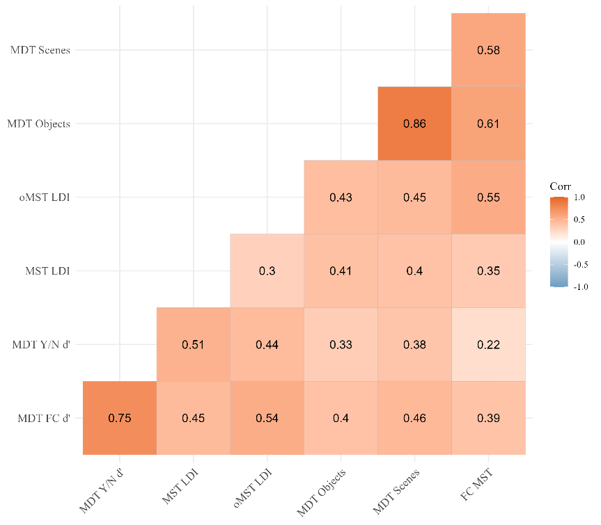
Figure 4
Pairwise Correlations Between MD Tasks

Note. Correlation coefficients based on pairwise complete observations. Tasks are ordered by factor membership identified in the EFA. MDT Objects, MDT Scenes, and FC MST comprise the Corrected Hit Rate factor; MDT FC d', MDT Y/N d', MST LDI, and oMST LDI comprise the Discriminability factor. Stronger within-factor correlations are visible in the upper-left and lower-right clusters.

Parallel analysis suggested two factors best explained the structure of MD tasks, collectively explaining 59.2% of variance (Table 3). Factor 1 reflected tasks that use corrected hit rate as the outcome measure (MDT objects: λ = .972; MDT scenes: λ = .884; FC MST: λ = .609), thus labelled Corrected Hit Rate. The label reflects both corrected hit rate and accuracy indexed tasks, which is related due to the use of raw performance indices rather than deriving sensitivity-based indices. Factor 2 comprised tasks using d’ or LDI as outcome measures (MDT FC: λ = .870; MDT YN: λ = .882; MST LDI: λ = .427; oMST LDI: λ = .431) and is labelled Discriminability. These findings reject H1, as MD tasks did not load onto a single latent factor but instead reflected two distinct factors. The factor structure suggests the distinction between MD factors likely reflects measurement method more strongly than task content, as both factors include tasks from different paradigms. These two factors were subsequently retained as outcome variables in regression analyses.
Table 3
Factor Loadings for MD Tasks
Task | n | Corrected Hit Rate | Discriminability
MDT objects | 52 | .97 | -
MDT scenes | 52 | .88 | -
FC MST | 61 | .61 | -
MDT FC d’ | 62 | - | .87
MDT Y/N d’ | 61 | - | .88
MST LDI | 50 | - | .43
oMST LDI | 60 | - | .43
Variance explained (%) |  | 31.9 | 27.4
Note. Loadings < 0.32 are omitted. Oblimin rotation, maximum likelihood estimation. n varies due to missing data.

Within-domain EFAs were also conducted for all cognitive domains comprising three or more measures to examine the latent structure and determine whether indices loaded onto a common domain factor. Factor loadings confirmed that episodic memory measures loaded onto a single factor (50.8% variance); executive function yielded two factors reflecting verbal and spatial working memory (39.1% variance), and perceptual measures loaded onto a single factor (33.0% variance). CPT and Flanker showed a near-zero correlation (r = -.006, p = .969), indicating distinct aspects of attention.
Given the heterogeneity of measures revealed within domains, a cross-domain EFA was subsequently conducted on all 17 non-MD cognitive measures to empirically examine whether the proposed domain structure was supported by the data. Crystallised intelligence was excluded from the cross-domain EFA as it comprised a single composite measure, precluding meaningful factor extraction. Four factors emerged explaining 38.6% of variance, largely aligning with the proposed domain structure: Verbal Episodic Memory (ML1), Perceptual Ability (ML2), Verbal Working Memory (ML3) and Visuospatial Processing (ML4). Trail score, Flanker and PD scenes did not load onto any factor. The visuospatial processing factor cut across theoretical domain boundaries, comprising REY-O, PD objects, spatial span forward and CPT (Table 4), and was retained as a secondary predictor in exploratory regression analyses. Nevertheless, the marginal KMO for this analysis (KMO = .50), likely due to the many distinct constructs, warrants cautious interpretation of this cross-domain factor structure.
Table 4
Cross-Domain EFA: Visuospatial Processing Factor Loadings

Task | Domain | Loading
REY-O | Episodic Memory | .62
Spatial Span Forward | Executive Function | .46
Spatial Span Backward | Executive Function | .40
CPT | Attention | .45
PD Objects | Perception | .52
Variance explained (%) |  | 8.4
Note. Loadings < .32 are omitted. ML4 = Visuospatial Processing factor from cross-domain EFA of 17 cognitive measures. Variance explained reflects ML4 contribution to the four-factor solution (total variance explained = 38.6%).

Two multiple regression analyses were conducted to test H2, with the EFA-derived factor scores Corrected Hit Rate (ML1) and Discriminability (ML2) factor scores as separate outcome variables. The five theory-driven domain composites were entered as predictors. Table 5a presents the primary regression results for Corrected Hit Rate. The model explained 28.6% of variance (R² = .286, Adjusted R² = .226). Attention was the only significant predictor (B = 0.543, p = .007), indicating that higher attentional ability uniquely predicted better Corrected Hit Rate performance. Episodic memory showed a positive non-significant trend (B = 0.263, p = .137). Executive function, perception and crystallised intelligence were all non-significant (all ps > .389).
Table 5a

Primary Regression: Predictors of Corrected Hit Rate (N = 66, multiple imputation) R² = .286, Adjusted R² = .226

Predictor | B | β | SE | t | p
Intercept | 0.002 | - | 0.108 | 0.022 | .983
Episodic memory | 0.263 | .220 | 0.169 | 1.553 | .137
Executive function | 0.190 | .111 | 0.218 | 0.872 | .389
Perception | 0.159 | .102 | 0.233 | 0.683 | .507
Attention | 0.543 | .376 | 0.187 | 2.901 | .007**
Crystallised intelligence | -0.078 | -.084 | 0.106 | -0.736 | .465
Note. B = unstandardised coefficient; β = standardised coefficient. Multiple imputation (m = 5, pmm). Full missing data summary in Appendix C. ** p < .01.

Table 5b presents the primary regression results for Discriminability. The model explained 32.3% of variance (R² = .323, Adjusted R² = .265). Two predictors reached significance—episodic memory (B = 0.439, p = .014) and crystallised intelligence (B = 0.248, p = .025)—both positively predicting Discriminability after controlling for other domain composites. Executive function, perception and attention were non-significant (all ps > .305).
Table 5b

Primary Regression: Predictors of Discriminability (N = 66, multiple imputation) R² = .323, Adjusted R² = .265

Predictor | B | β | SE | t | p
Intercept | -0.122 | - | 0.126 | -0.969 | .345
Episodic memory | 0.439 | .349 | 0.166 | 2.650 | .014*
Executive function | 0.110 | .061 | 0.216 | 0.508 | .614
Perception | 0.276 | .167 | 0.256 | 1.079 | .305
Attention | 0.131 | .087 | 0.191 | 0.685 | .498
Crystallised intelligence | 0.248 | .256 | 0.108 | 2.297 | .025*
Note. B = unstandardised coefficient; β = standardised coefficient. Multiple imputation (m = 5, pmm). Full missing data summary in Appendix C. * p < .05.

The two models revealed a dissociation between outcomes: attention was the primary significant predictor of Corrected Hit Rate while episodic memory and crystallised intelligence were the primary significant predictors of Discriminability (Figure 5), suggesting the two MD factors may rely differentially on distinct underlying cognitive processes.

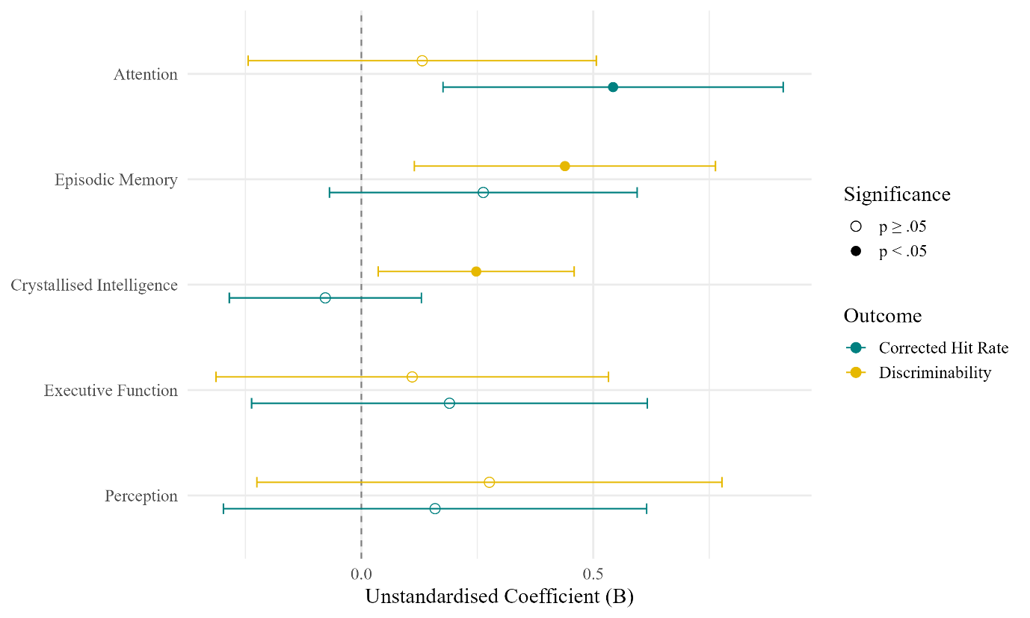

Figure 5

Regression Coefficients for Predictors of Mnemonic Discrimination
Note. Error bars represent 95% confidence intervals. Filled symbols indicate p < .05. Corrected Hit Rate and Discriminability are EFA-derived factor scores representing distinct MD outcomes. Results based on multiple imputation (m = 5, N = 66).

A secondary exploratory regression analysis examined whether the cross-domain visuospatial factor accounted for unique variance in MD performance beyond the five theory-driven domain composites. As the visuospatial factor was derived post-hoc from the cross-domain EFA, results are interpreted as exploratory alongside the primary regression findings. For Corrected Hit Rate, the addition of the visuospatial factor produced negligible improvement in model fit, with attention remaining the only significant predictor (Table 6). The visuospatial factor was non-significant (B = 0.184, p = .415), indicating it did not account for unique variance beyond the primary domain composites. Similarly for Discriminability, crystallised intelligence remained significant while the visuospatial factor was non-significant (Table 6). Episodic memory dropped to non-significant (p = .128) when the visuospatial factor was added, which is most parsimoniously explained by reduced statistical power from the additional predictor rather than genuine suppression of the episodic memory effect. These findings suggest that shared visuospatial processing ability does not account for unique variance in MD performance beyond theory-driven domain composites.
Table 6

Secondary Regression: Visuospatial Factor as Additional Predictor. Model 1 R² = .295, Adjusted R² = .222; Model 2 R² = .343, Adjusted R² = .275

 | Corrected Hit Rate |  |  | Discriminability
Predictor | B | β | p | B | β | p
Intercept | 0.006 | - | .955 | -0.116 | - | .365
Episodic memory | 0.187 | .157 | .349 | 0.319 | .253 | .128
Executive function | 0.145 | .085 | .517 | 0.038 | .020 | .868
Perception | 0.065 | .040 | .795 | 0.127 | .073 | .682
Attention | 0.465 | .322 | .034* | 0.009 | .006 | .966
Crystallised intelligence | -0.094 | -.102 | .390 | 0.222 | .229 | .048*
Visuospatial factor | 0.184 | .162 | .415 | 0.292 | .245 | .232
Note. B = unstandardised coefficient; β = standardised coefficient. Multiple imputation (m = 5, pmm). * p < .05.

Hierarchical regression was subsequently conducted on complete cases (n = 42) to examine whether adding predictors beyond the primary cognitive domains improved model fit for each outcome. For Corrected Hit Rate, attention was entered as the primary predictor due to its emergence as the sole significant predictor in the primary multiple regression. Attention alone explained 22.7% of variance at Step 1 (R² = .227, Adjusted R² = .208). Adding the remaining domain composites at Step 2 did not significantly improve model fit (ΔR² = .101, p = .270), and both AIC and BIC increased (Table 7a). Adding the visuospatial factor at Step 3 produced negligible R² change (ΔR² = .006, p = .569) with further increases in both AIC and BIC.
Table 7a

Hierarchical Regression: Corrected Hit Rate (n = 42, listwise deletion)

Step | R² | Adj R² | ΔR² | AIC | BIC | F change | p
Primary predictor | .227 | .208 | - | 118.282 | 123.495 | - | -
Domain composites | .328 | .235 | .101 | 120.401 | 132.565 | 1.353 | .270
Visuospatial factor | .334 | .220 | .006 | 122.006 | 135.907 | 0.331 | .569

Note. Step 1 = Attention. ΔR² = change in R² from previous step. AIC = Akaike Information Criterion; BIC = Bayesian Information Criterion. Lower AIC/BIC indicates better model fit. Listwise deletion was used rather than multiple imputation to enable valid F change statistics and AIC/BIC comparisons, which require a fixed sample across nested models.

For Discriminability, episodic memory was entered as the primary predictor in the hierarchical regression, due to its greater robustness across missing data methods. Episodic memory explained 32.6% of variance at Step 1 (R² = .326, Adjusted R² = .309). Adding domain composites at Step 2 again did not significantly improve model fit (ΔR² = .097, p = .219) and both AIC and BIC increased (Table 7b). The visuospatial factor produced negligible improvement (ΔR² = .011, p = .420).
Table 7b

Hierarchical Regression: Discriminability (n = 42, listwise deletion)

Step | R² | Adj R² | ΔR² | AIC | BIC | F change | p
Primary predictor | .326 | .309 | - | 106.996 | 112.209 | - | -
Domain composites | .423 | .342 | .097 | 108.466 | 120.630 | 1.514 | .219
Visuospatial factor | .433 | .336 | .011 | 109.676 | 123.577 | 0.665 | .420

Note. Step 1 = Episodic memory. ΔR² = change in R² from previous step. AIC = Akaike Information Criterion; BIC = Bayesian Information Criterion. Lower AIC/BIC indicates better model fit. Listwise deletion was used rather than multiple imputation to enable valid F change statistics and AIC/BIC comparisons, which require a fixed sample across nested models.

Across both outcomes, BIC consistently favoured the most parsimonious Step 1 model, and no F change test reached significance, supporting attention alone as the most parsimonious predictor of Corrected Hit Rate and episodic memory alone as the most parsimonious predictor of Discriminability.
Dominance analysis quantified relative predictor importance across all possible model subsets (Tables 8a and 8b). For Corrected Hit Rate, attention was the dominant predictor (General Dominance = 0.143, accounting for 43.6% of variance explained by all predictors), with episodic memory a close second (0.122, 37.2%), and remaining predictors contributing relatively little.
Table 8a

Dominance Analysis: Relative Importance of Predictors for Corrected Hit Rate

Predictor | General Dominance | Standardised
Attention | 0.143 | .436
Episodic memory | 0.122 | .372
Perception | 0.046 | .140
Executive function | 0.012 | .037
Crystallised intelligence | 0.006 | .018

Note. General dominance statistics represent the average contribution of each predictor across all 31 possible model subsets (5 predictors = 2⁵ – 1 = 31 subsets). Standardised values represent each predictor's proportional contribution to total explained variance and sum to the model R² = .328. Analysis conducted on listwise complete cases (n = 42). Attention and episodic memory accounted for 80.8% of explained variance.

For Discriminability, episodic memory was the clearly dominant predictor (General Dominance = 0.247, accounting for 58.4% of explained variance), with all other predictors combined accounting for only 41.6%. Attention was the second most important predictor (0.060, 14.2%). Crystallised intelligence contributed modestly (11.6%) despite reaching significance in the primary regression, suggesting its contribution should be interpreted cautiously alongside the dominance statistics.
Table 8b

Dominance Analysis: Relative Importance of Predictors for Discriminability

Predictor | General Dominance | Standardised
Episodic memory | 0.247 | .584
Attention | 0.060 | .142
Crystallised intelligence | 0.049 | .116
Perception | 0.045 | .106
Executive function | 0.021 | .050

Note. General dominance statistics represent the average contribution of each predictor across all 31 possible model subsets (5 predictors = 2⁵ – 1 = 31 subsets). Standardised values represent each predictor's proportional contribution to total explained variance and sum to the model R² = .423. Analysis conducted on listwise complete cases (n = 42).

Dominance analysis confirmed the dissociation between outcomes observed in the primary regression, with attention and episodic memory dominating Corrected Hit Rate and Discriminability performance respectively, while executive function was consistently the least important predictor across both outcomes, as shown in Figure 6. Thus, H2 is partially supported: episodic memory was the strongest predictor of Discriminability, consistent with the hypothesis, but attention was the primary predictor of Corrected Hit Rate, indicating that the relationship between episodic memory and MD performance is outcome-specific.
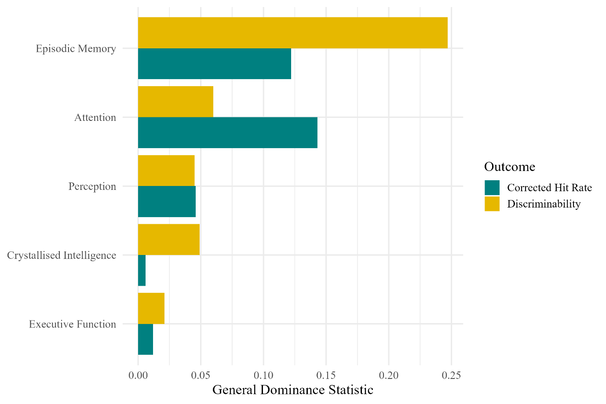
Figure 6

Relative Predictor Importance for Corrected Hit Rate and Discriminability
Note. General dominance statistics represent each predictor's average contribution to R² across all possible model subsets. Corrected Hit Rate (listwise R² = .328) and Discriminability (listwise R² = .423) are EFA-derived MD factors. Analysis conducted on listwise complete cases (n = 42).

- Discussion
The present study revealed two key findings. First, EFA identified two distinct MD factors distinguished by outcome measure—Corrected Hit Rate and Discriminability—rejecting H1. Second, a dissociation between cognitive predictors was observed across the two factors: attention was the primary predictor of Corrected Hit Rate while episodic memory dominated Discriminability, partially supporting H2.
  - Mnemonic Discrimination Latent Structure
The latent structure of MD revealed a dissociation between corrected hit rate and sensitivity-based discrimination metrics, suggesting that the factor structure of MD performance reflects measurement methods more closely than task format or stimulus category, which is notable given the substantial methodological attention paid to format and stimulus design in the MD literature. Both factors include tasks from different stimulus types and paradigms, and different stimuli and formats are thought to target different neural pathways and cognitive strategies (Berron et al., 2016; Gellersen et al., 2021). However, the choice of outcome measures, often a downstream analytical decision, may exert greater influence on what MD tasks measure than the upstream design decisions that have dominated theoretical discussion.
The choice of indices used across MD tasks is not arbitrary, with each argued by task developers to best capture MD in their respective task designs. Each index makes different assumptions about how response bias should be handled, utilising divergent quantitative conventions. The objects and scenes MDTs account for response bias using corrected hit rates. The FC MST is indexed by accuracy; Huffman and Stark (2017) contend that the simultaneous presentation of target and lure negates individual differences in response criterion, making sensitivity indices unnecessary. Despite the FC format, the use of an accuracy index likely caused this task to load onto the Corrected Hit Rate factor, as both corrected hit rate and accuracy are raw performance indices that do not apply a formal psychometric transformation to separate sensitivity from bias. The distinction between accuracy and corrected hit rate metrics may have contributed to the weaker factor loading of the FC MST onto the Corrected Hit Rate factor.
In contrast, LDI is conventionally used for the MST and oMST, while d’ is the primary index for both FC and Y/N formats of the MDT. Trelle et al. (2017) and Gellersen et al. (2021) argue that FC formats do not eliminate response bias, and d’ is therefore necessary to separate sensitivity from response bias. This methodological disagreement between task developers about whether FC format inherently controls for response bias is reflected in the latent structure of MD performance. Although derived from slightly different calculations, both LDI and d’ are sensitivity-based discrimination indices based on signal detection theory principles, and this shared psychometric framework likely explains why these indices loaded together onto the Discriminability factor despite originating from different paradigms. Thus, task variants whose developers prioritised raw performance metrics loaded onto one factor, while those whose developers prioritised sensitivity-based correction loaded onto another. The factor structure may therefore reflect divergent theoretical commitments about response bias as much as genuine differences in cognitive demands.
The two-factor structure is direct evidence that MD does not represent a unitary behavioural index of pattern separation; this challenges the assumption that MD tasks can be used interchangeably across studies, raising concerns about the validity of cross-study comparisons that aggregate findings across paradigms, as different outcome measures may capture partially distinct variance in MD ability. More fundamentally, these findings expose a category error underlying much of the MD literature: pattern separation is a neural computation, whereas MD is a behavioural outcome necessarily involving multiple cognitive processes. While this limitation is widely acknowledged in the MD literature, the implicit assumption that behavioural performance can provide clear insight into a specific neural process may set unrealistic expectations. Given the impossibility of behaviourally isolating a single neural computation and the inevitability of other cognitive processes being involved, it is unsurprising that varying designs capture different constructs, and continued efforts to refine MD tasks toward process purity may be pursuing an unattainable goal. Empirical support comes from Pishdadian et al. (2020), who found MST performance was predicted by global cognition and non-mnemonic subscales of the MoCA, but not the delayed recall subscale, suggesting MD performance is highly sensitive to general cognition, yet generalisability of this finding is limited as this was shown in older adults. Despite not loading onto a unitary construct, individual MD tasks remain valuable as sensitive markers of hippocampal change, but their interpretation may benefit from explicitly characterising the multiple cognitive processes contributing to performance rather than treating MD as a behavioural index targeting pattern separation.
  - Cognitive Predictors of Mnemonic Discrimination
Subsequently, multiple regression revealed differential predictors of the two MD outcomes after accounting for shared variance between domains, consistent with the two MD factors placing differential cognitive demands on participants, and further supporting the presence of distinct constructs. The attention composite was the primary predictor of Corrected Hit Rate, in accordance with sustained attention being critical for the formation of high-fidelity memory representations during encoding. Dominance analysis confirmed this pattern and further revealed that Corrected Hit Rate was dominated by attention, but was closely followed by episodic memory, together accounting for 80.8% of explained variance. Across both outcomes, no single cognitive domain accounted for the majority of explained variance: non-primary predictors collectively explained 56.4% of variance in Corrected Hit Rate and 41.6% in Discriminability. This pattern empirically supports the reconceptualisation of MD performance as a multi-determined behavioural outcome rather than a measure of any single cognitive process. Converging evidence from Foster and Giovanello (2020) demonstrates that domain-general cognitive processes significantly moderate MST performance, even when controlling for age. However, the substantial unexplained variance in both models (71.4% in Corrected Hit Rate; 67.7% in Discriminability) demonstrates that the cognitive domains assessed do not fully account for MD performance. This is consistent with pattern separation contributing meaningfully to performance beyond what the cognitive battery captured; therefore MD tasks likely remain sensitive to hippocampal processes, but performance reflects a broader combination of cognitive contributions than pattern separation alone.
    - Corrected Hit Rate Predictors
The emergence of attention as the primary predictor of Corrected Hit Rate aligns with the CHiPS framework, which proposed that controlled attention regulated by the frontoparietal control network is central for pattern separation (Amer & Davachi, 2023). Wahlheim et al. (2024) similarly challenge the process-pure view of MD tasks, demonstrating that attentive encoding facilitates both correct lure rejections and recollection-based retrieval, supporting the conclusion that attention is fundamentally implicated in MD performance rather than merely a peripheral influence. Although attention was not measured during MD tasks in the present study, neuropsychological composite performance likely mirrors attentional capacity available during encoding, in which sustained focus would support more detailed memory representations.
Several aspects of the tasks involved likely contributed to the role of attention only emerging as significant in the Corrected Hit Rate factor. All tasks in this model use incidental encoding conditions, which place greater demands on spontaneous attentional engagement. Furthermore, both objects and scenes MDTs use sequences of four images, with the latter two comprising the test phase, and response windows were limited to 3 seconds. The shorter delay between encoding and testing minimises the contribution of long-term episodic memory and places greater demands on short-term attentional maintenance. Additionally, the fixed response window penalises any attentional lapse with a missed response. These design characteristics only apply to the objects and scenes MDTs, but as these design features are incorporated in two of the three tasks comprising the Corrected Hit Rate factor, they are likely to substantially influence the attentional demands imposed by this factor overall. These distinctions may also contribute to the weaker factor loading of the FC MST onto this model.
Notably, the emergence of attention as a primary predictor of MD performance, despite receiving minimal previous investigation, suggests that non-mnemonic processes may have been systematically underestimated due to a theoretical bias toward hippocampal-based explanations of MD performance. Pishdadian’s (2020) finding that executive and monitoring processes drove MST performance in older adults further demonstrates a lack of pattern separation specificity. These findings call into question the validity of these tasks as behavioural measures predominantly targeting pattern separation, implying attentional deficits may partially drive impaired MD performance in Corrected Hit Rate.
Episodic memory accounted for 37.2% of the explained variance in the Corrected Hit Rate model, consistent with its role in hippocampal encoding capacity supporting distinctive memory formation during incidental encoding. The non-significance of episodic memory in regression alongside its substantial dominance statistic suggests considerable shared variance with attention, making their independent contributions to this model difficult to disentangle. This shared variance is consistent with attentional engagement during encoding being a prerequisite for episodic memory formation, suggesting these domains may represent sequential rather than independent contributions to Corrected Hit Rate performance.
    - Discriminability Predictors
The Discriminability factor initially presented two significant predictors under multiple regression: episodic memory and crystallised intelligence. However, crystallised intelligence emerged as significant only under multiple imputation methods, suggesting this finding is highly sensitive to sample composition, warranting caution in its interpretation. Furthermore, this domain only comprises the NART, limiting its construct validity in comprehensively representing crystallised intelligence. These statistical limitations, along with crystallised intelligence’s comparatively limited empirical basis as a predictor of MD performance, informed the decision to enter episodic memory alone as the primary predictor for the Discriminability factor in the hierarchical regression. Dominance analysis confirmed that episodic memory dominated the Discriminability factor, accounting for 58.4% of explained variance alone, followed by attention and then crystallised intelligence, which contributed modestly at 11.6%. Therefore, H2 was partially supported, as episodic memory was found to be the strongest domain predictor of the Discriminability MD factor.
Episodic memory ability reflects hippocampal encoding capacity, supporting the formation of high-fidelity traces, which may directly facilitate precise pattern separation by supporting the formation of high-fidelity, distinct memory representations. Both episodic memory and pattern separation depend critically on the DG/CA3 subfields of the hippocampus. The stronger relationship between episodic memory and Discriminability than with Corrected Hit Rate may suggest that sensitivity-based indices (d’ and LDI) are more sensitive to the precision of hippocampal memory representations than raw performance measures. These findings tentatively suggest that sensitivity-based MD indices may provide a more direct behavioural approximation of hippocampal pattern separation than corrected hit rate or accuracy-based measures, though this interpretation requires further validation through structural and functional neuroimaging.
Additionally, the use of explicit foreknowledge of task demands in the FC and Y/N MDTs may encourage more deliberate and precise encoding, minimising the influence of individual differences in encoding strategy, and engaging hippocampal encoding processes more directly (Gellersen et al., 2021). All of the tasks in the Discriminability factor have a longer delay between encoding and test, placing greater demands on hippocampal-dependent long-term memory retrieval. Attention only accounted for 14.2% of variance, which aligns with Vanderlip et al.’s (2026) findings that attention did not predict oMST performance once age was accounted for, suggesting attention may play a comparatively minor role in sensitivity-based MD performance within young adult samples. However, the current study cannot distinguish whether the relationship between episodic memory and Discriminability reflects shared hippocampal dependence or a more specific functional link between episodic memory and pattern separation. Future research combining MD tasks with neuroimaging or hippocampal subfield volume measurement would help clarify the neural basis of this relationship.
Executive function consistently contributed the least variance across both MD models and missing data methods, aligning with evidence that executive function does not significantly predict MD performance in young adults (Qian et al., 2025). Similarly, impaired inhibitory control significantly affected MST performance in older adults only, with no relationship in younger adults (Foster & Giovanello, 2020). This may reflect genuinely reduced variability in healthy young adults compared to older adults, where prefrontal decline introduces more pronounced individual differences (Idowu & Szameitat, 2023), supporting the compensatory role of executive function contributing to MD performance. Alternatively, the executive function measures may lack sensitivity to the range of individual differences present in healthy young adults, potentially limiting their ability to detect meaningful variance in this sample, which may contribute to the null finding of executive function’s role in MD.
Perceptual discrimination ability was also non-significant across both outcomes, which contrasts with Gellersen et al.’s (2024) finding that perceptual sensitivity was a primary predictor of MD performance in FC formats. This discrepancy may reflect the broader composite approach—aggregating across perceptual measures that did not load cleanly onto the within-domain factor may have contaminated the composite, limiting its sensitivity as a predictor. Alternatively, perception may play a greater role in older adults, aligning with Davidson et al.’s (2019) finding that perception significantly predicted MD in older adults, suggesting perceptual contributions may become more detectable with greater age-related variability.
    - Limitations of Domain Approach
Theory-driven composites allow direct comparison with existing literature, but carry several limitations. First, generalisability across existing studies must be interpreted with caution, as domain boundaries assumed in the literature may not reflect the latent structure in this sample. Not all measures loaded onto their proposed domain factors, such as the PD objects and scenes not loading onto the perception factor. The use of non-loading factors in the averaged composite may contaminate the intended construct. Similarly, the executive function domain EFA suggests two distinct factors, revealing substantial heterogeneity that cannot be accurately conflated into one construct. Composite-level analysis may mask unique predictor relationships between individual measures or clusters of measures and MD performance; for example, delayed recall or spatial working memory specifically may show stronger relationships than the broader composites suggest. Additionally, crystallised intelligence was represented by a single task and attention by only two, which limits construct validity and increases susceptibility to measurement error. Regardless, theory-driven composites were used for all domains for consistency.
The visuospatial factor emerging from cross-domain EFA was non-significant across all models, suggesting it does not contribute unique variance beyond domain composites. This may indicate that the visual demands of MD tasks do not constitute a primary cognitive limitation in healthy young adults, and therefore fail to meaningfully differentiate performance. This cannot be interpreted as the absence of visuospatial influence, especially given the heterogeneous task composition and the substantial overlap of the factor with existing domain composites; rather, there is limited evidence that this visuospatial composite of tasks contributes variance to these MD models in young adults. Future research using purer visuospatial measures with minimal composite overlap would provide a cleaner test. The null findings of the visuospatial factor, along with other cross-domain factor loadings largely aligning with the proposed domains, support the appropriateness of the theory-driven domain composite approach—MD tasks appear to be better explained by established cognitive domains than by a data-driven multidimensional factor.
  - Methodological Considerations and Limitations
The sample size (N = 66) was adequately powered to detect effects of the magnitude observed (f² = 0.213), but insufficient for conventional medium effects (f² = 0.15), meaning that smaller true effects may have gone undetected. Therefore, the absence of significance should not be interpreted as evidence of no relationship. Multiple imputation was justified to retain the full analytic sample, but the missing at random assumption cannot be definitively confirmed. A larger sample would have reduced reliance on imputation and stabilised estimates across missing data methods.
The assumption of normality was violated for Corrected Hit Rate (W = 0.813, p < .001), and borderline heteroscedasticity was observed for Discriminability (BP = 10.587, p = .060), meaning p values and standard errors may be slightly affected, and findings should be interpreted with appropriate caution. Additionally, despite standardised procedures, variations in instruction administration and display hardware across the two collection sites may have introduced minor inconsistencies.
Furthermore, multiple relevant variables were not measured in the present study. Functional and structural MRI would provide direct measures of hippocampal integrity, as cognitive tasks can only capture behavioural correlates of hippocampal function. Future research incorporating these methods could directly examine whether DG/CA3 volumes and activity predict MD performance independently of cognitive composites, or whether they mediate the relationship between episodic memory ability and MD performance. Sleep is also critical for memory consolidation and hippocampal-dependent learning (Prince & Abel, 2013), and has been found to impair lure discrimination on the MST (Stark et al., 2019). Future research standardising sleep duration and statistically controlling for sleep quality may produce more parsimonious models of MD performance.
  - Clinical Implications and Future Directions for Research
Findings regarding MD performance in young adults provide a normative baseline to compare with performance associated with age-related or pathological memory decline. Future research would substantially benefit from larger samples, allowing detection of medium effects and more precise examination of predictor relationships. This would enable replication across more diverse young adult populations. MD performance often displays the first sign of episodic memory impairment in healthy ageing as well as in clinical pathology (Gellersen et al., 2024; Stark et al., 2019), supporting the use of these tasks for early detection of Alzheimer’s disease. Findings provisionally suggest that performance in the MST, oMST, FC MDT and Y/N MDT may serve as more sensitive clinical markers of hippocampal performance than tasks using corrected hit rate or accuracy measures, and may therefore better predict future decline. Clinicians should be aware that different MD tasks may not be interchangeable as screening tools for hippocampal dysfunction, and impaired performance on Corrected Hit Rate tasks may partially reflect attentional deficits. Future research utilising structural and functional MRI can directly confirm whether DG/CA3 volumes and activity are more strongly associated with Discriminability than Corrected Hit Rate tasks, and could also test for relationships between neurological factors and MD performance independent of cognitive composites.
Future research could then manipulate the indices used across tasks, to test whether applying sensitivity-based indices to all tasks would shift the factor structure toward one unitary construct. If this aligns with greater predictive power from episodic memory ability, as originally detected in the Discriminability factor, authors might consider promoting sensitivity-based indices, over corrected hit rates and accuracy, to better isolate hippocampal-based MD ability. The field has produced increasingly diverse paradigms that have been validated independently, leaving a fragmented evidence base that cannot be coherently standardised, limiting clinical applicability. Standardising MD outcome measures across paradigms would enable more meaningful cross-study comparisons, which could contribute to the development of a standardised MD battery with agreed outcome measures. This would represent a significant methodological advance for MD research and could facilitate the inclusion of MD tasks in clinical settings.
Beyond adding clarity on the most appropriate measure of MD, research employing a longitudinal design could identify whether poorer MD performance represents an elevated risk of accelerated cognitive decline, which would emphasise the importance of young adulthood as an informative window for early identification, potentially supporting the use of preventative methods.

  - Conclusion
The current study provided evidence that MD tasks can be divided into two factors based on measurement method, rather than representing a single unitary construct. These findings challenge the assumption that MD tasks are interchangeable, representing the first study to empirically examine the latent structure of established MD tasks within a single young adult sample. A dissociation between cognitive factors for each MD outcome was observed: attention was the primary predictor of Corrected Hit Rate, while episodic memory dominated Discriminability. This suggests that Corrected Hit Rate tasks reflect partially distinct cognitive processes from Discriminability tasks, despite both being designed to measure pattern separation, illustrating the practical consequences of the unexamined assumption that all MD tasks index the same ability. The present results support reconceptualising MD tasks as multi-determined behavioural outcomes, rather than measures of pattern separation. The substantial unexplained variance in both models suggests that hippocampal pattern separation continues to contribute to performance beyond the cognitive domains assessed, supporting the continued utility of MD tasks even in light of conceptual limitations.
These findings underscore that outcome measures must be considered when interpreting cognitive predictor relationships in MD research, and screening tools should specify which MD indices are employed, as attentional deficits and episodic memory deficits may produce similar behavioural impairments on different task types. Understanding the cognitive basis of individual differences in MD performance in young adults establishes a baseline for informed comparisons with age-related decline and clinical pathology, supporting the use of MD tasks as highly sensitive measures of memory impairments for early detection and treatment.

Bibliography
Amer, T., & Davachi, L. (2023). Extra-hippocampal contributions to pattern separation. ELife, 12, e82250. https://doi.org/10.7554/eLife.82250
Azab, M., Stark, S. M., & Stark, C. E. L. (2013). Contributions of human hippocampal subfields to spatial and temporal pattern separation. Hippocampus, 24(3), 293–302. https://doi.org/10.1002/hipo.22223
Bakker, A., Kirwan, C. B., Miller, M., & Stark, C. E. L. (2008). Pattern Separation in the Human Hippocampal CA3 and Dentate Gyrus. Science, 319(5870), 1640–1642. https://doi.org/10.1126/science.1152882
‌ Belleville, S., Mellah, S., Cloutier, S., Thien Thanh Dang-Vu, Duchesne, S., Maltezos, S., Phillips, N. A., & Hudon, C. (2021). Neural correlates of resilience to the effects of hippocampal atrophy on memory. 29, 102526–102526. https://doi.org/10.1016/j.nicl.2020.102526
Berron, D., Cardenas-Blanco, A., Bittner, D., Metzger, C. D., Spottke, A., Heneka, M. T., Fliessbach, K., Schneider, A., Teipel, S. J., Wagner, M., Speck, O., Jessen, F., & Düzel, E. (2019). Higher CSF Tau Levels Are Related to Hippocampal Hyperactivity and Object Mnemonic Discrimination in Older Adults. The Journal of Neuroscience, 39(44), 8788–8797. https://doi.org/10.1523/jneurosci.1279-19.2019
Berron, D., Neumann, K., Maass, A., Schütze, H., Fliessbach, K., Kiven, V., Jessen, F., Sauvage, M., Kumaran, D., & Düzel, E. (2018). Age-related functional changes in domain-specific medial temporal lobe pathways. Neurobiology of Aging, 65, 86–97. https://doi.org/10.1016/j.neurobiolaging.2017.12.030
‌Berron, D., Schutze, H., Maass, A., Cardenas-Blanco, A., Kuijf, H. J., Kumaran, D., & Duzel, E. (2016). Strong Evidence for Pattern Separation in Human Dentate Gyrus. Journal of Neuroscience, 36(29), 7569–7579. https://doi.org/10.1523/jneurosci.0518-16.2016
Buivolova, O., Malyutina, S., Morozova, A., Fedorov, M., Gomozova, M., Loshchinina, V., & Dragoy, O. (2025). The Russian Rey Auditory Verbal Learning Test (RAVLT): version comparison and normative data for children aged 5-18 years. Child Neuropsychology : A Journal on Normal and Abnormal Development in Childhood and Adolescence, 1–16. https://doi.org/10.1080/09297049.2025.2555311
Casaletto, K. B., Marx, G., Dutt, S., Neuhaus, J., Saloner, R., Kritikos, L., Miller, B., & Kramer, J. H. (2017). Is “Learning” episodic memory? Distinct cognitive and neuroanatomic correlates of immediate recall during learning trials in neurologically normal aging and neurodegenerative cohorts. Neuropsychologia, 102, 19–28. https://doi.org/10.1016/j.neuropsychologia.2017.05.021
Cohen, J. R., Sreenivasan, K. K., & D’Esposito, M. (2012). Correspondence Between Stimulus Encoding- and Maintenance-Related Neural Processes Underlies Successful Working Memory. Cerebral Cortex, 24(3), 593–599. https://doi.org/10.1093/cercor/bhs339
Davidson, P. S. R., Vidjen, P., Trincao-Batra, S., & Collin, C. A. (2018). Older Adults’ Lure Discrimination Difficulties on the Mnemonic Similarity Task Are Significantly Correlated With Their Visual Perception. The Journals of Gerontology: Series B, 74(8), 1298–1307. https://doi.org/10.1093/geronb/gby130
Foster, C. M., & Giovanello, K. S. (2020). Domain general processes moderate age-related performance differences on the mnemonic similarity task. Memory, 28(4), 528–536. https://doi.org/10.1080/09658211.2020.174332
Gellersen, H. M., McMaster, J., Abdurahman, A., & Simons, J. S. (2024). Demands on perceptual and mnemonic fidelity are a key determinant of age-related cognitive decline throughout the lifespan. Journal of Experimental Psychology General, 153(1), 200–223. https://doi.org/10.1037/xge0001476
Gellersen, H. M., Naspi, L., Przygodda, X., Duezel, E., Berron, D. (2026). Dynamic shifts between pattern separation and reinstatement in human CA3 and dentate gyrus [Preprint]. bioRxiv. https://doi.org/10.64898/2026.04.24.720552
‌Gellersen, H. M., Trelle, A. N., Henson, R. N., & Simons, J. S. (2021). Executive function and high ambiguity perceptual discrimination contribute to individual differences in mnemonic discrimination in older adults. Cognition, 209, 104556. https://doi.org/10.1016/j.cognition.2020.104556
Huffman, D. J., & Stark, C. E. L. (2017). Age-related impairment on a forced-choice version of the Mnemonic Similarity Task. Behavioral Neuroscience, 131(1), 55–67. https://doi.org/10.1037/bne0000180
‌ Idowu, M. I., & Szameitat, A. J. (2023). Executive function abilities in cognitively healthy young and older adults—A cross-sectional study. Frontiers in Aging Neuroscience, 15. https://doi.org/10.3389/fnagi.2023.976915
Jensen, A., Karpov, G., Collin, C. A., & Davidson, P. S. R. (2023). Executive Function Predicts Older Adults’ Lure Discrimination Difficulties on the Mnemonic Similarity Task. The Journals of Gerontology: Series B, 78(10), 1642–1650. https://doi.org/10.1093/geronb/gbad091
Kim, S., Adams, J. N., Chappel-Farley, M. G., Keator, D., Janecek, J., Taylor, L., Mikhail, A., Hollearn, M., McMillan, L., Rapp, P., & Yassa, M. A. (2023). Examining the diagnostic value of the mnemonic discrimination task for classification of cognitive status and amyloid-beta burden. Neuropsychologia, 191, 108727. https://doi.org/10.1016/j.neuropsychologia.2023.108727
Lezak, M. D., Howieson, D. B., Bigler, E. D., & Tranel, D. (2012). Neuropsychological assessment (5th ed.). Oxford University Press.
Kirwan, C. B., Hartshorn, A., Stark, S. M., Goodrich-Hunsaker, N. J., Hopkins, R. O., & Stark, C. E. L. (2012). Pattern separation deficits following damage to the hippocampus. Neuropsychologia, 50(10), 2408–2414. https://doi.org/10.1016/j.neuropsychologia.2012.06.011
Kirwan, C. B., & Stark, C. E. L. (2007). Overcoming interference: An fMRI investigation of pattern separation in the medial temporal lobe. Learning & Memory, 14(9), 625–633. https://doi.org/10.1101/lm.663507
Ngo, C. T., Michelmann, S., Olson, I. R., & Newcombe, N. S. (2020). Pattern separation and pattern completion: Behaviorally separable processes? Memory & Cognition, 49(1), 193–205. https://doi.org/10.3758/s13421-020-01072-y
Pishdadian, S., Hoang, N. V., Baker, S., Moscovitch, M., & Rosenbaum, R. S. (2020). Not only memory: Investigating the sensitivity and specificity of the Mnemonic Similarity Task in older adults. Neuropsychologia, 149, 107670. https://doi.org/10.1016/j.neuropsychologia.2020.107670
Prince, T.-M., & Abel, T. (2013). The impact of sleep loss on hippocampal function. Learning & Memory, 20(10), 558–569. https://doi.org/10.1101/lm.031674.113
Putcha, D., Brickhouse, M., Wolk, D. A., & Dickerson, B. C. (2019). Fractionating the Rey Auditory Verbal Learning Test: Distinct roles of large-scale cortical networks in prodromal Alzheimer’s disease. Neuropsychologia, 129, 83–92. https://doi.org/10.1016/j.neuropsychologia.2019.03.015
Qian, J., Chang, Y.-L., Liu, X., Goh, J., & Gutchess, A. (2025). Cognitive Mechanisms Underlying Mnemonic Discrimination Across Age And Cultural Groups. Innovation in Aging, 9(Supplement_2). https://doi.org/10.1093/geroni/igaf122.1582
Stark, S. M., Kirwan, C. B., & Stark, C. E. L. (2019). Mnemonic Similarity Task: A Tool for Assessing Hippocampal Integrity. Trends in Cognitive Sciences, 23(11), 938–951. https://doi.org/10.1016/j.tics.2019.08.003
Stark, C. E. L., Noche, J. A., Ebersberger, J. R., Mayer, L., & Stark, S. M. (2023). Optimizing the mnemonic similarity task for efficient, widespread use. Frontiers in Behavioral Neuroscience, 17. https://doi.org/10.3389/fnbeh.2023.1080366
Stark, S. M., & Stark, C. E. L. (2017). Age-related deficits in the mnemonic similarity task for objects and scenes. Behavioural Brain Research, 333, 109–117. https://doi.org/10.1016/j.bbr.2017.06.049
Stark, S. M., Yassa, M. A., Lacy, J. W., & Stark, C. E. L. (2013). A task to assess behavioral pattern separation (BPS) in humans: Data from healthy aging and mild cognitive impairment. Neuropsychologia, 51(12), 2442–2449. https://doi.org/10.1016/j.neuropsychologia.2012.12.014
Stark, S. M., Yassa, M. A., & Stark, C. E. L. (2010). Individual differences in spatial pattern separation performance associated with healthy aging in humans. Learning & Memory, 17(6), 284–288. https://doi.org/10.1101/lm.1768110
Stern, Y. (2002). What is cognitive reserve? Theory and research application of the reserve concept. Journal of the International Neuropsychological Society: JINS, 8(3), 448–460. https://pubmed.ncbi.nlm.nih.gov/11939702/
Tabachnick, B. G., & Fidell, L. S. (2019). Using multivariate statistics (7th ed.). Pearson Education Limited.
Toner, C. K., Pirogovsky, E., Kirwan, C. B., & Gilbert, P. E. (2009). Visual object pattern separation deficits in nondemented older adults. Learning & Memory, 16(5), 338–342. https://doi.org/10.1101/lm.1315109
Trelle, A. N., Henson, R. N., Green, D. A. E., & Simons, J. S. (2017). Declines in representational quality and strategic retrieval processes contribute to age-related increases in false recognition. Journal of Experimental Psychology: Learning, Memory, and Cognition, 43(12), 1883–1897. https://doi.org/10.1037/xlm0000412
‌Vanderlip, C. R., Salim, H., Houle, A., Cortes, A., Virovka, A., Liang, Y., Luc, K., Kellogg, A., & Craig. (2026). Attentional Deficits Do Not Explain Age‐Related Impairments on the Mnemonic Similarity Task. Hippocampus, 36(3), e70095–e70095. https://doi.org/10.1002/hipo.70095
Wahlheim, C. N., Garlitch, S. M., Mohamed, R. M., & Weidler, B. J. (2024). Associations among attentional state, retrieval quality, and mnemonic discrimination. Journal of Memory and Language, 139, 104554. https://doi.org/10.1016/j.jml.2024.104554
Yassa, M. A., & Stark, C. E. L. (2011). Pattern separation in the hippocampus. Trends in Neurosciences, 34(10), 515–525. https://doi.org/10.1016/j.tins.2011.06.006

Appendix
Appendix A
Abbreviations
AIC – Akaike Information Criterion
BIC – Bayesian Information Criterion
CHiPS – Cortico-Hippocampal Pattern Separation
CPT – Continuous Performance Task
d' – Discriminability Index (signal detection theory measure of sensitivity)
DG – Dentate Gyrus
EFA – Exploratory Factor Analysis
FC – Forced Choice
KMO – Kaiser-Meyer-Olkin
LDI – Lure Discrimination Index
MD – Mnemonic Discrimination
MDT – Mnemonic Discrimination Task
MST – Mnemonic Similarity Task
oMST – Optimised Mnemonic Similarity Task
Pcon – Perceptual Control
PD – Perceptual Discrimination
pmm – Predictive Mean Matching
RAVLT – Rey Auditory Verbal Learning Test
REY-O – Rey-Osterrieth Complex Figure Test
TMT – Trail Making Test
VIF – Variance Inflation Factor
Y/N – Yes/No

Appendix B
Cognitive Battery Details
Appendix G provides full procedural and scoring details for each cognitive domain measure. Composite scores were created by z-scoring individual measures within the young adult sample and averaging within each domain.
Episodic Memory
The RAVLT involves seven recall trials using a 15-word list: trials 1–5 take place immediately after each oral presentation, trial 6 follows exposure to a separate distractor word list, and trial 7 occurs after a 20-minute delay. The three indices were extracted from trials 1-5 averaged (learning), trial 6/ trial 5 (resistance to retroactive interference), and trial 7 (delayed recall), and were selected based on robust evidence that these three processes demonstrate dissociable patterns and therefore reflect distinct aspects of episodic memory functioning (Putcha et al., 2019; Casaletto et al., 2017; Buivolova et al., 2025). The REY-O requires participants to copy a complex figure within a 2-minute time limit, after which the image is removed and they are asked to reproduce it from memory, both immediately and after a 20-minute delay. All reproductions are scored according to a standardised scoring system. Initially, a retention index was calculated alongside the episodic memory composite, as the ratio of immediate to delayed scores, however this was discarded after 45 participants showed higher delayed than immediate scores, indicating that the index did not reliably capture retention.
Executive Function
The Trail Making Test (TMT) comprises two parts. Trail A requires participants to connect consecutively numbered circles, then Trail B requires participants to alternate between numbered and lettered circles. The TMT difference score was employed to isolate set-shifting and cognitive flexibility from processing speed. Separate forward and backward scores for Wechsler’s Digit Span and SpatioTemporal working memory span tasks were motivated by robust evidence that forward and backward digit span tasks reflect distinct cognitive processes—passive short-term storage and active executive manipulation, respectively (Lezak et al., 2012)—and while there is less conclusive evidence for an equivalent distinction in spatial span, the same approach was adopted for theoretical consistency.
Perception
In the PD oddity task, stimuli consisted of unfamiliar computer-generated objects (greebles) and indoor scenes, with high and low ambiguity conditions reflecting varying amounts of feature overlap (Gellersen et al., 2021). The standardised difference score was utilised to control for general perceptual ability and response bias, and isolate ambiguity-specific discrimination ability. Discriminability indices were derived for the Pcon sequential and pairwise tasks as z-scored hit rate minus z-scored false alarm rate to capture perceptual sensitivity while controlling for response bias. For objects in noise, mean opacity represents the average degraded conditions at which participants could correctly identify objects, with task difficulty modified based on accuracy on the preceding trial, thus higher average opacity indicates better perceptual discrimination under degraded conditions.
Attention
Participants completed 246 trials of the CPT to assess sustained attention and response inhibition. The composite integrated hit rate, error rate, mean reaction time and reaction time variability, to capture accuracy, efficiency and stability of attentional engagement. The Flanker task requires participants to indicate the direction of the central arrow (via button press) while ignoring flanking distractors. The composite averaged standardised reaction time interference (incongruent minus congruent reaction time) and accuracy, to capture the efficient attentional conflict resolution across both speed and accuracy dimensions.
Crystallised Intelligence
Participants from the University of Cambridge site completed the NART, while participants from the University of California, Irvine site completed the AMNART (American National Adult Reading Test). The only variation between the two tasks is the word list, with the AMNART replacing words that are common in British English with culturally equivalent American English irregular words. Participants were asked to read 50 irregular words aloud. Correct pronunciation requires prior exposure, therefore this is considered a reliable reflection of crystallised, learned knowledge.

Appendix C
Table C1 summarises the number and percentage of missing values for each variable included in the regression analyses. Missingness ranged from 3.0% (Crystallised Intelligence) to 33.3% (Visuospatial Factor). Participants missing any component measure were assigned a missing composite score. This conservative approach was adopted to ensure composites comprehensively reflected the intended construct, but consequently contributed to higher missingness rates in multi-component composites. Of the 66 participants, 42 (63.6%) had complete data across all regression variables. Visual inspection of the missing data pattern, along with independent samples t tests, confirmed that missingness was distributed across participants rather than concentrated in a systematic subset, supporting the missing at random assumption and the suitability of multiple imputation as a missing data strategy to retain the full analytic sample.
Table C1
Missing Data Summary Prior to Multiple Imputation
Variable | N Missing | % Missing
Visuospatial factor | 22 | 33.3
Corrected Hit Rate (factor score) | 16 | 24.2
MD Discriminability (factor score) | 16 | 24.2
Executive function | 16 | 24.2
Attention | 15 | 22.7
Perception | 10 | 15.2
Episodic memory | 4 | 6.1
Crystallised intelligence | 2 | 3.0
Note. Total N = 66. Missingness was assessed prior to multiple imputation. Independent samples t tests confirmed missingness was not significantly associated with age for any variable (all ps > .55), supporting the missing at random assumption. Multiple imputation (m = 5, pmm) used to retain full sample.

Appendix D
Table D1 summarises regression coefficients and p values for the Corrected Hit Rate model under both listwise deletion (n = 42) and multiple imputation (N = 66). Attention was significant under multiple imputation (p = .007) but marginal under listwise deletion (p = .057). Episodic memory showed a marginal trend under listwise deletion (p = .058.) that did not reach significance under imputation (p = .137). Discrepancies are attributed to reduced statistical power in the listwise sample rather than substantive differences in the pattern of results, and are expected given the large difference in sample sizes between methods, even when true effects exist.
Table D1
Sensitivity Analysis: Corrected Hit Rate—Listwise Deletion vs Multiple Imputation
 | Listwise Deletion (n = 42) |  | Multiple Imputation (N = 66)
Predictor | B | p | B | p
Episodic memory | 0.420 | .058. | 0.263 | .137
Executive function | -0.001 | .997 | 0.190 | .389
Perception | 0.312 | .353 | 0.159 | .507
Attention | 0.490 | .057. | 0.543 | .007**
Crystallised intelligence | 0.027 | .881 | -0.078 | .465
Note. Listwise deletion n = 42; multiple imputation m = 5, N = 66. Discrepancies in significance levels are attributed to reduced statistical power in the listwise sample. ** p < .01, . p < .10.

Appendix E
Table E1 presents unstandardised regression coefficients and p values for the Discriminability model under both listwise deletion (n = 42) and multiple imputation (N = 66). Episodic memory was significant under both methods (listwise p = .001, imputed p = .014), representing the most robust finding across the analyses. Crystallised intelligence only reached significance under multiple imputation (p = .025) and not under listwise deletion (p = .149), suggesting that the significance of crystallised intelligence is sensitive to the missing data method employed and cannot be considered a reliable finding without further replication. Accordingly, episodic memory was prioritised as the primary predictor in hierarchical regression, further supported by its stronger theoretical basis in the pattern separation literature.
Table E1
Sensitivity Analysis: Discriminability—Listwise Deletion vs Multiple Imputation
 | Listwise Deletion (n = 42) |  | Multiple Imputation (N = 66)
Predictor | B | p | B | p
Episodic memory | 0.656 | .001** | 0.439 | .014*
Executive function | -0.105 | .735 | 0.110 | .614
Perception | 0.386 | .188 | 0.276 | .305
Attention | 0.129 | .554 | 0.131 | .498
Crystallised intelligence | 0.230 | .149 | 0.248 | .025*
Note. Listwise deletion n = 42; multiple imputation m = 5, N = 66. Discrepancies in significance levels are attributed to reduced statistical power in the listwise sample. ** p < .01, * p < .05.

Appendix F
Table F1 presents variance inflation factors (VIFs) for all predictors in both primary regression models. All VIFs were below 1.4, indicating that multicollinearity was not a concern in either model (Tabachnick & Fidell, 2019), and component plus residual plots indicated broadly linear relationships between predictors and outcomes. Influential cases were assessed using Cook's distance (threshold = 4/n); no cases were removed as inspection revealed influential observations reflected genuine performance variation.
Table F1
Variance Inflation Factors for Primary Regression Models
Predictor | Corrected Hit Rate | Discriminability
Episodic memory | 1.310 | 1.310
Executive function | 1.323 | 1.323
Perception | 1.255 | 1.255
Attention | 1.363 | 1.363
Crystallised intelligence | 1.112 | 1.112
Note. VIF = Variance Inflation Factor. Values below 5 indicate no multicollinearity concern. Assumption checks conducted on listwise complete cases (n = 42), as regression assumption diagnostics cannot be applied directly to multiply imputed datasets, but are considered representative of the imputed models due to broad consistency of results.

Appendix G
Table G1 shows Shapiro-Wilk test statistics for residuals from both primary regression models. The normality assumption was met for Discriminability (W = 0.970, p = .324) but violated for Corrected Hit Rate (W = 0.813, p < .001). The cause of this violation is unclear but may reflect the distributional properties of the outcome variable. As multiple regression is robust to violations of normality, all models were retained but Corrected Hit Rate results are interpreted with appropriate caution.
Table G1
Shapiro-Wilk Tests of Residual Normality
Model | W | p
Corrected Hit Rate | 0.813 | <.001
Discriminability | 0.970 | .324
Note. W = Shapiro-Wilk statistic. Non-significant p indicates normality assumption is met. Assumption checks conducted on listwise complete cases (n = 42).

Appendix H
Table H1 presents Breusch-Pagan test statistics for both primary regression models. Homoscedasticity was confirmed for Corrected Hit Rate (BP = 2.000, p = .849), while the test approached but did not reach significance for Discriminability (BP = 10.587, p = .060). Results for Discriminability are thus interpreted with recognition of this borderline heteroscedasticity.
Table H1
Breusch-Pagan Tests for Heteroscedasticity
Model | BP | df | p
Corrected Hit Rate | 2.000 | 5 | .849
Discriminability | 10.587 | 5 | .060
Note. BP = Breusch-Pagan statistic. Non-significant p indicates homoscedasticity assumption is met. Assumption checks conducted on listwise complete cases (n = 42).

