09.04.2021
Jomir Ullah 1708855

Strategic Management SME
Lecturer: Paul Bocij

Contents
1.0 Introduction 2
2.0 Current Strategic Direction 3
2.1 Porters Five Forces 4
2.2 Value Chain Analysis 7
2.3 Balance Score Card 10
2.4 Evaluation of Strategic Direction & Absence of Vision Statement 12
3.0 External Environmental (Macro) Analysis 14
3.1 PESTEL 14
3.2 SWOT 17
3.3 Advanced SWOT for Naya 19
3.4 Ansoff Matrix 20
3.5 Evaluation of Environmental Scanning 21
4.0 Stakeholder Analysis 22
4.1 Stakeholder Mapping 23
4.2 Stakeholder Power / Interest for Naya 24
5.0 Sustainable Strategic Options 25
6.0 Recommendations 27
6.1 SFA Matrix 31
6.2 Resistance to Change 31
6.3 Competitors Response 32
6.4 Future Development Awareness 32
7.0 References 33

Figure 1 Strategic Management Process source: Barney and Hesterly (2019). 4
Figure 2 Porters Value Chain Analysis; Source: https://research-methodology.net/theory/strategy/value-chain-analysis-2/ 8
Figure 3 Organisational Structure of Naya 10
Figure 4 SWOT analysis of Naya 19
Figure 5 Ansoff Matrix source: CFI Education Inc. (2021) 21
Figure 6 Naya Stakeholder Analysis 23
Figure 7 Mendelow's Matrix Source: Adapted from Mendelow, A.L. (1981). 'Environmental Scanning - 24
Figure 8 Power/Interest Grid for Naya 25
Figure 9 Sustainability Options 26
Figure 10 Management Levels in an Organisation Source: : https://2012books.lardbucket.org/books/management-principles-v1.0/s10-01-the-nature-of-goals-and-object.html 27
Figure 11 Decision Making Levels Source: Bocij, Greasley and Hickie (2019). 27

1.0 Introduction

This report will aim to critically appraise the current strategic direction of an Indian restaurant which is located in the heart of Warwickshire, in a rural town of Henley-in-Arden. The restaurant is strategically located on the Henley high street and has gained popularity from local residents and high-income earners and tourists who frequent the affluent town of Henley. This is a small restaurant employing twelve people. It has been trading for ten years and gained cumulative experience in the catering and hospitality industry.
Since its opening in 2009 the restaurant has faced challenges in human resource management and internal logistics which has impacted on the firms competitive advantage. Naya Indian cuisine are also facing difficulty as the environment that they operate in has changed dramatically due to Covid-19. Customers eating preferences and changes in regulation and law are restricting customers and this causal effect has had a negative impact on the sales and growth prospects of the business, often limiting the business to a take-away service only.
The company at present does not have vision statement. The business’ objectives at present is survival and to maintain customer loyalty. Values in the business, although not written are communicated in the socialisation process of new recruits and reinforced by existing members of the workforce. This report will aim to formulate a vision and mission statement for Naya.
In order to understand the current business direction, this report will include an industry analysis with the aim of highlighting the strengths and weakness of the business, identify new opportunities and threats and determine which functional strategies can add value and competitive advantage. A PESTLE analysis will provide insight into current and future trends and identify key drivers for change in this industry and the broader ecosystem in which the business operates and also identify external factors/components that can limit the competitiveness of the business.
Prior to formulating new strategies this report will include a stakeholder analysis and examine their motivations and expectations. At the end of this report strategies proposed will be mostly geared towards technological and process improvements as this will aid the business to sustain a competitive advantage.

2.0 Current Strategic Direction

Strategic planning is an important aspect for any business as it helps the business to match its objectives to the vision statement and establish what resources are required to reach their strategic goals (David, 2011).
To establish the current strategic direction of Naya this report will aim to use research data from industry sources to measure how Naya compares with its competitors in the market. The findings of the analysis can be used to understand the competitive strategies the business is currently pursuing to remain in the number one position in the marketplace. The report will follow this routine below to establish the strategic appraisal process and propose new strategies for the future.
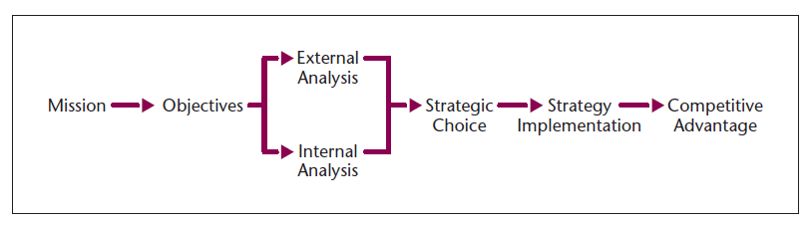
Figure 1 Strategic Management Process source: Barney and Hesterly (2019).

2.1 Porters Five Forces

Force | Risk H/L | Notes
Threat of new entrants | Medium | Barriers to entry are currently medium. There is a shortage of expert human resources such as Chefs in the Indian restaurant industry. The setup cost in a rural town is considerably high. Also the incumbents have an advantage as they have ten years cumulative experience in this sector.
Threat of substitutes | High | Substitutes are alternative products that fulfil the same need. There are various businesses such as Pubs, fast-food outlets and supermarkets in the business ecosystem that can attract customers as they are readily available.
Bargaining power of customers | Low | Customers at present cannot force the prices down as it a rural town. Switching cost are relatively high as they need to go out of town to make a saving which in turn will increase fuel cost and time.
Bargaining power of suppliers | Low | Supplier for the industry are readily available and products are differentiated. So the business can choose to obtain resources from a variety of suppliers. However, the wine merchants have tied the business into a contract which means they are unable to source beverages without high exit fees.
Industry rivalry | High | Rivals are trying to increase market share. Current pandemic has reduced sales and rivals are reacting strongly with competitive warfare tactics by reducing prices and aggressive marketing and promotion.
Complementors | High | The business has many other outlets and service providers such as Pubs, Henley Ice Cream. These businesses provide a leverage due their proximity and social patterns. i.e. customers like to have spicy food after drinking at the pub.

Analysis of Porters forces indicate that Naya operates in an environment where there is intense rivalry amongst the three main providers of Indian food. To maintain a sustainable competitive advantage Naya is currently adopting a cost reduction strategy on takeaway orders up to 20% to make the products and service more attractive to customers to increase their sales and profit margin. Their rivals are not able to match this offer.
At present the rivals are increasing their promotion and marketing tactics by using social media platform and digital communication to gain leverage. Naya is competing to attract customers through regular offers during the current lockdown. However, their rivals are offering better means of contact between customer and business through an online ordering system via the website.
Customers are increasingly using the internet to connect to service providers and planning ahead to book a table or pre-order food to avoid waiting long during peak times. Naya needs to improve its digital marketing activities and incorporate an online ordering system. The use of technology will further reduce the operational cost of the business, raise the entry barriers for new entrants through patented technology, increase switching cost and lock in customers and suppliers. It will also create opportunities for employees to work remotely (Bocij, Greasley and Hickie, 2019).
The threat of substitutes is another major concern as rivals and supermarkets in the business ecosystem are providing similar products that would satisfy the need of the customer. Therefore, attracting them away from the business. The business is currently creating value for the customer and competitive advantage by differentiation of the products available. Naya is using fresh ingredients and locally produced produce to serve customers thereby providing quality food and also reducing their carbon footprint. In addition they are using information leadership (Susskind and Maynard, 2019) and cumulative experience to offer customers a unique taste and quality of food and often tweaking the recipe to individual customer needs.
Naya is focusing attention on a niche market, their wealthier clients. The business is keen to attract the employees from the local and wider area of the community for business meetings and office parties and can cater for large numbers of people. Currently their rivals are not able to do this due to a lack of capacity.
Naya restaurants prices are comparatively higher than the rivals and so it does not fully benefit from cost leadership although it is making savings in its value chain. However, the type of customers who like to dine are mostly retired customers who have high disposable income and can afford to spend more on quality of food, attentive service in a modern restaurant.
Currently, due to the worldwide pandemic (also discussed in environmental scanning). Naya is now offering a free delivery service and a greater discount on takeaway orders to attract customers who have been impacted by the pandemic.
The threat of new entrants is medium at present. However, this might change in the future due to changing social patterns and trends and changes to the external environment. According to Lock (2021) the restaurant industry is at the maturity stage and the demand in the food and drinks sector has steadily decreased as a result of the pandemic. Alternatively, McCulloch (2021), in his report states that firms can survive post coronavirus by creating and developing strategies to formulate a brand image to gain customer loyalty and maintain a sustainable competitive advantage over rivals.
Although this type of analysis is useful to measure the level of competition and to gather insights into how the business can sustain an advantage; critics of Porter (Bruijl, 2018; Gnjidić, 2018; Walder, 2013) state it is not always possible to gather complete information due to the turbulent nature of the business environment and in the current age of innovation and digitalisation Porters forces can become irrelevant. No industry operates in isolation so businesses need to monitor the environment more frequently to identify new and emerging opportunities or threats.
The analysis suggests there is competitive parity at present and there are opportunities for Naya to increase its growth and sales margin through innovation and formulation of new strategies.

2.2 Value Chain Analysis

An alternative view of the firms strategic direction can be assessed using Porters Value Chain Analysis. This is where managers look at a variety of function of the business and identify areas of opportunity or improvements that can be made to create value and competitive advantage for the business (CFI Education Inc., 2021).
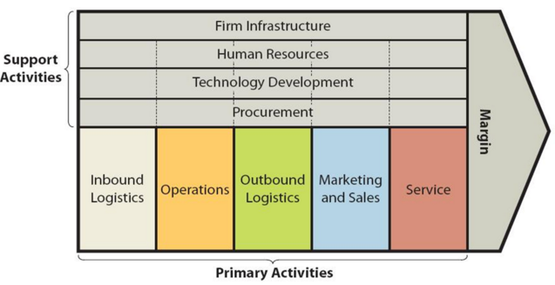
Figure 2 Porters Value Chain Analysis; Source: https://research-methodology.net/theory/strategy/value-chain-analysis-2/

Primary Activities:
Inbound and Outbound logistics:
The business is making a cost reduction in sourcing inputs from locally produced farms. This is beneficial to consumers as they attach more value to locally acquired goods (Yoon, Chung and Jun, 2020). The business also reduces its cost in terms of storage as produce is readily available, its environmentally sustainable and organic food has a better quality and taste compared to food prepared in a factory. The use of technology to enhance this operation can be improved to produce invoices and receipts and reduce paper and administration duties.

Operations:
Naya needs to improve it machinery that is used to cook and prepare food. Faulty machinery can lead to a loss of service for customers and reduce overall profits. It will also impact on the quality of the food. New cooking methods and machinery will improve economies of scale for the business, as a result they can charge a higher premium for their service and quality. Once again Naya is not taking advantage of technology to control inventory or sensors to notify of emergencies such as gas leaks or faults within the machinery.
Marketing and sales:
Currently Naya is only marketing its products on a single social media platform and targeting a niche market. This can be improved by incorporating a Customer Relationship Management tool to benefit from an information leadership strategy; an online ordering system for customers and also targeting different segments of the population to inform them of the new products on offer.
Service: Naya is exceeding customer after sales as they have a competent workforce who are always ready to engage with customers to meet their needs. However, further training can be given to support newcomers and temporary staff so that service level does not impact on the customers overall experience. This can be achieved through an online training programme.

Secondary Activities
Infrastructure: Naya has a hierarchical organisational structure which can limit effective communication and innovation in the organisation. It can also lead to a lack of collaboration amongst the employees. However, Naya has a strong organisational culture and power is decentralised. With a flat organisation structure the business would benefit from employee engagement, greater employee job satisfaction leading to better performance and motivated workforce.
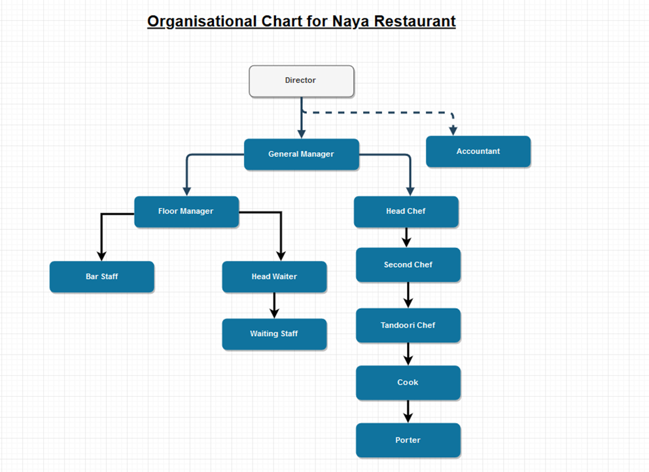
Figure 3 Organisational Structure of Naya
Human Resource Management:
Naya does not have a HRM policy and employees are head hunted or referred through trusted contacts. The need to monitor, train and retain qualified staff is becoming more essential as there is a gap for qualified Chefs in this sector (Cajander and Reiman, 2019). The new generation of workers are not interested in manual work. However, through the use of technology, the business can add value to this factor, through online recruitment activities and introducing reward programmes and incentives for high achievers.
Technology development:
A memorable innovation moment for this sector is the use computer software such EPOS system to take customers’ orders more efficiently. This has revolutionized how the business operates, leaving behind the iconic pen and writing pad. Customers order can be taken quickly, errors can be reduced. However, Naya needs to incorporate a online ordering system and introduce more content for advertising to target customers more efficiently.

2.3 Balance Score Card

Most commonly an organisation success is measured on its financial outcome. However, this provides a limited insight into the business. Kaplan and Norton (1996) suggested four different metrics to measure performance and success of the business. This provides a better perspective for businesses and a benchmark to measure their current objectives and ultimately their targets and goals. Below is a balance score card for Naya
 | OBJECTIVES | MEASURES | TARGETS | INITIATIVES
CUSTOMER | - Increase loyalty  - Reduce complaints  - Increase customer satisfaction | - number of repeat customer orders  - reduce waiting time and food preparation times  - number of touchpoint with customer | - >1 per week  - Complete orders within 30mins  - >85% happy | - Regular promotions  - Hire extra staff during weekends  - Surveys, reviews, testimonial
FINANCIAL | - Increase market share  - Increase sales revenue  - Reduce costs | - new customers  - sales value per customer  - limit errors and wastage of food products | - 10 new customers per month  - Min spend per customer > £25  - <3 error per month | - Advertising, posting menus  - Upselling, training staff  - Prize giveaways, employee of the month
BUSINESS PROCESS | - Reduce waste  - Improve quality of food  - Improve ambience | - Use recycling bins.  - Quality control  - Customer surveys review ratings | - 100% recycling  - <3 quality issues per month  - >85% satisfaction | - Recycle policy, educate staff  - Best practises training  - Team bonding exercise, programmes to enhance customer experience
GROWTH AND LEARNING | - Comply with food safety laws  - Improve teamwork  - Employee Job satisfaction  - Job enrichment enlargement | - Food safety inspection  - Rate of absenteeism  - Employee turnover  - Staff surveys/feedback | - 5 star  - <12 days absence in a year  - < 15 %  - 85% positive | - Review and monitor current protocols  - Rewards and appraisal system  - 360degree feedback, coaching and mentoring in the workplace.

LEGEND: RED: NOT MEETING TARGET GREEN: ON TARGET

The Balance score card analysis has highlighted key areas where the business is not meeting its targets. As each category is different, the managers and owners can devise new strategies or set new measures and initiatives to meet these key performance indicators. The strategies can be made at different organisational levels to fulfil the mission of the business.
Benefits of conducting a BSC means that the strategy can be communicated quickly and actions can be taken to meet the specific objectives. It helps align the various business sections such as kitchen and front waiting staff. Employees are also able to visualise their progress and this can be linked to their personal goals and the businesses strategy. The metrics used in the BSC can be used as a basis of reporting on progress made within each category.

2.4 Evaluation of Strategic Direction & Absence of Vision Statement

Key Findings:
It can be argued that Naya restaurant has not taken full advantage of the resources available to gain leverage and sustainable competitive advantage over their rivals. The analysis of the Value Chain and Porters Forces suggest that opportunities are available to enhance the business operations such as introducing an online ordering system for customers to order food and book tables without the need to speak to a member of staff.
Online businesses are always open and accessible for customers at any time. Online facilities for customers will add leverage and increase information leadership as data can be used to see how long customers spend on the website, which items are popular and also feedback from customers can be taken promptly. This increases customers’ ease of access, it will increase customer loyalty and help to create a brand image for Naya.
Naya also needs to improve its marketing and sales strategy to a wider target market as the current pandemic has limited the business operations to takeaway food only. As different customers use certain social media, Naya needs to reach out to them with their offering to attract new and existing customers.
The current machinery that is being used in the business is outdated. New machinery can improve the quality of cooking methods and allow the employees to be more innovative in the processes they use. This will not only save time, but it will also increase the customer experience and lock them in.
The balance score card analysis identifies that Naya is not meeting targets in business processes and financial targets. The business can improve or make new strategies to meet these key performance indicators such as creating new initiatives for each category or totally revisiting the key metrics.
Bora, Borah and Chungyalpa (2017) have stated that having a vision and mission statement provides multiple benefits to an organisation as well as showing strategic intent. It gives them a sense of purpose and a long-term direction, as a result, goals and objectives can be used by managers to measure performance in terms success and failures. It can be argued that a vision statement is not necessary for a small business such as Naya, as its operations and ambitions are limited. It is the opinion of the researcher that Naya should create a vision and a proposed statement is below:

NEW VISION STATEMENT: Our Vision Is To Become A Carbon Neutral Restaurant In The UK And Gain Michelin Star Status By 2030
CURRENT MISSION STATEMENT:
UPDATED MISSION STATEMENT: At Naya our staff will be empowered to be exceptionally responsive to our guest, and make them feel welcome in a relaxed atmosphere, we aim for extraordinary customer service through our people focused strategy. Our customer satisfaction is our reputation.
In addition it helps the business to formulate strategies on business and operational levels to unite the workforce to fulfil the vision of the company. Furthermore, having a vision statement will make the business more attractive to customers and potential investors as the vision also details other aspects such as ethical, corporate social responsibility and sustainable approaches which the business may pursue for the future.

Lynch (2018) stated that a good vision statement should include how the customers can benefit from the services as well the corporate social responsibility of the business to the environment in which they operate.

3.0 External Environmental (Macro) Analysis

3.1 PESTEL
In this section the report will examine the external factors and determine which factors are impacting the business and which are providing a leverage for competitive advantage. This report will also highlight the equilibrium effect of these factors i.e. how changes in the external environment can impact the business and vice versa. Below are the factors which can impact strategic decision making for Naya.
Political:
- Brexit- price of goods will rise due to taxation and tariff charges. Logistical channel-transportation costs are likely to increase and food safety is constantly being upgraded.
- Elections
- War and famine
- COVID-19 restrictions
Elections in exporting countries can impact on the cost businesses pay for fuel and overhead cost such as gas and electric as Britain relies on other countries for raw materials. If there is war in a country and supply routes are blocked then this can impact on inputs needed to produce goods.
A larger organisation may be able to absorb the costs associated with VAT increases and continue to make a profit. However, SME’s may not be able to withstand an increase in rates. As a result a VAT increase is beneficial to the large organisation as its competition will not be able to make as much profit and may go out of business.
Economical:
- Recessions and depression
- Inflation
- Rise in oil prices
- COVID-19 restrictions
The economic climate can have a significant impact on the business cycle such as during depressions and recession, if customers have more money they are likely to spend, so businesses can target them with better services and quality products. In a recession people are out of pocket and will look for cheaper options to satisfy their need.
Here, companies that can innovate are likely to prosper, and companies that have a hierarchical structure will find it more difficult to gain a leverage in times of recession as communication of the vision is not established effectively. Again strategies need to be changed to take into account of these changes in economic climate.

Socio-cultural:
- Change in local demography
- Changes in work patterns
- Changes in preferences
Customers tastes and preferences are continuously changing, they now seek health-conscious option. More people are becoming vegetarians. Customers no longer using cash, so the business needs to have alternative methods of payment such as WeChat which is commonly used in China. Further, UK residents are not always willing to work unsociable hours in the industry so the challenge to find talented staff and keep them motivated is a real concern.
Demographics is key to success. Henley has baby boomers and is often referred to as ‘gods waiting room’. These customers have a high disposable income and are willing to pay for premium prices in return of good value in food and service. If there is a shift in the demographics then new strategies need to be formulated to take advantage of change, to satisfy the needs of the new demography and simultaneously showing concern for social welfare and conducting business in an ethical manner and showing consideration for the environment.

Technological:
- Automation
- Mechanisation
- Better Telecommunication
- Social media
Innovative cooking methods and techniques will maintain freshness, increase productivity and efficiency. Online ordering system, 5G, Internet of things, CCTV monitor and sensors for temperature control and record out of stock items are effective tools to manage the business.
Advances in technology can be a source of competitive advantage as well as a threat. Technology makes it easier to perform business functions more accurately and can be used to monitor business activities such as HR, Finance, Marketing, Supply chain Management and Business Intelligence by creating a Knowledge sharing database. Also technology if not implemented in the right time can be difficult to adapt to, as change management programme require training, time and are costly to implement.

Environmental:
- Pressure/focus groups
- Sustainable and ethical sourcing of inputs
- Unstable weather
Pressure groups, Focus groups, pandemics and poor unstable weather such as floods snow have hampered business and bookings have been cancelled. Naya does not have a dedicated delivery service. There is a lot of food wastage and recycling targets are not currently being met. Changes in environmental law and pressure from focus groups are likely to exert pressure on businesses. This can impact on the reputation of the business. So Naya needs to clearly address these issues in its vision and mission statements.
Legal:
- Minimum wage increase, National Living wage
- Food safety regulation
- Changes in public health regulations
Additional cost to employer. Changes in health laws, tighter curfew on opening hours. Recent deaths from allergic reactions, staff need to more training. Naya is not able to attract new talent as Home office requirements are unfavourable to the industry.
Laws which are enacted can also be a favourable or unfavourable such as minimum wage increases. This will eat into profits and the business may need to reduce the staff and organisational size. If visa rules are relaxed Naya can hire skilled chefs from abroad with relative ease.
Businesses that adapt to the changing nature of the external environment can prosper through first mover advantage. Businesses that have taken advantage of such changes in the macro environment are now successful and making more profit with higher market share and growth. e.g. changes made by Ofcom on energy regulation has allowed smaller suppliers to compete in the energy sector making it more competitive and giving customers more choice creating perfect competition rather than price wars.
Businesses that have failed to identify risks or responded too late have been forced to completely shut down e.g. Blockbuster did not take action over changes in technology.
Powerful industries can and will lobby to exert pressure on government to make the market more favourable for them e.g. American gun laws.

3.2 SWOT

This type of analysis looks into the businesses internal proficiencies such as areas of weakness and strength, favourable conditions and threats. Naya must identify its position relative to others in the marketplace. Competitive advantage is derived from the businesses ability to perform their business operations more effectively and efficiently.
Naya has a strong organisational culture and these equates to a workforce that is highly skilled and committed to perfection. This means that the management do not have to use time to manage and monitor staff. They can concentrate on other areas such as any weaknesses and deduce how their strengths can be used to mitigate weaknesses and threats. Below is an exhaustive list of the key components of the SWOT for Naya.

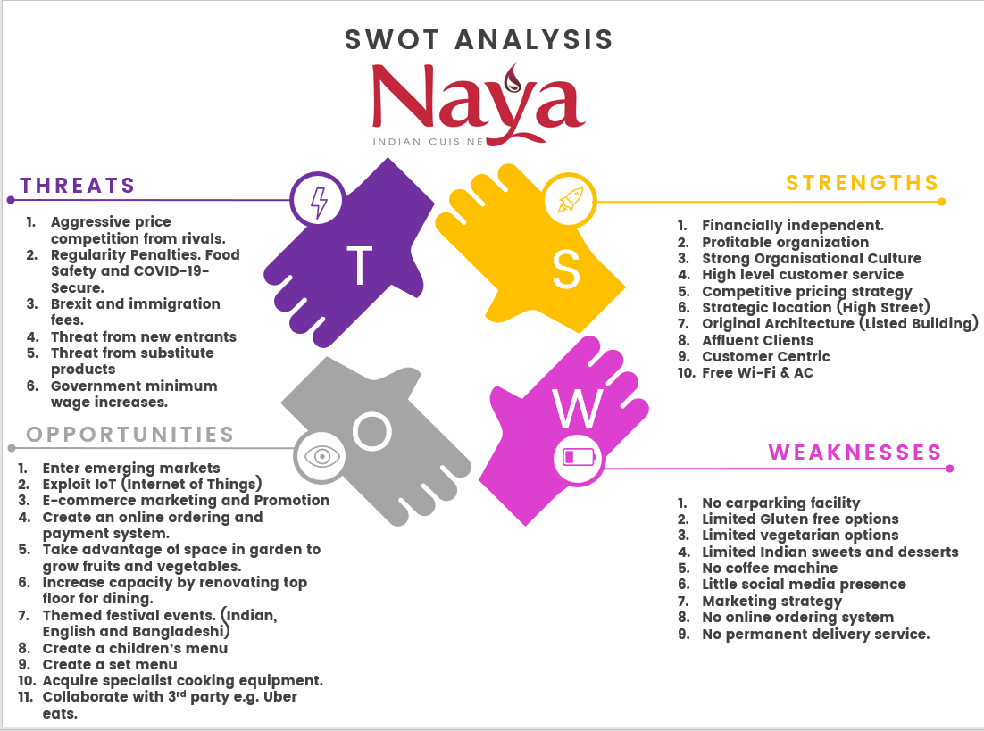
Figure 4 SWOT analysis of Naya

3.3 Advanced SWOT for Naya
The advanced SWOT has highlighted critical success factors and weaknesses of the business. Naya can mitigate weakness such as purchasing new technology as it is financially profitable business. Also the threats which have been identified can be mitigated through opportunities to increase capacity to increase sales. They can also use IT and digital marketing too on several platforms to attract the attention of new and existing customers. Advertising digitally is also cheaper and environmentally friendly.

3.4 Ansoff Matrix

Making predictions for the future can be difficult as the environment is constantly changing. Igor Ansoff’s matrix is used by businesses to look at the environment and plan four different strategies to enhance and grow the business. Naya restaurant strategies for growth can be enhanced by using this matrix.

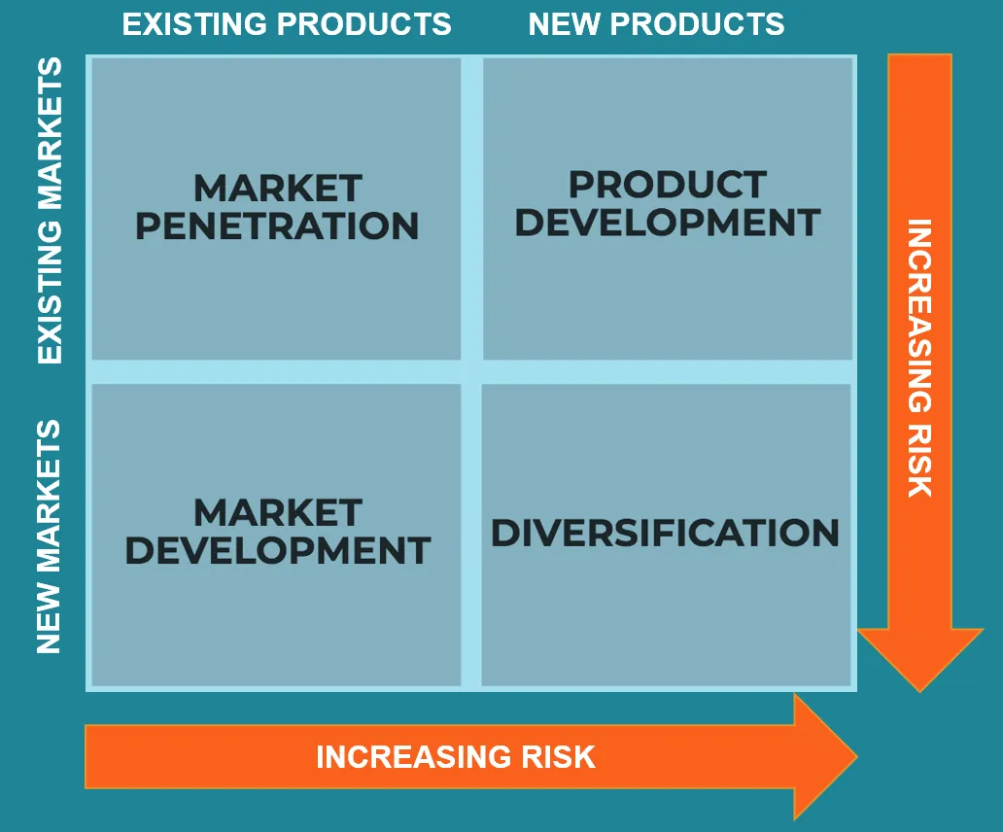
Figure 5 Ansoff Matrix source: CFI Education Inc. (2021)
The external analysis suggests that Naya should remain in its existing market and offer new products to cater for changes in people eating preferences. So a Product development strategy will be the most appropriate solution to grow the business. This strategy is medium risk for the business as it has loyal customers and gets repeat business.
Most likely product development strategy will help the business to increase growth and gain market share in this industry.

3.5 Evaluation of Environmental Scanning

Key findings:
The PESTEL analysis has found factors that are currently impacting on the business such as Covid 19 , closure of business, the demographics of the external environment in which the business operates in is gradually changing and the business has not adapted to these changes and neither have they changed their strategy to counter these changes, as a result the business is at a competitive disadvantage as compared to their rivals.
The swot analysis has identified strengths and resources and capabilities which the business already has acquired such as cumulative experience and financial independence. It has also highlighted the long history of the business and its loyal customers. However, the weaknesses within the business are impacting on its growth. The business has failed to mitigate and counter the effects of the weakness.
The business requires an update in the machinery and process improvements to minimise errors and wastage. The business needs to embrace technological change and adapt with the environment as most business are operating digitally and able to monitor their business activities with relative ease.
Although, the analysis has identified many different areas where the business can improve upon and areas where it is doing well. They can’t formulate multiple strategies at once as this will be counterproductive. It should only carry out the strategies as listed in the recommendations.
The business now needs to win over the support from its key stakeholders to take advantage of its strength and make long term planning to maintain its competitive advantage and market share.

4.0 Stakeholder Analysis

According to Freeman et al (2014) a stakeholder is a person or a group of people who have influence and power over the decisions an organisation makes. They can be internal or external stakeholders. Prior to formulation and implementation of a strategy, the business needs to identify key stakeholders within the business as each stakeholders needs are varied. A stakeholder analysis will help to prioritise the stakeholders according to their level of participation, power and influence on the strategic decision-making progress. This determines the level of communication and information to be directed so the right person gets the information to react to change.
Figure 6 Naya Stakeholder Analysis

Internal stakeholders: Employees, Managers, Owners
Connected Stakeholders: Supplier/Vendors, Logistics, Customers, Creditors, Waste Disposal, Pest Control.
External Stakeholders: Government, Media, Focus Groups, Parish Council, Regulators, Competitors, The Public.

4.1 Stakeholder Mapping

Power in the organisation is derived from the position one holds. For example, the owners will have ultimate say in how strategy is implemented as apposed to someone further down the hierarchy.
Influence in the organisation is dependent on social interaction and connections. For example, the accountant for the business is not directly linked to the business. However, they have a lot of contact and communication with the owners see fig 3. It is, therefore, imperative to accurately map the stakeholders. This can be achieved by using Mendelows Matrix.
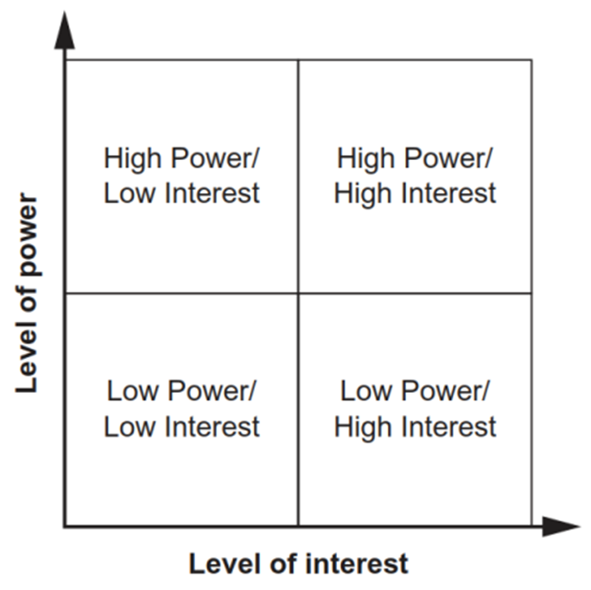
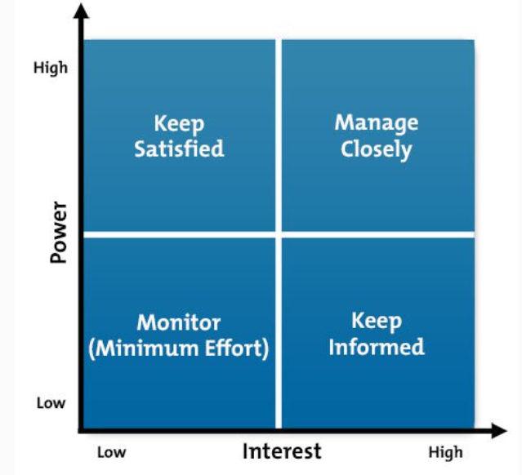

Figure 7 Mendelow's Matrix Source: Adapted from Mendelow, A.L. (1981). 'Environmental Scanning -
BENEFITS:
- Get the viewpoints of significant stakeholders to help in executing the strategic change.
- Gaining their support to acquire resources, build on a high degree of understanding.
- Be able to communicate the change effectively and monitor progress through collaboration.
- Understanding stakeholder motivations, feelings and needs can help to anticipate their reaction and remedy situation effectively.

4.2 Stakeholder Power / Interest for Naya

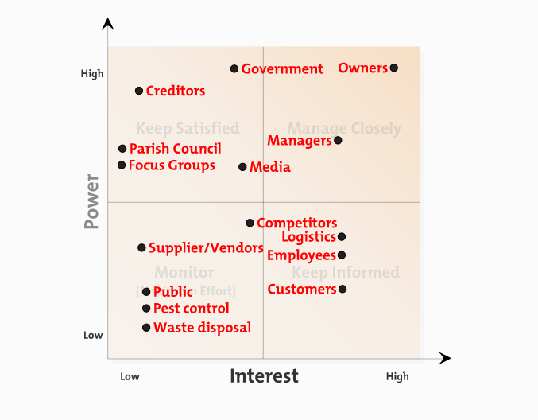
Figure 8 Power/Interest Grid for Naya

5.0 Sustainable Strategic Options

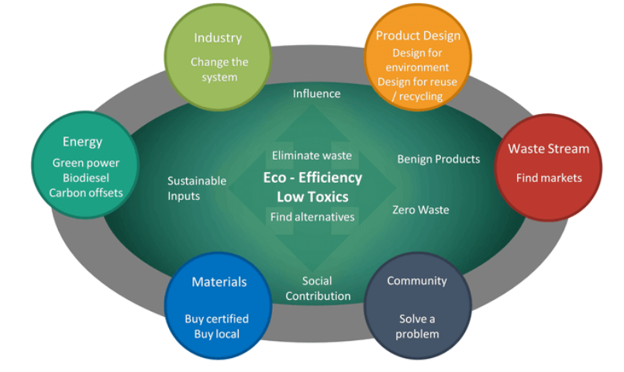
Figure 9 Sustainability Options

The Brundtland Report sanctioned by the UN in 1987 described sustainability as managing the earths resources carefully so that the impact is not felt by the future generations. In business terms sustainable strategies are those which have a long-term impact on the business and is not short lived. Also taking care that strategies do not impact on the socio-environmental balance. Every business relies on the environment for resources and these should be sourced using an ethical and environmentally friendly approach (Hoffman, 2018).
Strategies can be made at different levels in the organisation. This includes corporate, tactical and operational level. The top of the organisational hierarchy is where strategies will take longer to fulfil and have a far-reaching impact on the organisation. Whereas the operational level strategies will have a medium impact and within a limited time scale.

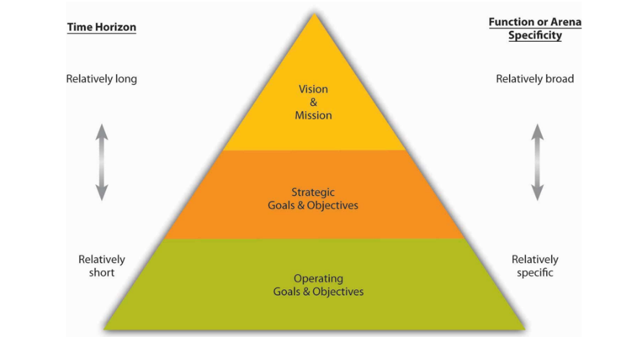
Figure 10 Management Levels in an Organisation Source: : https://2012books.lardbucket.org/books/management-principles-v1.0/s10-01-the-nature-of-goals-and-object.html
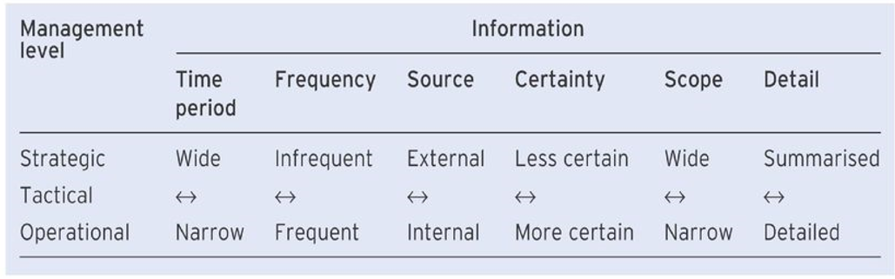
Figure 11 Decision Making Levels Source: Bocij, Greasley and Hickie (2019).
Currently the restaurant industry is in the maturity stage of the industry lifecycle. Barney and Hesterly (2019), suggest process innovation strategies which was also identified in the Balance Score Card. Organisations usually do not innovate at this stage and lose profit to competitors. Adoption of this strategy will allow the business to reduce its cost and increase the ‘perceived’ quality of the products and services.

6.0 Recommendations

1. Resource based strategy: Tactical Level
The business is in dire need to go fully digital, it has relied on traditional methods to take orders, advertise through newspapers, posting material in letterboxes and taking feedback verbally from the customers.
Through the introduction of the IT system the business will have a dedicated customers ordering system. The details of the customers will be kept on a database to make the second visit more personal and tailored to their needs and this can form the basis of a CRM system for the future. This benefits the customer as they can pre-order their food and pay for it online. It means they don’t have to wait in a queue or call the restaurant to place an order- so the issue of communication error is eradicated here.
Benefits to the organisation means that less time spent on the phone taking orders and more time attending to the diners needs. The business can prioritise the days and judge how many staff they need based on the booking schedule. The business can also see what ingredients are required to make the dishes. Inventory management, work rota, monitor pay and rewards are the various benefits of installing a fully automated system.
It is important to note that although technological advance can significantly improve business functions it can also be a risk factor for the business. Privacy issues related to customer data and how data is handled needs to follow GDPR rules. The business needs to be aware of malicious attacks such as Denial of Service attacks and security and data breaches. This can be costly to repair and remedy if the business does not install security to protect the data that it is collecting and processing.

2. Resource based strategy: Operational Level
Use available space in back of restaurant to cultivate and harvest fresh produce. Employ local people to maintain the garden. Reduce carbon footprint and create added value through quality and freshness. Furthermore, resources required to maintain garden will be inexpensive.
Implementation of this strategy will add many benefits to the organisation. This strategy is sustainable and has potential for it to be developed on a larger scale. This will bring added value to the customer and the organisation. The business will benefit from lower input costs and farm produce directly from their own land.
The customers are keen on having food which is fresh. This will meet their needs as the restaurant can introduce ‘dish of the day’ based on seasonal produce which has been harvested locally.
Some challenges do exist in following through on this strategy and a level of control needs to be put in place. For example, the setup cost will be considerably low. Maintenance of the garden needs to be done on a regular basis. Problems might arise if the harvest is low due to too much rain or a lack of rain. The British weather is very unpredictable and this may impact on the operations of the business if some raw materials are not available.

3. Expansion Strategy: Business Level
Increase capacity: Renovate and make the top level available for dining. Although this will incur cost- it will increase the longevity of the business and meet the demands of the customers who want to dine in at present COVID-19 restrictions limit maximum capacity due to social distancing.
If the business can make use of the property to its full potential, then it stands to gain more in terms of increased sales and more profit. However, to do this the business needs to renovate the second floor and design it so that it can accommodate the demand for the service.
Challenges to this strategy requires that the business invest a large amount of money to increase capacity. Currently , the business is financially independent and the investors have access to funds to carry out this project. They will need to have access to quality workmanship to carry out the project and set a specific timeline for completion.
Another challenge is that whilst the business is increasing its capacity, the business will need to remain closed whilst the works are carried out. The owners need to accommodate the loss of income for a temporary period and periodically notify current and new customers of the project so that they are keen to come back. The key stakeholders also need to be informed on a regular basis as they have more power and influence over this strategic decision.
Further, the business needs to find acquire more talented and skilled workforce to attend to the needs of the customer. Human resources need to be managed carefully to accommodate the surge in demand. The new recruits needs to be trained so that the level of service does not drop.

4. Product Development strategy: Operational Level
Targeted marketing for vegetarians, Pescatarians and vegans. Also adopt a gluten free menu for customers with allergy, this will gain more market share and increase profitability.
The Ansoff matrix suggested that the business would benefit from market penetration and product development, this is also supported by the industry analysis and swot analysis. As a result the business needs to open up the products and services for a new generation of people taking into account of their needs. Currently, we can see that many people have different dietary requirements and the restaurant has limited vegetarian and gluten free option.
The restaurant needs to tap into the market and create a menu that will attract new customers. They can do this by marketing online on several different platforms to attract attention. They can also offer a special night, where aspiring customers can have a free sample to taste what is on offer.
This type of market penetration will take some time to focus on the key ingredients and how easily the inputs can be acquired. The owners would need to communicate and engage with the chef and the team and educate them on gluten allergies and how it impacts on the health of the customer.

6.1 SFA Matrix

When the are multiple recommendations available the business can use the SFA matrix proposed by Johnson et al., (2017) to further narrow down their choices based on suitability, feasibility and acceptability of the strategic choices.
SAF Matrix | Strategic Options
SAF Matrix | Option 1 | Option 2 | Option 3 | Option 4
Suitability | 9 | 6 | 7 | 8
Acceptability | 8 | 6 | 8 | 8
Feasibility | 7 | 6 | 7 | 8
Total | 24 | 18 | 22 | 24

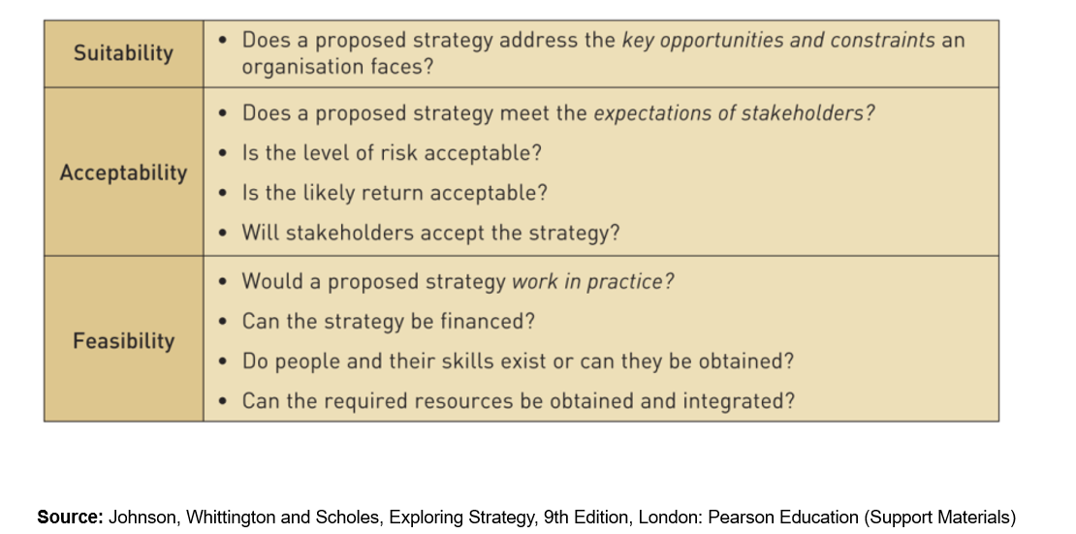

6.2 Resistance to Change

Human Resources: Current employees might resist the change as they may not agree with expanding the business, which on some occasions means a change in ranks or fear of losing their job. They might not have the right skill level to use new machinery that the business might bring in. Internal satellite cultures that exist in the workplace may be disrupted by the new work culture.
Again, we might see some resistance from the employees who are told to adapt to a new menu and educate customers about how the meal was prepared. This may seem like extra work. It is expected that during launch of this strategy the demand may be slow at first. The leaders need to remain focused, energised and continually educate and encourage the employee and waiting staff to stay ahead and keep up to date with emerging cooking methods and also be wary of the consequences if the procedures are not followed.
Finance: SME often find it difficult to finance their strategic objectives. Especially if they have to take out a loan with added interest. This may deter them from pursuing the strategies thus rendering the business at a competitive disadvantage.
Leadership Style: During a change management phase in the business, the leader needs to adopt the most appropriate style to win the support and confidence of the employees and managers to carry out the strategic change. Employees may not engage well if they notice a change in leadership style. If the workforce do not embrace the vision of the business then resistant will occur and this can hamper the implementation of the strategy
So leaders need to factor this in when devising new strategies and have a change management programme such as Kotter (2011) 8 step model to transition into a new of doing business.

6.3 Competitors Response

The battle to gain market share and increase sales is a never-ending process. As new strategies are formed competitors are likely to follow suit and imitate, tweak their strategy to minimise the disruption to their business. Some business may also consider investing more into the company to make it more profitable. Having insight and identify competitors reaction is useful to make the strategy a success.

6.4 Future Development Awareness

Emerging trends in this sector include:
- Artificial Intelligence embedded on the website and mobile apps helping the customer as well as the business. ASMR is now becoming a new phenomenon which is currently used to attract customer attention (Poerio et al., 2018).
- Robotics: Japan has already started to use robots to deliver food to guests (Berezina, Ciftci and Cobanoglu, 2019).
- Electric Cars: The move to petrol and diesel free cars is forthcoming. The business needs to consider the environment in all their procurement.

7.0 References

- ‌ Berezina, K., Ciftci, O. and Cobanoglu, C. (2019). Robots, Artificial Intelligence, and Service Automation in Restaurants. Robots, Artificial Intelligence, and Service Automation in Travel, Tourism and Hospitality, pp.185–219.
- ‌ Kotter, J., 2011. Change Management vs. Change Leadership -- What's the Difference?. [online] Forbes.com. Available at: <https://www.forbes.com/sites/johnkotter/2011/07/12/change-management-vs-change-leadership-whats-the-difference/#402d59364cc6>
- Barney, J.B. and Hesterly, W.S. (2019). Strategic management and competitive advantage : concepts and cases. New York: Pearson.
- Bocij, P., Greasley, A. and Hickie, S. (2019). Business information systems technology, development and management for the modern business. Harlow, England Pearson.
- Bruijl, G.H.Th. (2018). The Relevance of Porter’s Five Forces in Today’s Innovative and Changing Business Environment. SSRN Electronic Journal, [online] 1(1). Available at: https://www.researchgate.net/publication/326026986_The_Relevance_of_Porter’s_Five_Forces_in_Today’s_Innovative_and_Changing_Business_Environment.
- CFI Education Inc. (2021). Value Chain - Overview, How To Implement, Advantages. [online] Corporate Finance Institute. Available at: https://corporatefinanceinstitute.com/resources/knowledge/other/value-chain/.
- David, F.R. (2011). Strategic management : concepts and cases. 13th ed. Prentice Hall: Pearson.
- Gnjidić, V. (2018). Interdependence of company’s industrial competitive position and its strategic orientation: A dynamic theoretical model. Management: Journal of Contemporary Management Issues, 23(2), pp.103–122.
- Hoffman, A.J. (2018). The Next Phase of Business Sustainability. SSRN Electronic Journal, 16(2).
- Johnson, G., Whittington, R., Scholes, K., Angwin, D. and Regner, P. (2017). Exploring strategy : text and cases. 11th ed. Harlow, England: Pearson.
- Kaplan, R.S. and Norton, D.P. (1996). The balanced scorecard. Harvard: Hbs Press.
- Lock, S. (2021). Restaurant numbers in the UK 2008-2018 | Statista. [online] Statista. Available at: https://www.statista.com/statistics/298871/number-of-restaurants-in-the-united-kingdom/.
- Lynch, R.L. (2018). Strategic management. Harlow, England: Pearson.
- McCulloch, M. (2021). RESTAURANTS AND BARS REPORT 2021 Without a doubt, this year’s topic of COVID-19 plays a huge part in our report. UK: BDO LLP.
- Mendelow, A.L., 1983. Setting corporate goals and measuring organizational effectiveness—A practical approach. Long Range Planning, 16(1), pp.70-76.
- Poerio, G.L., Blakey, E., Hostler, T.J. and Veltri, T. (2018). More than a feeling: Autonomous sensory meridian response (ASMR) is characterized by reliable changes in affect and physiology. PLOS ONE, 13(6), p.e0196645.
- Porter, M.E. (1980). Competitive strategy : techniques for analyzing industries and competitors. New York: Free Press.
- R Edward Freeman, Harrison, J.S., Wicks, A.C., Parmar, B.L. and Simone De Colle (2014). Stakeholder theory : the state of the art. Cambridge: Cambridge University Press.
- Susskind, A.M. and Maynard, M. (2019). The next frontier of restaurant management : harnessing data to improve guest service and enhance the employee experience. Ithaca: Cornell University Press.
- Walder, J. (2013). Critical evaluation of michael porter’s five forces framework. Grin Verlag.
- Yoon, B., Chung, Y. and Jun, K. (2020). Restaurant Industry Practices to Promote Healthy Sustainable Eating: A Content Analysis of Restaurant Websites Using the Value Chain Approach. Sustainability, 12(17), p.7127.

‌

