AI ACKNOWLEDGMENT

I acknowledge the use of ChatGPT (https://www.chatgpt.com) on 11 November 2025 to support my research using the prompts:
- Examples of ethical issues in cognitive research from the 1950s-1970s
- Examples of socially sensitive research in the cognitive era that involved deception
- Experiments in the early cognitive revolution that had no ethical concerns

I confirm that I have not presented any AI generated text as my own work. I confirm I
have copies of my drafts, notes, and other resources I used before, and after the use of
AI tools which I may be asked to provide in evidence.

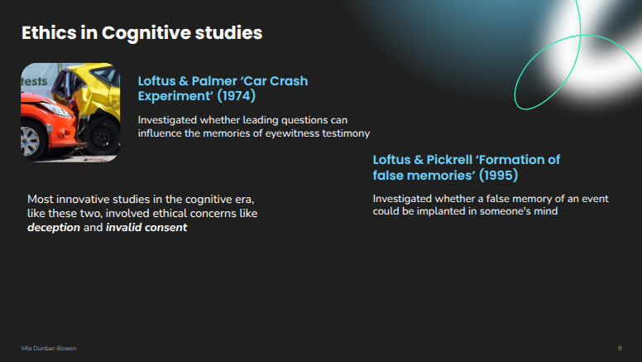
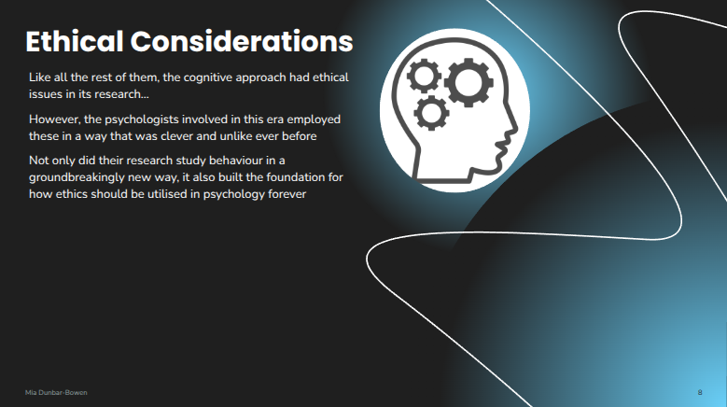
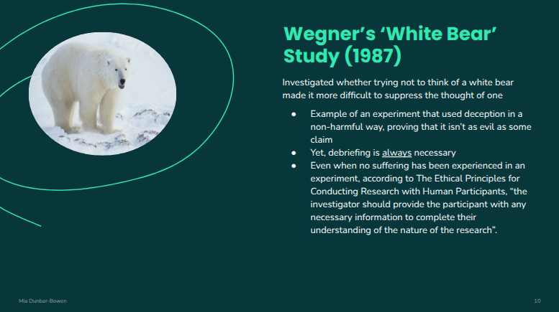
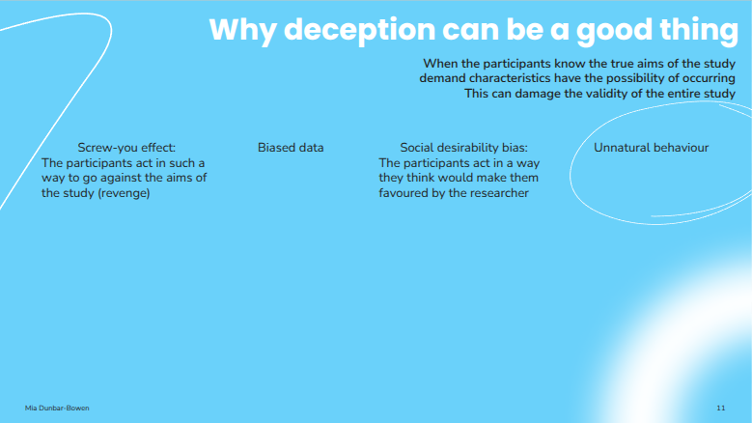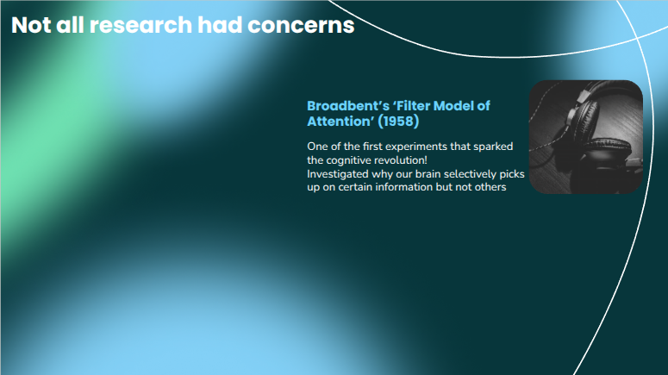

Slide 1
Here, in the cognitive era, psychologists aren’t afraid to break new ground. They are bold when it comes to revealing things about the mind that no one else had even imagined to discover. Although the ethical considerations may be concerning to some, they, in reality, have proven that this era is fearless and perceptive. After all, they laid the groundwork for most future investigations in psychology by looking at the mental processes that happen in the brain instead of observing behaviour alone.

Slide 2
A notable study by Loftus and Palmer included deception, or in other words…a smart misdirection which disclosed how our minds actually work. Deception aims to find out our genuine social attitudes, and demonstrates how easily our minds can be moulded. (Or in this case, how the wording of a question can easily influence our memory). Many researchers believe that deception is quote unquote ‘evil’. However, despite its supposedly cunning nature, it is being continuously used in research, either actively or passively.
A reason for this may be because without deception we would not be able to investigate socially sensitive topics, such as the work by Loftus & Pickrell. Their study was the first systematic demonstration of false memory formation, expressing how beneficial and useful deception truly is, especially to cognitive studies.

Slide 3
Additionally, deception cannot be avoided on the whole! There is always a chance that participants can be misled, yet this is nothing to worry about. Various research includes debriefing afterwards. Debriefing is a necessary ethical safeguard that is used to undo any harm or misleading that may have resulted from an experiment. Luckily, most cognitive research had limited risk of harm to their participants unlike the behaviourist and psychodynamic approaches which utilised methods that did not protect the participants safety or confidentiality.
An example in the cognitive approach is Wegner's ‘White Bear’ study where deception was incorporated but it induced very little harm to the participants.

Slide 4
If participants were to know the true aims of a study then demand characteristics may occur, threatening the ecological validity of the study which could ultimately lead to biased data. Therefore, it can be said that deception is one of the only ways to measure genuine human behaviour without damaging the results. Plus participants who have been deceived, more often than not, are approving of it retrospectively.

Slide 5
Not all research had ethical concerns! Broadbent’s ‘Selective Attention’ experiment is a great example. His method of dichotic listening encompassed no ethical issues at all.
In conclusion, the cognitive era sparked a more ethically responsible revolution. Yes, deception raised ethical debates but it has aided the work of psychology in ways no other approach could. It didn’t just change how we study the mind, it altered how we treat our participants for the better. So what’s stopping you from stepping back in time to the cognitive revolution?

Reference list
Gross, R. (2020, p. 1426-1450). Psychology: The science of mind and behaviour (8th edition). Hachette Learning.
Kimmel, A.J. (2011, August 26). Deception in psychological research - a necessary evil?. The Psychologist. https://www.bps.org.uk/psychologist/deception-psychological-research-necessary-evil
Winerman, L. (2011). Suppressing the ‘white bears’. American Psychological Association, 42(9). https://www.apa.org/monitor/2011/10/unwanted-thoughts

