Reflection on the Role Play and Career Develop Planning
BMSW4005
Lecture: Husam Alaharahsheh
Student: Sofia Maria Gasdali
ID: 2023081

I participated in my interview role play with lecture Husam on Monday, December 17th 2021. The goal of this was too take everything I had learned throughout the term, and apply it in my role play interview, which help me prepare myself for a job interview in the near future. In the beginning I felt as though I really struggled with eye contact. As I’m naturally a little bit of a shy person I tend to find it particularly hard to make eye contact, and struggled with speaking more slowly and not rushing my words. These two things were the only imperfections I wanted to perfect for my role play interview final. Eye contact is really important as it shows you have confidence in what you are saying and emphasis on how important the interview/meeting is for you. The interviewer wants to believe the interview for you is crucial. Speaking at a calm and steady pace is important because you don’t want the interviewer to think you’re nervous or as if you want to get out of that interview.

In order to help me with my career planning we did exercises in class which required us to answer questions about where we see ourselves in 5 years time career wise and why. This really helped put into perspective what I need to do in order to achieve what I need to achieve so I can get to where I want to be in the future. The goals I have developed with my planning are gain my certificate of higher education, apply to study Law, while studying law try and place myself in a law firm for some work experience so I have some practical knowledge and understanding of how a law firm operates and what I can expect. I then would like to graduate and be able to place myself in a top law firm. I. The next following years I’d like to apply for manager position so I’m able to get a real feel of the struggles that comes with the role. This would prepare me as I’d like to own my own law firm which will be a big goal in the future of my career development. In one of my lessons we was fortunate enough to create a personal development plan. A personal development plan was very crucial as it helps and enables me to take charge of my own learning.

In my reflection on my experience I have gained clarity on what a excellent job interview for a position in a Law firm should be like. In order to identify and evaluate my strengths, weaknesses, opportunities and threats of becoming a lawyer I did a SWOT analysis which is a helpful planning technique. Doing this role play interview tested me and my approach in a difficult situation that may occur in the outside business or legal world.
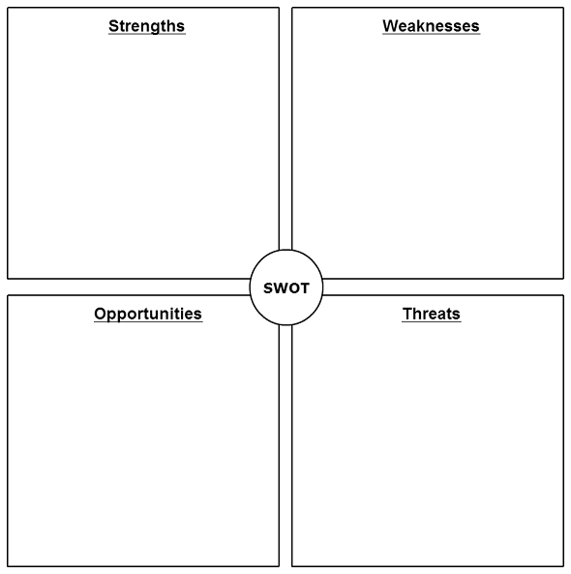
• Extent of networks (including contacts and clients)
•Education and training
•Commitment and passion for the Law field
•Ability to get on with people
•Reliable
•Attention to detail
•Honest
•Able to take initiative
•Analytical and research skills
•Determined

•Rejections
•My mental health
•Being unsupported at work
•Fitting into company culture
•Transport problems may result in my unreliability

•Wide network within the law field
•Studying Law at a university
•Gain experience of dealing with people
•Work in a team
•Earn money
•Get experience in the world of work
•Client development
•Time-keeping
•No work experience related to what I’m studying
•Lack of database skills
•Lack of confidence when dealing with clients
•Get stressed easily
•Can get shy around larger groups
•Perfectionist

Throughout this module I have understood the key skills needed for further development. The essential skills I’ve identified while doing my career development planning are essential for the field I want to go into. Some skills I learned are..

Communication and listening skills: It’s crucial to have communication skills as they are the first set of skills a potential employer will notice. Also strong oral and written communication skills are vital within the law field and without that I’ll struggle to carry out basic tasks of a lawyer/solicitor. An excellent listening ability is also important when working with clients as you are trying to build a relationship with them and make them feel comfortable around you, enough for them to trust you.

Analytical and Research: In the Law field every lawyer must be trained or learnt to have good logical and analytical reasoning. If a lawyer is ever in doubt when it comes to making decisions or have any questions related to any case that’s where legal research is an essential and necessary tool for individual lawyers. Majority of lawyers, everyday have to digest the law and it’s requirements so having good logical and analytical reasoning is crucial.

Leadership Skills: Leadership skills are important especially if I’m trying to move up in the legal career ladder. Having a good sense of judgment when it comes to people and situations. Having the ability to be fast at problem solving and make a fast good decision is essential in the law field. As I hope to move up in the legal sector I will eventually work on bigger cases with a much larger team and will have to collaborate in order to succeed working with clients and different colleagues.

High Ethical Standards: High ethical standards are important in order to enjoy a long and successful legal career. Failing to compose yourself with ethical standards will enable other colleagues and clients to think you are untrustworthy and unprofessional, and a lawyer that doesn’t hold themselves with ethical standards may be disbarred and disciplined for lying and breaking client-lawyer relationship.

Initiative and independence: it is very important in law to be able to be decisive fast when you’re in a demanding situation.

Time Management: Having effective time management is critical in the legal career field. Usually lawyers charge for their time per hour, this means staying on track of client meetings, hearings, meditations and other tasks during the day that day receive.

When I first practised my role play I was very shy and wasn’t projecting my words clearly. I rushed all my words and hardly made eye contact. I would sometimes go off topic with my answers to the questions and mumble on. However, I kept on practising and applied all the skills and techniques I learnt throughout the term. I knew if I want to have a successful career in the legal field then I knew I needed to work on some of my weaknesses. I struggled a lot at the start with speaking to a large group and public speaking. In order to help with that I did a public speaking task outside of university at a youth group and I had to speak to a large group of people about a certain topic. I was really nervous but it really helped boost my confidence and when it came to my role play I felt a lot more courage in myself to do well. While planning my career development I discovered loads of different learning styles and identified which particular learning style was best for me. I found that visual, social and physical learning worked best for me. What I learnt about the role play interview is that confidence is key. It’s very crucial that you display good body language and actually know what you are talking about and there for. Dealing with every question and or scenario that you are given or asked is important to be handled professionally. I liked when I did group work as I found it for supportive, when work is divided amongst each member of the group it gets done quicker, every team mate shares their different views and opinions and the synergy between team mates can produce productive and creative results. However, I do prefer working alone more. What I have found with regards to myself, as a student over the term is huge. I learned that I can peruse the material way ahead of time and just momentarily skim over the text and recall pretty much everything, were as I suspected perusing nearer was more advantageous. I additionally discovered that working in bunches truly isn't my forte. I incline toward working without anyone else
since I'm ready to accomplish significantly more and not need to stress over others failing to remember their part of the task. I would really rather avoid agonising over others not
finishing.

I did some research upon the world of employment in the law field. I learnt that employment law exists only to be able to support the balance of employers and employees both the same. Employment law provides economic stability by giving employers the right to operate their business just as long as they are not harming, bullying, discriminating or making employees work in horrible conditions.

I have acquired important abilities and develop my capacities as a working professional. Through self-reflection, I have had the option to develop my exhibition and progress towards accomplishing my career goals.

I used the Gibb’s reflective experience to help me through this. The reflective cycle model by Gibbs (1988) permits the clients to organise their previous encounters, feelings, and discoveries in the way supporting future learning and improvement. It incorporates six sequential stages that I will use to investigate the chose issue more top to bottom in the accompanying sub-areas.

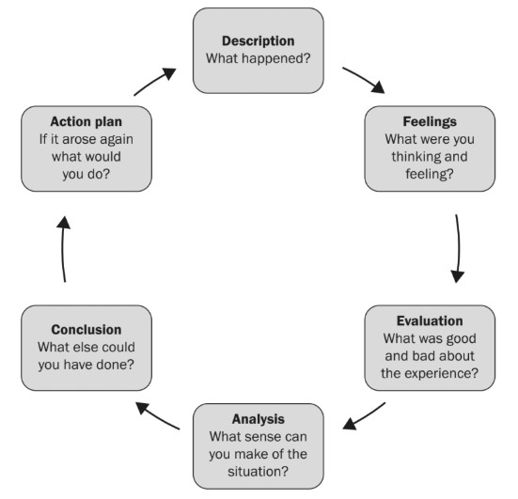
Source: Bottomley et al. (2019,p.23)

I consider this experience with self reflection extremely valuable because it allowed me to face my personal barriers and understand what areas needed to be developed and what I need to achieve step by step. I additionally anticipate that the need should overhaul my activity plan later on assuming my college course or down to earth preparing produce a few new bits of knowledge as far as better self-improvement procedures.

In conclusion, I have cryptically analysed and reflected on what it is I need to do in order to develop my career, and how to project myself clearly especially in a job interview. I’ve had the opportunity to have a real life experience of what a job interview in my selected career path would be like. I’ve also had time to create a personal development plan which helped guide me through what I need to do in order to get to where I want to be in my career future. I plan to be an effective and ethical person by educating and gaining experience within the legal field. I came across so many challenges throughout this module but I also overcame many of my weaknesses and turned them into strengths. I know have confidence within myself when it comes to public speaking and making eye contact with people when speaking. I’ve gained more knowledge and I will take on everything I’ve learnt this term and apply it in my career development and my day to day life. I have gained great motivation and determination to work to my best ability that I know now that I’m capable of. I have the confidence in myself to become a lawyer as I’ve been lucky enough to plan my next steps. I’ve gained enough knowledge of tools and techniques throughout this term that I will use to my advantage to develop my career in the legal field now.

Reference: Johnson, D., and Johnson, F. (2008). Joining together: group theory and group skills. New York: Pearson.
(Barton in Flaherty, 1983 cited in
Hargreaves & Hadlow, 1997)
Cook, S., Anoop, M., Firosh U. (2009) Building a High Performance Team. IT Governance
Ltd: Cambs.
Gibbs, G. (1988) Learning by Doing: A guide to teaching and learning methods. Oxford
Polytechnic: Oxford.
Mindful Schools (2017) Available: http://www.mindfulschools.org/tr

Cook, S., Anoop, M., Firosh U. (2009) Building a High Performance Team. IT Governance
Ltd: Cambs.
Gibbs, G. (1988) Learning by Doing: A guide to teaching and learning methods. Oxford
Polytechnic: Oxford.
Mindful Schools (2017) Available: http://www.mindfulschools.org/tr

Cambs.
Gibbs, G. (1988) Learning by Doing: A guide to teaching and learning methods. Oxford
Polytechnic: Oxford.
Mindful Schoo
Gibbs,G. (1998) Learning by Doing: A guide to teaching and learning methods.

Bottomley, J., Cartney, P. and Pryjmachuk, S. (2019) Critical Thinking Skills for your Social Work Degree, New York: Critical Publishing.

Eaude, T., 2014. The changing role of the teacher. In: T. Cremin and J. Arthur, ed., Learning to Teach in the Primary School, 3rd ed. Oxon: Routledge, pp.543 - 554.

Bogdewic, S., et al., Leadership & Organizational Skills in Academic Medicine, Family Med.,
29:262-5, 1997.

