Anthony Njonge (1809703)
MSc Software Engineering (Web Development) – ACCA7004
Report on the use of Design Patterns in Web Development
Layered Architecture Pattern and ORM with Repository and Unit of Work Pattern


Contents
Introduction 2
Software Design Patterns 2
Advantages of Design Patterns 3
Criticism of Design Patterns 3
Software Architecture: 4
Layered Architecture Pattern 4
MVC – Model View Controller 6
ORM – Object Relational Mapping 6
ORM with Repository 7
ORM with Repository and Unit Of Work Pattern 9
Development without ORM 10
Future Patterns 10
Conclusion 10
References 11
Appendix 13
Gang of Four 23 Patterns Summary 13
Widget/Server Architecture 14

Introduction
First principle dictates that to understand design patterns in web development, it is best to consider the definition of patterns. A dictionary definition of pattern is “a particular way in which something is done, is organized, or happens” [1]. All these definitions are relevant to the software computing world. These definitions imply that a pattern lends itself to the principle of repeat, which in turn infers that for something to be repeated then it must also have a design. Simply a pattern cannot exist without design, therefore making design a prerequisite.
Patterns and design are a part of human nature and therefore are pervasive to anything that is man-made. It is the reason why the idea of patterns was best described by architect, mathematician and design theorist C. Alexander and colleagues [2] who after extensive research about buildings, architecture, and planning theorised that , "Each pattern describes a problem which occurs over and over again in our environment, and then describes the core of the solution to that problem, in such a way that you can use this solution a million times over, without ever doing it the same way twice". They identified solutions of building techniques that over time man had found that provided the best solutions of solving usual mundane problems encountered in the design of the real physical world. This experience coincidentally is a similar experience that is reflected in software development.
Patterns started to appear in software development in the ‘80s and gathered pace of following and interest in the ‘90s, mainly because at around this time software development had matured. In 1994, the first conference focussing on patterns known as the Pattern Languages of Program Design(PLoP) was held at the University of Illinois [ref]. The participants congregated to the conference due to the realisation that despite the use of object-oriented techniques, from their experience, there was a lack of improvement in quality despite their adoption. From their experience, patterns offered a way of organising object-oriented development through confirmed experience of use and good practice and allowing that niche experience to be disseminated to novice developers.

Software Design Patterns
In the “Gang of Four”(GoF) book, design patterns are described as the capturing of experience in designing object-oriented software. The GOF summarised the elements of a design pattern as having a:
- Pattern name: This describes the design problem, solution, and consequence in simple terms. It allows for a higher level of abstraction if the problem can be communicated easily
- Problem description: Describes the situation that results in the problem. This allows capturing of the circumstance that results in the problem.
- Solution: This states the elements that are part of the design, problem, relationships, collaborations, and implementation. The wording allows for an abstract description.
- Consequence: This states the result and trade-offs that follow the implementation of the pattern [3].
GoF also noted that the user’s point of view and the choice of programming language affected how the pattern is viewed. For a design pattern to succeed it is necessary that it fulfills the following requirements:
- Reuse: the use of names, abstract and descriptions of objects and classes should allow the easy identification of what is available.
- Focus: A design pattern only focusses on one and only one issue which avoids confusion during the time of selecting which pattern to choose and allows for the transfer of the know-how.
Patterns can further be divided into catalogues and languages. A pattern catalogue is a makeup of documented patterns, a kind of dictionary of available patterns [4]. It is common that experienced developers might know most but maybe not use all the patterns. The availability of a catalogue allows for new (learning) developers to get to speed with the various patterns. A pattern language [2] [5] is a system of defining the terms used in software development and the relationships among patterns. This allows for a commonly shared understanding. No pattern can be defined without the use of a pattern language. Also, another way of defining the relationships is through the use of a pattern framework [6].
The use of design patterns allows for a high-level perspective avoiding the focus on detail earlier on during development stages. The 23 design patterns identified by the GoF are summarised in the Appendix.

Advantages of Design Patterns
The advantages of implementing design patterns and use of catalogues and languages in an organisation include [7] [4] [6]:
- better team communication by use of common vocabulary
- leveraging a proven solution that others have proved works
- allowing for modification and maintainability of code
- illustration of basic object-oriented principles like the use of interfaces, use of aggregation over inheritance and identification of when to vary a class or use encapsulation.
- Avoiding the creation of large inheritance hierarchies while creating designs for complex software.
- Avoid overall architectural drift.
In the context of the DVLA, and in the wider UK Government development, in addition to the use of Agile practices, UK Government Digital Service(GDS) guidelines [8] [9] [10] are used in development to take advantage of design patterns. In particular, the advantages identified include to:
- avoid repeating work that has already been done elsewhere
- avoid making mistakes that others learned from, allowing for institutional learning
- build on research and experience of the various teams across government
- making all services from the government have the same feel, allowing the users to find the use of any government service indistinguishable from any other.

Criticism of Design Patterns
As with everything, too much of anything is bad and it can easily be misused. The overuse of design patterns has led to the problem of over-engineering by increasing the complexity of systems [11].
Anti-patterns have been hypothesised to explain the anti-thesis of the outcomes of patterns. During the implementation of any good solution, if the solution turns out to be wrong and poor that scenario is considered an anti-pattern. An example of an anti-pattern is the Golden Hammer. This is a scenario where a development team is determined to develop a solution where perfectly working open-source superior solutions exist.

Software Architecture:

The goal of software architecture is to minimise the human resources required to build and maintain the required system [12].

Layered Architecture Pattern
The idea of using layers in web applications became a common technique in the late 1990s although the use of layers in software architecture has existed since the early 1960s [ref]. The use of the World Wide Web, “The Internet”, led to the increase in the development of enterprise application that needed to be delivered as web applications. This pattern is the most common architecture pattern. It is the de facto standard of most Java EE applications [13]. This was due to the promise of Java propelled with the “develop once, run everywhere” idea. The problem with a lot of enterprise application being developed in Java EE is that they have followed the “Core J2EE Pattern” catalog [6] [14].
The catalog proposes use of layers where a typical architecture consists of :
- Presentation layer – this is the layer where the web server delivers content through HTML via the web browser to the user. In the Enterprise Java Beans, this was delivered a Web Application archive file(WAR).
- Domain layer which can be split out to the Business layer and Persistence layer – these two layers contain the business logic and were mainly delivered by the Enterprise Java Beans(EJB). The persistence layer can be implemented through the use of entity beans, data access objects or through object relational mapping frameworks [15]. The delivery of this in EJB is through Java archive (JAR) files. This is the “brains” of the system.
- Data source or Database layer – this layer contained the data that the user interacted with beyond the presentation layer. This layer handles the communication with where the data is held.
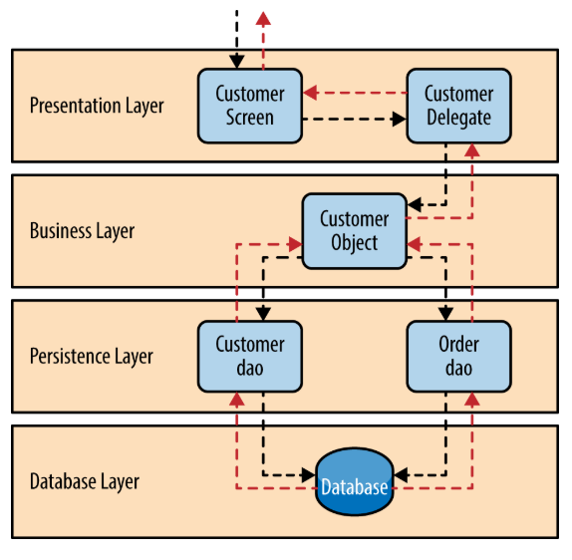
Figure 1 Layered Architecture [16]
The use of layers ensured behaviour encapsulation, high cohesion, with a clear decoupling of responsibilities of actions, and providing the opportunity for system testing and deployment across multiple servers [17]. Across all the layers within the web server, common tasks of security, operational management, and communications are shared.
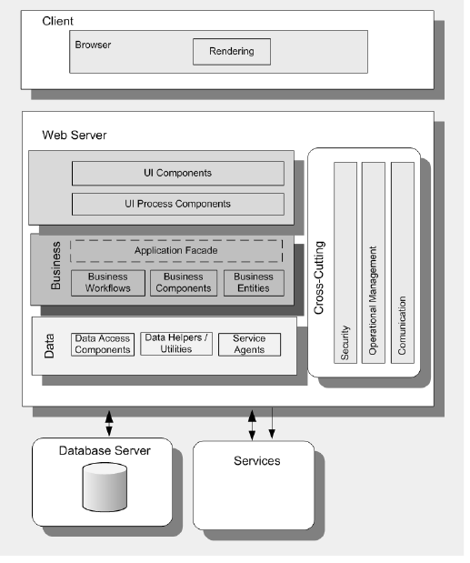
Figure 2 Common Web application architecture [18]
Various incarnations of the layered architecture and implementation of the pattern include the client/server model, browser/server model or the existing widget/server model(see Appendix). Deployment of the architecture in the client/server model is either a non-distributed deployment, same physical server, or a distributed deployment where the layers exist in different physical tiers and communicate remotely.
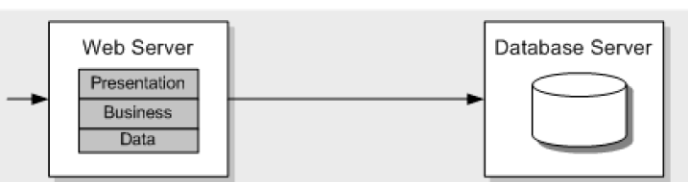
Figure 3 Non-distributed deployment
Figure 4 Distributed deployment

MVC – Model View Controller
Web applications are mainly delivered through the presentation of information as a web page in HyperText Markup Language(HTML) format. The user through a client sends a HyperText Transfer Procol (HTTP) request to the request model and received back a response from the response model. That response is what is presented as HTML however, what lies behind the HTML page is a lot more complex especially in a dynamic web application.
The commonly used presentation pattern was formed from the nature of the three distinct roles of the Model, View, and Controller.
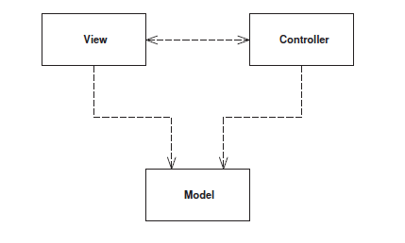
Figure 5 Roles in system user interaction [13]
The MVC pattern was developed as part of a framework in the late 1970s as a user interface design framework. The model represents an object of the system data information. It is a nonvisual object that requires the interpretation of the view through a user interface (UI). The controller is the manager of the flow of instruction between the view and the model. The controller handles any user interaction, interrogates the model and refresh the view when required.
The basic tenet of the MVC is about separation of concerns [17]. The concerns being the separation of the view from the model and the controller from the view. It is a fundamental heuristics of good software development that the view is separated from the model [13]. It is for this reason that time and effort is spent to develop UI frontends that are capable of presenting information correctly.
Two methods of implementing the view in MVC is through the use of Templates or Transform. Template allows the composition of the contents of the page in relation to the structure of the view. It is for this particular strength that for example across UK government services, UI design patterns are expressly defined with suitable templates and formats for use defined across services [8]. The separation of the UI and the data model allows for different implementation in the consumption of the services while keeping the structural view the same. MVC also allows for services being developed to be consumed from application programming interfaces (APIs).

ORM – Object Relational Mapping
Why is object relational mapping(ORM) important?
To consider it’s importance, the significance starts with the theory of the makeup of enterprise applications. As previously highlighted most enterprise applications are mainly developed from the principles of layered architecture. The nature of the system means that parts of the system are developed under object-oriented paradigms where software engineering 101 of cohesion, coupling encapsulations are paramount while on the data layer end relational paradigms rules of the primary and secondary keys are paramount. Each end of the system is concerned on different ideas, where the object-oriented system part is concerned on building objects with data and behaviour while the data end is concerned about storing data in a relational manner [19]. This leads to the “impedance mismatch” problem (IMP).
The two most popular implementations of ORM are Active Record and Data Mapper. In Active Record the model is able to determine properties of the model automatically by referencing the schema of the database [17] but the inheritance nature of this action imposes a strong coupling to the resultant classes [20]. The Data Mapper implements where none of the classes know about the persistence layer [17] providing for encapsulation of the access and keeping the classes loosely coupled [21].
To resolve the issue of IMP, it becomes necessary to implement an intermediate layer of abstraction known as the repository.

ORM with Repository
Lerman defined a repository as,
“..a wrapper that lets us work with our entities as though they are part of a collection. The repository lets us add, update, and delete entities in the collection rather than being concerned with how to get those entities into and out of a database or how to send and retrieve the entities from a web service…and execute queries [22].
Repositories, therefore, act as storage locations where any requested object is returned in the same state [23]. The repository mediates between the data model layer and the business logic layers acting like an in-memory domain object and facilitates automated unit testing and or test-driven development methods [24]. This decoupling of the data access to the logic allows for the persistence framework e.g. Entity Framework, Hibernate, or Apache Cayenne to be changed without difficulty or risk of making the application unworkable. The use of the repository pattern allows for the reduction in the amount of code required in querying logic.
A repository pattern can be implemented in two ways:
- One repository per entity(non-generic) – each entity in the data layer requires its own individual repository
- Generic repository – one repository is customised to allow operations relating to all entities.
The common method of implementing this is through the use of interfaces.
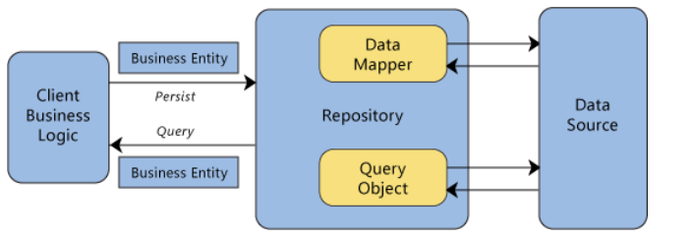
Figure 6 Interaction of the repository

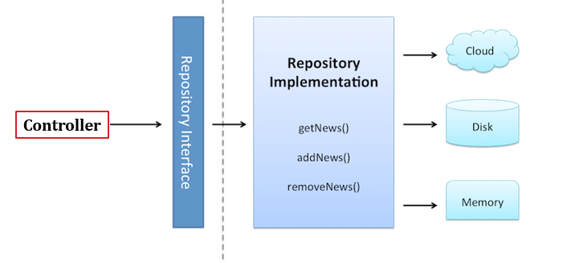
Figure 7 A Repository Pattern example with an interface [25] [24]
The client object controller constructs queries which are then submitted to the Repository for action through the interface. The Repository then actions them while encapsulating the objects in the data layer and the operations done giving the impression of an object-oriented view on the persistence layer. The Repository pattern supports the objective of clean separation and one-way dependency between the domain and data mapping layers [13]. The benefits of abstraction are in line with the single responsibility principle, the class has responsibility for a single part of the system and responsible for encapsulations.
It is also possible for enterprise web application to implement high abstraction than the usual create, read, update, delete(CRUD) semantics with the use of cache. The use of cache allows for the repository only to interact with the cache and only access the data store if the required items are non-existent or have expired in the cache. This allows for increased response reducing the need for constant interactions with the data source.
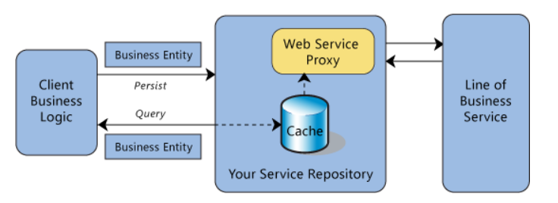
Figure 8 Example of web service repository

Disadvantages of using the Repository pattern:
The use of repository pattern increases the number of classes that need to be created to match the entities. This means that the size of code maintenance increases. Due to the high level of abstraction, it means that only experienced developers are able to understand and work with the pattern.
Although the pattern allows for the mocking of objects during unit testing it is difficult to unit test the repositories. To test the repositories further tests have to be carried out such as integration tests, which translates to more time need for development and cost.

ORM with Repository and Unit Of Work Pattern
Unit of Work class is the action of a single transaction for any multiple operations that are required on the database. In other words, its main purpose is to allow the use of multiple repositories on a single shared database context. It ensures that rather than multiple calls on the database from the different repositories, only single calls are necessary. That means that one Unit of Work call can carry out multiple CRUD actions on the database. In Figure 9, the Unit of Work class actions the DbContext instance to the database through the means of a tool to the database. For Unit of Work to succeed, it requires instantiation of a sinlge database context for all the repositories involved and the availability of a save property. It is the implementation of the save property that ensures that the pending actions are carried out as a single unit of work action.
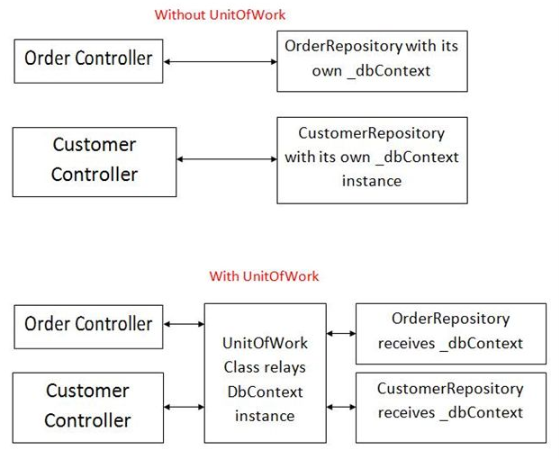
Figure 9 Implementation showing with and without Unit of Work
The use of Unit of Work allows for testing to be easy as this requires the use of mock repositories and a database, which can be a different database even type. This is a useful function for development since it allows for developers to be able to test using other databases without changing the implementation of the classes.
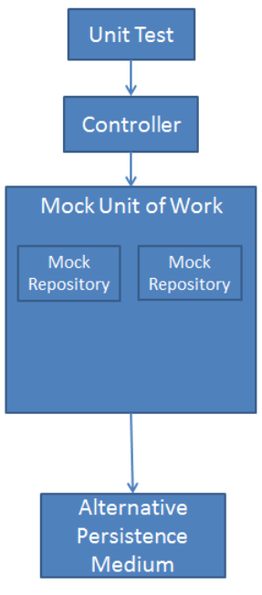
Figure 12 Illustration example unit of work testing [26]

Development without ORM
The topic of ORM, Repository, and Unit of Work is a contentious topic with varying camps of the need for using both is deemed an overkill to requirements. However, the assessment here is that on one hand repository is used to abstract and encapsulate data storage and related items and on the other hand ORM handles the abstraction of the access to the data.
The said arguments might have to be revisited and reconsidered due to the new development of NoSQL databases. With this new development, it is now possible to implement enterprise application that does not require a relational database just for the sake of having a database which makes it easier for developers to avoid the IMP, by not adhering to Object-Oriented (OO) practices [21]. It allows developers to choose the best “database” for the problem domain and not worry about object relational mapping. It appears that the future might just be about polyglot persistence where both SQL and NoSQL databases are in use for enterprise applications [27].

Future Patterns
The future of enterprise web applications is in the “cloud”. This will mean that the future developers will have to rely on more adaptable patterns that will work better with the delivery of future applications. Homer et al in conjunction with representations from the developer community identified the current common problems in the delivery of enterprise application in the web, in the current incarnation of the cloud. The claim is not that there are new problems but the recognition being that these are the “now” problems. They are:
- availability
- data management
- design and implementation
- messaging
- management and monitoring
- performance and scalability
- resilience and
- security [28]
In identifying the problems it has now been possible to identify some 24 design patterns relevant to cloud web applications. It is interesting that that number is close to the GoF proposal of design patterns at a different time of need. Some of the new design patterns are:
- cache-aside
- circuit breaker
- compute resource consolidation
- event sourcing and
- command and query responsibility segregation (CQRS)
- index table
- sharding esp in databases [28]

Conclusion
The concluding view of this report is that having patterns is good for web development but they should not sacrifice the aim of sticking to the principles of great architecture that provides for an understandable, explainable, testable and maintainable system. The test, in the words of Uncle Bob [12], should be that if a novice developer had a look at the repository they can learn how the system works despite not understanding the detail of the delivery.

References

[1] | C. McIntosh, Cambridge Advanced Learner's Dictionary, Cambridge: Cambridge University Press, 2013.
[2] | C. Alexander, A Pattern Language, New York: Oxford University Press, 1977.
[3] | R. H. R. J. J. V. E. Gamma, Design Patterns: Elements of Reusable Object Oriented Software, Reading: ADDISON-WESLEY PUBLISHING COMPANY, 1995.
[4] | W. Tichy, “A catalogue of general-purpose software design patterns,” in Proceedings of TOOLS USA 97. International Conference on Technology of Object Oriented Systems and Languages, Santa Barbara, 1997.
[5] | M. Stine, “Give me that old-time pattern language,” in O'Reilly Software Architecture Conference, New York, 2017.
[6] | J. C. D. M. D. Alur, Core J2EE Patterns - Best Practices and Design Strategies, Santa Clara: Sun Microsystems Inc., 2003.
[7] | I. Sommerville, Software Engineering, Harlow: Pearson Education, 2016.
[8] | GOV.UK, “Using, adapting and creating patterns,” GOV.UK, 11 April 2017. [Online]. Available: https://www.gov.uk/service-manual/design/using-adapting-and-creating-patterns. [Accessed 10 March 2019].
[9] | GOV.UK, “GOV.UK Design System,” 3 April 2012. [Online]. Available: https://design-system.service.gov.uk/patterns/. [Accessed 10 March 2019].
[10] | GOV.UK, “Government design principles,” GOV GDS, 03 April 2012. [Online]. Available: https://www.gov.uk/guidance/government-design-principles. [Accessed 10 March 2019].
[11] | E. R. E. Freeman, Head First Design Patterns, Sebastopol: O'Reilly Media, Inc, 2014.
[12] | R. Martin, Clean Architecture: A craftsman's guide to software structure and design, Boston: Prentice Hall, 2017.
[13] | M. Fowler, Patterns of Enterprise Application Architecture, Boston: Addison Wesley, 2007.
[14] | M. Eisele, Modern Java EE Design Patterns - Building Scalable Architecture for Sustainable Enterprise Development, Sebastopol: O'Reilly Media, 2016.
[15] | IBM, “IBM Rational Application Developer for WebSphere, v9.1.1 documentation,” 2014. [Online]. Available: https://www.ibm.com/support/knowledgecenter/SSRTLW_9.1.1/com.ibm.javaee.doc/topics/cejb3vejb21.html. [Accessed 20 March 2019].
[16] | M. Richards, Software Architectural Patterns, Sebastopol: O'Reilly Media, 2015.
[17] | M. Dacey, ACCA7004 MVCPatterns DVLA lecture notes, Swansea: UWTSD, 2019.
[18] | J. Meier, Web Application Architecture Pocket Guide, Seattle: Microsoft, 2008.
[19] | S. Ambler, “Mapping objects to relational databases,” IBM Developer Works, pp. 1-20, 01 July 2000.
[20] | B. M. R.S. Pressman, Software Engineering: A Practitioner's Approach, New York: McGraw-Hill, 2015.
[21] | R. G. M. P. A. M. A. Torres, “Twenty years of object-relational mapping: A survey on patterns, solutions, and their implications on application design,” Information and Software Technology, vol. 82, pp. 1-18, 2017.
[22] | J. Lerman, Programming Entity Framework, Sebastopol: O'Reilly Media Inc., 2010.
[23] | C. S. K. A. C. Buenosvinos, Domain Driven Design in PHP, Birmingham: Packt Publishing, 2017.
[24] | K. Ademoye, “ACCA7004 Lecture 3: Repository and Unit of Work Pattern,” UWTSD, Swansea, 2019.
[25] | H. Dorfmann, “THE EVOLUTION OF THE REPOSITORY PATTERN - BE AWARE OF OVER ABSTRACTION,” http://hannesdorfmann.com, 17 July 2016. [Online]. Available: http://hannesdorfmann.com/android/evolution-of-the-repository-pattern. [Accessed 26 03 2019].
[26] | T. Dykstra, “Implementing the Repository and Unit of Work Patterns,” Microsoft MSDN, 30 July 2013. [Online]. Available: https://docs.microsoft.com/en-us/aspnet/mvc/overview/older-versions/getting-started-with-ef-5-using-mvc-4/implementing-the-repository-and-unit-of-work-patterns-in-an-asp-net-mvc-application. [Accessed 26 March 2019].
[27] | M. F. P.J. Sadalage, NoSQL Distilled: A Brief Guide to the Emerging World of Polyglot Persistence, Upper Saddle River: Pearson Education, 2013.
[28] | A. Homer, Cloud Design Patterns - PRESCRIPTIVE ARCHITECTURE GUIDANCE FOR CLOUD APPLICATIONS, Seattle: Microsoft, 2014.
[29] | Z. X. e. al., “A new architecture of web applications — The Widget/Server architecture,” in 2nd IEEE InternationalConference on Network Infrastructure and Digital Content, Beijing, 2010.
[30] | J. Vlissides, “PLoP '94,” Chicago, 1994.
[31] | J. T. A. Shalloway, Design Patterns Explained, Boston: ADDISON-WESLEY, 2004.

Appendix

Gang of Four 23 Patterns Summary

Below is a summary of the 23 Patterns in the GoF book [3]:
Purpose | Design Pattern | Summary
Creational | Abstract Factory | an interface for families of product objects without concrete classes
Creational | Builder | how a composite object gets created with separation of construction of complex representation
Creational | Factory Method | interface for creating objects but subclass of object can determine instantiation
Creational | Prototype | copy class of object that is instantiated
Creational | Singleton | the sole instance of a class, provide one point of access
Structural | Adapter | swap interfaces to an object
Structural | Bridge | decoupling the abstraction and implementation of an object
Structural | Composite | object structure and composition held as whole
Structural | Decorator | add responsibilities of an object without subclassing on the fly
Structural | Facade | interface to a group of subsystem intefaces
Structural | Flyweight | sharing of storage costs of objects
Structural | Proxy | Placeholder for another object and how it is controlled
Behavioral | Chain of Responsibility | more than one object that can fulfill a request, avoiding coupling
Behavioral | Command | encapsulation of a request, and when and how a request is fulfilled
Behavioral | Interpreter | representation of the grammar and interpretation of a language
Behavioral | Iterator | how an aggregate’s elements are accessed, traversed without revealing underlying logic
Behavioral | Mediator | how and which objects interact with each other
Behavioral | Memento | what private information is stored outside an object, and when without violation of encapsulation
Behavioral | Observer | Defined a one-to-many dependency between objects; if one changes the others change too
Behavioral | State | state of an object determines its behaviour
Behavioral | Strategy | a collection of algorithm that rely on each other for encapsulation and allow for interchangeability
Behavioral | Template Method | skeleton / steps of an algorithm
Behavioral | Visitor | operations that can be applied to object(s) without changing their class(es)

Widget/Server Architecture
The widget/server architecture is a proposed new web architecture that proposes to “bridge the gap” left by Browser/Server architecture and Client/Server architecture. Xiao et al. [29] proposed that W/S “combines merits of the information efficiency and light-weighted flexibility”. The platform job layers are the representation layer and the service interaction layer. The server job layers include a service provision layer, the information processing layer and a data convergence layer.
The presentation layer is presented to the user in the form of widgets. Widgets form part of the everyday software choice with them being incorporated in operating system when Microsoft incorporated widgets as part of the Windows system in 2006.
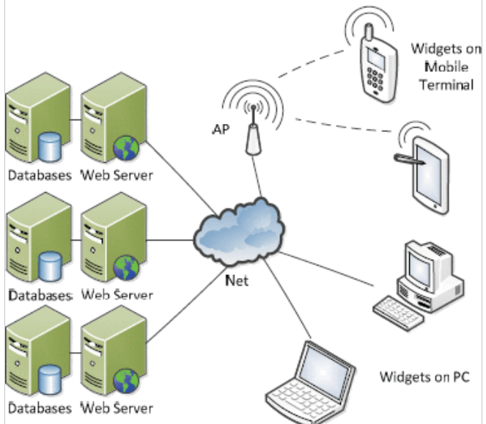
Figure 5 W/S topology [29]

The aim of the W/S architecture is to allow for the use of any device to access resources and having similar experiences.
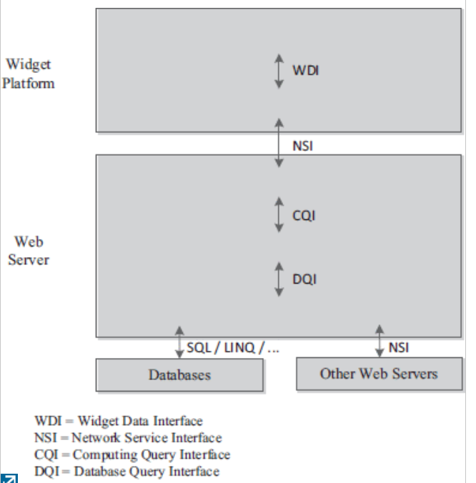

Figure 6 Layer Map W/S Architecture [29]
Figure 6 Layer Map W/S Architecture [29] shows the separation of logic, interpretation of code and transmission and presentation to users. The interfaces in and between the layers as shown shows the different resources are best implemented through the use of interfaces.

marking criteria and Student FEEDBACK

This section details the extent to which the assessment criteria are demonstrated by you, which in turn determines your mark. The marks available for each category of skill are shown. Lecturers will use the space provided to comment on the achievement of the task(s), including those areas in which you have performed well and areas that would benefit from development/improvement.

Common Assessment Criteria Applied (Assignment 1) | Marks available | Marks  awarded
1. Engagement with Literature Skills

A very good range of appropriate literature has been consulted and referenced in the work and the review and discussion of the literature is of a good standard, but aim to focus your research to what is relevant in the context of your assignment briefs first. (Grade mark: 66.67%) | 15 | 10
2. Knowledge and Understanding Skills

A good overview of the layered architecture pattern has been provided, but you have not really evaluated the use of the pattern or discussed the benefits and/or disadvantages of the pattern. A very good overview of the repository and unit of work patterns with some good points discussed in the advantages and disadvantages section, but the description of ORM is too brief and requires more detail. You do identify some of the criticisms of using the repository and unit of work patterns with ORM frameworks, but again this section is too brief. Generally, it appears that you have focused your time and effort on sections that have less relevance in terms of the assignment brief. (Grade mark: 59.33%) | 75 | 44.5
3. Cognitive and Intellectual Skills

4. Practical Application Skills

5. Transferable Skills for Life and Professional Practice

The report is of a good standard. (Grade mark: 65.00%) | 10 | 6.5

Assignment Mark (Assessment marks are subject to ratification at the Exam Board. These comments and marks are to give feedback on module work and are for guidance only until they are confirmed. ) | Late Submission Penalties (tick if appropriate) |  | 61%
 | Up to 1 week late (40% Max) |  | 61%
 | Over 1 week late (0%) |  | 61%

