
Academic and Employability Skills
Name: Nicole Yango
ID: 1912732
Module Code: BMSW4001_LON

Table of Contents
Introduction 3
Reflection of the experience 3
Description 4
Feelings 5
Evaluation 6
Analyses 7
Conclusion 8
Action plan 9
Conclusion 12
References 13

Introduction
According to Carnegie, (2019), for career readiness students are required to explore some skills for career progression. Academic skills are described as the basic requirements for the students to be efficient in school and college career. On the other hand, employability skills are described as the basic requirements of the employers as well as the critical success factors in the current hyper-competitive workplace. As a result, students need to make them competent in each area of different skills. Considering the significance and necessity of different skills the module on skill development has focused on different dimensions of it. In this reflection paper, I'm going to reflect my learning and experience of the module by using a well-known reflective model namely ‘Gibbs reflective cycle’ designed by an American psychologist and sociologist named Graham Gibbs in 1988.

Reflection of the experience
According to Trought, F., (2019), to share and express about the experiences people had during a specific event, situation, or activity people need the help of systematic reflective models. Considering this appeal Graham Gibbs designed his reflective cycle in 1988. With the help of this reflective model my experiences and learning are described below:
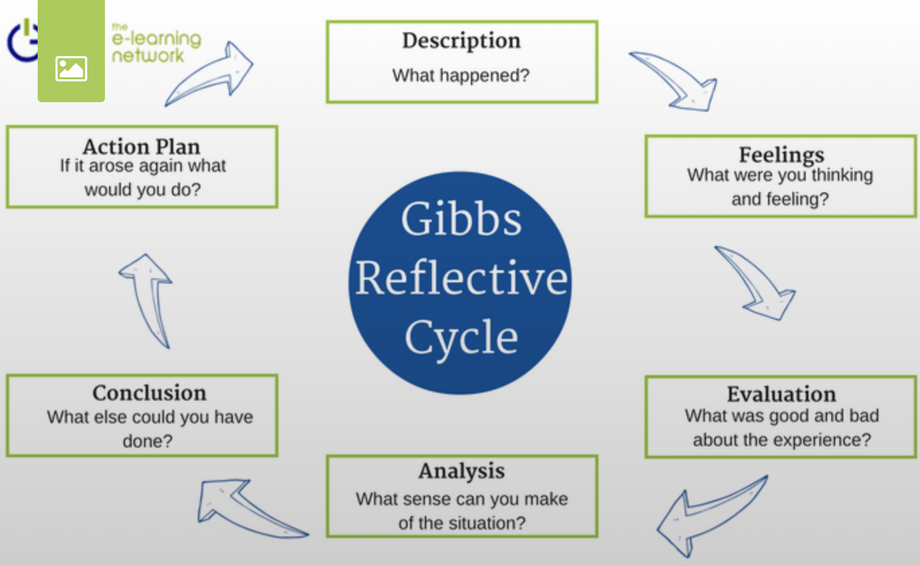
Figure: Gibbs reflective cycle (Carnegie, 2019)

Description
The journey of the module was started to make students confident and competent as effective employees by developing a range of academic and employability skills such as effective time management skills, academic writing, presentation skills, and more. As per the objectives of the model was concerned we learned different areas of academic and employability skills to develop our skills portfolios such as academic writing and language, paraphrasing, referencing, summarising, time management, CV writing, cover letter writing, presentation, public speaking, and more. Besides, the overall activities of the module were full of essential information and resources to make us competent in different areas of skills.

Feelings
The overall experience of the module was impressive. While I was reading the outline of the module, I thought that it was going to be a very difficult task for me. I never had good academic writing skills. However, the resources of the module came up with a short guide for effective academic writing. The module focused on different critical areas of academic writing including grammatical issues, sentence structure, clause structure, paragraph structure, and more. Now I feel that I have significantly improved my academic writing skills. To explore the improvement in my writing I often write in different blogs and websites. Besides, I also practice my academic writing in Grammarly. Before starting the module, I often got 40-45% scores in academic writing but now I have significantly improved my writing as I can score more than 80%. It is a really good feeling to me as the confidence in my academic writing skills is significantly improved with the help of this module. I also practice my learning in academic writing by writing emails, academic essays, and more. As a result, I'm on the way of continual improvement of my academic writing skills.
Before starting the module, I had no idea about referencing. However, referencing is the most prominent way of providing credit to the author and acknowledging his/her contribution. Throughout the module, I have learned the critical issues of references by participating in workshop and classroom exercise. Now I can successfully acknowledge the contribution of authors using appropriate referencing. It makes me feel ethical while each time I reference the contribution of others.
I was never a good time manager. I was often failed to do urgent tasks within the timeframe. I sometimes used notes of my daily tasks to manage time but It was not fully effective. I never thought of a model of time management. However, during the module, I was introduced to Eisenhower's approach of time management that classifies tasks based on emergency and importance. I have practised this time management framework on my classroom activities as well as on my activities. It has brought significant pleasure to me as I can complete all the important and urgent tasks within the timeframe.
Abbott, (2018) said, 'who doesn't enjoy the improvement of skills?' and I am also improving my skills and enjoying the improvement. It makes me feel impressive as I have started developing my academic and employment skills most easily with the help of the module instructor as well as the useful resources.

Evaluation
The overall experience of the module was very good for me. I had really good times during the module. According to Done, (2019), effective academic writing skill is the most dominant competence of a student and students should learn the grammatical issues, sentence structure, clause structure, summarizing, paraphrasing, essay writing, etc. These are exactly the issues that the module has focused on. Besides, the resources and study materials that are provided in the module were very effective as well. Our module instructor acted as a superhero. His constructive guidance along with the effective teaching style was very enjoyable to us. In summary, we had some good times with lots of good resources during the timeframe of the module.
Though the weight of good experience is very high in comparison to the bad experience, I had some challenging times as well. We had some presentation sessions during the module. I had to use PowerPoint and other technological resources during the presentation. But I have little knowledge of that. Besides, my public speaking skills are not very good. As a result, I obtained poor marks regarding these issues. Though it seems bad personally for me it may not be true for everyone. However, while designing the study materials and resources of the module, our instructors may have some scope for the improvement of our presentation by arranging more practice presentation sessions.

Analyses
There is no doubt that the module was very effective for me. I have learned how to summarize articles to write my assignments. Different aspects of employability skills were helpful for me to be more effective in my current workplace.
Second term really helped me to write one-page CV providing my details, areas of experience, educational background, work experience, voluntary work, and interests with a specific format. According to Reed.co.uk (2020), when someone writes a cv for the first time they do not know where to start and they always struggle to write personal statement. My lecturer taught me how to write a personal statement on the CV appropriately.
During this module, my lecture really emphasized importance of public speaking skills for both academic and employability skills. This term we need to deliver a presentation for effective team working module. Learning from this module is helping me to make my PowerPoint slides without any stress. According to my tutor I need to especially focus on my body language including keeping the eyes on the audience with a natural gesture. Besides, I also keep notes and points to keep me on track. Lofstead (2018) states that engaging audience and focusing on their needs are essential traits of a successful presenter.
However, I was not prepared to explore the optimum benefits from the module. Besides, I was not able to give my best effort during the module.
During the module, I learnt about cover letter writing including the elements of the cover letter. But I did not clearly understand the necessity of it. But now I can realise it is a selling document to the employer and it should be prepared based on the job description and job specification. So if I could participate in this module I could have learned writing a cover letter in a better way. It may also help me to write a better CV.

Conclusion
Eliot, (2017) said that the development of different skills is a continual process. I am a learner and I have just started to improve my skills with the help of this module. The improvement of my academic writing skills, time management skills, presentation skills, and CV writing skills is very clear. Though the module has a very big scope to improve academic and employability skills I may not have explored the optimum benefits of it. It must require focusing on practising and practising academic and employability skills to make me efficient in each area. So, I still have the scope to improve my academic and employability skills. According to Cottrell (2010), a continual action plan is required to improve different areas of strengths and weaknesses including the resources requirements and timeframe.

Action plan
A personal development plan is a systematic framework that addresses personal weaknesses to design an interactive plan to wipe out the weaknesses. Vishnu, P., (2012), provided a personal development framework to design a personal action plan addressing the resource requirements and timeframe. I have also identified my weaknesses in different skills as well as my future ambitions to be a competitive employee in the workplace. So, my development plan is as follows:
Areas of improvement | Required activities | Resource requirements | Timeframe | Notes/comments
Academic writing | Need to practice academic writing in the area of grammatical issues, sentence structure, paraphrasing, clause structure, referencing, etc. while writing. | Requires the support of books, notes journals, websites, articles, and more for continual practice (Finch, 2014). | It will be continued for the next 12 months and will be evaluated after every two months. | Should keep the record of quality of writing in every time while practising writing with the areas of improvement.
Time management | Need to classify tasks based on importance and urgency and make a continual schedule of the tasks. | Requires the support of time management framework and notes of daily activities (Abbott, 2018). | It will be continued for the rest of my life. | Should keep the record of tasks that missed during the timeframe and provide priority to the urgent tasks.
Referencing | Need to practice different types of referencing including books, journals, websites, etc. | Requires the support of appropriate guidance for different types of references. | It will be continued for the next 6 months and will be evaluated after each month. | Should find out the mistakes in different types of referencing including books, journals, websites, etc.
CV writing | Need to follow the CV's of successful people and practice their ways of writing with a specific format. | Require to have appropriate format and structure for different job descriptions (Vishnu, 2012). | It will be continued for the next 12 months and will be evaluated after each submission of CV. | Need to collect and evaluate the CV of successful people and follow their style.
Cover letter writing | Need to follow the cover letter of successful people and practice their ways of writing with a specific format. | Requires the support of books, notes journals, websites, articles, and an online platform like Grammarly or mindtools to practice. | It will be continued for the next 12 months and will be evaluated after each submission of cover letter. | Need to collect and evaluate cover letter of successful people and follow their style.
Presentation skills | Need to practice presentation and public speaking with the help of PowerPoint considering specific structure and guidance. | Requires the support of PowerPoint, information technology, and other instruments for PowerPoint presentation. (Vishnu, 2012) | It will be continued for the next 12 months. | Need to follow the presentation of successful people like Steve Jobs, Bill Gates, and more.

Conclusion
This reflection paper has systematically reflected the learning from the module by using the Gibbs reflective framework. At the very beginning section of the reflection paper, a brief description of the experience, as well as thinking and feelings, are provided then in the evaluation section both the good and bad experiences were shared. Then a brief analysis of development in different skills is provided in the analysis section. It is founded that the module contributed to the development of some crucial competencies including academic writing, presentation, time management, CV writing, cover letter writing, and more. However, continual improvement requires a continual development plan. Based on the areas of improvement a career development plan is provided in the action plan section. It is expected that the appropriate implementation of the action plan can help to explore the career ambitions and sustainable success for a longer period.

References
Abbott, M., 2018. History Skills. New York: Routledge.
Carnegie, S., 2020. Employability Skills | Skillsyouneed. [online] Skillsyouneed.com. Available at: <https://www.skillsyouneed.com/general/employability-skills.html> [Accessed 18 July 2020].
Cottrell, S., 2010. Skills for Success: Personal Development and Employability. Hampshire: Palgrave MacMillan.
Cottrel, S., 2020. What Is Employability and Why Is It Important? [online] FutureLearn. Available at: <https://www.futurelearn.com/courses/career-success/0/steps/21285> [Accessed 18 July 2020].
Eliot, G. and Haight, G., 2017. The Mill On The Floss.
Finch, E. and Fafinski, S., 2014. Employability Skills For Law Students. Oxford; New York: Oxford University Press.
Lofstead, G.F., 2018. What Makes a Good Presentation? NM: Albuquerque.
Reed.co.uk, 2020. How to: Write a CV. Available at: <https://www.reed.co.uk/career-advice/how-to-write-a-cv/#:~:text=How%20to%3A%20Write%20a%20CV%201%20Personal%20details%3A,with%20the%20most%20recent%20first.%20More%20items...%20> [Accessed 25 July 2020]
Slorach, J., Embley, J., Goodchild, P. and Shephard, C., 2018. Legal Systems & Skills.
Vishnu, P., 2020. [online] Exeter.ac.uk. Available at: <https://www.exeter.ac.uk/ambassadors/HESTEM/resources/General/STEMNET%20Employability%20skills%20guide.pdf> [Accessed 18 July 2020].

