GPU Programming

ABSTRACT: The purpose of this document is to illustrate the development of shaders developed using C++ alongside this to also discuss the methods and technology that goes into developing graphics using a GPU.
  - By Jacob James-Machin

Contents
Introduction 2
The concept behind GPU Programming 2
Shaders 2
Application of Shaders 2
GPU vs CPU rendering 3
SDK’s 4
API’s 4
Vulkan 4
OpenGL 5
DirectX 6
Compute-Focused API’s 7
CUDA 7
OpenCL 7
DirectCompute 7
Practical application 8
Blur 8
Sharpen 8
Bloom 8
Code Demonstration 8
Overview 8
Main 9
Shaders 11
Textures 13
Shader Effects 17
Output 17
Conclusion 18
Bibliography 18
Appendix 21

Introduction
GPU Programming is the process of developing software that utilizes a Graphical Processing Unit aka (GPU) to perform tasks that mainly revolves around parallel computations and rendering graphics. [1] Doing this by using thousands of small, specialized cores GPU programming can accelerate intensive tasks such as AI, scientific simulations and image processing. For example, 3D animation companies use powerful GPUs to render movies.

The concept behind GPU Programming
The general concept behind GPU programming is the use of a specialised piece of hardware/processor that is designed with its own dedicated memory to manage multiple different threads at once. [2] With each core or multiprocessor uses the same mechanism as CPU’s but hosted thousands of times simultaneously. [3]

Shaders
With Shaders they are used as a small program that runs on the graphics processing unit in how it controls the data about graphics. [4] These graphics are then processed and rendered doing the work that the CPU usually does. While letting the GPU handle highly parallel tasks like drawing pixels, lighting and Geometry. [5]

Application of Shaders
The Application of shaders involve small programs that rely on the GPU with it being the key aspect of GPU programming. [6] They control how data especially graphics data is processed and rendered rather than the CPU handling graphical calculations. These shaders let the GPU do this work in parallel to the CPU. Which is way more efficient for GPU programming. [7]
The Type of shader applications in the pipeline include:
- Input assembler
- Vertex Shader
- Tessellation
- Geometry shader
- Rasterization
- Fragment shader
- Colour Blending
- Framebuffer
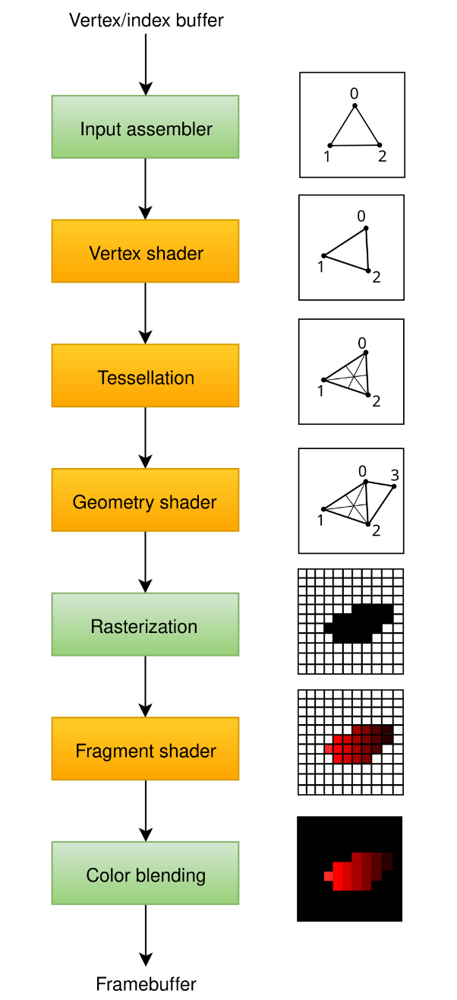 [8]

GPU vs CPU rendering
In regard to how a GPU vs CPU renderings visual data its always dependant on how the work is processed through parallel and sequential computing. It’s important for game developers through rendering workflows.
The biggest difference between the two includes:
- CPU(Central Processing Unit) it uses less cores than a GPU and it’s intended for a sequential workflow. Its also seen as the brain of the computer. Game Developers tend to use the CPU for physics simulations or high-end simulations because of how the CPU architecture is designed. [9]
- GPU(Graphics Processing Unit) GPU uses thousands of cores and instead of working in a sequential fashion. They all work/render at the same time. This is why its works well for real time rendering and its ideal for use in gaming. It also handles shaders very efficiently. [10]

SDK’s
A software development kit SDK’s is a set of tools used by developers and when it comes to GPU programming there are many types of development kits which are a collection of tools, libraries, compilers and documentation that allows for developers to write programs intended to be used on the GPU rather than the CPU. Regarding real time simulations as mentioned in the GPU vs CPU section. [11]

API’s
API’s (Application Programming Interface) are seen as frameworks that allows developers to directly communicate with the GPU and these types of tasks include rendering graphics, running shaders etc. There are many types of API’s that developers use and below are the 3 most popular ones used in games development. [12]

Vulkan
The Vulkan API is developed by a team known as the “Khronos Group” and it’s a modern low-level API giving a more precise control over the GPU. It is more complex however it is made up for a faster and more efficient workflow. Plus, a huge advantage that game developers need to consider is that its cross platform as it works on Operating Systems like Windows or Linux or Android. [13]

[14]

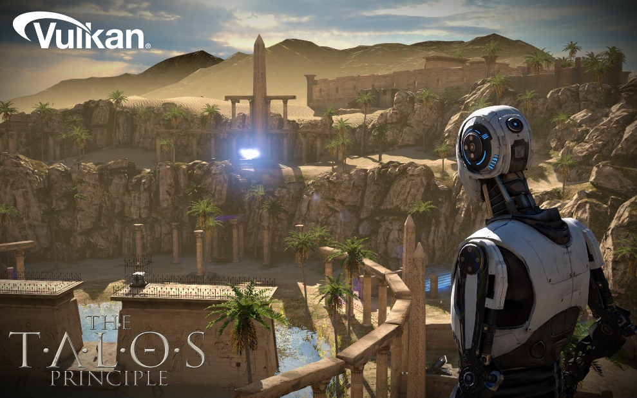

[15]

OpenGL

OpenGL is a cross platform and widely supported API that game developers have been using for decades. While being older it’s still a legacy system that is heavily used in education. It also uses a pipeline model with programmable shaders, and it is also easier to learn compared to other API. Its best used to learn how GPU rendering. [16]

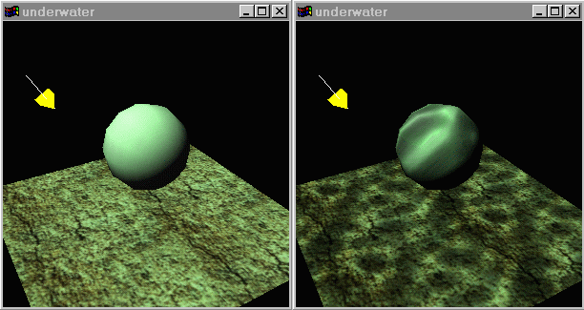
[17]

DirectX

DirectX is an API developed by Microsoft and unlike other API’s this is an API used exclusively on windows it won’t work on Linux or Android without some modification. Its allows for a strong performance and it’s used in AAA games and it uses legacy systems like Direct3D (graphics) and DirectCompute (GPU compute) etc. Its best used for Windows games development. [18]

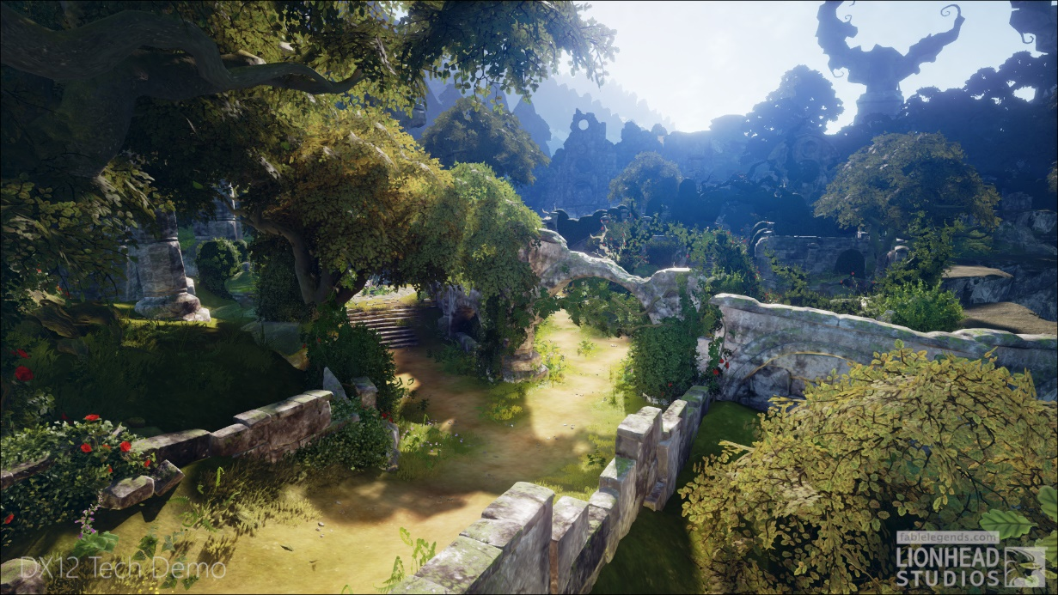

[19]

Compute-Focused API’s
Used for non-graphical tasks for a GPU with stuff like AI, Physics and simulations allowing a GPU to act like a CPU. [20]

CUDA
Cuda is developed by NVIDIA so it can only be used on its own line of GPU like the GeForce GTX or RTX series of cards and it’s a very powerful API used for scientific computi9ng and AI. With its main language being C/C++. Its used in areas that are utilize machine learning or scientific simulations. [21]

OpenCL
OpenCL is developed by the Khronos Group the main developers behind the Vulkan API and it’s designed to be cross platform so it can work on CPU’s, GPU and FPGAs. And because of that it is more portable than a CUDA but it’s also harder to optimize. Its best used on hardware-independent compute tasks. [22]

DirectCompute
DirectCompute is part of DirectX, and it allows for a general-purpose GPU task on windows, and it also works alongside with Direct3D. It is designed to be used on windows-based engines. [23]

Practical application
The intent of this document is to demonstrate the practical application of various GPU rendering techniques with showcasing the technology behind stuff like Shaders which include Blur, Sharpen and Bloom. [24]

Blur
In graphical applications the blur effect have multiple uses for things like:
- Depth of Field (which blurs the background creating a more striking cinematic image)
- Motion Blur (Blurs the movement creating the illusion of smooth and fluid movement)
- Softening the UI in the background
- Post Processing (enhances the final image)

Sharpen
When it comes to the sharpen effect this is also used in graphical renderings with examples including:
- Enhancing image clarity and making the image look more crisper
- Post processing after you blur or upscale.
- And it improves the detail and clarity of in game or in graphical textures

Bloom
Regarding graphical applications the bloom effects allow for these effects to occur:
- Simulating the glow of light
- HDR Rendering (High-Definition Range)
- Emphasising bright areas on an objects or spots making the object in game look real.
[25]

Code Demonstration

Overview
As demonstrated in this section the code displayed can properly portray the shader technology powered by the GPU alongside a texture being displayed also.

Main
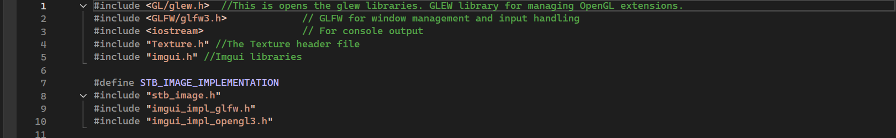
Figure 1
This is the includes. When creating a C++ project using visual studio it’s best to utilize the various libraries that can be installed with the program. In this case it’s the “vcpkg” libraries which includes all the graphical features to use.

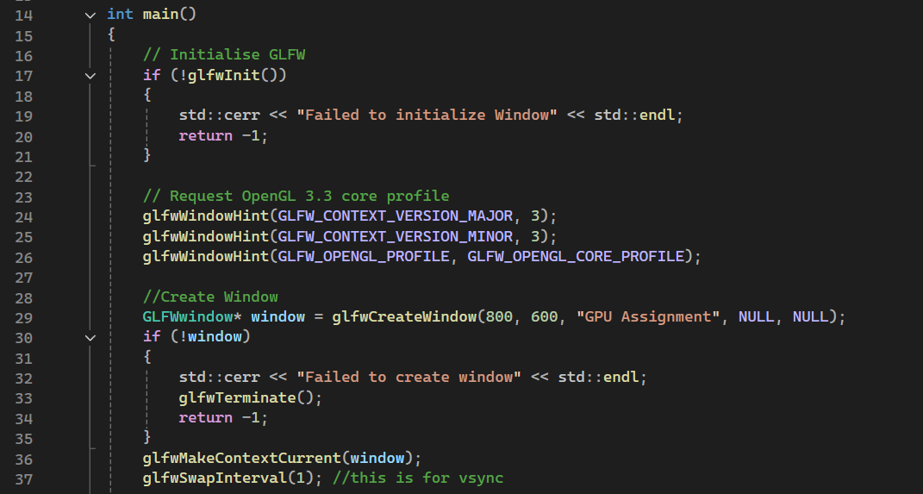
Figure 2
In this screenshot the code is initializing the GLFW libraries so the program can utilize that to enable features such as OpenGL. Plus, it allows for the creation of the window that displays the graphics like using GLFWwindow. Also, another thing used in GPU programming is the use of Swap Intervals which enables VSync.
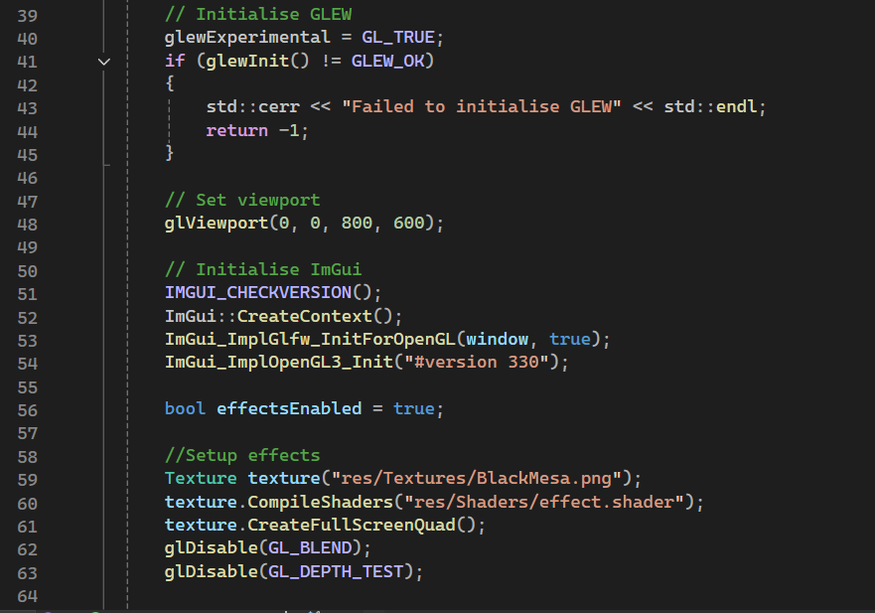
Figure 3
Theres a lot going on in this part of the code such as initializing GLEW which also uses OpenGL and below that is setting the viewport of the window which is the resolution displayed. Then next is the “ImGui” which enables the graphical user interface and the effects like pointing towards the location where the texture file is located and the effect.shader file (which has the shader information.

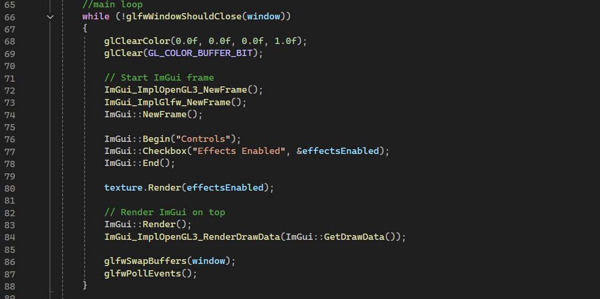
Figure 4
Rendering the Imgui library that lets the user enable or disable the shader effects.
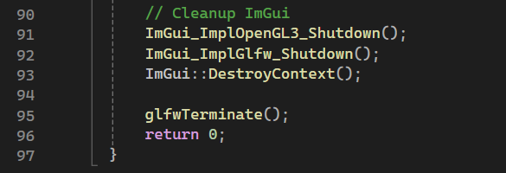
Figure 5

Shaders
Here are the Shaders
Cleaning up the Imgui information.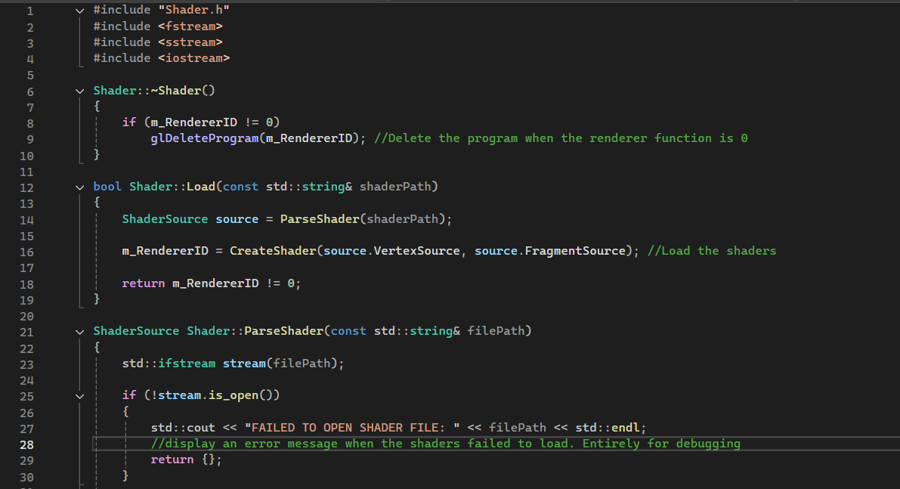
Figure 6
The main code here loads the shaders plus also debugging for developers in case they want to add new features like displaying a message whatever if a shader file has loaded.
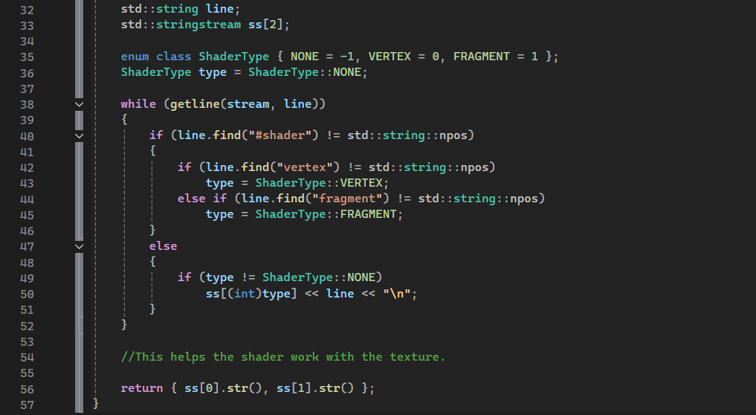
Figure 7
This allows the shaders to work with the textures using vertex and fragment arrays.
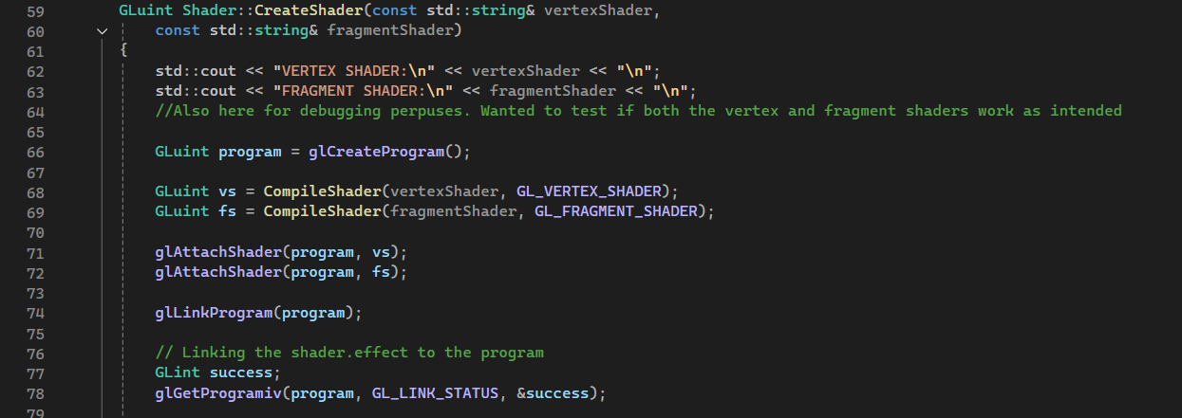
Figure 8
More debugging which helps developers in case they want to apply shaders. Alongside this is code helping to link the shader.effect file (which holds all the shader information) into the main shader file. Which holds the code to allow the shaders to run.
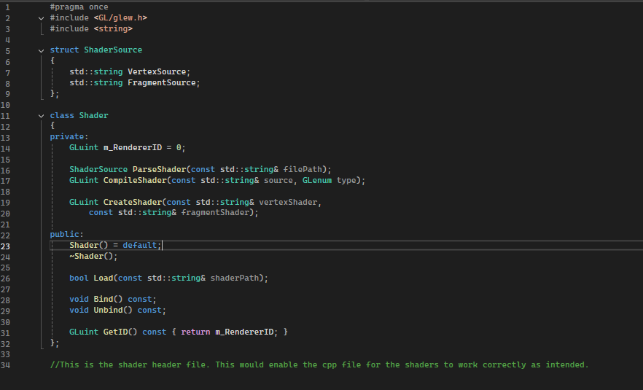
Figure 9
This is the shader header file. Helps the shader cpp file to work as intended.

Textures
Here are the textures
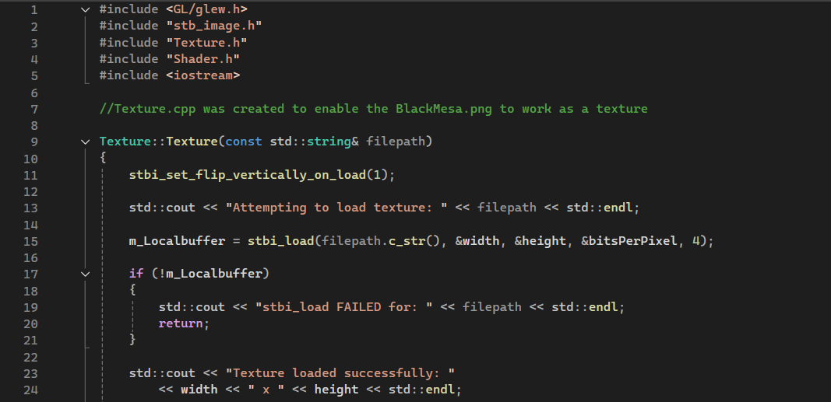
Figure 10
The Texture.cpp files enable the selected texture chosen the “BlackMesa.png” file to work as a texture on this program.
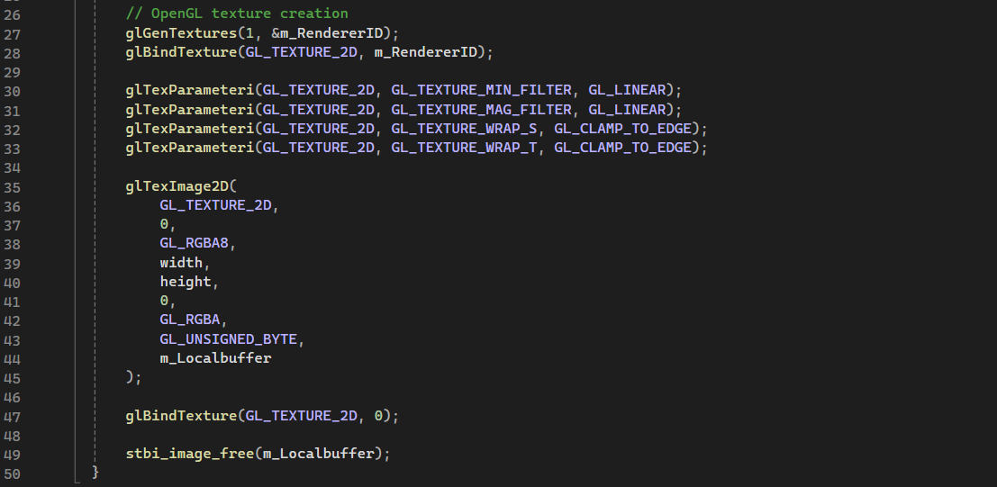
Figure 11
Enables OpenGL filters to work on the texture
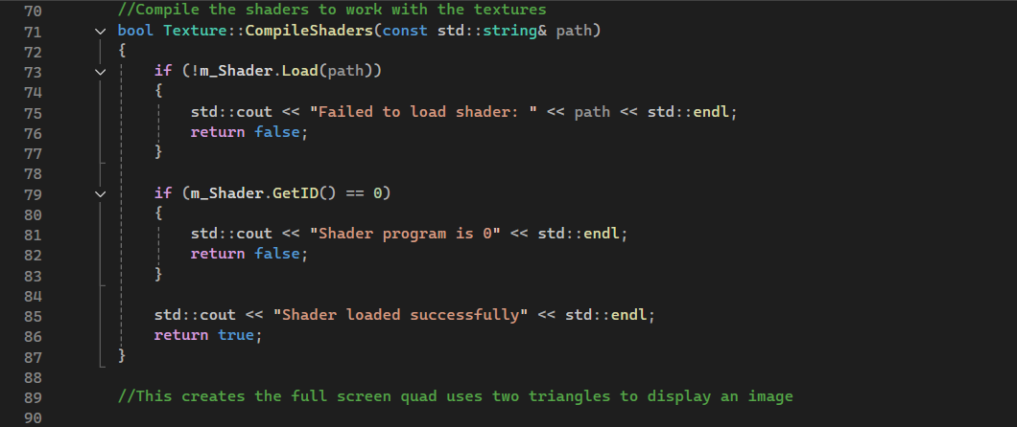
Figure 12
Compiling the shaders to work on the texture as an overlay.

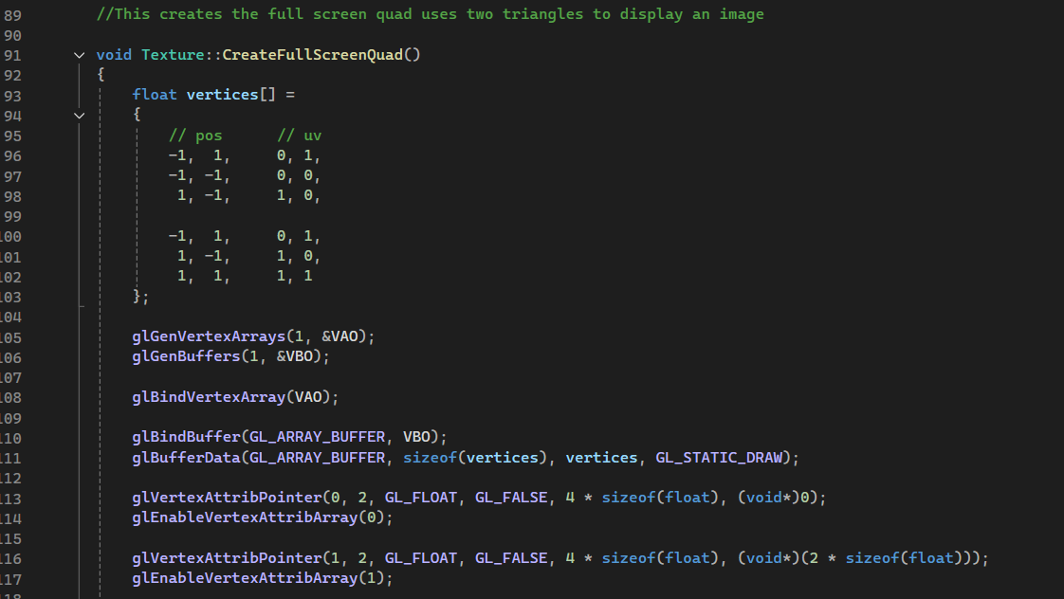
Figure 13
Full screen quads use 2 triangles to display a square or rectangle as a screen. Its akin to a hack to apply fragment shaders onto the program. Making it as a technique to apply shaders like blur or sharpen.
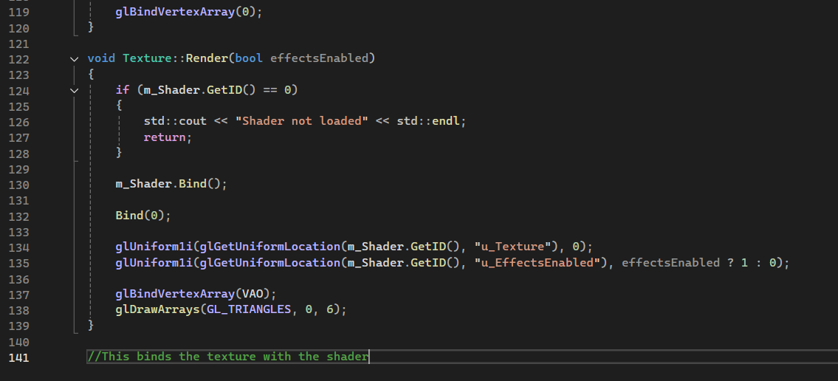
Figure 14
Binding the textures with the shaders allowing to work like an overlay.

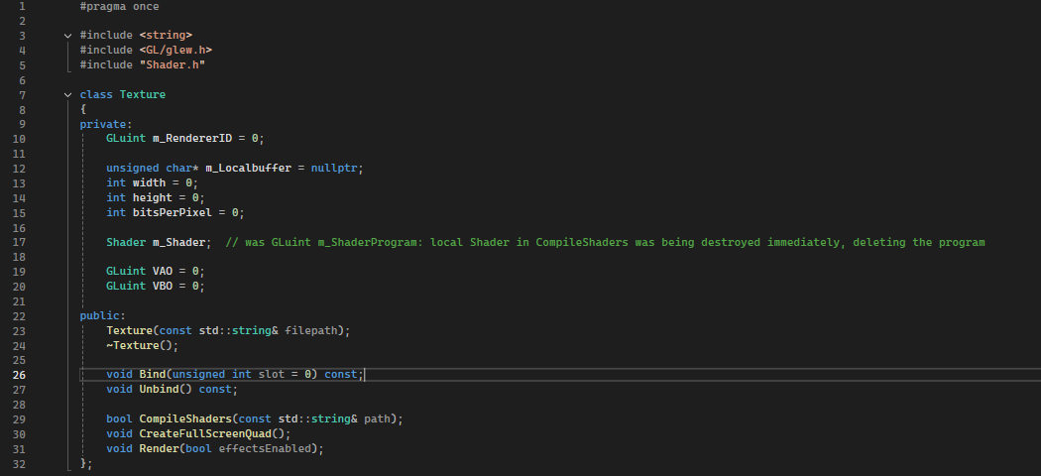
Figure 15
Finally, this is the texture header file. The ender function allows for the effects to work as intended. Plus using the “width” and “height” function for the resolution of the texture.

Shader Effects
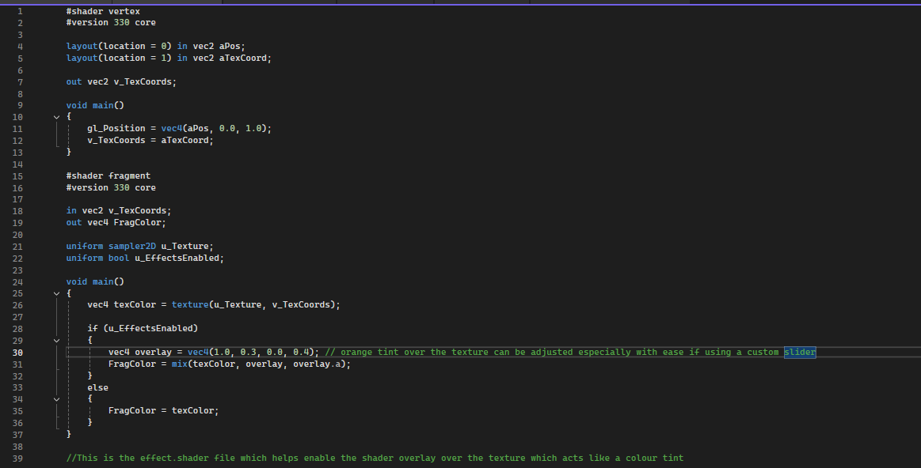
Figure 16
This is the Shader Effect file. Whereas the “shader.cpp” basically enables the function of the shaders to work on the program. This allows for the effects to work as an overlay over the texture. The technique used here is using a light colour tint over the texture image. You can also change the colours of the shader overlay with the “vec4 overlay” and “FragColor” functions

Output
The final output.

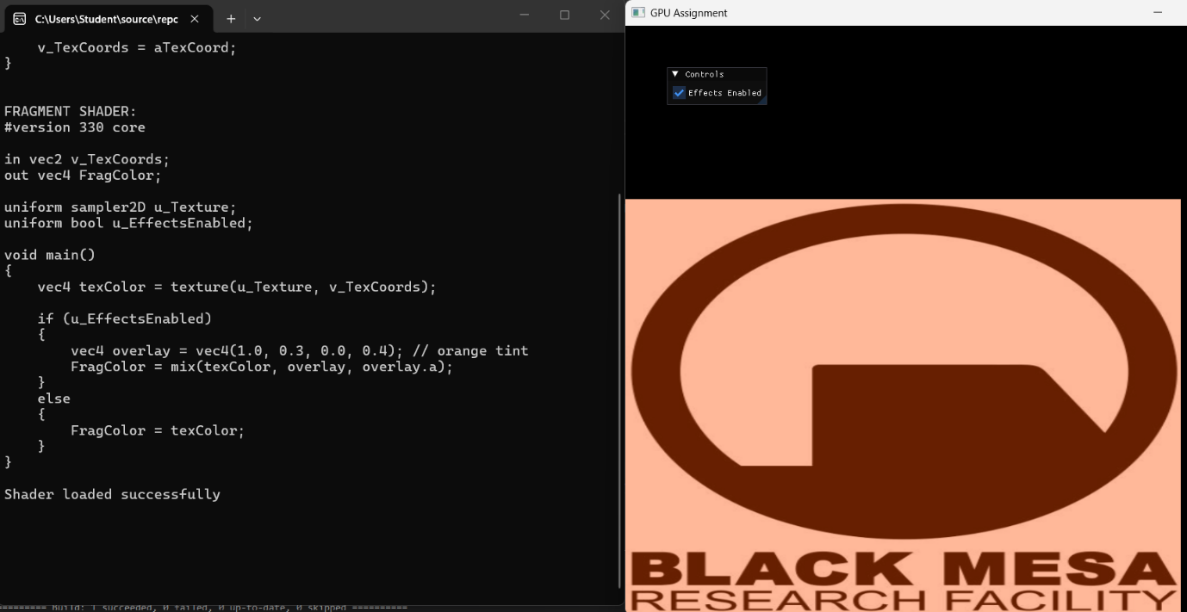
Figure 17
The final output of the code working as intended. With the debugging process on the left so the developer can see if the code is working as intended and on the right is the visual representation of what’s going on with the overlay over the texture and the Imgui function allowing for an interface to work to enable or disable the shader overlay.

Conclusion
To conclude this document the aim is for this project is to showcase the design and implementation of a GPU processing application using shader techniques like Bloom or Blur or Sharpen. This would show how flexible and efficient the process of translating these shaders is using the right API. Furthermore, the effects is also used in so many games and this document hopefully showcases the kind of technology that make all kinds of games not just 3D look up to standard.

Bibliography

[1] | M. Mahdi All Ing, “GPU-Programming : A brief introduction,” 3 September 2024. [Online]. Available: https://medium.com/@mahdiall99/gpu-programming-a-brief-introduction-1150f8a53f15.
[2] | K. Ge, “What is GPU programming?,” Red Hat Developer, 7 August 2024. [Online]. Available: https://developers.redhat.com/articles/2024/08/07/what-gpu-programming. [Accessed 05 04 2026].
[3] | F. T. a. S. M. James Fung, “Mediated Reality using Computer Graphics Hardware for Computer Vision,” International Symposium on Wearable Computing , Seattle, Washington, USA, 2002.
[4] | M. S. K. Akeley, “The OpenGL® Graphics System:,” Khronos Group, 2006.
[5] | N. Tabor, “graphics processing unit,” Britannica Encylopedia, [Online]. Available: https://www.britannica.com/technology/graphics-processing-unit. [Accessed 05 April 2026].
[6] | W. Harris, “A bluffer's guide to Shader Models,” Bit-Tech, 25 July 2005. [Online]. Available: A bluffer's guide to Shader Models. [Accessed 05 April 2026].
[7] | Various, “Vulkan® 1.4.348 - A Specification (with all registered extensions),” Khronos Group, 03 04 2026. [Online]. Available: https://registry.khronos.org/vulkan/specs/latest/html/vkspec.html#shaders. [Accessed 05 April 2026].
[8] | A. Overvoorde, “Shader Pipeline Illustration,” GitHub, 16 June 2016. [Online]. Available: https://github.com/Overv/VulkanTutorial/blob/02e283d54835aa0c4aed2cdc361baf10335137a6/images/vulkan_simplified_pipeline.svg. [Accessed 05 04 2026].
[9] | S. Muñoz, “CPU vs. microprocessor: What are the differences?,” TechTarget, 26 June 2020. [Online]. Available: https://www.techtarget.com/searchitoperations/tip/CPU-vs-microprocessor-What-are-the-differences. [Accessed 05 April 2026].
[10] | Intel, “CPU vs. GPU: What's the Difference?,” Intek, 05 April 2026. [Online]. Available: https://www.intel.com/content/www/us/en/products/docs/processors/cpu-vs-gpu.html. [Accessed 05 April 2026].
[11] | K. Sandoval, “What is the Difference Between an API and an SDK?,” Nordic APIs, 2 June 2016. [Online]. Available: https://nordicapis.com/what-is-the-difference-between-an-api-and-an-sdk/. [Accessed 06 04 2025].
[12] | M. Reddy, API Design for C++, Burlington: Elsevier Science, 2011.
[13] | K. Ghavam, “Vulkan SDK and Ecosystem Tools (SIGGRAPH 2023),” in SIGGRAPH, W Marriott LA, 2023.
[14] | Anon, “Vulkan Modern GPU API,” NVIDIA, 2026. [Online]. Available: https://developer.nvidia.com/vulkan. [Accessed 06 04 2026].
[15] | A. Burnes, “The Vulkan Graphics API Is Here, and Your NVIDIA GPU Is Ready,” NVIDIA, 16 Feburary 2016. [Online]. Available: https://www.nvidia.com/en-us/geforce/news/vulkan-graphics-api-launches-nvidia-gpus-game-ready/. [Accessed 06 04 2026].
[16] | M. S. K. Akeley, “The OpenGL Graphics System: A Specification,” 11 March 2010. [Online]. Available: https://registry.khronos.org/OpenGL/specs/gl/glspec40.core.pdf. [Accessed 06 04 2026].
[17] | “All About OpenGL Extensions,” Khronos Group, 10 July 2000. [Online]. Available: https://www.opengl.org/archives/resources/features/OGLextensions/. [Accessed 06 04 2026].
[18] | Anon, “Microsoft DirectX and Windows Media Technologies on Windows CE,” Gamessurge, Microsoft, June 1999. [Online]. Available: https://www.gamesurge.com/dreamcast/technical_pages/directx.shtml. [Accessed 06 04 2026].
[19] | B. Langley, “DirectX 12 Lights Up NVIDIA’s Maxwell Launch,” Microsoft, 18 September 2014. [Online]. Available: https://devblogs.microsoft.com/directx/directx-12-lights-up-nvidias-maxwell-launch/. [Accessed 06 04 2026].
[20] | Anon, “CPU vs. GPU: Powerful Options for Your Computing Needs,” Intel, [Online]. Available: https://www.intel.com/content/www/us/en/products/docs/processors/cpu-vs-gpu.html. [Accessed 06 04 2026].
[21] | D. Perez, “NVIDIA® CUDA™ Unleashes Power of GPU Computing,” NVIDIA, 29 March 2007. [Online]. Available: https://web.archive.org/web/20070329144655/http://www.nvidia.com/object/IO_39918.html. [Accessed 06 04 2026].
[22] | O. W. Group, “The OpenCL™ Specification,” Khronos Group, 10 July 2025. [Online]. Available: https://registry.khronos.org/OpenCL/specs/3.0-unified/html/OpenCL_API.html. [Accessed 06 04 2026].
[23] | E. Young, “DirectCompute Optimizations and Best Practices,” in GPU Technology Conference, San Jose, 2010.
[24] | Anon, “An Investigation Of Fast Real-Time GPU-based Image Blur Algorithms,” Intel, 15 7 2014. [Online]. Available: https://www.intel.com/content/www/us/en/developer/articles/technical/an-investigation-of-fast-real-time-gpu-based-image-blur-algorithms.html. [Accessed 06 04 2026].
[25] | Y. Feng, “Evolution of Shader Technology: From Fixed Pipeline to Real-Time Ray Tracing, A Case Study on Racing Games,” 10 July 2025. [Online]. Available: https://www.researchgate.net/publication/394870261_Evolution_of_Shader_Technology_From_Fixed_Pipeline_to_Real-Time_Ray_Tracing_A_Case_Study_on_Racing_Games. [Accessed 06 04 2026].

Appendix
Further Appendances
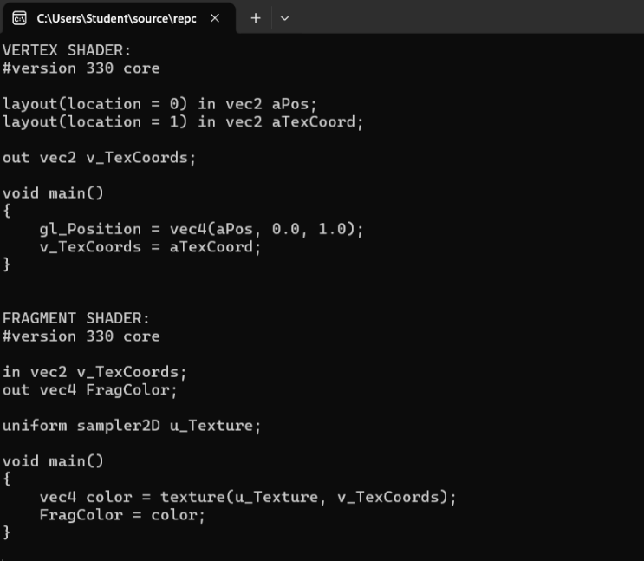
Initially it did take a lot of debugging to get the program to work and its why there’s a debugging log next to the output as initially the output result was this:
Figure 18

Figure 19

This was fixed by properly making sure the shader was sampling the texture properly.

