Student Number: 2215853

Word Count: 3700
5349 (including tables/figures)

Date of Submission: 12th May 2023
MSc Digital Technology in Health and Social Care
BMDS7007
Cohort 2 (2022)
Managing Digital Strategy to Enhance Health and Care

Table of Contents
Page Number
Table of Contents 2
List of Tables 3
List of Figures 3
Executive Summary 4
Business Drivers
Size, Scope, and Purpose 5
Environmental Factors 6
Strategic Directions 8
Challenges and Opportunities 9
Technology and Digital Transformation
Core Operational Systems 10
Infrastructure 11
Interoperability 12
Information Standards 13
Data Analytics Capabilities 14
Key Aims, Principles, and Programmes 15
Strategic Analysis 17
The PESTLE Tool 17
Building a Digital Strategy 20
Conclusion 23
Reference List 24

List of Tables
Page Number
Table 1: Key External Environmental Factors 6
Table 2: Key Internal Environmental Factors 8

Table 3: Challenges and Opportunities Faced by BCUHB 9

Table 4: Core Operational Systems 10

Table 5: Summary of the evaluation of ‘Our Digital Future’ 17
against the PESTLE framework

Table 6: Summary of the evaluation of ‘Our Digital Future’ 20
against the Building a Digital Strategy (2021) best
practice factors

List of Figures

Figure 1: Urban / Rural Classification in North Wales 6
Figure 2: Delivering Ambition 1: Enabled Patients & Carers 16
Figure 3: Delivering Ambition 2: Enabled Staff 16

Executive Summary
“A great digital strategy provides direction, enabling executives to lead digital initiatives, gauge their progress, and then redirect those efforts as needed” (Ross, Beath, and Sebastian, 2017). The question may remain though, what constitutes a great digital strategy?
The aim of this paper is to critically evaluate the Betsi Cadwaladr University Health Board’s (BCUHB) Digital Strategy, ‘Our Digital Future’ (ODF), employing two peer-reviewed tools as frameworks with which to analyse the strategy contents, and assess where improvements can be made.
For context, BCUHB is the largest Health Board in Wales, covering the North Wales footprint. It provides primary, secondary, community, mental health care, and commissioned services.
It could be considered that, with respect to cyber security, capacity, and resilience, the Board is relatively mature. However, regarding aspects such as systems, interoperability, and general digital culture there is much further to go on its digital transformation journey. There is a clear emphasis within the strategy to get the basics right and build a strong digital foundation.
The first tool utilised, PESTLE (Political, Economic, Social, Technological, Legal and Environmental factors) is a strategic planning tool that can be used to analyse and evaluate external environmental factors (i.e., those that cannot be controlled by the organisation). Opportunities and threats can be identified and their potential impact on objectives and performance assessed so that the organisation can plan/strategise accordingly.
- Key strengths were found relating to the technological and social factors, with significant material relating to innovation and digital exclusion respectively.
- ODF does not make reference to the escalation and intervention status of the Board, which was found to be a weakness relating to the political factor.
- A particular gap generally was with reference to environment factors.
The second tool utilised was ‘Building a Digital Strategy’ (BDS) (NHS Providers, 2021). The tool outlines six key points (integrated, user centred, useful to teams, mainstream, realistic, and focused) that can be utilised to provide a framework by which to evaluate the quality of an existing strategy.
- A particular strength related to the strategy being ‘user centred’, with a clear commitment throughout to engagement with key stakeholders.
- The ‘realistic’ and ‘focussed’ factors found that although there was reference to them, relating to points such as challenges faced and getting the basics right respectively, there were also weaknesses regarding clear timelines and ownership of realistic and tangible actions, and work that must be offset against areas of focus.
- ‘Integration’ also requires more attention, with reference to national and local strategy and plans, and an acknowledgement that there is more to be done regarding the inclusion of digital technology in business planning, but no plans to support this requirement.
Despite some limitations of the tools as frameworks, the employment of them to evaluate ODF has highlighted some useful strengths, weaknesses and gaps that could be utilised to improve future iterations.

Business Drivers
Size, Scope, and Purpose
BCUHB is the largest health board in Wales, providing a wide range of health services for the residents, and visitors, of its North Wales footprint. The census population in 2021 was 687,000, which swells, in particular, during peak holiday seasons; “North Wales received 23 million tourism day visits in 2018” (Statistics for Wales, 2020, p32), and received 37% of overnight domestic trips, 29% of international visits and 24% day visits to Wales (Government Social Research, 2021, p5).

The footprint covers the diverse geography of Anglesey, Gwynedd, Conwy, Denbighshire, Flintshire and Wrexham Local Authorities, from the cities of Bangor and Wrexham and towns of various sizes, through to villages and rural areas. As illustrated in the figure overleaf, urban areas are concentrated on the coastline and in the east along the border with England.

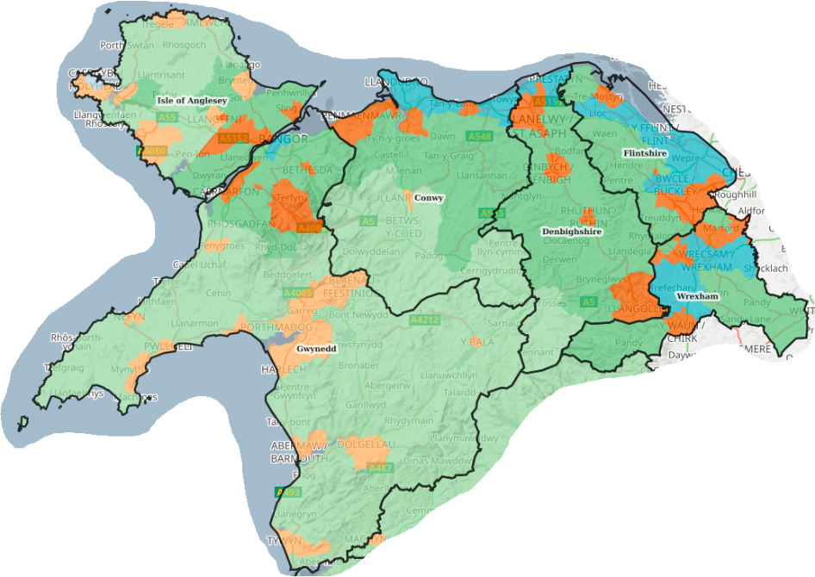
■ Rural town and fringe
Rural town and fringe in a
sparse setting
Rural village and dispersed
Rural village and dispersed
in a sparse setting
Urban city and town
Urban city and town in a
sparse setting

Figure 1: Urban/Rural Classification in North Wales (DataMapWales, 2023)

The Board is responsible for the provision of primary, secondary, community, and mental health care services, as well as commissioned services such as community pharmacies, opticians and dentists, and as such, works out of a network of sites, including acute and community hospitals, surgeries, health centres, mental health units, community sites, admin hubs, as well as patient’s/staff’s homes.

Environmental Factors
Strategic management relies on maintaining an understanding of the factors impacting the internal and external environments of an organisation, in order to make better plans for optimal management. Health care is complex, and as such there are numerous environmental factors effecting it; following are some of the key ones affecting BCUHB.
Key External Environmental Factors
Sub-category | Factor
Demographics | General population figures have dropped by approximately 1,000 in the past 10 years
Demographics | The population is aging, with 24% aged 65 or over, compared to 20% in 2011 (StatsWales, 2022)
Demographics | Public Health Wales (2022) outline that, as per 2018/22 figures, the average life expectancy for females within the BCUHB footprint is 82.3 years, and for males is 78.8 years
Demographics | Healthy life expectancy in the BCUHB area is much lower than average life expectancy, at 65.2 and 63.9 years for females and males respectively (Public Health Wales, 2022)
Demographics | Health inequalities impact life expectancy, with the difference between the most and least deprived areas being 6.1 years for females and 7 years for males, but with a more pronounced effect of healthy life expectancy with 10.9 years difference for females and 12.2 years for males (Public Health Wales, 2022)
Demographics | 180,000 adults in Wales today (7%) are not online; only 41% of over 75s have basic digital skills, and economically inactive groups are 11% less likely to visit a website than their employed counterparts (Digital Communities Wales, 2023)
Demographics | As of September 2019, almost 3,800 homes and businesses (1.1%) were unable to access a download speed of 10Mbit/s and an upload speed of 1Mbit/s (the Universal Service Obligation), and 20% of Gwynedd was not covered by any operator (Statistics for Wales, 2020).
Pandemic | “Healthcare systems around the world are under pressure after the Covid-19 pandemic” (Ratwatte, 2022), and BCUHB is no different, experiencing the pressure on staff morale (McFadden et al, 2021; Sethi et al, 2020), waiting lists, and finances that have been commonly seen.
Pandemic | The public’s familiarity with virtual means of communication was propelled by the pandemic, paving the way for greater acceptance of the concept (and potential) of using virtual means for facilitating healthcare.
Available talent | Generally, the “NHS is in the grip of chronic workforce shortages” (Ratwette, 2023), and again, BCUHB are no exception, with the Annual Report (2022) referencing recruitment issues across specialisms.
Governmental | There was a change of Health Minister in May 2021.
Governmental | In February 2023 the Health Board was placed back into special measures following “serious concerns about the performance of the organisation, about its governance, and issues with leadership and culture that are holding back progress” (Welsh Government, 2023).
Governmental | Brexit has had an ongoing impact on trade and availability of some products, such as pharmaceuticals, as well as on the labour market.
Financial | Austerity measures have had a negative impact on public spending.
Financial | The economic downturn impacted, amongst other things, on staff recruitment and retention due to the effect on salaries.
Table 1: Key External Environmental Factors Currently Effecting BCUHB
Key Internal Environmental Factors
Sub-category | Factor
Leadership and Culture | During the last financial year an operational restructure was initiated resulting in a significant amount of movement and interim staffing at senior level, thus leadership and culture within BCUHB have been unstable.
Leadership and Culture | Alongside being placed in special measures, the Chair and Independent Members (IMs) were replaced, and some internal processes and governance procedures are in the process of changing in line with new requirements.
Workforce | BCUHB employed circa 19,000 staff, however, the vacancy rate currently sits at 5.7% (BCUHB, 2023). The Board’s position regarding vacancies is very much influenced by the external general shortages of skilled staff.
Finances | There are budget and savings pressures on the Board currently.
IT software | The Board are working with a lot of legacy systems that are not integrated
Table 2: Key Internal Environmental Factors Currently Effecting BCUHB

Strategic Directions
There are a number of legislations, acts and National strategies, plans and programmes that BCUHB have a duty to adhere to when producing its own strategies and plans, such as:
- A Healthier Wales: A Plan for Health and Social Care (2018)
- The Well-Being of Future Generations Act (2015)
- Social Services Well-Being Act (2014)
- The Equality Act (2010)
- Welsh Language (Wales) Measure (2011)
- The Socio Economic Duty (2021)
- Data Protection Act (2018)
- The Digital Strategy for Wales (2021)
- Informed Digital Health – A Digital Health and Social Care Strategy for Wales (2015)
BCUHB’s corporate, long term strategy, ‘Living Healthier, Staying Well’ (LHSW) outlines a vision to “improve health, well-being and health care” in North Wales (2018, p2), which it breaks down to six principal areas to set objectives, and outline broad measures, against. These areas are:
- Improving health and reducing inequalities
- Care closer to home
- More serious health needs
- Mental health and wellbeing
- Children and young people
- Healthy aging

Challenges and Opportunities
The table below outlines some broad challenges, and opportunities faced by the organisation with respect to provision of care.
Challenges | Opportunities
Increased demand / increased acuity of care due to an aging population and life expectancy versus healthy life expectancy | The Office 365 roll-out gives broad functionality to staff, particular with respect to virtual meetings and consultations
System pressures as a result of the Covid-19 pandemic | The accelerated rate of digital technology use with the public during the Covid-19 pandemic
Staff shortages and vacancies, and a reliance on bank/agency staffing | WPAS implementation completion across the whole of BCUHB
Special Measures leading to changes in leadership and some process changes | The support, process changes and leadership accompanying special measures
An operational restructure resulting changes to and interim leadership | Digital technology innovations
Austerity measures impacting on public spending, and thus, tighter budgets and savings | National solutions offering interoperability and a ‘Once for Wales’ approach, including the National Data Resource
Short term grant funding in place of long-term / sustained funding | Work with the Small Business Research Initiative
National solutions aren’t always timely and do not always meet needs | Transformational monies
Legacy operating systems
Lack of external infrastructure leading to digital exclusion
Digital skills: 7% of the population of Wales do not use the internet, and 22% of those who do use the internet lack at least one of the five basic digital skills (Welsh Government, 2022)
Aging estate
Table 3: Challenges and Opportunities Faced by BCUHB

Technology and Digital Transformation
Core Operational Systems
There are in excess of 380 operational systems/applications within the clinical and business domains of BCUHB. The systems in the table below are those that may be considered as core operational systems, though it is acknowledged that other clinical/departmental and corporate systems are pivotal in the delivery of services, and the digital strategy.
System | Description
Community Information Sharing System (currently WCCIS) | A system to allow secure information for care to be available across health and social care
Digital Health Record (DHR) | ‘Cito’ – a clinical document repository enabling the digitisation of the acute health record so as to become paperless at the point of care
Picture Archiving and Communications System (PACS) | An electronic diagnostic imaging system that records, transmits, and saves pictures digitally so they are simultaneously and remotely accessible
Welsh Clinical Portal (WCP) | Access to documents including discharge letters; GP system patient records; transcribed discharge medication lists; electronic test requesting; and pathology and radiology results, with a single log-on
Welsh Emergency Department System (WEDS) | The ‘Symphony’ system rolled out across the Emergency Departments (EDs) and Minor Injury Units (MIU) of BCUHB
Welsh Laboratory Information Management System (WLIMS) | A clinical IT system for storing, recording and exchanging pathology information
Welsh Patient Administration System (WPAS) | One patient administration system across the Board
Welsh Nursing Care Record (WNCR) | Successfully implemented across East and Centre to date, WNCR facilitates standardised, digital nursing documentation. The West area is due to be implemented in the coming months.
Welsh Radiology Information System (WRIS) | Also known as RadIS, this system works in conjunction with PACS to manage the storage, retrieval, distribution, and presentation of images. It also allows the sharing of these images nationally.
Electronic Staff Record (ESR) | An integrated ‘hire to retire’ workforce management system accessible at any time, from any device and any location.
Information Reporting Intelligence System (IRIS) | A web portal that enables staff to view all of the Information Services Department’s published reports relating to BCUHB data
Table 4: Core Operational Systems
Infrastructure
There is a dedicated Information and Communication Technology (ICT) team within BCUHB who are responsible for the development, management and support of the core ICT infrastructure in the Board.
BCUHB currently operates a 3 data centre model across the region and opts for virtual infrastructure as far as is possible.
Performance
The majority of the Board’s resources respond back to a central, live monitoring system. Alerts are set-up to signal where there may be any capacity or responsiveness issues. With respect to high-level targets, systems are measured against ‘up time’, and response to/resolution of logged issues, as per specific Service Level Agreements.
Reliability
As mentioned earlier, live data is gathered, which means that automated predictive analysis can be used to warn of issues such as low disk space. Routine maintenance, such as software updates, and cyclical hardware refresh as per industry practice, assist in maintaining the reliability of the infrastructure. In addition, BCUHB has high availability/clustering, so can endure failovers, avoid single points of failure and protect against issues such as site outage.
Security
BCUHB is compliant with all statutory requirements within the Network & Information Systems Regulations Directive (NIS-D) and have gained best practice certifications including Cyber Essentials (CE), IASME and OSO 27001. A ‘defence in depth’ approach to security is taken. Methods such as horizon scanning, firewalls, anti-virus, anti-malware, anti-ransomware, and heuristic based measures are employed.
Capacity
Predictive analysis supports with capacity planning and monitoring at BCUHB. Alerts flag issues such as low disc space or spikes in usage/server pressure. Additionally, the Team have contact with the business owners of the various operating systems, so communication can take place regarding planned usage, and in advance of software upgrades/scale-ups in order to increase resource where necessary.

Interoperability
There is a dedicated Patient Records and Digital Integration Team within BCUHB who have undertaken a lot of work to advance effective interoperability. Some of the key projects carried out are as follows:
- Symphony implementation has been completed across all unscheduled and emergency care departments, meaning that clinicians have access to inter-departmental information sharing, as well as a patient tracking grid, to follow patient care through their time in the department.
- Microsoft 365 phase 1 implementation
- Work is ongoing to create a single instance of WPAS in BCUHB, with the WPAS in the East area of the Board merging with the West-Central WPAS imminently. This will be the first step to achieving a fully integrated digital patient record.
- The Board have embarked on a re-design of existing paper processes into digital via the ‘Cito’ product’s e-form and workflow capability. It is envisaged that this work will take four years to complete, but once it has, the ‘Cito’ product will provide a complete view of the patient record.
There is still much scope for improvement and development with regards interoperability; BCUHB currently has a large number of systems that do not ‘talk’ to each other. Future development or procurement will fully assess for interoperability.

Information Standards
BCUHB has a dedicated Reporting and Standards Team (R&S Team), who are responsible for producing and maintaining routine and mandated reporting, both internally and externally. The team provide minimum data set submissions as required, monitor data quality, and ensure methodologies are consistent with requirements. An internal Information Standards Working Group (ISWG) is in its infancy, which seeks to provide consistency in the use of data within BCUHB and will be supporting the development of a Data Strategy for the Health Board.
Data structures
Data structures for national data are determined by the data dictionary. Locally, to allow for additional granularity in the data, there is a separate structure within the data warehouse. Numerous tables, named using a structured naming convention, provide reference information and data, which is then mapped to national requirements where necessary. Associated meta-data is also available, which can be used to view hierarchies, lineage and so on.
Controlled terminology
The largest source of patient level information within BCUHB is via WPAS. This system uses International Classification of Diseases (ICD) and Operating Procedure Code Supplement (OPCS) to inform its controlled terminology. SNOMED CT is also used within Primary Care.
Locally, the warehouse includes a number of reference tables that hold valid values, and these are managed by mapping tables. Due to the number of disparate systems in use within the Health Board further work is required to bolster controlled terminologies across all systems, and this governance will be included within the planned Data Strategy mentioned above.
Data Dictionaries
BCUHB adhere to the NHS Wales Data Dictionary, which is maintained and published by the Data Standards Team within Digital Health Care Wales (DHCW). The R&S Team ensure methodologies determined by the published Data Standards Change Notices (DSCNs) and Data Dictionary Change Notices (DDCNs) are applied.
Coding adheres to the International Classification of Diseases (ICD-10) and OPCS Classification of Interventions and Procedures.
Value Sets
Data Standards Change Notices (DSCNs) outline associated value sets for nationally required data. The management of WPAS was transferred to the Data, Intelligence and Insight team from the ICT team to ensure that value sets can be used optimally. The Information team will be in a position to train users to be providers of information, by understanding the implications of using value sets appropriately and optimally.
At a local level, again due to the disparate, and legacy nature of many of the systems, work is required to ensure the standardisation and governance of value sets within some systems. This work will be included in the Data Strategy.

Data Analytics Capabilities
BCUHB has a dedicated analysis team, with Account Managers who lead on the focussed analyst support for a number of specialisms, and the Business Information Unit who facilitate miscellaneous analytics.
The Board have embraced the functionality that PowerBI has provided with respect to data analytics and sharing intelligence and are developing the use of other Microsoft 365 products such as PowerApps in the provision of quality analytics that there may not previously have been the capacity (people or time) to deliver.
The Digital, Data and Technology team are currently exploring Facebook Prophet and Python for forecasting work, which has been an area requiring growth to date, and also linking in with the advanced analytics programme through the NDR.

Key aims, principles and programmes
BCUHB’s Digital Strategy is entitled ‘Our Digital Future’. It was approved by the Board in May 2021 and outlines the approach for transforming health services through the use of digital technologies. The vision outlined within the strategy is about “transforming the patient experience, safety and outcomes through digital ways of working” (BCUHB, 2021, p4). In order to achieve the vision, the strategy has two key aims, termed ‘ambitions’:
- to enable patients and carers to actively manage their care and communicate with health professionals
- to connect staff with the right information and devices to improve the services they provide
The six principles, termed ‘key enablers’ are in place to support the realisation of the ambitions:
- strengthened digital foundations
- information for improvement
- digital organisation “Think Digital”
- strong partnerships
- digital inclusion, and
- embracing innovation
In order to achieve these ambitions and enablers, the strategy outlines a number of programmes of work and associated projects that can support with their delivery, as can be seen in the figures overleaf.
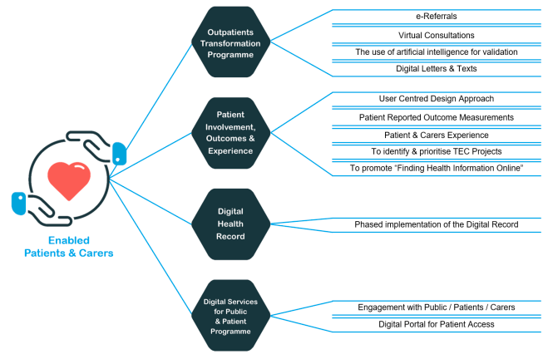Figure 2: Delivering Ambition 1: Enabled Patients & Carers (BCUHB, 2021, p24)
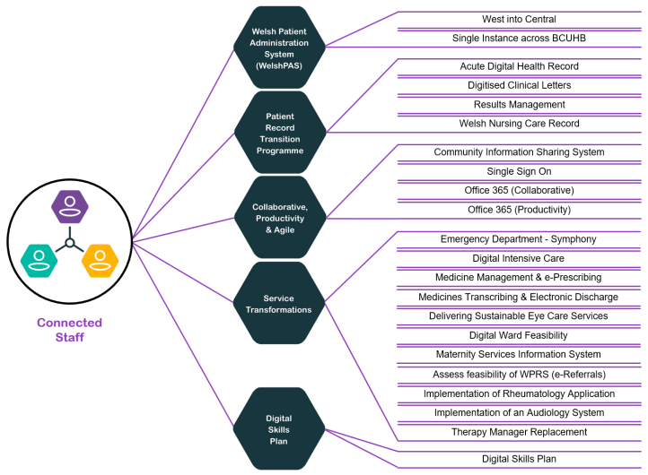
Figure 3: Delivering Ambition 2: Connected Staff (BCUHB, 2021, p27)
Strategic Analysis
“A great digital strategy provides direction, enabling executives to lead digital initiatives, gauge their progress, and then redirect those efforts as needed” (Ross, Beath, and Sebastian, 2017). It is, therefore, important to be able to evaluate what constitutes a ‘great’ digital strategy. In an attempt to do so, two peer reviewed tools have been employed to critically evaluate ‘Our Digital Future’.
The frameworks utilised do not have their own scoring grid to reference, thus, subjective scoring was applied against each of the factors, based on the strategy contents. Scores were out of 5 with 5/5 being the strongest. The strategy has a number of appendices, but these were excluded from the evaluation.

The PESTLE Tool
The PESTLE framework (Political, Economic, Social, Technological, Legal and Environmental factors) is generally considered to be a resource light, simple, strategic planning tool that can be used to analyse and evaluate external environmental factors (cannot be controlled by the organisation), that may affect performance. By examining the PESTLE factors, organisations can identify the opportunities and threats that may be evident relating to the six outlined factors, assess the impact of these factors on its strategy, objectives and performance, and plan accordingly to minimise risks and take advantage of opportunities. A summary of scores, and their justification can be seen below.
Factor | Definition/Potential topics | Rating | Key points Included/Justification
Political | Government stability, continuity and interventions, national policy and strategy, tax policy, foreign trade, education system, health regulations | 2/5 | -Outlines key national strategies, plans and programmes  -Highlights that national infrastructure and projects may not deliver as required  -Does not mention escalation and intervention status
Economic | Taxes and duties, interest rates, inflation, economic growth, disposable income, budget | 3/5 | -Refers to DHCW national funding to deliver programmes for all Boards  -States budget  -Highlights requirements to address lifetime funding for projects in future business cases  -Highlights lack of sustainable funding as a risk and the requirements to look for alternate funding streams  -Highlights areas for improvement, predominantly relating to finances
Social | Social, cultural and demographic characteristics | 4/5 | -Commitment to engagement throughout  -Local demographics acknowledged  -‘Digital First-Leaving No-One Behind’ concept
Technological | Innovation, use of outsourcing, build or buy (or have provided), network coverage, research and development, technical awareness | 4/5 | -Embracing innovation  -Getting the basics of technology right  -External digital infrastructure and digital skills recognised as an issue  -National programmes highlighted  -Digital Communities and Small Business Research Initiatives mentioned
Legal | Regulations, policies and laws | 3/5 | -Outlines legislative environment and key acts  -Multiple references to cyber security and data protection
Environmental | Disposal, pollution targets, carbon footprint, environmental offsets | 0/5 | -Inferred link to virtual consultations and digital letters  -Absence of any direct environmental issues
Table 5: Summary of the evaluation of ‘Our Digital Future’ against the PESTLE framework
It should be acknowledged that some of the contents within the strategy align to more than one factor. For this paper any such topics were considered against all relevant factors, however, Ho (2014) would recommend that a second stage analysis, a systemic PESTLE, is carried out. This method results in a diagram illustrating directional relationships between factors, though it is more complex to carry out.
Unsurprisingly, for a digital strategy, the majority of the content related to technology, spanning subcategories such as innovation, infrastructure, cyber security, operating systems, and so on, however, through the PESTLE analysis there was a requirement to distinguish between internal and external factors, so many points were discounted.
The strategy discusses innovation throughout, which in the ever-changing digital world can only be a strength. One of the ‘enablers’ key to achieving the ambitions of the strategy is dedicated to ‘Embracing Innovation’. There is material outlining a commitment to continue involvement in schemes such as the Digital Communities Initiative and the Small Business Research Initiative, as well as plans for future development, including creation of an inter-Health Board forum to support good practice, keeping up with new models of care, research and so on.
Another strength of the strategy is the awareness concerning social factors. Potentially due to the large emphasis on engagement when developing the strategy, there is acknowledgement about the demographics of the area, and the impact of these on the effective delivery of the strategy. In particular, the embedded approach ‘Digital First – Leaving No-One Behind’ nods to the impact of external digital infrastructure and digital skills. The strategy notes the importance of having efficient processes in place for those who choose not to, or cannot, access services digitally, and also refers to plans to support with digital skills in the community.
An area of weakness may be considered to be material associated with the political factor. There is reference to national strategy and policy, and also reference to the risk posed by the pace/detail of implementation of national infrastructure. However, surprisingly there is no mention of the escalation and intervention status of the Board. BCUHB is currently in special measures, which came into effect after ODF was published, though, at the time Welsh Government had placed certain aspects of the Board’s governance and operations, including strategy, planning and performance, into the level below: ‘targeted intervention’. The role that quality data, and thus, related technology, could play in improving the Board’s position was not mentioned.
A particular gap in the strategy, highlighted through the analysis, was environment. There was mention of projects to expand the use of virtual consultations where appropriate, and digital patient letters, however, these were not discussed in the context of the environment, so a link was only inferred for reasons of this analysis. There was no acknowledgement of recycling with regards to old hardware, or the impact of technology on virtual meetings and consultations, thus the reduction in carbon footprint, particularly taking the large landmass of BCUHB into account.

Building a Digital Strategy (BDS)
NHS Providers published a paper named ‘Building a Digital Strategy’ (2021) that sets out “a list of key characteristics that indicate a good digital strategy” (NHS Providers, 2021, p6). Six key points are outlined, that can be used to provide a framework by which to evaluate the quality of an existing strategy. ‘Our Digital Future’ was analysed and scored against the factors of integrated, user centred, useful to teams, mainstream, realistic, and focused. A summary of scores, and their justification can be seen in the table below.
Factor | Definition | Rating | Key points Included/Justification
Integrated | Digital should be integral to system and BCUHB strategies and business plans | 3/5 | -Reference to national strategies and plans  -Reference to how ODF supports the delivery of local strategy  -Business cases need strengthening
User centred | Transformation should address the most important needs of users | 5/5 | -Ambitions centre around patients, carers, and staff  -User Centred Design approach  -Engagement commitment  -Digital Inclusion Charter  -Digital Communities Initiative
Useful to teams | Provide guiding principles to support in decision making | 3.5/5 | -Vision provided  -Informatics Department rebranding  -Strengthening governance  -Acknowledgement that some services will need a different model of care  -How you can support delivery’ sections for enablers
Mainstream | Widely understood and adopted | 3.5/5 | -Engagement is central to the ambitions which will promote understanding  -Associated experiences relate to adoption  -Ambition sections conclude with ‘how you can support the delivery of this strategy’ for key stakeholders
Realistic | Build trust: outline delivery to date and set realistic goals | 3/5 | -Recognition that the Board needs to invest in, and get the basics right  -Changing culture required  -Outlines challenges and achievements  -Timelines and ownership lacking
Focussed | Be clear about what is included, and what is not | 3/5 | -The format of the strategy supports focus leading from the vision to ambitions, through to enablers and then objectives/programmes and projects  -Clear about a focus on getting the basics right  -General outline of some key programmes/projects against ambitions/enablers  -No reference of off-sets
Table 6: Summary of the evaluation of ‘Our Digital Future’ against the Building a Digital Strategy (2021) best practice factors
Similarly to the application of PESTLE, and potentially more so as the factors are broader, there were points within the strategy that corresponded to more than one factor within BDS, in which case, they were considered in all those that were appropriate.
A particular strength within the strategy, from the perspective of BDS would be ‘User Centred’. The strategy is clear from the outset that it was shaped in line with engagement feedback from patients, carers and staff, and the ambitions laid out centre around the experience of these stakeholder groups. Particular topics raised via engagement, such as digital exclusion, have been referred to, and projects outlined that attempt to address them. The strategy shows a strong commitment to the continuation of using a User Centred Design (UCD) approach to development, and acknowledges the possibility of engagement bias, in that those who have engaged to date may have a higher level of knowledge and skill.
There is much within the strategy that can be considered for the realistic factor of BDS, and it outlines to the reader some of the challenges that digital transformation faces both internally, such as finance, staff capacity, and digital maturity, and externally, such as digital exclusion. There is a section that highlights some of the positive steps taken and programmes/projects implemented to date, and also statements about where improvements could be made. Some of these improvement statements are picked up elsewhere in the strategy, particularly within the ‘Delivery of Enabler’ sections, where objectives are laid out. However, it is hard to assess how realistic some of these objectives are as the measure of success has to be inferred, and there is an absence of reference to timescales. There are sections under each of the ‘Ambition’ headers that outline how patients and carers, and staff, can support in the delivery of the strategy, however, elsewhere, including within the ‘Delivery of Enabler’ sections, ownership is generally denoted as ‘we’. It is not expected that the strategy provides a great level of detail regarding timelines and ownership, though NHS Providers state that the “best strategies turn ambitions into firm commitments with clear ownership” (2021, p8).
As with the ‘realistic’ factor above, there is material within the strategy that can be aligned to ‘focussed’ though there are weak points. ODF makes it clear that achieving the vision involves getting the basics right, and strong digital foundations is a focal point. It clearly outlines networks, hardware, systems, security, and storage, as well as a move to portfolio management, as a focus. However, there is little reference to the offset of this, and what is not being/cannot be prioritised as a result.
NHS Providers recommend that Boards “with less experience of digital transformation may benefit from a separate digital strategy to focus on getting the basics right” (2021, p8). ODF notes that the organisation is not a digitally mature one, and also that it is focussed on the basics, so it is appropriate that is it separate to the corporate strategy (LHSW). Integration is touched on at a number of levels within ODF. Nationally it mentions ‘A Healthier Wales’ (2018), and ‘Informed Digital Health’ (2015) in particular and makes several references to integration with DHCW. Locally, ODF outlines how it can support the delivery of LHSW and BCUHB’s 9 Population and Organisation Outcomes (2021/24). With respect to other strategies, it may be argued that publishing timelines may have been a barrier to integration, and improvements may be seen with future refreshes and as each of the strategies become more embedded. At a lower level within BCUHB there is recognition that there is certainly more work to be done with regards to the inclusion of digital technology in business planning, particularly from a ‘lifetime’/from outset through to business as usual perspective, however, there are no specific plans regarding how ODF hopes to address this.

Conclusion
There are limitations to the use of both PESTLE and BDS as evaluation frameworks, not least in that there is no accompanying scoring matrix/methodology, so evaluation and scoring is subjective, particularly when conducted by one individual. Additionally, if considered alone, the obvious limitation of PESTLE is its focus on external environmental factors only.
Despite the limitations, the employment of the frameworks to evaluate ODF has though highlighted some useful strengths, weaknesses and gaps that could be used to improve future iterations.

Reference List

BCUHB (2018) Living Healthier, Staying Well. Available at: https://bcuhb.nhs.wales/lhsw/living-healthier-staying-well1/living-healthier-staying-well-strategy/ (Accessed: 07/03/2023).

BCUHB (2021) Our Digital Future. Available at: Digital Strategy - Betsi Cadwaladr University Health Board (nhs.wales) (Accessed: 07/03/2023).

BCUHB (2022) Annual Report and Accounts. Available at: https://bcuhb.nhs.wales/about-us/governance-and-assurance/annual-report-and-accounts/annual-reports-and-accounts/bcuhb-annual-report-amp-accounts-2021-22pdf/ (Accessed: 02/04/2023).

BCUHB (2023) ‘Workforce Monthly Dashboard’. BCUHB. (Unpublished).

DataMapWales (2023) Rural-Urban Classification. Available at: https://datamap.gov.wales/maps/new?layer=geonode:rural_urban_classification_of_lsoa#/ (Accessed: 02/04/2023).

Digital Communities Wales (2023) Digital Inclusion in Wales. Available at: Digital inclusion in Wales (gov.wales) (Accessed: 15/04/2023).
Government Social Research (2021) Tourism Profile – North Wales 2017 – 2019. Available at: Tourism Profile – North Wales 2017 - 2019 (gov.wales) (Accessed: 29/04/2023)
Ho, J.K. (2014) 'Formulation of a systemic PEST analysis for strategic analysis', European academic research, 2(5), pp. 6478-6492.
McFadden, P., Ross, J., Moriarty, J., Mallett, J., Schroder, H., Ravalier, J., Manthorpe, J., Currie, D., Harron, J. and Gillen, P. (2021) 'The role of coping in the wellbeing and work-related quality of life of UK health and social care workers during COVID-19', International journal of environmental research and public health, 18(2), pp. 815.
NHS Providers (2021) Building a Digital Strategy. Available at: https://nhsproviders.org/media/691167/building-a-digital -strategy-1i.pdf (Accessed: 07/03/2023).
Public Health Wales Observatory (2022) Health Expectancies in Wales with Inequality Gap. Available at: https://publichealthwales.shinyapps.io/PHWO_HealthExpectanciesWalesProfile_v2a/ (Accessed: 31/03/2023).
Ratwatte, M. (2023) 'The NHS workforce crisis is a retention crisis', BMJ, 380.
Ross, J.W., Beath, C.M. and Sebastian, I.M. (2017) 'How to develop a great digital strategy', MIT Sloan Management Review, 58(2), pp. 7.
Sethi, B.A., Sethi, A., Ali, S. and Aamir, H.S. (2020) 'Impact of Coronavirus disease (COVID-19) pandemic on health professionals', Pakistan Journal of Medical Sciences, 36(COVID19-S4), pp. S6.
Statistics for Wales (2020) Summary statistics for North Wales region: 2020. Available at: Summary statistics for North Wales region: 2020 (gov.wales) (Accessed: 29/04/2023).
StatsWales (2022) Usual resident population by age and local authority. Available at: https://statswales.gov.wales/Catalogue/Census/2021/usualresidentpopulation-by-age-localauthority (Accessed: 15/04/2023).
Welsh Government (2022) National Survey for Wales Available at: National Survey for Wales headline results: April 2021 to March 2022 | GOV.WALES (Accessed: 15/04/2023).
Welsh Government (2023b) Betsi Cadwaladr University Health Board put Into Special Measures with board Stepping Aside. Available at: https://www.gov.wales/betsi-cadwaladr-university-health-board-put-special-measures-board-stepping-aside (Accessed: 15/04/2023).

