

Methods and Search Strategy Academic Poster

Student name: Ela Nana Afia Sakyibea
Student ID: 2232149

Module name: Independent Project

Module code: BMHP6020

Exploring the Role of Artificial Intelligence in Supporting Autistic Children in Mainstream
Education: A Health and Social Care Perspective

01 Introduction and Research Aim  This methodology chapter outlines the systematic, desk-based approach used to identify and synthesise existing literature regarding AI support for autistic children. A structured review allows for a comprehensive evaluation of current evidence while minimizing researcher bias (Snyder, 2019).  Research Aim: The research aims to explore how AI technologies support autistic children within mainstream UK education and to evaluate their implications for health and social care. The study seeks to deepen understanding by identifying best practices and discussing the ethical challenges of AI in child-centred care. | 02 Search Strategy  A search strategy is a planned method used to locate relevant information. For this study, a systematic strategy was employed to ensure transparency and reproducibility.  Primary keywords including "artificial intelligence", "autism", and "mainstream education “were derived from the research title. Boolean operators were utilised to refine the search: AND combined concepts (e.g., “AI AND autistic children”), while OR captured technical synonyms such as “machine learning” or “assistive technology” (Paré and Kitsiou, 2017).
03 Searching for Information  Information was retrieved from academic databases including Google Scholar, PubMed, ScienceDirect, and the UWTSD library portal, ensuring coverage of health, education, and social care literature.  To ensure the research remained current and relevant to UK policy, searches were filtered for English languagepublications and peer-reviewed articles or government reports published between 2015 and 2025. This process initially yielded over 250 records, which were screened down to a final core corpus of 42 sources used for the thematic synthesis.  You can also include definitions here if appropriate. | 04 Picture / Graph / Visual Aid / Statistics  .  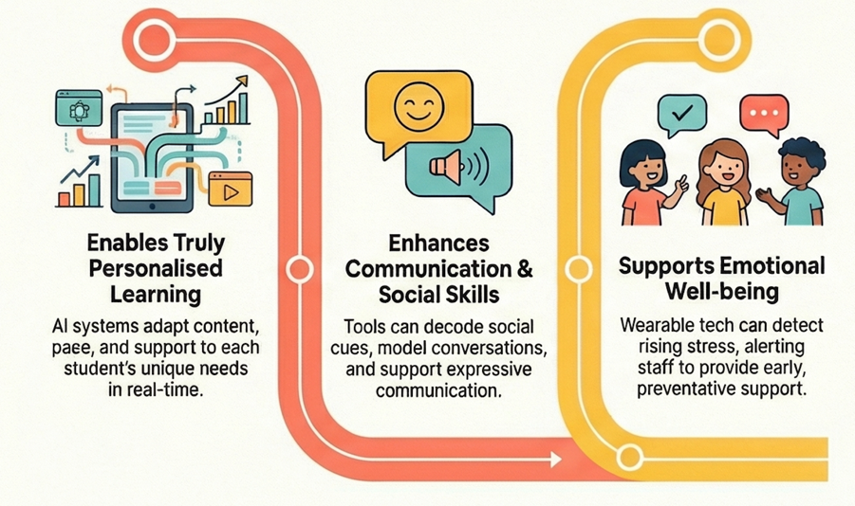

05 Research Validation and Analysis
Validation: Research validation ensures that findings are credible and reliable. The CRAAP test (Currency, Relevance, Authority, Accuracy, Purpose) was applied to appraise sources, prioritizing recent, methodologically robust studies from reputable institutions to ensure high-quality evidence (Teesside University, n.d.).
Analysis: Thematic analysis was used to interpret the data. Following Braun and Clarke’s (2006) framework, literature was coded inductively. Patterns across the 42 sources were grouped into three dominant themes:
- Personalised Learning.
- Communication and Social Development.
- Implementation and Ethical Challenges.

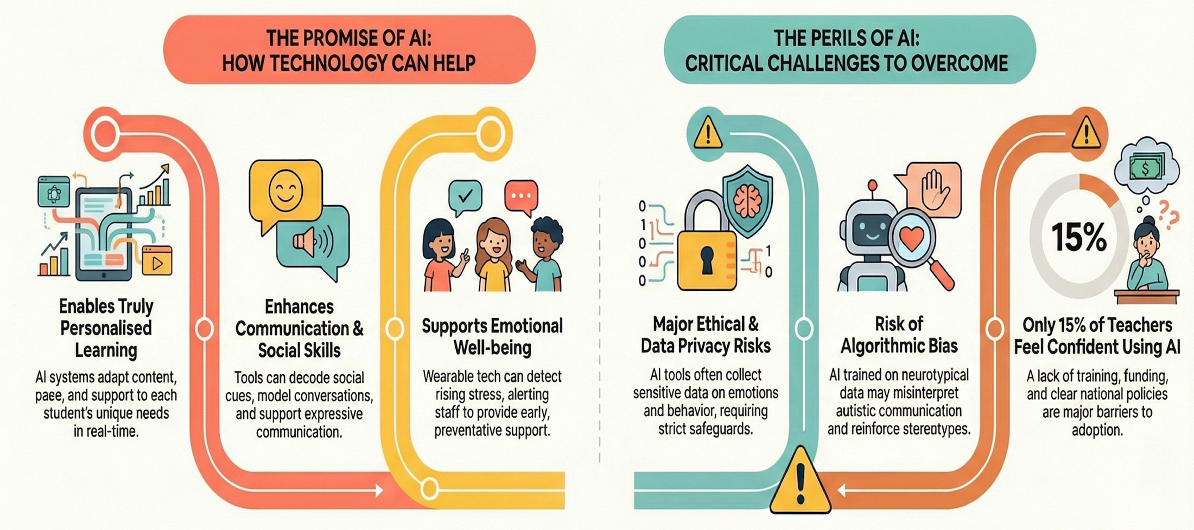

06 Inclusion Criteria  • Peer-reviewed journal articles and systematic reviews.  • UK government and reputable NGO reports (e.g., Department for Education).  • Published between 2015–2025 to ensure currency.  • Direct focus on AI or assistive technologies for autistic children in mainstream/inclusive education. | 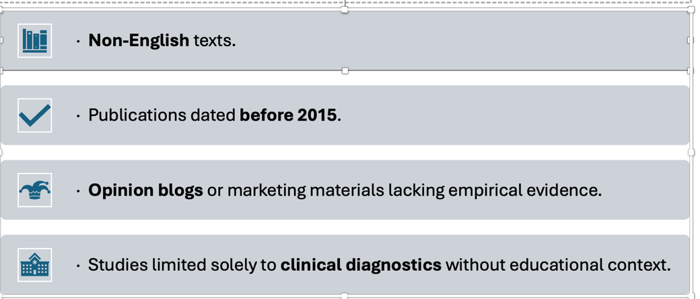  07 Exclusion Criteria  .

08 Ethical Considerations
Ethics in secondary research involves the responsible use of existing data. As no primary data collection took place, formal ethical approval was not required; however, rigour was maintained by:



References
Braun, V. and Clarke, V. (2006) ‘Using thematic analysis in psychology’, Qualitative Research in Psychology, 3(2), pp. 77–101.
Li, G., Smith, J., Ahmed, R. and Thompson, P. (2024) ‘Teachers’ experiences of AI in education’, BMC Psychology, 12, pp. 1–14.
Paré, G. and Kitsiou, S. (2017) ‘Methods for literature reviews’, in Lau, F. and Kuziemsky, C. (eds.) Handbook of eHealth Evaluation. Victoria: University of Victoria.
Snyder, H. (2019) ‘Literature review as a research methodology’, Journal of Business Research, 104, pp. 333–339.
Teesside University Library (no date) Secondary research–research methods. Available at: https://libguides.tees.ac.uk(Accessed: 16 November 2025).

