Yazdan Hossaini - 1809843

Fine Art

Ways of perceiving (ADAD4010)

Historical and contextual studies (contextual practices)

1575 words

The purpose of this assignment is to create a metaphorical art exhibition of my own. Throughout the assignment I will expand on my metaphorical art exhibition and describe it in further details. I will also include anyone or anything that has influenced me in my metaphorical art exhibition along with appropriate references. While expanding on my art exhibition I will also touch upon theoretical and historical perspectives which fit well with my art exhibition. There will be a structure set out throughout the assignment and a structure in place on the art exhibition. I will keep this assignment visually pleasing by adding photos which are relevant to my work. It is also important to note that my metaphorical art exhibition will be backed up by research practices and approaches which are relevant to art and design.
When I picture creating my own art exhibition, I picture a big open space with clean fresh white walls. I would like to have different art sections, I would like one section to be wildlife paintings, one section to be nature paintings and within the nature section I would like art focused on the four different seasons so Summer, Winter, Autumn and spring art, one section to be portraits of people and I would like the art to range from portraits of children to elderly and finally I would like to dedicate one section to up and coming artists to help them gain experience and get their work showed and their name heard and art work seen.
When thinking about the venue my art exhibition would be held. I think about a large venue, nice and open space. I do not want a small and over crowded space. I picture my space to be very well lit, calm and structured extremely well. It is important for me for the art exhibition to be organised, clean and run efficiently. The colour of the walls is also important for me, I want plain white painted walls as I believe this will allow the art to be seen better, no colour to take away the details of the art being shown. Below is a picture of an art exhibition which matches my metaphorical art exhibition.
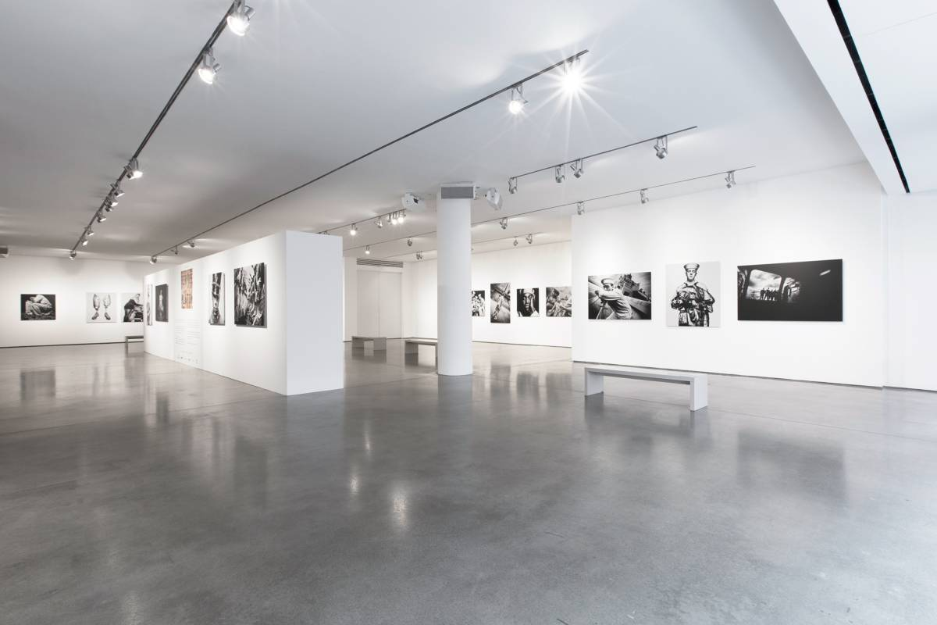(Google.com, 2019)

One of the most famous Art Exhibitions was the primary structures 1966 created by Kynaston McShine (Wallace, 2014). Below is a photo of Kynaston Mcshine’s art exhibition.
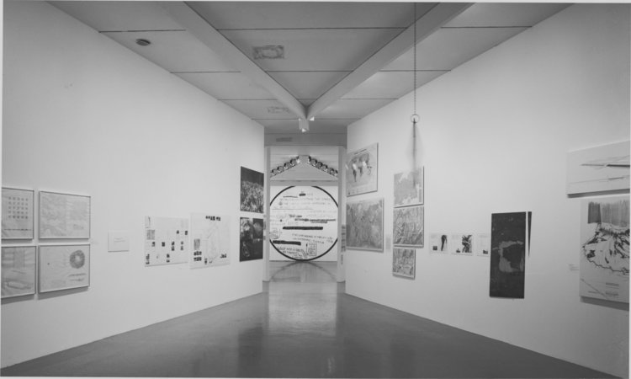
(Google.com, 2019)
Upon examining the photo, you can see that he also chose his walls to be white. This inspired me to choose white for my walls. White makes spaces look and feel bigger, this will help open the space of the art exhibition, and it also helps keep the space bright by optimizing natural light in the room. Also, white is the perfect canvas for any colour and décor which makes it perfect for an art exhibition as the art hanging on the walls will have so many different colours, so the white will not clash and not take anything away from the art on display (realliving.com.ph, 2019).
It is important to note that Primary Structures 1966 changed the course of contemporary art. Also, while looking into the history of art exhibitions white was not always the first choice for exhibitions. According to Zimmerman, 2019 the historical preferences before the growth of modernism in the late 19th century, exhibition walls were usually decorative, golden rooms with deep coloured walls or heavily wall papered walls. These background walls were made to keep up with the art being produced at the time. However, through the rise of modernism, the way art was displayed underwent momentous changes. Modern artists trialled new ways of seeing art and new ways to present art exhibitions. Through modern artists trialling new ways to present art, galleries and exhibitions were adapted in line with new art, materials and ideas that were being explored in the modern society. This is then when white became the new colour for presenting art, it is now considered an effective way of creating a pure space, and a void-like atmosphere. Zimmerman then goes on to explain how this allowed people to experience the art without having extra distractions from a busy background. Carrier, 1987 also states that when the display of art in exhibitions changed it was hard to remember how it was previously displayed because the new display of white walls under arterial lighting was a lot better and it focused on the art more, which drew more attention to detail. Looking at modern art display art is placed in a visually neutral setting, an example of this would be art work taken from temples, churches or mosques and then they are set where they will be contemplated aesthetically. The exhibition will then arrange the art work chronologically and segregates objects of aesthetic interest from precious natural things, living and stuffed animals. The assumption of this being done is that work is being shown over importance and not religion, which can become an assumption that money making has become more important in the world of art exhibitions rather than the actual art work and importance. Which leads me back to my art exhibitions, I would not follow the contemporary assumption made by Carrier 1987, as I do not want money to overrule my passion for art, I want my art exhibition to shine on the hard work artists have put into their work, and I do not want the beauty of the art work to be overrun by the power of money. Of course when creating an art exhibition it is created primarily to display art and sell art, and you need to display it in an appealing way for potential customers, but I also think it is paramount to stick to your beliefs, it is important to find a middle ground of making money from the art exhibitions for yourself, staff and artists selling their work, but it is also important not to allow money to overtake your passion.
It is also extremely important to ensure all guests and potential customers in my art exhibition are comfortable, if they are not comfortable then they will not stay long, they will leave, they may not buy any art. If this happens not only am I letting myself down, but I am also letting the artist showing their work down. Schoutens 2007 says that in order to value any art on display in an art exhibition then guests need the right environment to thrive, they need to be able to think, remember and dream. And sometimes art exhibitions can be seen quite negative because they can become overcrowded and over bearing, there is art displayed on top of each other without enough space between them which takes the attention to detail away from each individual piece of art work. Therefore, I want a large open space, which is well lit, and a nice room as stated before when speaking about my art exhibition. Also, to make guests more comfortable I would like to have a bar where guests can purchase drinks and light snacks, the drinks can be alcoholic, non-alcoholic or simply water. I would only stick to light snacks such as toasties, sandwiches, finger food, snacks such as crisps, fruit and vegetables because if guests have a heavy meal it can make them feel sleepy which could distract them from the displayed art. Also, I would like to place a suggestion box in my art exhibition, so guests can write down any suggestions they feel can be useful for my next exhibition as there is always positive criticism to take away from any project you create, and I also think it is important for guests to feel like they have a say as a guest and a potential paying customer of art work.
Overall, it is clear to see that for my art exhibition I would choose to stay on the more modern art route in displaying art, but the focus on money in today’s modern art would be the only thing I would not be fixated on. As I have previously stated I know I would need to make money, to ensure staff were paid, my expenses covered and artists are actually selling work, so it would be important to me, but I would not allow guests and potential customers to feel uncomfortable due to the pressures of money. I will aim to always put my artists, guests, customers and staff’s needs first in hopes of having a happy and successful art exhibition at the end of it all.
References
Carrier, D. (1987). The Display of Art: An Historical Perspective. Leonardo, 20(1), p.83.
Google.com. (2019). Kynaston Mcshine art exhibition - Google Search. [online] Available at: https://www.google.com/search?q=Kynaston+Mcshine+art+exhibition&rlz=1C1GCEA_enGB821GB821&source=lnms&tbm=isch&sa=X&ved=0ahUKEwjR_fG02cbhAhWoUhUIHTACD2kQ_AUIDygC&biw=1422&bih=678#imgrc=IuBP5M1aP8OenM: [Accessed 10 Apr. 2019].
Google.com. (2019). large art exhibitions - Google Search. [online] Available at: https://www.google.com/search?q=large+art+exhibitions&rlz=1C1GCEA_enGB821GB821&source=lnms&tbm=isch&sa=X&ved=0ahUKEwijnaXR9qXhAhXuSxUIHQDnAuYQ_AUIDygC&biw=1280&bih=610#imgrc=1ykFkCEqVNGmQM: [Accessed 28 Mar. 2019].
realliving.com.ph. (2019). 7 Benefits Of Having All-White Walls. [online] Available at: https://www.realliving.com.ph/home-improvement/building-renovating/7-benefits-of-having-all-white-walls-a00170-20161027 [Accessed 28 Mar. 2019].
Schoutens, E. (2007). Narrative Theories and Learning in Contemporary Art Museums: A Theoretical Exploration - Stedelijk Studies. [online] Stedelijk Studies. Available at: https://stedelijkstudies.com/journal/narrative-theories-learning-contemporary-art-museums-theoretical-exploration/ [Accessed 14 Apr. 2019].
Wallace, I. (2014). 10 Exhibitions That Changed the Course of Contemporary Art. [online] Artspace. Available at: https://www.artspace.com/magazine/art_101/art_market/10_exhibitions_that_have_changed_the_course_of_contemporary_art-52142 [Accessed 28 Mar. 2019].
Zimmerman (2019). Zimmerman Art Gallery - Why do galleries have white walls?. [online] Zimmerman.co.nz. Available at: http://www.zimmerman.co.nz/insider-info/44-why-do-galleries-have-white-walls [Accessed 28 Mar. 2019].

