Student id: 2009466 Gabriel Ciprian Muntean

Lecturer: Dr Ze Zook

LCBB4004 Marketing Fundamentals Assessment 2
Marketing is a social and managerial process with the help of which individuals fulfil and satisfy their needs and wants through creating and exchanging value with others and developing a long-term bond or relationship (Kotler and Armstrong, 2016). The main goals of marketing are to attract customers by promising superior value and later build a long-term profitable relationship by providing superior value and delivering satisfaction. Todays’ marketing plays a major role as it has now become a part of life and enrich the customers’ experience with different brands. Besides, companies also recognise that only ensuring customer satisfaction and wellbeing is not enough, other members are also stakeholders and their wellbeing and engagement need to be ensured that’s companies are nowadays focusing more on responsible and sustainable marketing where these stakeholders’ engagement is playing a significant role. This write-up has been tried to find out the role of marketing in creating value for customers and how stakeholder engagement impacts on marketing activities of an organisation.
Marketing itself a process that works toward creating value for customers and this value is also known as customers’ perceived value as customers perceive value through differentiating its perceived benefits and costs for a product or service (Kotler and Keller, 2016). Marketing plays a major role in creating value for customers and also capturing value from customers through its marketing process which is widely used by different organisations in different spectrum to create value.
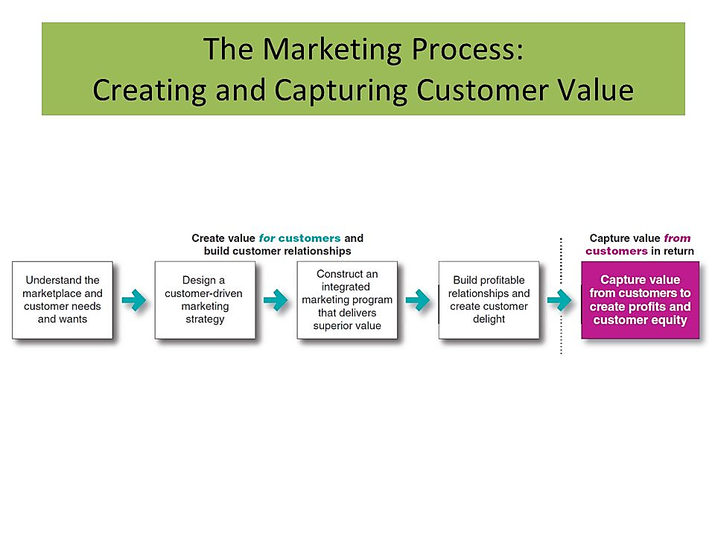
Figure 1: Marketing Process for Creating and Capturing Value (Kotler and Armstrong, 2016).
In the 1st phase of this process, marketers try to identify customers’ needs and want so that they can come with market offerings which are the combination of product, service, information, and experience to meet customers’ needs and wants which in return creates value for customers (Grönroos, 2017). But this offering can also be a person, place, idea, or anything just like as UK’s government is offering the idea “Road Safety- Your road, your safety, your responsibility” for promoting safe driving to mitigate road accidents. Such type of idea is creating value in terms of saving their life through promoting and implementing this idea with the help of various campaigns (Lo, 2012). Customers have many options to choose from to satisfy their needs and to get value and that’s why companies nowadays not only provide offerings but also creating a brand experience so that customers can get extra and get involved themselves with the brand. For example, when anyone visits Walt Disney they not only visit the place they also live with it as they feel that they are in a magical world and their imagination comes true and this is what Disney has created which customers consider as value and they choose to go there over other places (Kotler and Armstrong, 2016). But this value creation and marketing occurs when the target audience decides to satisfy their needs with a particular offering through an exchange relationship and marketing is consists of several activities to create, maintain, and grow expected exchange relationships with its target audiences by relentlessly offering superior value (Webster, 2012). Marketers do search for buyers to engage them, identify their needs, satisfy these needs by designing suitable offering, set prices for these offerings, promote them, deliver them, and do more research for further development of the offerings just like as Nike which identifies that everyone has an athletic spirit in their self so it has designed it shoes, set price, and promote its products to attract these buyers and they are still coming up with new features with the help of R&D and Nike is doing all of these to create value for customers and to build a sustainable relationship (Troise and Camilleri, 2021).
When marketers develop a full understanding of customers and the marketplace then they can easily develop customer value-driven marketing strategies where they select the customers that they want to serve and the way of serving these customers with a value proposition.
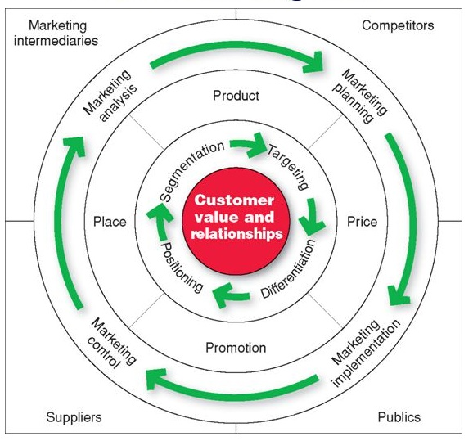
Figure 2: Managing Marketing Strategies and the Marketing Mix for Value Creation (Kotler and Armstrong, 2016).
The companies at first select their customers through segmentation whom they want to serve and then they do decide the specific segment through target marketing because no companies can satisfy the needs and create value for every type of customer and it is not profitable at all to target all of the segments (Grönroos, 2017). That’s why Rolls-Royce Motor Cars Ltd selects only the very exclusive target market as its offering is too expensive and everyone can’t afford and it has designed each car uniquely and in limited addition which increased its value among customers as they can enjoy premium and unique service with a high-quality product that uplifts their social status. But most of the companies add more segments after successfully conquering that market just like Nike has done, even though it first served the market of serious runners, it is now serving different athletes as well. After targeting the segment, companies then decide how it will create differentiation and positioning to stand out in the marketplace so that they can attract their targeted customers and to ensure that companies create a value proposition for their different brands which is nothing but the set of values or benefits that companies promise to provide its customers through its offerings (Webster, 2012). Such as BMW promises “the ultimate driving machine” for keeping this promise and to create differentiation it designs its car with innovation and new technology to ensure a high-quality driving experience and this promise they’ve positioned in the mind of customers so customers who seek the value of high performing driving experience they prefer BMW (Jakhar, 2016). Moreover, at this stage companies also decides which philosophy it will follow to engage its target customers, stakeholders, and to build a profitable relationship with the customers and most of the companies nowadays shifting their philosophies from marketing to societal marketing concept to become more responsible towards its customers and the society where it belongs to(Kotler and Keller, 2016) Through societal marketing, British Airways is now ensuring customers ' long-term needs and social interests through its sustainable activities like mitigating CO₂ emissions and introducing more eco-friendly fleets and fuel sourcing which is enhancing the condition for future generations to have a better environment.
The marketers develop an integrated marketing plan and program to deliver the actual value to their target customers and this program develops customer relationships through converting the strategies into action with the help of a marketing mix (Weinstein, 2010). Just like Primark which is a fast-fashion retailer which offers fashion wear to accessories for those who want to adorn themselves with trendy kinds of stuff but at a reasonable price. So to target this cost-conscious but fashion seeker customers it has designed its clothes with the idea of latest trends and sets its price lower than its competitors which have created price competitiveness and also met the expected price of the customers. Moreover, it locates its stores on the roadside with a huge outlet that can attract its customers and accommodate both its huge range of products and customers and it promotes its different offers and offerings by focusing on its cost friendliness and a large collection of fashion wears and accessories to attract its customers (Dimyati, 2018). These all are happening in an integrated way to deliver its core message and its value to its target customers.
Marketers try to build up a long-term profitable relationship with their customers by providing superior value and satisfaction and this is based on customers’ perceived value about the company’s offering. Besides the extent to which the perceived performance of a product or service matches with customers' expectations ensures satisfaction (Emery, 2012). Both perceived value and satisfaction ensure long-term relationships and that’s why companies like Ritz-Carlton is providing their service in such a way that gives the essence of personalized marketing as this hotel take care of the small needs of the customers from their past stayover and ensure to fulfill these needs before asking in the next stay over which drives the customer happy and they perceive the service valuable and satisfactory in exchange of the high price that they pay for. Companies either try to build basic relationships with their customers or to create full partnerships with their key customers, just like Ritz Carlton has developed (Kotler and Armstrong, 2016). But many companies use specific marketing tools like frequency or loyalty program to create a strong bond with their customers and this is seen in easyJets’ Flight Club program where it provides specific discount and other facilities to its frequent customers and their relatives or friends and such type of programs make the customers feel more valued and connected with the companies that drive them to return to this company. Companies are also do customer engagement through their social media platforms and community where customers engage themselves in the content of the companies and they also share their thoughts and develop a community that makes the brand more meaningful to customers (Webster, 2012). Persil detergent has launched its “dirt is good” project for children where they can participate in tree plantation to playing games and their these stories are uploaded in Persil’s YouTube, Instagram, and Facebook pages which let others talk about and share with others and make them be engaged with a brand other than only buying it. Moreover, many customers also can share their stories regarding their experience of dirt removal or why dirt is good which creates user-generated content and ensures credibility among other target customers. So marketing is creating value for customers in each phase and the process ensures this value creation which is playing a significant role.
There are two types of stakeholders one is a primary and another one is a secondary stakeholder. Customers, suppliers, shareholders, employees, regulators, and the community is considered as primary stakeholders whereas special interest groups, trade associations, competitors, mass media, and social media is considered as secondary stakeholders. Depending on the industry and environmental interests, multiple stakeholders can include both primary and secondary stakeholders (Hillebrand, Driessen, and Koll, 2015). Nowadays companies are becoming more responsible towards the society, environment, and the people of this society who are greatly impacted by the activities of the companies Besides, companies also recognise that if stakeholders engage in business activities including marketing it results in a better outcome in creating and implementing marketing strategies and that’s why recently the concept of stakeholder has emerged where it recognises that along with that customer relationship may be influenced by the stakeholders as it provides a vast network with value (Wright, 2010). Sustainable marketing, societal marketing, and responsible marketing have emerged from the concern of and the engagement of the stakeholders. This stakeholder engagement has a great impact on marketing activities and they can engage in the marketing activities in many ways as there are many types of stakeholder engagement that exert influence (Jakhar, 2016).
Stakeholder Influence | Engagement Type
Stakeholder Influence | Communicate /  Disclose | Consult | Participate | Partner/ Negotiate | Empower
Figure 3: Types of Stakeholder Engagement (Hult, Mena, Ferrell, and Ferrell, 2011)
Communicate/ Disclose: The companies just maintain a one-way communication by letting them know about the new practices or development that can affect them or may impact society or the environment. P&G communicates with its shareholders through mail, newsletter, conference, and publishing reports that as a result creates trust and transparency that hold the willingness of the stakeholders to participate in the activities of the organization (Troise and Camilleri, 2021).
Consult: Companies like Nestle ask for the consultancy and sharing perspective of the shareholders to decide whether they should run their specific campaigns or not and whether it has any negative impact on the society or environment. Stakeholders then provide feedback regarding this which may or may not be considered but stakeholders feel valued as they are asked to provide advice and feedback. With the Stakeholder Community survey, Nestle surveys the world’s opinion leaders for taking feedback regarding their business and marketing activities, and such stakeholder consultancy forces Nestle to use water responsibly under the CDP index (Nestlé, 2021).
Participate: Companies lets the stakeholders participate in decision making and these decisions are sometimes carried out by the company or the stakeholders like government, policymakers, trade unions, etc. to modify or implement any regulations relating to business and marketing activities such practice is seen in Unilever. This can be done through advisory panels, leadership boards, focus group discussion, and research and analysis (Weinstein, 2010).
Partner/ Negotiate: Stakeholders and companies collaborate to achieve a mutual interest which brings synergy and also reduces risks of losing resources and areas of expertise as they are combined. A negotiated resolution often enables businesses and stakeholders to reach a mutually acceptable decision, and it may be necessary in some cases where an agreement is required to continue operations (Hult, Mena, Ferrell, and Ferrell, 2011). Virgin Atlantic Airways has made a partnership with Save the Children to ensure emergency food and necessary supports for the underprivileged children and such type of partnership helps Virgin Atlantic to operate its responsible marketing (Dimyati, 2018).
Empower: Here stakeholders are given power and legal responsibility to authorise company decision making or corporate governance through whistleblowing, warranty, or representation of Stakeholders in the board of directors. Such type of engagement is not profoundly seen in any companies (Murphy et al., 2005).
Sustainable marketing calls for socially and environmentally responsible marketing that meet or fulfil the current need of the customers and society but also meet the ability of the future generation to fulfil their need that means it fulfils the future need (Emery, 2012). Stakeholders often engage in and raise issues in marketing activities which has lead companies to improve or modify their offerings or to shift their focus from harmful to a healthy one. Nestle has been criticized by its external stakeholders for gearing up obesity by producing fatty foods, draining aquifers, and bombarding the environment with its plastic packaging. Such criticism has made Nestle take into account these issues and they have now launched Nestle Net Zero Roadmap where it addresses eight key topics including climate change, biodiversity, water, responsible sourcing, nutrition, breast milk substitution, Nestlé needs YOUth, and sustainability promise and commitments (Nestlé, 2021). All of them are now looked after with the discussion and advice of stakeholders. Moreover, stakeholders often raise voice if any marketing action like content of advertising or sourcing of the product goes against the community or environment which is seen in the case of Nestle’s KitKat brand which was forced to stop promote its pump oil ingredient as the supplier was involved in deforestation. Besides, both internal and external stakeholders of the airline industry criticised airline companies for damaging the environment with carbon and greenhouse gas emissions and they demand more eco-friendly products and carbon emission reduction and also for responsible marketing where they’ll showcase their environment friendly and socially responsible activities (Hillebrand, Driessen, and Koll, 2015). As a result airlines like British Airways, Virgin Atlantic, and easyJet have undertaken both sustainable and responsible marketing programs and they’ve already modified most of the fleets which reduces carbon emission to almost zero level and have shifted to alternative sources of fuel that cause almost no harm to the environment . The same sorts of criticism and pressure have been raised in the automobile industry for promoting cars that cause carbon emissions and this criticism has led to the invention of the electric car which not only reduce carbon emission but also prevent road accident that will ensure road safety and such type of invention in product development has been possible for the stakeholders’ engagement (Troise and Camilleri, 2021). For being too much sugary drink, carbonated beverage industry also faces challenges and criticism from both customers and other stakeholders which has led the companies like Coca-Cola and Pepsi to develop sugar-free drink which causes less harm. Moreover, they are also actively participating in social welfare-related projects that resemble their responsible behaviour (Dimyati, 2018). Plastic packaging and promoting fast foods are always been questioned for being irresponsible towards the environment and as a result company like Starbucks and Nike has omitted plastic packaging and embrace eco-friendly packaging and McDonald is developing and promoting more healthy foods and these all are happening just because of the engagement of the stakeholders in the marketing activities (Grönroos, 2017).
.

Marketing is a continuous process that creates and delivers value and build long term profitable relationship with customers and it plays a major role in value creation (Kotler and Keller, 2016). From the understanding of the marketplace to creating a profitable relationship, each phase of the marketing process creates value for customers. Besides companies have recognised the importance of stakeholder engagement in decision making and strategy implementation as it minimises risk and ensures more value creation. This engagement affects the marketing activities and different types of stakeholder engagement have influenced the sustainable marketing of the companies and lead the companies to take decisions and implement their strategies.

Reference
- Dimyati, M., 2018. The role of customer satisfaction in mediating marketing communication effect on customer loyalty. Journal of Arts Science & Commerce. 4(1), pp.75-87.
- Emery, B., 2012. Sustainable marketing. 1st ed. Harlow, England: Pearson, pp.22-28.
- Grönroos, C., 2017. On Value and Value Creation in Service: A Management Perspective. Journal of Creating Value, 3(2), pp.125-141.
- Hillebrand, B., Driessen, P. and Koll, O., 2015. Stakeholder marketing: theoretical foundations and required capabilities. Journal of the Academy of Marketing Science, 43(4), pp.411-428.
- Hult, G., Mena, J., Ferrell, O. and Ferrell, L., 2011. Stakeholder marketing: a definition and conceptual framework. AMS Review, 1(1), pp.44-65.
- Jakhar, S., 2016. Stakeholder Engagement and Environmental Practice Adoption: The Mediating Role of Process Management Practices. Sustainable Development, 25(1), pp.92-110.
- Kotler, P. and Armstrong, G., 2016. Principles of marketing. 16th ed. Pearson, pp.29-45, 74-78.
- Kotler, P. and Keller, K., 2016. Marketing management. 15th ed. Pearson, pp.565-575.
- Lo, S., 2012. A study of relationship marketing on customer satisfaction. Journal of Social Sciences, 8(1), pp.91-94.
- Murphy, B., Maguiness, P., Pescott, C., Wislang, S., Ma, J. and Wang, R., 2005. Stakeholder perceptions presage holistic stakeholder relationship marketing performance. European Journal of Marketing, 39(9/10), pp.1049-1059.
- Nestlé, 2021. Creating Shared Value and Sustainability Report 2020. [online] nestle.com, pp.1-23. Available at: <https://www.nestle.com/sites/default/files/2021-03/creating-shared-value-report-2020-en.pdf> [Accessed 23 April 2021].
- Troise, C. and Camilleri, M., 2021. The Use of Digital Media for Marketing, CSR Communication and Stakeholder Engagement. Strategic Corporate Communication in the Digital Age, pp.161-174.
- Webster, F., 2012. The Changing Role of Marketing in the Corporation. Journal of Marketing, 56(4), pp.1-17.
- Weinstein, A., 2010. Designing and delivering superior customer value: concepts, cases, and applications. CRC press, pp.38-42.
- Wright, C., 2010. Stakeholder marketing. London: BPP Learning Media Ltd., pp.35-46.

