An Analysis of the Factors Impacting the Body Shop

Student name: Ileana Ionita
Student ID: 2310530
Module code: BMSW4014

Contents
1. Introduction 1
2. Findings 2
2.1. PESTLE Analysis, Advantages and Disadvantages 2
2.2. PESTLE Analysis of the Factors Influencing the Body Shop 2
2.3. Stakeholder Analysis, Advantages and Disadvantages 4
2.4. Stakeholder Analysis of the Body Shop 4
3. Conclusion 5
4. Recommendations 6
References 7

Introduction
A well-known global beauty and cosmetics brand, The Body Shop was proved in Brighton, UK, in 1976 and its owner is Dame Anita Roddick. It is renowned for its emphasis on natural ingredients and ethical principles (The Body Shop, 2024a). In Europe, the Africa, Asia Pacific region and Middle East region, there are almost 2,500 retail locations spread over more than 80 countries. The Body Shop runs in 70 different countries (The Body Shop, 2018) (Figure 1). The SWOT (Strengths, Weaknesses, Opportunities and Threats) analysis of the body shop company revealed its strong brand value which is related to ethics and natural positioning in the marketplace; however, the stagnant innovation and failure of the company to satisfy customer demands have affected the brand position. Although it could expand its business in other countries; however, it could experience competition from its competitors, Lush, L'Occitane, Boots and Superdrug (Bhasin, 2024 and Jordan, 2024).
Based on the above facts, the report aims to analyse the factors affecting the Body Shop Company through PESTLE analysis involving Political, Economic, Social, Technological, Legal and Environmental analysis followed by Stakeholder analysis.
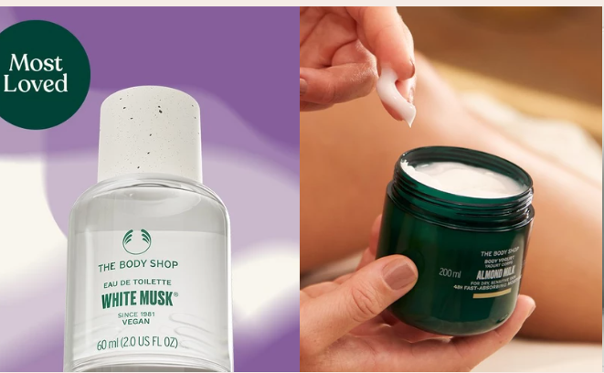
Figure 1: The Body Shop Company Brands (The Body Shop, 2018)

Findings

PESTLE Analysis, Advantages and Disadvantages
A tool for finding the external factors that may have an influence on an organisation’s performance is known as PESTLE analysis. Organisations can find their strengths and weaknesses for a SWOT analysis with the support of PESTLE analysis. Additionally, it can help firms in planning and developing methods for mitigating risks (CIPD, 2019). Concerning the advantages of PESTLE Analysis, Dalirazar and Sabzi (2020, p. 180) proved that businesses can develop marketing plans with the support of PESTLE analysis by finding target markets, efficient marketing channels, the most effective times for communicating messages, and conversion goals. However, a disadvantage of PESTLE Analysis is that it does not consider the internal competencies of the company which are significant for sustainable competitive advantage and depends on subjective assessment of broad external trends. In addition, Font-Cot et al. (2024, p. 4173) said that PESTLE analysis is static because the dynamic and ever-changing characteristics of corporate environments may not be sufficiently represented.

PESTLE Analysis of the Factors Influencing the Body Shop

Political Factors
Concerning the political factors affecting the Body Shop Company, Oboolo (2023) showed that due to The Body Shop’s global reach, consistency at this level is essential to reassuring its customers worldwide completely and to continuing the discussions.
Brexit negatively affected many businesses, including The Body Shop, especially in England. The company intended to move some of its operations to Germany, where there are expected redundancies within the group due to the country’s improved political environment. The Body Shop’s business operations were additionally significantly affected by the conflict in Ukraine, as the company stopped its relationships with Russia.

Economic Factors
The United Kingdom had seven months of double-digit inflation between September of year 2022 and March of year 2023, with a highest of 11.1% in the month October of 2022 (Statista, 2024) (Figure 2). In this context, Wearden, Davies, and Elliott (2024) illustrated that high inflation and recession reduced the spending of consumers on beauty products of the company. Furthermore, the fluctuating rates of the currency due to unstable economic circumstances influenced the import and export costs of the products.
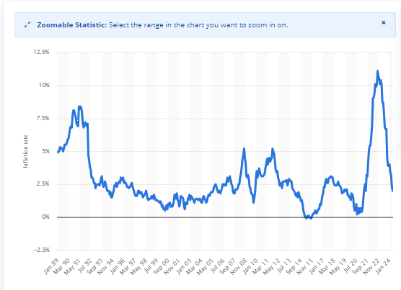
Figure 2: Inflation in the United Kingdom (UK) (Statista, 2024)

Social Factors
The Body Shop company focuses more on the ethical values that correlate with its customers in terms of ranking customer support and opposing animal testing for their products. In this context, the customers have become more concerned with the company as societal trends have changed towards vegan, organic and natural products which are driven by environmental protection and the welfare of animals (Oboolo, 2023).

Technological Factors
Although the company struggled to embrace online marketing and electronic commerce (e-commerce) websites initially as compared to its competitors due to the changes in customer preferences of online social media platforms, the Body Shop company shows its commitment to data-driven and e-commerce strategies (KPS, 2022).

Legal Factors
The Body Shop Company strongly prohibits the use of forced, bonded, or involuntary prison labour, as well as any other type of involuntary labour. Employees are allowed to select their employment opportunities, and suppliers are not allowed to use any kind of coercion to force them to work above their designated hours (The Body Shop, 2024c).

Environmental Factors
In 2021, the carbon dioxide (CO₂) emissions of the company were 5,338 tons of CO₂ equivalent (tCO₂e) due to which the company committed to reduce the emission for which they utilized business vehicles and backup energy sources, heating and cooling the stores, and reducing power purchases to zero by 2030. In 2022, their emissions from these sources decreased by 3,713 tons tCO2e (The Body Shop, 2022).

Stakeholder Analysis, Advantages and Disadvantages
The process of finding and evaluating the significance of important people, teams, or divisions that could have significant effects on how the business runs is known as stakeholder analysis (Gregory et al., 2020, p. 321). Considering the advantages and disadvantages of stakeholder analysis, Schaltegger, Hörisch and Freeman (2019, p. 192) reported that stakeholder mapping helps decide where to concentrate efforts and potential problems that might occur while interacting with specific people or groups. Understanding who matters is always beneficial when making right decisions and proving reasonable expectations for the future. However, stakeholder analysis has a disadvantage in that it requires judgment to assess each stakeholder’s level of power and interest, which occasionally results in the exclusion of important stakeholders (Kujala et al., 2022, p. 1136).

Stakeholder Analysis of the Body Shop
The key stakeholders of the Body Shop company are mentioned below in detail:

Internal Stakeholders

Employees
A motivated and engaged workforce is significant for the company’s operations as the uncertainties affect their morale and productivity. In this context, Union (2024) proved that the Body Shop UK had 2568 employees and 10,000 employees in different countries. However, due to administration, 2000 jobs are at risk of redundancy. Concerning these facts, the company must involve its employees through internal communication to share the company vision, in devising plans and making strategies for the company.

External Stakeholders

Customers
Customers are significant for generating revenues and profits for the Body Shop company. In this context, the younger audience of the company has become conscious of innovative products while sustaining ethics for which the company must innovate their products as per consumers’ demand while taking into consideration the ethical aspects of the products (Font-Cot et al., 2024, p. 4173).

Suppliers
The Body Shop company source their products’ ingredients ethically from farming communities across the world (The Body Shop, 2024a). However, as per Butler and Davies (2024), the company has recently experienced financial troubles as the company entered administration when HSBC stopped its credit line and its new owner, Aurelius, was unable to obtain new capital. The company is making efforts to revive its supplier partnership through auditing suppliers and negotiating bulk raw material contracts to develop a reliable sourcing network.

Owners
The ownership of the Body Shop company has changed from L'Oreal to private equity firms have negatively affected the strategic decision of the company. In this context, each new owner has their business priorities which clash with the founding business ethos at that time (Two Birds, 2024). At present, the company has been owned by Natura & Co. since 2017 whose mission is aligned with the Body Shop; however, further alliance with purpose-driven strategies will develop a strong relationship between the brand and the ownership (James, 2023).

Competitors
The preferences of the consumers have been modifying after COVID-19 in terms of ethics and sustainability for which the company is required to maintain its competitive advantage over its competitors through the utilization of digital marketing, identification of weaknesses and innovation of its products ethically (Font-Cot et al., 2024, p. 4173).

Conclusion
In conclusion, the Body Shop company experiences challenges from the external environment since factors such as Brexit, inflation, and ownership changes might significantly affect its growth trajectory. However, there are chances to enter new markets and complement products with the increasing significance of ethical products. Active participation can help in addressing issues and regaining ground missed through community organisation, networking, and digital change. Enhancing customer service while helping suppliers and employees will develop relationships. It is recommended to restore growth by using the parent company's competitive criteria and communication. Adopting innovations with a sustainability focus can help inventive leaders as important assets.

Recommendations
The research of Barbara Monahan FAIBF (2024) recommended that the Body Shop should concentrate on developing innovative, ethical products that are committed to producing revolutionary products for morally conscious consumer segments. It will be able to appeal to younger consumers and increase its brand positioning as a result. Furthermore, Jordan (2024) recommended that setting app an internal conversation with business leaders from several departments could help in the production of ideas for a comprehensive brand makeover. The work culture of The Body Shop can also be regenerated by strong internal operations.

References
Barbara Monahan FAIBF. (2024) ‘Exploring the Decline of The Body Shop: A Customer and Creative Perspective’, [online] Linkedin.com. Available at: https://www.linkedin.com/pulse/exploring-decline-body-shop-customer-creative-barbara-monahan-faibf-c3noe [Accessed 5 Jul. 2024].
Bhasin, H. (2024) ‘SWOT analysis of The Body Shop (Updated 2024)’, [online] Marketing91. Available at: https://www.marketing91.com/swot-analysis-of-the-body-shop [Accessed 5 Jul. 2024].
Butler, S. and Davies, R. (2024) ‘The Body Shop collapses into administration in UK’, [online] the Guardian. Available at: https://www.theguardian.com/business/2024/feb/13/the-body-shop-collapses-into-administration-in-uk [Accessed 5 Jul. 2024].
CIPD. (2019) ‘CIPD | PESTLE analysis’, [online] Available at: https://www.cipd.org/en/knowledge/factsheets/pestle-analysis-factsheet/ [Accessed 5 Jul. 2024].
Dalirazar, S. and Sabzi, Z. (2023) ‘Strategic analysis of barriers and solutions to development of sustainable buildings using PESTLE technique’, International Journal of Construction Management, 23(1), pp.167-181.
Font-Cot, F., Lara-Navarra, P., Serradell-López, E. and Manetti, A. (2024) ‘Design-driven external analysis: A framework for adaptation and innovation in digitally native enterprises’, Journal of Infrastructure, Policy, and Development, 8(6), p.4173.
Gregory, A.J., Atkins, J.P., Midgley, G. and Hodgson, A.M. (2020) ‘Stakeholder identification and engagement in problem structuring interventions’, European journal of operational research, 283(1), pp.321-340.
James, D. (2023) ‘Natura & Co considers selling The Body Shop’, [online] Retail Dive. Available at: https://www.retaildive.com/news/the-body-shop-considers-sale-natura/691991/ [Accessed 5 Jul. 2024].
Jordan, D. (2024) ‘The Body Shop: What went wrong for the trailblazing chain’, [online] Bbc.com. Available at: https://www.bbc.com/news/business-68273425 [Accessed 5 Jul. 2024].
KPS. (2022) ‘The Body Shop’, [online] Available at: https://kps.com/uk/en/insights/industries/references/the-body-shop-global-ecommerce.html [Accessed 5 Jul. 2024].
Kujala, J., Sachs, S., Leinonen, H., Heikkinen, A. and Laude, D. (2022) ‘Stakeholder engagement: Past, present, and future’, Business & Society, 61(5), pp.1136-1196.
Oboolo. (2023) ‘The Body Shop - example of a PESTEL Analysis, environment factors’, [online] Available at: https://www.oboolo.com/blog/our-tips/pestel-analysis-the-body-shop-07-09-2023.html [Accessed 5 Jul. 2024].
Schaltegger, S., Hörisch, J. and Freeman, R.E. (2019) ‘Business cases for sustainability: A stakeholder theory perspective’, Organization & Environment, 32(3), pp.191-212.
Statista. (2024) ‘UK inflation rate 2024 | Statista’, [online] Available at: https://www.statista.com/statistics/306648/inflation-rate-consumer-price-index-cpi-united-kingdom-uk/ [Accessed 5 Jul. 2024].
The Body Shop. (2018) ‘About Us-The Body Shop’, [online] Available at: https://careers.thebodyshop.com/content/About-Us-The-Body-Shop/?locale=en_US [Accessed 5 Jul. 2024].
The Body Shop. (2022) ‘Sustainability Report’, Available At: https://www.thebodyshop.gr/media/files/The_Body_Shop_Sustainability_Report_2022.pdf. Accessed On: 5th July 2024
The Body Shop. (2024a) ‘The Body Shop®’, [online] Available at: https://www.thebodyshop.com/en-gb/ [Accessed 5 Jul. 2024].
The Body Shop. (2024b) ‘Our Values’, [online] Available at: https://www.thebodyshop.com/en-gb/about-us/brand-values/a/a00006 [Accessed 5 Jul. 2024].
The Body Shop. (2024c) ‘The Body Shop - Global Supplier Code of Conduct’, Available At: https://www.thebodyshop.com/legal/coc_supplier.pdf. Accessed On: 5th July 2024
Two Birds. (2024) ‘The Future of The Body Shop and its International Franchisee Network’, [online] Available at: https://www.twobirds.com/en/insights/2024/global/the-future-of-the-body-shop-and-its-international-franchisee-network [Accessed 5 Jul. 2024].
Union, W. (2024) ‘The Body Shop UK Faces Uncertain Future: 2000 Jobs at Risk’, [online] The Workers Union. Available at: https://www.theworkersunion.com/2024/02/14/the-body-shop-uk-faces-uncertain-future-2000-jobs-at-risk/ [Accessed 5 Jul. 2024].
Wearden, G., Davies, R. and Elliott, L. (2024) ‘The Body Shop UK falls into administration; UK wage growth and US inflation hit rate cut hopes – as it happened’, [online] the Guardian. Available at: https://www.theguardian.com/business/live/2024/feb/13/uk-pay-growth-slows-employment-unemployment-us-inflation-business-live [Accessed 5 Jul. 2024].

