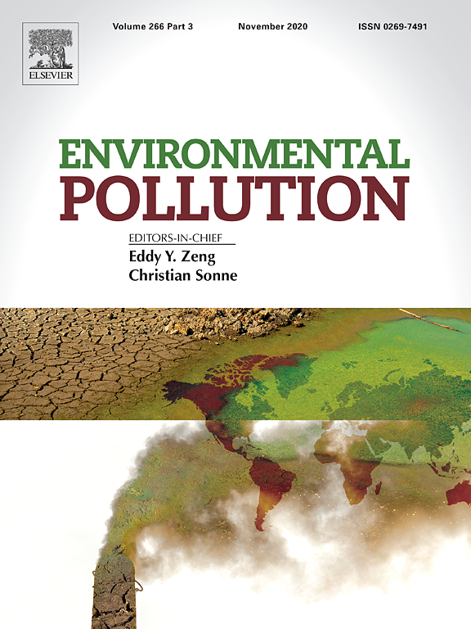

Environmental Pollution
Professor C. Sonne, E. Zeng, (2020)
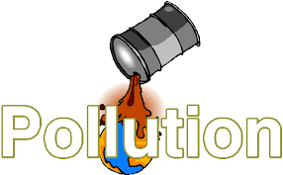Distinctiveness and Regeneration
Jenna Jackson:1907875
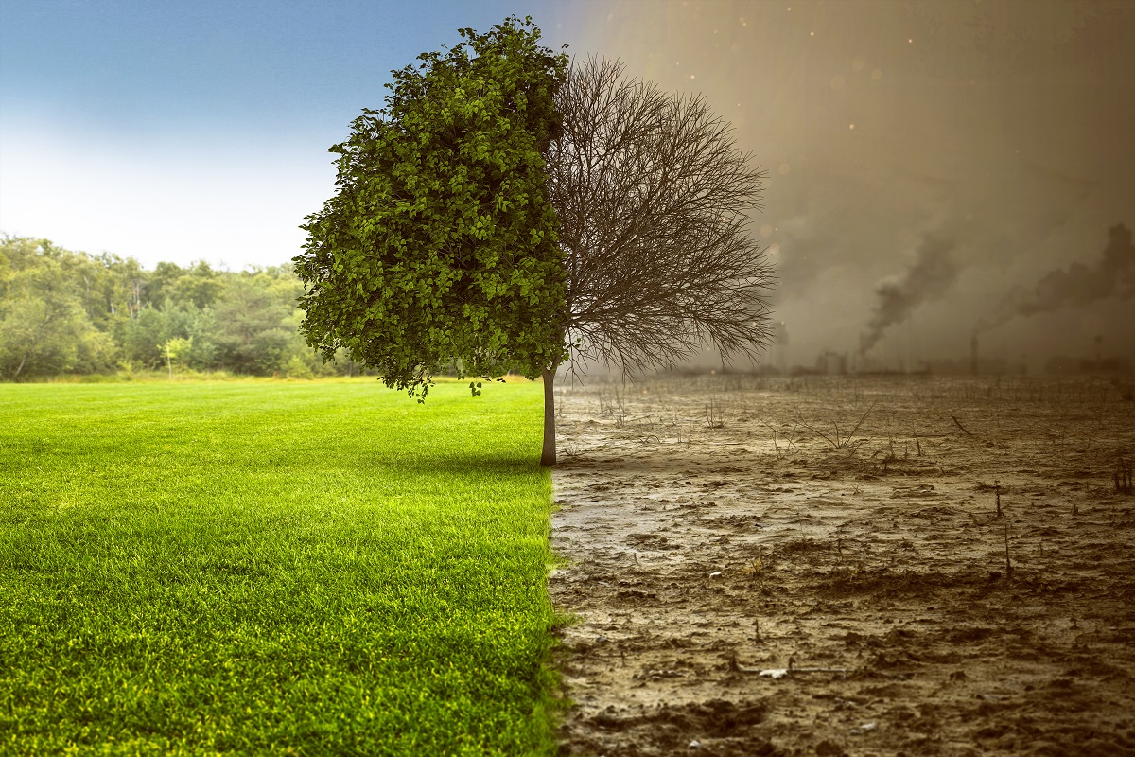
The global risk report, Brende (2020) presents the major risks that the world will be facing this coming year. Brende, (2020) stresses that multi stakeholders' main approaches to addressing the world's greatest challenges, the focus is for a cohesive and to create a more sustainable world. My chosen topic is pollution as this is having a massive effect on our global warming. The Pollution is the introduction of harmful materials that is put into the environment. These harmful materials are called pollutants. There are many types of pollution such as air pollution, water pollution, noise pollution and landfill pollution etc. The problem of pollution is one of the most serious problems facing by human society, which is increasing rapidly. The main reason for this terrible problem has increased the use of industrialization, deforestation, urbanization and the natural substance of contaminating our natural resources. It is no secret that climate change is one of the biggest challenges our world face’s today. In the Global Risk Report, (2016), the failure to mitigate the effects of climate change as well as related risks such as water crises, food security and extreme weather events which is dominated the list mentioned of major threats. There are many important key factors of the effect's pollution is having on us human's health as well as our planets natural resources. Pollution is one of the biggest global killers, affecting over 100 million people. That’s comparable to global diseases such as Malaria and HIV. The three major types of pollution are air pollution, water pollution, and land pollution.

Water pollution
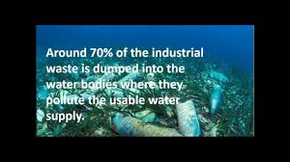
M. Denchak, (2018)

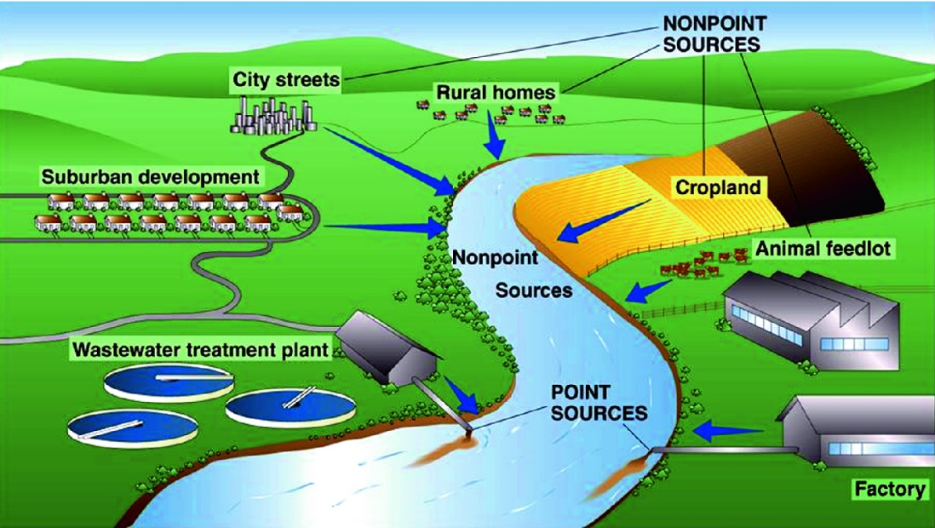
Breaban, (2019)

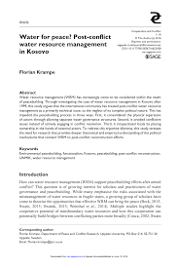
water pollution resource management: by Harlan, April 15, (2016
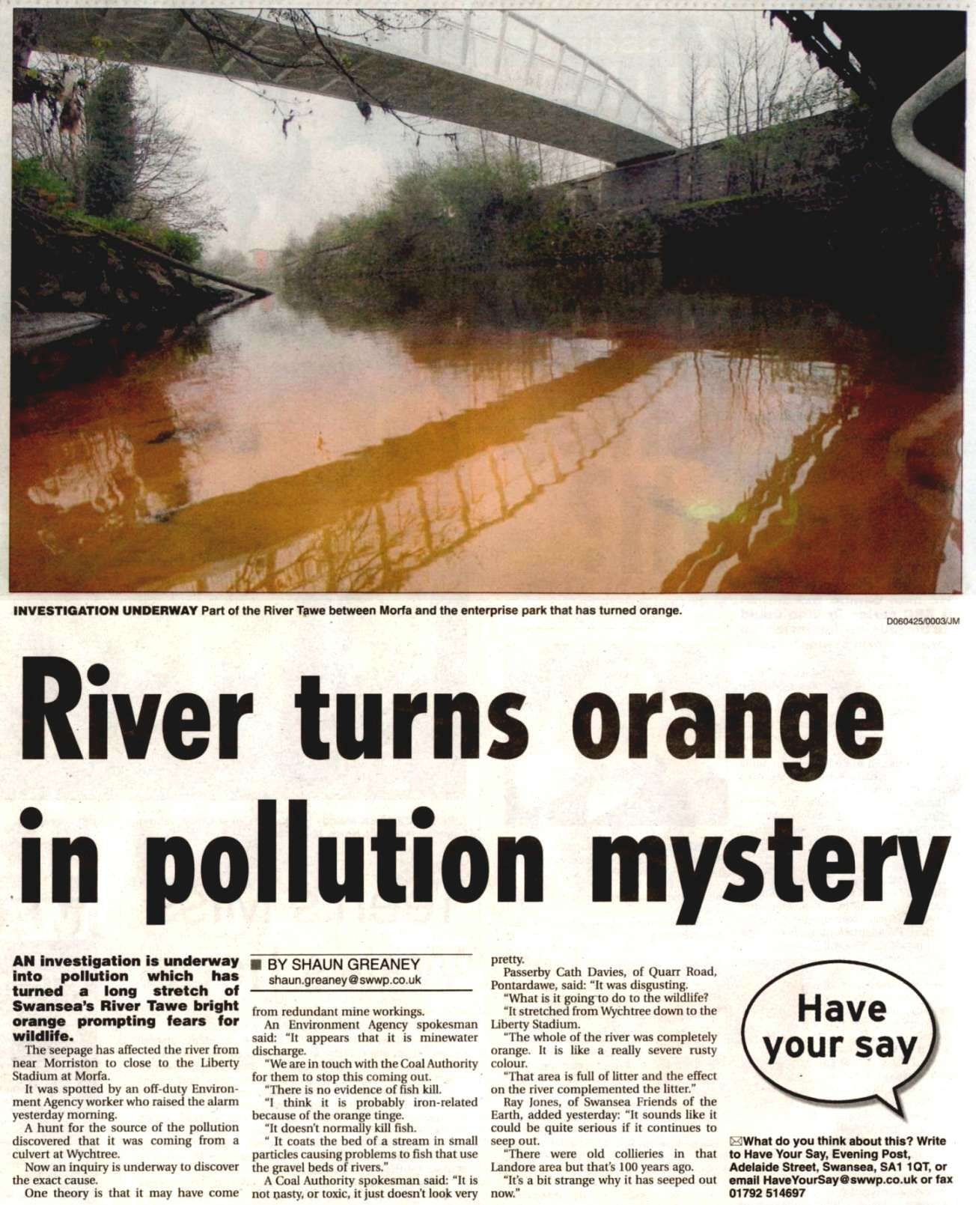
Zhang, (2015)

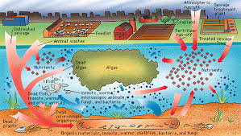
Professor Grigg, (2017) is the world's class expert on water infrastructure, he argues in favour of science-to-practice the approach to integrated water resources management (IWRM0. He reminds us that our water supply is our highest priority service and that the lack of safe drinking water is the most pressing water issue globally. Water managers can promote good water governance by effective management with stakeholders. The integration begins when the water and water waste are operated as one utility. The management of water systems requires sound decisions. Access to water is essential and is also a basic human right, so paying for services is also essential, according to the water acts a connector for security, for food production, environment, economy and health.
Water pollution occurs when harmful substances more often chemicals or microorganisms which contaminate streams, rivers, lakes, and oceans etc. This means that the water quality and rendering it very toxic to humans and the environment. The cause of water pollution is Water that is uniquely vulnerable to pollution. Known as a “universal solvent, toxic chemicals and microorganisms,” water can dissolve more substances than any other liquid on earth. It’s the reason we have Kool-Aid and brilliant blue waterfalls. It’s also why water is so easily polluted. Toxic substances from farms, towns, and factories that are readily dissolve into and mix with it, causing water pollution. The widespread of problems from water pollution is affecting our health massively, as the unsafe water is killing more people each year than war and all other forms of violence combined. But the resources of drinkable water are finite as less than 1 percent of the earth's freshwater is accessible to us. These challenges will only increase by 2050, when the global demand for freshwater that is expected to be a third greater than it is now. To better understand the problem and what we can do about it, states an overview of what water pollution is, and what exactly causes it and how we are able to protect ourselves from this.

Air pollution
Air pollution is the name given for extremely small particles and gases that is released into the air, which can cause harm if you breathe them in. These gases such as nitrogen dioxide, ozone, sulphur dioxide and carbon monoxide which are extremely harmful liquid particles such as dust and soot.
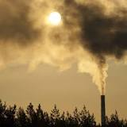
Mackenzie, (2016) states that pollutants can be natural, such as volcanic ash. They can also be created by human activity, such as trash or runoff produced by factories. Pollutants damage the quality of air, Cars release pollutants from their exhaust pipes. Burning coal to create electricity also pollutes the air.
All living things from one-celled microbes to blue whales depend on Earth’s supply of air and water.
Walke, (2016) states that air Pollution is a global problem, air pollution can spread to remote places where no people live. For example, pesticides and other chemicals have been found in the Antarctic ice sheet.
Air winds can pick up radioactive material accidentally released from a nuclear reactor and scatter it around the world. Smoke from a factory in one country drifts into another country.
Industrial Factory pollution
The most common Factory air pollution released are greenhouse gases from the burning of fossil fuels, factories also contribute to land and water pollution by disposals of their toxic waste and chemical spills. Factory’s and industrial companies have caused masses of air pollution by carrying out chemical process and burning fossil fuels effecting the planets ecosystem which has contributed towards climate change by releasing such toxic and dangerous materials into our environment. Global warming is serious as the effect have worsened to rising of sea levels, the raising earths temperatures then causing wildfire also increased floods and hurricanes and natural disasters.
Port Talbot Steel works
Port talbot steel work industries is one of the largest integrated steel production company in the UK located in Port Talbot Wales this large company is known for producing around five million tonnes of steel per year. The health study news Pigott, (2013) states that the air pollution from Tarta steel is having a big impact on its local surroundings and nearby residents who are living close by the health statistics show that the neath and port talbot area records show that the deaths and new cancer patients are above average from the air pollution and masses of dust released and being inhaled from the large steel works by residents living close by. When passing through Port Talbot before reaching there you can smell a very strong putrid smell of sulphur dioxide. When sulphur dioxide is combined with water and air with then forms acid rain which can cause highly affective damage towards pants, deforestation and limestone structures such as brides. Tarta steel industry have commit to make new changes to help cut their dust emissions for their nearby resident's health and they have also spent thousands to do so.
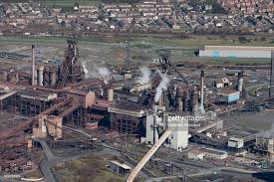
Agricultural Farming pollution
Agricultural and animal farming pollution is the main source of pollution for water rivers, lakes and the environment. The chemicals from the use of fertilizers and pesticides in agricultural farming which flow through our water systems and becomes our own drinking water with these toxins used in the process of farming, such as oil, metal and toxins from the farming machinery, this can cause a lot of health problems for us humans and animals.
Agricultural pollution is caused by different sources, such as potent greenhouse gases that is released into our waterway systems with dangerous pollutants and chemical pesticides varying toxic effects which contaminate our air and water which reside directly to our food and water supply. Methane the big global warming contributor which is released through a cow's digestive Agriculture is divided into two categories which pollution that comes from raising food crops and the other is from raising animals, because of demand for meat, milk eggs and cheese. The effects this pollution is having on animals as they consume parts of crops, parts of plants which is contaminated, and animals can even die from this.
Agriculture farming pollution Contributes to CO2 emissions from burning fossil fuels such as coal, gas and oil, from burning old land waste. when the uncultivated the land or pasture is converted to land. When the soil has been disturbed via ploughing it causes soil bacteria which also releases CO2 and nitrous oxide.
The climate change that we are facing today caused by greenhouse gases will hit the farming industries worse due to changes of rainfall distribution, raising of sea level flooding over farming land, prolonged and more drought and severe weather events which will affect the farming food crops.
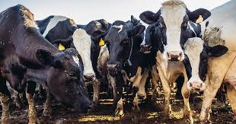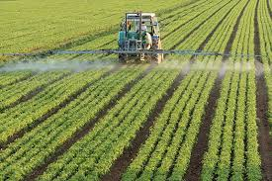
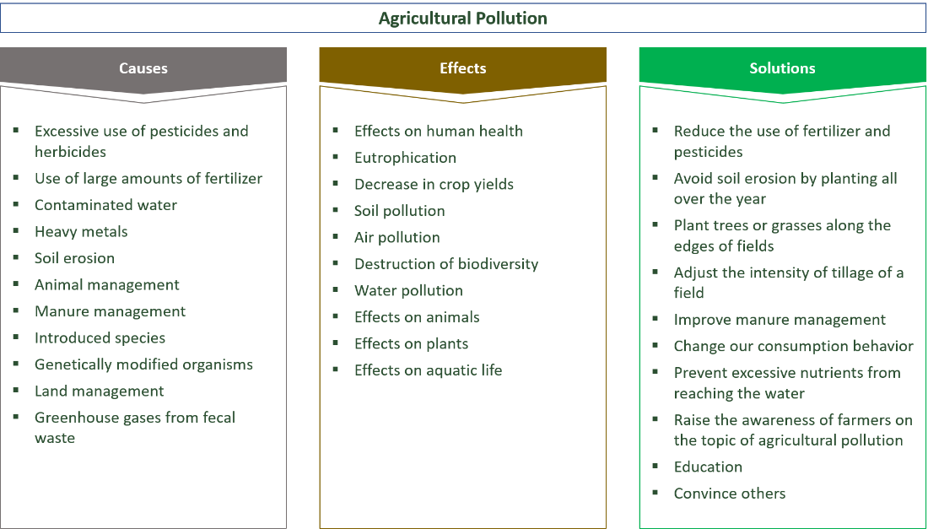
Environmental conscience
Agricultural pollution is defined as the degradation or contamination of the environment through abiotic and biotic by products of farming. For many years, our ancestors did farm in a sustainable way, thus there were almost no problems with agricultural pollution. The use of pesticides and herbicides has become a big problem for our health and environment as pesticides and herbicides contain many chemicals that can impact the ecological system in an adverse manner. This is caused when the crops have been contaminated with these bad chemicals which are eaten by us and can cause us health issues. These chemicals are washed through the soil in the groundwater. In addition, animals will eat part of the crops and plants and are harmed by the chemicals as well.

Landfill pollution
Landfill pollutes the environment mostly by emitting gas consisting of methane and carbon dioxide. They also include small amounts of volatile compounds. The toxic and explosive gases produce an obnoxious smell which move through the ground and air and can congregate through buildings, this is called vapour intrusion. Landfill can produce these gases for around 45 years. This process can cause many health hazards which include breathing difficulties, nausea, headaches and sleeping difficulties and weight loss. Landfills emit, and landfill gas consists mostly of methane and carbon dioxide, with small amounts of volatile organic compounds made up from the bacterial of decomposition from organic materials. Carbon dioxide and methane are both greenhouse gases and methane are highly toxic and explosive in such large concentrations.
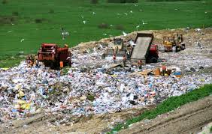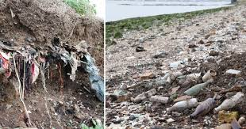
Shapley, (2010)
Landfill Pollution is the introduction of harmful materials into the environment. Landfills collect garbage and other land pollution in a central location. Many places are running out of space for landfills.
Landfills emit landfill gas that consists mostly of methane and carbon dioxide, with small amounts of volatile organic compounds from the bacterial decomposition of organic materials. Methane and carbon dioxide are both greenhouse gases, and methane is toxic and explosive in large concentrations.
Landfill incinerators burn the trash at high temperatures and produce steam to power turbines. There are three incinerators in Illinois. These incinerators reduce the volume of incoming trash by 90% and the weight by 75% these incinerators produce dioxins, from furans and heavy metals such as mercury and lead, sulphur and nitrogen compounds, and particulate matter. When the temperature and air mixture is not optimal, incinerators release products of incomplete combustions, like aldehydes, chlorinated hydrocarbons, polycyclic aromatic hydrocarbons, polychlorinated temperatures and dibenzofurans.
According to Chainey, (2016) the environmental and natural resource security state the next steps of the process which involves turning the leftover carbon into precious jewels. Which means that under 30 minutes of pressure this can be turned into diamonds. The proceeds from the sale of this jewellery will be put towards the installation of more towers.
Plastic is one of the most world's most destructive materials. It's the workhorse of the modern economy, used in the manufacture of numerous products - but the facts are that it's near indestructible means that it's devastating to our environment and simply hard to make plastic go away.

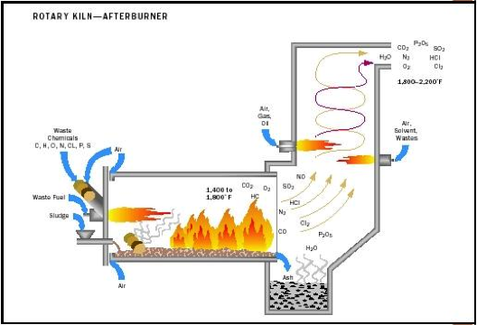
Shapley, (2010)
Air pollution
Air pollution is greenhouse gases which release pollutants into the air and is highly toxic for us humans and our planet these toxins released can lead to a person's death, and long-term health effects which can also occur from air pollution. This includes heart diseases, lung cancer and respiratory diseases such as emphysema. Air pollution can also cause long-term damages to people’s nerves, brain, kidneys, liver and other organs. The cause of most air pollution comes from energy use and production when burning fossil fuels releases gases and chemicals into the air which contributes towards our climate change.
According to the world health organization Hutt & Breene, (2016) they state that air pollution is the fourth largest threat to human health along with dietary risks, high blood pressure and smoking these are health risks from breathing in dirty air which include respiratory infections and cardiovascular diseases, stroke, chronic lung diseases and lung cancer.
Air pollution can be reduced, to help harmful effects our climate change is facing
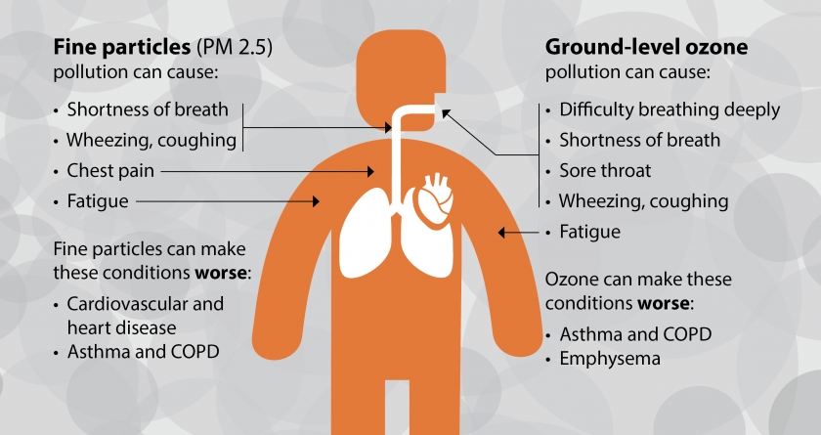
Minnesota pollution control agency: (w016)
Walke, (2016) states When air pollutants such as carbon monoxide, nitrogen oxide and sulphur dioxide these the source of smog and soot are similar they both come from trucks factories, power plants engines which combustion fossil fuels such as gas, coal and gases.
Nunez (2019) explains that greenhouse gases cause climate change by trapping heat which then causes extreme weather and increases wildfires. Greenhouse gases are another source of air pollution. Greenhouse gases such as carbon dioxide and methane occur naturally in the atmosphere. In fact, they are necessary for life on Earth. They absorb sunlight reflected from Earth, preventing it from escaping into space. By trapping heat in the atmosphere, they keep Earth warm enough for people to live. This is called the greenhouse effect.
According to case studies Shaftel, (2020) global warming states that human activity is the root cause of this phenomenon, specifically since the industrial revelation, carbon dioxide water vapour’s are the main greenhouse gas when sunlight.

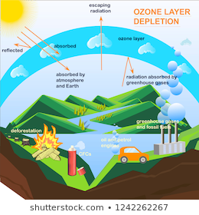
Ozon depletion images

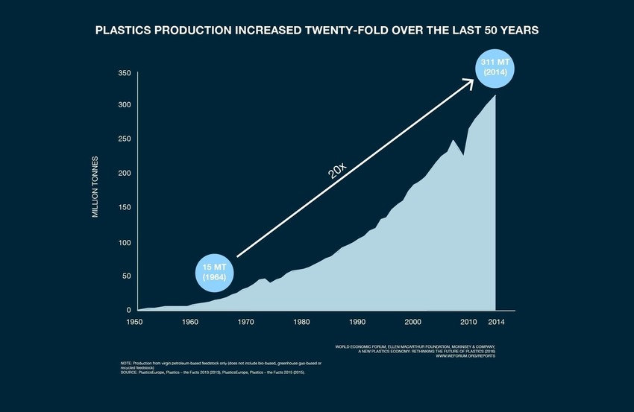
Macmillan, (2016) states because our global warming is at a frightening crisis worldwide with threats of severe weather change as a nation, we are working together to help reduce CO2 emissions by using new energy efficient technology and the use of cleaner fuels, generation cleaner electricity and reducing burning of fossil fuels. Case studies show that earlier this year, we hit the highest levels of atmospheric CO2 in 4 million years, moving past the point where we will ever be able to return to 'safe' levels again. With all this surplus carbon dioxide floating around in our atmosphere, wouldn't it be great if we could turn it back into fuel? Let us wait and see the outcome to help towards global warming.

References

A.Macmillan, (2016) Global warming, Cited online: https://nrd.org/stories/global-warming-101/.com
B. Brende, (2020) Global risk report 2020, cited online: https://webforum.org/reports.com
C. Sonne, (2020) Environmental pollution, cited online: https://journals.elsevier.com/enviromental-board/professor-eddy-zen.com
C. Nenez, (2019) Environment global warming national geographic, cited online: https;//nationalgeographic.com
E. Zeng, (2020) Environmental pollution, Cited online: https://journals.elsevier.com/enviromental-pollution/editional-board/professor-eddy-zen.com
G. Breaban, (2019) Causes and effects of water pollution, cited online: https://link.springer.com
H. Shaftel, (2020) Global climate change, cited online: https://climate.nasa.gov/about-us/.com
J. Mackenzie, (2020) Air pollution everything you need to know, cited online: https://nrdc.org/stories/air-pollution-everything-you-need-know/.com
J. Walke, (2016) Air pollution clean air project, Cited online: https//nrdc.org/stories/air-pollution-eveything-you-need-to-know/.com
J. Harlan, (2016) Water pollution resource management, cited online: https://google.com/search?r12=icichbfengbgb803gb803&source=univ&+bm=ish+g=jessica+harlen+(2016)+facts.com
M. Denchak, (2018) Water pollution everything you need to know, Cited online: https://nrdc.org/stories/water-pollution-everything-you-need-to-know/.com
Neil S. Grigg, (2017) An interdisciplinary approach Water resource system planning and management, Cited by 1394. Online: https://books.google.co.uk/books?hl=en&id/.com
P. Shapley, (2010) University of Illinois, Cited online:// https://butane.chem.vivc,edu/.com
R. Hutt, K. Breene, (2016) Minnesota pollution control, Cited online: https://pca.state.mn.us/air/greenhouse-gas-emissions-data/.com
P. Pigott, (2013) health study on port talbot, Cited online: https://bbc.co.uk/news/uk/wales-south-west-wales-24308823/.com
R. Chainey, (2016) environmental and natural resource security Cited online: https://ozondepletionimages-danylyukk/.com
S. Zhang, (2015) The EPA accidently turned this river toxic and orange, Cited online: https://weired.com?/2015/08/epa-accidentally-turned-river-toxicand-orange/.com

