Using one of the establishments visited how easy is it to gain a sense of what constitutes Welsh culture?

Welsh Identity can be seen throughout Wales and its history. An instance that Welsh culture and identity could be seen was in the February of 1963 when protesters from the Welsh Language Society protested at Pont Trefechan in Aberystwyth. This was to promote the Welsh Language and make sure it doesn’t die out. A language is an important part of any culture and identity, and with people protesting to keep it alive suggests that it is very important part of being Welsh and that it was in danger. It’s now mandatory in school because of the 1993 Welsh Language Act (Mason 2007) that children age between 5-16 has to learn Welsh, even if it is a second language. This shows what is important to the Welsh, and rightfully so the national language is important to the Welsh. Figure one shows how many people within Wales spoke their national language in 1901. In another census in 2001, 21% of the population of Wales could speak Welsh, with lower proportions in the south-east and much higher in the north and west (Mason 2007). You can see a decline in the Welsh Language, in Pembrokeshire at places like St. Catherine’s Fort as information and history of it was in just English. Many places in Wales have a mixture of both English and Welsh, however not here. Furthermore, Tenby is a big tourist spot, and many places is tourism over culture. Places tend to appeal to the tourists, those who most likely can’t speak the native language.
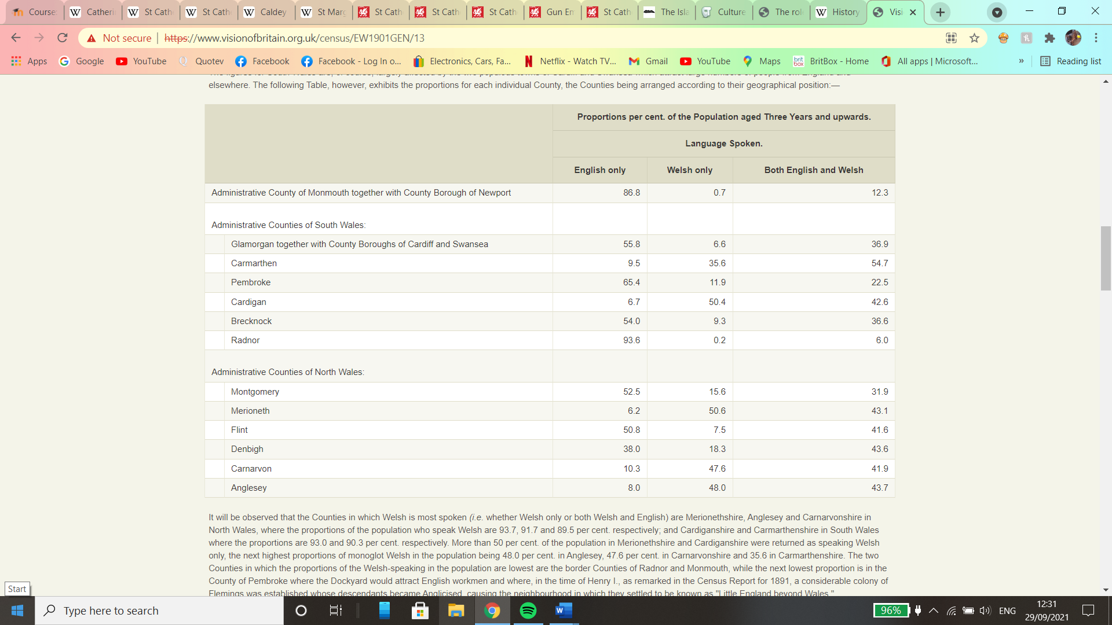
Fig.1 (Table from the 1901 census of the Welsh Language, website link in reference list)

Welsh culture can also be seen in folklore and religion. Folklore is everywhere in Wales, for example the Welsh flag has the dragon on it, this story of the dragon comes from a folk tale in which Vortigern wanted to build his castle on an area of land but was warned by a boy (whom people think was Merlin) that two dragons dwelled beneath it. When construction began on the castle, two dragons were found, a red one and a white one, however they were fighting each other, which concluded in the red dragon win. Christianity became the major religion in Wales in 1534, however you can see many Celtic influences nowadays in crosses, where Celtic knots can be seen on them. In Tenby religion is still present as just off the coast of Tenby on Caldey Island resides Cistercian Monks known as Trappists who took over from the Anglican Benedictine Monks. The island is name Ynys Bŷr which is named after the abbot monk, later named saint, Saint Pyr, it was the Vikings who names the island Kaldey ‘Cold Island’ (Manwaring, 2008). Naming the island after a Welsh abbot, turned saint gives off this idea of Welsh pride and culture. If you compare the name of this island to St. Catherine’s Island which are only a few kilometres away from each other, one is name after a European Saint and the other a Welsh national saint. This suggests that there is an aspect of Welsh identity in Tenby, but this Welshness has been slowly taken over by the foreign, yet widely popular movement of Christianity. This suggests a heavy influence as the island is known as one of Britain’s ‘Holy Island’ and although they are Christian, they still have roots to their Celtic ancestry where they continue traditions that began in Celtic times. This suggests strong links to their heritage and past.

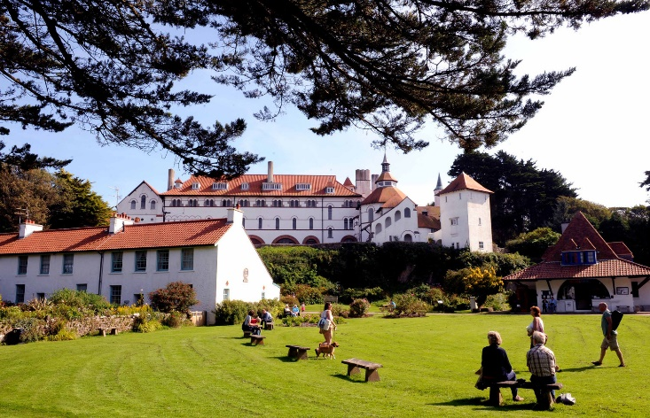
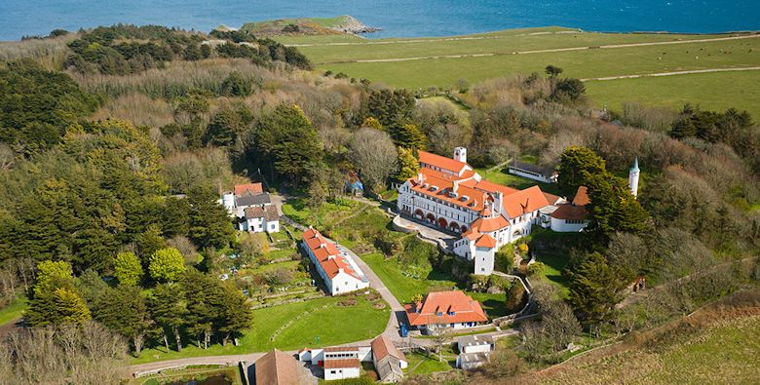
Pictures from- https://caldeyislandwales.com/

St. Catherine’s Fort’s namesake comes from Saint Catherine of Alexandria who was the Patron saint of spinners and weavers. Before the fort was made on the island there was said to be a chapel that was supposedly to the Saint Catherine as this was mentioned in documents of 1525 and 1585 (Coflein). This is clear links to religious purposes just like Caldey Island. Having two sites for religion suggests that Tenby has quite big links to religion. However, in 1868-1871 the chapel had been destroyed for the fort to be built. During the construction of the fort three third century AD Roman coins were discovered (Coflein). This suggests that the island was used before the time of the chapel and suggest Roman presence in Tenby. There are now modern defensive structures on the island such as steel holdfast for 4-inch Mk IX QF gun (Coflein) with the magazine located in pre-existing concrete roofed structure. This shows that the island was used for more recent defensive reasons, and it was briefly used by the army during World War I but was quickly turned into a home by the Windsor Richards family. However, during World War II it was purchased and turned into an anti-aircraft battery. Units from the Royal Marines and other units were garrisoned here. The fort was decommissioned after the war, where it became a Grade 2 listed building because it’s an important naval fort, because of how it was built and where it was built. In 1968 it was turned into a zoo and opened to the public, but the zoo was moved a few years later than eventually became a place where tv shows were filmed and opened to the public to view. Throughout the history of St. Catherine’s Island, the meaning of it constantly changed, with it first being for religious purposes, the being changed to warfare and disuse throughout the rest of its history. The history of St. Catherine’s Island doesn’t scream Welshness in it’s fullest due to the continuous change of this establishment. The beginning of the island was very religious, although not Celtic in its being, as the chapel was to a Christian Saint, lots of Welsh religious places do have Celtic undertones to it, however due to the chapel not surviving today we can not say how Welsh this religious establishment was. Then when it was later turned into a fort, it also does not give off this Welsh identity, even now where it’s a museum of sorts telling you the history of St. Catherine’s all information is in English, not even the Welsh/English information boards you get in many Welsh establishments. This can show a sense of lost identity within this structure, or the idea this fort is catering to tourists, who are most likely non-Welsh speakers. However, you would’ve thought despite that there would be some parts in Welsh.

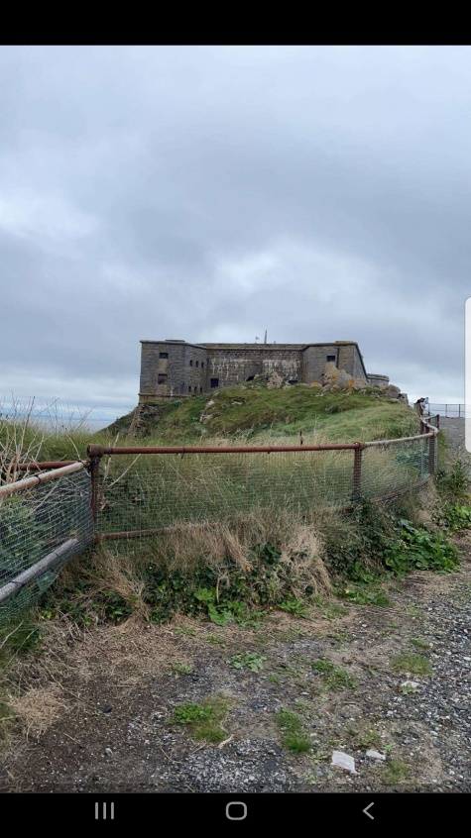
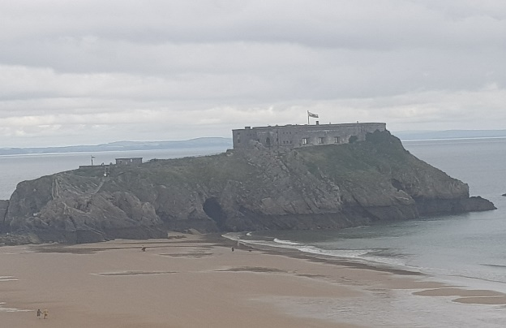
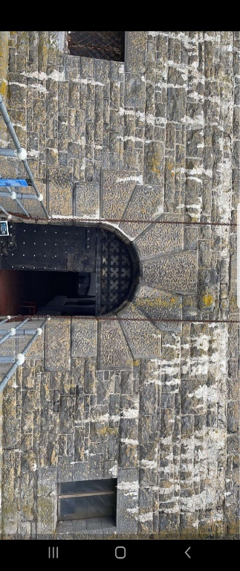
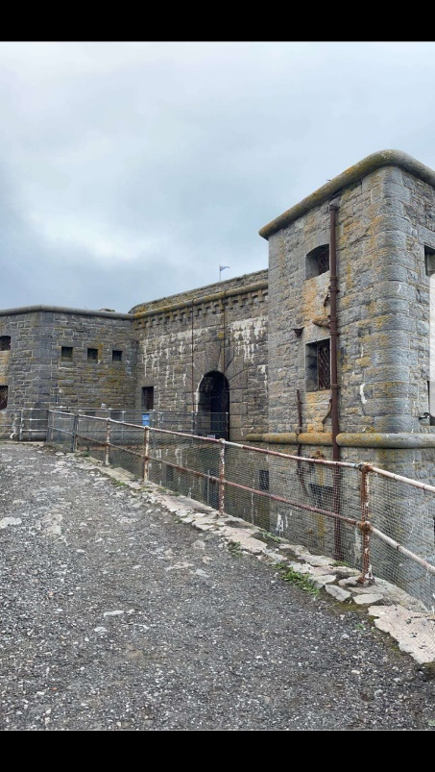

The town of Tenby has lots of history surrounding it, it has remains of defensive structures in and around the town, which suggests this was an area that often-feared war. This can be seen in the Five Arches Gate. These walls were originally built in 1245. They were re-built in 1457 after a period of neglect under Jasper Tudor (uncle of Henry Tudor). Tenby was very important to economically to Wales. Jaspar Tudor added turrets for more defence as this was a bustling trade town and drew in lots of money. Throughout the town you can see multiple defences varying from different periods in time. Which suggests that this was a town that needed protection from invasions and attacks. This is understandable considering it’s positioning as a Harbour town. Its harbour is sheltered from the Atlantic Ocean and the Irish Sea. Furthermore, traders sailed along the coast to Bristol and Ireland and even to France, Spain, and Portugal. They would be exporting wool, coal, iron, and oil. During this period that the town was considered to be a national port as it got busier from traders, either trading in the town or using it as a shelter point. Henry Tudor, sheltered at Tenby during the Wars of the Roses before sailing into exile in 1471. Furthermore, within the town walls you can see a religious aspect to it, as part of the walls have the Christian Cross on it. This could suggest that the town of Tenby are being protected by God, as these walls defensive. This can link with the town of Tenby being very close to religion as it has had many religious buildings linked with it. Furthermore, in the centre of the town there is St. Marys Church which some features date back to the 13th century and most of it dating back to the 15th century. There are 75 bosses carved on the ceiling with many different designs. The most noticeable one is the ‘Green Man’ which links back to folklore to many different to people. The ‘Green Man’ or ‘Jack in the Green’ links to the coming of spring and is celebrated in many folk traditions and is still celebrated today in some towns, such as Hastings. Despite the Green man being part of Folklore it’s still in a religious building which suggests that the Welsh haven’t lost their Folk traditions despite this presence of Christianity.
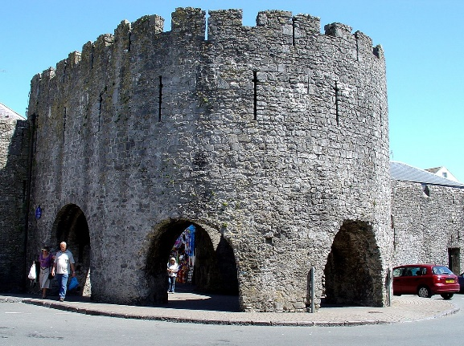
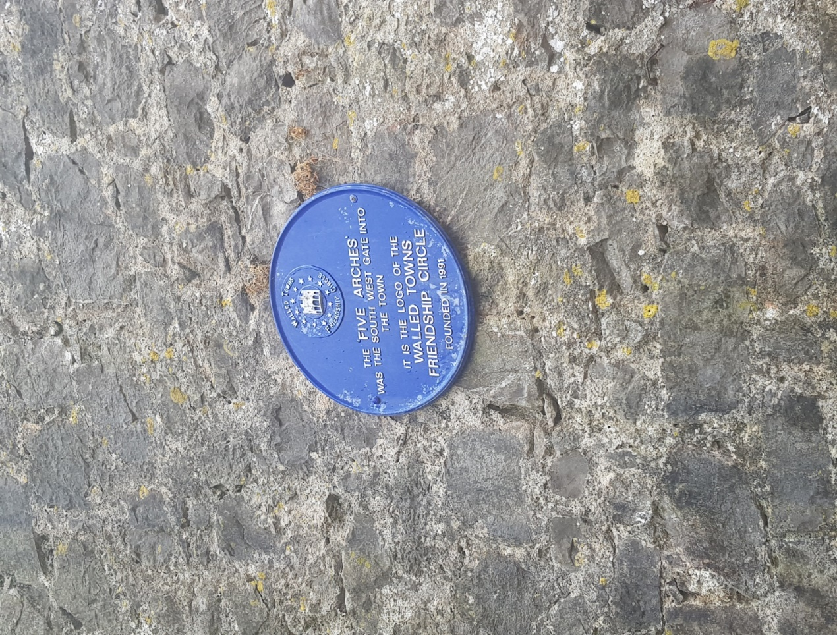
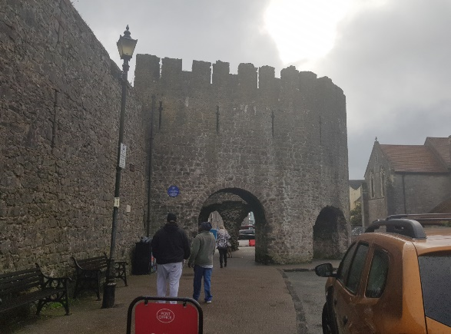
By Aeronian at English Wikipedia, CC BY 2.5, https://commons.wikimedia.org/w/index.php?curid=3098057

Tenby Castle came with the presence of the Normans in the 1100s during their invasion of West Wales. The Castle was captured and destroyed by the Welsh in 1153, and this was by Maredudd ap Gruffydd and Rhys ap Gruffydd who were to be the future rulers within Wales. For the future rulers to reclaim their land from the Normans shows Welsh pride because to be future rulers, nationality is important and for parts of Wales to be taken by the Normans removes the Welsh identity. With the Norman presence alone in Wales is sure to removes parts of Welshness, as we saw this with the Anglo-Saxons in England, and you see this change especially in modern times. The English language is a mixture of French and Latin, which now formed this ‘English’ language, however even though Wales do speak English they still have their own identity because the Welsh language survives, and people still speak it. Language changes over time so it’s obviously not the same but Wales still have their national identity within their language. Furthermore, Tenby was attacked again in 1187 and then in 1260, this was when Llewellyn the Last sacked the town during his campaigns. Most of the town walls were built in the 13th century, to defend the town of Tenby even more from incoming invaders. We are told that ‘the promontory was walled where it faces the town. It is reached by a sloping roadway rising along the southern wall. The much-ruined gate has a D-plan barbican or outwork’ (Coflein) this helps to show us how the defensive this castle would have been and that can tell us Tenby was considered very important. Where Tenby is located is very advantageous as it’s able to be a hub of trade and that was considered to be very important during this time period. Which probably suggests why there’s so much defensive structures, not only is it to solidify someone’s rule over an area, but a place where they are able to defend a town. Welsh identity was very important then as the Welsh fought to keep their lands and protect them from the outsiders. This shows strong Welsh culture that still survives today. Even though this castle was built by the Normans to solidify their position, the Welsh chose to keep the ruined castle here, and that’s to show the strength of the Welsh as they managed to do what the English couldn’t and that was to keep the Normans away. The Normans never really successfully invaded Wales; however, Henry II reached a compromise with Rhys ap Gruffydd for control of part of the south.

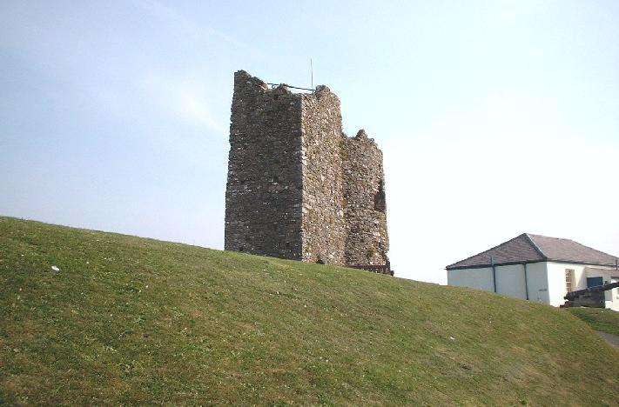
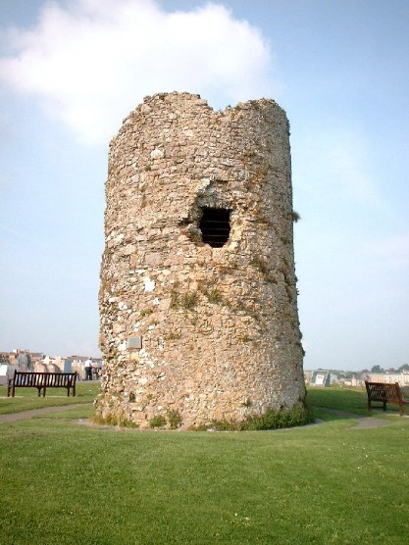
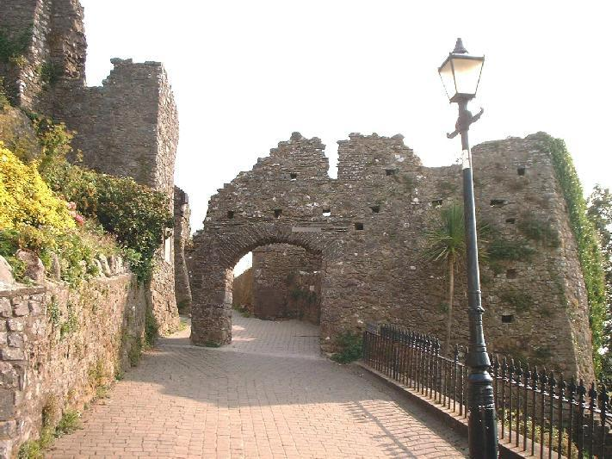
Pictures of Tenby Castle- http://www.castlewales.com/tenby.html

References-

https://www.visionofbritain.org.uk/census/EW1901GEN/13 - 1901 Census of the Welsh Language
Sylvain Scaglia. The role and importance of the Welsh language in Wales’s cultural independence within the United Kingdom. Linguistics. 2012. ffdumas-00719099
Coflein- https://coflein.gov.uk/en/site/127/?term=tenby%20five%20arches – The Five Arches Gate
Coflein- https://coflein.gov.uk/en/site/418975/?term=fort%20st%20Catherine%27s%20 – Chapel St. Catherine’s
Coflein- https://coflein.gov.uk/en/site/92614/?term=tenby – Tenby Castle
Caldey Island- https://caldeyislandwales.com/
Mason, Rhiannon 2007 Museums, nations, identities: Wales and its national museums. Cardiff: University of Wales Press.
Manwaring, Kevan (2008). Lost islands: inventing Avalon, destroying Eden. Heart of Albion.

