DATA HANDLING AND BUSINESS INTELLIGENCE: ANALYSIS OF MOVIE RATINGS, AUDIENCE ENGAGEMENT AND POPULARITY

TABLE OF CONTENTS
1. Introduction 3
2. Data Cleaning and Preparation 3
2.1 Data quality checks 3
2.2 Variables checked 3
2.3 Genre cleaning 4
3. Descriptive Statistics; Data Summary 4
3.1 Numerical variables 4
3.2 Language distribution 5
3.3 Rating distribution 6
4. Trend Analysis and Visualisation 7
5. Statistical Analysis using SPSS 9
5.1 Pearson Correlation 9
5.2 Multiple Linear Regression 11
5.3 Critical interpretation 13
6. Insights and Recommendations 14
7. Conclusion 14
Reference List 15

1. Introduction
The Letterbox Movie Classification Dataset consists of 10,000 movie records, and information related to film characteristics and the opinions and social interactions of viewers. The variables contained in the dataset are: Film_title, Director, Average_rating, Genres, Runtime, Original_language, Watches, Likes, Fans and Total_ratings. The variables are analysed in this report to find patterns in the performance of the movies, the behaviour of the audience and its popularity. Average_rating is the primary metric on which to evaluate a film, while Watches, Likes and Fans are the audience size and engagement metrics. Genres and Original_language offer categorical comparisons, while Runtime provides information on the length of the film. The data cleaning and preparation of the dataset, along with computations of descriptive statistics, examinations of genre and language distributions, and trend visualisations were carried out using the appropriate spreadsheets from the program Excel. Relationships between the variables were then analyzed using SPSS Pearson correlation and multiple linear regression analysis. An analysis should find a meaningful pattern, measure variables that relate to Average_rating, and deliver evidence-supported conclusions and suggestions for decision making in the entertainment and movie industry.

2. Data Cleaning and Preparation

2.1 Data quality checks
Data were first scanned in Excel to judge data quality/susceptibility for statistical analysis. Average rating, Runtime, Watches, Likes, Fans, Genres and Original language were all checked for missing values, records containing the same value twice, zeros, and inconsistencies. There were 10,000 observations in the numerical variables. Variables like Likes, Fans, etc., have zeros and were not automatically regarded as "Missing" as these could be true zero values where a film has not received any likes or it has no known fans (Madongo et al., 2026) . Again unusually high and low values were investigated for the numerical variables. Runtime ranged from 2 to 907 minutes, while Watches ranged from 2 to 5,195,503, Likes from 0 to 2,730,813 and Fans from 0 to 326,000. Large ranges can represent that there are extreme observations that were considered in the analysis.

2.2 Variables checked
The key variables selected for analysis in the preparation process were Average_rating, Runtime, Watches, Likes, Fans, Genres and Original_language. These variables were chosen to correspond directly to the movie ratings, length, popular audience reaction to movie, engagement, and pieces of categorical characteristics needed for the next descriptive and statistical analysis.

2.3 Genre cleaning
The Genres variable was focused on due to the fact that a single film may be classified into numerous Genres. Therefore, due to lack of genre consistency, the genre information was separated and standardised for the purpose of conducting genre level analysis. This allowed films to have more than one genre classification registered, and thus be counted in multiple genres for calculating frequencies, average ratings, watches and likes (Biam et al., 2025). Data preparation was crucial as data that was incomplete, inconsistent or not in the proper structure would alter some of the Descriptive Statistics, the visual trend and the statistical relationships, ultimately decreasing the reliability of the information that would allow making decisions from Business Intelligence.

3. Descriptive Statistics; Data Summary

3.1 Numerical variables
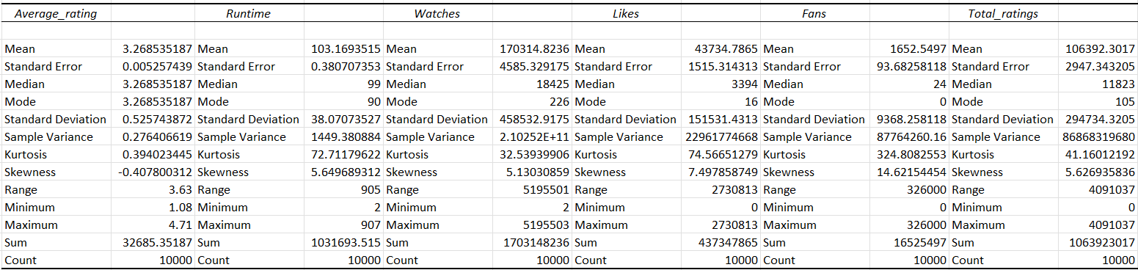
Figure 1: Descriptive statistics
(Source: Self-Created)
For Average_rating, report a mean of 3.2685, median of 3.2685, standard deviation of 0.5257, minimum of 1.08 and maximum of 4.71. The value of skewness ( −0.4078) shows slight negative skew of data; mean equal to median shows it lies around 3.27.
Report the mean, median, standard deviation, minim and max for Runtime: 103.17, 99, 38.07, 2 and 907, respectively. The mean is greater than the median and the skewness is 5.6497, suggesting positive skewness. Also notice the high Kurtosis, k = 72.7118, which indicates that there are extreme observations (O'Keefe-Smith, 2023).
For Watches, the mean is 170,314.8, while the median is only 18,425, with a standard deviation of 458,532.9. This is a great difference between mean and median scores and the skewness value of 5.1303 suggests a highly right-skewed distribution.
For Likes, the mean is 43,734.79, compared with a median of 3,394, and the standard deviation is 151,531.4. There is significant positive skewness with a skewness value of 7.4979. The skewness is asymmetric, with a very large standard deviation and mean of 1,652.55, and a median of just 24. This shows that there is the potential of a significant number of movies with a very low number of fans.
Finally, Total_ratings has a mean of 106,392.3, median of 11,823, standard deviation of 294,734.3 and skewness of 5.6269, again demonstrating considerable positive skewness. As indicated by the much wider spread of the audience-related measures from Average_rating, popularity seems to be concentrated among a smaller number of movies (Benitez et al., 2025).

3.2 Language distribution
The findings reveal that the language totally dominates with 8,074 films, which is 80.7%. Italian accounts for 396 films (4.0%), Japanese for 308 (3.1%), French for 291 (2.9%), Korean for 145 (1.5%), Spanish for 115 (1.2%), German for 96 (1.0%), no spoken language for 94 (0.9%), Chinese for 66 (0.7%) and Danish for 60 (0.6%). As seen in figure 2, the language distribution was highly uneven with English by far the largest language group.

3.3 Rating distribution
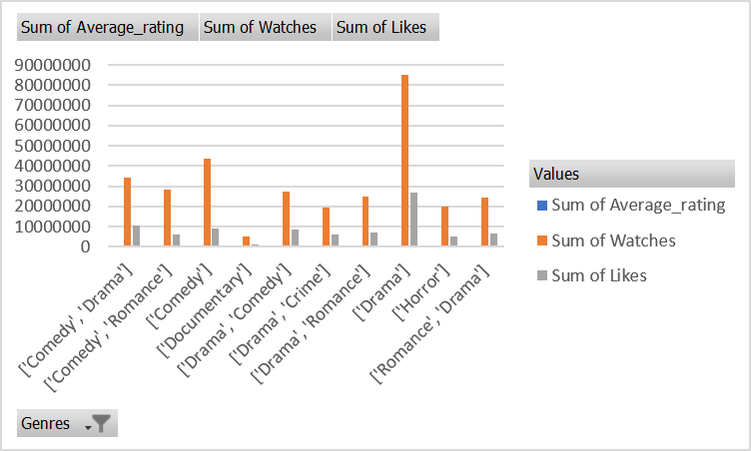
Figure 2: Top 10 movie genre by average rating
(Source: Self-Created)
For the numerical results, Average_rating is found to be 3.2685, with a standard deviation of 0.5257, and range of data from 1.08 to 4.71, a mean, and median of 3.2685. It has a skewness of −0.4078, which indicates a slight negative skew. Describe, using the real histogram, the distribution of observations around the central rating or over the range of ratings available (Badeji and Omotunwase, 2026). Don't assume the distribution is normal unless the shape of the histogram is strongly indicative of that.

4. Trend Analysis and Visualisation
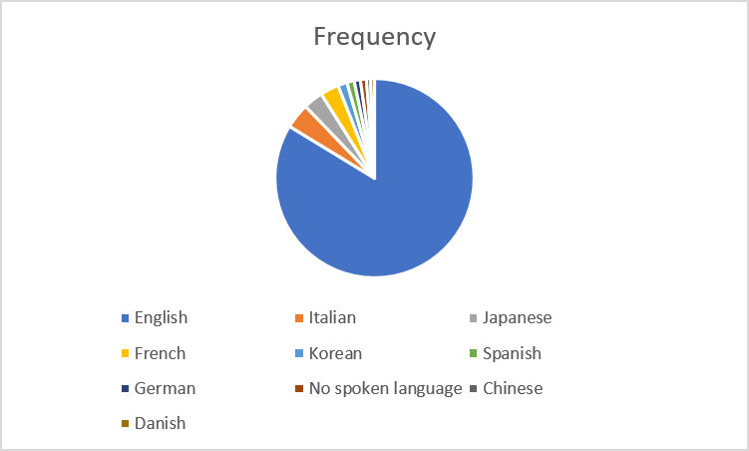
Figure 3: Frequency of language movies
(Source: Self-Created)
Patterns in movie ratings, reach and engagement were analysed out using excel trend. Average_rating, Watches and Likes were compared as a genre-level summary at the genre level, using scatterplots to explore the relationship between Runtime and Average_rating as well as between Watches and Likes. To avoid the impact of language level differences, the Original_language field was also taken into account. To do the genre-rating analysis, use the final individual-genre PivotTable to determine what genres achieved the highest and lowest average ratings, and argue whether or not the difference is significant (Gurazada et al., 2026). The number of films in the genres to be interpreted should also be taken into account as very few films may not be sufficiently representative to produce accurate average results. The analysis should thus primarily address the implications of the differences regarding the audience's evaluation of various kinds of films and not just provide information on the maximum value.
The comparisons of Genres and Watches should then provide an explanation of which genres had the highest average audience size. The results should be contrasted with the average-rating results as highly popular genres do not necessarily receive high ratings. This separation indicates that there are two types of evaluating how movies perform: popularity and audience ratings. The Genres and Likes analysis should also help determine the specific genres that are driving the most engagement and compare this with the watch count. If high-viewers genres also gain high numbers of likes, this means that there is agreement between genreranking and the extent of active acceptance; if they diverge, this indicates that not always relevantly high numbers appear in the rankings of genreranking (Alikhani et al., 2026).
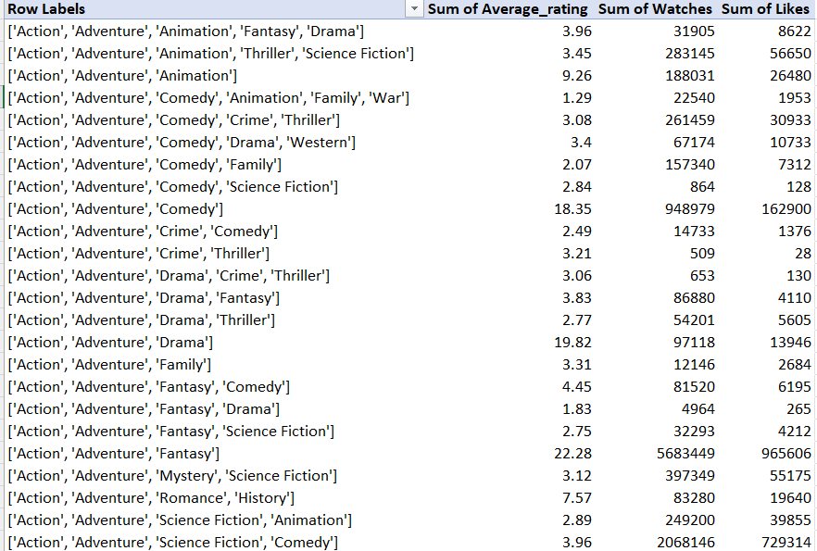
Figure 4: Movies genre
(Source: Self-Created)
The nature and intensity of the relationship should be detailed from the plotted observations and any unusual observations should be drawn to the reader's attention. The skewness and maximum value in the descriptive statistics are considerable for Runtime extreme values can be seen to have a significant influence on the visual pattern. The relationship should be called an Association, NOT an effect.

5. Statistical Analysis using SPSS

5.1 Pearson Correlation
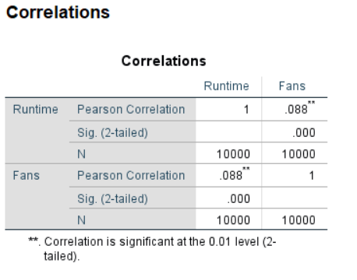
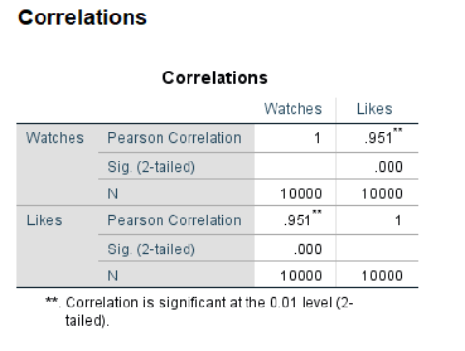
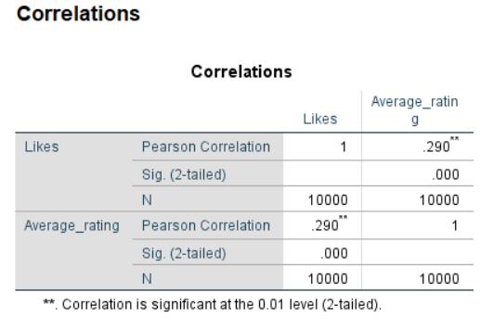
Figure 5: Correlation analysis
(Source: Self-Created)
Data was analysed using Pearson correlation in SPSS to explore the relationship between movie characteristics and the engagement of audience. There were 10,000 observations analyzed. There was a positive but very weak relationship between Runtime and Fans, r = .088, p < .001. This suggests that a tendency to have more followers emerges over the length of the film, albeit the small beta value implies that this relationship is not of strong magnitude in practice (Djamaly et al., 2025).
Likes were significantly related to Watches (r = .951, p < .001) the most strongly. This is an extremely high positive correlation and implies that there is a big increase in the number of likes as the number of times a film has been watched increases. This is a strong indication that there is a correlation between audience reach and audience engagement. But this doesn't mean that the greater the number of views, the more likes.
A positive and significant correlation was also found between Likes and Average_rating (r = .290, p < .001). This indicates a low to moderately positive correlation between the number of likes and the rating, suggesting that higher ratings are generally associated with increased likes. This relationship is, however, much less strong than the Watches–Likes relationship (Ghosh and Jha, 2025).

5.2 Multiple Linear Regression
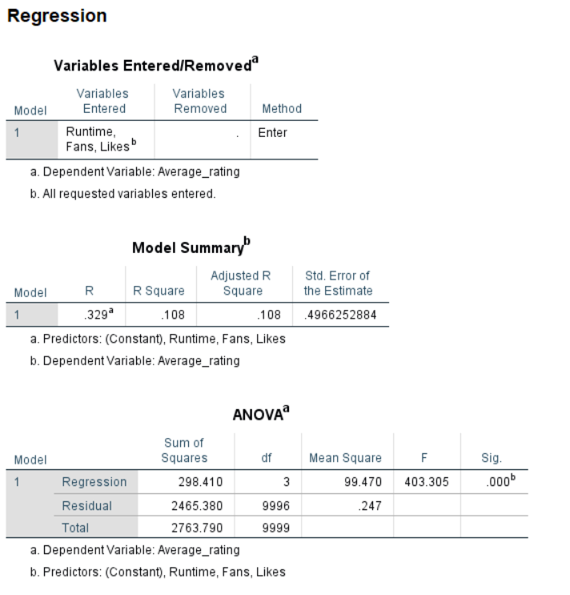
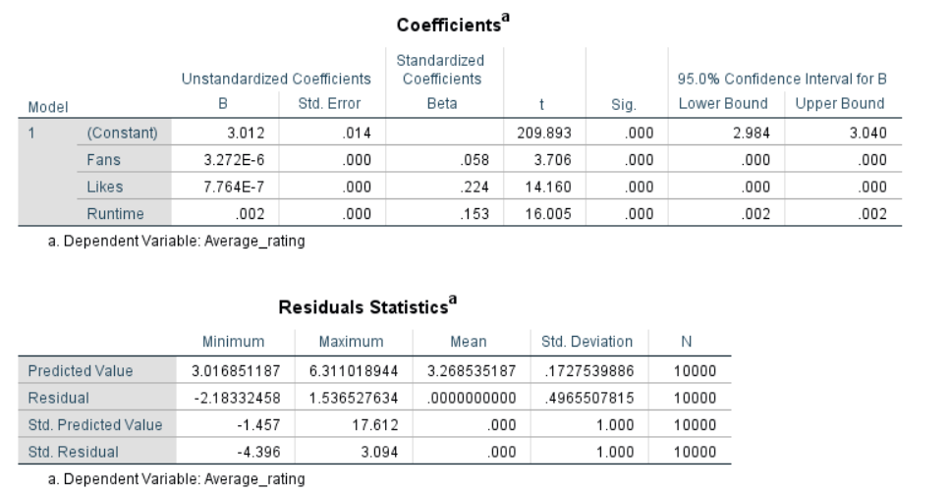
Figure 6: Multiple regression
(Source: Self-Created)
Average_rating was fitted to Models of Fans, Likes and Runtime by a multiple linear regression. The model produced R = .329, R² = .108 and Adjusted R² = .108. Thus, the three predictors account for about 10.8% of the variance in Average_rating. This means that the predictors account for some of the variance in ratings, but don't account for a lot of it.
The overall regression model was statistically significant (F(3, 9996) = 403.305, p < .001). This means that this relationship between the three variables, Fans, Likes and Runtime, is a statistically significant predictor of the Average_rating (Zhao et al., 2026).
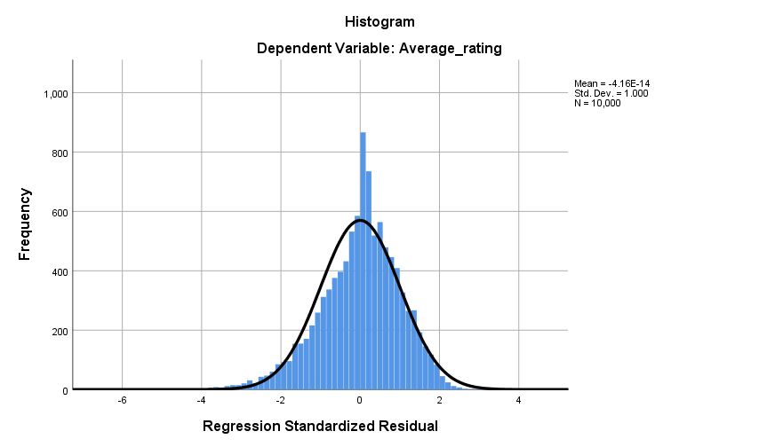
Figure 7: Histogram
(Source: Self-Created)
Capacity of Likes, Runtime, and Fans is shown with standardised coefficients, with Likes the strongest contributor (β = .224), and Fans (β = .058) as the third strongest contributing factor. Average_rating is positively associated with all three predictors and each predictor is statistically significant (p < .001).

5.3 Critical interpretation
Results show how important statistical significance and practical significance appear to be separate issues. There is a positive and small correlation (0.088) between Runtime and Fans, which is statistically significant. On the other hand, Watches and Likes are both statistically significant and very strongly correlated, at .951. The regression model is also statistically significant, but has an R² of .108, which suggests it is not a very good model (Liang et al., 2025). Because of this, do not use Fans, Likes and Runtime as a complete explanation of ratings for movies. There could be rating variance that is significant due to other factors. Moreover, due to an observational dataset, the analyses only provide associations and predictive relationships but not causal effects.

6. Insights and Recommendations
This indicates that the performance of the movies is affected not by a single measure of the audience behaviour but by multiple aspects (Kurki, 2025). The highest correlation that was found, which indicates a very strong association between the two, is the relationship between Watches and Likes (r = .951, p < .001). Likes also had a positive relationship with Average_rating (r = .290, p < .001). The overall model was statistically significant (F (3,9996) = 403.305, p < .001) but barely accounts for 10.8% of variation of ratings (R² = .108). Genres, viewing and engagement data should therefore be considered together by businesses in content creation and promotion decisions.

7. Conclusion
In the analysis learning module of the Letterbox Movie Classification Dataset, students explore how Excel and SPSS can be applied to analyze movie performance, audience engagement and rating patterns. A substantial variation was found within the audience measures with a high percentage of the data being English-language films (80.7%). The trend analysis revealed insights into differences between genres and languages. The SPSS correlation results indicate a very high correlation between Watches and Likes, and the regression analysis results indicate a strongly significant regression model for Fans, Likes and Runtime. But the R² is low and it is clear that other factors play a role in predicting the ratings of movies. The overall results are positive for the support of evidence-based decision making; observational relationships and their interpretations are cautionary.

Reference List
Alikhani, A., Ghasemi, B., and Sarmadsaidy, S. (2026). Identification and Evaluation of the Customer Engagement Model with Domestic Home Appliance Brands. Management Strategies and Engineering Sciences, 8(3), 1-12.
Badeji, A. J., and Omotunwase, S. M. (2026). Exploring the role of social media marketing in the box office success of Funke Akindele's Everybody Loves Jenifa. Journal of Arts and Sociological Research.
Benitez, J., Braojos, J., Pavlou, P., and Llorens, J. (2025). Impact of social media technologies on new product development performance: theory and empirical evidence. European journal of information systems, 34(1), 46-71.
BIAM, M. F. D., Rina Astini SE, M. M., and Daru Asih, S. E. (2025). Customer engagement and decision to watch indonesian films in cinemas: A relationship marketing perspective. Communication Today, 16(1), 206-221.
BIAM, M. F. D., Rina Astini SE, M. M., and Daru Asih, S. E. (2025). Customer engagement and decision to watch indonesian films in cinemas: A relationship marketing perspective. Communication Today, 16(1), 206-221.
Djamaly, M. F., Djumarno, D., Astini, R., and Asih, D. (2025). Entrepreneurial Perspective on Customer Decisions to Watch Indonesian Movies. Aptisi Transactions on Technopreneurship (ATT), 7(3), 848-862.
Ghosh, A., and Jha, M. (2025). Exploring Viewers' Engagement With Advertisements on Over-the-Top (OTT) Platforms: A Systematic Literature Review.
Gurazada, P., Moutusy, M., Kwak, H., and Taylor, C. R. (2026). When they like and when they comment: drivers of consumer engagement on social media. European Journal of Marketing, 60(6), 1395-1430.
ideas.repec, (2025), How consumers evaluate movies on online platforms? Investigating the role of consumer engagement and external engagement, [Online] Available from: https://ideas.repec.org/a/eee/jbrese/v176y2024ics0148296324001176.html [Accessed 12 August, 2026]
Kurki, V. (2025). Viral marketing and customer engagement of animated films on TikTok (Master's thesis, V. Kurki).
Liang, J., Gao, F., and Kwon, O. (2025). The Effect of Image-Text Congruency on Customer Engagement in Streaming Platforms: Dual Coding and Cognitive Consistency Theory Perspectives. International Journal of Contents, 21(3), 43-59.
Madongo, C. T., Tang, Z., and Chiwaridzo, T. O. (2026). The recursive engagement economy of film success: Social media eWOM, box office sustainability, and marketing efficiency in China. Sustainable Futures, 11, 101654.
O'Keefe-Smith, E. (2023). Social media strategies that lead to success in the film industry. Walden University.
Zhao, N., Zhu, X., and Pan, X. (2026). Examining the Relationship Between Perceived Value and Movie Consumption Behavioral Intention: The Mediating Role of Satisfaction. Behavioral Sciences, 16(4), 556.

