Student Self Evaluation Form

This section repeats in brief the common assessment criteria detailed on previous pages. The extent to which these are demonstrated by you determines your mark. Using these criteria, tick the box that best indicates the level of achievement you feel you have achieved with regard to each of them.
Common Assessment Criteria Applied
Common Assessment Criteria Applied | REFER |  | D |  | C | B | A
 | OUTRIGHT FAIL | UNSATISFACTORY | SATISFACTORY | GOOD |  | VERY GOOD | EXCELLENT
1. Subject Knowledge and Understanding (which includes using research-informed literature and knowledge and understanding of the subject)
2. Intellectual Skills (Analysis)
3. Pedagogic and Professional Applications (Practical Application and Deployment)
4. Key Transferable Skills

PLEASE COMMENT ON AREAS IN WHICH YOU FEEL THAT YOU HAVE PERFORMED WELL | PLEASE COMMENT ON AREAS you feel that you need TO DEVELOP
Overall I think I performed well in regards to subject knowledge and understanding and was able to utilise pertinent literature within the field to inform my understanding.  I think I analysed my findings well and showed an ability to use thematic analysis when analysing lesson study. | Upon reflection I would have perhaps made more practical applications when discussing key literature.  I also feel as though I could have written more concisely in order to get even more points across.

Student’s Name |  | Date | 15/04/18
Student’s Signature

The Enquiring Teacher
(ECPP7001)

Assignment Title: Write a critical and analytical essay that discusses your practitioner research ‘lesson study’ in relation to a chosen field.
Level 7
Research Question:
How can the use of regular peer assessment during a lesson influence pupils’ understanding of the learning objective?

1700144
Group 5
Word Count: 6574

Table of Contents
Section 1: Aim, focus and purpose of the research …………………………4
Section 2: Research Context ………………………………………………..4
Section 3: Literature Review ……………………………………………….6
Section 4: Methodology…………………………………………………… .9
Section 5: Ethical Considerations………………………………………… 12
Section 6: Lesson study 1 & 2 and Analysis……………………………… 13
Section 7: Discussion……………………………………………………….20
Section 8: Conclusion………………………………………………………22
Section 9: Recommendations……………………………………………… 23
References………………………………………………………………… 24
Appendices………………………………………………………………... 28
Appendix 1:Lesson 1 Plan…………………………………………….. 28
Appendix 2: Semi structured focus group interview schedule………… 29
Appendix 3: Assisted Reflective Conclusions (ARC) model…………. 30
Appendix 4: Excerpts from focus group interview setting 1…………... 32
Appendix 5: Excerpts from focus group interview setting 2…………... 34
Appendix 6: Observation schedule- Setting 1 (Stop 1)………………… 35
Appendix 7: Observation schedule- Setting 1 (Stop 3)………………… 36
Appendix 8: Observation schedule- Setting 2 (Stop 1)………………….37
Appendix 9: Observation schedule- Setting 2 (Stop 2)………………….38
Appendix 10: Observation schedule- Setting (Stop 3)…………………. 39

How can the use of regular peer assessment during a lesson influence pupils’ understanding of the learning objective?
Aim, focus and purpose of the research.
The aim of this research study is to explore whether the utilisation of peer assessment regularly throughout a lesson can influence pupils understanding of the learning objective (LO). Peer assessment, in the context of this study is understood as a process whereby individuals both provide and receive feedback about a piece of work. Whilst small in scale, the purpose of this enquiry as close to practice research, is to facilitate my own professional development, where the insurance of pupils having a clear understanding of both the success criteria and LO throughout the lesson was a key area for development highlighted by mentors. As an aspiring practitioner the conduction of research can allow for an increased understanding of key aspects of their practice, allowing for opportunities to reflect upon one’s craft (Grigg, 2015) Thus, this research will focus upon utilising regular peer assessment in order to establish whether an understanding of the LO can be facilitated throughout a lesson.
Research context
This research study was conducted within two differing settings, both of which are Yr Athrofa partnership schools. School 1 is situated within a town in Swansea, being deemed as a large primary school. School 2 is also situated in Swansea and is considered a medium sized primary school. The research enquiry was conducted within two KS2 classes of 30 pupils.
Importantly, both myself and my research partner had the same area of development. Whilst both having been encouraged within practice to utilise peer assessment as a plenary task to consolidate learning, our research question was born out of interest as to whether using peer assessment regularly throughout the lesson could facilitate an understanding of the LO.
Both classes had experience in utilising peer assessment, usually once during a plenary. This was significant as for peer assessment to be effective pupils must fully understand the process (Boon, 2016). Thus, whilst the use of regularly employing peer assessment was a new practice for both classes, this was explored without concerns over pupils being new to conducting peer assessment generally. Furthermore, both classes operate on the principle that the success criteria can be viewed as a ‘stepping stone’ to achieve the LO. This is arguably common practice, where often the criteria of success is shared with pupils to allow them to comprehend what they will be judged on when determining if the LO has been achieved (Grigg, 2015). Thus, within this research the same notion was applied.

Literature Review
Assessment for learning (AFL)
In order to gain a thorough understanding of regular peer assessment it is vital to explore pertinent literature within the field. It is frequently discussed how peer assessment is often utilised as a key mechanism for AFL (Brown, 2005; Jones, 2005; Thomas, Martin and Pleasents, 2011). It is here where AFL, originating from the work of Black and Wiliam (1998), is based on the premise that both evidence and dialogue can be utilised to ‘find out where pupils are in their learning, where they need to go and how best to help them get there’ (Grigg, 2015: 399). The effectiveness of AFL has been documented within the literature, where its employment within the educational context has been argued to be highly successful in relation to improving learning quality (Black et al, 2003; Jones, 2005). Thus, demonstrating the significance of utilising AFL strategies within practice.
Yet as discussed by Black et al (2003) AFL moves beyond traditional conceptions of assessment which usually refer to ‘testing’ and rather point to the importance of a formative use of assessment, through the application of strategies such as questioning, self or peer marking and practitioner feedback. Yet the manner in which such strategies are delivered arguably plays a fundamental role in the effectiveness of learning. For instance, not only should the criteria that pupils learning is judged upon be made explicit to individuals (Brown, 2005), but crucially, in order to avoid adverse effects, feedback must be provided in relation to the work quality, where the overemphasis on grading or competition must be avoided (Black and Wiliam,1998). Thus, this research will utilise positive and constructive feedback as opposed to grading. Hargreaves, Gipps and Pickering (2014) concur arguing that AFL feedback must be constructive in order to avoid negatively impacting upon emotions.
Interestingly, the timing of which such AFL opportunities are presented is an area of discussion within the field. Brown (2005) argues that if assessment is to be effective, this cannot simply be utilised at the end of a lesson or programme, as it does not allow learners to progress from early mistakes or misconceptions. Brown (2017) concurs arguing that AFL strategies such as self or peer assessment should not be used solely within a plenary, as this does not allow sufficient time for pupils to respond to feedback and rather should be utilised several times within a lesson. Thus, supporting the employment of regular peer assessment.
Peer Assessment
When looking specifically at peer assessment, it is argued that we must move away from simplistic notions of the process that refer to pupils purely ‘ticking’ their peers work and rather it must be acknowledged as a valuable AFL strategy (Dunn, 2006). Peer assessment has been frequently argued to be a reciprocal process (Topping, 2009), whereby success criteria if utilised to provide and receive feedback in relation to the quality of work (Falchikov and Goldfinch, 2000). This process is arguably valuable in numerous contexts, where as discussed by Biggs and Tang (2007) the ability to assess whether a product hits criteria is a highly transferable skill.
However, scholars have frequently warned that in order for peer assessment to be successful pupils must have a clear understanding of how to conduct the process (Boon, 2016; Min, 2005; Topping, 2003). For example, Topping (2003) highlights the significance of providing pupils with training and demonstrations of how to peer assess, translating their role and expectations. Min (2005) concurs, finding a positive relationship between pupil training and the successfulness of the peer assessment method. Thus, highlighting the significance of insuring a sound understanding prior commencement.
When exploring the benefits of peer assessment, pertinent literature within the field points towards its ability to promote effective learning when undertaking both the roles of assessor and assessee (Catterall, 1995; Topping, 2009; Topping & Ehly,1998). For example, not only is receiving effective feedback from a peer argued to facilitate learning (Wiliam,2011), but as argued by Orsmond, Merry, and Reiling (2002) the process of providing feedback to a peer may in fact aid pupils in understanding, recognising and implementing strengths within their own work. Thus, in order to truly explore how regular peer assessment effects pupils understanding of the LO, it must arguably be considered how both providing and receiving the feedback plays a role. However, as discovered by Tsui and Ng (2000) during the peer assessment process the assessors became conscious of the deficiencies of their own produced work when marking their peers. Whilst such identification of weakness can be beneficial in terms of an increased understanding and the ability to address misconceptions (Black et al, 2003; Topping, 2009), this must not become counterproductive. Van-Gennip, Segers and Tilema (2009) concur arguing that for peer assessment to be effective the environment must be secure, where weaknesses are viewed as something positive to be developed upon.
It is argued that peer assessment can produce a variety of benefits, such as the encouragement of metacognition and deep level learning (Brown, 2005), and the development of co-operative learning and communication skills (Harris, 2007). More specifically, Topping (2009) argues that due to the quantity of pupils compared to practitioner’s peer assessment provides pupils with more individualised and instantaneous feedback than that off a practitioner. Thus, demonstrating the range of benefits. Most significant for the context of this study however are the frequently documented arguments that peer assessment can contribute to an enhanced familiarity and understanding of success criteria and learning outcomes (Black et al, 2003; Catterall, 1995). However, whilst the potential is present, practitioners must insure that pupils are given sufficient time to explore feedback and are made explicitly aware of the need for feedback to relate to the criteria if developments are to be made (Boon, 2016). Yet despite arguments that peer assessment can be utilised to facilitate an understanding of the LO, there is arguably little research exploring the specific use of regular peer assessment, thus this research will address a potential gap within the literature.

Methodology
In order to truly explore this line of enquiry, it is imperative that employed methods are fit for purpose. Lesson Study (LS), a form of action research, was utilised, which as stated by Dudley (2011) refers to a process whereby educators work together to highlight a key area for development or ‘problem’ to be focused upon, where pedagogues plan, conduct, survey and analyse learning through a series of research lessons, often utilising or innovating a particular teaching technique with an aim to elicit progress. Thus, having identified the need to insure pupils understanding of the learning objective, regular peer assessment was identified as a technique to potentially aid such an understanding. LS arguably being highly beneficial as not only can it promote professional development and pupil progress (Dudley, 2011) but it also allows for the elicitation of pupil voice (Lewis and Hurd, 2011).
The following methods, utilised as part of the LS process, aimed to collect qualitative data. Qualitative research allows for the gaining of rich in-depth data that allows for an subjective exploration of individuals experiences and understandings (Denzin and Lincoln, 2011). Thus, allowing for an in-depth exploration of how pupils experienced and understood regular peer assessment. Qualitative data was analysed following a thematic approach, whereby patterns or themes are analysed that emerge within the data (Braun and Clarke, 2006). This method was selected due to its accessibility and it allowance for an in-depth interpretation of findings (Sparkes and Smith, 2014).
Observation
As part of the LS process, observations were utilised as a means of collecting qualitative data during the two lessons. This method is arguably vital within the LS process, where as opposed to other methods, observation does not simply rely on what participants say they feel or experience, rather the researcher can examine what individuals do or experience within the natural setting (Smith and Sparkes, 2014). Thus, allowing for an in-depth exploration of how the peer assessment process influenced the understanding of the LO, as opposed to solely relying on pupil recall.
Whilst one researcher participated within the lesson by delivering the content, the primary source of data collection was conducted by the non-teaching researcher in the form of a non-participant observation, whereby the researcher observes the participants but does not actively participate within the setting (Scott and Marshall, 2009). Both observations conducted were overt. Whilst this arguably risks inducing an ‘observer effect’ where the simple presence of a researcher may influence participants to behave in an unnatural way and thus impact validity (Papatheodorou, Luff and Gill, 2013), it was deemed as vital to ensure that ethical procedures were upheld. However, these observations were non-intrusive, as the researcher passively observed the peer assessment process, embracing a ‘fly on the wall’ approach, thus increasing the probability of maintaining the settings genuineness (Denscombe, 2014).
Observations were made of the target pupils during each peer assessment stop. Each lesson had three stops, each lasting 5 minutes (2 minutes marking, 1 minute to write strengths and areas for development, and 1 minute for verbal discussion) (see appendix 1). Peer assessment stops were conducted initially every 12 minutes during the main activity. Data was collected through the use of a self- created observation schedule (see appendix.6), where specific indicators were sought after during the peer assessment process e.g. ‘Provide positive verbal feedback in relation to the success criteria’. This schedule incorporated a Leuven Scale of involvement to simply determine how involved pupils were during each stop. Whilst observations may be interpreted by different individuals in differing ways (Markula and Silk, 2011) it was insured that all researchers had a shared understanding.
Focus group interviews
After each delivered research lesson, a focus group interview was conducted with the four target pupils from each setting. Focus group interviews being recognised as a technique to yield qualitative data, where groups of individuals explore their opinions, perceptions and feelings in relation to a specific topic or enquiry (Denscombe, 2007). Thus, this allowed for the exploration of our identified pupils feelings in regards to the lesson and peer assessment process. Given the studies context, focus group interviews were selected to explore pupil’s perceptions as they arguably provide a more social, non-threatening setting over one to one interviews (Krueger, 1994). Interviews were conducted immediately after the lesson in order to minimise the risk of forgotten or inaccurate recall of experiences.
The focus group interviews were semi-structured due to the fact that as opposed to structured methods, they allow for a greater deal of flexibility and freedom in relation to each participant’s experiences whilst maintaining some structural support (Markula and Silk, 2011). Questions utilised were predominantly open-ended i.e. ‘How did you find using regular peer assessment today?’ as they arguably inspire rich qualitative data in greater depth than closed questions (Sparkes and Smith, 2014). Open ended- questions ranged from targeting the pupils general attitudes towards the lesson to more specific questions regarding giving and receiving feedback (See Appendix 2). All participants were asked for their opinion if not automatically volunteered, in order to alleviate a potential issue of dominant individuals overshadowing others views within the group (Breen, 2006). Interviews were recorded to gain a rich depth of data whilst insuring a focus on participants (Bell, 2010).
Target Pupils
Permission was granted to study four target pupils per lesson. This was identified as most appropriate given that the peer assessing process requires working in pairs, thus allowing both members from each of the two pairs to take part. Purposive sampling was utilised, where participants are selected based on their ability to meet specific criteria appropriate to the research enquiry (Atkinson, 2012; Denscombe, 2014). Having consulted with the teachers, pupils were selected who were particularly vocal in expressing their opinions and confident in speaking orally. Whilst this may cause issues in relation to representation of the whole class (Wood and Smith, 2016), this was necessary when considering the desire to observe peer assessment and gain opinions within focus interviews.
Reflection
Reflections were carried out after each research lesson and focus group interview, where LS requires practitioners to reflect upon whether or how the research lesson and thus the teaching techniques elicited the desired response (Teacher Development Trust, 2015). During post research lesson discussions and reflections, it was considered vital that not only the learners response to the technique was considered but additionally any difficulties or areas for improvement in the teaching or learning process must be considered (Dudley, 2014). Amendments to the research lesson and the regular peer assessment process were made accordingly in preparation for the second research lesson. Further post lesson reflections were conducted post lesson two.
The UWTSD ARC reflective model, was utilised to aid such reflections (See appendix 3). Questions were modified to suit the specific research enquiry, for instance, ‘What were the elements of the regular peer assessment process that were disappointing?”. This model was selected due to the researcher’s confidence in effectively using the model for reflection aimed at improving practice. Additionally, post it notes, utilised for proving peer feedback, further informed the post lesson discussion. Such reflections are arguably fundamental, allowing practitioners to learn from their enquiries as opposed to teaching uncritically, actively contributing towards their growth (Grigg and Lewis, 2017).
Ethical considerations.
Prior to commencement ethical approval was granted from the universities ethics committee. Due to the context of the study, where when working amongst vulnerable participants or young children parental consent is vital (BERA, 2011), written informed consent was gained from participants parents/guardians. Informed consent being understood as the gaining of consent whereby the nature and purpose of the research is both revealed and conveyed in a comprehensible manner (Thomas, 2009). Prior to both lessons, pupil assent was taken verbally from the whole class and the identified pupils, where participants were informed of the nature and purpose of the study and their right to withdraw at any point. Class teachers signed to confirm the witnessing of assent.
Yet ethical considerations must be upheld throughout and after the studies completion and cannot be forgotten consent is granted (Miller and Bell, 2012). Thus, throughout the study participants were reminded of their right to withdraw or to refuse to answer any questions at any time, where importantly they could do so without explanation or consequence (Oliver, 2010). This was the case during one lesson where a participant withdrew prior to observation.
Both lessons aligned with usual lesson content. Whilst conducting peer assessments, pupils were reminded of the requirements of constructive as opposed to negative feedback. In order to ensure participants felt comfortable, and risks to the researcher were minimised, focus group interviews were conducted in an open, accessible setting with clear access to the corridors and additional adults. During the observations the non-participant researcher was situated in a place that was non-intrusive to the greatest extent possible.
All pupils and schools have been presented with pseudonyms throughout the report in order to allow for anonymity. All data has been anonymised and confidentiality protected. Data has been stored in accordance with ethical requirements and will be archived when appropriate.

Lesson study 1 and analysis.
When analysing the lesson and thus the data collected throughout the LS process, it can be argued that the use of regular peer assessment as a key teaching technique, had a positive influence on pupils understanding of the LO. As demonstrated within the reflective ARC (see appendix 3) it was felt that all pupils responded positively to the shift in carrying out peer assessment regularly and demonstrated a good understanding of the LO. This has become apparent through both reflections on the lesson and the identification of key patterns within the data.
Role as the assessor
It can be argued that having to regularly assess and provide feedback to a given partner throughout the lesson allowed for an understanding of the LO to develop. As previously highlighted, within both settings the success criteria is viewed as a ‘stepping stone’ to achieve the learning objective, and thus the identification of success criteria being met or not met would arguably indicate an understating of the LO. This is reflected in a statement (see Appendix 4) from Pupil Cl:
“…it focuses on like one thing (reference to LO) but then I suppose to do that thing you have got to include all of the things in the success criteria”
Throughout the course of the lesson pupils during all three stops, were noted to have provided regular positive or constructive feedback in relation to the success criteria. For example, when referring to observational notes verbal feedback was provided such as:
‘You have included the characters movements and gestures’(Pupil C1)
‘You have not used any time connectives’ (Pupil D1)
It can be argued that such positive and constructive feedback provided within the lesson demonstrates a clear understanding of the LO, which was to ‘to develop a knowledge and understanding of how to write a narrative’, where for instance, pupils highlighted that in order to write a narrative successfully (LO), time connectives would have to be present. Such feedback was provided throughout all three peer assessment stops, where as noted within the ARC the depth of feedback in relation to the LO arguably progressed throughout the lesson. Therefore, it can be argued that regular peer assessment provided pupils with continuous opportunities to think about and reflect upon the success criteria in relation to the LO, at different stages of the narrative, progressing in the depth of explanation given throughout.
Interestingly, both during the lesson and the focus group discussion pupils praised the use of regular peer assessment for making a difference in relation to their understanding as usually the peer assessment process would be conducted once, at the end of a lesson where as discussed (see appendix 4) by Pupil C1:
“…people rush because they want to go out for break and things” (Pupil C1).
Thus, suggesting that by utilising regular peer assessment pupils fully engaged with the process and continuously considered the success criteria in relation to the LO, where the use of conducting the process solely at the end of the lesson, where it is rushed can negatively affect the impact on learning (Boon, 2016).
Furthermore, when reflecting upon the lesson it became apparent that in relation to the role of assessing, the use of regular feedback allowed them to consider what they had included within their own work, where often pupils would highlight their own strengths or misconceptions in relation to the success criteria and LO. This is supported by Pupil B1’s comment (see appendix 4) who when asked about the role of providing feedback stated:
“When you are marking somebodies work you are just thinking umm, if you’ve done that or if you could improve on doing that” (Pupil B1)
As demonstrated above pupils felt that when taking on the role of the assessor during the three stops, they not only considered the progress that their partner had made in relation to the success criteria and thus the LO but additionally they considered their own meeting of the success criteria ‘every time’ (Pupil A1), where such processes allow for the simultaneous recognition of what the marker requires to be successful (Lee, 2006).
Role as the assessee
When analysing the lesson, and collected data, it can be argued that receiving regular feedback during the lesson (positive and constructive) in relation to the success criteria influenced pupils understanding of the learning objective. For example, when asked about the role of regular peer assessment in relation to an understanding of the LO (see appendix 4) Pupil C1 stated:
“…if you haven’t done something then that’s in the success criteria and then the peer marker can always write down that you haven’t done that and then you can remember about the learning objective.”
Such a statement arguably demonstrates the value of receiving regular feedback in relation to the LO for the pupils when specifically looking at the constructive aspect for what they ‘haven’t done’, where arguably through regular assessment pupils are given continuous opportunities to address their misconceptions and issues. Furthermore, the clear link that feedback causes pupils to ‘remember’ about the learning objective could arguably imply an understanding, where they are able to associate this with the components required (success criteria) to be successful to achieve the LO.
It is here where repeating the process regularly throughout the lesson was continuously highlighted as being valuable, where during the focus group interviews pupils discussed how it allowed them to “learn more” (Pupil A1) as opposed to conducting the process once. Interestingly a common pattern amongst pupil’s responses indicated that pupils felt that they could recognise and change their work in accordance with meeting the success criteria and LO during the lesson. For instance, Pupil A1 commented:
“You can fix it whilst in the process of doing it”
This arguably demonstrating how regular peer assessment allowed pupils to get fully involved in the process, as demonstrated by the Leuven scale, (see appendix 6) during several points within the lesson and engage with understanding the success criteria as the building blocks to the LO, addressing through peer assessment any issues or misconceptions held during the process (Black et al, 2003).
Key improvements
Whilst all data collection tools were felt to be effective in the collection of data, during the lesson however it became apparent that the timing and thus the structuring of the lesson would require modification prior to the commencement of the next lesson. For example, when conducting the first peer assessment stop, it was noted that a target pupil commented:
“We did not have enough time to write another paragraph” (Pupil D1, Appendix 6).
Such comments coupled with the reflective process would therefore suggest that in order to ensure that pupils are able to fully immerse themselves within the tasks and insure that they have sufficient time to meet aspects of the success criteria more initial time is presented. Thus, as discussed in depth within the reflective ARC (see appendix 3) a key modification was put in place to allow more initial time prior to stop one’s commencement. Furthermore, upon reflection the adaption of structuring was also felt to be required in between each stop:
“I would add more time to let them write the story” (Pupil B1)
Thus, more time between stops was highlighted for Lesson twos commencement, where sufficient must be allocated to allow individuals to immerse themselves with the task make adaptions based on their peer feedback (Boon, 2016).

Lesson 2 and analysis.
When analysing the lesson it became apparent that key patterns identified coincided with those identified within lesson 1. Upon reflection it was felt that target pupils made progression throughout the lesson in understanding the LO through utilising regular peer assessment.
Role as the assessor
When exploring and reflecting upon lesson two it is arguably apparent that by taking on the role of the assessor and thus utilising regular peer assessment pupils were able to gain an understanding of the LO. Throughout the lesson it became evident during each stop that through having to assess a peer’s work, and thus provide positive or constructive feedback, pupils as argued within the literature simultaneously assessed their own understanding (Orsmond, Merry and Reiling, 2002). For example, when analysing the observational data, it was noted throughout all three stops that pupils often reflected upon their inclusion of the success criteria within their own work whilst marking a peers writing. For instance, observational notes such as ‘examines their own work as well as their partners’ (Pupil B2, Appendix 8) indicate how pupils often felt the need to check their own inclusion of the success criteria, and thus the building blocks of the LO, whilst simultaneously undertaking the process. This is further supported by observational notes (Appendix 8):
‘Pupil states how they have not got a method and their partner has not either’ (Pupil B2)
It can be argued that the identification of not having a method, a key component of meeting the LO ‘to write instructions for a purpose’, demonstrates a clear understanding of the lesson outcomes. Due to the fact that this had not been previously included, it can be argued that their understanding has positively developed. Thus, it can be argued that by conducting regular peer assessment pupils are provided with the opportunity to continuously reflect upon their meeting of the success criteria and the meeting of the LO through exploring their partners work on several occasions throughout the lesson, where they are able to address any gaps in their knowledge or misconceptions (Topping, 2009) that relate to the success criteria and LO.
Furthermore, through engaging in providing regular positive or constructive feedback to their peers it can be argued this provided pupils with regular opportunities to reflect on the meeting of the success criteria in relation to the LO. For example, pupils were able to identify and provide both positive and constructive areas of feedback to their partner. This is reflected within the comments such as:
“You need to put in a method” (Pupil C2, Appendix 8)
“You have used good diagrams” (Pupil B2, Appendix 10).
Such comments are clear indicators of what is required to meet the LO and thus suggest an understanding, as the success criteria is often utilised to determine the meeting of the LO (Grigg, 2015). Additionally, due to the peer assessment process being conducted regularly, as demonstrated within Appendix 9 pupils were able to comment upon how the meeting of the success criteria had progressed over time when comparing peers work to previous stops. Thus, arguably demonstrating an increasing understanding of the LO as the stops progressed.
Role as the assessee
Both during the lesson and upon reflection it became apparent that by receiving positive or constructive feedback from their partners pupils understanding could be positively influenced (Wiliam, 2011) during each stop. This is supported by the focus group discussion where when asked if the utilisation of regular peer assessment and the receiving of regular feedback from their peers helped them to understand the LO, all pupils stated yes, where Pupil D2 discussed the connection between the receiving of feedback and its link to being part of achieving the learning objective (See appendix 5).
Throughout the peer assessment process, it became apparent that through utilising the feedback, on the post it notes given, pupils could identify key areas in relation to the success criteria that they needed to improve upon in order to insure they met the LO during each peer assessment stop. For example, as demonstrated during Stop 2, Pupil D2 ‘Looked at the post it and realised diagrams were not in’ their own work. It can be argued that the inclusion of diagrams forms a key component of producing instructions for a purpose (LO) where pupil D2 then through discussing with peers understood the significance of diagrams within instructions. Thus, it can be argued that such moments highlight the significant influence that regular feedback, whether this being positive or constructive can have on an understanding of the LO.
Key Improvements
Despite amendments it became apparent both within the lesson and the analysis of data that further improvements could be made within the future in relation to conducting regular peer assessment. For example, both observational notes and statements made during the interview demonstrated a desire for more time. When looking specifically at the observational notes it is here where Pupil B2 during the lesson discussed how they “needed more time” to provide more positive and constructive feedback to their peer. Despite pupils being given slightly more time, the initial modification to give them extra time was difficult to achieve as the start of the lesson was delayed. Thus, within the future it is clear that pupils require more time to conduct the process regularly.
Furthermore, pupils towards the end of the lesson some pupils did begin to provide feedback that was arguably detached from the learning objective, (see appendix 10) such as:
“Your work is colourful” (Pupil B2)
“Improve handwriting” (Pupil D2).
Thus, whilst during all three peer assessment stops, the Leuven scale indicated that they were fully involved within the process, it can be argued that pupils must be reminded to stay on task in regards to providing feedback in regards to the success criteria (Boon, 2016).

Discussion
When considering the results above it can be argued that regular peer assessment throughout a lesson did influence pupils understanding of the LO, where through providing and receiving feedback pupils understood the learning intention. This is perhaps unsurprising when considering pertinent literature within the field, where it is frequently discussed how the use of peer assessment can lead to an increased understanding of both the success criteria and learning outcomes (Black et al, 2003; Catterall, 1995; Topping and Elhy, 1998). However, this research makes a progressive step in demonstrating the value of conducting the process regularly throughout the lesson, addressing a gap within the literature.
Key findings, that through continuous opportunities to both providing and receiving feedback on a regular basis pupil’s understanding of the LO was influenced, are in concurrence with pertinent literature within the field (Catterall, 1995; Topping, 2009). For instance, as previously highlighted, Topping (2009) found that the quality and effectiveness of learning can progress through both undertaking the role of ‘assessor’ and ‘assessee’. This is arguably significant as it suggests a clear importance of emphasising the use of regular peer assessment as a reciprocal process within practice to gain an understanding of the LO, rather than viewing peer assessment as a one-way activity (Falchikov,2007; Topping, 2009). Therefore, demonstrating the value of encouraging learners to undertake both roles regularly within future practice.
By engaging in regular peer assessment and having continuous opportunities to take on the role of the assessor, pupils often expanded upon their own understanding of the LO by using their peers work to reflect upon any gaps of knowledge or misconceptions they themselves had in regards to the success criteria or LO. Such findings mirror those by Tsui and Ng (2000) where through engaging in peer assessment individuals often identified weaknesses or areas of misconceptions in relation to their own work and understanding. Similarly, results also indicated that pupils were able to recognise their own areas of strengths in relation to the success criteria, where as discussed by Orsmond, Merry and Reiling (2002) providing feedback to another peer encourages pupils to simultaneously identify and understanding their own strengths. Thus, the findings of this research are arguably significant as they demonstrate how an understanding of the learning objective can be achieved if pupils are encouraged to simultaneously reflect upon their own understandings when undertaking the role of the assessor regularly. A key point that will be taken forward within my own practice.
Furthermore, the opportunity to peer assess regularly throughout the lesson was consider highly valuable within the LS, as pupils could act upon the feedback and thus expand upon their meeting of the success criteria and LO after each stop. These findings are significant as they suggest the need to go beyond conducting one peer assessment, which is often conducted within or as a plenary (Brown, 2017), and rather highlights the significance of allowing pupils to actively engage with the process regularly throughout a lesson. Such findings strongly concur with those within the literature, where Brown (2005) argues that AFL strategies, such as peer assessment must be conducted prior to completion to allow individuals to recognise and identify any gaps in their knowledge at an early stage. This being of importance as it demonstrates the potential for regular peer assessment to influence an understanding of the LO, where as discussed by Drummond (2003) such types of formative assessment are evidently successful when they allow for pupils to master knowledge and understanding in a specific area.

Conclusion
In conclusion, it can be argued that overall, results indicate that regular peer assessment throughout a lesson can influence pupils understanding of the LO, whereby through engaging in providing and receiving positive and constructive feedback related to the success criteria pupils were continuously able to build upon their understanding of the LO. Such research has arguably been significant in demonstrating the importance of allowing learners to engage in the process throughout a lesson and has contributed in addressing a gap within the literature.
It can be argued that the use of LS has been highly beneficial, where as discussed by Dudley (2011) LS allows for researchers to collaborate and reflect upon the employment of key teaching techniques, allowing for professional development and thus promoting pupil progress. Thus, LS greatly facilitated the exploration of regular peer assessment within the classroom in relation to influencing the understanding of the LO, addressing an area of self-development. Such self- research arguably being vital when considering Donaldson (2015) and the developing curriculum. Yet conducting LS did cause initial nerves for myself, where whilst not the focus of the observation, the presence of a ‘peer’ as the non-participant researcher was initially daunting. Mon et al (2016) concur arguing that a key challenge of LS is overcoming the fear of exposing ‘weaknesses’ to a peer or colleague.
Perhaps most beneficial when considering LS more broadly and in particular the use of focus group interviews was the ability to elicit pupil voice. It is here where the utilisation of focus group interviews allows for the perspectives, understandings and opinions of pupils to be presented and offered as opposed to individuals making assumption on their behalf (Eder and Fingerson, 2001). Therefore, this research was able to gather target pupil’s opinions on the delivered lesson and more specifically regular peer assessment, where information was gained on how to develop and progress to better facilitate learning. This research therefore invoking the Rights of the Child (UNICEF, 1990) to both provide and have their opinions taken seriously (Article 12). However, during the second focus group interview one pupil did continuously state their concurrence with their peers yet sometimes could not elaborate on their reasons why when asked. As Dilshad (2013) states, one possible consequences of group interviews is that individuals may conform to the response of the majority despite differing opinions or vocal participants may dominate discussions.
The use of observational methods proved to be highly advantageous when wanting to explore the use of regular peer assessment in relation to its influence of the LO, where it was possible to gain an in-depth exploration in relation to what happened during the peer assessment process and stops and how participants experienced this. Sparkes and Smith (2017) concur arguing that such methods allow for the phenomena to be observed within the moment where the researcher does not have to depend purely upon what they say they do but rather they can observe their participants actions.
However, as previously discussed overt methods of observation whilst ethical, run the risk of compromising the validity of the data as the presence of a researcher may produce an ‘observer’ effect, where such presence may distort behaviour of participants (Papatheodorou, Luff and Gill, 2013). Yet, the non-participant researcher did endeavour to be non-intrusive to the greatest possible extent, thus improving the chance of validity. Furthermore, when exploring whether the sample is representative it must be considered that the use of purposive sampling does draw concerns in reflecting the larger class population (Wood and Smith, 2016). Thus, if conducting such a process again, differing groups of individuals would be selected in order to insure the results are representative of all pupils.
What became evident through conducting the LS process was that for both groups of target pupils, more time was felt to be needed at both the beginning of the activity and during each peer assessment stop. Thus, if conducting such a lesson or regular peer assessment again it is important to ensure that enough time is available to undertake the process and complete the narrative, where arguably at least the full hour of a lesson is required.
Recommendations
In light of the research I would therefore recommend that regular peer assessment is utilised throughout a lesson as a key technique to facilitate an understanding of the LO. This will be taken forward within my own future practice and arguably demonstrates the advantages of not simply utilising peer assessment as a singular plenary exercise. Thus, through engaging in LS, a process which allows for professional development (Dudley, 2011), my own personal targets of insuring pupils are aware and understand the LO and success criteria throughout the lesson can be met.
Whilst this study has made a contribution to understanding the effectiveness of utilising peer assessment regularly and addressing a key ‘gap’, it is small in scale and therefore future research should endeavour to further explore this enquiry on a larger scale to insure generalisability. Whilst admittedly such research did not venture to improve educational standards nationally, and rather sought to elicit professional development, the sharing of good practice can be utilised to demonstrate the effectiveness of regular peer assessment throughout a lesson and thus inform future practice.
References
Atkinson, M. (2012). Key concepts in sport and exercise research methods. London: Sage.
Bell, J. (2010). Doing your research project: A guide for first time researchers in education, health and social sciences (5th ed). Maidenhead: Open University Press.
BERA 2018. Ethical guidelines for educational research. London: BERA.
Biggs, J. and Tang, C. (2007). Teaching for quality learning at university: What the student does (3rd ed). Maidenhead: Open University Press.
Black, P. and Wiliam, D. (1998) Inside the Black Box: Raising Standards Through Classroom Assessment. Kappan, 80, 2, pp.139-144.
Black, P., Harrison, C., Lee, C., Marshall, B. and Wiliam, D. (2003). Assessment for Learning: Putting it into practice. Maidenhead: Open University Press.
Boon, S. (2016). How can peer assessment be used in ways which enhance the quality of younger children’s learning in primary schools? Thesis. University of Leicester.
Braun, V. and Clarke, V. (2006) Using thematic analysis in psychology. Qualitative research in psychology, 3,2, pp.77-101.
Breen, R. (2006). A Practical Guide to Focus-Group Research. Journal of Geography in Higher Education, 30, 3, pp.463-475.
Brown, C. (2017). 7 Tips For Peer And Self-Assessment. Teacher Toolkit. Available at: https://www.teachertoolkit.co.uk/2017/05/18/peer-assessment/ [Accessed 5th April 2018].
Brown, S. (2005). Assessment for learning. Learning and teaching in higher education. 1, pp.81-89.
Catterall, M. Peer learning research in marketing. In S. Griffiths, K. Houston, and A. Lazenblatt (Eds.), (1995) Enhancing student learning through peer tutoring in higher education. Coleraine: University of Ulster, pp. 54-62.
Denscombe, M. (2007). The good research guide: for small-scale social research projects, (3rd ed). Maidenhead: Open University Press.
Denscombe, M. (2014). The good research guide: for small-scale social research projects, (5th ed). Maidenhead: Open University Press.
Denzin, N. and Lincoln, Y. Introduction: The discipline and practice of qualitative research In. N. Denzin. and Y. Lincoln. Handbook of qualitative research, (eds) (2011) London: Sage, pp.1-19.
Dilshad, R. (2013). Focus Group Interview as a Tool for Qualitative Research: An Analysis. Pakistan Journal of Social Sciences, 33, 1, pp-191-198.
Donaldson, G (2015) ‘Successful Futures Independent Review of Curriculum and Assessment Arrangements in Wales’ Available at: http://gov.wales/docs/dcells/publications/150225-successful-futures-en.pdf [Accessed 6th April 2018].
Drummond, M.J. (2003). Assessing children’s learning, (2nd ed). London: David Fulton.
Dudley, P. (2011). Lesson study: a handbook [online]. Available at: http://lessonstudy.co.uk/wp-content/uploads/2012/03/Lesson_Study_Handbook_-_011011-1.pdf [Accessed 7th April 2018].
Dudley, P. (2014). Lesson study: a handbook. Cambridge. Available from: http://lessonstudy.co.uk/wp-content/uploads/2012/03/new-handbook-revisedMay14.pdf [Accessed 1st April 2018].
Dunn, D. (2006). Using peer assessment in the primary classroom. Teach Primary [Online]. Available at: https://www.teachprimary.com/learning_resources/view/using-peer-assessment-in-the-primary-classroom [Accessed 1st April 2018].
Eder, D. and Fingerson, L. Interviewing children and adolescents. In J. F. Gubrium. and J. A. Holstein. Handbook of interview research (eds) (2001). Thousand Oaks: Sage, pp.181-201.
Falchikov, N. and Goldfinch, J. (2000). Student Peer Assessment in Higher Education: A Meta- Analysis Comparing Peer and Teacher Marks. Review of Educational Research, 70, 3, pp.287-322.
Falchikov, N. The place of peers in learning and assessment. In: D. Boud. And N. Falchikov (eds) (2007). Rethinking assessment in higher education: Learning for the longer term. London: Routledge, pp.128-143.
Grigg, R. (2015) ‘Becoming an outstanding primary school teacher’ (2nd ed) London: Routledge.
Grigg, R. and Lewis, H. (2017). Is reflective practice worth all the effort? School Leadership Today, 7, pp.46-51.
Hargreaves, E., Gipps, C. and Pickering, A. Assessment for learning. In: T. Cremin. and J. Arthur (eds).(2014). Learning to teach in the primary school (3rd ed). London: Routledge, pp.313-324.
Harris, L. (2007). Employing formative assessment in the classroom. Improving Schools, 10, 3, pp.249-260.
Jones, C. (2005). Assessment for learning. London: Learning and Skills Development Agency.
Krueger, R. (1994). Focus Groups: A Practical Guide for Applied Research (2nd ed). Thousand Oaks: Sage Publications.
Lee, C. (2006). Language for Learning Mathematics: Assessment for Learning in Practice. Maidenhead: Open University Press.
Lewis, C. and Hurd, J. (2011). Lesson study: step by step. Portsmouth: Heinemann.
Markula, P. and Silk, M. (2011). Qualitative research for physical culture. UK: Palgrave Macmillan.
Miller, T. and Bell, L. Consenting to What? Issues of Access, Gate-Keeping and ‘Informed’ Consent. In: T. Miller, M. Birch, M. Mauthner. and J. Jessop, (ed), (2012) Ethics in Qualitative Research. London: Sage, pp. 53-70.
Min, H. T. (2005). Training students to become successful peer reviewers. System, 33, 2, pp. 293-308.
Mon, C. Hasani, M. and Sam, L. (2016). Issues Relating to the Implementation of Lesson Study in the Malaysian Education Context. Journal of research and method in education, 6, 1, pp.77-85.
Oliver, P. (2010) 2nd ed The student’s guide to research ethics. Maidenhead: Open University Press.
Orsmond, P., Merry, S. and Reiling, K. (2002). The Use of Exemplars and Formative Feedback when Using Student Derived Marking Criteria in Peer and Self-assessment. Assessment and Evaluation in Higher Education, 27, 4, pp.309-323.
Papatheodorou, T., Luff, P. and Gill, J. (2013). Child observation for learning and research. New York: Routledge.
Scott, J. and Marshall, G. (2009). Non-participant observation. Oxford: Oxford University Press.
Smith, B. and Sparkes, A.( 2017). Routledge handbook of qualitative research in sport and exercise. Routledge: Abingdon.
Smith, B. and Sparkes, A.(2014). Qualitative research methods in sport, exercise and health. Abingdon: Routledge.
Teacher Development Trust (2015) What is lesson study? Available from: http://tdtrust.org/what-is-lesson-study [Accessed 1st April 2018].
Thomas, G. (2009) How to do your research project: a guide for students in education and applied social sciences. London: Sage.
Thomas, G., Martin, D. and Pleasents, K. (2011). Using self- and peer assessment to enhance student’s future- learning in higher education. Journal of university teaching and learning practice, 8, 1, pp. 1-17.
Topping, K. (2009) Peer Assessment. Theory into practice, 48,1, pp.20-27.
Topping, K. and Ehly, S. (1998). Peer assisted learning. Mahwah: Lawrence Erlbaum Associates.
Topping, K. Self and peer assessment in school and university: Reliability, validity and utility. In: M. Segers., F. Dochy. and Cascallar, E. Optimizing new modes of assessment: In search of qualities and standards, (eds) (2003). Dordrecht: Kluwer Academic, pp.55-87.
Tsui, A. and Ng, M. (2000). Do Secondary L2 Writers Benefit from Peer Comments? Journal of second language writing, 9, 2, pp.147-170.
UNICEF (1990). The United Nations Convention on the Rights of the Child. Available at: https://www.unicef.org.uk/what-we-do/un-convention-child-rights/?sisearchengine=284&siproduct=Campaign_G_02_Our_Work&gclid=EAIaIQobChMIpJ_Bm-Gd1wIVBOcbCh12KgSVEAAYASAAEgINLPD_BwE [Accessed 2nd April 2018].
Van Gennip, N., Segers, M. and Tilema, H. (2009). Peer assessment for learning from a social perspective: The influence of interpersonal variables and structural features. Educational research review, 4, 1, pp.41-54.
Wiliam, D. (2011). What is assessment for learning? Studies in educational evaluation, 37, pp.3-14.
Wood, P. and Smith, J. (2016) Educational Research- Taking the Plunge. Carmarthen: Independent thinking press.

Appendix 1- Lesson 1 Plan (Main activity)


Appendix 2: Semi structured focus group interview schedule.
Semi-structured focus group interview.
- How did you find using regular peer assessment today?
- Did you find that having to give regular feedback to your partner made you think more about your work and why?/ why not?
- Did you find that receiving regular feedback from your partner helped you to understand more about your work and the learning objective and why?/ why not?
- Did using regular peer assessment help you understand the success criteria and if so how? Or why not?
- Do you think that using regular peer assessment helps you to understand how to meet the learning objective and if so how?
- Would you like to carry out regular peer assessment again and why?
- Are there any parts of today’s peer assessment that you would like to change? And if so, how would you change it?

Appendix 3:

Model Beirniad Wedi Adfyfyrio (BWA)

Assisted Reflective Conclusions (ARC) Model
Dyddiad/Date: 27/3/18
Digwyddiad critigol (Ffocws)/Critical incident (focus): Research lesson- Regular Peer Assessment.
Profiad/ Experience

Teimladau/  Feelings  Beth yw eich teimladau ynghylch y profiad?  “What are your feelings regarding the research lesson?” | Overall, I am very pleased with how the taught lesson and more specifically the regular peer assessment went. I feel that all pupils were engaged and worked hard when carrying out the overall task and regular peer assessment. Pupils appeared to adjust well to carrying out the peer assessment three times.  However, upon reflection I feel that there are structural aspects we need to amend to improve upon the regular peer assessment process and the overall lesson.
Cofio a Deall/  Remember and Understand  Allwch chi restru’r agweddau ar y profiad dysgu a aeth yn dda?  “Can you list the aspects of the regular peer assessment process that went well?”  Pa elfennau o’r profiad dysgi oedd yn siomedig?  “What were the elements of the regular peer assessment process that were disappointing?” | The vast majority of learners were engaged during the peer assessment process and worked hard in identifying strengths and areas for developments for their peers.  Pupils engaged in purposeful dialogue with their peers during each stop and related the strengths/ areas for development in relation to the success criteria and learning objective. This appeared to progress and gain depth during each stop.  Pupils appeared to enjoy and were comfortable with undertaking the peer assessment process and the opportunity to engage with their partners work.  When reflecting upon the peer assessment process it has come apparent that the structuring requires some improvement. For example, pupils commented upon how the first stop was harder to assess due to there being little time to write/ get started. Additionally, upon reflection and discussion with my research partner it became apparent that more time could have been allocated in between stops. Furthermore, some pupils did spend more time than others on the writing feedback in comparison to others who spent more time verbally feeding back.
Gwerthuso a dadansoddi/  Evaluate and analyse  Beth fyddwch chi’n cadw’r un fath i sicrhau dysgu ac addysgu effeithiol yn y dyfodol?  “What will you keep the same to ensure effective teaching and learning in the future?”  Beth oedd achos yr elfen siomedig bwysicaf?  “What was the cause of the most important disappointing element?” | I will continue to ensure that I set fun and engaging tasks that facilitate in depth peer assessment.  I will continue to ensure that pupils have access to the success criteria and learning objectives at all times.  I will continue to ensure that pupils get an appropriate amount of time to conduct all stages of the peer assessment process.  I will continue to ensure that pupils are comfortable with the peer assessment process and have a good understating of the process.  A key area to improve upon before the next research lesson is the structure of the process. As highlighted, upon reflection there was not enough time allocated before the first stop to allow pupils to get in to depth with their narratives. Additionally, I would argue that there was not enough time allocated between the peer assessment stops to allow learners to carry on with their task to an extent that I would have liked. Also, whilst the timings were allocated pupils appeared to gage with differing aspects of the process for longer than recommended.
Casgliadau a chamau gweithredu/  Conclusions and actions  Beth yw eich atebion posibl i’r materiaon siomedig a nodwyd?  “What are your possible solutions to the disappointing issues identified?”  Beth ydych yn mynd i’w wneud nesaf?  “What will you do next?” | When looking at possible solutions, the timings of the peer assessment process can be amended. Firstly, more initial time must be allocated before conducting the first peer assessment stop to allow pupils to get in to the task.  Secondly, pupils should be given more time (roughly another minute or two) between each stop to insure they can gage with their feedback.  Thirdly, pupils can be given more rigid time limits for each step of the peer assessment process to insure they do all of the necessary stages in depth.  Myself and my partner will now further reflect upon this and insure that the necessary steps/ solutions are put in place before conducting this repeated lesson this week.
Y profiad newydd / Transformed experience

Appendix 4: Excerpts from focus group interview setting 1 (Full transcript available on request)
Role of assessee Role of assessor Timing issues
Researcher 1- Okay, so how did you find using regular peer assessment today? So, regular being more than once? Who would like to go first?... Would you like to go first?
Pupil A1- Umm, I think it will be useful because umm well you can learn more and also then you know what you are doing wrong so you can put it write when you are doing it. So if you are in the middle of it you can quickly change it before it’s the end of it when you don’t have time.
Researcher 1- Okay, so when you say if you know you are doing something right… how do you know? What are you looking at to find out if you are doing something right?
Pupil A1- Umm, your friend will write down what would be wrong with it and you can fix it while it is in the process of doing it.
Excerpt 2
Researcher 1- So we talked about how usually we only do it once, do you think that doing it a couple of times has helped you understand or do you think there’s a difference?
Pupil C1- Yeah like normally, at the end of the lesson we just do it once and people rush it because they want to go out for break and things. But with that you have to think and say what they could improve on.
Researcher 1- Okay, and what do you think?
Pupil B1- I think that, well its good doing it a couple of times because you know what to improve on, what you are doing well and keep on doing.
Excerpt 3
Researcher- You think the same. Have you got anything to add?
Pupil B1- Umm, that it helps you more when you are doing, when you are marking somebodies work you are just thinking umm, if you’ve done that or if you could improve on doing that.
Excerpt 4
Pupil C1- Yeah I get what ‘Pupil D1’ means it focuses on like one thing but then I suppose to do that thing you have got to include all of the things in the success criteria.
Researcher- Okay, da iawn.
Pupil B1- Yes, I think because umm, because umm if you haven’t done something then that’s in the success criteria and then the peer marker can always write down that you haven’t done that and then you can remember about the learning objective.
Researcher- Okay, da iawn. Would you like to carry out regular peer assessment again? So doing it more than once and if so why? And if not, why not?
Pupil A1- umm I would like to do it because it will improve my work and the way that I wont forget the success criteria so if someone, if something I haven’t done my partner can remind me what it is so I can do it.
Excerpt 5
Pupil B1- I would add, I would add more time to let them write the story.
Researcher- Okay so that’s interesting so you think that you need a bit more extra time to get the writing done?
Pupil B1- Yeah.

Appendix 5: Excerpts from focus group interview setting 2 (Full transcript available on request)
Excerpt 1
Researcher 2- Any other opinions? No that’s fine. Did you find that having to give regular feedback to your partner made you think more about your own work?
Pupil C2- Yeah it did. When you were, so say now when I was looking at Pupil D2’s work and the things that I had and she didn’t have I would think ohh I don’t have that and she doesn’t have it
Researcher 2- Okay thank you. Did you find that receiving regular feedback from your partner helped you understand more about your work and the learning objective? Why or why not?
Pupil D2- Umm, it did make me feel like it was part of the work and part of the LO because when I did it, it felt kinda tricky but it was still fun at the same time so it was fun to do.
Excerpt 2
Researcher 2- So would you like to carry out regular peer assessment again? Yes or no and you can give a reason?
Pupil A2- Yes, if we do it again and we have more time to do it we could finish the work and if we finish the work we can get more points in.

Appendix 6: Observational schedule- Setting 1 stop 1

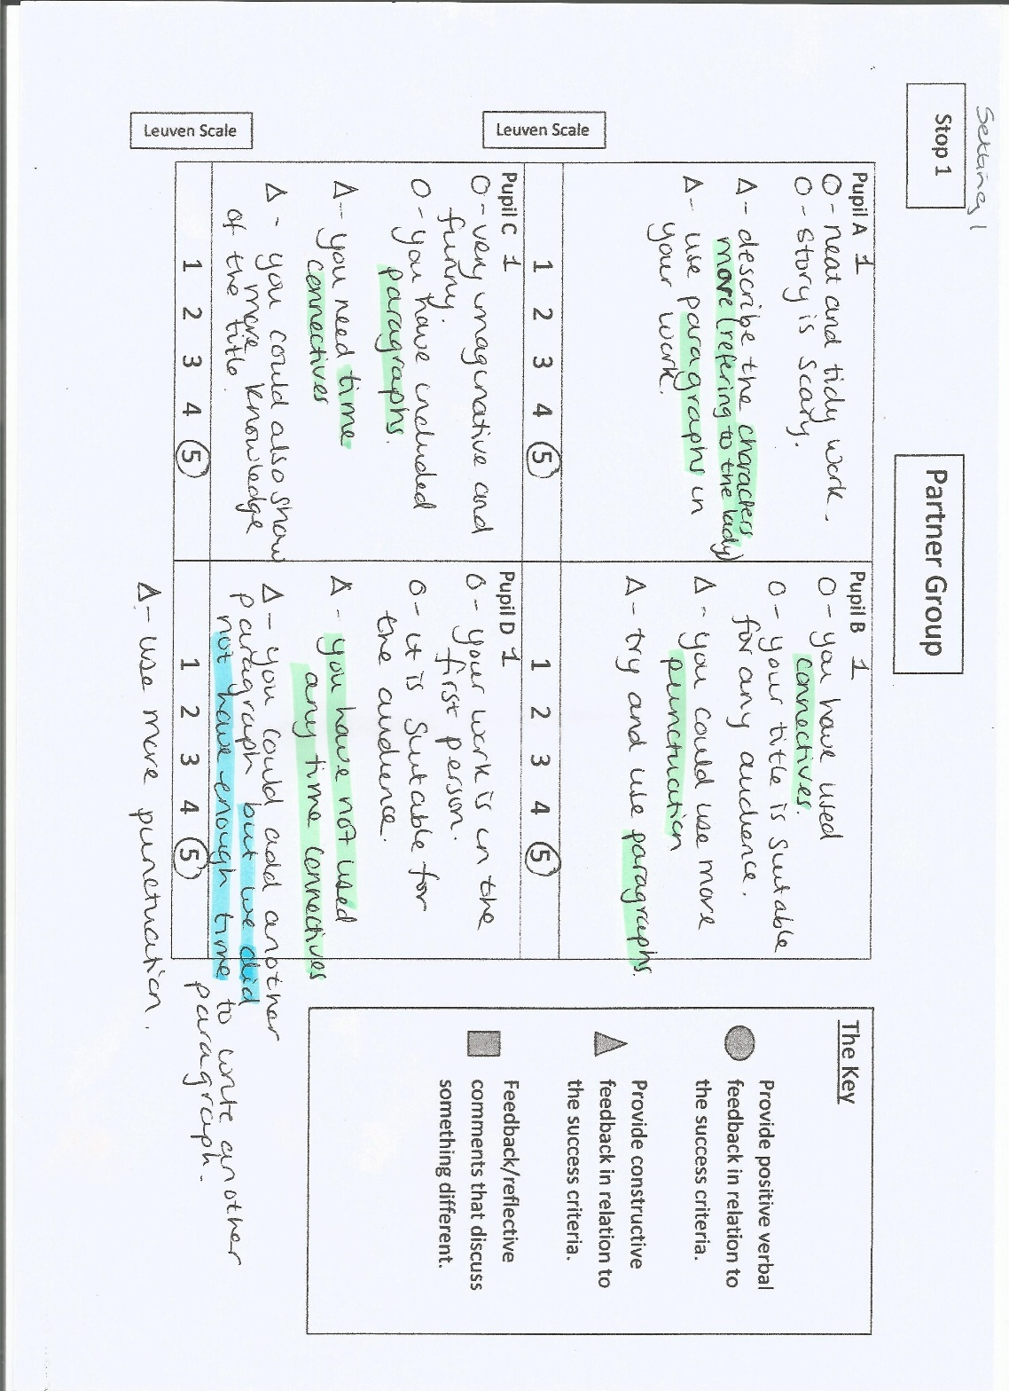

Appendix 7: Observational schedule- Setting 1 stop 3
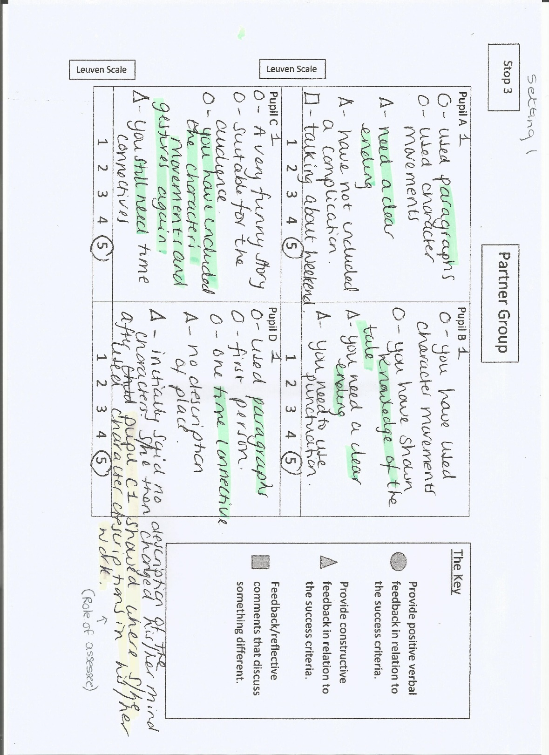

Appendix 8: Observational schedule- Setting 2 stop 1
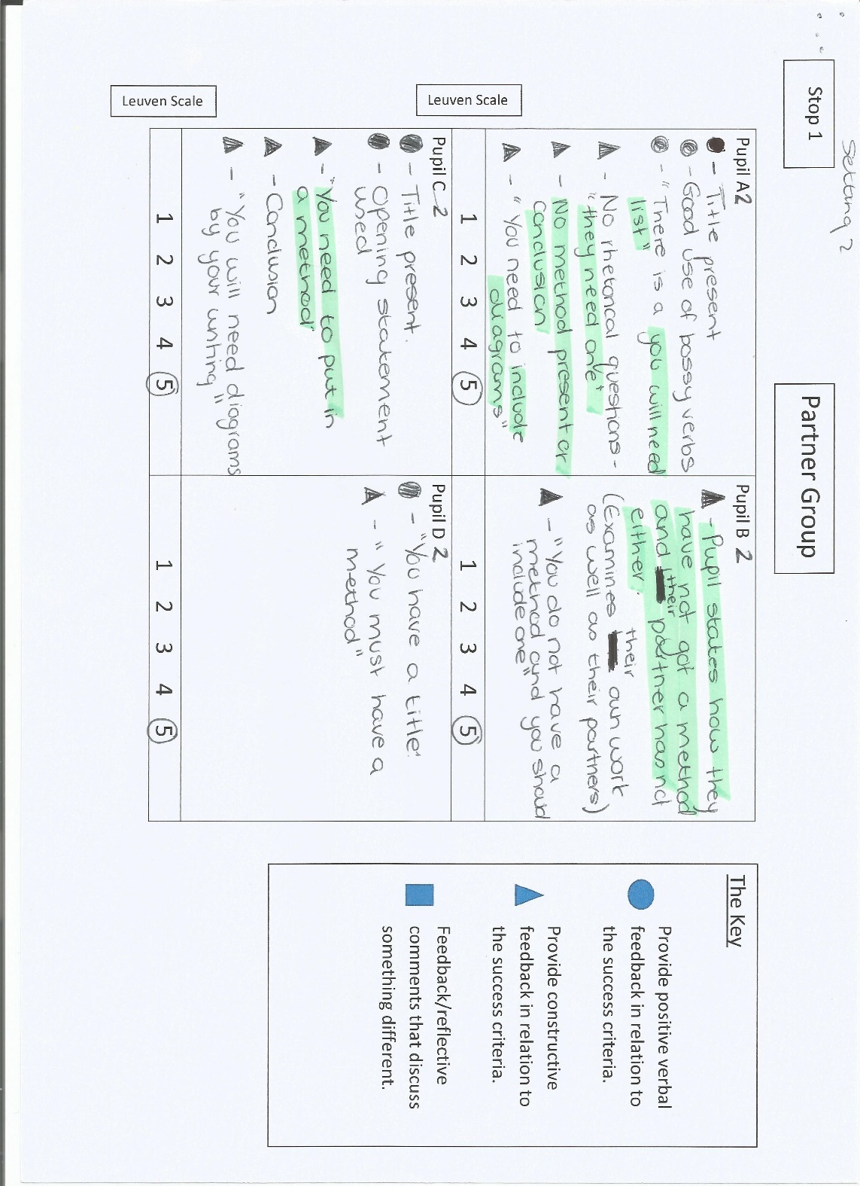

Appendix 9: Observational schedule- Setting 2 stop 2

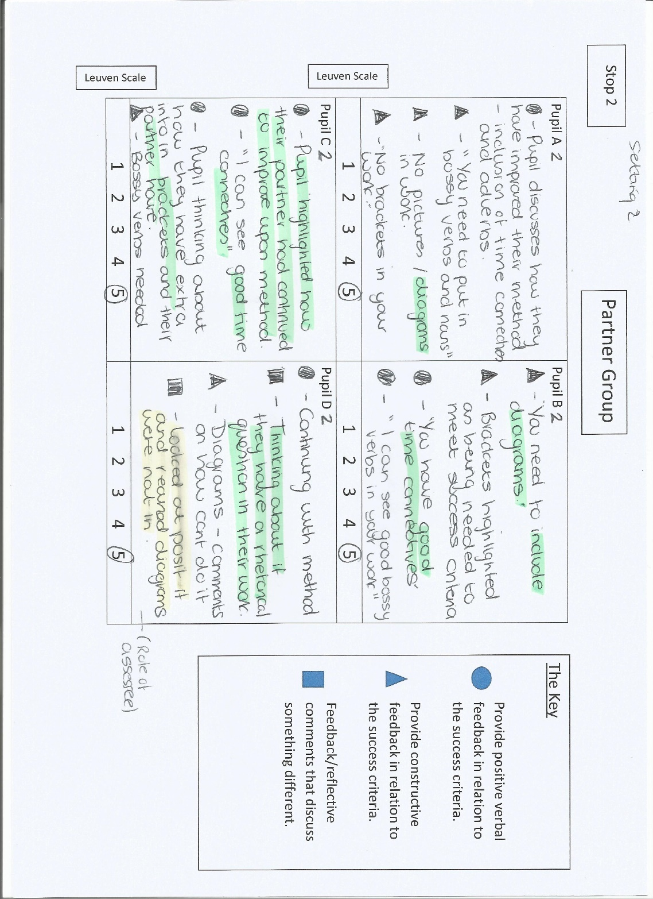

Appendix 10: Observational schedule- Setting 2 stop 3


