Testing Digital Modulation Techniques against AWGN in MATLAB Simulink:

Theo Benjamin David Rose
2114615
L5 - Digital Signal Processing and Communications (ACDA5008)
Embedded Electronics Degree Apprenticeship

Abstract

This work involved creating the modulation/demodulation models of ASK, PSK, QPSK and QAM in MATLAB Simulink [1]. Which were then tested against additive white gaussian signal to noise ratio ranging from 10 dB to -25 dB between the demodulation and modulation to see the effectiveness of each modulation method. Each simulation was run 10 times per noise level and then the average error rate from the model was calculated and plotted on a graph against that associated noise level. The standard deviation between the results are also plotted as error bars. From the results it shows that ASK performed the best when introducing -25 dB of noise into the model however, the standard deviation for ASK was greater than PSK meaning that the data was more spread out and therefore future tests need larger samples to ensure it accurately represents that [2].

Table of Contents
Abstract 2
1 – Introduction 5
2 – Matlab Simulation Models 6
2.1 – ASK 6
2.2 – PSK 6
2.3 – QPSK 6
2.4 – QAM 6
3 – Results 7
3.1 – ASK 7
3.1.1 – Table 7
Graph 8
Observations 9
PSK 10
Table 10
Graph 11
Observations 12
QPSK 13
Table 13
Graph 14
Observations 15
QAM 16
Table 16
Graph 17
Observations 18
Discussion 19
Conclusion 20
References 21

Figure 1 - ASK Simulation Model 7
Figure 2- ASK Filter Settings 7
Figure 3 - ASK Scope Output 8
Figure 4 - PSK Simulation Model 9
Figure 5 - PSK Filter Design 9
Figure 6 - PSK Scope Output 10
Figure 7 - QPSK Simulation Model 11
Figure 8 - QPSK Filter Design 11
Figure 9 - QPSK Scope Output 12
Figure 10 - QAM Simulation Model 13
Figure 11 - QAM Filter Design 13
Figure 12 - QAM Scope Outputs 14
Figure 13 - QAM Constellation Diagram 14
Figure 14 - ASK Table of Results 15
Figure 15 - Graph Showing ASK Average Error Rate 16
Figure 16 - PSK Table of Results 18
Figure 17 - Graph Showing PSK Average Error Rate 19
Figure 18 - QPSK Table Of Results 21
Figure 19 - Graph Showing QPSK Average Error 22
Figure 20 - QAM Table of Results 24
Figure 21 - Graph Showing QAM Average Error Rate 25

1 – Introduction

ASK, PSK, QPSK and QAM are all modulation techniques for transmitting digital data. ASK and PSK is capable of transmitting a single bit per second by changing the amplitude of the signal depending on whether a 0 or 1 bit is being transmitted. Common use cases for ASK/PSK are low frequency RF applications and Wireless LANDs, RFID and Bluetooth.
QPSK is capable of transmitting 2 bits per transmission this is because QPSK has 4 possible phases that it can be. This means that each of the 4 symbols can be mapped to every possible value for a 2-bit binary number meaning that it can send twice the amount of data as ASK and PSK at once. Common use cases for QPSK include satellite transmission and cellular networks.
Lastly, QAM is capable of transmitting 4 bits per transmission this is because QAM combines different phase shifts and different amplitudes so that it can map out 16 possible symbols on a constellation diagram. This allows 16-QAM to send 4 bits of data at once. Common use cases for QAM is within most high-speed data transmission such as cellular networks.
This report will be looking at these 4 different modulation methods and will be testing it against additive white gaussian noise. The bit error rate will then be captured across 10 samples for each level of noise and then the average error rate will be taken. This data will then be presented as a graph and discussed in the report.

2 – MATLAB Simulation Models

2.1 – ASK
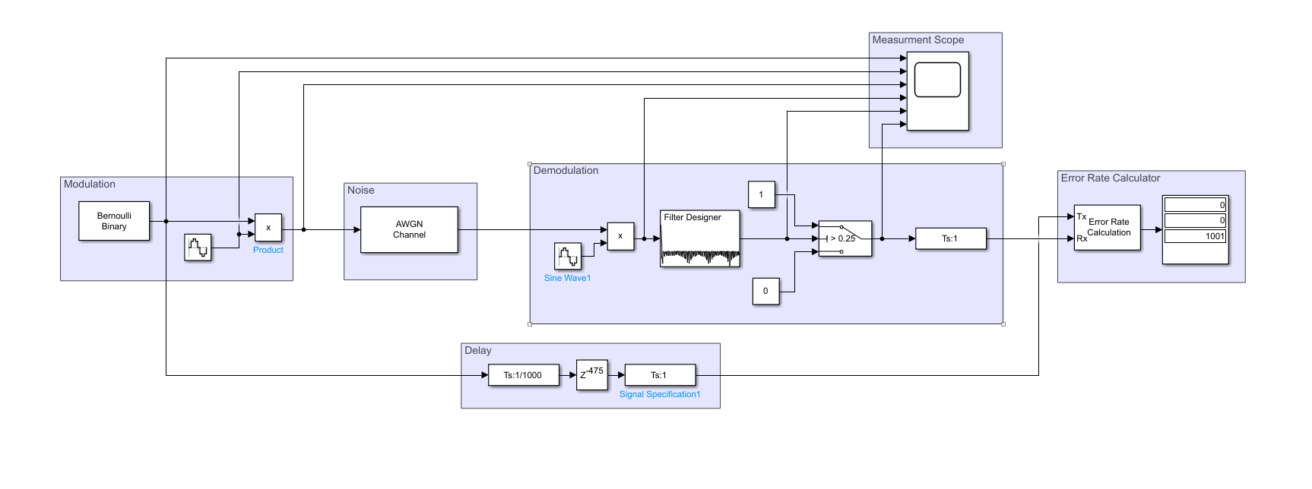
Figure 1 - ASK Simulation Model
The model shown above is simulating amplitude-shift keying or ASK modulation [1]. This is where the amplitude of the transmitted wave is at its highest value when the input binary value is 1 and the transmitted wave is at its lowest value when the input binary value is 0 [3]. The carrier wave for this simulation is set to a frequency of 2 Hz (2*pi*2 in Simulink) with a sample rate of 1/1000. The model works by passing a single binary value every sample frame which is then multiplied by the sine carrier wave using a product block. This means that when a zero is passed to the product block the transmitted wave will be at its lowest value and when a 1 is passed the amplitude will be at its highest value. [4]
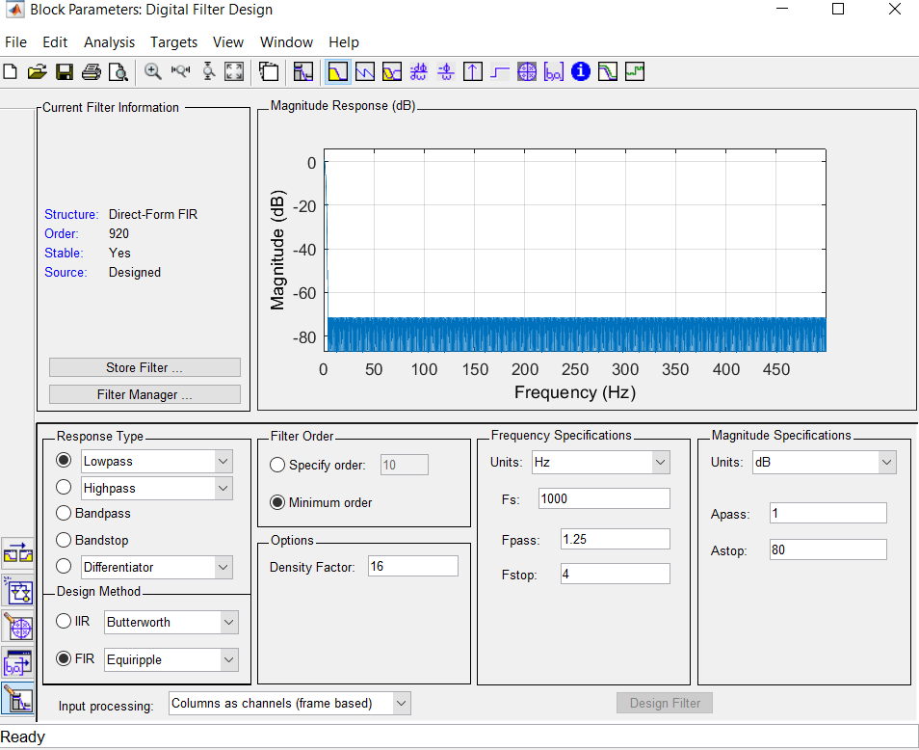
Figure 2- ASK Filter Settings
The transmitted wave is then passed through an additive gaussian noise block which will apply average noise across the signal. The signal is then multiplied by the carrier wave again and passed through a filter which will display the original binary signal sent out with added noise. Shown above is the filter settings for this model. To smooth out the signal it is then passed through a switch with a threshold of 0.25 which means that when the signal is greater than that it will pass the constant 1 and if less than it will pass 0. [4]
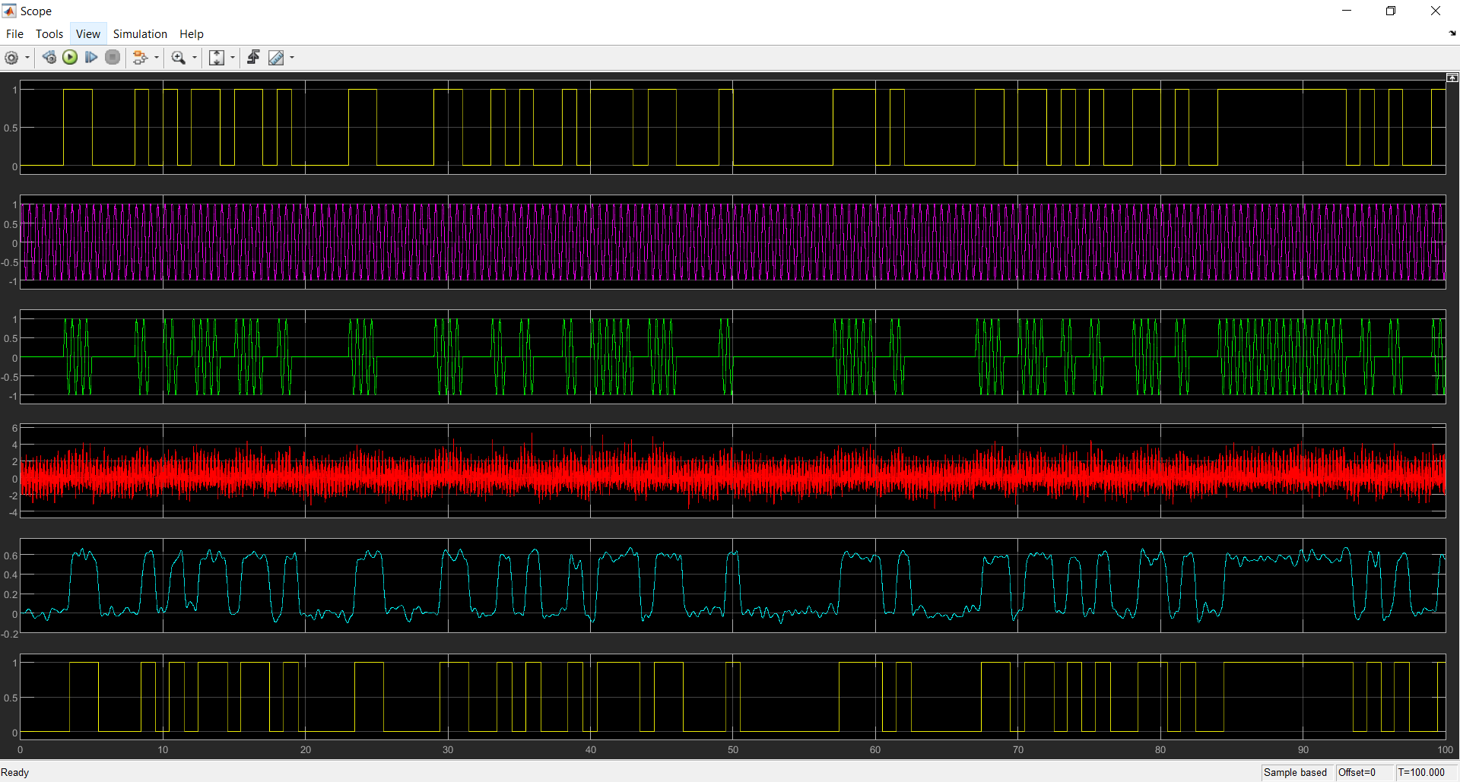
Figure 3 - ASK Scope Output
The measurements shown above in figure 3 show the modulation process of the signal. The first wave shows the input bit stream. The second graph shows the sine wave. The third graph shows the output of the multiplied signals. The forth signal shows the transmitted wave after noise has been and the carrier wave have been applied to the signal. The fifth graph shows the signal after being passed through a filter removing all the unwanted noise. The sixth graph shows the signal after being passed through a switch to square it off.

2.2 – PSK
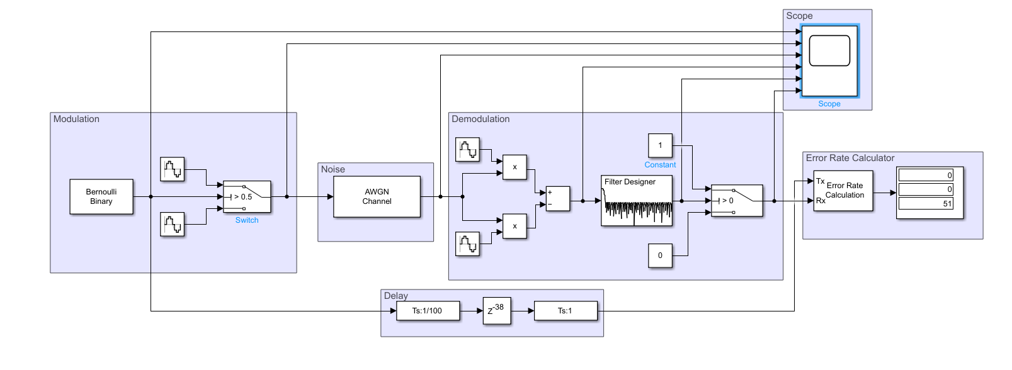
Figure 4 - PSK Simulation Model
The model shown above is simulating phase-shift keying or PSK modulation [1]. This is where the phase of the transmitted wave is at 0 degrees when the input binary value is 1 and the transmitted wave is 180 degrees when the input binary value is 0. The carrier wave for this simulation is set to a frequency of 2 Hz (2*pi*2 in Simulink) with a sample rate of 1/100 and it has two carrier waves one with a phase of 0 and one with a phase of 180 [5]. The model works by passing a single binary value every sample frame which is then passed through a switch with a threshold of 0.5. If the binary output is 1 the carrier wave with the phase of 0 degrees will be passed through whereas if the binary output is 0 the carrier wave with the phase of 180 degrees will be passed through.
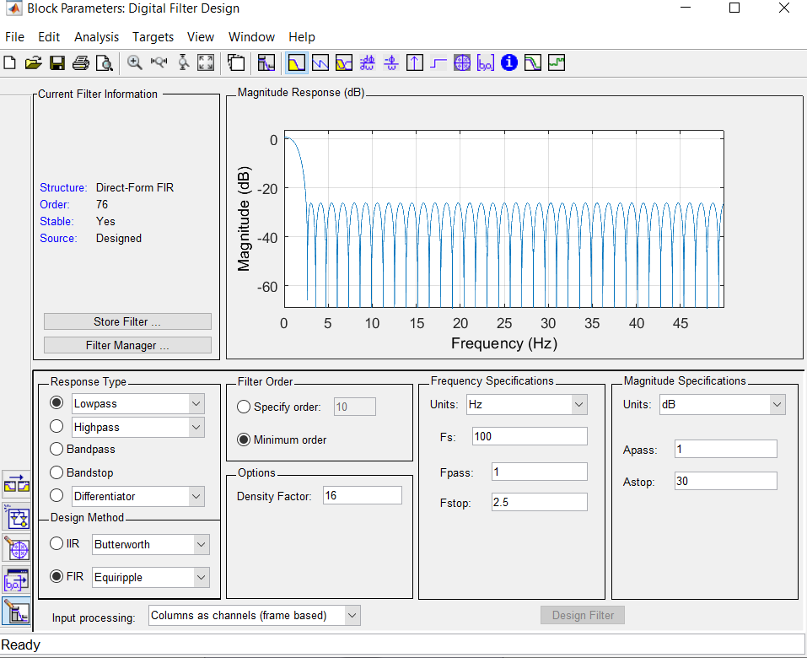
Figure 5 - PSK Filter Design
The transmitted wave is then passed through an additive gaussian noise block which will apply average noise across the signal. The signal is then multiplied separately by each individual carrier wave again and then subtracted form one and another. It is then passed through a filter which will display a signal ranging from 1 to -1 with added noise. Shown above is the filter settings for this model. To smooth out the signal it is then passed through a switch with a threshold of 0 which means that when the signal is greater than 0 it will pass the constant 1 and if less than 0 it will pass 0.
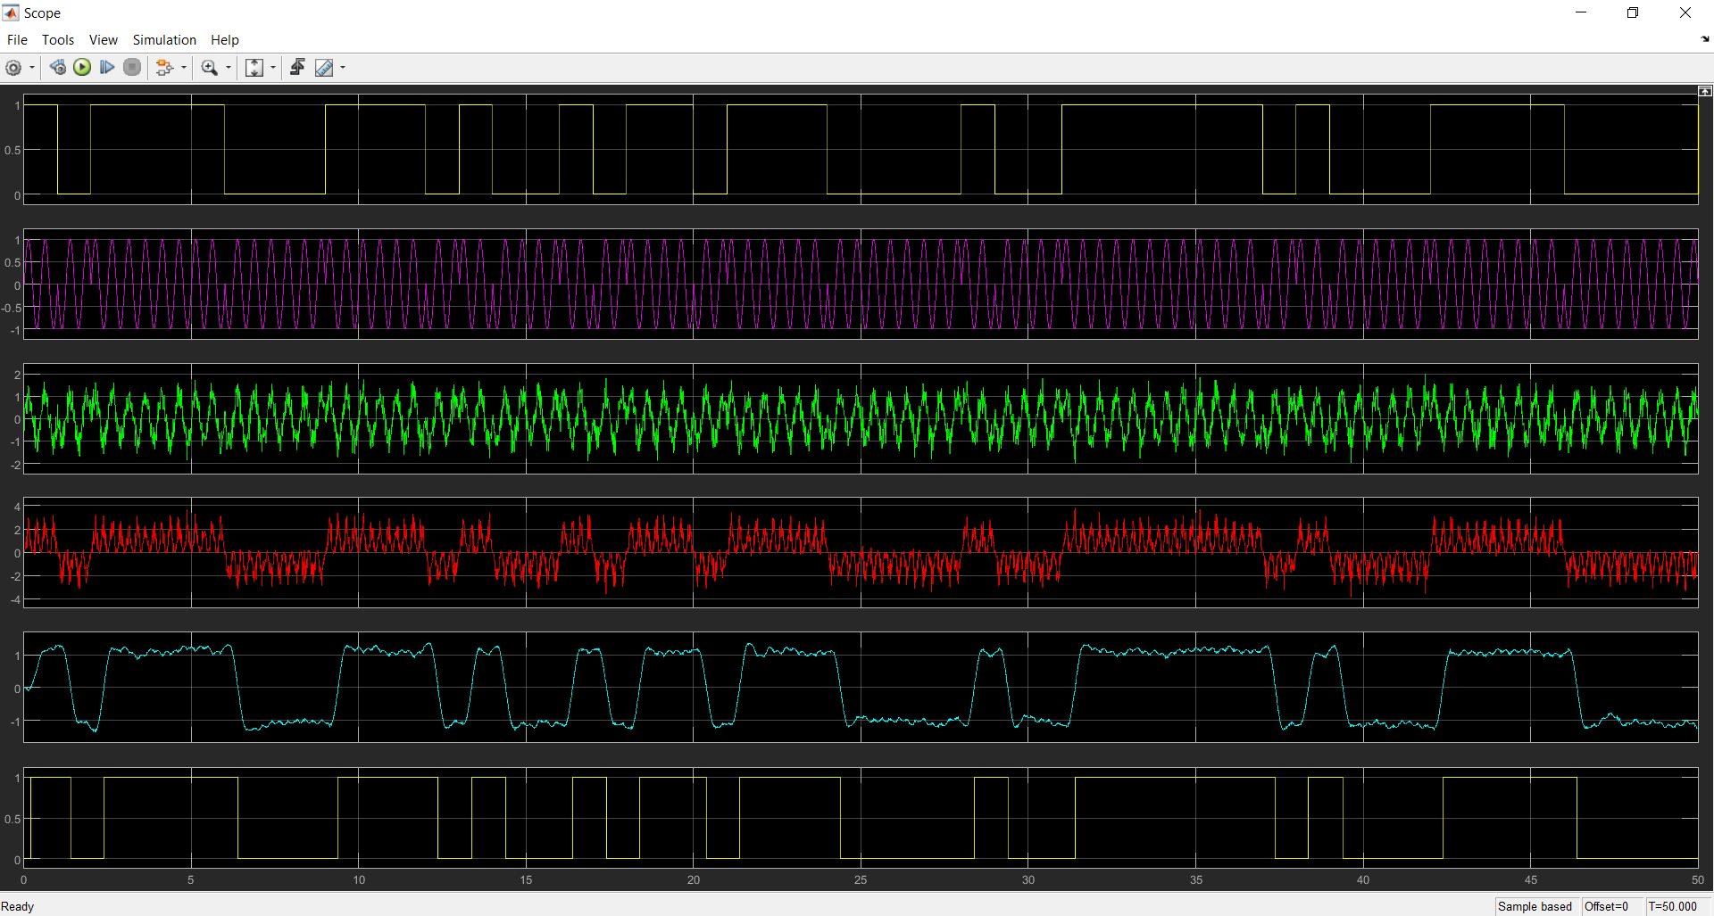
Figure 6 - PSK Scope Output
The measurements shown above show the modulation process of the signal. The first wave shows the input bit stream. The second graph shows the combination of the sine and cosine wave when the bit stream changes values. The third graph shows the transmitted signal after being exposed to noise. The forth signal shows the transmitted wave after each being multiplied by their individual carrier waves and subtracted from each other to produce a signal to ranges from 1 to -1. The fifth graph shows the signal after being passed through a low pass filter removing all the unwanted noise. The sixth graph shows the signal after being passed through a switch with a threshold of 0 so that it becomes the original bit stream again.

2.3 – QPSK
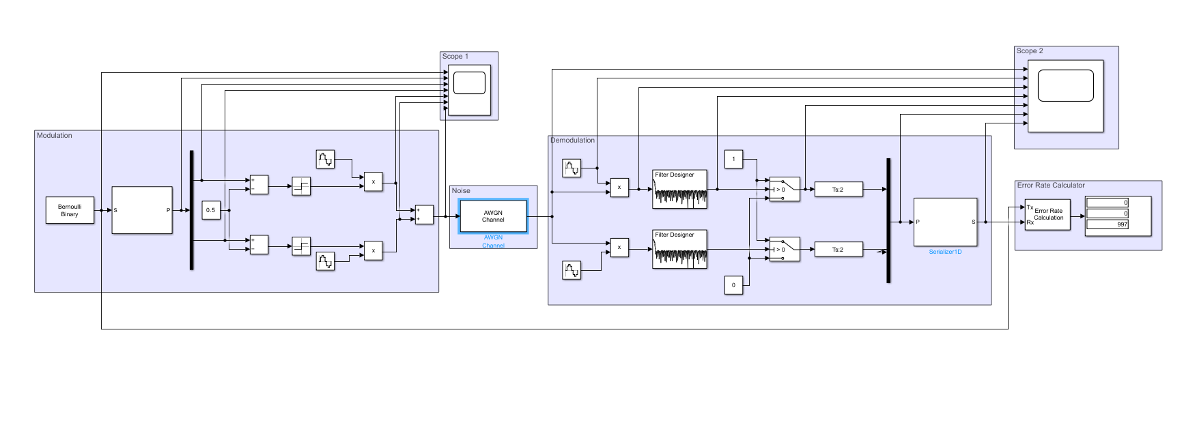
Figure 7 - QPSK Simulation Model
The model shown above is simulating quadrature phase-shift keying or QPSK modulation [1]. This modulation type has a 2-bit rate per second as it is sending two separate data value on two carrier waves with a difference of 90 degrees phase. This results in 4 different types of carrier phase shifts when the two separate carrier waves are added together. These can be 0, 90, 180 or 270 degrees [6]. The carrier wave for this simulation is set to a frequency of 2 Hz (2*pi*2 in Simulink) with a sample rate of 1/100 and it has two carrier waves one with a phase of 0 and one with a phase of 90 degrees. The model works by passing a single binary every sample frame which are then passed through a demux which will split the two data bits into individual streams. This binary number is then passed through a subtraction block with 0.5 and then a signum block which will output either a 1 or -1. This value is then multiplied by the carrier wave of 0 and 90 degrees separately and then added together to produce the 4 different possible phase shifts of the carrier.
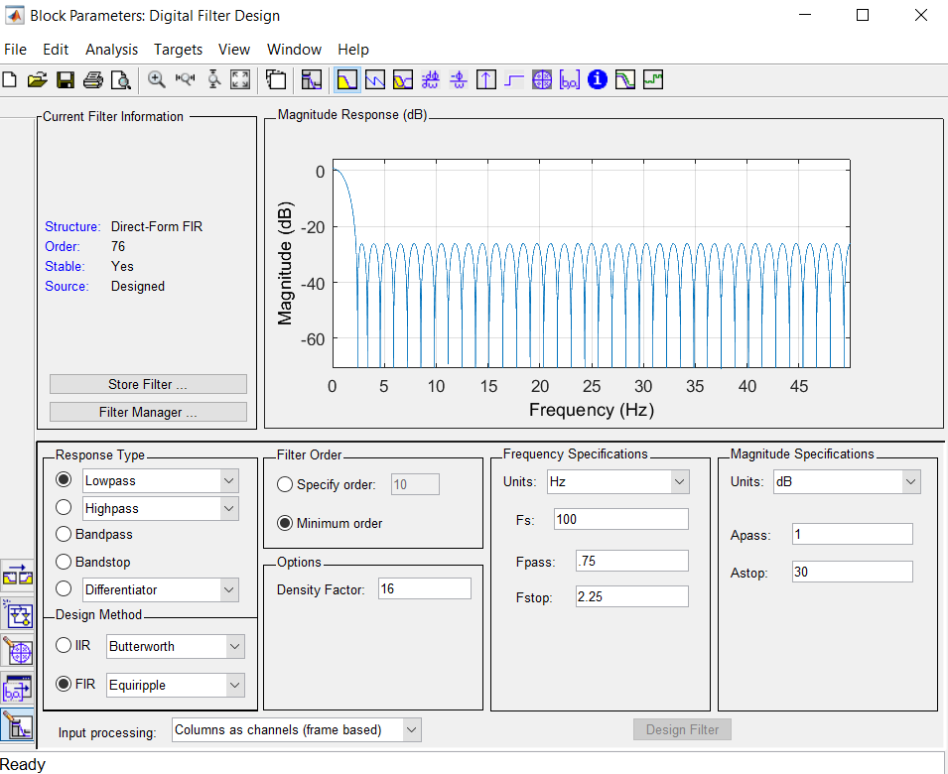
Figure 8 - QPSK Filter Design
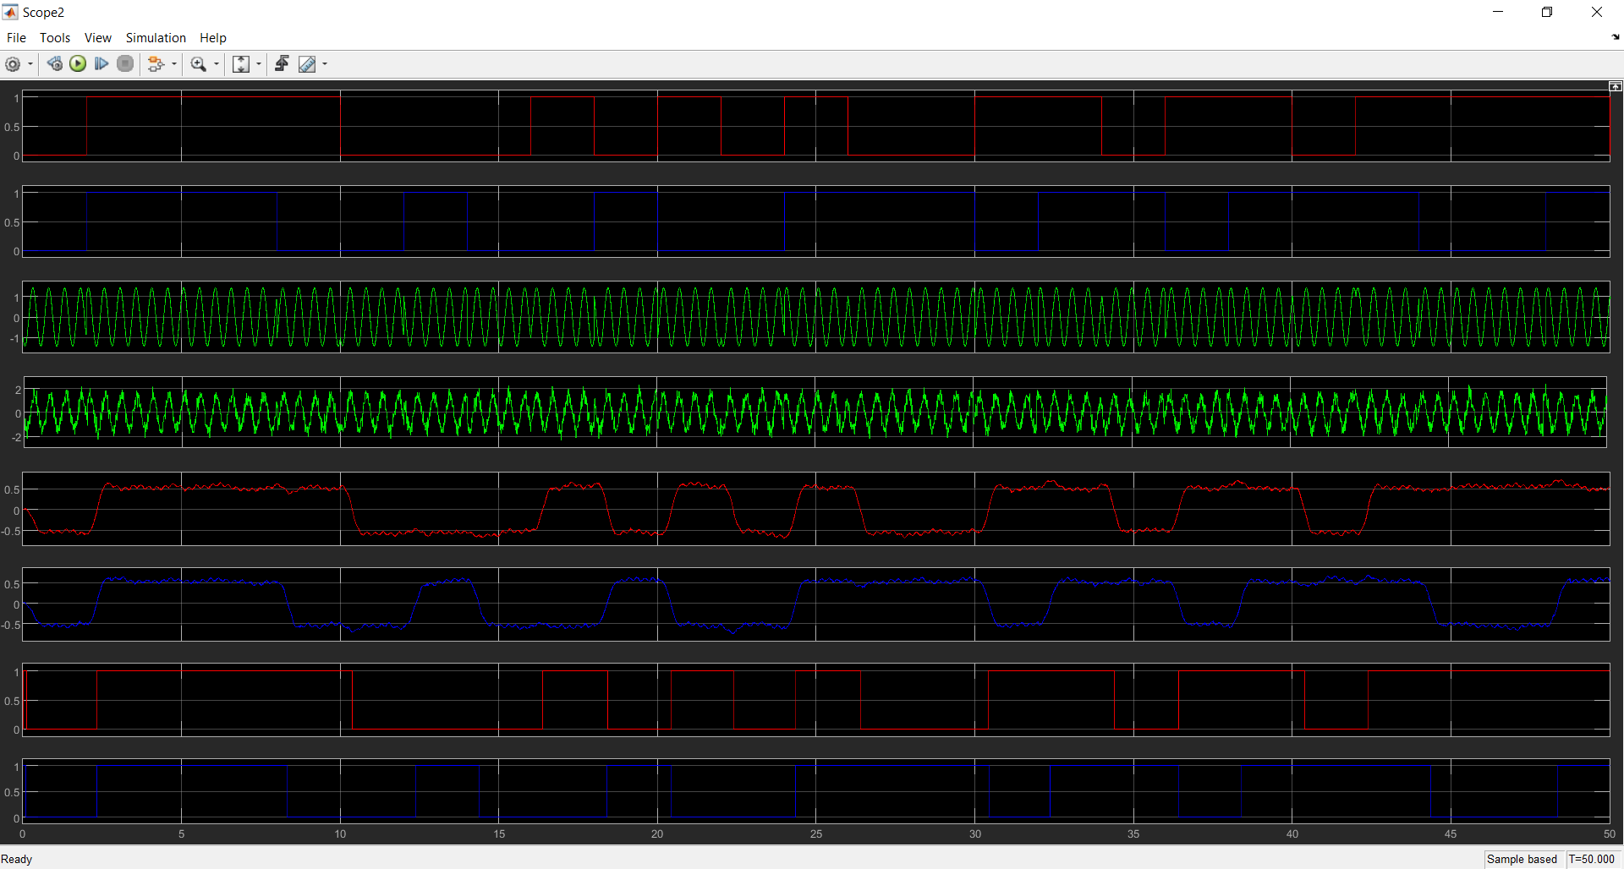
Figure 9 - QPSK Scope Output
The green coloured graphs show the output of the QPSK modulation and you can see the 4 different changes in phase as well as the effect of noise on the signal shown below it.

2.4 – QAM

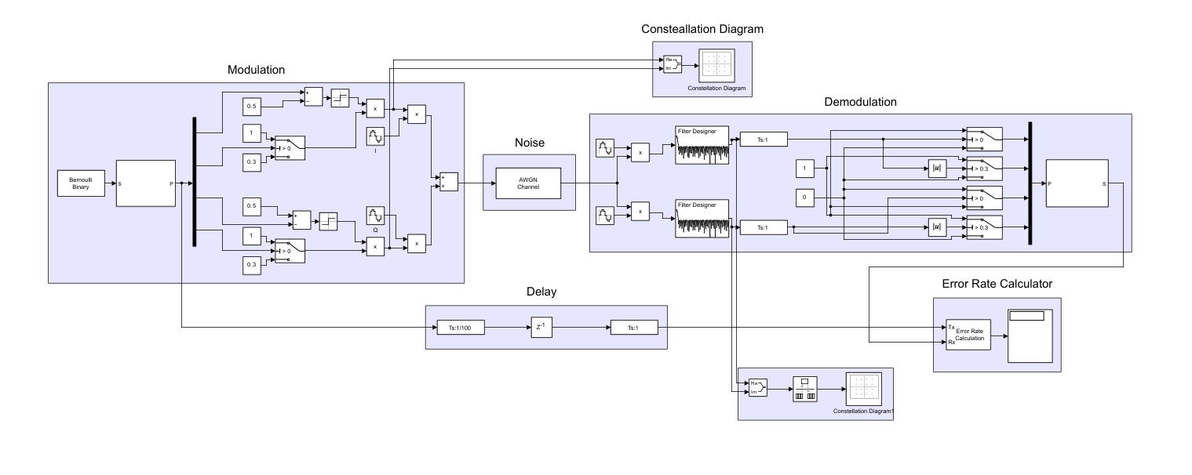
Figure 10 - QAM Simulation Model
The model shown above is simulating QAM modulation [1]. This modulation type has a 4-bit rate per second as it is sending 4 data values on two carrier waves with a difference of 90 degrees phase. This results in 8 different types of carrier phase shifts when the two separate carrier waves are added together. In addition to that it also has 2 different amplitudes which results in a total of 16 different symbols meaning it can send 4 bits of data per transmission.
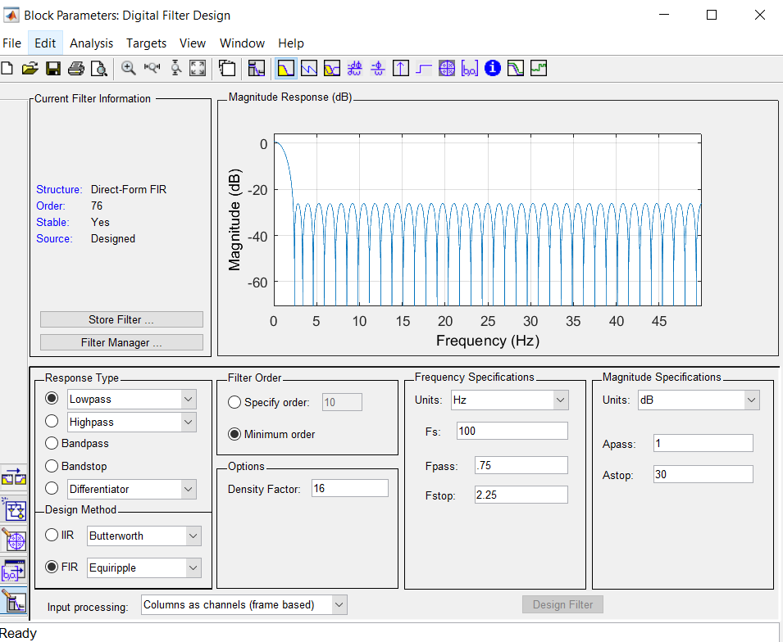
Figure 11 - QAM Filter Design
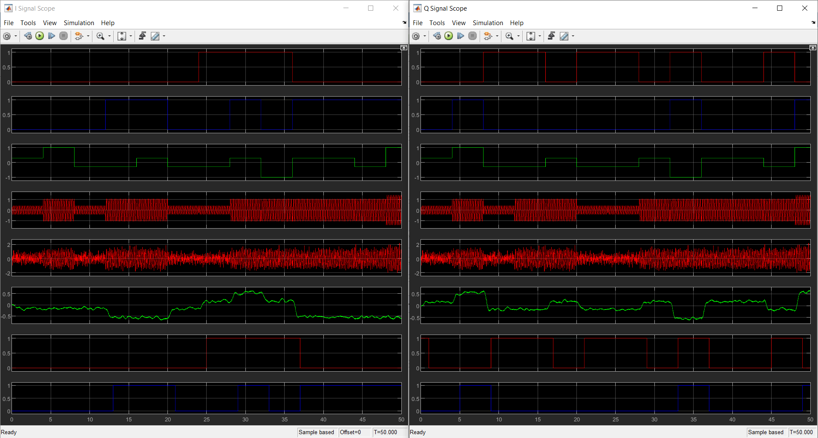
Figure 12 - QAM Scope Outputs
The left window shows the modulation process of the I signal and the left shows the Q signal. The first two graphs show the incoming bit stream for each component. The green graphs show the two separate bit streams encoded into the I and Q signals. The values vary from positive to negative and from 0.5 to 1. The two red graphs show the I, Q and carrier signal combined and the one below is showing it with noise. The green shows it after filtering out the carrier signal.
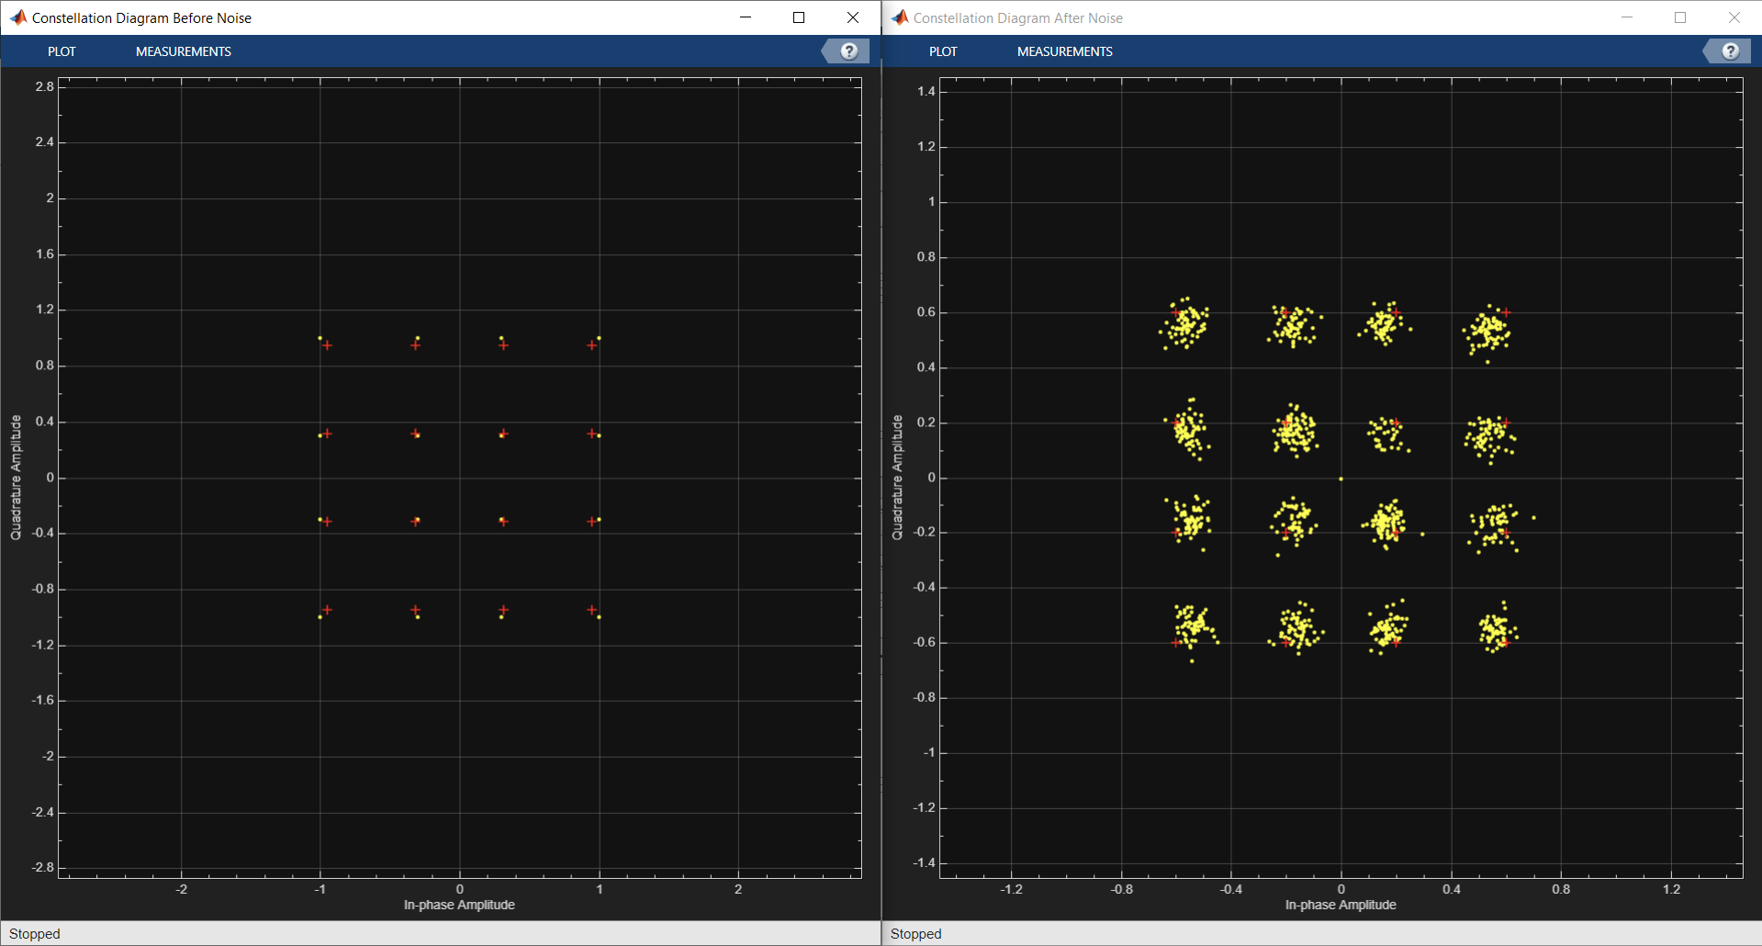
Figure 13 - QAM Constellation Diagram

This shows the before and after constellation diagrams from the noise added to the system.

3 – Results

3.1 – ASK

3.1.1 – Table
Figure 14 - ASK Table of Results

Graph

Figure 15 - Graph Showing ASK Average Error Rate

Observations

The data shows that ASK starts introducing errors at -10 dB and starts to reach a 20% error rate at -18 dB. At the maximum SNR level of -25 dB ASK achieves an error rate of 34.7%. Compared to the other modulation methods it manages to retain a 0 zero error rate at worse noise conditions. However, the standard deviation for the sample of data is higher which means that in order to achieve more reliable results more samples should be taken to help justify the claim that ASK performs better.

PSK

Table
Figure 16 - PSK Table of Results

Graph

Figure 17 - Graph Showing PSK Average Error Rate

Observations

The data shows that PSK starts introducing errors at 0 dB and starts to reach a 27% error rate at -18 dB. At the maximum SNR level of -25 dB PSK achieves an error rate of 36%.

QPSK

Table
Figure 18 - QPSK Table Of Results

Graph

Figure 19 - Graph Showing QPSK Average Error

Observations

The data shows that QPSK starts introducing errors at -5 dB and starts to reach a 26% error rate at -18 dB. At the maximum SNR level of -25 dB QPSK achieves an error rate of 38%.

QAM

Table
Figure 20 - QAM Table of Results

Graph

Figure 21 - Graph Showing QAM Average Error Rate

Observations

The data shows that QAM starts introducing errors at 5 dB and starts to reach a 41% error rate at -18 dB. At the maximum SNR level of -25 dB QAM achieves an error rate of 47%.

Discussion

From the results we can see that ASK modulation performed the best when applying AWGN into the model as it had an average error rate of 0.347 in the worst conditions and it didn’t have any errors until the SNR was put to -10dB which compared to PSK had a difference of -5 dB. This was followed closely by PSK with an average error rate of 0.3619 then QPSK with 0.3862 and finally the worst was QAM with 0.4691.
The results also show that ASK had the highest standard deviation, at the worst signal to noise conditions, out of all the models. This meant that the samples collected had the largest spread from the mean which indicates that on occasion it still performed as bad as PSK but without a larger data set it is difficult to identify which model actually performs better. This happens because the models are simulated by adding average noise to the signal and without a large enough sample/ small standard deviation you can’t say for certain which model performs best.
The expected results were that PSK would perform the best as the phase is less susceptible to noise compared to amplitude modulation. And that QPSK and QAM would perform the worst because they not only transmit more data per second but also use far more complicated methods to modulate the data which involve both amplitude and phase shifting.
The reason ASK and PSK performed better on the average bit error rate is because they are only transmitting 1 bit per second where as QPSK is transmitting 2 bits and QAM is transmitting 4 bits. This means that both QPSK and QAM are more susceptible to more errors as they are transmitting more data at the same rate as the other models meaning that more errors occur.
Compared to PSK and ASK where it can only be 2 symbols, QPSK and QAM have 4 and 16 symbols respectively. When these symbols are plotted on a constellation diagram you can see that the more symbols you have the tighter the groupings need to be for it successfully demodulate the data which further increases the chances of errors occurring.
When you start introducing noise not only will the amplitude be affected but so will the phase. Both these values will directly affect where the points are plotted on the constellation diagram and therefore will cause the groupings to cross the boundaries causing errors. Meaning that the more advanced systems that have multiple different symbols which are in close proximity to each other are susceptible to higher rates of error because any minor changes in phase or amplitude from the additive noise will drastically change where that data is perceived on the constellation diagram.

Conclusion

In conclusion, the results from the simulations show that ASK performed the best when introducing AWGN to the signal. The results show that not only did it achieve the lowest bit error rate compared to all the other modulation methods at -25 dB but it also didn’t produce any bit errors until reaching -10 dB where as the other modulation methods, at best, produced errors at -5dB. This meant that ASK not only produced the least amount of errors at the worst noise conditions but it was the most resilient to noise as well. The next best modulation method was PSK then QPSK and the worst was QAM due to its high error rate at fairly low levels of noise.

References

[1] | Mathworks, “MATLAB,” Mathworks, 2023.
[2] | National Library of Medicine, “Finding and using statistics,” National Library of Medicine, [Online]. Available: https://www.nlm.nih.gov/oet/ed/stats/02-900.html#:~:text=A%20standard%20deviation%20(or%20%CF%83,data%20are%20more%20spread%20out.. [Accessed 09 11 2023].
[3] | S. M. T. Matsumoto, “Theoretical analysis of BER performance in ASK-SS and M-ary/ASK-SS systems using compact matched filter bank for an optical ZCZ code over AWGN channels,” IEEE, 2011.
[4] | G. Smithson, “Introduction to digital modulation schemes,” IEEE, London, 1998.
[5] | V. V. A. Suhartomo, “Comparison of BER Performance for M-ary QAM and PSK on DWT-based OFDM System with PTS Technique Through AWGN Channel,” IEEE, 2020.
[6] | Analogue Devices, “What is QPSK?,” [Online]. Available: https://www.analog.com/en/design-center/glossary/qpsk.html#:~:text=Quadrature%20Phase%20Shift%20Keying%20(QPSK,180%2C%20or%20270%20degrees).. [Accessed 10 11 2023].
[7] | F. Zhang, “Experimental Comparison of Different BER Estimation Methods for Coherent Optical QPSK Transmission Systems,” IEEE, 2011.
[8] | C. S. I. M. A. V. D. T. S. G. M. Lodro, “BER measurement and OTA performance of QPSK receiver in an anechoic chamber,” IEEE, 2018.
[9] | S. M. Sadinov, “Simulation study of M-ARY QAM modulation techniques using Matlab/Simulink,” IEEE, 2017.
[10] | P. S. N. K. V. B. M. -S. A. P. K. Singya, “A Survey on Higher-Order QAM Constellations: Technical Challenges, Recent Advances, and Future Trends,” IEEE, 2021.

