Chapter 4: Analysis of Results
This chapter presents the analysis of data collected through an online questionnaire designed to explore the impact of the role of Police Constable on individual mental health. The primary objective of the research was to determine whether the responsibilities and experiences associated with this role contribute to mental health deterioration. The data collected provides insight into the prevalence of poor mental health among police officers both before and after joining the force, and how this aligns with existing literature on occupational stress in policing. The findings are particularly relevant in the context of increasing awareness of mental health challenges in high-stress professions and the growing body of research that identifies policing as one of the most psychologically demanding careers (Anshel, 2000; Edwards & Kotera, 2021).
The questionnaire received responses from 150 individuals across a range of roles within the police force, including frontline constables, supervisory officers, and staff in both public-facing and non-public-facing positions. The results revealed a significant and consistent increase in reported poor mental health after joining the police. Among Police Constables specifically, 18 out of 76 respondents (approximately 24%) reported experiencing poor mental health prior to joining the force. However, this figure rose dramatically to 54 individuals (71%) after joining, indicating a 47% increase. This trend was not isolated to constables alone. Among those in broader public-facing roles—including Police Inspectors, Chiefs, and Sergeants—68 out of 93 respondents (73%) reported poor mental health after joining, compared to only 19 beforehand. Similarly, when police staff were included in the analysis of public-facing roles, 80 out of 115 respondents (74%) reported poor mental health post-employment, compared to 28 prior to joining.
When considering the entire sample of 150 respondents, which included both public-facing and non-public-facing roles, 42 individuals (28%) reported poor mental health before joining the police, while 100 individuals (66.7%) reported poor mental health after joining. This represents a more than twofold increase in the prevalence of mental health issues, suggesting that the occupational environment and demands of policing may be a significant contributing factor. These findings are consistent with the literature, which highlights the cumulative psychological burden of policing, including exposure to traumatic incidents, irregular shift patterns, high workloads, and organisational stressors such as lack of support and under-resourcing (Purba & Demor, 2019; Violanti et al., 2020).
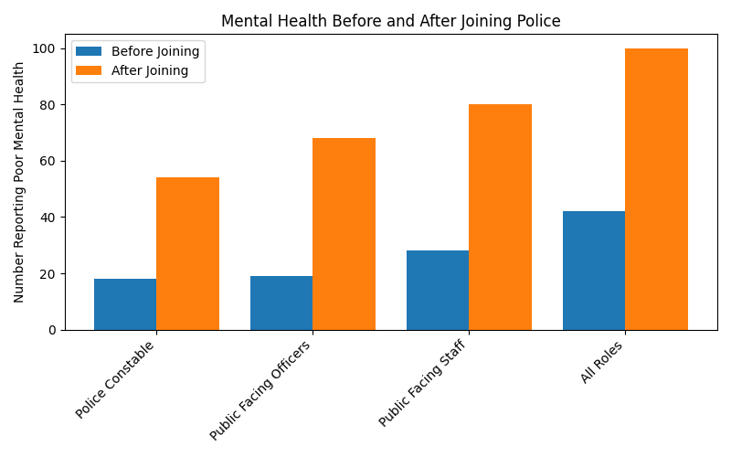

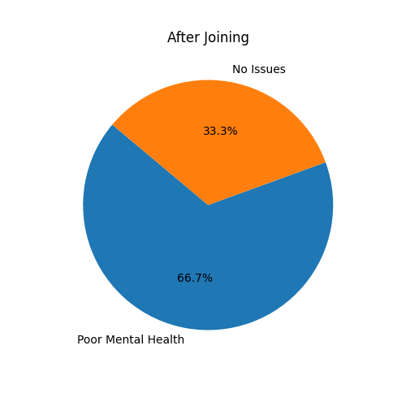
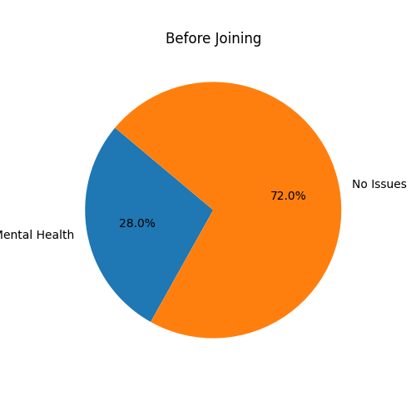
Figure 1: Bar chart showing poor mental health before and after joining the police force.

Figure 2: Pie charts showing distribution of poor mental health before and after joining.
These findings offer strong support for the hypothesis that the role of a Police Constable has a detrimental impact on mental health. The data reveals a significant increase in reported poor mental health after joining the police force, particularly among those in public-facing roles. For example, among Police Constables, only 18 out of 76 respondents reported experiencing poor mental health before joining, compared to 54 after joining—a 47% increase. This trend is mirrored across other public-facing roles, with 68 out of 93 and 80 out of 115 respondents reporting poor mental health after joining. When considering all roles, including non-public-facing positions, the overall increase from 42 to 100 respondents further reinforces the conclusion that the occupational environment of policing contributes substantially to mental health deterioration.
The pronounced increase in poor mental health among public-facing officers suggests that specific aspects of the role—such as exposure to traumatic incidents, high-pressure decision-making, and frequent confrontations—are key contributors. These findings are consistent with Edwards and Kotera (2021), who identified high rates of PTSD, anxiety, and depression among UK Police Constables. The Home Office (2023) also reported that police officers are assaulted on average every ten minutes in the UK, highlighting the physical and psychological risks inherent in the profession.
The literature reviewed in the previous chapter supports the interpretation that both inherent and organisational stressors play a significant role in shaping officers’ mental health. Inherent stressors, as described by Spielberger et al. (1981), include traumatic events, long working hours, and the constant threat of danger. These stressors are unavoidable aspects of frontline policing and are known to have long-term psychological effects. Organisational stressors, on the other hand, are often systemic and include factors such as inadequate staffing, lack of managerial support, and excessive administrative burdens. Purba and Demor (2019) and Davey et al. (2001) emphasised that these organisational issues are particularly damaging because they are often perceived as unnecessary and beyond the control of individual officers.
The data also aligns with research on the impact of shift work and sleep disruption. Violanti et al. (2020) and Kahn et al. (2021) found that irregular shift patterns and chronic sleep deprivation are common in policing and significantly contribute to mental health issues. Officers working night shifts or rotating schedules often experience disrupted circadian rhythms, which can lead to fatigue, irritability, and impaired cognitive functioning. The high prevalence of poor mental health among constables in this study supports the conclusion that shift work is a major contributing factor.
Work-life balance is another critical issue. Donnelly and McKeown (2018) noted that the demanding nature of police work often leads to strained personal relationships and reduced time for rest and recovery. This imbalance can increase vulnerability to stress and burnout. Additionally, Larson et al. (2007) and Chopko et al. (2013) found that substance use, particularly alcohol, is sometimes used by officers as a coping mechanism for work-related stress. These behaviours, while offering short-term relief, can exacerbate mental health problems over time.
Stigma surrounding mental health remains a significant barrier to effective intervention. Harris and Lim (2021) argue that many officers avoid seeking help due to fear of being perceived as weak or unfit for duty. This cultural stigma not only prevents early intervention but may also contribute to underreporting, meaning the actual prevalence of mental health issues could be even higher than the data suggests. Reavley et al. (2022) advocate for peer support programs and open dialogue within police teams as effective strategies to reduce stigma and encourage help-seeking behaviour.
In conclusion, the data obtained from the questionnaire strongly supports the research objective: the role of a Police Constable has a substantial negative impact on mental health. The increase in poor mental health across all occupational categories, particularly among public-facing roles, is consistent with the stressors identified in the literature. These findings highlight the urgent need for comprehensive mental health support within police organisations. This includes evidence-based interventions such as flexible shift scheduling, access to counselling services, peer support programs, and organisational reforms aimed at reducing unnecessary stressors. By prioritising officer well-being, police forces can improve job satisfaction, reduce absenteeism, and enhance the overall effectiveness of the service.

Word count: 1073

References
Davey, J.D., Obst, P.L., & Sheehan, M.C. (2001). Demographic and workplace characteristics which add to the prediction of stress and job satisfaction within the police workplace. Journal of Police and Criminal Psychology, 16, pp.29-39.

Donnelly, J., & McKeown, J. (2018). Stress and Mental Health in Policing: A Review. Police Journal, 91(4), pp.321-339.

Edwards, A.M., & Kotera, Y. (2021). Mental health in the UK police force: a qualitative investigation into the stigma with mental illness. International Journal of Mental Health and Addiction, 19(4), pp.1116-1134. Accessed 25 July 2025. Available at: https://psycnet.apa.org/record/2020-03788-001

Harris, N., & Lim, J. (2021). Reducing Stigma: A Multi-Faceted Approach for Police Officer Mental Health. Policing and Society, 31(2), pp.123-139. Accessed: 25 July 2025.

Home Office (2023). Police Remuneration Review Body Ninth Report England and Wales. Accessed 25 July 2025. Available at: https://www.gov.uk/government/publications/police-remuneration-review-body-ninth-report-2023

Kahn, M., Bärring, V., & Persson, M. (2021). The impact of shift work on sleep patterns among police officers. Sleep Medicine Reviews.

Larson, S.L., et al. (2007). Worker Substance Use and Workplace Policies and Programs. Substance Abuse and Mental Health Services Administration.

Purba, A., & Demor, E. (2019). The relationship between organisational stressors and mental wellbeing within police officers: a systematic review. BMC Public Health, 19, pp.12-86.

Spielberger, C.D., et al. (1981). Stress and Police Work. National Institute of Justice.
Violanti, J.M., et al. (2020). Sleep disturbances and mental health among police officers. Journal of Police and Criminal Psychology, 35(4), pp.367-375.

