L5 Group Project 23-24 (Part-Time) _GRP


1251151 - Morgan James

For the Attention of: Richard Sutton
Course: Mechanical Engineering BEng
Institution: University of Wales Trinity St David
Contents
Figures and Tables 7
Acronyms 8
1.0 Introduction 9
1.1 Foreword 9
1.2 Objective 9
1.3 Implementation 9
2.0 Objectives and Expectations 10
2.1.1 Aims of This Report 10
2.1.2 Objectives of This Report 10
2.1.3 Research and Practical Limitations/Implications 10
2.1.3.1 Research 10
2.1.3.2 Practical 11
2.2 Project Background 11
2.2.1 Aims of the Project 11
2.2.2 Objectives of the Project 12
3.0 Gantt Chart and Project Plan 13
3.1.1 Report Gantt Chart 13
3.1.2 Report Gantt Chart Analysis 15
3.2.1 Project Gantt Chart 16
3.2.2 Project Gantt Chart Analysis 18
4.0 Methodology 20
4.1 Approach for Analysing Management-Based Issues 20
4.1.1 Org Chart 20
4.1.2 PDS 20
4.1.3 Gantt Chart 20
4.2 Analysis of Management-Based Issues 21
4.2.1 Management Style Analysis 21
4.2.2 Time Management Evaluation 21
4.2.3 Communication Assessment 21
4.3 Application of Analytical Methods 21
4.4 Integration of Project Management Techniques and Planning Methods 21
4.5 Validation and Verification Processes 22
5.0 Literature Review 23
5.1 Scope 23
5.2.1 Project Management 23
5.2.1.1 Historical Evaluation 23
5.2.1.2 Theoretical Frameworks in Project Management 23
5.2.1.3 Methodologies and Best Practises 24
5.2.1.4 Contemporary Challenges and Emerging Trends 25
5.2.2 Time Management 25
5.2.2.1 Theoretical Foundations: 25
5.2.2.2 Practical Strategies: 25
5.2.2.3 Psychological Insights: 26
5.2.2.4 Challenges and Opportunities: 26
5.2.3 Communication 26
5.2.3.1 Theoretical Foundations: 26
5.2.3.2 Practical Strategies: 27
5.2.3.3 Challenges and Opportunities: 27
5.3.1 Org Chart 27
5.3.1.1 Significance: 27
5.3.1.2 Types and Uses: 27
5.3.1.3 Challenges: 28
5.3.2 PDS 28
5.3.2.1 Importance: 28
5.3.2.2 Components: 28
5.3.2.3 Benefits: 28
5.3.3 Gantt Chart 28
5.3.3.1 Purpose: 28
5.3.3.2 Components: 29
5.3.3.3 Advantages: 29
6.0 Analysis and Evaluation 30
6.1 Management Style Evaluation 30
6.1.1 PDS 30
6.2 Time Management Evaluation 30
6.2.1 Gantt chart 31
6.3 Communication Evaluation 32
6.3.1 Org Chart 32
7.0 Conclusion and Reflections 32
8.0 References 34
Appendix 38
1.0 PAUT Technicians Interview 38
1.1 Watson Email 38
1.2 Case Study 39
1.3 Job Hazard Analysis for PAUT Compared to Radiography 40
2.0 Meta-Analysis of HNC Project On PAUT Scanner 41
2.1 Introduction 41
2.2 PDS 41
2.3 Project Plan. 41
2.4 Critical Path. 42
2.5 PERT Analysis 42
2.6 Cost Research. 43
2.7 Overall Project Approach 43
3.0 Org Chart 44
4.0 Phased Array carriage PDS 44
4.1 Performance 44
4.2 In service Environment 45
4.3 Life in Service 45
4.4 Maintenance 45
4.5 Target Product Costs 46
4.6 Competition 46
4.7 Shipping 46
4.8 Packing 46
4.9 Quantity 46
4.10 Manufacturing 47
4.11 Size 47
4.12 Weight 47
4.13 Aesthetics, Appearance and Finish 47
4.14 Materials 47
4.15 Product Life Span 47
4.16 Standards and Specifications 48
4.17 Ergonomics 48
4.18 Customer 48
4.19 Quality and Reliability 48
4.20 Shelf Life Storage 48
4.21 Time Scale 48
4.22 Testing 48
4.23 Safety 49
4.24 Legal 49
4.25 Company Constraints 50
4.26 Market Constraints 50
4.27 Patents Literature and Product Data 50
4.28 Political and Social Implication 50
4.29 Instillation 50
4.30 Energy Requirements 51
4.31 User Training 51
4.32 Sales Potential 51
4.33 Documentation 51
4.34 Disposal 52
5.0 Conformance to PDS 56
5.1 Performance 56
5.2 In service Environment 56
5.3 Life in Service 56
5.4 Maintenance 57
5.5 Target Product Costs 57
5.6 Competition 57
5.7 Shipping 58
5.8 Packing 58
5.9 Quantity 58
5.10 Manufacturing 58
5.11 Size 59
5.12 Weight 59
5.13 Aesthetics, Appearance and Finish 59
5.14 Materials 59
5.15 Product Life Span 59
5.16 Standards and Specifications 59
5.17 Ergonomics 60
5.18 Customer 60
5.19 Quality and Reliability 60
5.20 Shelf Life Storage 60
5.21 Time Scale 60
5.22 Testing 61
5.23 Safety 61
5.24 Legal 61
5.25 Company Constraints 62
5.26 Market Constraints 62
5.27 Patents Literature and Product Data 62
5.28 Political and Social Implication 62
5.29 Installation 63
5.30 Energy Requirements 63
5.31 User Training 63
5.32 Sales Potential 64
5.33 Documentation 64
5.34 Disposal 64
6.0 Fredrick Winslow Taylor 64
7.0 QFD 65
7.1 QFD Breakdown 66
7.2 QFD Example 67
8.0 Feedback E-mails 68
9.0 Shannon-Weaver Information Transmission Model 69

Figures and Tables
Figure 1 Report Gantt Chart 13
Figure 2 Report Gantt Chart (continued) 14
Figure 3 Project Gantt Chart View A 16
Figure 4 Project Gantt Chart View B 17
Figure 5 Achieved Timeline (see figure 4 for reference to proposed timeline) 31
Figure 6 Interviews with PAUT Technicians 38
Figure 7 Correspondence with CAN Senior RPS 38
Figure 8 JHA for PAUT 40
Figure 9 JHA for Radiography 40
Figure 10 Lubricant Data Sheet (Ambersil Industrial Devision, 2023) 52
Figure 11 Existing product Cost (Aldom, 2023) 53
Figure 12 Max430 Tough IP67 Rated Case (Trifibre, 2023) 53
Figure 13 IP Rating Breakdown (Clarion , 2023) 54
Figure 14 Safe Lifting Weights (Burton-Hughes, 2021) 55
Figure 15 PAUT Technician Interviews (Lewis, 2022) 55
Figure 16 Tool Weight. (Canadian centre for Ocuupational Health and Safety , 2023) 56
Figure 17 QFD Breakdown (Hessing, 2024) 66
Figure 18 QFD Example (Hessing, 2024) 67
Figure 19 Feedback E-mail 1 (Watson, 2024) 68
Figure 20 Feedback E-mail 2 (Davies, 2024) 68
Figure 21 Feedback E-mail 3 (Howells, 2024) 69

Table 1 Financial Forecast of Job steps 19
Table 2 General Management Vs Project Management (Maylor, 2010) 24
Table 3 Time Management Matrix (Sáez, 2024) 25

Acronyms
AI - Artificial Intelligence
CPM - Critical Path Analysis
JHA - Job Hazard Analysis
MBO - Management by objectives
NDT - Non-Destructive Testing.
OCB - Organisational Citizenship Behaviour
PAUT - Phased Array Ultrasonic Testing
PERT - Project Evaluation Review Technique
PDS - Product Design Specification
PMBOK - Project Management Body of Knowledge
QFD - Quality Function Deployment
RPS - Radiation Protection Supervisor
SMAC - Social, Mobile, Analytics and Cloud
SMART - Specific, Measurable, Achievable, Relevant and Time-Bound
VOC - Voice of Customer
VR - Virtual Reality

1.0 Introduction

1.1 Foreword
The field of mechanical engineering continuously evolves, with innovation playing a key role in the advancement in technology. Giving the advancements a direction and purpose, it is often useful to look back and gain perspective on the professional and ethical conduct of previous innovative projects, through reflection of its implementation.

1.2 Objective
Through this report a detailed analysis of a project, conducted through CAN Group, will be presented. The project featured the design of an ultrasonic phased array scanning carriage. Which was to be used in lieu of radiographic inspection on pipework of a specific criteria. This was for the purpose of seeing improvements in time management and safety. The report will communicate to a technical and non-technical audience the knowledge and understanding of management techniques that have been, or may be, used to achieve the aims and objectives of the project. This will be achieved through a reflective analysis discussing the pros and cons of the projects results and evaluation of its effectiveness demonstrating research into ways in which the implementation could have been improved. Through doing this, information can be extrapolated to be amended, or built upon in future projects.

1.3 Implementation
Initially an overview of the aims and objectives of this report will be given. A Gantt chart denoting the progress plan of this report will be presented and the projects Gantt chart will be discussed. Research into analysing management-based methods within engineering design will be explained along with the rational for selecting the chosen methods, with a further discussion into what project management and planning techniques could be applied and to what effect. A detailed evaluation of the project’s outcomes will be addressed accompanied by a reflection on the personal learning outcomes from the project discussing the strengths and weaknesses identified through analysis, applying academic theories and strategies. The report will conclude with a summary of the key findings, encompassing communication skills, and reflecting on the overall project experience. Additionally, it will offer recommendations based on insights gained, which could be applied to future projects.

2.0 Objectives and Expectations
This report is being written a year after the focus project was concluded and serves the purpose of reflective analysis on the project management and product implementation.
It should be understood that simply because a project is a success does not mean that the company as a whole is successful in its project management endeavours. Excellence in project management is defined as a continuous stream of successfully managed projects
Kerzner, (2009)
Through reflective analysis isolation of areas of both success and failure can be used to better future projects to obtain a successful project portfolio.

2.1.1 Aims of This Report
This report's aim is to offer a thorough analysis and reflection on the phased array scanner project's execution. It aims, through the use of academic theory to analyse project management performance, and gauge how well the applied techniques worked. In addition, the report will look at professional and ethical behaviour within engineering practice, emphasising on participants' mastery of important outcomes, such effective communication, problem-solving skills, project management knowledge, and engineering principles knowledge.

2.1.2 Objectives of This Report
This report's objectives are to methodically review and analyse the phased array project's implementation, with an emphasis on SMART goal setting (Doran, 1981) . These objectives include assessing the performance of the project, identifying its advantages and disadvantages, and assessing the efficacy of existing and prospective project management techniques. In addition, new insights into academic discussions and useful recommendations for future project enhancements will be demonstrated, the objective is to promote comprehension and utilisation of engineering principles within the context of real-world projects.

2.1.3 Research and Practical Limitations/Implications
Limitations are found when areas of data are unable to be measured or assessed, this can be found in areas of the project.

2.1.3.1 Research
As the project only ever reached a prototype stage the availability and quality of data may pose limitations on the accuracy of the analysis of the project’s findings. Small or incomplete datasets could impact the comprehensiveness of the findings (Yohan Kim, 2014). As the project was discontinued and the scanner was not implemented the unique circumstances of the project may restrict the applicability of the findings to other settings.

2.1.3.2 Practical
Resource constraints including budget and personnel, may have an overall impact on the extents on which the report can be carried out. These limitations may restrict the scope of the analysis or the ability to implement recommendations for project improvement.
Organisational factors within CAN Group may limit the availability to publicly share data on the project’s outcome or future revisit. These factors may also limit the analysis of the product itself as availability to the prototype is restricted geographically.

Project Background
Inspection work is implemented at Valero refinery under the Pressure Systems Safety regulations 2000 Approved Code of Practice (HSE, 2000) in which a suitable maintenance programme is outlined which includes:
Reports of examinations carried out under the written scheme of examination by the competent person;
The results of other relevant inspections (e.g. for maintenance or operational purposes) (HSE, 2000)
Therefor improved inspection techniques allow for better options within the examination written scheme and can offer improved results of relevant inspections.
Two commonly utilised NDT techniques used within the written scheme are PAUT and radiography.
Radiography being favoured because of its lower cost and availability of use on a wider range of pipework. The project attempted to implement a way in which to make the safer and less time-consuming option of PAUT a more accessible technique.

Aims of the Project
The limitations of the current Phased array carriages used by CAN have been explained in interviews held with two of the PAUT technicians, (see appendix 1.0). This was considered in the PDS for the project, with their comments being the driving force behind the required change in the new product.
The new product fit the purpose of improving the navigation of smaller bore equipment that is problematic as mentioned by one of the PAUT technicians and supported by Watson, (2023) (appendix 1.1).

Objectives of the Project
The project was implemented to create a benefit to the company in the confidence of the accuracy of the readings taken. This can greatly affect the decisions made by inspection engineers to estimate the duration of pipework. This is supported by a case study (found in appendix 1.2).

Gantt Chart and Project Plan

Report Gantt Chart
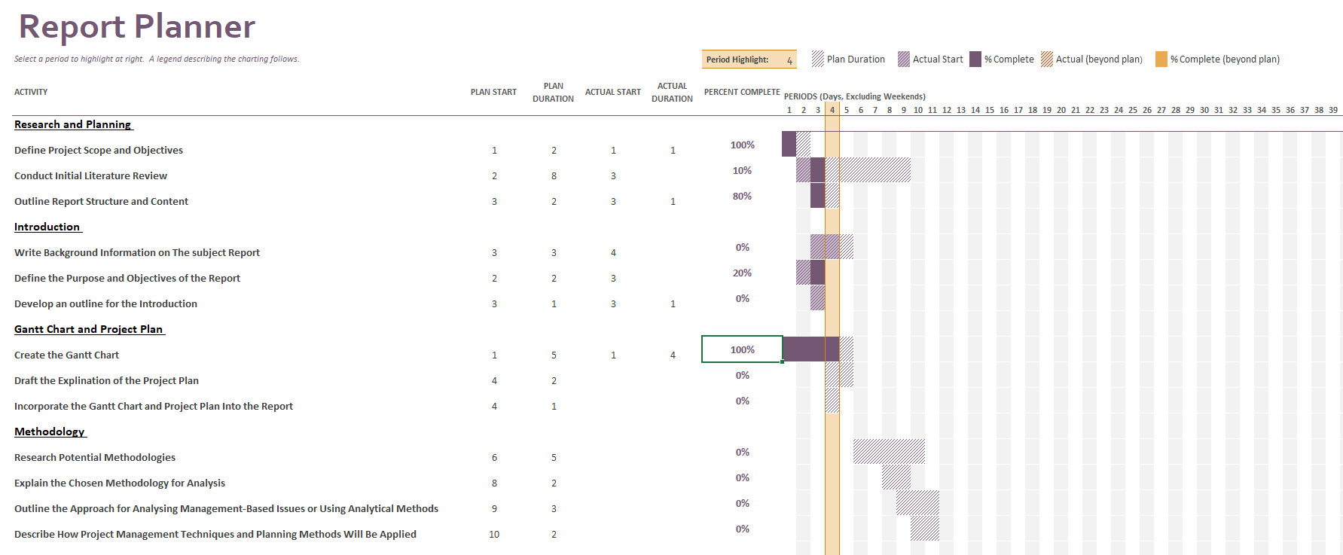
Figure 1 Report Gantt Chart


Figure 2 Report Gantt Chart (continued)

Report Gantt Chart Analysis
An initial image of the Gantt chart made in Microsoft Excel shows a detailed view of the way in which the report will be approached. Considering every niche aspect of the report writing the Gantt chart offers to dissipate the workload into manageable areas making the report easier to manage and deadlines achievable. The use of integrated completion statistics dates add depth to the Gantt chart that enable easier time management allowing for real time feedback on the reports progress (see figure 3 & 4 for the achieved timeline).

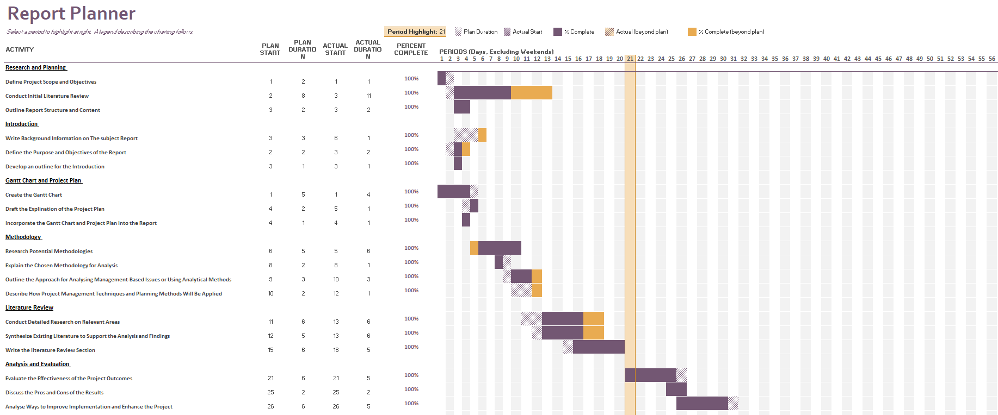
Figure 3 Achieved Timeline 1
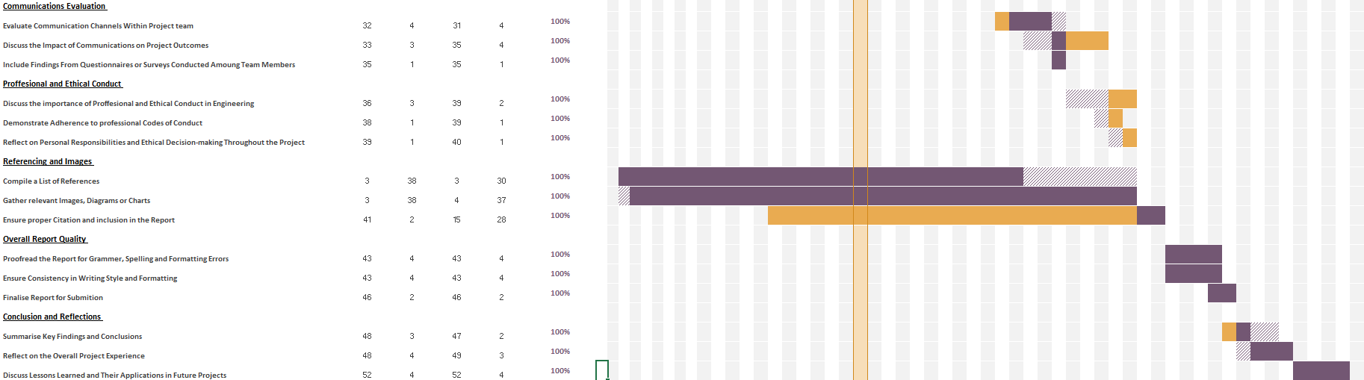
Figure 4 Achieved Timeline 2

As shown in the completed Gantt chart, the use of proposed start date and achieved dates, with highlighted areas of where the project has overrun helps to review the level of progress in real time. As seen later in the report, the evaluation of the Gantt chart used within the project, the achieved timeline is harder to compare with the proposed timeline as the two are shown within separate figures.

Project Gantt Chart
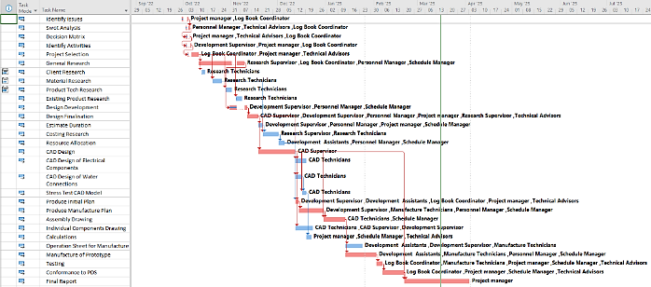
Figure 5 Project Gantt Chart View A
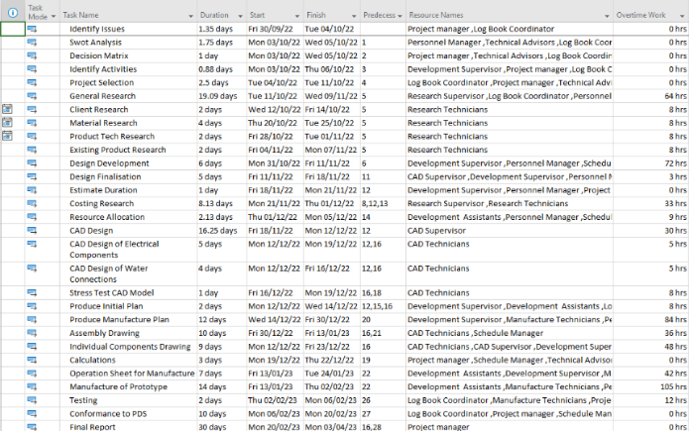
Figure 6 Project Gantt Chart View B

Project Gantt Chart Analysis
The project Gantt chart was used using Microsoft Projects as opposed to excel which offered more usable tools necessary for a more dynamic project like the subject matter of this report. The tool which presented most useful was the task dependencies tool which allowed for the creation of a critical path. The addition of a critical path allowed for a better understanding of the necessary time management of the project. By linking the path from start to finish of tasks critical to the completion, the focus of resources would be theoretically easier to manage. Another useful tool found within Microsoft Projects can be attributed to the resource allocation. This meant the time management of individuals or work groups could be managed into the project plan. This also was acknowledged as a co-operative tool for the development of the cost estimation for the project as the estimated hours could be collated into job steps and applied to a financial forecast for the project through an automated table (table 1) generated within the software
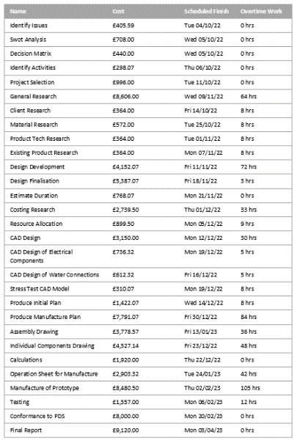
Table 1 Financial Forecast of Job steps

Methodology
In order to comprehensively evaluate the management aspects of the project, a structured methodology has been employed. This encompasses the analysis of organisational structure through the utilisation of an organisational chart (org chart), the alignment of project goals with the PDS, and the evaluation of project scheduling via a Gantt chart. By examining these components, insights into the management-based issues affecting the project's progress and outcomes are clarified.

4.1 Approach for Analysing Management-Based Issues
An initial academic meta-literature review (see appendix 2.0) was carried out and led to selecting the key themes, concepts and research questions relevant to the project. This identified some management-based issues that led to the project failing to get beyond a prototype stage. Acknowledged as drawbacks to the project, the project management style, time management and communication manifested as areas of improvement within the specific areas of the org chart, PDS and Gantt Chart being identified as defective. These have been recognised as the elements of the project which carried the weight of management-based issues.

4.1.1 Org Chart
The org chart (see appendix 3.0) had been used to represent the hierarchy of the team involved in the project by department. Analysis of this has involved examining the lines of authority, communication channels and the distribution of responsibilities within the project. Through this undertaking, identification of bottlenecks, communication barriers and areas of ambiguity in roles and responsibilities have been found. By comparing the used structure and the observed dynamics, inefficiencies can be identified.

4.1.2 PDS
The PDS (see appendix 4.0) outlined the requirements for the product. Analysis has involved reviewing relationship between the stated requirements and the actual project outcomes, helping to identify any deviations in the product design and development stages. By assessing how well the PDS was implemented insights have been gained into known issues such as the competitive market, compliance to the VOC and interaction of components of the design.

4.1.3 Gantt Chart
The Gant chart (see figures 5 & 6) has been used as a visual representation of the projects schedule, displaying tasks, resources, financial information and a critical path. Its analysis has involved assessing the application, adherence to the planned schedule, the critical path and resource constraints. In doing so benefits can be seen in the evaluation of the project management style, specifically in resource allocation and scheduling decisions. By comparing the planned schedule with the achieved timeline issues have been acknowledged of inadequate planning.

4.2 Analysis of Management-Based Issues
The following is a comprehensive approach to analyse the management-based issues identified within the project, namely, management style, time management and communication. The analysis which has been informed by the meta review of the project will be focusing on the observations made on project documentation such as the PDS, Gantt chart and the org chart.

4.2.1 Management Style Analysis
An examination of the predominant management style observed throughout the project’s lifecycle has been conducted. The approach to leadership, decision making and team dynamics influenced by the management style have been analysed. Emphasis being placed on grasping the influence management strategy impacted the formulation of the PDS, ultimately affecting the project outcomes.

4.2.2 Time Management Evaluation
The analysis has questioned the time management strategies, identifying any discrepancies or bottlenecks from the planned schedule that have contributed to project delays, investigating deviations from project progress and meeting of project milestones compared to those found in the Gantt chart.

4.2.3 Communication Assessment
The clarity, frequency and effectiveness of the communication within the project has been critiqued through an analysis of communication pathways established through the org chart. The investigation has queried the communication breakdowns or inefficiencies, impacted collaboration, decision making and overall project consistency.

4.3 Application of Analytical Methods
The analysis has used qualitative and quantitative methods to clarify the complexities of project management-based issues. Qualitative analysis techniques such as thematic coding and content analysis will be utilised to highlight patterns and themes within the project documentation. Quantitative analysis will include statistical measures on the impact of management practises on project performance metrics.

4.4 Integration of Project Management Techniques and Planning Methods
An integration of established project management techniques and planning methods have been used to improve on the findings. Concepts such as time management matrix’s, VOC engagement and agile methodologies will alter the relationship between the management strategies and project outcomes.

4.5 Validation and Verification Processes
This will involve referencing findings from multiple sources integrating data from different perspectives and seeking feedback from those involved in the project.

Literature Review

5.1 Scope
The key themes have been focused on communication, project management and time management. Taking these key themes, they have been aimed at some of the concepts that have been used within the project such as the PDS, organisational chart and the Gantt chart and its surrounding time management concepts.

5.2.1 Project Management
Project management is a multifaceted discipline crucial for the successful execution of initiatives across various industries. As a fairly new role and one that has often been accidentally found by people in a variety of industries (Heerkens, 2001) organisations strive to deliver projects efficiently and effectively. Understanding the theoretical foundations, best practices, and emerging trends in project management, becomes imperative (Lock, 2022). This literature review aims to explore the landscape of project management literature, offering insights into its evolution, key theoretical frameworks, methodologies, and contemporary challenges.

5.2.1.1 Historical Evaluation
Although history shows us great projects have been completed without the defined role. The stipulations where lower as the projects seen today. In the modern age, expectations are higher and the need for project management is much greater. (Simon, 2018) The origins of modern project management begin in the early 20th century with the development of scientific management principles by Frederick Taylor (see appendix 6.0). However, it was during the mid-20th century that project management began to emerge as a distinct discipline, with scholars like Henri Fayol and Henry Gantt laying the groundwork for its theoretical underpinnings. The 1950’s was the emergence of a structured approach, where numerical methods were developed such as PERT, for quantifying uncertainty during the development of planning along with alternative management approaches such as MBO, developed by Peter Drucker in 1954 (Mind tools Content Team, 2024). In the following decade methodologies such as CPM revolutionised project planning and scheduling. The 1990’s brought about a standardisation of approach through the development of professional associations such as the association for project management. As for the last two decades or so with the development of communications technology, an emphasis on strategy has been adopted (Maylor, 2010).

5.2.1.2 Theoretical Frameworks in Project Management
Project Management can often be compared to general management (see table 2); however, it brings its own unique set of disciplines in which a person is required to lean on to complete a successful project. 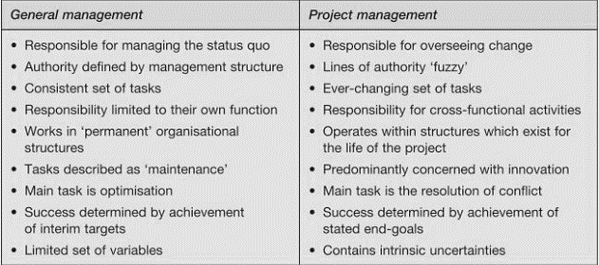
Table 2 General Management Vs Project Management (Maylor, 2010)
Central to the field of project management, various theoretical frameworks provide a basis for guiding managerial decision-making. Among these, (Haniff, 2016) discusses, the Systems Theory offers a holistic perspective on projects as complex systems comprising interrelated components and stakeholders. Similarly, the Contingency Theory emphasises the importance of adapting project management approaches to the unique characteristics of each project environment. Furthermore, the Stakeholder Theory highlights the significance of identifying and managing the diverse interests of stakeholders throughout the project lifecycle.

5.2.1.3 Methodologies and Best Practises
Effectively project managing becomes about the team and understanding their driving factors to encourage an environment in which egos aren’t challenged, but ideas instead. Something to consider is cultural environment and what that means to the project. For instance, an all inspiring speech would work within a US company but something much subtler would be required for the UK. (Bruce, 2000) A wide range of project management methodologies and best practices have been developed over the years to enhance project outcomes.
With greater emphasis now on the strategic management of projects in organisations and the increasing need to integrate projects with business strategy. Winter,(2007).

Traditional approaches such as Waterfall methodology prioritize project phases, while agile methodologies like Scrum and Kanban advocate for incremental project delivery (Lal, 2018). Additionally, the PMBOK framework defines the essential processes, tools, and techniques involved in project management, serving as a comprehensive guide for practitioners.

5.2.1.4 Contemporary Challenges and Emerging Trends
In the current landscape, project managers grapple with a numerous amount of challenges ranging from resource constraints and stakeholder conflicts to technological disruptions and geopolitical uncertainties (Salama, 2021). Moreover, emerging trends such as AI, big data analytics, and VR are reshaping practices, offering new opportunities for efficiency gains and innovation (Zasa, 2021). However, these trends also pose new challenges related to data security, ethics, and skill requirements.

5.2.2 Time Management
In the fast-paced landscape of today's society, mastering time management is essential for achieving personal and professional goals. However, (Hellsten, 2012) says there is a lack of a theoretical model of time management. The following is an in-depth exploration of the theoretical foundations, practical strategies, psychological insights and opportunities in the field of time management.

5.2.2.1 Theoretical Foundations
Time management theories are rooted in psychology and organisational behaviour, quality time over the quantity of time is what matters (Fleet, 2021). Focusing on concepts such as goal-setting, prioritisation, and decision-making can vastly improve time management. Notable frameworks, such as Stephen Covey's Time Management Matrix (Table 3) offer structured approaches to task management and resource allocation, simplifying effective time utilisation.
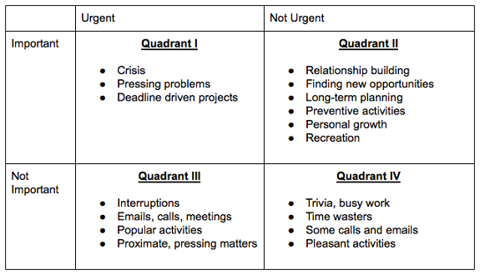
Table 3 Time Management Matrix (Sáez, 2024)

5.2.2.2 Practical Strategies
A diverse array of strategies and techniques exist to assist in managing time efficiently. From traditional methods like the Pomodoro Technique, which advocates for breaking work into focused intervals (Biwer, 2023), to modern digital tools like Todoist (Todoist, 2024) and Trello (Atlassian, 2024), which provide organisational support and task tracking functionalities. Additionally, practices such as time blocking and task prioritisation empower individuals to allocate their time effectively (Hutmanová, 2022), maximising productivity and minimising procrastination.

5.2.2.3 Psychological Insights
Behavioural science shed light on the psychological factors influencing time management behaviour. OCB is defined as,
Contributions to the maintenance and enhancement of the social and psychological context that support task performance. Organ, (1988)
And is utilised to aid in the accumulative efforts of a group collaborating on a concept or task. Implementation of OCB must be issued responsibly to avoid reaching a point of diminishing returns. Concepts such as time perception, self-regulation, and cognitive biases play crucial roles in shaping individuals' time management habits (Rapp, 2013). Understanding these psychological mechanisms can help overcome common hurdles and adopt more effective time management strategies.

5.2.2.4 Challenges and Opportunities
While advancements in technology have provided new tools and opportunities for managing time, they have also introduced new challenges. The spread of digital distractions and the steady integration of work and personal life in remote work environments pose significant challenges to effective time management (Gaffin, 2023). However, these challenges also present opportunities for innovation, with the potential for AI assistants and scheduling algorithms to revolutionise the way individuals manage time in the future (Rampton, 2023).

5.2.3 Communication
Effective communication is essential for fostering understanding, collaboration, and productivity in personal and professional contexts (Brewer, 2016). This review explores the theoretical foundations, practical strategies, psychological insights, and technological advancements in the realm of communication.

5.2.3.1 Theoretical Foundations
Communication theories draw from diverse fields such as psychology, linguistics, and sociology. Models like Shannon-Weaver's Communication Model (Weaver, 1950) and Grice's Cooperative Principle (Grice, 1975) provide frameworks for understanding communication and factors influencing its effectiveness.

5.2.3.2 Practical Strategies
A wide range of strategies exist to enhance communication effectiveness. Active listening, empathetic communication, and clarity in message delivery are fundamental skills. (Samfira, 2020) says, techniques such as assertive communication and non-verbal communication awareness contribute to successful interactions in a way that conveys ideas or feelings without disrupting the rights of other people.

5.2.3.3 Challenges and Opportunities
While advancements in technology have revolutionised communication, they also present challenges such as information overload which attribute to losses of an estimated $650 billion worldwide each year (Roetzel, 2019) , which can lead to decreased productivity and decision-making. Additionally, the potential for misinterpretation in digital communication channels (Laumeister, 2011) poses risks to effective communication.
Technological innovations continue to offer new avenues for connectivity and collaboration. Video conferencing platforms enable face-to-face interactions regardless of geographical barriers, fostering more engaging and personal communication. Instant messaging applications facilitate real-time communication, enhancing team collaboration and responsiveness (Adriana, 2023). SMAC provide opportunities for networking, knowledge sharing, and community building, enabling organizations to reach broader audiences and engage with stakeholders in meaningful ways (Linnes, 2021). Embracing these technologies can be useful tools to individuals and organisations to overcome challenges and unlock new opportunities for growth and innovation.

5.3.1 Org Chart
Organisational charts (see appendix 3.0 for project org chart) serve as visual representations of hierarchical structures within an organisation, depicting reporting relationships, divisions of labour, and lines of authority. This brief review outlines the significance, types, uses, and challenges associated with organisational charts.

5.3.1.1 Significance
Organisational charts provide clarity on roles and responsibilities, aiding communication, decision-making, and coordination. They offer a snapshot of the hierarchy and help employees understand their place in the larger structure. (Aita, 2016)

5.3.1.2 Types and Uses
Organisational charts come in various formats, including hierarchical, matrix, and flat structures, each suited to different contexts. They are utilised for orientation, workforce planning, and restructuring, facilitating effective management and resource allocation. (Organ, 2023)

5.3.1.3 Challenges
Despite their utility, organisational charts may oversimplify complex relationships and fail to capture informal networks or dynamic changes (May, 2009). Additionally, maintaining updated charts can be challenging in rapidly evolving environments.

5.3.2 PDS
PDS documents serve as blueprints for product development outlining design requirements, features, and functionalities. This concise review highlights the importance, components, and benefits of product design specifications.

5.3.2.1 Importance
PDS documents articulate stakeholders' expectations and guide the product development process from conception to realisation. They ensure alignment between design teams, stakeholders, and manufacturing partners, minimising errors and maximising efficiency. (Xiao-Jie, 2017)

5.3.2.2 Components
A typical PDS includes sections on product objectives, technical specifications, performance criteria, and regulatory requirements. It may also cover user requirements, aesthetic considerations, and design constraints, providing a comprehensive framework for product development (Branco, et al., 2020). A PDS is often driven by the VOC, governmental specifications and contemporary designs. This information can be collated in a QFD which takes the VOC requirements and compares them against the competition and design necessities (Ginting, 2023) which is a useful tool to use before constructing the PDS.

5.3.2.3 Benefits
Clear and detailed PDS documents facilitate effective communication, mitigate risks, and enhance the quality of the final product. They serve as reference points throughout the development lifecycle, guiding decision-making and enabling iterative improvements. (Guthrie, 2022)

5.3.3 Gantt Chart
Gantt charts are visual project management tools that display tasks, timelines, and dependencies in a structured format first used by henry Gantt in 1910 (Learning Gantt Charts, 2015). This brief overview outlines the purpose, components, and advantages of Gantt charts in project planning and tracking.

5.3.3.1 Purpose
Gantt charts provide a visual representation of project schedules, allowing project managers to plan, coordinate, and track progress efficiently being hailed as the 4th most useful tool out of a set of 70 project management tools in a survey of 750 project managers (Besner & Hobbs, 2008). They help teams understand task dependencies, allocate resources, and manage project timelines effectively (Geraldi & Lechter, 2012).

5.3.3.2 Components
A typical Gantt chart includes tasks or activities listed along the vertical axis and a timeline along the horizontal axis (see Figures 1 &3). Tasks are represented as bars, with their length indicating duration, and their position indicating start and end dates. Dependencies between tasks are shown through links or arrows. (Malsam, 2023)

5.3.3.3 Advantages
Gantt charts offer several advantages, including clarity of project timelines, identification of critical path activities, and visualization of resource allocation. They facilitate communication among project stakeholders and enable proactive management of project risks and delays (Orr, 2006).

Analysis and Evaluation
Thematic coding and content analysis will be utilised to highlight patterns and themes within the project documentation.

Management Style Evaluation
The analysis of the management style has been closely linked to the PDS. Through the meta literature review of the project it was acknowledged many of the project’s issues stemmed from the PDS. Issues such as stakeholder engagement which led to levels of dissatisfaction and inevitable resistance to the project’s implementation. An additional issue corelated to the PDS would be the lack of risk management, resulting in conflicting design constraints leading to unforeseen challenges such as the integration of a motor. Therefore, the approach to the PDS has been under review.

6.1.1 PDS
As seen in the conformance to PDS (see appendix 5.0) many of the areas were left unfulfilled due to clashing requirements. This area of the design stage would benefit through the application of systems theory. This would have inevitably aided in the understanding of each element of the PDS relationship to one another. There are a number of ways in which this could have been implemented. Applying systems theory to the PDS could be achieved through a QFD matrix (see appendix 7). The section, ‘technical correlation’ would be applicable to the theory, (see appendix 7.1) allowing for better understanding of how elements of the design will interact with one another. Benefits of using a QFD prior to writing a PDS are also acknowledged in a greater inclusion of the VOC to the design process known as stakeholder theory which involves identifying and managing the diverse interests of the stakeholder. This would have supported the projects PDS in a positive way to better encapsulates the customer requirements and may have led to the project being fully implemented by the customer. This valuable data was seriously lacking from the project as two brief answers from technicians using the PAUT scanner was all the first-hand research conducted leaving the VOC left almost unheard. Other ways to drive this research could have been broader questioning to end users, broader level of technicians questioned and then a specification of requirement as detailed as possible from higher management of NDT within CAN Group.

6.2 Time Management Evaluation
The time management of the project has been identified as a fundamental issue during the meta literature review. A key element to the time management of the project has been in the planning stage visualised through the Gantt chart. The level of speculation that went into the schedule shown within the Gantt chart had caused the project to run over, proving to be a main contributing factor to the project delays and inevitably being terminated at the prototype stage. To mitigate these issues, research into the time management of individual tasks, or grouping tasks into focused intervals, known as the Pomodoro technique. This would have allowed for a more detailed and mindful approach to the allocation of time to specific tasks.

6.2.1 Gantt chart
A Gantt chart was used to visualise and distribute the time management of the project (see figure 5 for proposed timeline & figure 6 for achieved timeline). As discussed in the literature review, Gantt charts are a widely used and useful tool in project management, if properly implemented. Where Microsoft Project housed many tools within it that made the management of the project easier, proving to be the preferred software for this style of project over a standard Excel Gantt chart. It lacked some specific tools that could have made the management of time preferable for the project manager. Such tools as team distribution were not available with the chosen software. The implementation of digital tools such as Todoist boast the ability to be distributed amongst the team, with roles and permissions allocated to members such as the scheduling management. The ability to do so could have made the plan a dynamic and evolving schedule with road blocks and setbacks altering the course. Implementing such software would have allowed for the schedule manager to communicate the schedules alteration and changes with the project manager and the rest of the staff involved in the project. That being said the ability to implement CPM and in turn PERT analysis to the project was best implemented with Microsoft Project. Therefore, as with the PDS, adding to the existing structure would benefit the outcomes of the project greatly. Combining the abilities of the two mentioned software’s to better plan, distribute and manage the schedule.
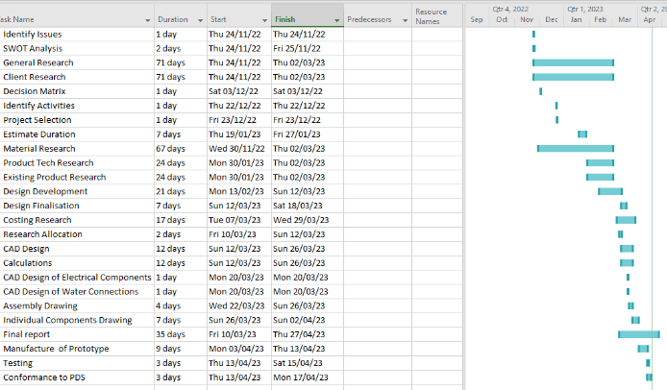
Figure 7 Achieved Timeline (see figure 5 for reference to proposed timeline)

6.3 Communication Evaluation
Communication would often relate to the management style, however, the issues caused through poor communication was enough of a setback with the project that it required its stand-alone evaluation. As noted throughout the meta literature review, communication has been a detriment to the progress of the project this has manifested in several ways. A focal point of poor communication has been the reasoning behind a lot of the decision making. This has led to the team feeling lost and unable to freely offer up suggestions to challenges faced within the project (see appendix 8.0). Its clear communication is an area of improvement for future project. This can be achieved through implementation of academic theory. The use of Shannon-Weaver’s communication model (see appendix 9.0), which offers a more structured approach to the communication network, would allow for a two-way conversation while maintaining the hierarchical structure of an organisation. Other ways in which communication theory could be applied is through the implementation of OCB. This refers to the extra-curricular behaviours of the team as a whole, interactions between staff that are not a part of their formal job role. This includes behaviour such as, showing initiative, helping other colleagues and engaging in constructive communication. This can be introduced through programmes such as regular feedback on instances were OCB has been demonstrated, promoting collaboration and teamwork and addressing barriers and challenges that are hindering staff from engaging in OCB. Active listening, empathetic communication, and clarity in message delivery are fundamental skills when encouraging OCB through a team.

6.3.1 Org Chart
The Org chart chosen for the project has shown to compartmentalise and add rigid structure. This could have been improved by including titles within the org chart linked to the Shannon weaver model such as source, encoder or receiver to assist in the understanding of the communication narrative. Also reducing the segregation of responsibilities to the departments this could be achieved through cross department inclusion for certain employees allowing for better communication between stages of design and development.

Conclusion and Reflections
The analysis and evaluation conducted in this report have drawn insights from a diverse range of sources, encompassing academic literature, project documentation, and established management theories. By synthesising these sources, a comprehensive understanding of the project's strengths and weaknesses has been achieved, enabling informed decision-making on areas requiring improvement.
Utilising a multi-disciplinary approach, the report has identified shortcomings in communication, time management, and management style within the project. These deficiencies have been analysed in depth, shedding light on the root causes and implications for project outcomes. For instance, the examination of the PDS revealed inadequacies in stakeholder engagement and risk management, leading to conflicting design constraints and project delays. Incorporating insights from QFD has been proposed as a solution to enhance stakeholder alignment and mitigate risks in future projects.
Similarly, the evaluation of time management, particularly through the Gantt chart, uncovered issues stemming from assumed scheduling and inadequate resource allocation. Recommendations such as the adoption of digital tools like Todoist have been put forward to improve schedule management and facilitate real-time communication among team members.
Furthermore, the assessment of management style highlighted the importance of clear communication and proactive leadership. By integrating structured communication models like Shannon-Weaver's communication model and fostering an environment of teamwork and good corporate citizenship, organisations can overcome challenges related to decision-making and team unity.
Overall, the insights gained from this report serve as a foundation for organisations to enhance their project management practices. By addressing deficiencies in communication, time management, and management style, organisations can improve project outcomes, ensure stakeholder satisfaction, and encourage long-term growth and success in a dynamic and competitive landscape.

8.0 References
Adriana, G., 2023. Online Communication is the Basis of Modern Communication in Business Management. Economy Transdisciplinarity Cognition , 26(1), pp. 21-28.
Aita, R., 2016. THE NETWORK ORGANIZATIONAL CHART AS A TOOL FOR MANAGING ORGANIZATIONAL COMPLEXITY. International Journal of Design & Nature and Ecodynamics, 11(4), pp. 593-599.
Aldom, J., 2023. HydroFORM [Interview] (27 Feb 2023).
Ambersil Industrial Devision, 2023. Ambersil Lubricant Silicone 500 ml Silicone LUBRICANT. [Online]
Available at: https://docs.rs-online.com/38eb/0900766b804c36b2.pdf
[Accessed 15 Feb 2023].
Atlassian, 2024. Trello. [Online]
Available at: https://trello.com/?&aceid=&adposition=&adgroup=150132215251&campaign=19250238417&creative=652231835178&device=c&keyword=trello&matchtype=e&network=g&placement=&ds_kids=p74526191747&ds_e=GOOGLE&ds_eid=700000001557344&ds_e1=GOOGLE&gad_source=1&gclid=CjwKCA
[Accessed 11th march 2024].
Besner, C., 2008. Project Management Practice, Generic or Contextual: A Reality Check. Project Managment Journal , 39(1), pp. 16-33.
Biwer, F., 2023. https://facilethings.com/blog/en/time-management-matrix. British Journal of Educational Psychology , 93(2), pp. 353-367.
Branco, L. G., Espindola, F. J. C. & Zen., M. P. H., 2020. Design structure network (DSN): a method to make explicit the product design specification process for mass customization. Research in Engineering Design, 31(2), pp. 197-220.
Brewer, E. C., 2016. Better Communication = Better Teams: A Communication Exercise to Improve Team Performance. IEEE Transactions on Professional Communication , 59(3), pp. 288-298.
Bruce, A., 2000. Project Managment. 1st ed. s.l.:Dorling Kindersley.
Burton-Hughes, L., 2021. Manual Handling Weight Limits: What are the Safe Lifting Guidelines and Techniques?. [Online]
Available at: https://www.highspeedtraining.co.uk/hub/manual-handling-weight-limits/#:~:text=As%20this%20shows%2C%20a%2025,and%20close%20to%20their%20body.
[Accessed 27 Feb 2023].
Canadian centre for Ocuupational Health and Safety , 2023. Hand Tool Ergonomics - Tool Design. [Online]
Available at: https://www.ccohs.ca/oshanswers/ergonomics/handtools/tooldesign.html
[Accessed 28 Feb 2023].
Clarion , 2023. IP Rating Explained. [Online]
Available at: https://clarionuk.com/resources/ip-ratings/#:~:text=An%20IP%20Rating%20(also%20known,and%20accidental%20contact%20(2022).
[Accessed 20 Feb 2023].
Claude Shannon, W. W., 1948. The Mathematical Theory of Communication. 1st ed. Champaign : University of Illinois Press.
Davies, D., 2024. Project Communication Feedback [Interview] (4th April 2024).
Doran, G. A. M. a. J. C., 1981. There's a S.M.A.R.T Way to Write Managment Goals and Objectives. Journal Of Managment Review , 70(1), pp. 35-36.
Fleet, D. D. V., 2021. Quality time: Productivity Through time Managment. 1st ed. Pheonix : Information Age Publishing Inc. .
Gaffin, K., 2023. The Impact of Remote Work on Time Management. [Online]
Available at: https://www.insightful.io/blog/impact-remote-work-time-management
[Accessed 11th March 2024].
Ginting, R., 2023. Determination of Technical Requirments and Priority of The Critical Part In The Quality Function Deployment Phase 1 and Quality Function Deployment Phase 2 Methods In Product Development: A Literature Review. Electronics for You, 1003(1), p. 12026.
Grice, H., 1975. Logic and Conversation . In: P. &. J. Morgan, ed. Syntax and Semantics, Vol 3: Speech acts. New York : Academic Press , pp. 41-58.
Guthrie, G., 2022. How to write a great product specification sheet (for beginners). [Online]
Available at: https://nulab.com/learn/design-and-ux/how-to-write-product-specification-sheet-for-beginners/
[Accessed 20 March 2024].
Haniff, A., 2016. Project Management , s.l.: Goodfellow Publishers .
Heerkens, G. R., 2001. Project Management. 1st ed. New York: Mcgraw-Hill.
Hellsten, L.-A. M., 2012. What Do We Know About Time Management? A Review of the Literature and a Psychometric Critique of Instruments Assessing Time Management. 2nd ed. Saskatoon : University of Saskatchewan.
Hessing, T., 2024. Quality Function Deployment (QFD) and House of Quality (HOQ). [Online]
Available at: https://sixsigmastudyguide.com/house-of-quality-hoq/
[Accessed 3 April 2024].
Howells, M., 2024. Project Communication Feedback [Interview] (4th April 2024).
HSE, 2000. Pressure Systems Safety Regulations 2000 Aproved Code of Practice. 1st ed. Surrey: Crown .
Hutmanová, N., 2022. Prevention of procrastination at work through motivation enhancement in small and medium enterprises in Slovakia. Entrepreneurship and Sustainability Issue, 10(2), pp. 418-428.
Kerzner, H. R., 2009. Defining Project Success . In: Project Management: A Systems Approach to Planning, Scheduling and Controlling . New York: Wiley-Blackwell, pp. 7-8.
Lal, M. K., 2018. Kowledge Driven Development: Bridging Waterfall and Agile Methedologies. 1st ed. Cambridge: Cambridge University Press.
Laumeister, B., 2011. Don't let analog/digital misinterpretations put your design in jeopardy. Electronic Engineering Times , 18 April, pp. 39-40,42.
Learning Gantt Charts. 2015. [Film] Directed by Chris Croft. s.l.: Indeed Learning .
Lechter, J. G. &. T., 2012. Gantt Charts Revisited. International Journal of Managing Projects in Business , 5(4), pp. 578-594.
Lewis, D. P. H., 2022. Flaws with HydrFORM [Interview] (13 Oct 2022).
Linnes, C., 2021. Let´s Talk SMAC: The Status of Business Today. In: I. R. M. Association, ed. Research anthology on strategies for using social media as a service and tool in busines. Østfold: Business Science Reference, pp. 27-45.
Lock, D., 202. Project Management. 10th ed. London: Routledge.
Malsam, W., 2023. How to Make a Gantt Chart In Excel Step-By-Step (Template Included). [Online]
Available at: https://www.projectmanager.com/blog/how-to-make-a-gantt-chart-in-excel
[Accessed 20 March 2024].
May, a. T., 2009. Do Org Charts Still Matter?. Computerworld, 43(32), p. 38.
Maylor, H., 2010. Project Management. 4th ed. Harlow: Pearson.
Mind tools Content Team, 2024. Management by Objectives (MBO). [Online]
Available at: https://www.mindtools.com/ahtq7qq/management-by-objectives-mbo
[Accessed 11th March 2024].
Organ, C., 2023. 7 Organizational Structure Types (With Examples). [Online]
Available at: https://www.forbes.com/advisor/business/organizational-structure/
[Accessed 19 March 2024].
Organ, D., 1988. Organizational Citizenship Behavior: The Good Soldier Syndrome. Lexington : Lexington Books .
Orr, A., 2006. Uncharted Territories? [Gantt Charts]. Engineering Management Journal , 13(3), pp. 28-31.
Pourkermani, H., 2018. Comparison of Rdiography and Ultrasonic testing for Thickness measurment of Corrosion in Industrial Pipelines. Materials Evaluation, 76(9), pp. 50-62.
Rampton, J., 2023. The Future of AI in Time Management. [Online]
Available at: https://www.calendar.com/blog/the-future-of-ai-in-time-management/
[Accessed 11th March 2024].
Rapp, A. A., 2013. The Influence of Time Management Skill on the Curvilinear Relationship. Journal of Applied Psychology, 98(4), pp. 669-677.
Roetzel, P. G., 2019. Information overload in the information age: a review of the literature from business administration, business psychology, and related disciplines with a bibliometric approach and framework development. Business research , 12(2), pp. 479-522.
Sáez, F., 2024. The Time Management Matrix. [Online]
Available at: https://facilethings.com/blog/en/time-management-matrix
[Accessed 11th March 2024].
Salama, M., 2021. Sustainability in the Context of Event Managment. In: Event Project Managment. s.l.:Goodfellow Publishers, pp. 19-37.
Samfira, E. M., 2020. ASSERTIVE COMMUNICATION SKILLS IN UNIVERSITIES. Journal Plus Education, 26(1), pp. 361-373.
Simon, P., 2018. Starting Out in Project Management. s.l.:Association for Project Managment .
Todoist, 2024. Todoist. [Online]
Available at: https://todoist.com/
[Accessed 11th March 2024].
Trifibre, 2023. MAX430 Tough IP67 Rated Case. [Online]
Available at: https://www.trifibre.co.uk/product/max430/?utm_source=google&utm_medium=ppc&utm_campaign=Shopping_Smart_v1&gclid=CjwKCAiA0cyfBhBREiwAAtStHOcSqwOdXsW8NUMPhC83-B5xd61axaOJhhXmYh6wFgMy6Up9eTk9XxoCCdEQAvD_BwE
[Accessed 20 Feb 2023].
Watson, G., 2023. Use of Radiography [Interview] (11 Mar 2023).
Watson, G., 2024. Project Communication Feedback [Interview] (4th April 2024).
Weaver, C. E. S. a. W., 1950. The Mathematical Theory of Communication. Mathematical gazette, 34(310), pp. 312-313.
Winter, M., 2007. Projects and Programmes as Value Creation Process: a New Perspective and Some Practical Applications. The International Journal of Project Managament , 95(103), pp. 2-14.
Xiao-Jie, M., 2017. Transforming Multidisciplinary Customer Requirements to Product Design Specifications. Chinese Journal of Mechanical Engineering , 30(5), pp. 1069-1080.
Yohan Kim, e. a., 2014. Dataset Size and Composition Impact the reliavility of performance benchmarks for Peptide-MHC Binding Predictions. BMC Bioinformatics , 1 July , pp. 1471-2105.
Zasa, F. P., 2021. Managing the Hybrid Organization: How Can Agile and Traditional Project Management Coexist?. Research Technology Management, 64(1), p. 55.

Appendix

1.0 PAUT Technicians Interview
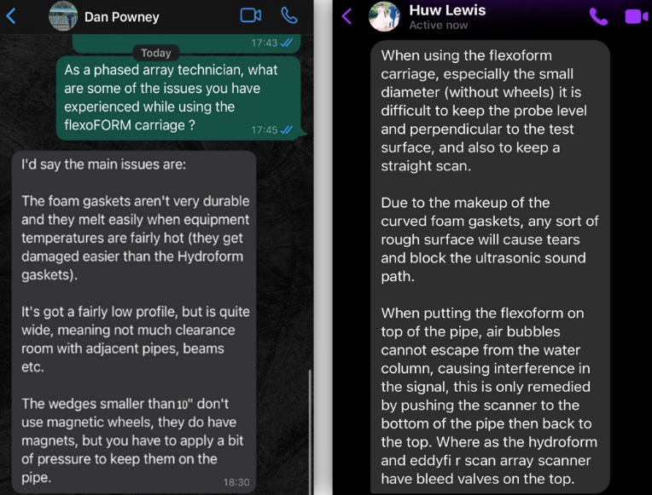
Figure 8 Interviews with PAUT Technicians

Watson Email
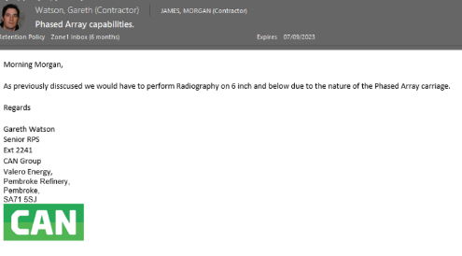
Figure 9 Correspondence with CAN Senior RPS

1.2 Case Study
A study by (Pourkermani, 2018) compared the accuracy and reliability of radiography and ultrasonic testing including PAUT. Both radiography and PAUT were performed on identical pipeline sections and the obtained measurements from each NDT method and were evaluated. The results showed that ultrasonic testing was able to provide more accurate and reliable measurements than radiography, particularly for areas with severe corrosion damage. This was due to the direct recording of the remaining wall thickness of the pipelines, while radiography tended to underestimate the thickness due to the absorption of radiation by the corroded material.
It was also mentioned within the article that PAUT was faster, more accurate, more reliable and less expensive than radiography and could perform without the necessary radiation safety measures (example in appendix 1.3). It was concluded that PAUT was a more effective method for thickness measurement of corroded Pipelines than radiography.
The company is still currently using radiography to capture images of lines. The implementation of the new carriage would have allowed for the use of PAUT. This benefits the company as the safety implications of radiography are superfluous in comparison to PAUT (as seen in appendix 1.3). Due to the safety implications of radiography, it can only be conducted during breaktime windows to ensure there are no other work groups in the area. Whereas with the new PAUT carriage, these lines could now be inspected at any time of day with minimal disruption to other work groups and could be achieved in significantly less time.

Job Hazard Analysis for PAUT Compared to Radiography
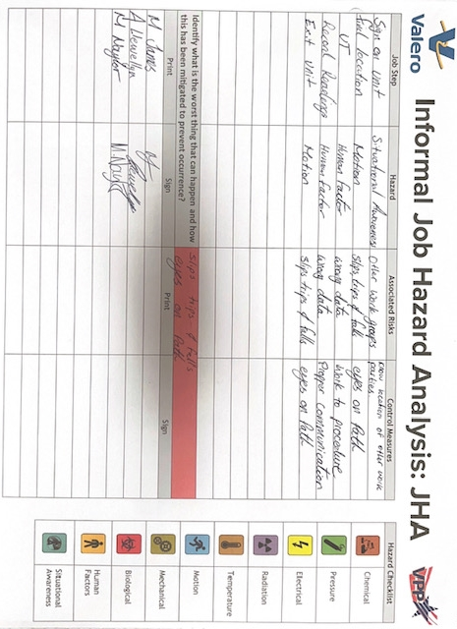
Figure 10 JHA for PAUT
Figure 11 JHA for Radiography

2.0 Meta-Analysis of HNC Project On PAUT Scanner

2.1 Introduction
It's efficient at explaining the contents of the report, but lacks any formal explanation of the reasons for the report. Some further information on the context for the report would introduce the report for the project better.
The introduction is more of an aims and objectives list, that being said this report is 2 of 2 and the first report outlines the criteria for the PAUT Scanner in further detail. Also, word count limitations restrict for further explanation however there is only a brief mention of the first report in the introduction

2.1.1 Recommendation:
A Hyperlink to the initial report or at least a greater explanation of the importance of the initial report is needed.

2.2 PDS
The use of words to explain the reasoning behind the PDS is very well portrayed. The Use of Citations to reinforce this aspect of the Report adds Weight to the understanding. However, other methods of communicating the information found within the PDS are not mentioned.

2.2.1 Recommendations:
Examples of other Methods of portraying the information found within the PDS should have been mentioned. This would have led to greater understanding of stakeholder requirements and contemporary products. Other areas required for a complete PDS are lacking, with a cross reference of the design requirements relationships not being discussed or thought about such as weight and power supply.

2.3 Project Plan.
A good Argument has been made in this section of the report as to why the style of scheduling has been used. Other methods of grouping tasks are spoken about and their benefits are discussed. However, the cons for this method are not mentioned. That being said, as the idea is briefly fleshed out, the project team is left with a chance to understand why this wasn't the best option for this Report.
It is observed that the timeline for each task is backed by no research, although research may have been conducted, the resulting timeline at the end of the project would show that many of the tasks were based of pure estimation alone.
Again, the explanation of the pros for the chosen scheduling method have been given but no mention of the cons. By mentioning the cons, the limitations of the method can be addressed and prepared for.
Although it does mention the method works better with other methods of scheduling and analysis such as CPM and PERT analysis and the reason why are given. Furthermore, this section states the software being used but no explanation as to why. Screenshots of the Gant chart made in Microsoft Projects help the project team to understand the process better.

2.3.1 Recommendations:
This section of the report could use with a better explanation as to why not only the scheduling methods were chosen but also a software analysis could be made in this report for scheduling management. Furthermore, supporting research to show how and where the timelines were chosen for the tasks could be included, further research into the project would demonstrate this research was never conducted. Highlighting the limitations of the used methods and software would benefit the project team as the limitations could then be resolved, mitigated or prepared for.

2.4 Critical Path.
The section does a good Job ab identifying what a critical path is. It follows on from the previous section, in which the report section mentions why it’s being used. Its purpose is bolstered by some references which are also used to help explain the Critical path.
As with other sections however the comparison to other options and why this has been favoured should have been considered.
The reference image showing the critical path helps the project team establish a better understanding of the concept.

2.4.1 Recommendations:
An argument as to why this method has been chosen should be better established. It would also be useful to link the required 'critical Path’ items together within the report. Giving better explanation as to why those tasks are critical. Also, an investigation into the relationship between the tasks could be given to extend the understanding to the project team as to why they are so crucially linked.

2.5 PERT Analysis
Once again, this section of the report only explains what the technique is and offers no other options and why it's been chosen. The section could also use with better formatting as the table is shown before the section write up. The write up consists of a colour coding key which should be shown before viewing the table. It is also does not mentioned within the table anything about PERT analysis evaluating timescale. In fact, this is not mentioned until quite late in the write up, making it harder for non-technical readers to understand. It is however mentioned in the write up that it is linked to the critical path which assists the project team in better understanding.
As for the table it is presented clearly and without clutter making it easy to digest.
Also, the write up addresses the anomaly and a further critical path identifies a non-essential task as the reason for the anomaly.

2.5.1 Recommendations:
Formatting.

2.6 Cost Research.
No direct method for analysing for researching the cost has been implemented. An academic approach supported by a citation would help add more structure and accountability to the approach taken. The way this has been set out is lacking in structure and relatability to the project team and offers very little to the cost research of another project.
That being said a lot of supporting material round in the appendix helps to add context to where the figures have come from. Referencing back to the PDS is also positive to add context to the figures shown within this section.
A detailed account of the research into material, personnel and equipment have been given, giving good supporting material to the estimations stated. Actual cost of the project is also demonstrated in the report proving the estimations accurate (within a tolerance)

2.6.1 Recommendations:
Implement a structured approach based in academic theory
Add reasons for the budget (Grant money etc.)
Add comparison (in appendix) of material costs and why the materials where selected.

2.7 Overall Project Approach
The management style of the project, left the project team uninspired an unable to adjust or add any of their own ideas to the product either through the design process or the development. This was due to strong compartmentalisation of the workgroups involved and minimal support for cross communication besides passing through the scheduling manager whose main role was too defined to facilitate better communication.
The design process was worked off the PDS. However, the PDS was lacking support from the VOC and mostly was derived from competitive market of existing products. An ill-defined project brief from the customer was taken at face value from the project manager and little effort was made to contact the customer or the technicians who would be using it to consider parameters defined within the PDS.
Time management errors left the project terminating at the prototype stage. discrepancies and bottlenecks in the planning stage have led to project delays. This could be due to a lack of time-based research into the duration of certain elements of the project and was largely based of estimations.
As seen throughout the report review there were gaps in fully explaining why choices had been made to the project team. This level of communication seems to have reflected through the project management and led to poor resource allocation, compartmentalisation of departments and a choke on innovation and design development.

3.0 Org Chart
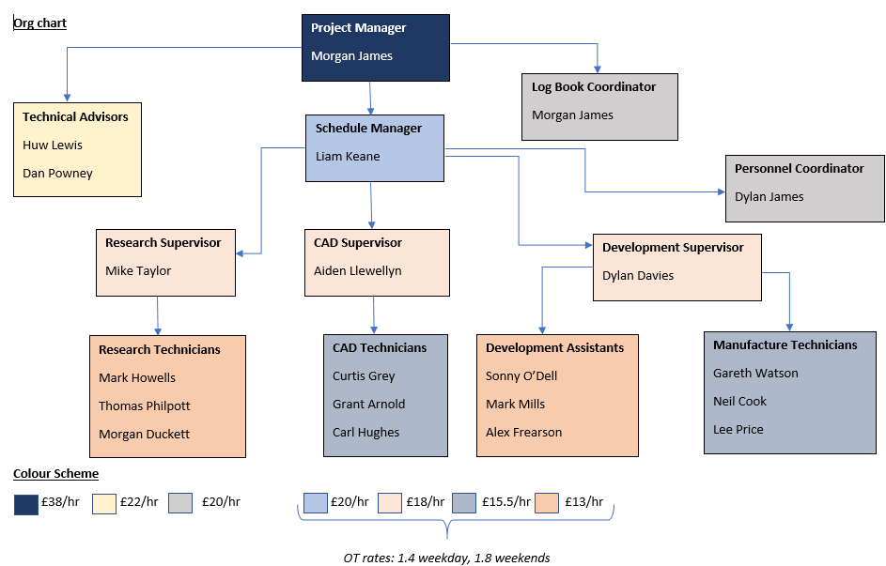

4.0 Phased Array carriage PDS

4.1 Performance
Attachment for probe (find out common probe type/s).
Water connectivity for coupling.
Rollers to move on pipe easily.
Low profile.
Interchangeable gasket to create coupling seal.
Heat resistant strap up to 500°c.
Able to navigate 90° and 45° elbows.
Use on pipes ranging from 1066.8 to 10.3mm

4.2 In service Environment
Industrial settings
Oily
Dirty
Hard materials
Dusty
Outdoors

4.3 Life in Service
Carriage is to be used in conjuncture with a PAUT probe for the purpose of establishing thickness and flaw detection on pipes vessels and welds in industrial setting (see In Service Environment)

4.4 Maintenance
Carriage to be checked weekly for:
- Proper roller function.
- Damage to fastenings.
- Damage to structure.
- Damage to protective edges
Carriage is to be checked before use for:
- Water connections.
- Probe connections.
- Water lines (for leaks).
- Hinges.
Carriage to be calibrated annually
Calibration to include:
- Water flow.
- Linearity of rollers.
- Condition of fasteners
- Hinges to be lubricated with Ambersil silicone lubricant 31631-AB (see appendix 4.0.1.1 for data sheet)

4.5 Target Product Costs
To stay competitive to existing products, individual costs should be between £13-15,000. (See appendix 4.0.1.2).

4.6 Competition
Olympus HydroFORM scanning carriage
Silverwing R scan
M2M Mantis
RexoFORM Glider
RexoFORM Chain scanner
HydroFORM Chain scanner.

4.7 Shipping
The product is to be shipped to CAN Group head office in Aberdeen for distribution worldwide for the company.
The product is to be shipped individually by various forms of transportation in its packaging. (See Packing).
Initial distribution is to remain domestic (Aberdeen) subject to change.
The product does not need lifting points. (See Weight).
The product will fit through all standard doorways. (See size).

4.8 Packing
The product shall be encased in purpose sized foam.
The product shall be packed in a Max 430 tough rated case. (See Appendix 4.0.1.3).
Packaging shall be sufficient for transport and storage.
Packing to be Rated IP67. (See appendix 4.0.1.3.1 for IP rating breakdown).
Product to be packaged individually.

4.9 Quantity
2 initial test pieces to be manufactured.
A batch production of 18 final products to be manufactured.
Subject to change as per company request.

4.10 Manufacturing
Product framework to be made of aluminium
Fasteners and hinges to made of electroplated galvanised steel.
Rubber guards to be used on critical edges and ergonomically interfaced areas.
Rubber wheels are to be used.
Elasticated rubber hoses are to be used for fluid transportation.
Coaxial cables are to be used for information transfer.
RS Pro miniature ball bearing I.D 3mm O.D 10mm to be used
Custom made concave wide rollers to be used.
Silicone rubber to be used with operational temp up to 305°C

4.11 Size
Product is to remain below a profile of 120mm (above pipe).
The product is required to have a bar which allows the scanning probe to run on 400mm lengths.
The product is required to fit around a range of pipes spanning 88.9-914.4mm (outside diameter).
Max extension of the product 1034.4mm
Minimum retraction of product 208.9mm
Storage and transportation size to be within L:426 x W:290 x D:159mm.

4.12 Weight
Product to be under 16Kg for safe single person manual handling. (See appendix 4.0.1.4)

4.13 Aesthetics, Appearance and Finish
Product to be user friendly as per technician feedback. (See appendix 4.0.1.5).
Product to have rubber protective edges.
Exposed metal to have brushed finish.

4.14 Materials
See Manufacturing.

4.15 Product Life Span
Product to last 8 years with annual servicing.

4.16 Standards and Specifications
Carriage must allow for scanning to be in accordance with ASME V.

4.17 Ergonomics
While pushing the carriage the user should not encounter more than 0.4kg of resistive force. (see appendix 4.0.1.6)
The hand grip position should be spherical grip (similar to a computer mouse)
Grip area should account for minimal wrist deviation.
For overall weight see Weight.

4.18 Customer
CAN Group/ Can offshore. (see Market Constraints).
NDT companies offering PAUT.

4.19 Quality and Reliability
1 in 10 units to be tested (see testing).
Life: 8 years,
Reliability 95%.

4.20 Shelf Life Storage
Units should be kept off the ground during storage.
Units should be kept away from moisture.
Units should be kept out of direct sunlight.
Units to spend max time of 3 months at manufacturer.
Units to spend max time of 3 years at distribution company.
Units to spend max time of 1 years and 9 months in personal storage.
Units to spend max time of 5 years total in storage before optimum operation is affected.

4.21 Time Scale
3 months design time.
Unit to build in batches of 50.
Manufacture of batch, 21 days.
Delivery to distribution company, 2 days.
Delivery to customer 2-14 days depending on region.

4.22 Testing
Testing to occur with prototype conformance to PDS and usability.
Testing on mobility.
1 in every 10 units to be tested.
Annual calibration test
Calibration test to assess proper function against the PDS.

4.23 Safety
All aspect of the product to be in accordance with the health and safety at work act 1974
Product liability is upon the owner after warranty (See legal)
Label to include:
- Manufacturer details
- Warranty details
- User liability
- Specification information
- Number of nearest tested model (See testing)
- Calibration dates (See testing)
- Warning labels (max temp, warranty voiding information, pinch point)
- Allergy advice (silicone)
Item is susceptible to DIY alterations
Definitive operating instructions (See User training)
Product is likely to become compromised by environment, safe cleaning operation to be included in user manual (see User Training).
Structure to be manufacture to withstand regular working environment wear and tear (see Life in Service and Environment).
Rubber covering to shield user from sharp edges.

4.24 Legal
Investigation into potential misuse.
Sticker stating CE UK and Standards met (see standards and specifications).
Certificates of testing supplied by material suppliers.
Quality control measures to be met.
Testing personnel to sign of tested units.
Manufacturing personnel to sign of each unit.
Warranty of 2 years in each unit subject to region variability.
Warranty voided if alterations have been made.
Only to be sold exclusively to CAN Group for 5 years.

4.25 Company Constraints
Dependant on manufacturing companies’ capabilities (see manufacturing).
Distribution network. (See distribution).
Suppliers of distribution material (see packing).
Maximum start up investment £170,000.
Design personnel: 1 person.
Development: 2 persons.
Testing: 2 persons.
Personnel to grow with demand of product.

4.26 Market Constraints
Price to remain competitive with existing products (see Cost).
Limitations on customers due to CAN group contract (5-year retainer).

4.27 Patents Literature and Product Data
User manual to be supplied with product. (See User Training)

4.28 Political and Social Implication
Instructions on recycling to be printed on sticker (see Disposal).
Material sourcing to be kept as local as reasonably practicable.
Ethical labour treatment within UK understanding.
Wages of staff to reflect appropriate UK average.

4.29 Instillation
Product to come pre-fabricated.
Schematic of operation to be included. (where moving parts are)

4.30 Energy Requirements
Nil.

4.31 User Training
Manual to be supplied with individual units.
Manual to include basic performance data. (see Performance).
Manual to include instillation requirements. (see Instillation).
Manual to include electrical connection requirements and instillation.
Manual to include operational instructions.
Manual to include basic troubleshooting options.
Manual to be translated in the following languages:
- English (UK)
- Spanish
- French
- German
- Mandarin
- Japanese
- Korean
- Russian
- Portuguese
Manual to Include disposal Instructions. (see Disposal)
Manual to include maintenance instructions. (see Maintenance).
Manual to include return Instructions.
Manual to include warranty information (see Legal).
Manual to include schematic of products movement capabilities.
Manual to include allergy advice.
Manual to include warning about misuse.

4.32 Sales Potential
First 5 years of product existence, exclusive sales to be given to CAN group.
After 5 years, the product is able to be sold on the free market.
(see Customer)

4.33 Documentation
For user Manual see User Training.
Units batch tested Unit to be documented and stored for reference.
Receipts to be duplicated, one copy sent to customer, the other to be stored on file.
Sticker to include product data.

4.34 Disposal
Units to be returned to manufacturer.
Units to be broken down for refurbishment.
Individual components to be recycled accordingly.

4.0.1 Phased Array Carriage PDS Appendix

4.0.1.1

Figure 12 Lubricant Data Sheet (Ambersil Industrial Devision, 2023)

4.0.1.2

Figure 13 Existing product Cost (Aldom, 2023)

4.0.1.3


Figure 14 Max430 Tough IP67 Rated Case (Trifibre, 2023)

4.0.1.3.1
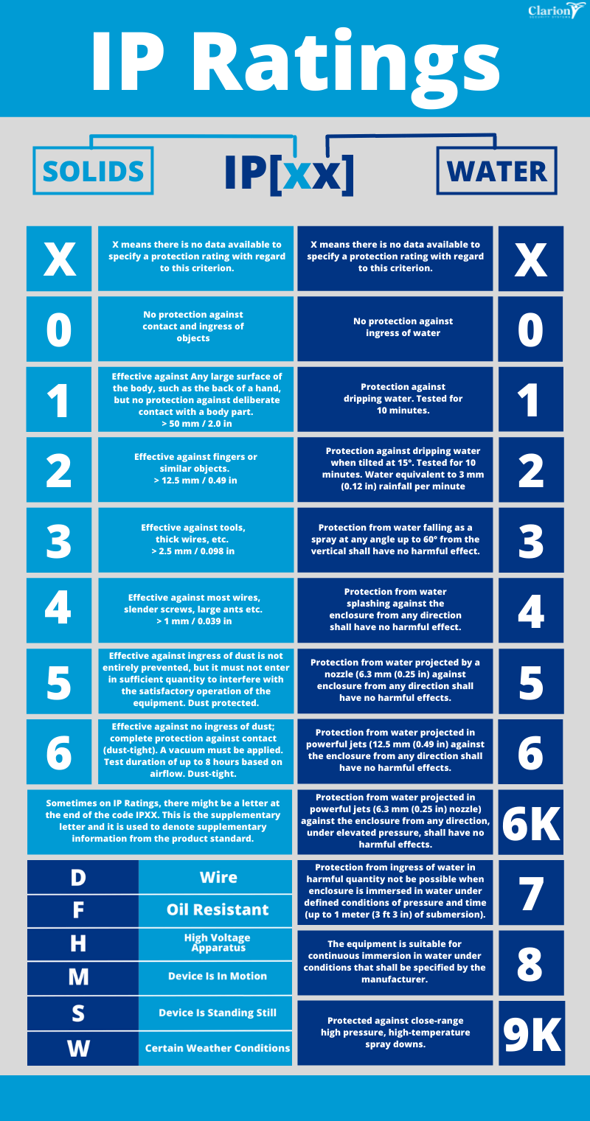
Figure 15 IP Rating Breakdown (Clarion , 2023)

4.0.1.4


Figure 16 Safe Lifting Weights (Burton-Hughes, 2021)

4.0.1.5

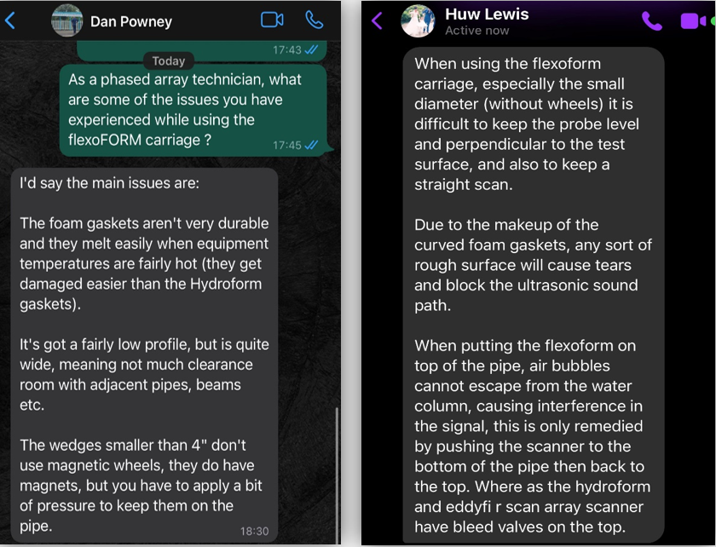
Figure 17 PAUT Technician Interviews (Lewis, 2022)

4.0.1.6


Figure 18 Tool Weight. (Canadian centre for Ocuupational Health and Safety , 2023)

5.0 Conformance to PDS

5.1 Performance
Attachment for probe – Designed with a universal mount (individual attachments required for different probes).
Water connectivity for coupling. - Yes
Rollers to move on pipe easily. - Yes
Low profile. – ≤ 80mm protrusion from pipe.
Interchangeable gasket to create coupling seal. – Gasket size depends on probe used.
Heat resistant up to at least 100°c. – Rubber Coating safe for up to 120°C.
Able to navigate 90° and 45° elbows. – Hinged Component Allows for Flexibility Around Bends.
Use on pipes ranging from 88.9mm to 273mm (3”-10”)- Yes.

5.2 In service Environment
Industrial settings
Oily
Dirty
Hard materials
Dusty
Outdoors – Rubber coating and sealed bearings allow for use in industrial environment.

5.3 Life in Service
Carriage is to be used in conjuncture with a PAUT probe for the purpose of establishing thickness and flaw detection on pipes, vessels and welds in industrial setting (see In Service Environment) – Yes.

5.4 Maintenance
Carriage to be checked weekly for:
- Proper roller function.
- Damage to fastenings.
- Damage to structure.
- Damage to protective edges
Carriage is to be checked before use for:
- Water connections.
- Probe connections.
- Water lines (for leaks).
- Hinges.
Carriage to be calibrated annually
Calibration to include:
- Water flow.
- Linearity of rollers.
- Condition of fasteners.
- Hinges to be lubricated with Ambersil silicone lubricant 31631-AB. (See Appendix B 1.0 for data sheet).

5.5 Target Product Costs
To stay competitive to existing products, individual costs should be between £13-15,000. (See Appendix B 2.0). – Sale price of £15,000.
A profit of 20-25% is required. - Profit of 37% attained.

5.6 Competition
Olympus HydroFORM scanning carriage
Silverwing R scan
M2M Mantis
RexoFORM Glider
RexoFORM Chain scanner
HydroFORM Chain scanner.

5.7 Shipping
The product is to be shipped to CAN Group head office in Aberdeen for distribution worldwide for the company. – Yes
The product is to be shipped individually by various forms of transportation in its packaging. (See Packing). – Yes.
Initial distribution is to remain domestic (Aberdeen) subject to change. – Yes.
The product does not need lifting points. (See Weight). – Yes.
The product will fit through all standard doorways. (See size). – Yes.

5.8 Packing
The product shall be encased in purpose sized foam. – Yes.
The product shall be packed in a Max 430 tough rated case. (See Appendix B 3.0). – Yes.
Packaging shall be sufficient for transport and storage. – Yes.
Packing to be Rated IP67. (See appendix B 3.1 for IP rating breakdown). – Yes.
Product to be packaged individually. – Yes.

5.9 Quantity
2 initial test pieces to be manufactured. – 1 test piece manufactured.
A batch production of 18 final products to be manufactured. - A plan for 18 units exists.
Subject to change as per company request. – No change yet.

5.10 Manufacturing
Product framework to be made of aluminium. – Yes.
Fasteners and hinges to made of electroplated galvanised steel. – Fasteners made of titanium to best limit galvanic corrosion.
Rubber guards to be used on critical edges and ergonomically interfaced areas. – Whole unit coated with rubber.
Rubber wheels are to be used. – Yes.
Elasticated rubber hoses are to be used for fluid transportation. – Yes.
Coaxial cables are to be used for information transfer. – Yes.
RS Pro miniature ball bearing I.D 3mm O.D 10mm to be used. – I.D 10 O.D 20 and I.D 20 O.D 40 bearings used.
Custom made concave wide rollers to be used. – Yes.
Silicone rubber to be used with operational temp up to 305°C. - Max temp 120°.

5.11 Size
Product is to remain below a profile of 80mm (above pipe). – Yes.
The product is required to allow the scanning probe to run on 400mm lengths. – 1000m lengths tested.
The product is required to fit around a range of pipes spanning 88.9mm-273mm (O.D.). – Yes.
Max extension of the product 290.mm. – Yes.
Minimum retraction of product 208.9mm. – Yes.
Storage and transportation size to be within L:426 x W:290 x D:230mm. – Fits within these dimensions.

5.12 Weight
Product to be under 16Kg for safe single person manual handling. (See Appendix B 4.0). – 10.2 KG.

5.13 Aesthetics, Appearance and Finish
Product to be user friendly as per technician feedback. (See Appendix B 5.0). – Some usability issues.
Product to have rubber protective edges. – Fully Rubber Coated.
Exposed metal to have brushed finish. – No exposed metal.

5.14 Materials
See Manufacturing. – Mostly Aluminium 6082 used.

5.15 Product Life Span
Product to last 8 years with annual servicing. – Unknown.

5.16 Standards and Specifications
Carriage must allow for scanning to be in accordance with ASME V. – Yes.
ASME Boiler and Pressure Vessel Code: inspection requirements. – Yes.
ASTM E1065 – 18. Standard guide for evaluating characteristics of ultrasonic search units. – Yes.
ASTM E2491 – 18. Standard guide for evaluating performance characteristics of phased array ultrasonic examination instruments and systems. – Yes.
ISO 9712:2012 NDT – Qualification and certification of NDT personnel. – Yes.

5.17 Ergonomics
While pushing the carriage the user should not encounter more than 0.4kg of resistive force. (see Appendix B 6.0). – Motorised (Motor still to be finalised).
Spring tension to be less than 25kg. – Yes.
For overall weight see Weight.

5.18 Customer
CAN Group/ Can offshore. (see Market Constraints). – Yes.
NDT companies offering PAUT. – Future Potential.

5.19 Quality and Reliability
1 in 10 units to be tested (see testing). – 1 unit tested so far.
Life: 8 years. – Unknown.
Reliability 95%. – Yes.

5.20 Shelf Life Storage
Units should be kept off the ground during storage. – Required.
Units should be kept away from moisture. – Required.
Units should be kept out of direct sunlight. – Not Required.
Units to spend max time of 3 months at manufacturer. – Required.
Units to spend max time of 3 years at distribution company. – Required.
Units to spend max time of 1 years and 9 months in personal storage. – Required.
Units to spend max time of 5 years total in storage before optimum operation is affected. – Required.

5.21 Time Scale
3 months design time. – Yes.
Unit to build in batches of 50. – 18 to be made initially.
Manufacture of batch, 21 days. – Yes.
Delivery to distribution company, 2 days. – Unknown.
Delivery to customer 2-14 days depending on region. – Unknown.

5.22 Testing
Testing to occur with prototype conformance to PDS and usability. – Complete.
Testing on mobility. – Complete.
1 in every 10 units to be tested. – Complete.
Annual calibration test. – Required.
Calibration test to assess proper function against the PDS. – Required.

5.23 Safety
All aspect of the product to be in accordance with the health and safety at work act 1974. – Yes.
Product liability is upon the owner after warranty. (See legal). -Yes.
Label to include:
- Manufacturer details.
- Warranty details.
- User liability.
- Specification information.
- Number of nearest tested model. (See Testing).
- Calibration dates. (See Testing).
- Warning labels. (Max temp, warranty voiding information, pinch point).
- Allergy advice. (silicone). – Label Not made Yet.
Item is susceptible to DIY alterations.
Definitive operating instructions. (See User training).
Product is likely to become compromised by environment, safe cleaning operation to be included in user manual. (see User Training). – Required.
Structure to be manufacture to withstand regular working environment wear and tear. (See Life in Service and Environment). – Yes.
Rubber covering to shield user from sharp edges. – Yes.

5.24 Legal
Investigation into potential misuse. – Required.
Sticker stating CE UK and Standards met. (See standards and specifications). – Required.
Certificates of testing supplied by material suppliers. – Required.
Quality control measures to be met. – Required.
Testing personnel to sign of tested units. – Required.
Manufacturing personnel to sign of each unit. – Required.
Warranty of 2 years in each unit subject to region variability. – Required.
Warranty voided if alterations have been made. – Yes.
Only to be sold exclusively to CAN Group for 5 years. – Yes.

5.25 Company Constraints
Dependant on manufacturing companies’ capabilities (see manufacturing). - Manufactured in House.
Distribution network. (See distribution). – Unknown.
Suppliers of distribution material. (See packing). – Yes.
Maximum start up investment £170,000. – Over budget.
Design personnel: 1 person. – (hypothetically no) (reality yes).
Development: 2 persons. – (Hypothetically no) (reality 1 person).
Testing: 2 persons. – yes (PAUT Tech and designer).
Personnel to grow with demand of product. – Required.

5.26 Market Constraints
Price to remain competitive with existing products. (See Cost). – Yes.
Limitations on customers due to CAN group contract. (5-year retainer). – Yes

5.27 Patents Literature and Product Data
User manual to be supplied with product. (See User Training). – Required.

5.28 Political and Social Implication
Instructions on recycling to be printed on sticker. (See Disposal). – Required.
Material sourcing to be kept as local as reasonably practicable. – All UK based.
Ethical labour treatment within UK understanding. – Yes.
Wages of staff to reflect appropriate UK average. – Yes.

5.29 Installation
Product to come pre-fabricated. – Yes.
Schematic of operation to be included. (where moving parts are). – Yes.

5.30 Energy Requirements
Motor to connect with 110v connection. – Required.

5.31 User Training
Manual to be supplied with individual units. – Yes.
Manual to include basic performance data. (see Performance). – Yes.
Manual to include instillation requirements. (see Instillation). – Yes
Manual to include electrical connection requirements and instillation. – Required.
Manual to include operational instructions. – Yes.
Manual to include basic troubleshooting options. – Required.
Manual to be translated in the following languages: - Required.
- English (UK)
- Spanish
- French
- German
- Mandarin
- Japanese
- Korean
- Russian
- Portuguese
Manual to Include disposal Instructions. (see Disposal) – Required.
Manual to include maintenance instructions. (see Maintenance). – Required.
Manual to include return Instructions. – Required.
Manual to include warranty information (see Legal). – Required.
Manual to include schematic of products movement capabilities. – Yes.
Manual to include allergy advice. – Required.
Manual to include warning about misuse. – Required.

5.32 Sales Potential
First 5 years of product existence, exclusive sales to be given to CAN group. – Yes.
After 5 years, the product is able to be sold on the free market. – Yes.
(See Customer).

5.33 Documentation
For user Manual see User Training.
Units batch tested Unit to be documented and stored for reference. – 1 unit tested and documented.
Receipts to be duplicated, one copy sent to customer, the other to be stored on file. – Required.
Sticker to include product data. – Required.

5.34 Disposal
Units to be returned to manufacturer. – Required.
Units to be broken down for refurbishment. – Required.
Individual components to be recycled accordingly. – Required.

6.0 Fredrick Winslow Taylor
Fredrick Wilmslow Taylor was a pioneer in project management and had a key philosophy of optimising the way in which people worked over getting them to work as hard as they can. In 1909 Taylor published the principles of scientific management. Found within were novel ideas on getting the most out of a team. Conducting time and motion studies on the way in which tasks were performed he concluded that some people were able to work faster than others at specific tasks and selection of personnel for tasks was important to an efficient workplace. Acknowledging his findings from the workplace studies he created four principles of scientific management which are now known as Taylorism.
- Replace working by habit or common sense, instead adapt a scientific method to develop the most efficient working practice for specific tasks.
- Match staff to tasks based on capability and motivation and apply training to maximise potential.
- Provide instructional supervision to staff to ensure they’re utilising the developed efficient working practise
- Combine the managers and workers tasks, with managers offering time planning and training freeing the staff to simply perform their job efficiently.
Taylorism has been critiqued as an out of date set of principles however as it promotes the idea there is one right way to achieve an objective. This system works with simple labour intense tasks however in modern organisations the tasks at hand and the staff working on them can benefit from a more open approach and individual responsibilities.

7.0 QFD
QFD is a methodological pillar of contemporary product development that dates back to DR. Yoji Akao's ground-breaking work with Mitsubishi in 1966. Originally utilised in the electronics and automotive industries, its applicability has expanded beyond industry borders and is now relevant in the healthcare, service, and many industrial domains. QFD, also known as matrix product lines, decision matrices, or customer-driven engineering, is a systematic methodology that is very sensitive to hearing the customer's voice and skilfully meeting their needs and expectations. Fundamentally, QFD is a methodical procedure and a set of instruments carefully designed to identify client needs and smoothly translate them into technical specifications, supported by a pre-established matrix structure.
Essential Elements of QFD:
- Focus on the client: At the heart of QFD's philosophy is the importance placed on the requirements and wants of the client, which takes precedence over assumptions about their preferences. The method carefully converts user input into technical specifications, steering the design process from broad system-level requirements to fine-grained component-level details.
- VOC Competitor Examination: A keystone of QFD, the House of Quality tool enables a comparison examination of product features against rival products, guiding strategic design changes meant to improve market competitiveness.
- Reduced Development Cycle: QFD's ability to prevent late-stage design changes by maintaining a laser-like focus on features that the customer approves of pays off in reduced development cycles and associated cost reductions.
- Structural Effectiveness: QFD provides a logical framework for classifying choices and learned lessons.

Framework for Implementation:
The QFD methodology is implemented in four carefully planned steps that allow for the smooth integration of consumer input into design considerations:
- Product Definition: The QFD process begins with the painstaking gathering and conversion of the VOC into concrete product specifications, frequently interspersed with comparative analyses in relation to immediate competitive products or services.
- Product Development: During this stage, crucial product characteristics and assemblies are identified and painstakingly translated into detailed component-level specifications, taking functional requirements into account.
- Process Development: This step of the QFD methodology involves designing and defining manufacturing and assembly processes, which are integrated with the specific design specifications found from the product development stage.
- Process Quality Control: the final stage involves fine-tuning process parameters and quality control methods to ensure smooth adherence to set criteria found within the process development stage.

7.1 QFD Breakdown
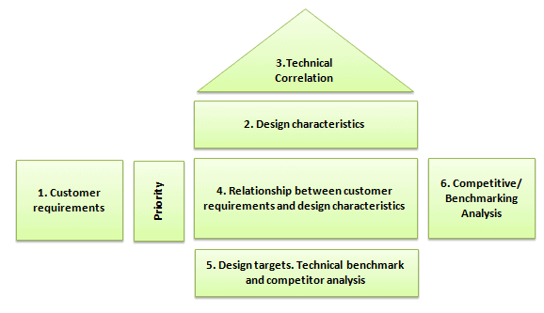
Figure 19 QFD Breakdown (Hessing, 2024)

7.2 QFD Example
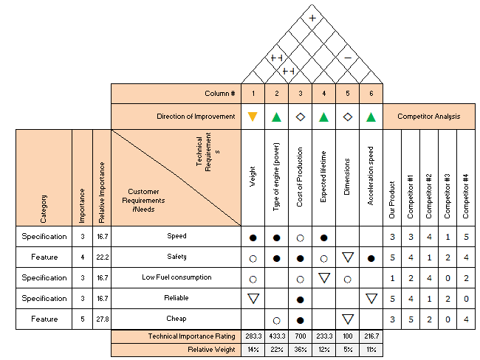
Figure 20 QFD Example (Hessing, 2024)

8.0 Feedback E-mails
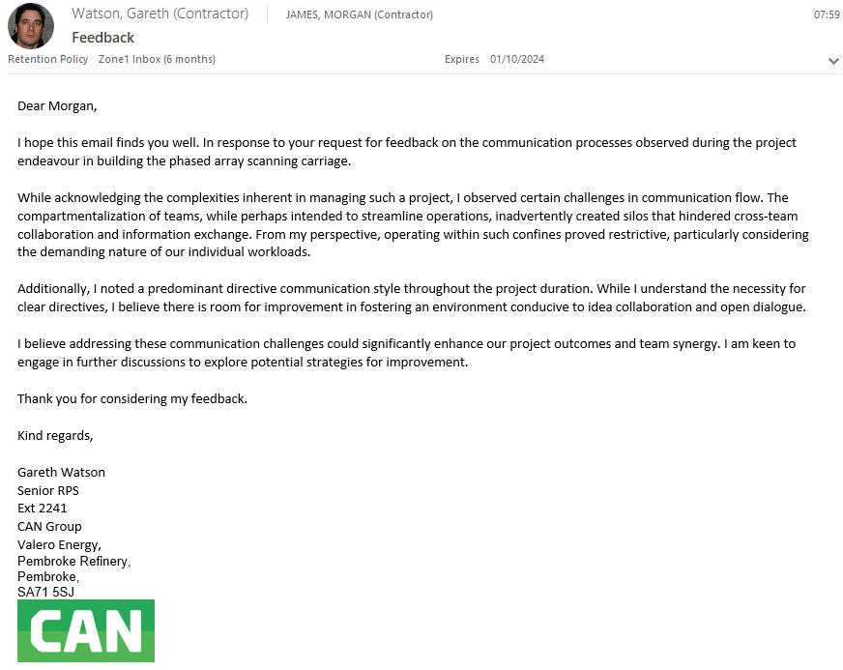
Figure 21 Feedback E-mail 1 (Watson, 2024)
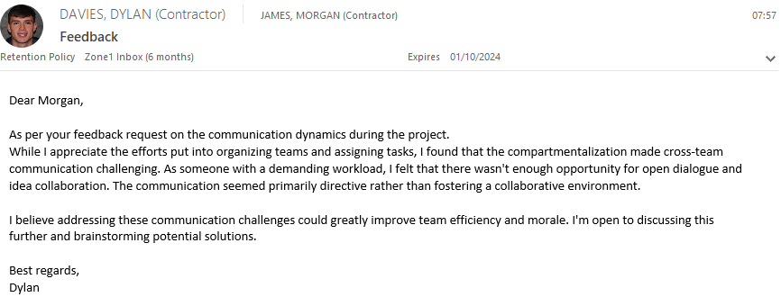
Figure 22 Feedback E-mail 2 (Davies, 2024)
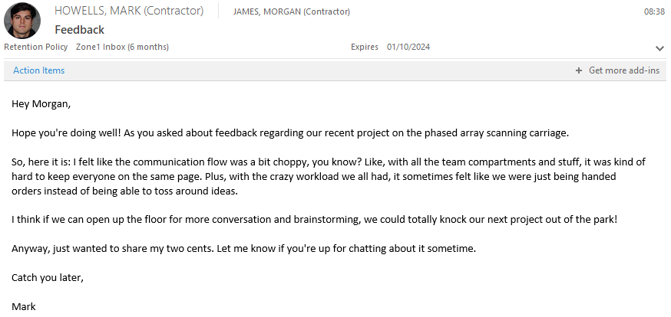
Figure 23 Feedback E-mail 3 (Howells, 2024)

9.0 Shannon-Weaver Information Transmission Model
1. Source: The source is the originator of the message. It could be a person, a group of people, a machine, or any entity that creates the message to be communicated.
2. Encoder: The encoder is responsible for converting the message from the source into a transmittable form. This could involve encoding the message into language, symbols, or signals that can be transmitted through a communication channel.
3. Message: The message is the information that is being transmitted from the source to the receiver. It could be verbal, written, visual, or non-verbal in nature.
4. Channel: The channel is the medium through which the message is transmitted from the sender to the receiver. It could be a physical channel like air for spoken communication, wires for telecommunication, or it could be a digital channel like the internet.
5. Decoder: The decoder is responsible for interpreting the message sent through the channel. It reverses the process of encoding, converting the transmitted signals back into a form that the receiver can understand.
6. Receiver: The receiver is the intended recipient of the message. They are responsible for receiving, interpreting, and understanding the message sent by the source.
7. Noise: Noise refers to any interference or distortion that occurs during the transmission of the message through the channel. This could include physical noise like static on a phone line, semantic noise like language barriers, or psychological noise like distractions.
8. Feedback: Feedback is the response or reaction of the receiver to the message sent by the source. It completes the communication loop by providing information to the sender about the effectiveness of the message transmission. (Claude Shannon, 1948)
In summary, the Shannon-Weaver Communication Model provides a framework for understanding the process of communication as a linear sequence of events involving a source, encoder, message, channel, decoder, receiver, noise, and feedback. It emphasizes the importance of encoding, transmission, and decoding of information, as well as the potential for interference and the need for feedback to ensure effective communication.

