COPD: AN INFORMATION BOOKLET FOR LONG-TERM CONDITION MANAGEMENT
Module Code: -LCHS7003
Programme Name: - MSc Public Health and Social Care in Practice

Student Name: Adnankhan Sindhi
Student ID: 2528923
Submission Date: - 19th March 2026
Lecturer: - Muhammad Khan

Intuition: University Of Wales Trinity saint David London Campus
City, Country: London UK

Table of Contents
1. Introduction 3
2. Understanding Chronic Obstructive Pulmonary Disease 4
3. Burden and Prevalence of COPD 5
4. Risk Factors and Aetiology of COPD 5
5. Impact of COPD on Individuals and Families 7
6. Evidence-Based Treatment and Management in the UK 8
7. Theoretical Models for Managing Long-Term Conditions 8
8. Recommendations for Improving COPD Management 9
9. Conclusion 10
10. References 11

1. Introduction
Long-term conditions (LTCs) is one of the most extreme challenges in the current healthcare scenarios. These conditions are incurable and seem to require continuous care with lifestyle control. COPD is also an appropriate illustration of a chronic illness. COPD is an insidious respiratory disease characterized by intractable airflow obstruction and dyspepsia. Chronic bronchitis and emphysema are included in the disease spectrum principally. The most common clinical characteristics are dyspnoea, chronic cough, wheeze, fatigue, and excessive mucus secretion. These symptoms continue to worsen significantly limiting the everyday functioning. World Health Organization (2024) argues that COPD is revealed when the tissues of the lungs are inflamed and structurally damaged, often due to being exposed to harmful particulates, including tobacco smoke or air pollution.
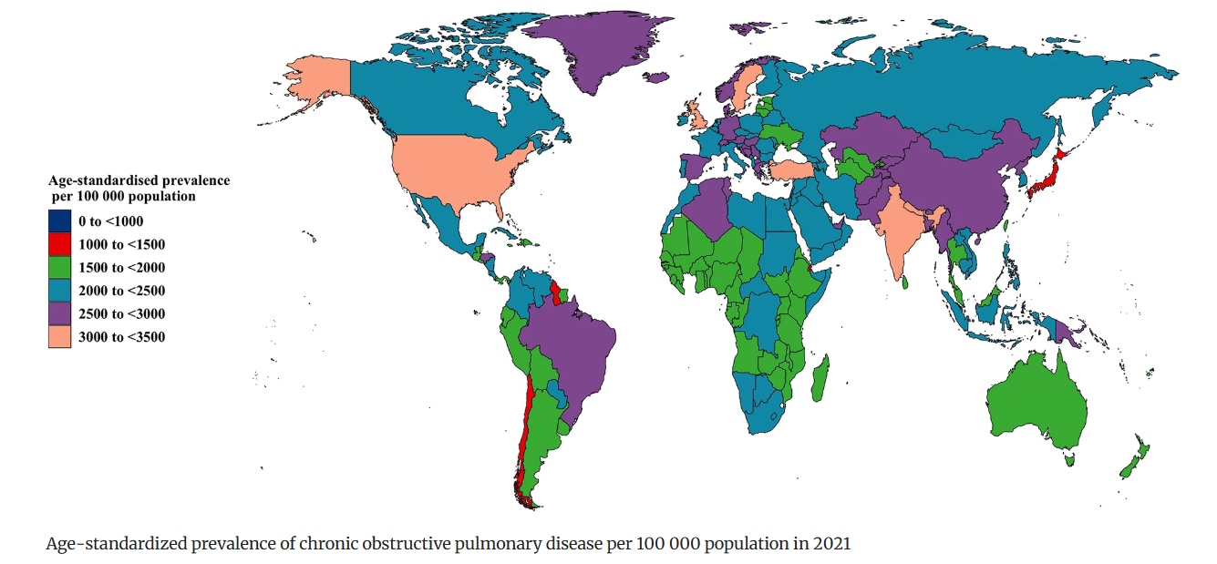
Figure 1: The prevalence of COPD and its associated risk factors on a national, regional, and worldwide scale from 1990 to 2021
(Source: Wang et al., 2025)
COPD is a major international health problem. Approximately 3.5 million deaths due to COPD were estimated in 2021, which is about 5 percentage of all global mortalities, and COPD is the fourth most frequent cause of mortality (World Health Organization, 2024). The estimates of COPD cases in the world show that over 213 million individuals are living with the disorder, hence a significant disease burden (Wang et al., 2025).
The effect of COPD is also intense in the United Kingdom. In the UK, COPD has been diagnosed in about 1.2 million populations out of the total population of about 2 per cent and 4.5 per cent of the adult population above 40 years (Primary Care Notebook, 2025). In turn, COPD results in significant burden on medical systems because of the frequent hospitalization, prolonged pharmacological care, and long-term care requirements.
This booklet is a comprehensive discussion of COPD and its etiological issues, prevalence, health effects, and evidence-based management practices utilized in the National Health Service. It also reviews care models and policy frameworks to enhance the outcome of people living with this condition of chronic respiratory conditions.

2. Understanding Chronic Obstructive Pulmonary Disease
Definition of COPD
COPD is a long-term respiratory disease which blocks breathing and airflow. It is the disorder that is mainly distinguished into chronic bronchitis and emphysema (Agarwal et al., 2023). Both phenotypes impair airway patency and alveolar integrity, impairing the capacity of the pulmonary oxygen exchange plus carbon dioxide. COPD is progressive in nature and clinical manifestations get worse with time.
The disease is usually insidious and often does not manifest itself in the early stages, but only at a later time, when a significant amount of lung damage has already occurred. The onset of the symptoms is mostly seen in the individuals who are at the age of 40 years and above. Empirical evidence suggests that the global population of adults aged over 40 years has a prevalence rate of COPD of about 910 percent; this makes the disease a huge burden to the general population (Vijayan, 2013).
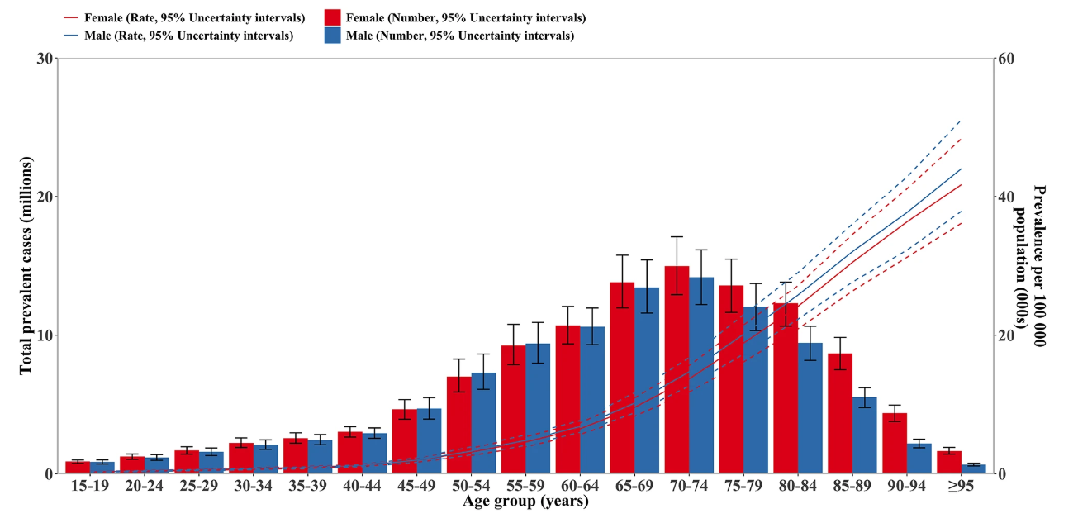
Figure 2: The number of common cases worldwide and the prevalence of COPD per 100,000 people in 2021, broken down by age and sex
(Source: Wang et al., 2025)
The most common clinical manifestations which have been reported include dyspnoea, chronic cough, purulent sputum, wheeze, and fatigue. Physical activity, e.g. walking or climbing stairs, will usually worsen dyspnoea. Patients also note a recurrence of pulmonary infections and acute exacerbations as a subset (World Health Organization, 2024).
The development of chronic obstructive pulmonary disease is mainly occasioned by extended exposure to harmful particulates or gases. Tobacco smoking is the main etiological agent, which causes more than 70 per cent of COPD cases in high-income environments. The other contributory factors include air pollutants in the environment, dust at work, and risky chemicals (American Lung Association, 2025).
Even though there is no cure of COPD, most of the diseases can be slowed down when identified at an early stage and managed properly. Interventions, such as the use of inhaled bronchodilators, pulmonary rehabilitation, and lifestyle changes, are linked to the symptom suppression and quality of life improvement in the impacted patients.

3. Burden and Prevalence of COPD
COPD is an impressive worldwide community health issue. Millions of people are afflicted with the disease, and there are many deaths every year. According to the World Health Organization, COPD is now the fourth major cause of death in the world (Xu et al., 2026). About 3.5 million COPD-related deaths were documented in 2021, which corresponds to about 5 percent of annual deaths worldwide (Naeem et al., 2025).
The COPD prevalence in the world is on an increasing trend. Epidemiological estimates have shown that in 2021 there were about 213 million people with COPD. The disease also caused almost 80 million disability-adjusted life years (DALYs), which is used as a measure of losses of years of healthy life through either morbidity or early mortality (Cao et al., 2026).
The COPD burden is unevenly distributed across certain areas of the world. Approximately 90% of mortalities in people under the age of 70 years are concentrated in low and middle-income countries, which is mainly caused by an increased exposure to risk factors, including tobacco smoking, household air quality, work-related dust, and inaccessibility of healthcare services (Yang et al., 2021).
COPD is a significant public health problem in the United Kingdom. In the UK, there are an estimated 1.2-1.4 million cases of the disease, but there are likely other cases that remain undiagnosed. In the UK, approximately 30,000 people die annually because of COPD, which makes the condition one of the largest causes of respiratory death (Kostikas et al., 2020). COPD is also one of the factors that lead to many hospital admissions and emergency department visits.

4. Risk Factors and Aetiology of COPD
COPD occurs because of prolonged exposure to polluted particles, gases, and other environmental aspects. These exposures together with personal factors of vulnerability, like genetics or ageing, usually result in the disease.
The most significant risk factor is smoking. In high-income countries, COPD is caused by tobacco smoking in over 70% of the cases (World Health Organization, 2023). Smoking harms airways and tissues of the lungs. The long-term smoking induces inflammation, airway constriction and destruction of air sacs. Smoking is the cause of approximately 34.8 percent of the disability-adjusted life years (DALYs) attributed to COPD all around the world. The risk is also increased by passive smoking and being exposed to second hand smoke.
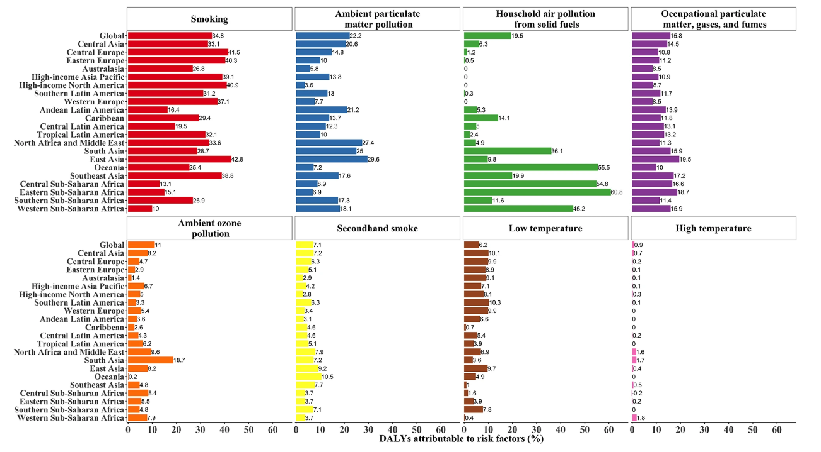
Figure 3: Percentage of DALY due to COPD in 2021 (DALY: disability adjusted life year)
(Source: Wang et al., 2025)
The other significant cause of COPD is air pollution. The disease burden of COPD in the world is approximately 22 percent due to ambient particulate pollution (Wang et al., 2025). Indoor pollution because of solid fuel burning (wood, coal, and biomass) to cook food is one of the most important risk factors in many low- and middle-income countries. Globally, household air pollution is the major cause of COPD DALYs of almost 19.5% (Martin et al., 2013).
There is also increased risk when there is occupational exposure. Lung damage can be brought about in the course of time by workers in industries that deal with dust, chemicals, gases, and fumes including mining, construction, and manufacturing industries. The occupational exposures contribute to around 15.8 percent of COPD disease burden in the world (Murgia and Gambelunghe, 2022).
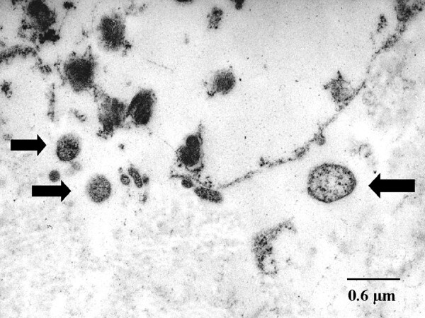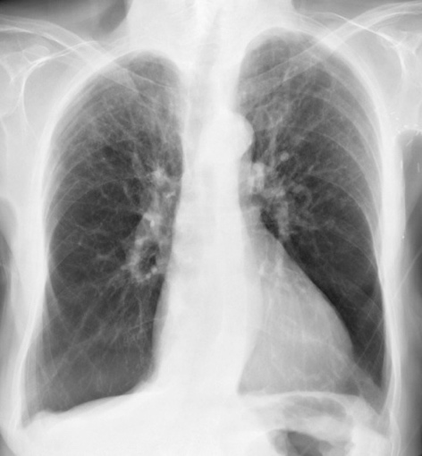
Figure 4: Alpha-1 Antitrypsin Deficiency in Emphysema and COPD X-ray (Transmission Electron Microscopy)
(Source: Meeshea et al., 2023)
Genetic causes may also play a role. Alpha-1 antitrypsin deficiency is a rare inherited disease that compromises the safety of lung tissue and may cause COPD to onset at an early age (Meseeha et al., 2023). Another significant factor is ageing. The normal aging of the lung function reduces the COPD, and it is diagnosed most frequently in adults of 40 years and above (Devulder, 2024). In general, COPD typically occurs following decades of exposure to harmful substances, in addition to personal risk factors, including genetics and ageing.

5. Impact of COPD on Individuals and Families
COPD has significant implications on physical health, mental wellbeing and social life. The condition slowly impairs the functioning of the lungs and constrains normal daily routine.
Physical Impact
The most widespread COPD symptom is breathlessness. Some of the patients find it difficult to perform simple tasks like walking, going up and down the stairs, or carrying groceries (MGM Healthcare, 2025). A decrease in exercise capacity and fatigue is also prevalent. Chest infections and sleeps are common in the patients. In the extreme, the level of oxygen in the bloodstream decreases and oxygen therapy can be taken in the long-term (Matthews, 2011). With the further development of the disease, severe complications can arise. These are respiratory collapse, heart diseases, muscle weakness, and weight loss. All these health issues create a serious decline in independence and the quality of life (Corneanu et al., 2025).
Psychological Impact
COPD has impacts on the mental health as well. People who have COPD are very susceptible to anxiety and depression. Research indicates that 1057 percent of COPD patients are depressed and 750 percent are anxious (Buican et al., 2025). COPD patients are also at increased risks of developing depression, 2–3 times higher than those of the general population (Qiu and Wu, 2024). Persistent breathlessness, loss of mobility, and anxiety about aggravation of the symptoms tend to augment psychological distress. Depression may occur in over half of the patients with severe COPD, particularly among the ones in need of oxygenation (Günaydin et al., 2026).
Social Impact
COPD in most cases constrains social activity. Travel, working, and social activities may become painful due to breathlessness and fatigue (Johansson et al., 2019). There are those who quit work because of the frequent sickness and hospitalization. This may cause economic problems and loneliness.
Impact on Families and Caregivers
The family members often become the unpaid caregivers of those who live with chronic obstructive pulmonary disease (COPD). These caregivers ease the daily living tasks such as bathing, dressing, preparing meals, and managing domestic duties in addition to supporting medication compliance, proper inhaler use, and even taking patients to hospitals and regular check-ups (Look and Stone, 2018). Furthermore, the caregivers usually keep a check on the clinical symptoms and help to cope with the sudden exacerbations or attacks of respiratory distress.
Caregiving is full of responsibilities that place a great burden on family members. Caregivers can also develop emotional distress, increased anxiety and a sense of helplessness over time especially when their patients are in a declining health condition. Chronic physical fatigue is also a common occurrence, which is explained by constant need of care. In addition, the job of caregivers may cause severe financial burden particularly when they lower their work hours or quit a job to fully support caregiving (Mayo Clinic, 2022).
Social isolation is another serious issue; the caregivers can have insufficient time to maintain personal relations and recreations, thus affecting the general well-being and quality of life. In this regard, it is important that patients and caregivers are provided with the necessary support. Counseling services can be used, caregiver support groups can be provided, they can be given financial help and provided with respite care, this will reduce this burden and improve the outcome of patients and their families.

6. Evidence-Based Treatment and Management in the UK
Even though COPD does not have a treatment, there are a number of evidence-based therapies, which can be provided by the National Health Service (NHS) in order to manage the symptoms and enhance quality of life. The treatment is typically a combination of medication, rehabilitation and lifestyle modifications according to the national guidelines of the National Institute of Health and Care Excellence (NICE) (Dr. Oracle, 2025).
Pharmacological Treatment
The primary therapy of COPD is medicines. Inhalers are usually applied in order to open the airways and decrease inflammation. Short acting bronchodilators are usually given initially to ease the breathlessness. LABA or LAMA inhalers are recommended in case the symptoms persist. In addition to the breathing of patients with more severe symptoms, combination inhalers containing long-acting bronchodilators and inhaled corticosteroids can be used to achieve better breathing and decrease flare-ups (EGuidelines.co.uk, 2025).
Pulmonary Rehabilitation
Pulmonary rehabilitation plays a crucial role in treating COPD. It is a combination of physical training, education and lifestyle counseling to ensure that patients cope with their symptoms. The length of the NHS rehabilitation programmes is typically 68 weeks, with two sessions a week, consisting of physical training and education (NHS England, 2017). Studies indicate that pulmonary rehabilitation may be very beneficial in terms of symptoms and physical capability. Research established an increase in the walking distance by approximately 40 metres and an increase in the overall quality-of-life scores (Zerbo Šporin et al., 2022).
Oxygen Therapy
Other patients with severe COPD have a low oxygen level in the blood. Home-based oxygen therapy can be administered in these situations to keep the patient alive by administering oxygen over a long period (Ergan and Nava, 2017). This therapy is usually advised to individuals with obscure illnesses and continuous low oxygen saturation.
Smoking Cessation
The best method of reducing COPD progression is cessation of smoking. Programmes supporting smoking cessation at NHS offer behavioural therapy and drugs like nicotine replacement therapy to assist individuals to stop smoking and mitigate additional lung harm.

7. Theoretical Models for Managing Long-Term Conditions
Effective management of long-term conditions such as COPD requires structured care models and supportive health policies. These frameworks help healthcare systems deliver coordinated, person-centred care.
UK Model: The House of Care Model
The House of Care Model is a popular approach in the United Kingdom to help people with long-term conditions. The model encourages person centred and integrated care. It puts the patient at the centre of health care system and emphasizes on collaborative care planning between the patients and the healthcare providers. The model includes four key components that work together like parts of a house. These components are:
- Engaged and informed patients and carers
- Healthcare professionals working in partnership with patients
- Organisational systems and clinical processes
- Effective commissioning and planning of services
The core of the model is a care and support planning conversation where the patients and the healthcare professionals collaboratively produce personalised care plans. This strategy promotes self-management and joint decision-making (Alliance, 2023).
International Model: The Chronic Care Model
Chronic Care Model (CCM) is a model that is actively used in the management of chronic diseases (Wagner et al., 1996). The model, which was created by Wagner and his co-workers, aims to change the care provision to a more proactive, systematic, and patient needs-centred approach.
The CCM has six related components (1) health-care organisational structure; (2) community resources; (3) self-management support; (4) delivery system design; (5) decision support; and (6) clinical information systems). Health-care organisations must adopt policies that can enable long-term care of high quality that is sustained and incorporate the support groups and social services provided by the community as ancillary support.
Self-management support enables the patient to understand the conditions and learn to live with them in the circumstances of daily lives, which raises the self-efficacy (Keller et al., 2010). The design of the system of delivery guarantees the systematic organisation and coordination of care, decreasing its fragmentation and enhancing interprofessional collaboration. Evidence-based guidelines are used to inform therapeutic interventions by decision support mechanisms, and to assist clinicians in monitoring patient data by clinical information systems, thus informing continuous quality improvement and outcome optimisation.
As empirical studies indicate, CCM is especially effective as a means of chronic obstructive pulmonary disease (COPD) management, as a way of encouraging regular check-ups, early therapy and prevention of complications. Additionally, the model promotes interdisciplinary collaboration and increasing patient engagement, which altogether lead to better clinical outcomes.
However, the CCM cannot be universal because resources are not always available, the workforce may not be adequate, and the infrastructure of the system is systemic. Regardless of these limitations, the model proves to improve health condition and reduce the frequency of hospitalisation, which highlights its usefulness in a variety of health-care environments.
Health Policy and Political Agendas
The role of health policies in COPD management is also significant. The NHS Long Term Plan, which was launched in the UK in 2019, reveals the priorities of enhancing care provided to chronic diseases and empowering community healthcare services. The plan focuses on earlier diagnosis, integrated care systems and improved community-based care. Moreover, the evidence-based guidelines provided by National Institute of Health and Care Excellence (NICE) offer recommendations on how to diagnose and treat COPD.

8. Recommendations for Improving COPD Management
Recommendation Area | Description | Expected Benefits
Strengthening Person-Centred Care | Healthcare professionals should involve patients in care planning and treatment decisions to support shared decision-making. | Improves treatment adherence, patient satisfaction, and overall health outcomes.
Supporting Self-Management | Patients should be encouraged to leave smoking and do regular physical exercises. | Reduces symptom severity, improves daily functioning, and lowers hospital admissions.
Improving Community-Based Care | Community respiratory services and multidisciplinary teams should provide ongoing support through coordinated care between primary care and hospitals. | Improves continuity of care and allows patients to receive treatment closer to home.
Enhancing End-of-Life Care | Palliative care should focus on symptom relief, emotional support, and advance care planning for patients with advanced COPD. | Improves quality of life and ensures dignity and comfort for patients and families.

9. Conclusion
Chronic Obstructive Pulmonary Disease is a significant issue of health concern in the world, and it has significant impacts to individuals, families and the health care system. Persistent airflow limitation and progressive respiratory symptoms characterise the disease and diminish the quality of life.
COPD is one of the most fatal causes of death in the world as well as it is still exerting significant burden to the health care systems especially in the UK. Smoking, air pollution, occupational exposure, and ageing are some of the risk factors that lead to the occurrence of the disease.
The physical, psychological and social effects of COPD underscore the need to consider holistic care methods which would consider both medical and psychosocial aspects. Pharmacological therapy, pulmonary rehabilitation, oxygen therapy and smoking cessation are some of the evidence-based therapies that are important in symptoms management and delaying the disease process. The theoretical models that have been used in this study, the House of Care Model and the Chronic Care Model, underscore the roles of integrated healthcare systems and patient empowerment in the management of long-term conditions.

10. References
Agarwal, A.K., Raja, A. and Brown, B.D. (2023). COPD. [online] National Library of Medicine. Available at: https://www.ncbi.nlm.nih.gov/books/NBK559281/.
Alliance (2023). The House of Care Model - Health and Social Care Alliance Scotland. [online] Health and Social Care Alliance Scotland. Available at: https://www.alliance-scotland.org.uk/past-work-and-projects/scotlands-house-of-care/the-house-of-care-model/? [Accessed 13 Mar. 2026].
American Lung Association (2025). COPD Causes and Risk Factors . [online] American Lung Association. Available at: https://www.lung.org/lung-health-diseases/lung-disease-lookup/copd/what-causes-copd.
Buican, I.-L., Buican-Chirea, A.-C., Mușat, Mădălina Iuliana and Streba, Costin Teodor (2025). Depression and Anxiety as Comorbidities in Chronic Obstructive Pulmonary Disease: A Comprehensive Narrative Review. Healthcare, [online] 13(18), p.2344. doi:https://doi.org/10.3390/healthcare13182344.
Cao, Z., Tong, X., He, L., Luo, Y., Huang, K., Li, W., Niu, H., Chen, Q., Jiao, L., Vollmer, S., Thompson, B., Pascal Geldsetzer, Rifat Atun, Till Bärnighausen, Wang, C., Yang, T. and Chen, S. (2026). Burden of chronic obstructive pulmonary disease and its attributable risk factors in 204 countries and territories, 1990–2021: results from the Global Burden of Disease Study 2021. BMJ Public Health, [online] 4(1), pp.e002489–e002489. doi:https://doi.org/10.1136/bmjph-2024-002489.
Corneanu, L.E., Sîngeap, M.S., Mutruc, V., Ovidiu Rusalim Petriș, Toma, T.P., Victorița Șorodoc, Laurențiu Șorodoc and Cătălina Lionte (2025). The Complex Relationship Between Heart Failure and Chronic Obstructive Pulmonary Disease: A Comprehensive Review. Journal of Clinical Medicine, [online] 14(13), pp.4774–4774. doi:https://doi.org/10.3390/jcm14134774.
Devulder, J.V. (2024). Unveiling mechanisms of lung aging in COPD: A promising target for therapeutics development. Chinese Medical Journal - Pulmonary and Critical Care Medicine, 2(3), pp.133–141. doi:https://doi.org/10.1016/j.pccm.2024.08.007.
Dr. Oracle (2025). What are the NICE guidelines for managing COPD? [online] Droracle.ai. Available at: https://www.droracle.ai/articles/348975/what-are-the-nice-guidelines-for-managing-chronic-obstructive? [Accessed 13 Mar. 2026].
EGuidelines.co.uk (2025). NICE: Chronic obstructive pulmonary disease: management of chronic obstructive pulmonary disease in adults in primary and secondary care. [online] Eguidelines.co.uk. Available at: https://eguidelines.co.uk/eguidelinesmain/guidelines/summaries/respiratory/nice_copd.php?.
Ergan, B. and Nava, S. (2017). Long-Term Oxygen Therapy in COPD Patients Who Do Not Meet the Actual Recommendations. COPD: Journal of Chronic Obstructive Pulmonary Disease, 14(3), pp.351–366. doi:https://doi.org/10.1080/15412555.2017.1319918.
Günaydın, S., Şimşek, M.H. and Şimşek, Ş.M. (2026). The effect of clinical and psychosocial factors on quality of life in COPD: a cross-sectional assessment using a mediation analysis approach. Frontiers in Psychiatry, 17. doi:https://doi.org/10.3389/fpsyt.2026.1756291.
Johansson, H., Berterö, C., Berg, K. and Jonasson, L.-L. (2019). To live a life with COPD – the consequences of symptom burden. International Journal of Chronic Obstructive Pulmonary Disease, [online] Volume 14(14), pp.905–909. doi:https://doi.org/10.2147/copd.s192280.
Kostikas, K., Price, D., Gutzwiller, F.S., Jones, B., Loefroth, E., Clemens, A., Fogel, R., Jones, R. and Cao, H. (2020). Clinical Impact and Healthcare Resource Utilization Associated with Early versus Late COPD Diagnosis in Patients from UK CPRD Database. International Journal of Chronic Obstructive Pulmonary Disease, Volume 15, pp.1729–1738. doi:https://doi.org/10.2147/copd.s255414.
Look, K.A. and Stone, J.A. (2018). Medication management activities performed by informal caregivers of older adults. Research in Social and Administrative Pharmacy, [online] 14(5), pp.418–426. doi:https://doi.org/10.1016/j.sapharm.2017.05.005.
Martin, W.J., Glass, R.I., Araj, H., Balbus, J., Collins, F.S., Curtis, S., Diette, G.B., Elwood, W.N., Falk, H., Hibberd, P.L., Keown, S.E.J., Mehta, S., Patrick, E., Rosenbaum, J., Sapkota, A., Tolunay, H.E. and Bruce, N.G. (2013). Household Air Pollution in Low- and Middle-Income Countries: Health Risks and Research Priorities. PLoS Medicine, [online] 10(6), p.e1001455. doi:https://doi.org/10.1371/journal.pmed.1001455.
Matthews, E.E. (2011). Sleep Disturbances and Fatigue in Critically Ill Patients. AACN Advanced Critical Care, 22(3), pp.204–224. doi:https://doi.org/10.1097/nci.0b013e31822052cb.
Mayo Clinic (2022). Practical solutions for caregiver stress. [online] Mayo Clinic. Available at: https://www.mayoclinic.org/healthy-lifestyle/stress-management/in-depth/caregiver-stress/art-20044784.
Meseeha, M., Attia, M. and Sankari, A. (2023). Alpha 1 antitrypsin deficiency. [online] PubMed. Available at: https://www.ncbi.nlm.nih.gov/books/NBK442030/.
MGM Healthcare (2025). MGM Healthcare. [online] MGM Healthcare | Best Super-MultiSpecialty Hospital in Chennai. Available at: https://mgmhealthcare.in/copd-symptoms-and-awareness/ [Accessed 13 Mar. 2026].
Murgia, N. and Gambelunghe, A. (2022). Occupational COPD—The most under-recognized occupational lung disease? Respirology, [online] 27(6), pp.399–410. doi:https://doi.org/10.1111/resp.14272.
Naeem, S., Wang, F., Mubarak, R., Shen, H., Li, X., Mommers, I., Hussain, S.R., Malik, S.S., Yu, C., Hak, E., Xu, X., Fawad, M. and Mubarik, S. (2025). Mapping the Global distribution, risk factors, and temporal trends of COPD incidence and mortality (1990–2021): ecological analysis. BMC Medicine, 23(1). doi:https://doi.org/10.1186/s12916-025-04014-0.
NHS England (2017). NHS England» Pulmonary rehabilitation. [online] England.nhs.uk. Available at: https://www.england.nhs.uk/ourwork/clinical-policy/respiratory-disease/pulmonary-rehabilitation/?.
Primary Care Notebook (2025). Prevalence. [online] Primarycarenotebook.com. Available at: https://primarycarenotebook.com/pages/respiratory-and-chest-medicine/chronic-obstructive-airways-disease-copd/prevalence? [Accessed 13 Mar. 2026].
Qiu, C.-J. and Wu, S. (2024). Depression and anxiety disorders in chronic obstructive pulmonary disease patients: Prevalence, disease impact, treatment. World Journal of Psychiatry, [online] 14(12), pp.1797–1803. doi:https://doi.org/10.5498/wjp.v14.i12.1797.
Vijayan, V. (2013). Chronic obstructive pulmonary disease. The Indian Journal of Medical Research, [online] 137(2), p.251. Available at: https://pmc.ncbi.nlm.nih.gov/articles/PMC3657849/? [Accessed 13 Mar. 2026].
Wang, Z., Lin, J., Liang, L., Huang, F., Yao, X., Peng, K., Gao, Y. and Zheng, J. (2025). Global, regional, and national burden of chronic obstructive pulmonary disease and its attributable risk factors from 1990 to 2021: an analysis for the Global Burden of Disease Study 2021. Respiratory Research, 26(1). doi:https://doi.org/10.1186/s12931-024-03051-2.
World Health Organization (2023). Smoking Is the Leading Cause of Chronic Obstructive Pulmonary Disease. [online] www.who.int. Available at: https://www.who.int/news/item/15-11-2023-smoking-is-the-leading-cause-of-chronic-obstructive-pulmonary-disease.
World Health Organization (2024). COPD. [online] Who.int. Available at: https://www.who.int/news-room/fact-sheets/detail/chronic-obstructive-pulmonary-disease-%28copd%29?.
Xu, J., Xu, H., Zhang, D., Deng, X., Bian, Y., Xu, Y., Ao, G., Liu, J. and Xu, F. (2026). Global, regional and national trends in burden of chronic obstructive pulmonary disease from 2000 to 2021 and the prediction for 2030. Chronic Respiratory Disease, [online] 23. doi:https://doi.org/10.1177/14799731261432520.
Yang, X., Zhang, T., Zhang, Y., Chen, H. and Sang, S. (2021). Global burden of COPD attributable to ambient PM2.5 in 204 countries and territories, 1990 to 2019: A systematic analysis for the Global Burden of Disease Study 2019. Science of The Total Environment, 796, p.148819. doi:https://doi.org/10.1016/j.scitotenv.2021.148819.
Zerbo Šporin, D., Domjanič, D. and Žvanut, B. (2022). Effectiveness of pulmonary rehabilitation performed through exercise training for patients with stable COPD: A meta-analysis of randomized controlled trials. Slovenian Journal of Public Health, 61(4), pp.231–241. doi:https://doi.org/10.2478/sjph-2022-0031.

