The impact of technology related
expectations on learner motivation

Louis Emyr Dare

Contents
Introduction 2
Literature Review 8
Research Methodology 21
Findings 27
Bibliography 34
A glossary of acronyms 38
Appendcies

Introduction

I have worked within the field of eLearning and Interactive Learning Technology (ILT) for over ten years. ILT, a term devised by the Welsh Assembly Government (2004) through it’s funding documentation, is defined as the technology used to interactively engage with learners in the classroom. The IL’ funding allowed many organisations to invest in interactive whiteboards, voting systems and classroom management tools such as Lan School. The purpose of this research is to identify if technology provides learning benefits within the post 16 Further Education sector in Wales. If proved, the finding could be used order to support the justification of new financial investment into new and exciting technologies that exceed learner expectations.
My current role of eLearning Development Manager within my organisation, a medium sized Further Education College in South Wales (which I shall refer to as The College), is focused on eLearning and contains several pillars of activity. The main pillar of activity that supports this research is in development of ILT, and how pedagogies can be applied in order to create a meaningful experience for our learners. The duties of this role include research, the development of strategic documentation and the coordination of staff development on subjects within the field. As well as delivering face to face ILT training, both internal and external on a commercial basis I have also written a number of accredited online, distance learning, courses which have been studied by lecturers all over the world. Prior to the creation of this role I taught Computing and Mathematics from Level 1 to Undergraduate at secondary school, college and university sectors.
Like many Further Education colleges, the college has a number of campuses located throughout the county. Whilst the college does attract learners from the age of 14 via a cost recovery partnership with feeder schools in the offering of vocational pathways, the majority of full time learners join at the age of 16 following the completion of their GCSEs. The main campus is situated in a large town where only one of the six local secondary schools host a sixth form, making progression into further education a natural choice for most learners. The college is very proactive when it comes to new technologies and I have been involved in the winning a number of a number of national ILT related awards including 2015 Colegau Cymru award for eLearning as well as gaining the Silver award in the 2017 Pearson Teaching Awards for The Outstanding Use of Technology in Education.
It is well documented that Further Education colleges in Wales, has suffered a series of funding cuts in recent years, (South Wales Evening Post, 2015) and so it is felt that this research is now as important as ever in demonstrating the value of such investments and the effects they have on learners.
September 2015 saw a number of revised qualifications and frameworks in Wales including the Welsh Baccalaureate and Essential Skills Qualifications (ESQ) which now contains a significant element of Digital Literacy (Jisc, 2015). The term Digital Literacy is used by Qualifications Wales, however has the same connotation as Digital Competency. The need for these changes where identified following a number of reviews into education in Wales in which it has been identified that learners leave often education with gaps in their understanding of the digital world. The Donaldson Report, Successful Futures (2015), clearly identifies the need to promote and develop skills in digital competence in order to shape an exciting future foe Wales. The European Commission (2008) has described Digital Literacy as the skills required to demonstrate Digital Competence.
As well as the introduction of a standalone Digital Literacy qualification throughout the Welsh Baccalaureate Qualification and the new Digital Literacy Essential Skill Qualification the Welsh Government has also written to all schools and colleges to unblock a significant number of websites and social media platforms so that learners can be educated in being responsible digital citizens, something which up until now has never been full addressed.
The college identified the delivery of the new Digital Literacy qualifications as a significant opportunity to promote digital competency across the entire curriculum. Qualifications Wales (2015), define the pillars of Digital Literacy include digital collaboration, digital production, digital learning and digital safety. Educators who will be supporting the new digital literacy content will be internally supported in the development of new digital competencies for use, not only in the timetabled ‘Digital Literacy’ class(es) but also into all other subjects taught, ensuring all new teaching skills are seamlessly embedded into the curriculum thus creating a greater impact on the teaching and learning experience.

Context
This study is focused on 16 year old learners who are enrolling onto a further education course in 2015. The Further Education experience will be new for all learners having recently left secondary education. Our current learners, are now younger than Google and Broadband Internet (GCN, 2007) and would have been 7 when Facebook friend requests first hit our inboxes. The majority of learners questioned have attended one of the eleven feeder secondary schools in the Carmarthenshire area. These learners will have a range of expectations based on a number of factors including their prior use of ILT during secondary education and the level of technology they have access to at home and in social settings.
In order to answer my second research question ‘Do learners have expectations with regards to technology enhanced learning?’, an initial survey was conducted during the September 2015 Induction Week to capture and record expectations and previous experiences in order to measure the increase or decrease in the appropriate use of ILT. The data captured will be used to measure expectation against standard lesson delivery pedagogies at the college. Learners provided a range of data that detailed their previous experiences and their expectations of the college.
It was vital that this questionnaire was completed during the Induction Week so that expectations were not skewed by initial observations and learning engagements. A second survey was issued after the autumn half term in order to identify the effects of technology on their attitude towards learning and assessment and how their expectations had been met.
As national funding budgets become stretched, the ability to justify the investment in the latest technologies becomes a greater challenge unless there is publish research which provides clear pedagogical advantages to teaching and learning.
In order to gain a true reflection of learner opinion I questioned learners in the following areas: A Level, Outdoor Education, Art and Design and Sports Science.
Rationale
The purpose of this research is to justify the continued developments into technology enhanced learning which in most cases carry a significant cost. My college, has been conducting small experiments for a number of years and as of September 2015 have decided to significantly increase the impact of technology on teaching and learning online with the introduction of a number of new Digital Literacy qualifications. I, Dare, L (2014), conducted an experiment in 2013-4, (which was published by Colegau Cymru) in which learners developed their Welsh language skills for 20 hours using online resources rather than 20 one hour face to face teaching. The award submission for this can be found in Appendix 4b. This method allowed learners to learn at their own pace, something which without detailed scaffolding, cannot easily happen with face to face teaching as each learner arrives with a varied amount of knowledge and each learner naturally picks up new language skills at differing rates. The 2014 experiment was extremely successful with learners proving extremely positive feedback in relation to the flexibilities offered by eLearning and the college was shortlisted for a national Colegau Cymru award. This experiment tested the learning experience and how the individual needs of learners were met however it was not designed to capture feedback on achievement as the unit of study was not formally assessed.
My main research question asks ‘Can classroom based interactive assessment strategies increase 16-19 learner motivation? ‘ The research contained within this project is aimed at proving that by further investing in compulsory staff development (CPD) and embedding the latest technologies into classroom delivery the expectations of learners can be met or exceed. It is hoped that this research will prove that the knock on effect of this will be that learners feel more motivated, when their expectations are met and in turn achieve higher grades.
An external, organisational outcome is to demonstrate that the results of this research will provide evidence that will support the justification of further developments and deployments in technology related learning classroom experiences, which can be costly both in terms of purchasing and supporting.
Whilst the focus of my research is aimed at increasing motivation, in the hope that it can be proved that an increase in motivation leads to an increase in attainment, it should also be proved that if expectations are not met, will learners become demotivated and sol this is the basis of my third, and final research question, ‘Are learners demotivated by failed expectations?’.

Aims
The aim of this study is to investigate if learners arrive at Post 16 Further Education with expectations in relation to ILT and what affect this has on motivation if these expectations are; met, exceeded or failed. As detailed in my Application for Ethical Approval (Appendix 1a) my research will be under pinned by these points which can been structured into three main questions:
- Can classroom based interactive assessment strategies increase 16-19 learner motivation?
- Do learners have expectations with regards to technology enhanced learning?
- Are learners demotivated by failed expectation?
Summary
This research activity will be structured in the follow layout:
- Literature Review
The initial part of this research will be a review of current literature, this includes a range of media such a books, ebooks, journals, published papers and websites. Caution will be given to the authenticity of websites as content can lack quality and evidence.
It is expected that a number of papers will be published on learner motivation, and also on the use of technology in the classroom for assessment however I am excited to discover what experiments and research have taken place where technology and pedagogy have been considered together, especially within subjects that are not traditionally associated with technology.
- Methodology
The methodology chapter with explain in detail which research methods are most appropriate for my area of study and the audience I intend to question. The research conducted will be primary and will focus on a specific group of learners, 16-19 learners who have recently enrolled at the college, a post 16 further education college, following a number of years at secondary education.
- Analysis and Discussion
This chapter will present my findings into the impacts of technology on learner motivation and will clearly demonstrate the relationship between both elements. Data will be presented visually and a number of questions will be selected for in depth analysis in order to highlight the outcomes to be discussed.
- Conclusion and Recommendations
The research activity will conclude with this final chapter than will clearly summaries the outcomes of the entire project and present a number of recommendations for post 16 further education in Wales.
- Appendices
Appendices will include additional information including referenced documentation that may not be in the public domain and also the results of the anonymised questionnaires
The first part of any research task should always be to thoroughly investigate existing research in order to measure the work that has already taken place to support the research questions, to identify possible gaps in the field and where appropriate question and critique the publish findings in order to challenge and research deeper. The following chapter reviews a range of literature what underpin the three research questions and concludes with a number of subject related findings.

Literature Review

The subject of eLearning, is constantly evolving, especially as new technologies are being developed every day. With this in mind many books (such Clarke 2007, Horton 2006 and Allen 2007 for example) published on this subject do not focus on the latest technologies but focus more on learning pedagogy of eLearning design, on distance or blended learning rather than the classroom experience. Many of the early texts and research articles that focused on a specific technology were first published over ten years ago and now feel outdated. Unfortunately, hard copy books quickly become out of date as new technologies, platforms and applications are developed and so the bulk of my research has been conducted from the reviewing of professional journals and other research articles.
The iPad was released in 2010 (Apple, 2018) and since then a number of advances have been developed, such as wireless internet access, which have improved access to such technologies in educational settings. Tablet computing is not a new concept, in fact Apple began development in 1987 and in 1993 released the Apple Newton. The Newton and the current iPad have many similarities both share a similar Notepad app, both have touch screens and both are portable however this concept was shelved five years later as its potential could not be realised until other technologies and environments developed and improved. Koehler & Mishra (2009) explain that many technologies used to support teaching and learning had not been designed to support education and so educators need to have a deeper understanding of both the context and technology to identify how new and existing technologies can be developed to create new learning experiences.
Whilst I have read a large number of papers and literatures prior to starting this research activity, the purpose of this literature review is to revisit the area and identify new research that has been published during the past two years. My research is focused on ‘The impact of technology related expectations on learner motivation’ and so my research is mainly focused on articles that can demonstrate a noticeable impact on learners attitude towards learning, especially where expectations have been exceed and the knock on effect against results. My research will primarily focus on the Further Education sector, which typically engages with learners between the age of 16 and 19. However as this area is extremely narrow my research will also investigate case studies from learners of primary and secondary education and will also examine learning experiences outside of the UK in order to identify areas of best practice which could be developed for the Further Education sector.
Not all findings are ground breaking and have become dated after 10 years of their publication, for example, Raacke & Bonds-Raacke (2008) produced research entitled ‘ Using Tablet PCs in the Classroom’ . This research is based on an experiment where tablet computers were only used to deliver PowerPoint presentations, reply to emails and access Blackboard.

Raacke & Bonds-Raacke, confirmed that learners do arrive on day one with certain expectations and it is very important that we meet these and that whilst the use of this technology was unimaginative and didn’t offer any new learning strategies, learners reported a positive attitude toward the implementation.

Unlike Raacke & Bonds-Raacke, Halat (2008) questioned the use of high level IT skills to produce ‘webquests’ , a learning resource that would not be possible without any technology. Learners were encouraged to engage with webquests and conduct online research in order to stretch their learning needs.

Price & Kadi-Hanifi (2011) explain how a group of mature learners used technology to restore motivation whilst struggling with work life balances. One group of learners studying FLDS used social networking sites such as Facebook whilst a control group studying DTLLS did not. Price & Kadi-Hanifi (2011) felt that previously there was a high dropout on this courses as a result of limited social integration opportunities on a one day a week HE course, Trotter & Cove (2005) back up this theory. The group FLDS group experimented with the forming of relationships via social networking such as Facebook and blogs, which could be easily and quickly commented on. Unfortunately the blogging was not a success however Facebook, and texting, were of huge benefit. Learners encouraged each other and gave each other emotional support when they felt like withdrawing from their course as external pressures mounted.
Unbeknown to me at the time of investigation, Jisc , a publicly funded research organisation, were also in the process of carrying out very similar research which were published in March 2015. According to Killen (2015) FE faces a number of challenges with regards to the embedding of digital learning resources and experiences which include lack of support for lecturers, lack of incentive to embed digital resources and lack of funding for research which altogether has led to outdated assumptions about learners digital literacy skill sets. Based on my FE experiences I would certainly agree with the reports’ findings and whilst there are areas of excellent practice within my own college, these are usually in niche areas. Unfortunately limited support has only further diminished as a result of reduced funding and even Jisc’s own funding of a ‘Welsh Learning Technology Forum’ has now been removed thus removing the conduit that allowed for termly cross college collaboration, networking, brain storming and sharing of best practices with in the narrow field of interactive learning technology in the further education sector.
The gap between lecturers and learners with regards to the use of technology is only going to increase based on the research of Neumann (2015) who suggests 36% of children aged 3 to 5 own their own tablet and as a result spend on average 70 minutes per day engaging with their device. Furthermore it is suggested that education is popular past time and literacy apps such as Pocket Phonics and Sesame ABC are extremely popular as well as a whole host of interactive ebooks that aid and support reading development.
In addition to the noticeable changes in the way children are learning through play and game play the use of wireless tablet technology is impacting in other areas of the modern home. According to a study by Greer (2015) 34% of people spend more time engaging with a tablet than watching their widescreen TV and that 26% of those surveyed watched on demand TV shows in their tablet rather than traditional scheduled TV programs. This report also suggests that 78% of tablet owners use their device on a regular basis for information searching. The concept of using an iPad as a portable device to quickly search for information is repeated in a number of educational case studies such as that showcased by Apple. At Essa Academy, Chohan (2015) in Bolton, Badat, the schools’ Principal explains how learner completion, defined as a minimum of 5 GCSEs, has raised from 28% to 100% since in introduction of ipads into joined up whole school approach into technology enhanced learning - Hamza U a year 7 student explains how the ipads allow them to carry out research and find answers at any time of the day. Badat believes this portable technology allows learning to seamlessly take place outside of the classroom and so increases learners access to education, especially when enhanced with a dedicated learning resource platform such as iTunes. This forward thinking has increased the time learners at Essa Academy can spend learning and the learner results justify the investment and classroom environment change.
Crawford (2007) research on information literacy suggests that there is also a strong link between the use of electronic information services (EIS) and learner retention and progression suggesting that EIS is having a positive impact on retention which in turn is having a positive effect on progression. There is also strong relationship between EIS activity and innovative teaching and learning styles. It is finding such as these two examples which I hope to replicate in my results and further demonstrate that the barriers to developing technology enhanced learning must be breaking down in order to drive up performance.
Whilst there are many positive example of how technologies are being used and how larger numbers of learners are using exciting new technologies, many educational managers within my college are still fearful that a breakaway from traditional teaching methodologies can be thwarted by digital divides. According to Livingstong (2007), 3% of learners between 9 and 19 are non-users of the internet, or have never used it, with 22% of parents in the same category. It is also reported that 13% of 9 – 19 year olds use the internet less than once a week with a similar number of parents, 17%, also engaging on an infrequent basis. It is important that where new technologies are trialed those learners who may be disadvantaged are recognised so that additional support can be provided or signposted. Without a uniform experience the ‘digital divide’ could provide a barrier to learning, which may have a negative impact on resource engagement, flipped learning and ultimately the understanding of content. This is not a new problem, in fact it was suggested that at a National Association of Teachers Teacher Conference in 1907 (Clay) educationalists debated the impact of ink replacing pencils for writing.
These and similar statistics that are often used by lecturers in order to defend why their teaching methods have not evolved with the technologies. It has been suggested, Welsh Government (2004), that most who provide such feedback feel unsupported in the development of digital learning. If such barriers were in places in other areas of education would assessments be modified to support learners without pens and would learning activities be scrapped for those who were unable to afford text books? Hopefully the answers to these is No, but such arguments have been made at my own college and todays barriers are just a wave ripple in the ocean of education and pedagogy.
According to Clay (2013) education has always faced resistance towards change and evidence of this can be found throughout history. Clay claims that in 1709 there was a resistance to the introduction of slate in the classroom, unlike bark slate would break if dropped which in turn may prevent some learners from continuing in their writing. Again in 1929 and 1950 education faced backlash to changes in the way in which students acquired inks and pens for writing tasks. James Clay feels the resistances we face today in the implementation of digital learning strategies are no different to those education has faced in the past and so we should expect similar barriers to continue to echo in the future as technologies develop and are introduced into classrooms. James claims staff will always focus on departmental duties and development tasks that have been given the greatest priority and so only by making the development of digital learning practices a high priority for the entire organisation will educators embrace and adopt new practices in a joined up way. Again reflecting on my own experiences I would agree with Clay, those who do not positively embrace new digital teaching strategies have indeed their focuses in other areas and have certainly given greater priority to these. Similarly Koehler (2009) also draw attention to the skill set of lecturers when it comes to the design of teaching and learning strategies. Its suggested that in the main the majority of today’s educators graduated at a time when educational technology was in its infancy and bridging the gap can be quite challenging especially if the benefits are not appreciated and a one-size fits all approach is taken to the delivery of educational CPD.
However the findings of Koehler & Mishra, Killen James Clay and many others can be counter argued against by a percentage of ‘traditional’ teachers who deliver very traditional subjects to very selective group of high performing learners. Many colleges boast excellent A Level results, and in most subject areas generate pass rates of over 97% with the most able and talented regularly progressing to leading Universities such as Oxford or Cambridge.
Despite the supposed lack of support and in some cases the perception that their teaching performance is excellent there are a number of lecturers who have given digital learning a high priority and have actively embraced pilots into their learning. Auster (2016) experimented with flipped learning by developing an experimental scheme of work which included a series of screencasts which learners observed outside of the traditional classroom environment. Auster described his learners as ‘Millennials’ ie those who are naturally digital natives as they we born after the year 2000 and so believed all of his possessed the skills required to communicate and engage with learning using the internet and web based tools. Students were questioned at regular stages throughout the experiment and returned excellent feedback with 100% of students claiming the screencasts were either very effective or somewhat effective in the preparation of exams and 98.8% indicated the screencasts had had a positive impact on the understanding of the subject concepts and ideas.
Jacobs (2013) aims to advise those who may be considering the embedding of technology into literacy. She explains how she carried out research with learners who had resistance to literacy claiming there are no reluctant readers just disengaged readers. Jacobs explained this view is also shared by other professionals. Jacobs initially explains that teachers often feel the links between technology and engagement are untested and so teachers can become frustrated when their efforts are met with a lack of enthusiasm. Jacobs argues that rather than assuming technology will automatically enthuse learners we need a different approach to the learning style that will allow the technology to generate motivation.

Wu et all (2010) explains that there is strong evidence to suggest technology increases motivation and in turn achievement. It is also detailed that there is a link between learning styles and achievement, however Wu et all (2010) confirm that little research has been conducted to test learning style, motivation and achievement with technical and vocational students, in relation to Information Technology and Society courses in Taiwan. Whilst is a very narrow area to sample, results could have reflected well against the research I intend to carry out with vocational students in Wales. Sadly after extensive research Wu et all (2010) claim they found little evidence to suggest a link and recommended that teachers need to reflect on a range of learning styles when the first technology is first introduced into their delivery.

During a report on the use of iPads with learners who suffer with Autism Spectrum Disorders (ASD) I found it interesting and somewhat heartwarming that a number of authors (Hourcade, (2012), Lorah (2013); McNaughton (2013); Shane ( 2012) claim that an iPad is extremely beneficial to this field explaining one of the reasons as being social acceptance. Thinking back to my own experiences as a learner during the 80s and 90s, learners with learning statements often used bulky IT devices that naturally caused curiosity and sometimes embarrassment. The use of an iPad would certainly breakdown some of these barriers and so could easily have a dramatic effect on learner motivation and engagement. Interestingly in Dixon’s report (2015) the apps that were used to support learners with ASD were also shared with the learners families so that learning goals could be shared and delegated. Whilst the study suggests parents of children with disabilities use iPads in a more constructive way the school / home relationship is one that should be explored in education with all parents being made aware of the apps used in their children’s education and how their use at home can aid further learning and development. This finding is very important as the digital tools investigated in this project will be available outside of the campus and tools such as Google Classroom include parental access. The impact of this feature will be investigated during the project research – however as the core focus is post 16, a percentage of the learners will be above the age of 18 and may not live at home.
One area of digital learning that seems to be in decline is in the teaching strategies that use handheld SRS (Student Response Systems) to collected learner feedback via multiple choice. These small devices where extremely popular with early adopters however since their introduction over 10 years ago have become less common. In reality those educators who embraced such devices have probably moved on to more dynamic systems that interact with mobile phones such as Socrative, NearPod and Smart Response VE which can collect more detailed learner feedback in the form of written text, annotation and idea sharing, plus do not require bespoke vendor hardware. Thomas (2015) conducted student voting research by delivering the same lecture to three set groups, a groups with SRS, a group with written responses and a group with no responses channels. During the experiment learners in the written response group outperformed the other groups on reading accountability items, however learners who engaged with electronic SRS systems demonstrated a higher understanding of the content overall. The SRS group felt reading accountability was increased and they were satisfied with the SRS as a way of proving feedback. Learners expressed they would prefer to use SRS in future which demonstrates that learners do desire a more modern teaching and learning environment, Oomen-Early (2015) states that colleges are using 20th century teaching methods when engaging with 21st century learners and that the gap between digital natives and digital immigrants is constantly growing.
One area of digital engagement where many further education lecturers have positively embraced is in the use of social networking to support learning activities and collaboration outside of the classroom. At my own college a number of educator have trailed various platforms including Facebook, Twitter, Pintrest, MyBigCampus, Google Plus and Google Classroom. Whilst Semiral (2015)’s research is primarily focused on education in Turkey many concerns which are discussed such as cyberbullying apply globally and should be considered when promoting social networking. Oncu also mentions there is a risk to learners who are unable to manage their time and how Facebook can become addictive and distractive, but like many educational papers lacks real detail on how the use of Facebook can enhance education. Furthermore Pasek (2016) highlights another concern that to a certain extent we are in the middle of an unplanned experiment and that the 80,000+ apps (Apple Store 2015) branded as educational are unregulated and have not been tested by academics – and if they have been authenticated, trialed or tested detailed and verifiable feedback is not readily available.
Koehler (2009) explain that the key to effective teaching with technology lies in the three core themes, content, technology and pedagogy with great focus on the interactions between each of these themes. As there is no one solution fits all, each of these themes will play a greater significance in the embedding of technology related teaching styles depending on the subject context. This model is known as TPACK (Technological, Pedagogical Content Knowledge) and recognises that the lecturer’s content knowledge should vary depending on the level of delivery. Pedagogical knowledge focuses on the underpinning knowledge required when teaching to understand ways learners develop and improve their own understanding of the subject, including the classroom engagement and assessment design. With these two themes in mind Koehler (2009) continue to explore PCK, known as the overlap of pedagogy and content, resulting in the knowledge transfer from educator to learner. TK, or Technical knowledge, which is an ever moving object, more so than pedagogy and content, is difficult to label without creating a soon to become out dated descriptor. Pedagogy does develop and adapt with the advancements of technology, however technology in general is advancing rapidly and not every advancement in technology has an impact on teaching and so each must be researched before implementing, where appropriate. It is important to develop educators that have a broad understanding of information literacy so that decisions can be made in order to recognise when technology can have a positive or negative effect on the learning experience. The overlap between technology and content, TCK, is discussed as a deep understanding of how technology can influence the subject matter and how technology has shaped the content as it currently exists. TPK, the overlap between Technology and Pedagogy explorers how the learning experience can be improved when technologies are applied in particular ways, especially those that were not designed to underpin education and so require an open mind when developing new learning strategies.
Summary
There are a vast amount of journal articles dated between 2014 and 2016 which explore the areas of digital literacy, digital classrooms, blended learning and interactive student engagement. Many of these either highlight the barriers to change (Clay 2013) , detail how such barriers have developed and how these can be overcome whilst other detail the results of technology enhanced learning experiments with a mix of both positive and negative results. Sadly some research papers and journal articles still lack clarity on understanding of the technology enhanced learning and simple detail how they have used the technologies without and real clarification on the impact to learning and possible benefits.
Some researchers’ claims that barriers we face today have always existed in one form or another and new barriers will emerge in the future, whilst others prove learners crave a more interactive learning experience and demonstrate a greater understanding of the context when technology is used to support knowledge transfer, assessment or feedback.
There is clear evidence within the literature reviewed that learners are motivated by technology and are demotivated when expectations are not met which are key themes throughout this dissertation.
The literature review conducted in this research task has helped to validate many of the situations I have observed in my own college. The articles have provided a good introduction into the subject of technology enhanced learning and helped identify research gaps that currently exist that my own research can help to address.
September 2015 sees an exciting new change to education in Wales. Digital Literacy becomes a theme within the new Welsh Baccalaureate qualification and a new Essential Skills Wales Digital Literacy qualification will be launched. My own college has taken positive action to not only pilot the new Welsh Baccalaureate with a significant number of learner groups but to also use the qualification as a catalyst to significantly develop and transform digital learning skills across the entire curriculum. I plan to build on the research from this literature review by gathering feedback from learners who have embraced these new teaching styles and hope to capture evidence that strongly supports the development of digital technology in the classroom.
Whilst the literature review has produced a number of exciting and comprehensive findings my research will continue and my focus is sharper than even. The literature review and the research techniques discussed within the following chapter are underpinned by the three research questions:
- Can classroom based interactive assessment strategies increase 16-19 learner motivation?
- Do learners have expectations with regards to technology enhanced learning?
- Are learners demotivated by failed expectation?

Research Methodology
The purpose of the project is to identify a relationship between technology related expectations and learner motivation within post 16 further education at the college. The research is focused on three key questions: Can classroom based interactive assessment strategies increase 16-19 learner motivation? Do learners have expectations with regards to technology enhanced learning? And are learners demotivated by failed expectation?
Hopkins (2008) explains that the professionalism of teachers and their desire to research new teaching strategies helps to create an environment of both top down and bottom up improvements in education, therefore it is right to continue with this research in order to have a potential positive impact on the teaching strategies.
Learner expectations underpin two of my research questions. I therefore felt that in order capture findings in relation to expectations, learners would need to be contacted directly in some way during their induction week, in order to record expectations prior to any teaching situation.
The initial point of contact was only intended to capture expectations, in order to measure if the expectations had been met and the effect of this I required a second point of contact at an appropriate point where the delivery methods still feel new, yet work had been graded and feedback issued. Denscombe (2002) explains how poorly timed research can result in poor results which may not be of any value, Denscombe also mentions those providing the information must be willing and cooperative in order to share their true feelings or record true facts.
Whilst the first point of contact has not generated any sensitive data, the second could potentially have caused some uneasy feelings as learners may not have wanted anyone in the college to be aware that they feel demotivated by the teaching strategies exposed. The purpose of this research is not to highlight bad practice, name and shame, embarrass or question bad practice, but to focus on technology and motivation. Furthermore the aim of this research is not to identify or highlight a particular technology, certain tools should be used when they are appropriate and so the questions have focused more on how the learners gauge their experiences and performances.
Learners were issued questionnaires and were completed anonymously at two planned intervention points. Initial questions were presented during induction week in order to measure their perceptions of FE and to record their previous experiences of secondary education whilst these were still fresh in their mind. Two months later learners were questioned again to identify if their expectations had been failed, met or exceeded and what impact, if any, this was having on learning and their assessment results.
It is important to ask the right questions, Denscombe (2002) and that the answers do not cause harm Taber (2007). Taber details that those interviewed could have their identity withheld and that they can withdraw at any time. As the research does not require any form of call back all submissions will be anonymous and learners were advised how any submissions that can be identified will be destroyed on request.
As I am now in a curriculum management position I am not suitably placed to carry out an action research project, Hopkins (2008) explains a comprehensive schedule where the teacher plans a specific event, executes a concept, observes the impact and reflects on it’s success before executing a revised plan to further improve the results. Unfortunately I do not have suitable teaching hours to support such a model. Whilst I am able to advice on pedagogies that are underpinned by ILT and observe their outcomes, I do not have the control required to implement such an experiment.
I decided to primarily opt for quantitative rather than qualitative research as I wished to gather specific raw data that could be collated in order to create measurable outcomes. It was hoped that there would be a small element of Qualitative (Schostak 2002) as I had wanted learners to be able to provide further feedback and detail examples they felt passionate about. Whilst qualitative data was not captured at the intended point, a small number of learners wished to share their end of year feedback which was captured digitally. The capturing of this data via this method was not detailed in the ethics and as a result has not been analysed in detail – however links can be found within the Pearson Award bid, Appendix 4a.
As I wished to carry out quantitative research Denscombe details techniques such as questionnaires and observations. I was unable to capture field notes or detail my findings, as described by Hopkins, in the form of notes from observations as I did not have my own regular group of leaners and I did not wish this research to be a reflection on the performance of the lecturer delivering the lesson. In addition I wished to capture ‘typical’ classrooms and my own classes would by nature of my own passion for technology present an element of bias and possible extravagance.
Questionnaires, according to Hopkins present specific questions and in return capture detail information from learners. I am confident that the data captured is valid, Cohen & Manion (1992) explain that there are two risks to validity, the first being whether the respondents respond truthfully and the other that those who withdraw or fail to partake due not cause a bias and that the findings would be the same with or without their responses. This finding is extremely important as my sample needs to contain a true reflection of the learning group, not just those who have proactively engage with ILT and so therefore wish to share their positive stories.

Research Aims
My area of research was split into three aims, the first being to: Can classroom based interactive assessment strategies increase 16-19 learner motivation? These findings have been captured from the second questionnaire, plus the feedback given by learners in the Pearson Award bid. Learners gave consent for this feedback to be saved digitally but also gave their permission for this to be used publically as part of the award submission. Most of the learners who gave end of year feedback actually requested to use a recording solution as they said they would feel more at ease. Both questionnaires issued have a consistent format where the audience can respond with tick box responses or scaled responses where learners can gauge their feeling towards a statement on the scale of 1 to 5 with 1 being strongly disagree and 5 being strongly agree.

The Pearson Award submission, which has resulted in a Silver Award, was a byproduct of the research carried out and at the time of initially investigating the subject and so was not detailed in the ethics submission.

The second aim ‘Do learners have expectations with regards to technology enhanced learning?’ has been captured via a single questionnaire. This method accurately captures the information required and again questions will either be structured with tick box responses or scaled responses. As the learners will be new to the college it is important that they feel able to give honest and appropriate answers without judgement. A questionnaire allows this to take place with the security of total anonymity.

The third line of enquiry, ‘Are learners demotivated by failed expectation?’ has been researched through the literate review and questions within the second questionnaire make reference to key statements that underpin this question. In addition to the anonymous questionnaires learners were given an opportunity to provide additional feedback using the same methods discussed in the first aim.

All submissions, either via Google Forms, or paper based have been transferred into a password protected Excel file which is stored on an encrypted drive. Encryption has become the norm at the college since the implementation of ISO27001 , IT Governance (2017) and has naturally provided an extra layer of security for this sensitive information.

A pilot study was conducted with fellow learners on the MA PDET course as well as staff at the college who have a passion for ILT. Feedback was constructive and questions with options have been amended so that learners can clearly select their desire. Other options such as PC were expanded to include the wording of laptop and MAC as learners may not be aware that laptops and MACs are PCs as the term has been inaccurately adopted by many to represent just the Windows desktop form of a computer.

Sample
The sample of 87 learners were identified by selecting student groups from three unique and distinct areas of the college: Level 3 Outdoor education, an A Level cohort and Level 2 Art. In order for the research to be meaningful it was essential that the learners were selected from areas that would not be engaging with technology by default, for example Business or Computer Science. It was also important that the areas were not within the same faculty. Each faculty has it’s own teaching and learning strategy and invests in resources to support such aims. The data would have been skewed if all learners were from a particular faculty, especially one which has heavily invested in Apple iPads for example.

Ethical Issues
All learners were given (Appendix 1b) a letter inviting them to take part in the research activity and as all learners were over the age of 16 no parental consent was required. Prior to the issuing of both questionnaires I clearly explained in person that the activity was voluntary and respected the wishes of those who chose not to complete questionnaires. Learners were also reminded that they could withdraw at any time and that their anonymous responses would be kept secure at all times. All responses were completed independently without any influence from fellow learners or myself. No reward was given for taking part and no discrimination was applied to those who chose not to take part.

It was also explained that their lecturers would not have access to the results and their identity would be protected at all times. In additional I also sought approval from the college’s principal which is included in Appendix 1a.

The end of year feedback was captured by the course leader using Screencastify and stored on an education subscription of G-Suite which conforms to ISO27001. Learners where asked if they would give permission for this to be used publically within a Person Teaching Award submission and then also if they would allow the information to be used in this research. As with the questionnaires the information was captured without reward and learners were aware this was not compulsory. A small number agree to share their feedback and this has been included , however it’s impact is minimal.

Conduct of Research
The research was carried out on two occasions during the first three months of enrolling on a post 16 further education course at the college during the 2015/16 academic year. It had been planned that students would have the opportunity to expand their feedback and via an open forum should they wish however no learners took this opportunity.

The first questionnaire (Appendix 2a )was issued during induction week (WC 7th September 2015) and the second questionnaire (Appendix 2b) was issued in November 2015. This method suited the target audience perfectly, especially as the three groups mainly consisted of 16 year old learners who had none or limited previous experience of taking part in such research methodologies for educational research purposes. The questionnaire allowed learners to remain anonymous during a period where they were new to the college yet were able to express their feelings clearly.

Whilst learners had not felt confident to provide feedback during their first few months at the college, some felt happier towards the end of the academic year and provided feedback as part of the standard end of year process. A small number of learners consented for the feedback to be used in this study and as part of the Pearson submission (Appendix 4a)

Asking young adult learners, who are new to the college to attend an open forum within the firth three months of enrolling was an issue and had I conducted this experiment again I would have formally included this option at a later date, especially as a June 2016 learners were more confident to share their feedback openly.

Research Analysis Methods
The quantitative data collected has been analysed using Microsoft Excel and information will be clearly displayed using tables, pie charts and bar graphs. It was felt that software packages such as SPSS would not enhance the output as the questions have been designed to clearly display the required information without the need for complex mathematical analysis.

The qualitative data collected was not collected as first planned and is extremely limited. The sample is small and as a result will only be used to briefly compliment the findings of the second questionnaire.

Presentation of Data collected
An example of the raw unprocessed data can be found in Appendix 3a and links to the feedback given can be found in Appendix 3c. This data has been automatically imported into a spreadsheet table by Google Forms. Whilst learners were given the opportunity to submit via paper based questionnaires or electronic via Google Forms, the limited number of paper based have been manually inputted and shredded for security purposed.

Findings

The purpose of this research is to prove a link between the appropriate use of technology and it’s impact on motivation, especially where expectations have not been met. Learners where questioned at two carefully selected dates in order to capture their initial expectations of the further education college experience and again after eight weeks to measure impact of their new learning environment. A complete and concise breakdown of every question can be found in Appendix 3b.

The primary focus of my research group was that of a 16 to 18 year old learner who had attended one of the local feeder schools in Carmarthenshire. I specifically wished this to be the main focus as it would ensure the majority of the learners had a relatively similar secondary education experience as the local County Council centralise their support for ILT (Interactive Learning Technology) via a team of Digital Learning Officers. My research demonstrated that 86% of the 85 students questioned had indeed attended a feeder school, which confirmed my intended target has been successfully identified. Furthermore the data also confirms that the sample includes learners from all secondary schools represented by Carmarthenshire County Council.

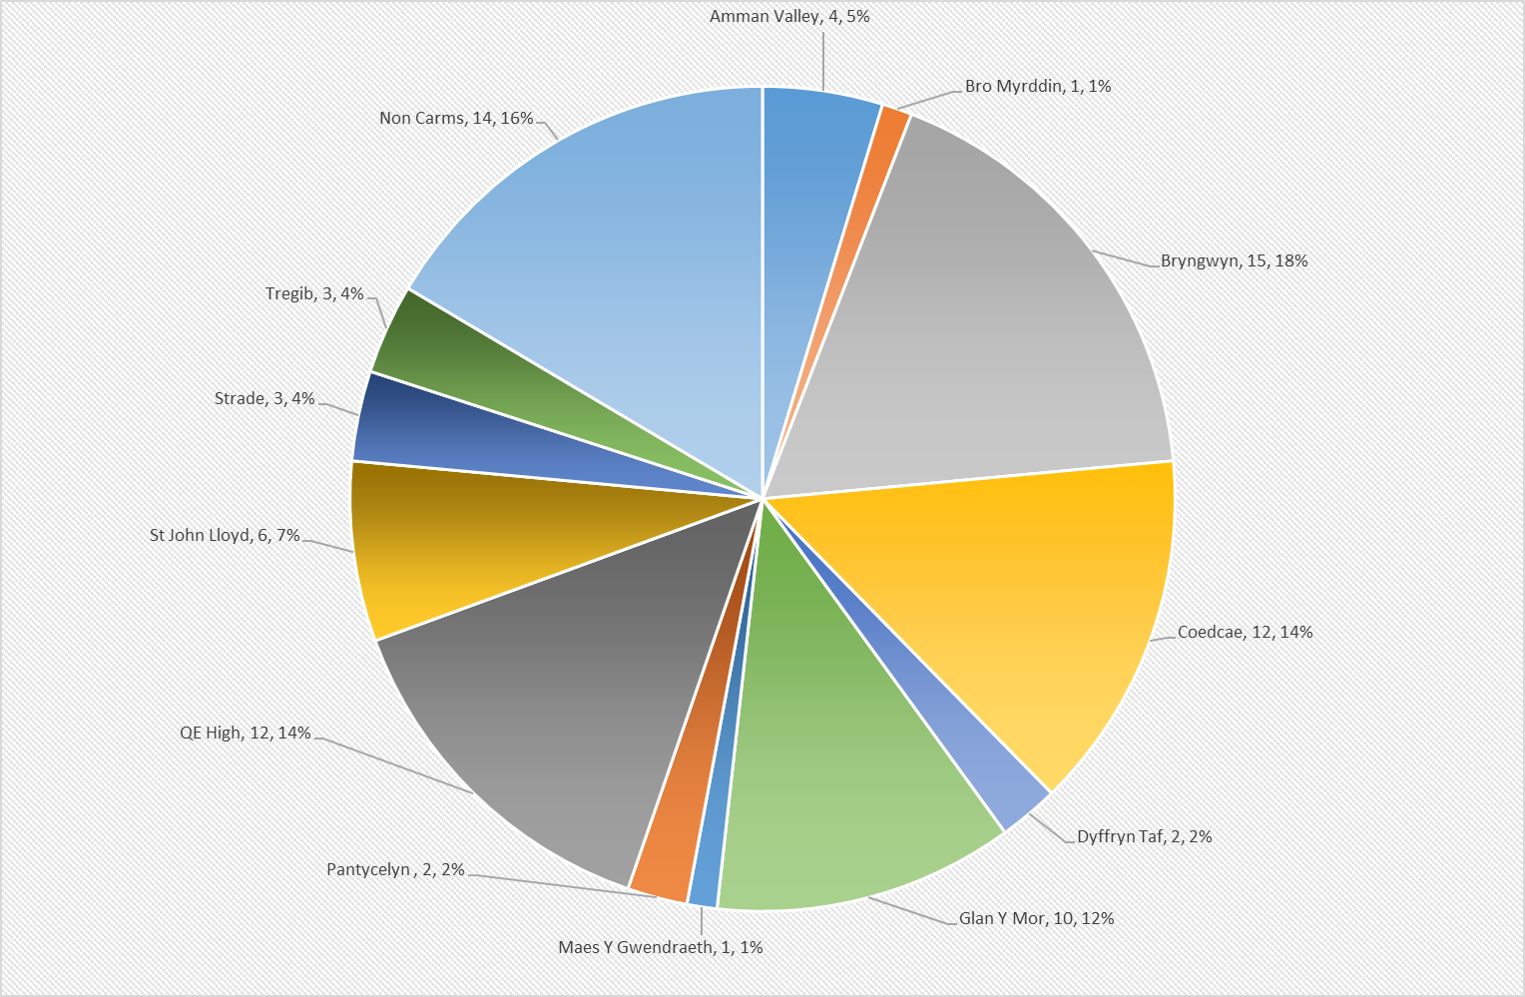

In order to establish a profile for the learners sample, including their previous experience with ILT, learners where asked a number of questions that related to the technologies used whilst in secondary education. These questions used the term, ‘regular’, however regularly was not defined quantitatively as it was felt this would be impossible to accurately measure by the learners, when reflecting on their entire secondary experience. The results demonstrate that 89% of the learners questioned have regularly engaged with fixed technologies such as PC and 74% have actively taken part in dynamic lessons delivered via an interactive whiteboard. The results also reveal that 48% of learners felt mobile technology was available but rarely used. These statistics confirm that the learners have a profound experience of technology in the classroom, but feel their learning could have been underpinned by a broader range of technology.

Question two asked learners to think about their experience in Secondary Education, by indicating which devices/platforms where used on a ‘regular’ basis whereas question three focused on the technologies which were available but not used on a regular basis.

In order to gain an understanding of learners expectations students were questioned on their desire for assessment design, including what tools they hoped would be available. The results clearly indicate that the majority of the group would like to carry out their assignments via a PC/Mac or Laptop and/or mobile technology such as Chromebooks, iPads or Tablets. This confirms that there is a strong desire to engage with technology which, if not met could impact learner outcomes.

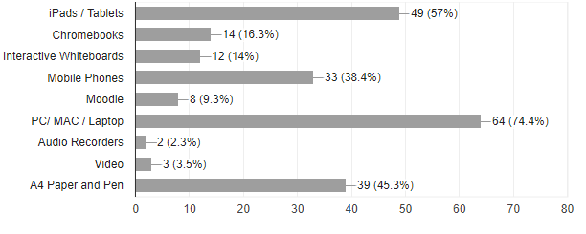

In order to ensure we are meeting learners expectations we need to be able to quantify them and compare with the second round data to measure success. 60% of learners confirmed they are expecting to engage with ILT on a more regular basis than in their secondary school, with 40% neither agreeing nor disagreeing. This statistic is key to this research as it demonstrates that a high percentage of learners have a high expectation which if not met could have an impact on motivation.

This result becomes even more significant when we consider the data from question 2 ie that 90% engaged with PCs regularly, and 74% engaged with Whiteboards, and that the majority are expecting to engage with even more technology during their college study as the question ‘At Coleg Sir Gar, I am expecting to engage with ILT on a more regular basis than in my previous school’ confirm:

Learners were also asked if they expected the majority of the ‘learning’ to be underpinned by ILT. This question is slightly different to the previous as it removes the expectation created by their secondary school experience and solely focuses on the learning journey going forward. The results show that almost 50% of learners have arrived with the expectation that the majority of learning will use some form of ILT, which if not met could impact motivation.

Learners were also asked about assessments, and again the results are similar to those demonstrated in the two previous questions with 50% agreeing or strongly agreeing that believe the majority of assessments will be conducted using a range of interactive learning technologies.

These three questions prove that our learners have high expectations of teaching, learning and assessment at the college and curriculum may need to be redesigned if these expectations are not met and learners become demotivated.

The data from the second round of questioning successfully confirms that there is a relationship between the appropriate use of technology and motivation. 49% feel there motivated, however it is a concern that some learners, even if lower than 10% feel demotivated when engaging with technology.

statics are extremely important to the research as they confirm that technology should only be used when appropriate and that there are a number of learners who are cautious about it’s use.

The amount of independent study time in Further Education is significantly more than that in Secondary education and typically a full time student at the colege may have a maximum of 18 hours, compaired to 25 previously. Again a high percentage, 74% have expectations that a large range of technology will be available to them during these period.

Whist certain elements are fixed and can easily be monitored, for example the number of computers in a library, the number of Chromebooks hired in ‘Yr Hwb’ the skillset of our lecturers is a more difficult statistic to measure. Over 50% either disagree or ‘neither agree or disagree’ that they are expecting all lecturers to use ILT. This is a very realistic expectation, especially as ILT should only be used when appropriate.

Questions so far have allowed the research to measure the previous experiences of the learners and their expectations of the college. The following questions allow the learners to reflect on themselves and their own performance. 49% feel there are extremely motivated, however it is a concern that 10% feel demotivated when engaging with technology, with 13% feeling demotivated when technology is not used. These statics are extremely important to the research as they confirms that technology should only be used when appropriate and that there are a number of learners who are cautious about it’s use.

The current new intake have a range of expectations and percentions of technology at the college and a large number are expecting to bring their own digital tools to aid their study. This is an important statistic which needs to be respected when designing learning spaces that meet student expectations, ie wifi coverage and access to charging sockets.

Learners who attend the college no longer expect to simply engage with their lecturers during set timetables slots. Almost 70% expect to enage with their tutor via social media, and almost 80% expect their tutors to respond to emails.

Learners were questioned again after 8 weeks in order to compaire the experiences with their expectations and the data clearly shows that a high percentage of learners have engaged with at least one form of technology, and this is having a positive impact with almost 60% agreeing this is having a positive impact on their learning experience and their attitude towards learning,.

Furthermore 50% of learners claim that they feel that the use of technology has resulted in them achieveing a high grade, with 25% being unable to comment as they have not yet had an assignement returned to reflect on. This results clearly show that the learners are motivated, they are positive about the learning and their assignment work is of a higher standard.

During the initial investigation 60% of learners expected to use more ILT at college than in secondary school, and our findings confirm that 63% agree that they have used more technology. This result is essential in confirming that the expectations of our learners have been met.

61% of students confirm that the majority of their learning is carried out using ILT which is positive when it is sonsidered that 50% where expecting this learning stategy to be impliamented.

60% of students agreed that they had used a range of ILT tools to complete assessments, which is inline with the expectation from 58% of learners who where expecting this form of assement.

51% of learners agreed they had access to a large range of technologies during independent study, which fell short of the 74% recorded from initial expectations.

68% of lecturers use ILT, comapaire to

The findings of this research are extemly positive, and learners were given the opertunity to provide further feedback on their learning experiences, with most opting to provide their positive feedback via their Chromebooks to demonstrate the how the technology was being used and how this was creating motivstion.

- An overview of the significant findings of the study
- A consideration of the findings in light of existing research studies
- A careful examination of findings that fail to support or only partially support your hypotheses
- Limitations of the study that may affect the validity or generalisation of the results

Discussion

The results confirm that learners arrive at secondary education with a range of conceptions about secondary education and that their learning experiences are going to enriched by the use of interactive learning technologies at a greater extent than that of their previous environment. In addition this expectation is indeed met, if not exceeded, and as a result students report that their grades are higher as their attitude towards learning is more positive.

The purpose of the second round of questionnaires was to capture feedback before the students became instutionalised and began to accept assessment strategies as the norm. By questioning learners after 8 weeks, 25% had not yet reecieved feedback from graded assignements and so were unable to confirm if the use of technology had had a positive impact on their learning.

Another limitation may be that at this exact point in time college are sector leading in their use of pedagogical use of G-Suite, which is underpinned by real-time feedback and mobile technology. Learners collaborate and complete tasks on Chromebooks in flexible learning spaces that have been designed to allow freedom, however the Welsh Government have recently announced plans to introduce G-Suite into secondary education and so the excitement created by a radical new learning strategy may diminish. That is not to say the evidence is not correct, ie by exceeding learner expectations motivationincreases, however the college will need to continue to experiment (quote from Phil Race) and evolve it’s learning strategies in order to raise standards further and continue to create a learning environment that superceeds that of the feeder schools.

Bibliography
Websites:

BBC News (2013). Swansea tablet computer project boosts pupils' reading. Available: http://www.bbc.co.uk/news/uk-wales-22806246. Last accessed 20/3/14.

Bandaranaya, T (2013) http://www.slideshare.net/thusharabandaranayake Last accessed 30/3/14

Barrett, E. (2015) English, maths and… digital literacy: the new essential skill in Welsh further education Available: https://www.jisc.ac.uk/blog/english-maths-and-digital-literacy-the-new-essential-skill-in-welsh-fe-03-jul-2015 Last Accessed 30 November 2015

Britannica Encyclopidia (2015). Apple Inc Available: https://www.britannica.com/topic/Apple-Inc Last accessed 14th July 2015.

Chohan et Al. (2015). An ailing UK school makes an incredible transformation. Available: http://www.apple.com/uk/education/real-stories/essa/. Last accessed 14th July 2015

GCN (2016) 25 years: A technology timeline. Available: https://gcn.com/Articles/2007/12/06/25-years--A-technology-timeline.aspx Last accessed 15th June 2015.

IT Governance (2017) ISO27001 Available: https://www.itgovernance.co.uk/iso27001 Last accessed 20th November 2016.

Killen, C. (2015). Enhancing the student digital experience: a strategic approach. Available:https://www.jisc.ac.uk/guides/enhancing-the-digital-student-experience . Last accessed 20th June 2015

Malta Government (2015) Green Paper Digital Literacy. Available: https://education.gov.mt/elearning/Documents/Green%20Paper%20Digital%20Literacy%20v6.pdf Last Accessed 22nd September 2015

The National Assembly for Wales (2004) Arrangements to Promote Equality of Opportunity - Financial Year 2004 – 2005 http://www.assembly.wales/Laid%20Documents/LD5283%20-%20The%20National%20Assembly%20for%20Wales%20Arrangements%20to%20Promote%20Equality%20of%20Opportunity%20-%20Financial%20Year%202004%20-24012006-19852/bus-GUIDE-N0000000000000000000000000040106-English.pdf , 96, Last Accessed 2nd September 2016
Petty, G (2013). Supported Experiments: http://geoffpetty.com/for-team-leaders/supported-experiments/ Last accessed 20/3/14

Shapiro, H. (2009) Supporting digital literacies, Topic report 4. http://ec.europa.eu/information_society/eeurope/i2010/docs/benchmarking/dl_topic_report_4.pdf Last Accessed 30 November 2015

South Wales Evening Post (2015) 60 Jobs Cuts Bite Coleg Sir Gar. Available: http://www.southwales-eveningpost.co.uk/60-jobs-cuts-bite-coleg-sir-gar/story-26201506-detail/story.html Last Accessed 22nd September 2015

Vaughan, R (2008). Conceptual Framework: http://www.slideshare.net/thusharabandaranayake/understanding-research-philosophies Last accessed 30/3/14

Various. (2015). Apple Newton. Available: https://en.wikipedia.org/wiki/Apple_Newton. Last accessed 15th June 2015.

Journals:

Auster C. (2016). Blended Learning as a Potentially Winning Combination of Face-to-face and Online Learning: An Exploratory Study. Teaching Sociology. 44 (1), 39-48.

Binnur (2008) Effect of Technology on Motivation in EFL Classrooms, Turkish Online Journal of Distance Education 10(4), 136-158

Clarke, R et al (2016) e-Learning and the Science of Instruction: Proven Guidelines for Consumers and Designers of Multimedia Learning (2)

Crawford, J & Irving C. (2007). Information literacy: The link between secondary and tertiary education project and its wider implications. Journal of librarianship and information science. 39 (1), 17-26.

Dag Elgesem (2002) what is special about the ethical issues in online research? Ethics Inf Technol (4) 195-203

Dare, Louis (2014). "Colegau Cymru Award Bid: Promoting the Welsh Language Wirelessly." Review. 01 Apr. 2014: 1-10. Print.

Dixon, R et Al. (2015). The Use of iPADs in the Home Setting for Students With Autism Spectrum Disorders. Journal of Special Education Technology. 30 (4), 193-206.

Denscombe, Martyn (2002). Ground Rules for Good Research, 1st Edition, Open University Press

Donaldson, Graham (2015) Successful Futures

Fee, K (2009) Delivering--Learning-Complete-Application-Assessment (1)

Greer, C and Ferguson D. (2015). Tablet computers and traditional television (TV) viewing: Is the iPad replacing TV?. Convergence: The International Journal of Research into New Media Technologies. 21 (2), 244-256.

Hirsh-Pasek, K et Al. (2015). Putting Education in “Educational” Apps: Lessons From the Science of Learning. Psychological Science in the Public Interest. 16 (1), 3-34.

Jacobs (2013) Rethinking Common Assumptions About Adolescents’ Motivation to Use Technology In and Out of School. Journal of Adolescent & Adult Literacy 56(4), 271-274

Koehler, M & Mishra,P. (2009). What Is Technological Pedagogical Content Knowledge?. Contemporary Issues in Technology and Teacher Education. 9 (1), 60-70

Livingstone, S & Helsper, E. (2007). Gradations in digital inclusion: children, young people and the digital divide. New Media & Society. 9 (4), 671-696.

Price, F & Kadi-Hanifu, K (2011). E-Motivation! The role of popular technology in student motivation and retention. Research in Post-Compulsory Education 14 (2), 173-187

Neumann M & Neumann D. (2015). The use of touch-screen tablets at home and pre-school to foster emergent literacy. Journal of Early Childhood Literacy. 0 (0), 1-18.

Oncu, S. (2015). Facebook habits among adolescents: Impact of perceived social support and tablet computers. Information Development., 1-14.

Oomen-Early, J & Early A. (2015). Teaching in a Millennial World: Using New Media Tools to Enhance Health Promotion Pedagogy.Pedagogy in Health Promotion: The Scholarship of Teaching and Learning. 1 (2), 95-107.

Raacke, J & Bonds-Raacke, J. (2008). Using Tablet PCs in the Classroom: Investigation of Student's Expectations and Reactions. Journal of Instructional Psychology. 35 (3), 235-239.

Riley, P. (2013). Teaching, Learning, and Living with iPads. Music Educators Journal. 81 (6), 81-86

Trotter E & Cove G (2005) Student retention: An exploration of the issues prevalent on a healthcare degree programme with mainly mature students. Learning in Health and Social Care 4 (1), 29-42

Vanderbroeck, G & Verschelden & Boonaert (2007). E-learning in a low-status female profession: the role of motivation, anxiety and social support in the learning divide. Journal of Computer Assisted Learning 24, 181-190

Wu et al (2010). A Survey of Technical and Vocational Students’ Motivation, Style and Achievement in Information Technology and Society Courses. The International Journal of Learning 17(8), 381-393

Books:

Blaxter et al (2010) How to research

Cohen et al (2007) Research Methods in Education

Cohen, Louis & Manion, Lawrence (1992), Research Methods in Education, 3rd Edition, Routledge

Hopkins, David (2008). A Teacher’s guide to classroom research, 4th Edition, Open University Press

Horton, W (2006) e-Learning by Design (1)

Schostak, J (2002) Understanding, Designing and Conducting Qualitative Research in Education, 1st Edition, Open University Press

Sharlene Nagy Hesse-Biber & Patricia Leavy (2010) The Practice of Qualitative Research

Taber, K (2007). Classroom-based Research and Evidence-based Practice, 2nd Edition, Sage Publications Ltd

Thomas, C et Al. (2015). Student Response Systems: Learning and Engagement in Preservice Teacher Education. Journal of Special Education Technology. 30 (4), 223-237.

A glossary of acronyms

ESQ Essential Skills Qualifications
FE Further Education
GCSE
ILT Interactive Learning Environment
ISO International Organisation for Standardisation
Appendices

Appendix 1a – Ethics Submission
Appendix 1b – Letter issued to learners
Appendix 2a - Questionnaire Issued September 2015
Appendix 2b – Questionnaire Issued November 2015
Appendix 3a – Example of Raw Data
Appendix 3b – Data Captured
Appendix 3c – Video feedback provided during end of year review
Appendix 4a – Pearson Teaching Award submission
Appendix 4b – Colegau Cymru Award submission

Appendix 1a – Ethics Submission

Appendix 1b – Letter issued to learners

Appendix 2a - Questionnaire Issued September 2015
An onscreen version can be accessed via : https://goo.gl/forms/sKwNQdYi0YGyRtO13 (Case sensitive)
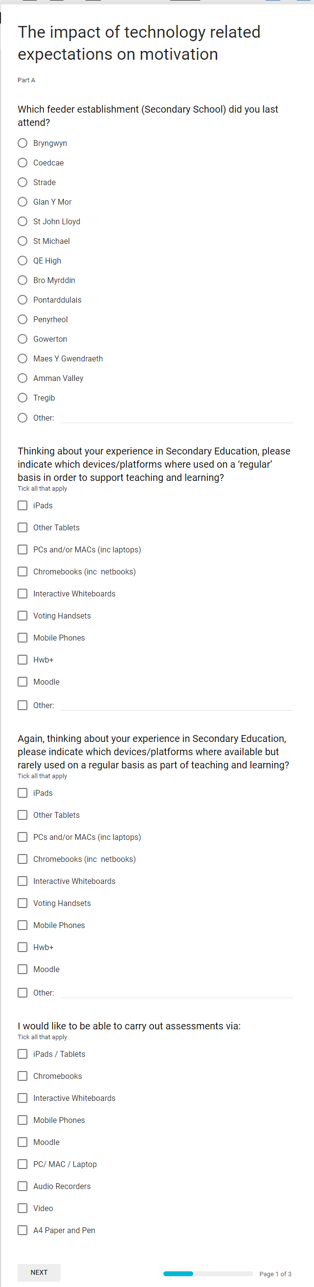
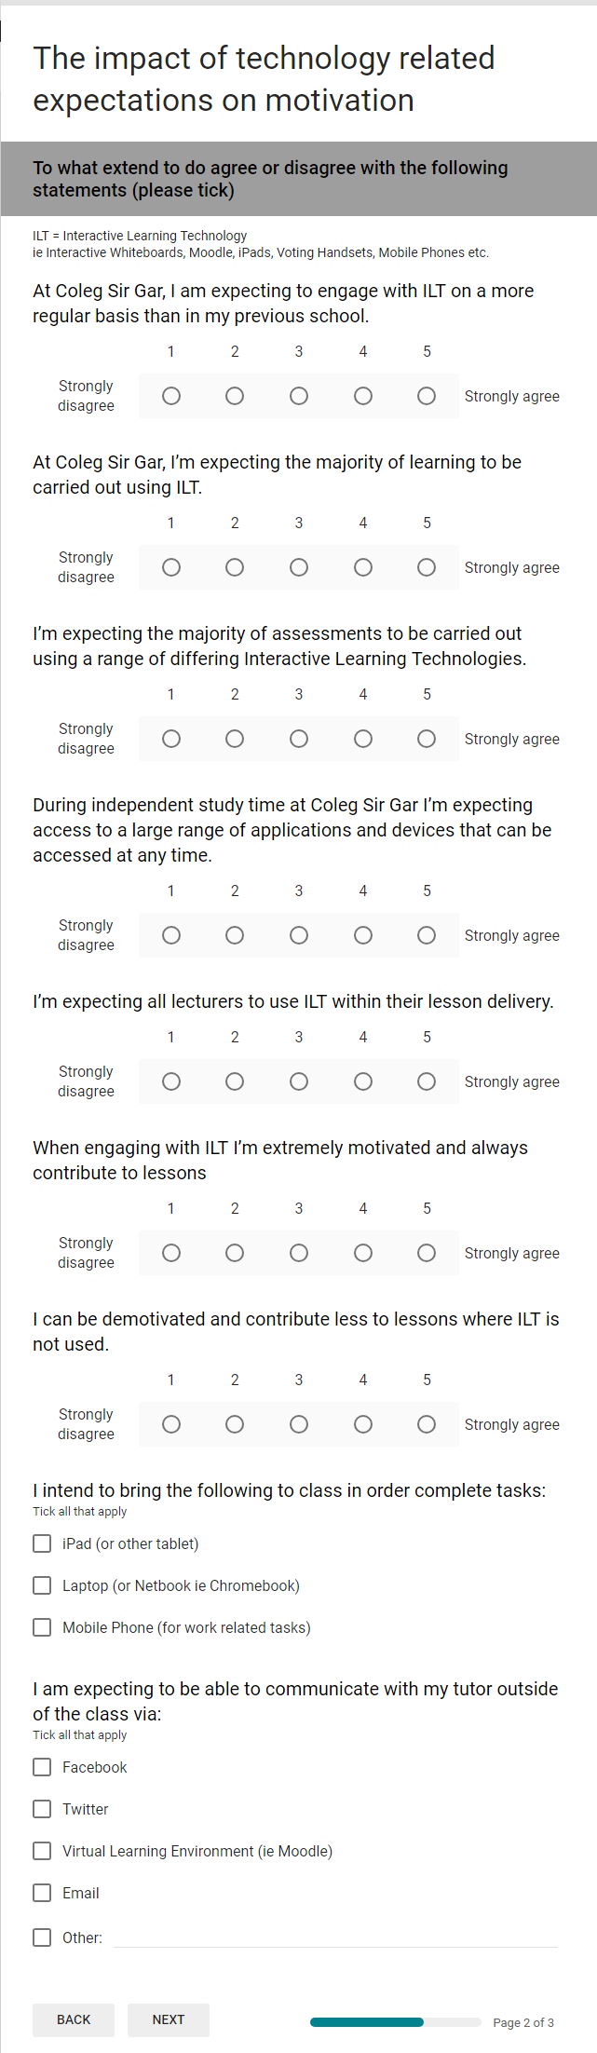
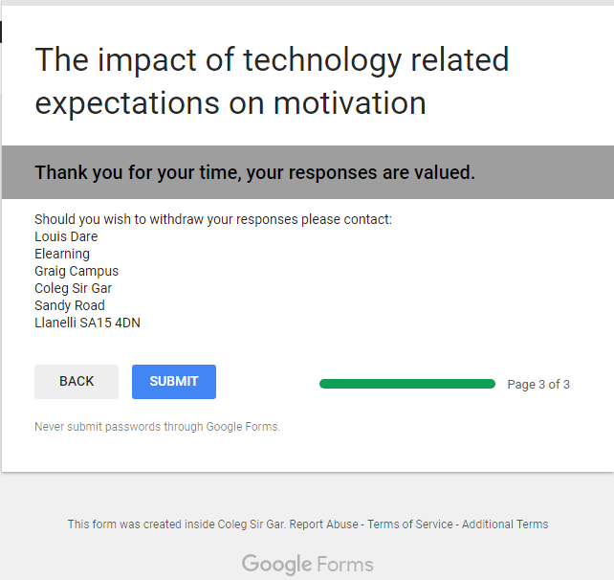

Appendix 2b – Questionnaire Issued November 2015
An onscreen version can be accessed via : https://goo.gl/forms/YahQCul5u7ZfMigr2 (Case sensitive)

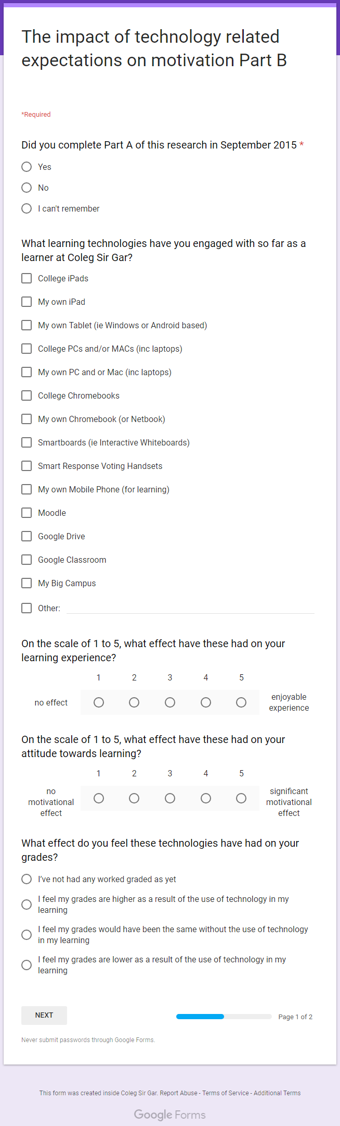
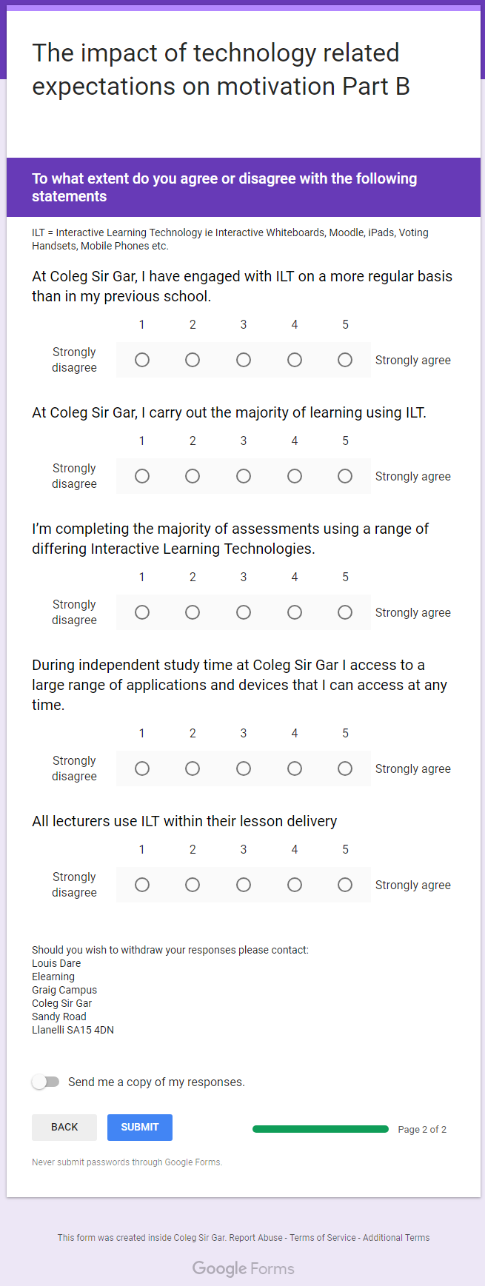
Appendix 3a – Example of Raw Data

Appendix 3b – Data Captured

Appendix 3c – Video feedback provided during end of year review
Learner Feedback One - https://goo.gl/ZGpkhn (Case sensitive)

Learner Feedback Two - https://goo.gl/AoMkao (Case sensitive)

Learner Feedback Three - https://goo.gl/J9T3tK (Case sensitive)

Appendix 4a – Pearson Teaching Award submission

Appendix 4b – Colegau Cymru Award Submission 2014

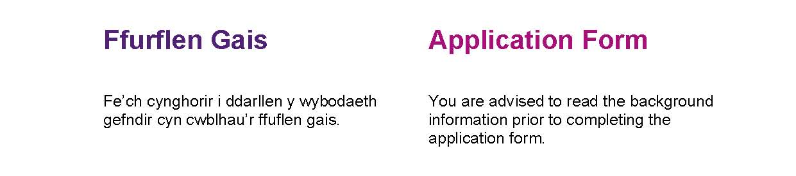
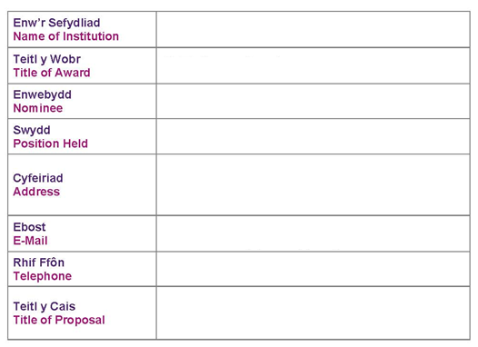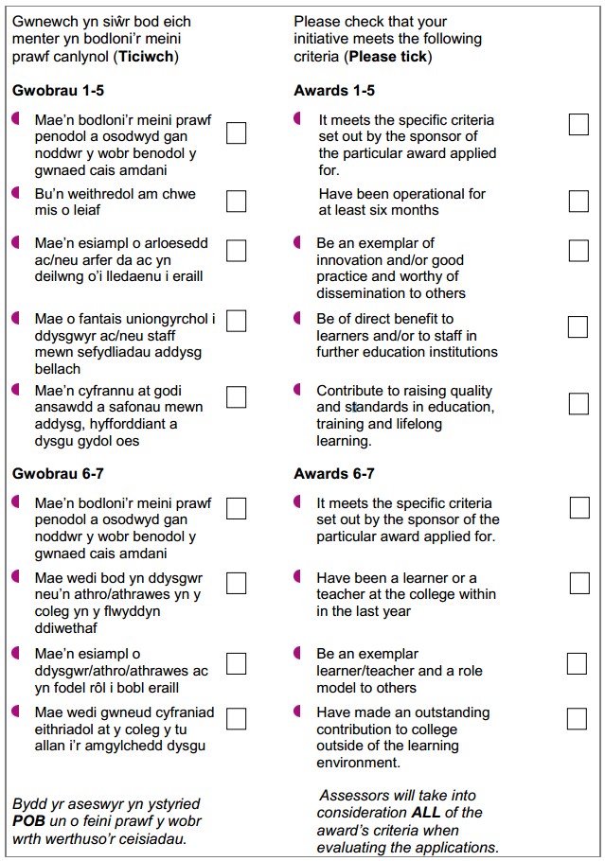
Coleg Sir Gar
Promoting the Welsh language wirelessly
e-learning coordinator
01554748365
louis.dare@colegsirgar.ac.uk
Coleg Sir Gar
Sandy Road
Llanelli SA15 4DN
Louis Dare
Technology Aiding Learning
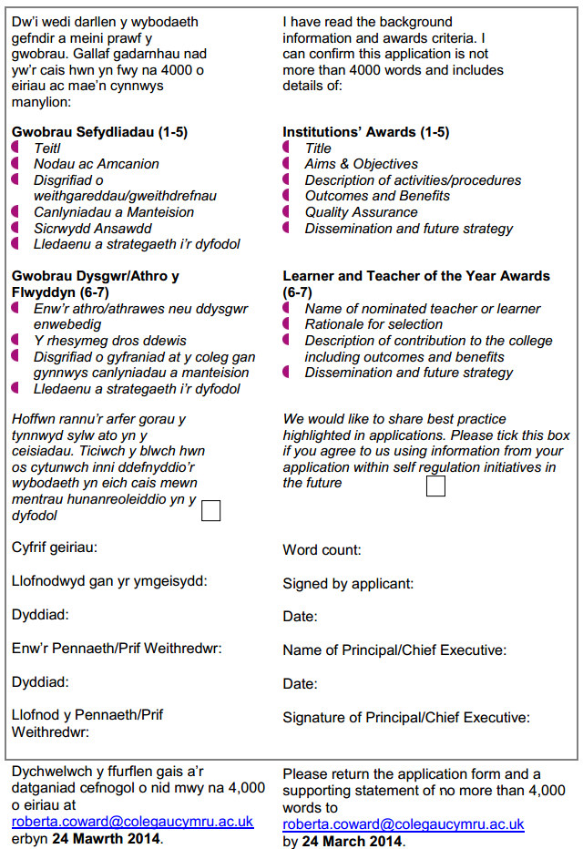
Title: Promoting the Welsh language wirelessly

1.0 Introduction
This submission is in support of the ColegauCymru Award for the ‘Technology Aiding Learning’ sponsored by JISC RSC. The report is structured using the headings provided in the guidance notes form the ColegauCymru website.

A pilot was delivered during the 12/13 academic year before being rolled out from September 2013 and so has been in operation for over 6 months. Due to the type of Digital Learning Resources used, screen shots of the various developments have been included to keep the word count to a minimum and provide a more visual explanation of the final concept.

Word Count: TBC

2.0 Aims and objectives
To:
- To assist lecturers in the delivery of the Welsh Language at a range of levels simultaneously in order to meet the individual needs of the learners
- Follow a standardised interface that is both professional and demonstrates effective pedagogy for learners to access all learning resources
- Provide all resources in Welsh and English
- To further develop online learning and promote best practice
- To deliver lessons wirelessly thus reducing the traditional access barriers
3.0 Description of activities/procedures
This section of the report takes the reader through the processes involved in developing the units of resource and how the project evolved at each of the key stages.
3.1 The Need
Coleg Sir Gar activity promotes the Welsh Language, culture and heritage and is determined to reverse the decline in the use of the Welsh language in Carmarthenshire. According to the 2001 Census XX% of the population spoke Welsh however by 2011 this had dropped to xx%.
In 2012 it was decided that the subject would be ‘modernised’ and delivered in a fresh, new and exciting way using high quality interactive resources and wireless technology.
3.2 Set Up
The initiative followed normal college management procedures and a specification document was created in the first instance to be signed off by the Assistant Principal of ‘Teaching, Learning and Quality’ . This ensured that EuroTalk lesson content was fit for purpose and confirmed to College policies and awarding body specifications.
3.3 Interface
The design of the interface was very important to ensure learners bought into this new delivery method and that learner progress could easily be demonstrated and evidenced. Resources supplied by the BBC such as ‘The Big Welsh Challenge’ offered a very comprehensive package, even differentiating between North and South versions of the Welsh Language however lacked tutor administration. It was decided that the EuroTalk language packages would be the preferred option and from August 2012 these would be available via the College’s learndirect contract. It was felt that the EuroTalk option provided a high quality professional look and feel, and included a range of levels and interactions.
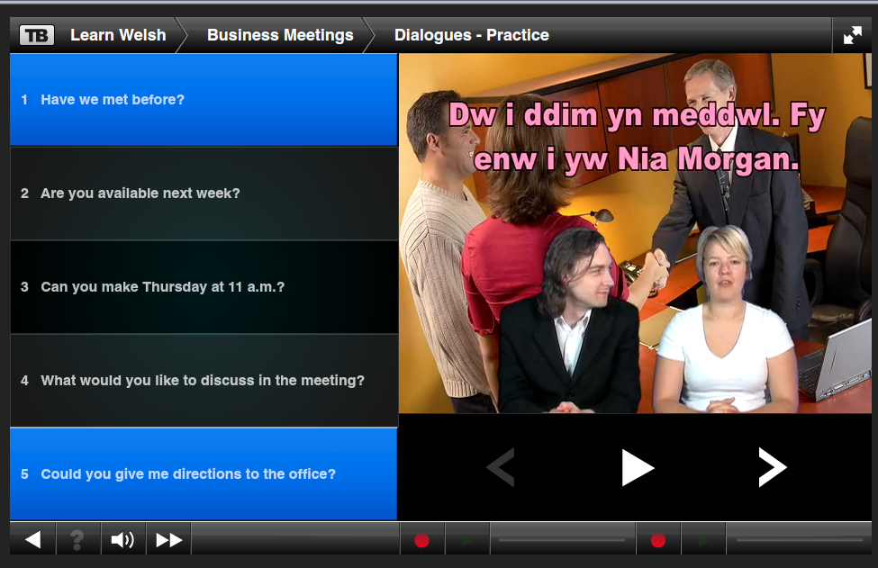
3.4 Learning Content and Assessment
The content within the EuroTalk learning packages included:
- Four levels from beginner to business
- Audio and Video
- Interactive Games
- Downloadable Vocabulary Check Sheets
- Quiz and Audio Based Assessments
It was fundamental that a learning package needed to supply reports to an admin system in order to track progress and measure improvements. The EuroTalk packages use SCORM reporting to pass data back to the learndirect LSE system. In addition to this learners complete their own tracking sheets (Appendix 1) in order to take ownership of their own learning journey.
Learners complete a range of learning activities which include matching oral descriptions to visual objects, multiple choice and even spoken responses. Once the learner has given their response orally the system will play the correct pronunciation and the learner and tutor can apply an agreed score.

3.5 Mobile Technology
Traditionally IT Labs are located in certain areas of the College, are in high demand and can appear very dated. It was therefore decided to embrace mobile and wireless technology in order to effectively manage existing resources and learning environments but to also exceed learner expectation in order to develop a relaxed learning environment free of bulky equipment.
.
The Samsung Chromebooks, as shown above, are extremely lightweight and compact and can run for up to 10 hours between charges. The sleek design allows a trolley of 20 to take up very little additional space and for a wireless classroom to be deployed with little difficulty. The Chromebooks also include built in microphones so learners can fully engage using headphones from their own iPods or other devices.
Prior to the deployment of Chromebooks the College had a satisfactory level of wifi coverage in areas of high digital device population such as the Libraries and Canteens. However academic corridors were initially supplied by single access points in order to support the occasional learner requirement. Since the deployment of Chromebooks the infrastructure has been improved. As funding is limited wireless networking has initially been upgraded in areas where lecturers and Curriculum Area Managers have registered and interested in the use of this technology and the College plans major cross campus investment in order to share best practice in other areas.
Photo of students enjoying the learning method in a non IT classroom

3.6 How to use these resources
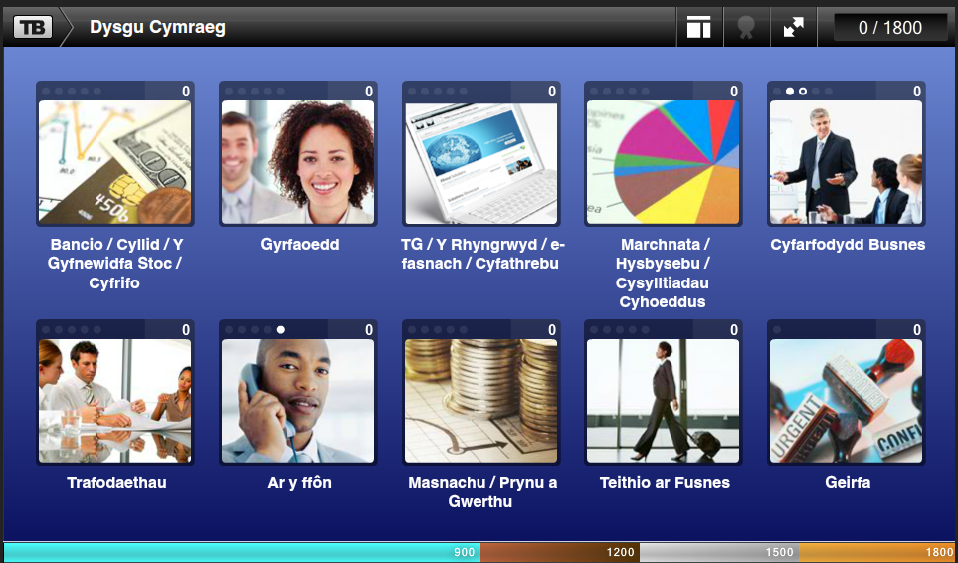
Each of the four levels include 10 lessons on a range of related topics. The example above is from the Business Welsh course. Learners simple click on the required lesson and complete a range of interactive activities and assessments. Grades are stored above each lesson and a cumulative total is also stored in the top right corner. Grades and dates achieved are also recorded in the learndirect staff LSE for monitoring and tracking.
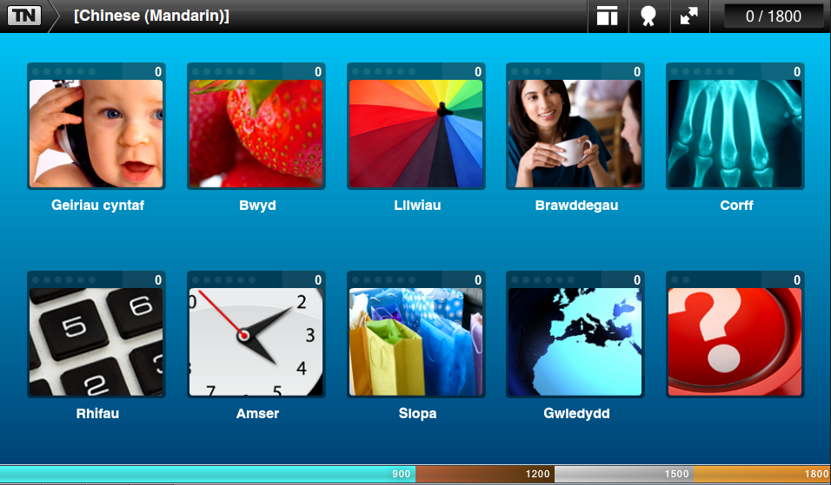
Once learners have developed their Welsh language skills to a high level they can further develop their language skills by embracing a new language. The above is an example of how a learner can learn Chinese Mandarin through the medium of Welsh.

3.7 Downloadable Worksheets

Below is an example of a downloadable worksheet. In this example the learner can take away a physical learning resource and practice the Mandarin translation, from Welsh, of clock times.
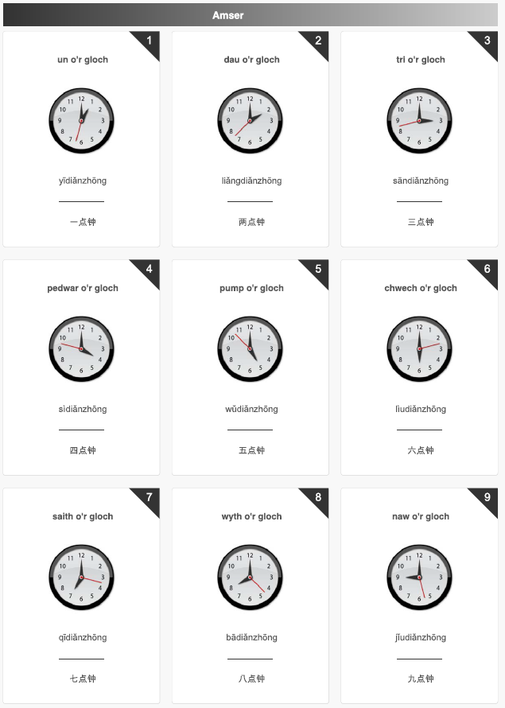
3.8 Learner Tracking Grids
Appendix 1 is an example of a learner tracking sheet. The sheet gives a clear indication to the progress of the learner and can be verified by the lecturer against the data stored in the learndirect LSE.

3.9 Lecturer Support

Appendix 2 is an example of the Coleg Sir Gar learndirect Best Practice Guide which details how to implement a learndirect course. Lecturers are also given full training on how to access and monitor learner data via the learndirect LSE.

3.14 Differentiation
These resources have been authored to support a large range of learners. All resources are available in both English and Welsh. The Welsh Language courses are delivered at four levels: Beginners, Intermediate, Advanced and Business Level Welsh.

Documents can be viewed with a range of free applications such Adobe Reader, Internet Explorer and Google Chrome. Within all of these packages the views can be increased or decreased using browser controls. Whilst third party accessibility software such as Read & Write are unable to identify text within the Flash formatting the majority of the learning activities are presented through speech.

Finally resources are also presented in a range of media to benefit a range of learning styles. Resources can be read, watched and interacted with. Converger learners may benefit from the interactive drag and drop activities, whilst Divergers learners may benefit from the video explanations.

4.0 Outcomes and Benefits

The high quality EuroTalk interactive learning materials have allowed learners at Coleg Sir Gar to seemly access a range of language courses that meet their individual needs. Learners on the same core pathway can easily develop their Welsh Language skills at their own pace and at levels that challenge individual learners. Able and talented learners who already have a deep understanding of the Welsh Language have embraced other languages through the Welsh Language.

By introducing new technologies and networking capabilities learners have embraced the language and have thoroughly enjoyed the learning experience and have exceeded expectations. Motivation has increased and learners have even become competitive in order to outscore their peers. Access and resources barriers have been broken and learners are able to learn within a relaxed environment that is conductive to the learning of a language.

The EuroTalk courses offer a great potential in further developing language skills within the College. Small pilots have started with first language Polish learners who wish to improve their use of the English language. As with the examples above the mother tongue can be set to a number of languages including Polish thus improving the learning experience.
These resources have not only benefited a range of learners both at Coleg Sir Gar but also within the county and across Wales via the local learndirect centres and Virtual College. Since August 2012 there have been 623 Welsh Language Enrolments (excluding those where learners have learnt a new language through the medium of Welsh) , 436 of these have been full time Coleg Sir Gar learners, 129 distance learners (via the Virtual College) and 58 in community learndirect centres.
[student quotes]
5.0 Quality assurance
With this type of delivery, there are four clear areas for Quality Assurance:

- The accuracy of the content
- The consistency of the final product to the original requirement
- Monitoring and Tracking of learning
- Learner experience

The accuracy of the content was determined by the subject specialists at Coleg Sir Gar including Welsh Language lecturers and Dr Nia Cole-Jones Welsh Language Manager. Their input to the programme implementation was based on current qualification requirements, such as the Welsh Bacc and the College’s Welsh Language policy.

The implementation of the courses was required in order to meet a specific learner requirement. The flexible delivery methods have allowed all learners to embrace the Welsh language, culture and heritage from virtually any classroom in the college with minimal disruption on existing resources.

The learndirect LSE is able to monitor and track all learner progress assuming network connectivity is a constant. As this cannot be 100% guaranteed at all times learners also keep a paper tracking sheet (Appendix 1) that demonstrate progression and development. At worst up to 5% of tracking data may fail to synchronise between a device on the Coleg Sir Gar network and the learndirect LSE.

Our learners have given extremely positive feedback in relation to the new developments and opportunities this programme has introduced. Learners have thoroughly enjoyed their learning and have welcomed the new technology.

6.0 Dissemination and strategy for the future
Further information on the EuroTalk Welsh Language course can be found here: http://eurotalk.com/en/store/learn/welsh/talknowdl/dl

The dissemination of this pilot is to be promoted through Virtual College newsletters, at local conferences, college network events i.e. CollegesWales and WTF Networks, mailing lists as well as being prominent on the Virtual College website.

