11/21/2025

Module NaMe: Business and Web Management
Module Code: ACCA5019
Student NAME: Malinson
Student ID: 2313686
Lecturer: Md Sadeque Imam Shaikh
Trinity saint david University of Wales (London Campus)

website link: https://malinsongonzalez18.wixsite.com/edunext


Assessment 1
Component 1 – Website Redesign for Online Business Presence

Contents
Introduction: 2
Task 1 3
Modern UI and Branding: 4
Benefits for EduNext 5
Task 2 6
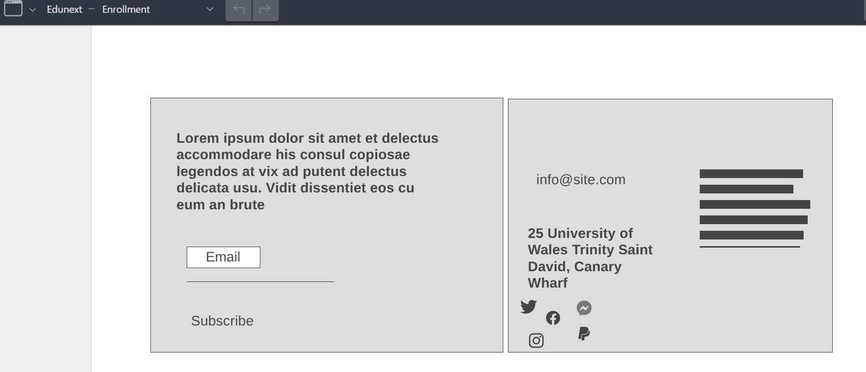 10
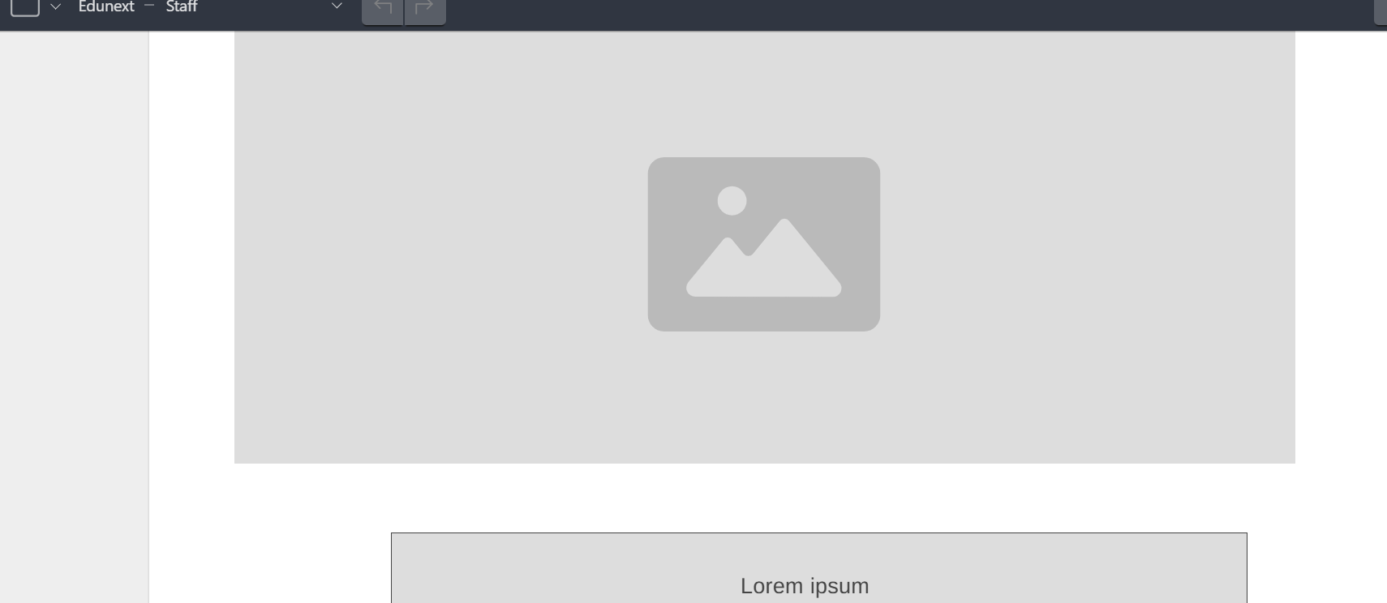 11
The redesign project for the EduNext website is one such example of how UI/UX strategies can transform an eLearning website into a contemporary and accessible online destination. This website is meant to enhance learner happiness and business success by bringing together user experience and responsive designs. 20
The design workflow from developing the mood board to prototype testing stressed the need for visual hierarchy, accessibility, and simplicity while fostering trust and user retention. This redesign not only enhances EduNext's visual identity but also echoes its goal to make education accessible to all. 20
Possible future upgrades may include real-time data features or adaptive learning functionality as well as AI-driven course recommendation functionality. This project shows how “design thinking” and “evidence-based user experience” can lead to success for both learning and business outcomes. 20
References 20

Introduction:
To enhance usability, accessibility, and user engagement, this study presents the redesign of the EduNext online learning platform utilising UI/UX design concepts. EduNext, a company that offers online classes, found several problems with its present website, such as inadequate navigation, out-of-date graphics, an unresponsive layout, and a lack of personalisation.
To improve usability, accessibility, and user engagement, this paper proposes the redesign of the EduNext online learning website using UI/UX designs. EduNext is one such company offering online classes to its customers. It identified several flaws in its website functionality, such as poor navigation, outdated graphics, non-responsive designs, and no personalization features.

This document will outline the entire process involved in designing, starting from research to create the mood board designs and wireframe designs to create interactive designs for achieving user-centred designs for EduNext's strategy to increase enrolment and customer satisfaction for its courses. It also highlights how responsive designs have been implemented and how user experience and commercial success have been achieved through this process.

“A good user experience is no longer nice to have […]
Having good navigation makes sure students have easy access to all lectures […] Sites which take too long to load are painful to use […]
A good user experience helps to improve learning outcomes for many types of learners at EduNext,"”

Another significant factor for this transformation is the shift to mobile first use. Many individuals are utilising smartphones and tablet devices to access education services offered to them by learning institutions; thus, for EduNext to remain at the forefront of its niche market, it must adapt to meet this growing need for use from smartphones and tablet devices for learning anytime and anywhere.

Task 1
4. EduNext Website Redesign
4.1 Current Issues
- The current EduNext website is plagued by:

Lack of modern visual identity: The colours and fonts of the current visual identity are unbalanced and lack appeal.

Poor Navigation: Users have trouble finding courses because of poor menu hierarchy and lack of clarity.

Non-Responsive Layout: The website does not perform or function properly on mobile devices.

Limited course information: Users are not provided information on courses before enrolling.

Complex enrolment process: Many stages discourage volunteers to convert.

Poor-quality multimedia: Poor-quality images and outdated videos reduce confidence.

Lack of personalisation: No interest-based suggestion system is implemented.

4.2 Proposed Solutions
The redesign aims to solve these problems by making several Important changes:

Modern UI and Branding:
This new design comes with a professional colour palette featuring blue, white, and yellow to convey trust, creativity, and hope. The use of fonts such as Montserrat and Open Sans makes it easy to read texts and maintain consistency for brands.

- Simplified Navigation:
The site uses a straightforward top-level menu — Home, Courses, About, Blog, Contact, and Login — with a dropdown for course categories to reduce cognitive burden.

- Responsive Design:
The new style automatically adjusts for computers, tablets, and smartphones, increasing accessibility and user pleasure.

- Enhanced Course Pages:
Each course page contains a summary, major outcomes, instructor profiles, ratings, and a "Enrol Now" option. This facilitates decision-making and builds trust.

- Personalized Recommendations:
An algorithmic strategy is proposed to recommend courses based on user interests and browsing history, hence increasing engagement and retention.

- Improved Multimedia Quality:
Updated high-resolution photographs and excellent videos highlight the professors and learning experience.

- Streamlined Enrolment:
A three-step signup process (Select Course → Create Account → Payment) lowers friction and boosts conversion rates.
- Accessibility Features:
Clear text contrast, keyboard navigation, and alt text provide WCAG 2.1 compliance.

4.3 Expected Outcomes

The redesigned website is expected to:

Improve usability to boost user happiness.
- Make calls to action clearer to enhance course enrolment.
- Improved navigation will reduce bounce rates.
- A modern, consistent interface can help improve brand perception.

Based on user-centred design research [1] Users' involvement in the design process ensures increased usability and acceptance. The EduNext redesign puts these ideals into action by focussing on empathy, accessibility, and participation.

5. Responsive Design Implementation
Responsive web design (RWD) allows a website's layout to adjust fluidly to any screen size or device. Response time is critical for accessibility and conversion in e-learning and e-commerce.

Benefits for EduNext
- Accessibility:
Many students use smartphones to access online classes. EduNext's content is guaranteed to be legible and navigable on all devices thanks to its responsive design.

- Improved SEO:
Google ranks mobile-friendly websites higher in search results, which could increase EduNext’s exposure and enrolment rates. [2]

- Higher User Engagement:
Studies show that people spend more time on responsive websites. [3]

- Consistency:
Responsive design provides a consistent user experience while preserving brand identification and functionality across platforms. [4]

  - Technical Implementation
This adaptability is ensured using media queries, fluid grids, and flexible images. Based on changes to the design layout provided by Canva software, responsiveness is created by the prototype. The menu is adaptive, and buttons are also simplified for easy navigation
while vertical scrolling is preferred.
5.3 Business Impact
Responsive design increases conversion rates, particularly on mobile devices. Enrolment obstacles are reduced because students can register instantaneously using any device. As mentioned by. [5] Educational websites optimised for mobile devices can boost enrolment by as much as 35%.

Task 2
6.0 Implementation
6.1 Mood Board

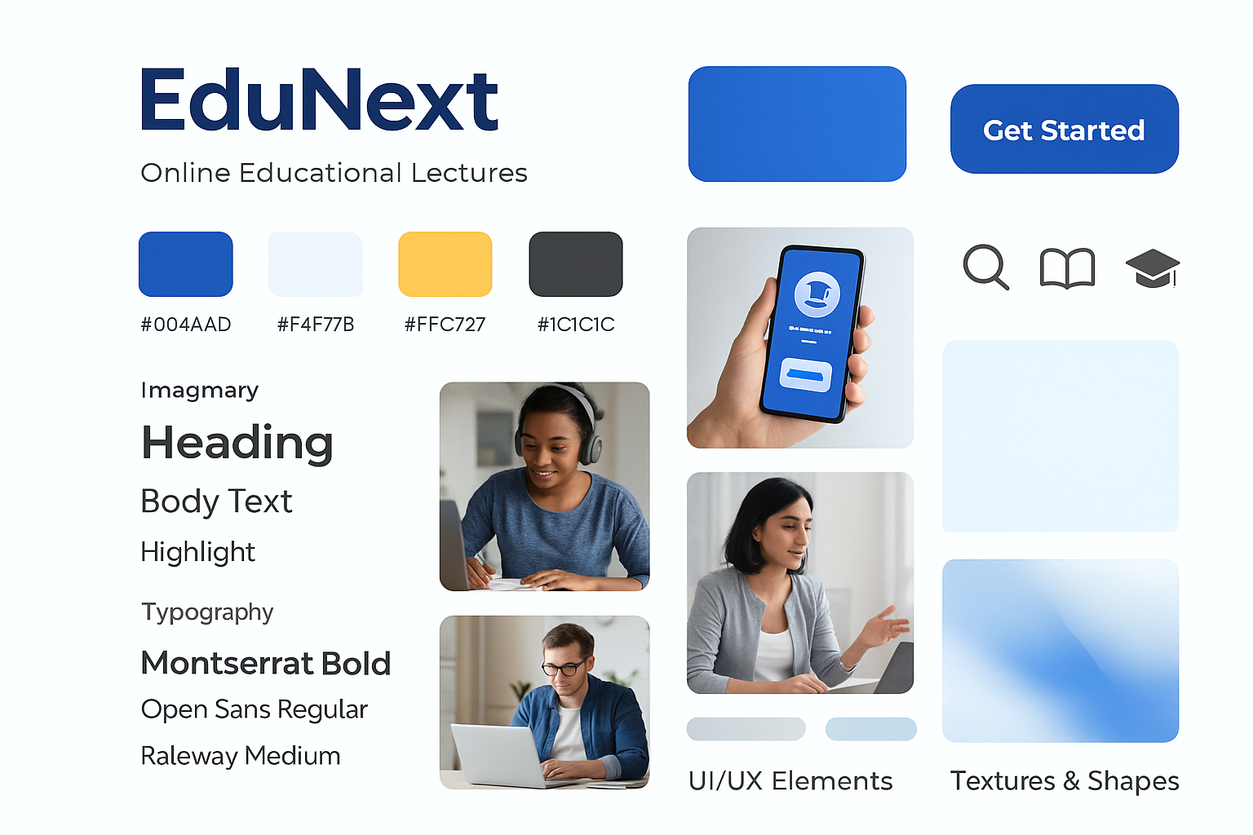

A "mood board" was created to establish this visual direction by integrating EduNext's corporate identity and design ideas now: "Incorporating trust and professionalism colors blue into your visual identity. Using yellow can add energy and happiness to your identity."
Including the corporate colours of blue for trust and professionalism and yellow for energy and happiness: “Typography is largely dependent on font combinations to create readable designs…. Using Open Sans Regular and Montserrat Bold for typography enhances readability.

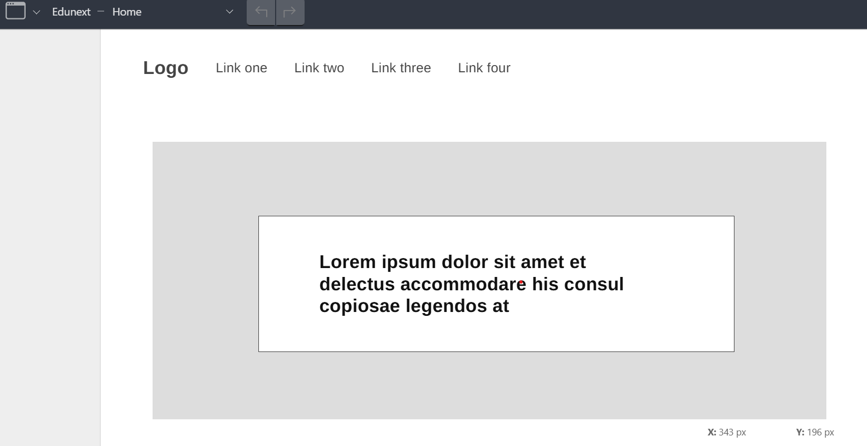
6.2 Wireframes
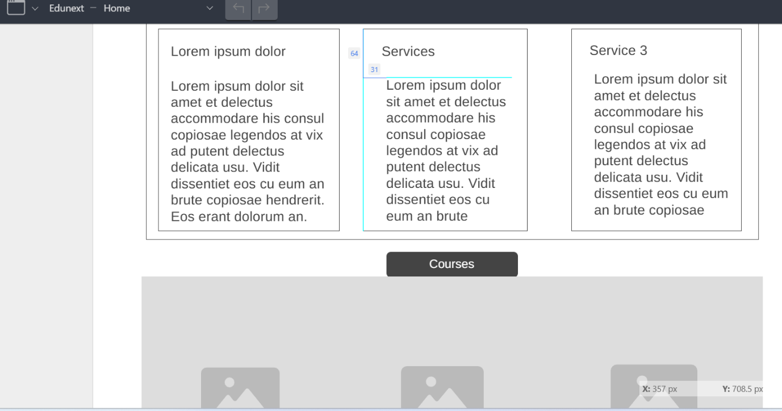

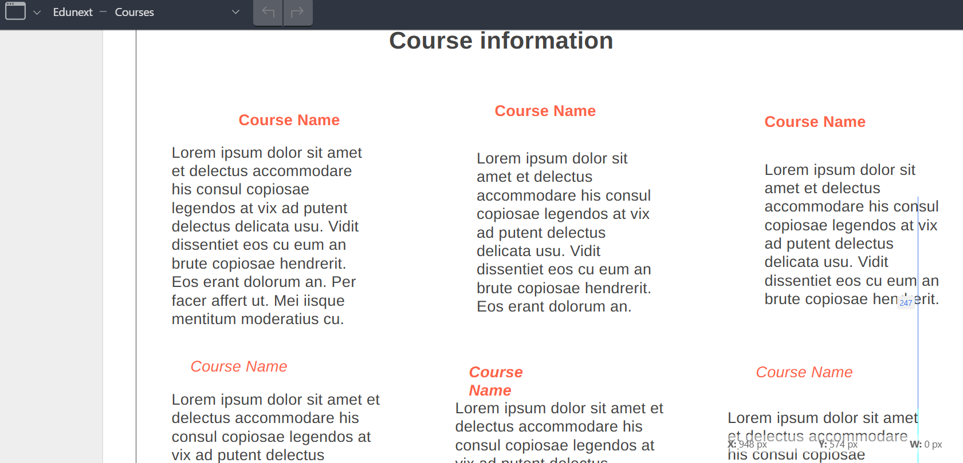
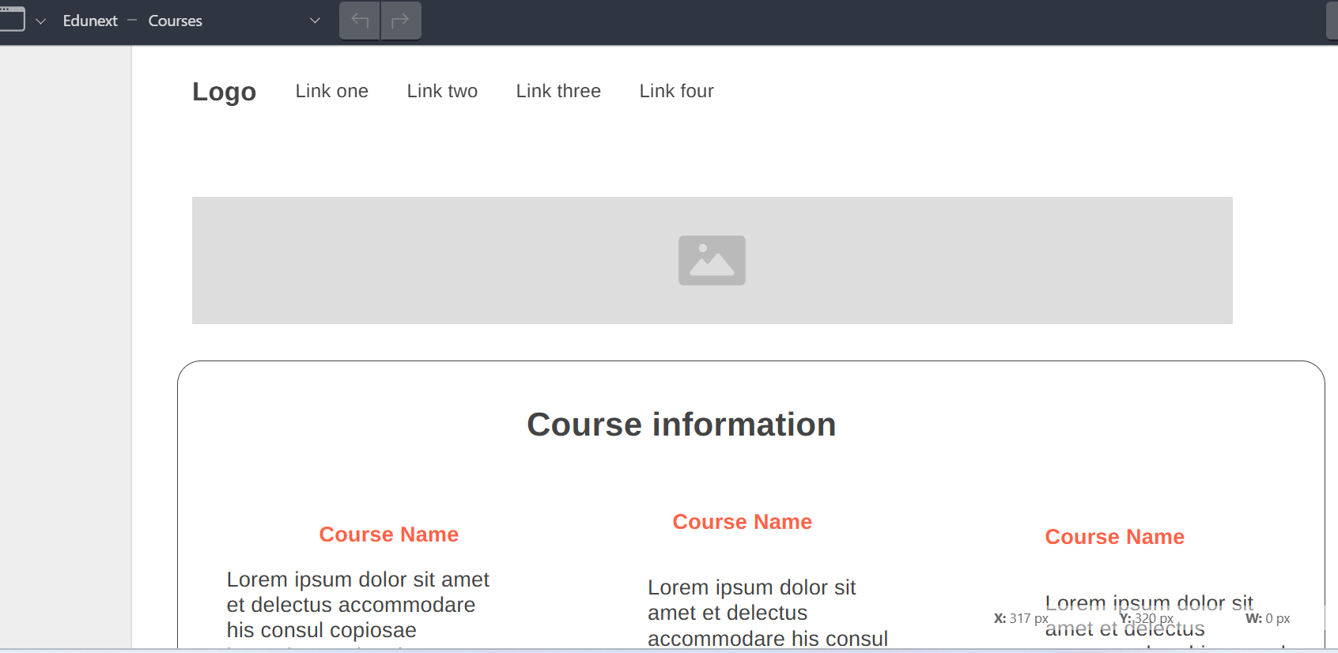

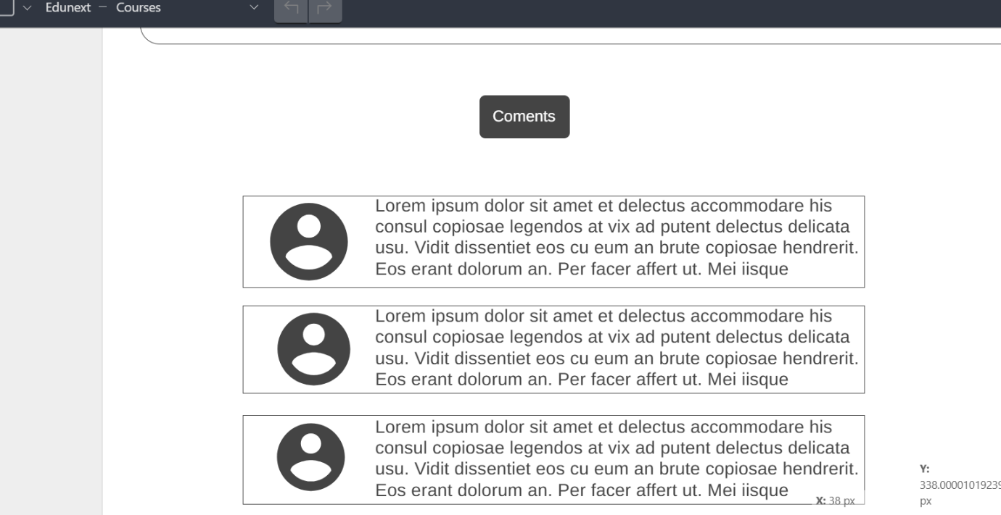
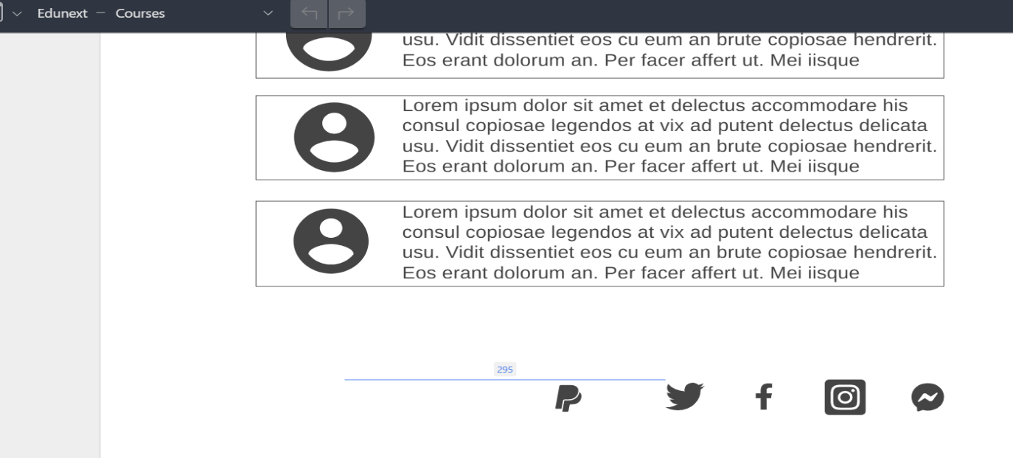
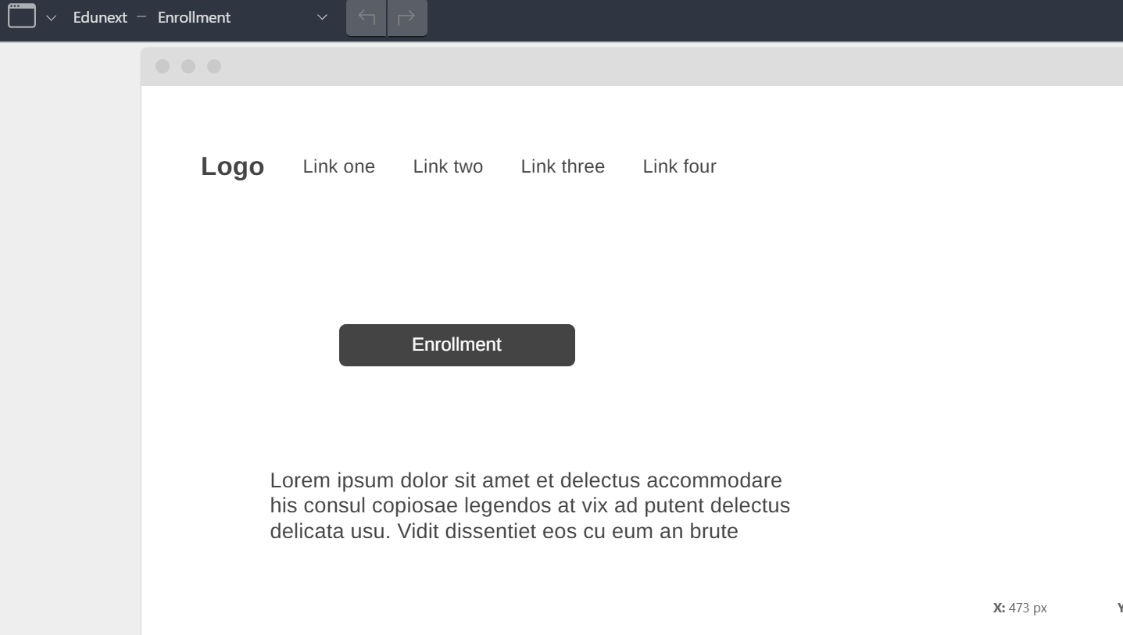
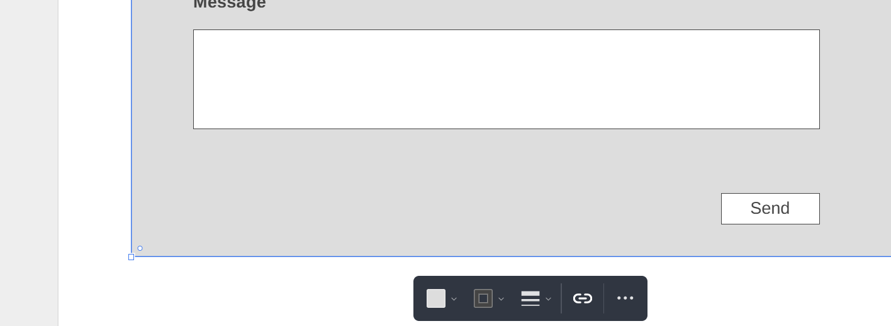
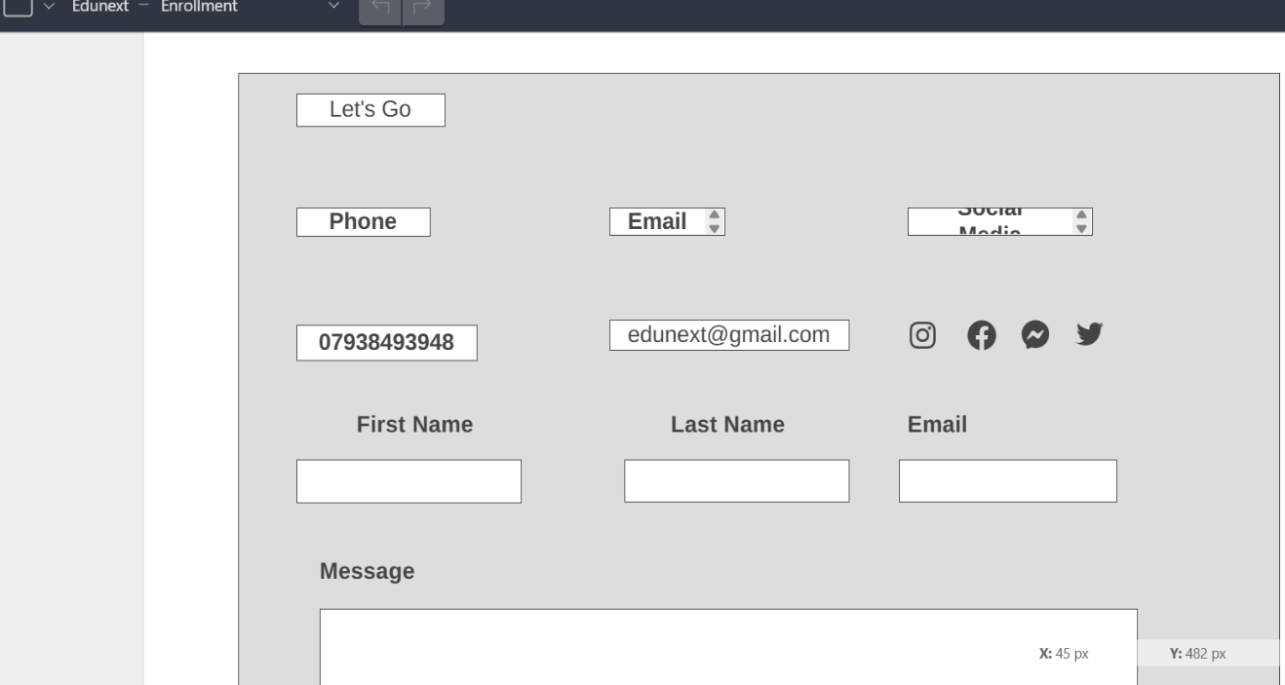

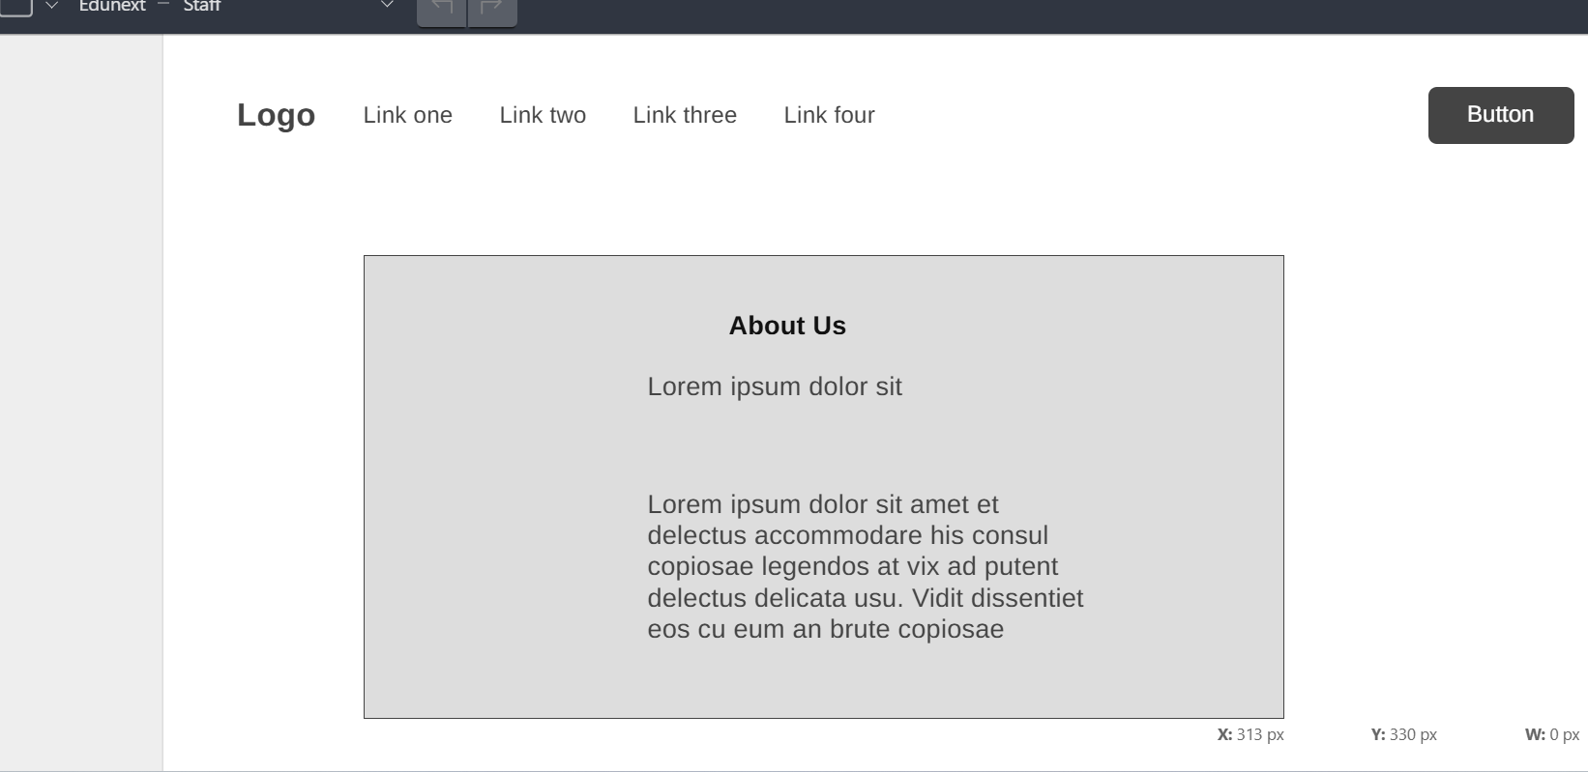

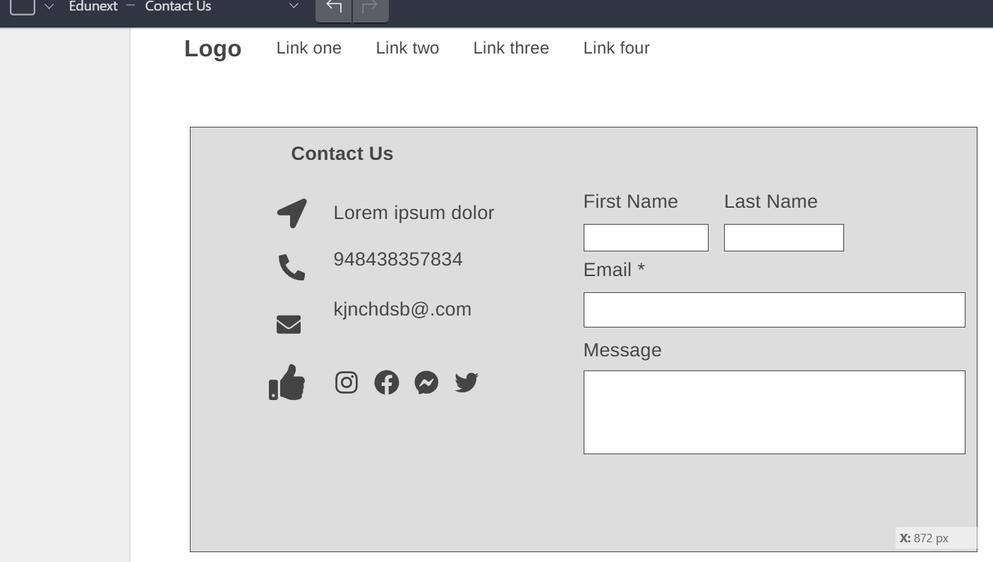
The wireframes played an integral role in identifying the foundation of structure for the EduNext website and helping to determine the layout of major sections such as the Home page, Course Listing page, Course Details page, Enrolment page, About Us page, and Staff Member page. At this stage of designing, efforts were put into ensuring that functionality was considered rather than focusing on visual appeal. The wireframes helped to create a simple user interface using basic shapes, placeholders, and greyscale colours to determine how information should be organized on each section to facilitate easy navigation and exploration by users for courses, information on tutors or teachers, information on the company or organization itself, and enrolment processes.
Additionally, wireframes enabled identifying and solving usability-related problems before proceeding to design. For instance, navigation menu positions, course filters, or enrolment processes were analysed to guarantee easy navigation between web pages by visitors. It is crucial to highlight having wireframes for “About Us” or “Staff Members” web pages to create credibility by conceptualizing locations for organizational information, teaching staff biographies, or mission statements to further promote visibility and trust establishment among all stakeholders at Franklin Pierce College.
In addition to basic navigation elements, wireframes also focused on contemporary communication trends, especially social media and its use to reach younger learners. To facilitate online engagement, social media icons and links to new and most popular social media sites were strategically integrated into many designs. Incorporating new social media sites such as TikTok and Instagram helps to keep EduNext contemporary to appeal to younger learners while also providing additional paths for enhanced communication for marketing and community building efforts. The positions offered were designed to integrate perfectly into the framework without cluttering it.
Wireframes served as a strategic ground for balancing functionality, clarity, and expectations of users. The wireframes formed a strong foundation for further stages of graphical design to guarantee that the final website is unified, accessible, and user-friendly. [6]

6.3 Interactive Prototype
https://malinsongonzalez18.wixsite.com/edunext

Home Page
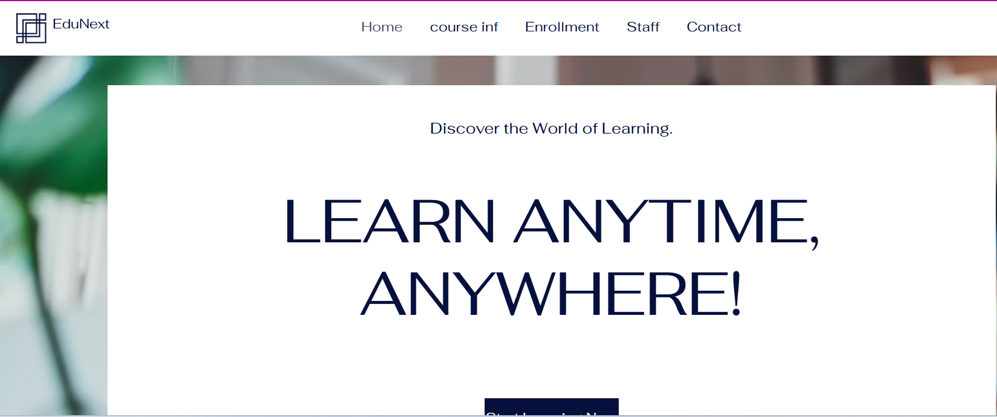
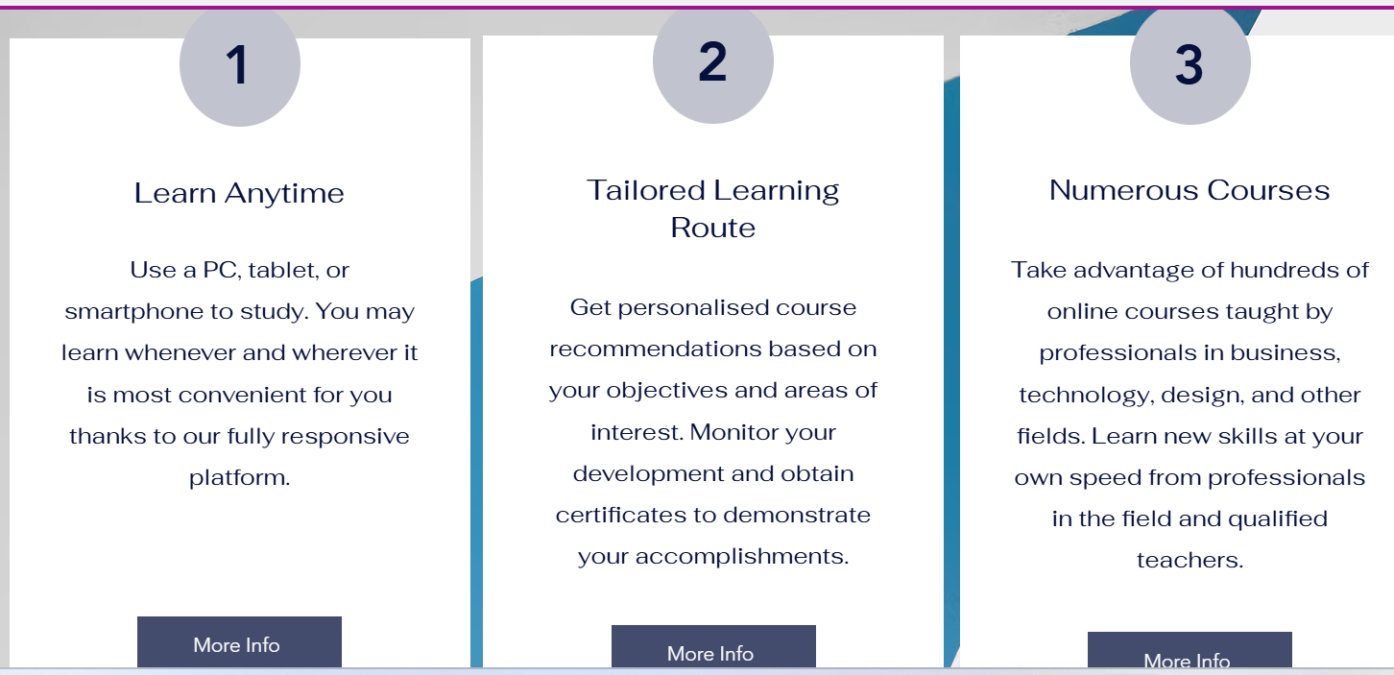
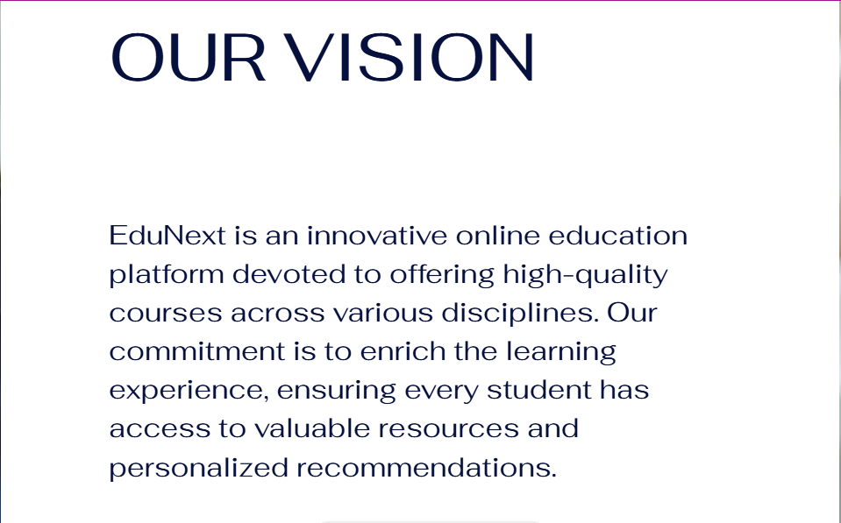

Course Inf.
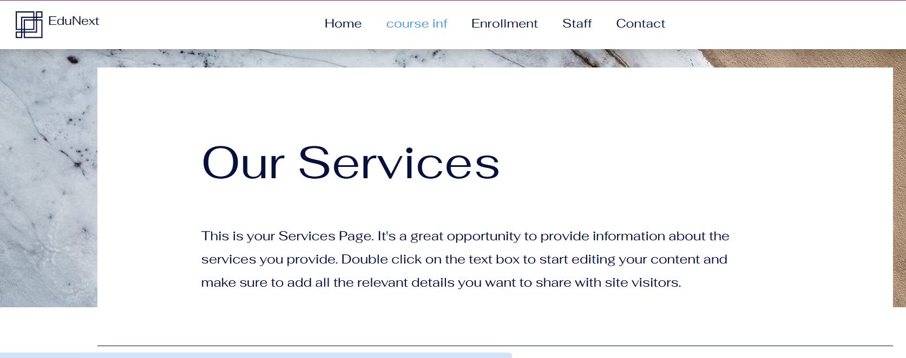
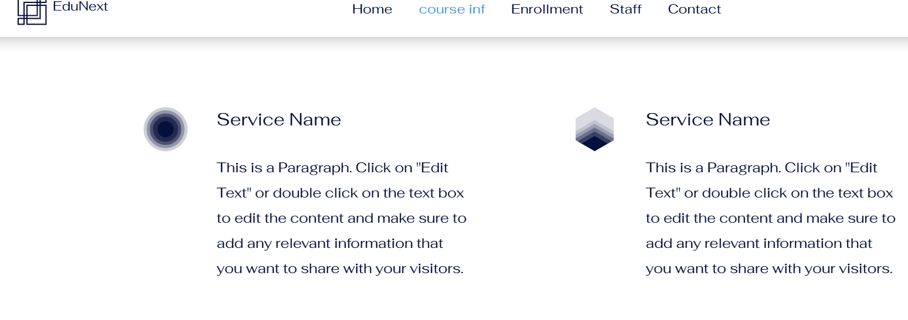
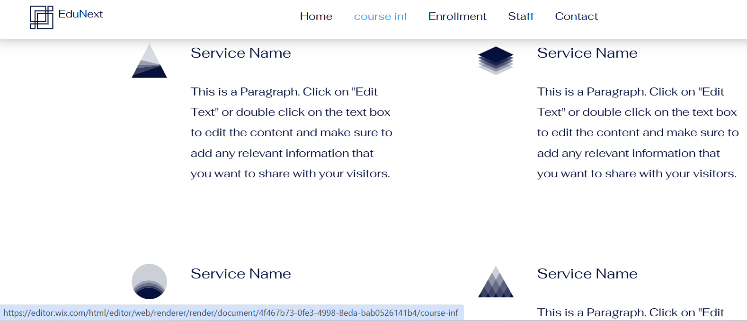
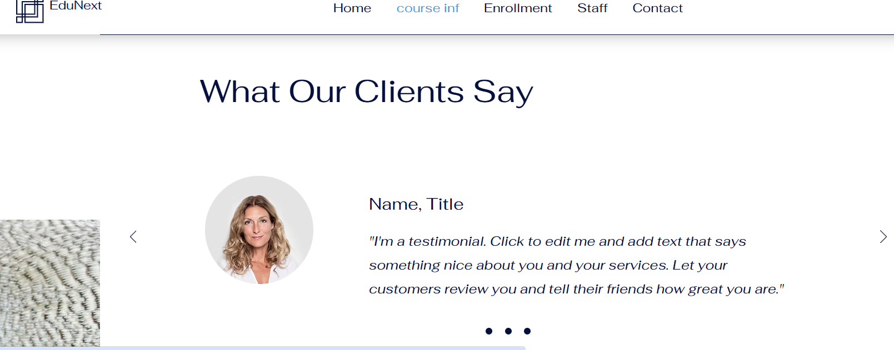

Enrolment Page
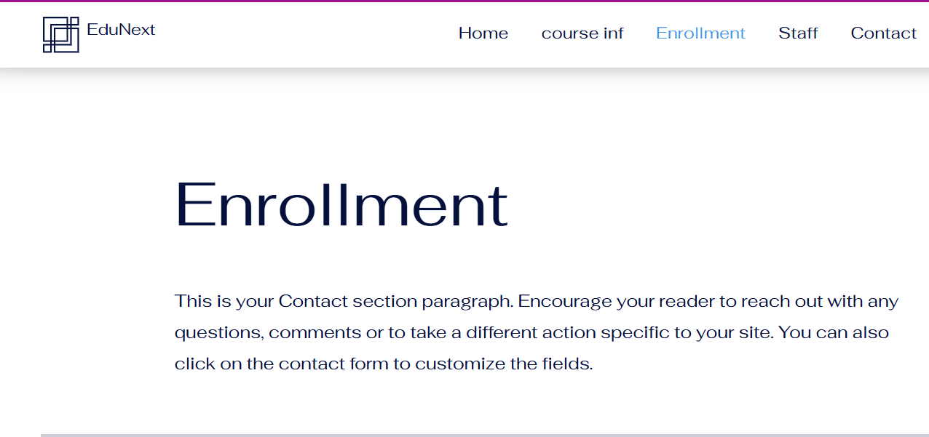
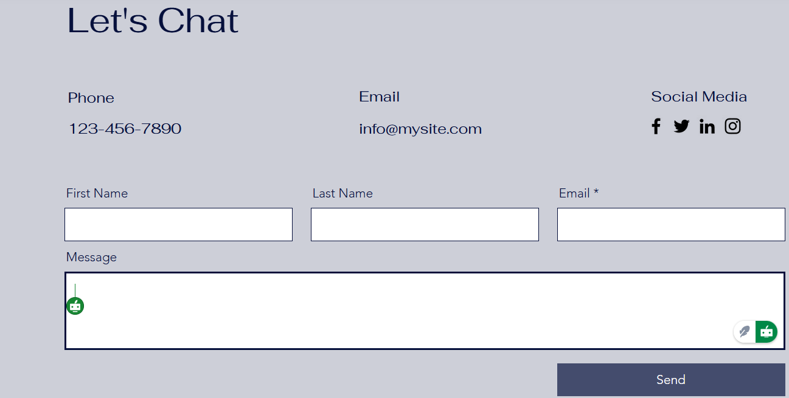

Staff
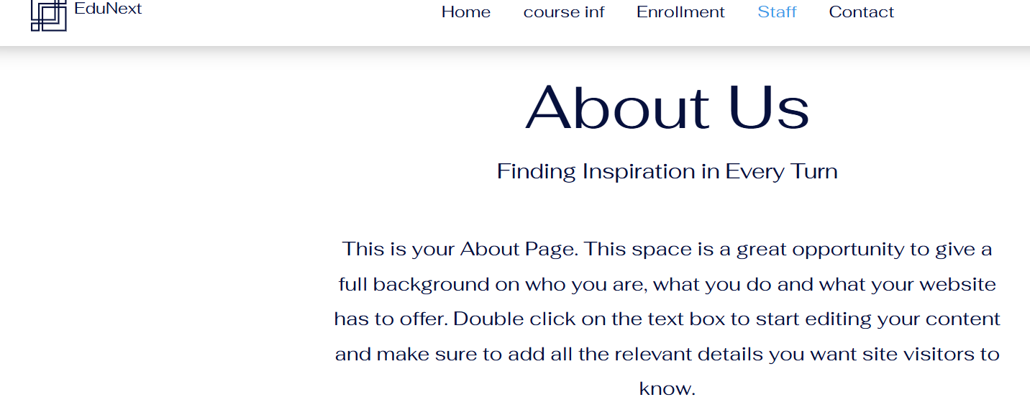
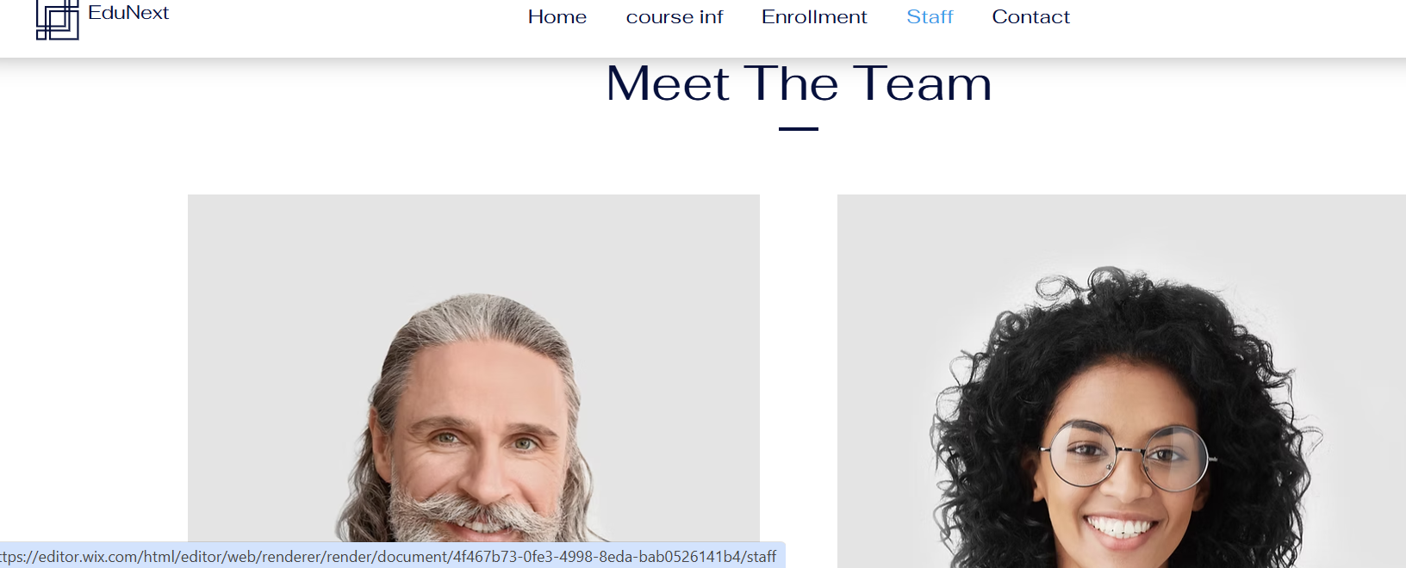
Contact
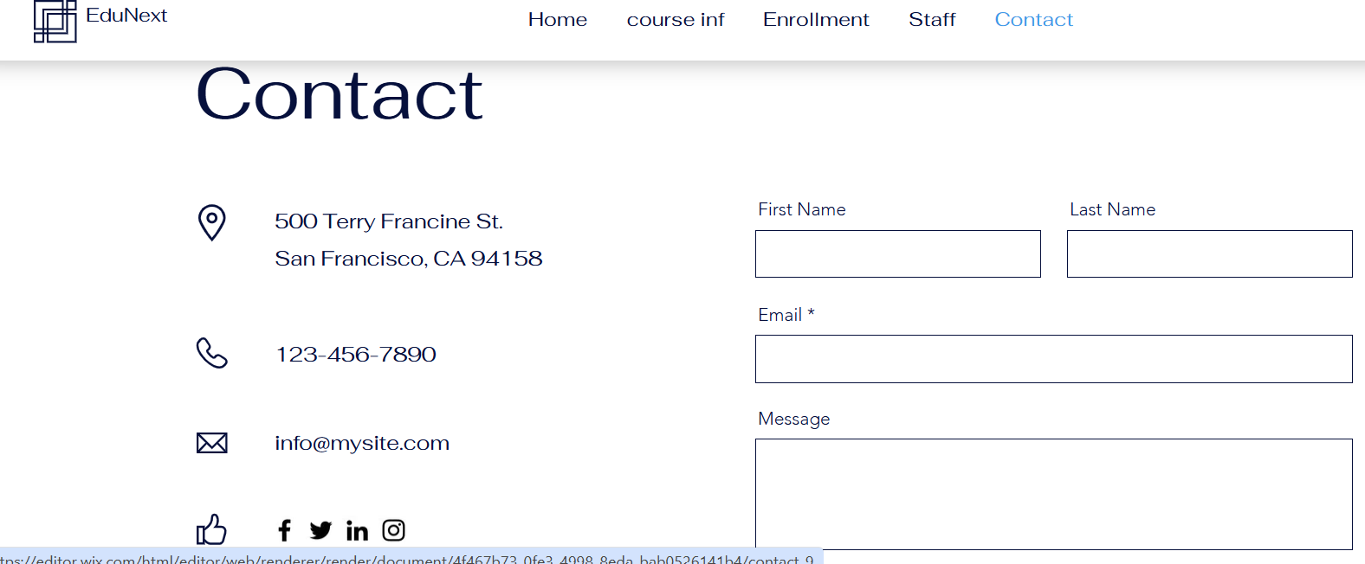
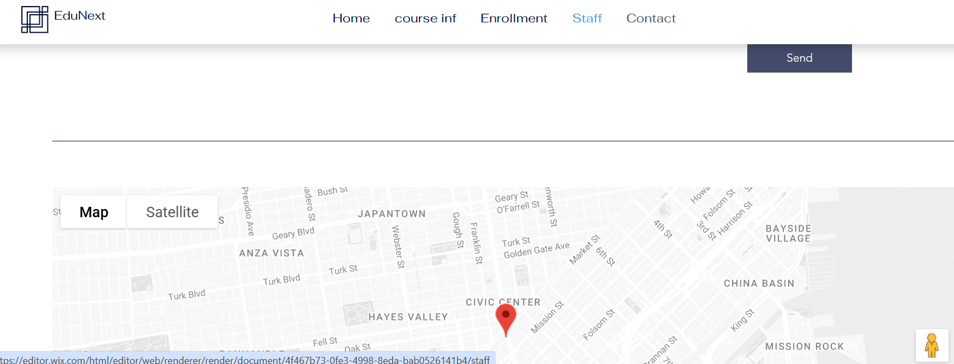

The interactive prototype developed using Wix is essentially a functional representation of the new EduNext user interface and is designed to mirror actual user navigation within the system itself. This prototype gives you an opportunity to inspect user interactions with key features such as browsing for available courses, reading detailed course information, and completing enrolment processes. Each transition between screens and user interaction was intended to mirror actual user behaviour to make this prototype usable for user testing as well as for user experience visualization.
The prototype was designed while placing high emphasis on visual hierarchy. The major elements such as Calls to Action, page titles, and navigation elements have been especially emphasized. This makes it easy for users to focus on them while decreasing cognitive load. Size, weight, and colour contrast have been utilized consistently. The layout is designed using grid systems to give perfectly aligned and spaced designs to create a highly organized and neat-looking EduNext website to signify its academic/professional identity.
Additionally, colour contrast and typography have been taken into consideration for their accessibility compatibility, especially Web Content Accessibility Guidelines 2.1 guidelines. This interactive prototype brings to the fore a detailed vision of how the final website for EduNext will come to function by balancing its aesthetic appeal and usability to ensure all decisions for its final designs create user happiness and are accessible to all users, whether having visual or cognitive impairments or otherwise. [7]

6.4 Influence of Mood Board and wireframes
The mood board was crucial in determining the overall tone, personality, and emotional appeal of the EduNext redesign. The mood board provided as a visual foundation for all subsequent design decisions by incorporating a consistent colour palette, font, and imagery. The chosen colours—primarily professional blues with lively yellow accents—were designed to convey trust, creativity, and accessibility. The mood board's emphasis on clarity and modernism also had a direct influence on typographic choices, such as crisp sans-serif typefaces. These visual aspects contributed to the brand's identity and ensured that the final interface elicited the required emotional responses from users, such as confidence, motivation, and ease of use.
In contrast, the wireframes served as a structural blueprint for the website's layout. They made it possible to organise content in a logical and user-friendly manner, prioritising usability over aesthetics. Wireframing involved meticulously mapping out critical areas of user flow, such as navigation, course browsing, enrolment procedures, and interaction points. This guaranteed that each page supported intuitive behaviour, decreased cognitive burden, and increased overall user journey efficiency.
The mood board and wireframes worked together to lead the creation of a cohesive, functional, and user-centred prototype. While the mood board determined the visual identity and emotional tone, the wireframes guaranteed that the interface was rationally structured and responsive to user needs. Their combination resulted in a prototype that not only looks good but also provides a clear, accessible, and engaging experience for learners who use the EduNext platform.

7.0 Conclusion

The redesign project for the EduNext website is one such example of how UI/UX strategies can transform an eLearning website into a contemporary and accessible online destination. This website is meant to enhance learner happiness and business success by bringing together user experience and responsive designs.

The design workflow from developing the mood board to prototype testing stressed the need for visual hierarchy, accessibility, and simplicity while fostering trust and user retention. This redesign not only enhances EduNext's visual identity but also echoes its goal to make education accessible to all.

Possible future upgrades may include real-time data features or adaptive learning functionality as well as AI-driven course recommendation functionality. This project shows how “design thinking” and “evidence-based user experience” can lead to success for both learning and business outcomes.

References

[1] | Don Norman and Jakob Nielsen, “NN/g,” 8 August August 8, 1998. [Online]. Available: https://www.nngroup.com/articles/definition-user-experience/. [Accessed 10 November 2025].
[2] | E. Stevens, “Career Foundry,” 22 JANUARY 2025. [Online]. Available: https://careerfoundry.com/en/blog/ux-design/what-is-user-experience-ux-design-everything-you-need-to-know-to-get-started/. [Accessed 10 November 2025].
[3] | E. Marcotte, “Alista Part,” 25 May 2010. [Online]. Available: https://alistapart.com/article/responsive-web-design/. [Accessed 10 November 2025].
[4] | T. Harmeling, “Usercentrics,” 25 Feb 2025. [Online]. Available: https://usercentrics.com/knowledge-hub/mastering-web-app-accessibility-wcag2-2-and-inclusive-design/?utm_source=google&utm_medium=cpc&utm_term=&utm_campaign=uc_src_uk_en_generic_tof_dsa&utm_content=en_knowledge-hub&campaign_id=22445955503&adset_id=1795819. [Accessed 10 Nov 2025].
[5] | K. Wetzel, “Educause,” 9 Nov 2015. [Online]. Available: https://er.educause.edu/articles/2015/11/responsive-web-design-in-higher-ed. [Accessed 2025 Nov 2025].
[6] | Written by Coursera Staff, “Coursera,” 22 Feb 2025. [Online]. Available: https://www.coursera.org/articles/wireframe. [Accessed 20 Nov 2025].
[7] | by Rikke Friis Dam and Teo Yu Siang , “Interaction Design Foundation,” Sept 2025. [Online]. Available: https://www.interaction-design.org/literature/article/prototyping-learn-eight-common-methods-and-best-practices#digital_wireframes-12. [Accessed 18 Nov 2025].

