


STUDENT NAME: SAIMA KAUSAR
STUDENT NUMBER: 2407682
MODULE NAME: BMHP5014 CHANGEMAKERS: CREATIVITY &VALUE CREATION
LECTURER NAME: PARESE AHMED

Menopause Awareness Campaign Pitch
Table of Contents
- Introduction
- Background of the Issue
- Aim and Objectives
- Target Audience
- Key Messages
- Campaign Strategies
- Role of Poster in the Campaign
- Expected Outcomes
- Conclusion
- References

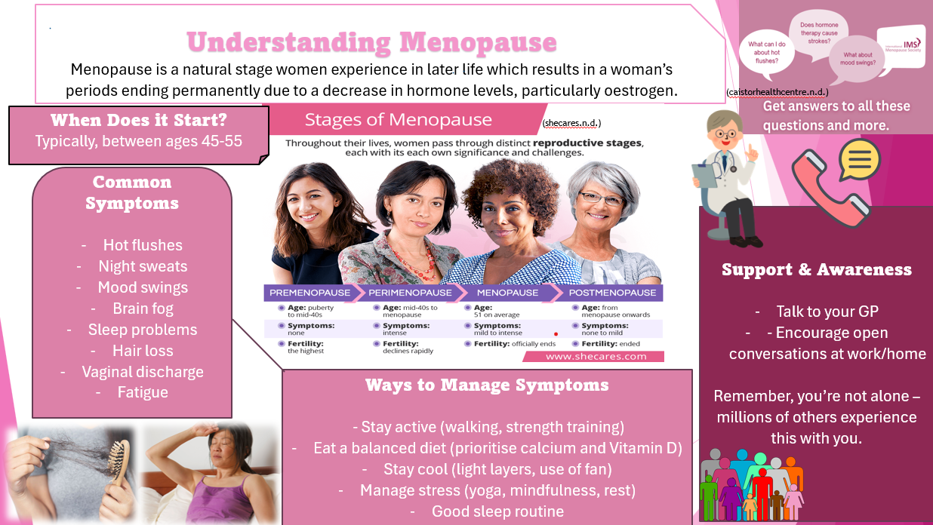

1. Introduction
Menopause is a natural stage in a woman’s life, usually occurring between the ages of 45 and 55 (Gold, E.B., 2011). It marks the end of a woman’s menstrual cycle and fertility, but it is much more than just a physical change (Frisch, R.E., 1988). For many women, menopause brings emotional, mental, and social challenges that can affect daily life, relationships and work (Northrup, C., 2021). Despite affecting millions of women worldwide, menopause is still often misunderstood and not openly discussed. Many women feel embarrassed talking about their symptoms, which can lead to feelings of isolation and lack of support (Laker, B. et al, 2024).
Common symptoms of menopause include hot flushes, night sweats, mood swings, fatigue, difficulty sleeping and memory problems (Comparetto, C. et al, 2023). Some women may also experience anxiety, reduced confidence and changes in their physical health such as weight gain, joint pain and headaches (Weiss, S.J., et al, 2016). These symptoms can vary from person to person, with some women experiencing mild effects while others struggle with more severe symptoms that impact their quality of life.
This campaign aims to raise awareness about menopause, reduce stigma and support women in managing their symptoms effectively. By encouraging open conversations in workplaces, communities and families, women can feel more comfortable seeking help and sharing their experiences (Hardy, C., et al, 2024). Providing access to reliable information, support groups and healthcare advice can empower women to make informed decisions about their wellbeing (Hickey, M., et al, 2024).
Menopause should not be seen as something negative, but rather as a natural life transition (George, S.A., 2002.). With the right support, understanding and awareness, women can manage menopause confidently and continue to live healthy, fulfilling lives (Hoga, L., et al, 2015). Creating a supportive environment ensures women feel valued, understood and respected during this important stage of life (Nieroda, M., et al, 2024).
2. Background of the Issue
Menopause has increasingly become recognised as a significant issue for women in the workplace, particularly as more women over the age of 45 remain in employment (Jack, G., et al, 2016). In the UK, women aged 50–64 are one of the fastest-growing groups in the workforce, meaning that many employees are now experiencing menopause while managing professional responsibilities (Cronin, C., et al, 2024). Despite this, menopause has historically been overlooked as a workplace concern. For many years, women were expected to manage symptoms privately without adjustments or support, which created barriers to career progression and wellbeing (Cowell, A.C., et al, 2024). Only in recent years has menopause begun to receive attention as an important workplace equality issue (Crawford, B.J., et al, 2021).
Evidence shows that approximately 90% of women experience menopausal symptoms, including hot flushes, sleep disturbances, anxiety, and reduced quality of life (Chemist4U, 2025). A UK-based study also found that women experience an average of 10 symptoms, with 81.8% reporting sleep disruption and over 72% experiencing psychological symptoms such as anxiety and depression (BMC Women’s Health, 2023). These symptoms can affect concentration, confidence and productivity, which may make it difficult for women to perform at their usual level, particularly in demanding or high-pressure roles (Hofman, R., 2025. ).
The impact of menopause also extends into employment and economic participation. Around 10% of women leave their jobs due to menopause symptoms, while over 60% report reduced motivation and confidence at work (Chemist4U, 2025). This highlights how menopause can influence career progression, financial security, and long-term employment opportunities. Additionally, workplace stigma continues to exist, with 41% of women reporting that menopause is treated as a joke in professional environments (Chemist4U, 2025). These experiences can discourage women from speaking openly about their challenges and contribute to feelings of embarrassment or isolation (Hofman, R., 2025. ).
One of the key reasons menopauses remains an issue is because it has long been considered a taboo topic (Beck, V., et al, 2020). In many societies, discussions about women’s health, ageing and hormonal changes have traditionally been avoided (Greer, G., 2018. ). Cultural differences also influence how menopause is viewed (Whelan, É., et al, 2026). In some communities, menopause is rarely discussed openly, while in others it may be associated with negative beliefs about ageing or reduced capability (Hoga, L., et al, 2015). These cultural expectations can make women feel uncomfortable discussing their experiences, particularly in professional environments. This silence can create disappointment and frustration, as women may feel unsupported during a natural life stage (Hall, L., et al, 2007).
A major concern is the lack of awareness and education around menopause. Research highlights that only 22% of women feel well-informed about menopause, which contributes to delayed diagnosis and inadequate care (UCL study reported in The Guardian, 2025). Furthermore, 72% of women are unaware of the link between menopause and mental health conditions, including anxiety and depression (Royal College of Psychiatrists poll, 2026). This lack of understanding can lead to misinformation, which may cause unnecessary fear, delayed treatment and worsening symptoms (Muir, K., 2022. ). Ensuring access to accurate and reliable information is essential for supporting women effectively.
Menopause also raises important issues around women’s empowerment and equality. Women are now working longer, progressing into leadership roles and contributing significantly to the workforce (Thelma, C.C. et al, 2024). However, without appropriate support, menopause can create barriers that prevent women from reaching their full potential (Barber, K. et al, 2023). Addressing menopause in the workplace helps promote equality and ensures women are supported throughout all stages of their careers.
Historically, other aspects of women’s health have followed a similar path. For example, pregnancy was once considered a taboo topic in workplaces and women often received little support or flexibility (Grandey, A.A., et al, 2020). Over time, awareness increased, leading to maternity leave policies, workplace protections and flexible working arrangements (Brega, C.,et al, 2023). This demonstrates that workplace change is possible when awareness grows, and organisations recognise the importance of supporting women’s health needs.
In recent years, some workplaces have begun taking steps to address menopause (Safwan, N., et al, 2024). Organisations are introducing menopause policies, offering flexible working arrangements, providing wellbeing support and training managers to better understand menopause-related challenges (Cronin, C., et al, 2024). These changes aim to reduce stigma, encourage open conversations and create more inclusive working environments.
Overall, menopause represents a wider public health and equality issue involving workplace discrimination, stigma, cultural barriers and lack of education. Addressing these challenges is essential to ensure women feel supported, empowered and valued during this natural stage of life.

2. Your Innovation
Campaign Idea: “Pause & Empower”
“Pause & Empower” is a multi-platform public health campaign designed to raise awareness, improve education, and provide accessible support for individuals experiencing menopause.

Objectives:
- To educate women about menopause symptoms and management
- To reduce stigma and encourage open discussions
- To promote access to healthcare support
- To inform employers about supporting menopausal employees

4. Target Audience
The campaign targets:
- Women aged 40–60
- Employers and workplaces
- Healthcare professionals
- Family members who support menopausal women

5. Key Messages
The campaign will deliver the following key messages:
- Menopause is a natural life stage, not a disease
- Symptoms can be managed with the right support
- Women should not feel ashamed to seek help
- Workplaces should create supportive environments

6. Campaign Strategies
The campaign will use different methods to spread awareness:

Social Media Campaign:
Platforms such as Instagram and Facebook will be used to share short educational posts and real-life stories.
Workshops and Community Sessions:
Local events will provide information and allow women to ask questions.
Healthcare Collaboration:
Working with GP clinics and organisations like NHS England to distribute leaflets and guidance.
Online Resources:
Providing access to trusted information from sources like NHS and British Menopause Society.

7. Role of Poster in the Campaign
The poster plays an important role in raising awareness. It provides quick, clear information about menopause symptoms and support options. Posters are effective because they are easy to understand and can reach a wide audience in places like clinics, community centres, and workplaces.
8. Expected Outcomes The campaign is expected to:
- Increase awareness and knowledge about menopause
- Encourage women to seek medical advice
- Reduce stigma and improve open conversations
- Promote supportive workplace policies
Research shows that education and awareness campaigns can improve health outcomes and quality of life (Hunter and Smith, 2014).

9. Conclusion
Menopause is an important health and social issue that affects many women. This campaign aims to provide education, reduce stigma, and improve support systems. By raising awareness and encouraging open discussions, the campaign can help women feel more confident and supported during this stage of life. The “Pause & Empower” campaign offers an innovative, inclusive, and technology-driven solution to address these challenges. By combining education, community engagement, and digital tools, the campaign will empower women, reduce inequalities, and promote a more informed and supportive society.
- References (Harvard Style)
Avis, N.E. et al. (2015) Duration of menopausal symptoms, JAMA Internal Medicine, 175(4), pp. 531–539.
Barber, K. and Charles, A., 2023. Barriers to accessing effective treatment and support for menopausal symptoms: a qualitative study capturing the behaviours, beliefs and experiences of key stakeholders. Patient preference and adherence, pp.2971-2980.
Beck, V., Brewis, J. and Davies, A., 2020. The remains of the taboo: experiences, attitudes, and knowledge about menopause in the workplace. Climacteric, 23(2), pp.158-164.
Brega, C., Briones, S., Javornik, J., León, M. and Yerkes, M., 2023. Flexible work arrangements for work-life balance: a cross-national policy evaluation from a capabilities perspective. International Journal of Sociology and Social Policy, 43(13-14), pp.278-294.
British Menopause Society (2023) What is menopause? Available at: https://thebms.org.uk
Comparetto, C. and Borruto, F., 2023. Treatments and management of menopausal symptoms: current status and future challenges. OBM Geriatrics, 7(3), pp.1-47.
Cowell, A.C., Gilmour, A. and Atkinson, D., 2024. Support mechanisms for women during menopause: perspectives from social and professional structures. Women, 4(1).
Crawford, B.J., Waldman, E.G. and Cahn, N.R., 2021. Working through menopause. Wash. UL Rev., 99, p.1531.
Cronin, C., Abbott, J., Asiamah, N. and Smyth, S., 2024. Menopause at work—An organisation‐based case study. Nursing Open, 11(1), p.e2058.
Faculty of Occupational Medicine (2021) Menopause and the workplace. Available at: https://www.fom.ac.uk
Frisch, R.E., 1988. Fatness and fertility. Scientific American, 258(3), pp.88-95.
George, S.A., 2002. The menopause experience: a woman's perspective. Journal of Obstetric, Gynecologic, & Neonatal Nursing, 31(1), pp.77-85.
Gold, E.B., 2011. The timing of the age at which natural menopause occurs. Obstetrics and gynecology clinics of North America, 38(3), p.425.
Grandey, A.A., Gabriel, A.S. and King, E.B., 2020. Tackling taboo topics: A review of the three M s in working women’s lives. Journal of Management, 46(1), pp.7-35.
Greer, G., 2018. The change: Women, ageing and the menopause. Bloomsbury Publishing.
Hall, L., Callister, L.C., Berry, J.A. and Matsumura, G., 2007. Meanings of menopause: cultural influences on perception and management of menopause. Journal of Holistic Nursing, 25(2), pp.106-118.
Hardy, C., Griffiths, A., Thorne, E. and Hunter, M., 2019. Tackling the taboo: Talking menopause-related problems at work. International Journal of Workplace Health Management, 12(1), pp.28-38.
Hickey, M., LaCroix, A.Z., Doust, J., Mishra, G.D., Sivakami, M., Garlick, D. and Hunter, M.S., 2024. An empowerment model for managing menopause. The Lancet, 403(10430), pp.947-957.
Hofman, R., 2025. Menopause in the Workplace: Qualitative Insights from Contrasting Work Environments (Master's thesis).
Hoga, L., Rodolpho, J., Gonçalves, B. and Quirino, B., 2015. Women's experience of menopause: a systematic review of qualitative evidence. JBI Evidence Synthesis, 13(8), pp.250-337.
Hunter, M.S. and Smith, M. (2014) Managing hot flushes and night sweats, BMJ, 348, g3093.
Jack, G., Riach, K., Bariola, E., Pitts, M., Schapper, J. and Sarrel, P., 2016. Menopause in the workplace: what employers should be doing. Maturitas, 85, pp.88-95.
Laker, B. and Rowson, T., 2024. Making the invisible visible: why menopause is a workplace issue we can't ignore. BMJ leader, 9, pp.67-71.
Muir, K., 2022. Everything you need to know about the menopause (but were too afraid to ask). Simon and Schuster.
National Health Service (2023) Menopause. Available at: https://www.nhs.uk
Nelson, H.D. (2008) Menopause, The Lancet, 371(9614), pp. 760–770.
NHS England (2022) Menopause support in the workplace. Available at: https://www.england.nhs.uk
NICE (2019) Menopause: diagnosis and management. Available at: https://www.nice.org.uk
Nieroda, M., Posso, D. and Seckam, A., 2024. Women's expectations for system support for a healthy menopausal transition: A pilot study. Maturitas, 190, p.108133.
Northrup, C., 2021. The wisdom of menopause: Creating physical and emotional health during the change. Hay House, Inc.
Office for National Statistics (2022) Population and ageing statistics. Available at: https://www.ons.gov.uk
Safwan, N., Saadedine, M., Shufelt, C.L., Kapoor, E., Kling, J.M., Chaudhry, R. and Faubion, S.S., 2024. Menopause in the workplace: challenges, impact, and next steps. Maturitas, 185, p.107983.
Thelma, C.C. and Ngulube, L., 2024. Women in leadership: Examining barriers to women's advancement in leadership positions. Asian Journal of Advanced Research and Reports, 18(6), pp.273-290.
Weiss, S.J., Simeonova, D.I., Kimmel, M.C., Battle, C.L., Maki, P.M. and Flynn, H.A., 2016. Anxiety and physical health problems increase the odds of women having more severe symptoms of depression. Archives of women's mental health, 19(3), pp.491-499.
Whelan, É., Dempsey, M. and Voon Yi Chi, C., 2026. Cultural Differences in Women’s Experience of Menopause: A Qualitative Review. Journal of Cross-Cultural Psychology, p.00220221261418307.
World Health Organization (2022) Women’s health and ageing. Available at: https://www.who.int

3
2

