Part 1: Analysis of the Welsh Health Survey
This report presents data from Tifanny et al.’s (2012) report on the Sub local Authority Analysis Welsh Health Survey examining variations in health status, illness prevalence, health-related lifestyles, and health service use across Upper Super Output Areas (USOAs) in Wales between 2003 and 2009. As part of the coursework requirements, the data are analysed using IBM SPSS statistic software (IBM Corp., 2021) and summarised using descriptive statistics, including tables and forest plots, to identify key themes and patterns.

Descriptive Statistics for illness prevalence, health-related lifestyles, and health status among people in Wales

 | N | Minimum | Maximum | Mean | Standard Deviation
High blood pressure | 94 | 15 | 25 | 19.41 | 2.649
Respiratory illness | 94 | 8 | 20 | 13.76 | 2.430
Mental illness | 94 | 4 | 14 | 9.62 | 2.338
Diabetes | 94 | 3 | 10 | 5.94 | 1.343
Poor or fair Health status | 94 | 14 | 34 | 21.47 | 5.054
Smoker | 94 | 14 | 36 | 25.37 | 4.207
High BMI (Overweight/obese) | 94 | 48 | 63 | 55.81 | 3.952
Valid N (listwise) | 94
Figure 1 Prevalence of Health illness, health-related lifestyle and health status in Wales

Figure 1 presents descriptive statistics for illness prevalence, health-related lifestyles, and health status among people in Wales. The data focus on measures of central tendency (mean) and variability (standard deviation) for a selection of the 17 health indicators against the total number of observations (N) or sample included in the Welsh Health Survey.
The illness indicators presented include high blood pressure, respiratory illness, mental illness and diabetes. The mean values represent the average prevalence of each condition within the sample. High blood pressure has the highest mean, with an average of 19.41 of adults reporting being treated for this condition. Respiratory illness (13.76) and mental illness (9.62) show progressively lower mean values, indicating lower reported prevalence compared to high blood pressure. Diabetes has the lowest mean, suggesting consistently low prevalence across the sample. All four illness indicators demonstrate relatively low standard deviations, indicating limited variability and that responses are closely clustered around their respective means. Diabetes has the lowest standard deviation, reflecting very little spread in the data. All of which show a stable and consistent patterns across observations.
In contrast, health status and health-related lifestyle indicators display higher mean values than illness indicators. Smoking (25.37) and fair or poor health status (21.47) have higher average values than any of the reported illnesses, while high BMI shows the highest mean overall, more than twice as high that of smoking. The standard deviations for health status and lifestyle indicators are also higher, suggesting greater variability and more widely dispersed responses within the Wales locality. This indicates a higher level of heterogeneity among participants for health-related factors, reflecting more diverse patterns across the population.

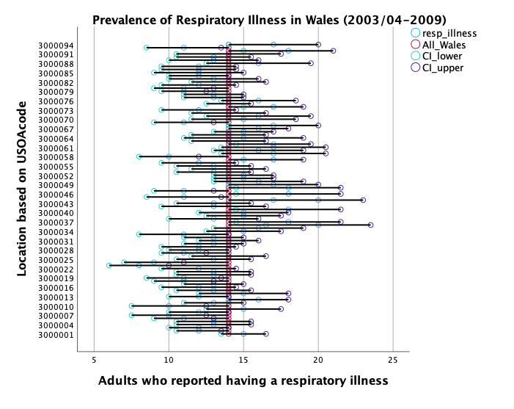
Figure 2 Prevalence of Respiratory Illness reported by adult population in Wales by USOA code

Figure 2 shows the prevalence of respiratory illness reported across multiple Upper Layer Super Output Areas (USOA) locations in Wales from 2003/04 to 2009. Each point represents the proportion of adults reporting respiratory illness, accompanied by corresponding lower and upper confidence intervals, plotted against all Welsh national average (approximately 14%).
Areas (USOA) with higher prevalence of respiratory illness have estimates positioned further to the right of the reference line, while those to the left indicate lower prevalence relative to the national average. Confidence intervals that cross the reference line suggest no significant statistical difference from the Welsh average, whereas narrower intervals indicate more clustered estimates. Considerable variation is observed across USOAs, with values ranging approximately between 5% and 25% suggesting geographical heterogeneity in respiratory illnesses. However, there is no observed pattern across all regions.
The observed differences in mean values and standard deviations between indicators classified as illnesses and those classified as health and lifestyle factors highlight important dynamics within the dataset. Illness indicators generally show lower mean values and smaller standard deviations whereas health and lifestyle indicators such as smoking, high BMI, and poor or fair health status shows higher means and greater variability, reflecting wider behavioural and experiential differences across individuals and areas. While it is plausible that these lifestyle and health status factors contribute to illness prevalence, this interpretation is likely to be incomplete, as illness patterns are also shaped by broader social and structural determinants, including socioeconomic conditions, age, culture, environmental exposures and access to healthcare (World Health Organisation, no date). Similar consideration is applied when interpreting Figure 2, where some locations consistently show higher or lower prevalence of respiratory illness relative to the Welsh average. Although these spatial patterns may reflect other influences such as geography, culture or healthcare accessibility, the descriptive nature of the analysis limits causal inference and further analysis is needed to fully explain the observed differences.
Overall, the descriptive statistics show clear differences in prevalence and variability between illness indicators and health-related lifestyle factors, while the forest plot (Figure 2) highlights area-level variation across USOAs. Together, they indicate that population health patterns are not uniform across Wales and are likely influenced by other that descriptive analysis alone cannot justify.

References
IBM Corp., Year. IBM SPSS Statistics for Windows, Version number 30. Armonk, NY: IBM Corp.
Social determinants of health (no date). Available at: https://www.who.int/health-topics/social-determinants-of-health#tab=tab_1 (Accessed: April 25, 2026).
Tiffany, C. et al. (2012) “Public Health Wales Observatory.” Available at: www.publichealthwalesobservatory.wales.nhs.uk (Accessed: April 25, 2026).

