Version 100912

9 Conclusion: 9-11 and Islam Today

Several of the themes discussed in this module have implications in relation to the events of 11th September 2001 (henceforth ‘9-11’) and its aftermath; for example: the media responses and representation of Islam; how these events are discussed in educational contexts; the application of the Internet as a means of disseminating different perspectives on the implications for Muslims in Britain. The attacks on the World Trade Center, the Pentagon, and the downing of United Airlines Flight 93 in Pennsylvania have had a resonance in terms of how Islam Today is interpreted, especially associated with relations between ‘Islam’ and ‘the west’ following the subsequent campaigns in Afghanistan (2001-) and Iraq (2003-), as well as a reconfiguring of relations between and within Muslim contexts and ‘the west’. This also has to be seen in the light of events such as the London 7-7 bombings (2005). It will only be with the benefit of a greater distance of time from events that a clearer picture emerges of the overall historical impact of 9-11.

Reading

Muslims Against Terrorism
http://www.m-a-t.org/

Bunt, Gary R. “Studying Islam after 9-11”, PRS-LTSN Journal, 1, 2, 2002, http://prs.heacademy.ac.uk/view.html/prsdocuments/65

DeLong-Bas, Natana J. . "Bin Laden, Osama." In The Oxford Encyclopedia of the Islamic World. Oxford Islamic Studies Online, http://www.oxfordislamicstudies.com/article/opr/t236/e0883

_____ . "Qaʿida, al-." In The Oxford Encyclopedia of the Islamic World. Oxford Islamic Studies Online, http://www.oxfordislamicstudies.com/article/opr/t236/e1228

Godlas, Alan. ‘Jihad, War, Terrorism, and Peace in Islam’

http://www.uga.edu/islam/jihad.html - 911

Lawson, Fred H. . "September 11." In The Oxford Encyclopedia of the Islamic World.Oxford Islamic Studies Online, http://www.oxfordislamicstudies.com/article/opr/t236/e0918

Note: there is an opportunity to study these issues in greater depth in the Muslim Politics and Muslim Networks modules.

Concluding Comment to Module

Islam Today has sought to identify some of the key issues associated with the study of Islam in contemporary contexts. Whether this is the only ‘Islam’ related module you will study, or an entry point into further studies, it is hoped that – whatever your own belief perspective - this has encouraged further reading and observation in this area. As will have been seen from this module, it is a substantial academic area in its own right, with many pathways and options to follow. Some of these are represented in other modules on the MA Islamic Studies programme. Please do not hesitate to provide feedback to the writer of the module, Gary R. Bunt, as this helps inform further module design (and re-configuration).

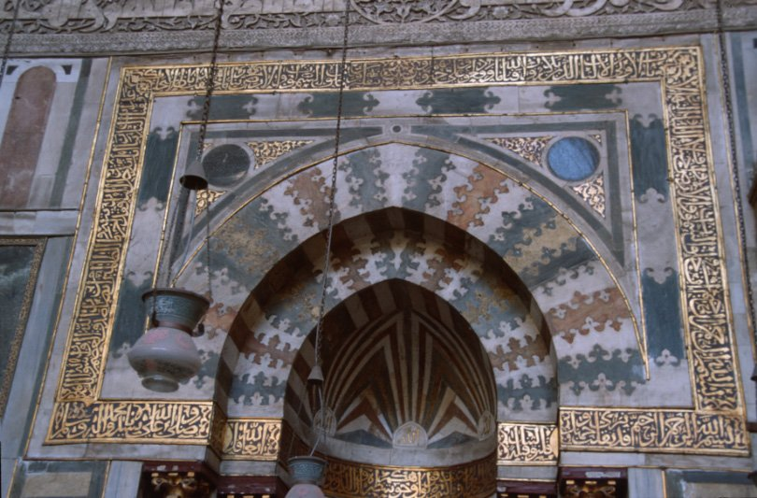

(photo: Mihrab, Sultan Hassan Mosque, Cairo, Gary R. Bunt)

