Student name: Scott Wiltshire
Student number: 1703317
BA course title: Fine Art
Word count: 1504 words (not including list of illustrations and bibliography)
Tutors name: Ryan L. Moule

List of Illustrations

Figure 1: Bacon, F. (1973) Self-Portrait. [Oil on canvas] Used on page 4.
Figure 2: Kasuma, Y (1966) Self Obliteration. Used one page 5.
Figure 3: Schiele, E. (1911) Self-Portrait with Black Vase and Spread Fingers. [Oil on canvas] Used on page 6.
Figure 4: Gormley, A. (1985) Untitled (For Francis). [Sculpture made of lead] Used on page 7.
Figure 5: Emin, T. (1977) Terribly Wrong. [Monoprint] Used on page 8.
Figure 6: Floor plan of Mission Gallery, Swansea. Used on page 9.

According to the NHS, “one in four adults and one in ten children experience mental illness.” The topic of mental illness could be considered a taboo topic in our current culture. This is something that as an artist and possible curator, I would like to challenge.
My exhibition is going to be based on mental health issues depicted through the representation of the self. Liz Rideal when writing for the National Portrait Gallery stated that “self-perception is a curious thing.” She went on to explain that “over the years, our emotions and experiences ricochet round inside our heads, gradually emerging in our patterns of behaviour and in our faces.” (Rideal, 2005:9) This could suggest that an artist’s representation of themselves could reflect their mental state. This kind of depiction of mental health could be beneficial to ending the stigma behind the topic. Jackie Higgins wrote “we expect a self-portrait to be an act of introspection, to somehow reveal the artists psyche.” (Higgins, 2013:9) This level of honest communication between the artist and the viewer could help work towards positive change.
She goes on to quote art historian Jean-Francois Chevrier saying that “every portrait, even the simplest and the least staged, is the portrait of another.” (Higgins, 2013:9) This quote could support the idea that the more we as a community talk more openly about mental health issues, the more accepted they will become and thus easier to get help for.
I have chosen to hold this event in the Mission Gallery in Swansea as my exhibition is based on mental health issues and helping the topic to become more discussed and widely accepted within the community. Therefore, I thought it would be best to hold this exhibition within my local town. Especially since I know from personal experience that a high proportion of local uni students and friends alike, struggle with their own mental health stigma issues.
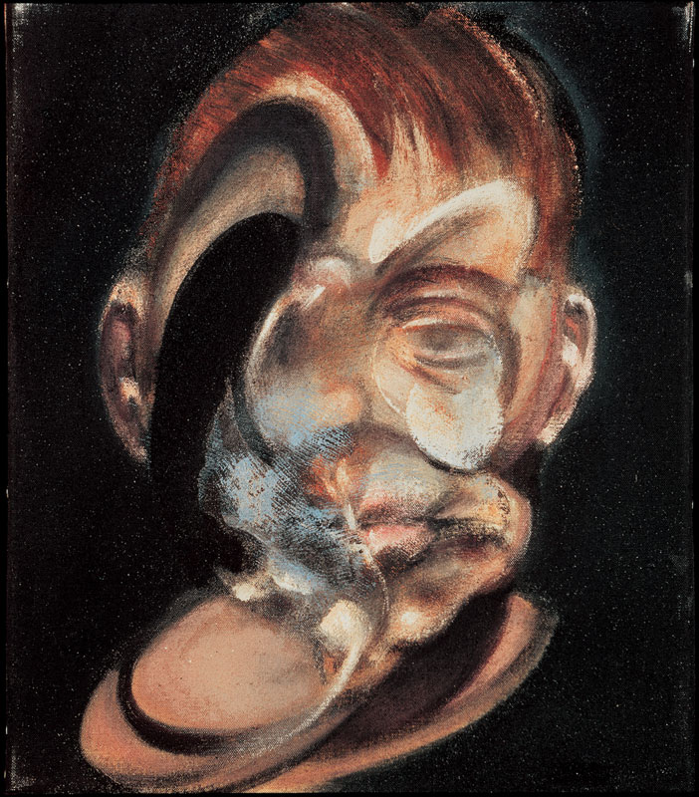
Figure one: Francis Bacon (1973) Self-portrait. [Oil on canvas]

The first piece of work I would have for this exhibition would be the self-portrait Francis Bacon painted of himself in 1973. Art historian Jon Berger describes Bacon’s work as “centred on the human body. The body is usually distorted, whereas what clothes or what surrounds it is relatively undistorted.” (Berger, 1980:119) The word distorted could suggest that the artist has trouble viewing a stable representation of one’s self. Berger goes on to state that within Bacon’s work that “there are many faces which move, and as they move they give an impression of pain.” (Berger, 1980:118) This depiction of pain creates an openness between the artist and the viewer. The artist has allowed himself to be seen at his most vulnerable state, thereby allowing the viewer to open up emotionally too. This idea of openness and the ability to be able to discuss these emotions will help end the stigma that mental health issues are something that people should be ashamed of or have to hide.
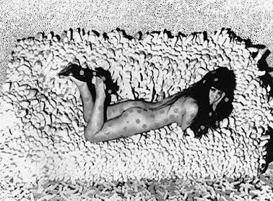
Figure Two: Yayoi Kusama. (1966) Self-Obliteration.
The second piece of work I have chosen to exhibit at this exhibition is Yayoi Kusama’s Self Obliteration. Kusama could be considered to be one of the most influential and prominent current artists who is making art about their mental health. Kusama is widely known to have voluntarily admitted herself to a mental institution, where she has been continuing to make art since the 1970s. The way that she creates are seems to be a means to her being able to process and work through the things that she thinks about and any possible mental health issues she may experience. Art historian Frances Morris writes for The Tate stating that “psychoanalysts Juliet Mitchell offers a fresh analysis, examining how this artist has put the experience of hallucinosis at the heart of her work” (Morris, 2012:15) This quote would support the idea that Kusama’s work revolves around her mental health. It is thought that Kusama also suffers with Obsessive Compulsive Disorder (OCD) which could be considered an irrational response to anxiety. In the piece shown above, Self-Obliteration, Kusama lies on a sofa she has made of ‘stuffed penises.’ Kusama’s response to dealing with an intense sexual anxiety has been to create over and over. She has been quoted as saying “Art is my medicine.”

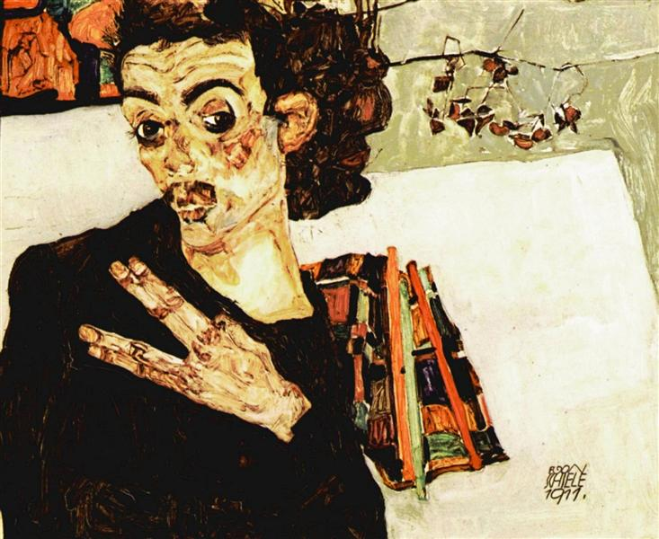
Figure three: Egon Schiele (1911) Self-Portrait with Black Vase and Spread Fingers. [Oil on canvas]
The third piece of work I have decided to include in this exhibition is Egon Schiele’s self-portrait with black vase and spread fingers. Klaus Albrecht Schroder wrote about Schiele stating that
the artist almost invariably shows the body mutilated and the face distorted by a grimace. Instead of a natural expression, he depicts the culture of the mask; instead of the ‘presentable’ face, the startling contortion.
Schroder, K A, 2006: 54

This idea of Schiele presenting the ‘distorted grimace’ could show the internal conflicts that the artist struggled with on a daily basis. Art historian Gerald N. Izenburg. Ph.D when writing an article named ‘Egon Schiele: Expressionist Art and Masculine Crisis’ stated that Schiele was notorious for the “ruthless honesty of his totured self-portraits.” (Izenburg, 2008)

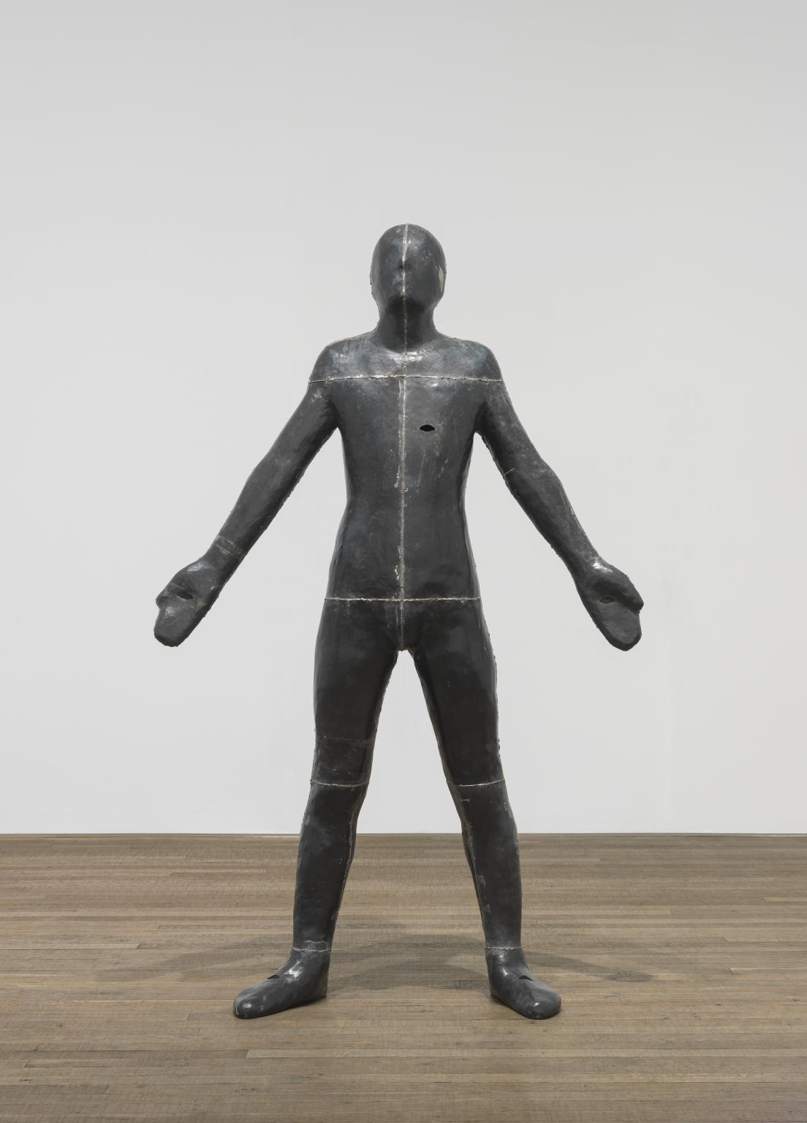
Figure four: Gormley, A. (1985) Untitled (For Francis). [Sculpture made of lead]
The fourth piece of work I have decided to include within this exhibition is Anthony Gormley’s sculpture, Untitled (For Francis), which presents a to scale cast of his own body. In 2012 Anthony Gormley himself spoke in a TedTalk about ‘sculpted spaced, within and without.’ Within this talk he shared with the audience that his goal as an artist is to create space explaining both “the space that exists within us and without us.” His work allows the viewer to reflect on not only their external surroundings, but also to the space that they have created within themselves. Gormley goes on to state in the TedTalk that he “really looked forward to going to that place of darkness.” (Gormley, 2012) I think the fact that Gormley has worked on the concept of his inner thoughts as a physical space that can be presented outside of his body would work well with this exhibition. Even though it hasn’t been stated previously that Gormley has ever suffered with mental health issues himself, I feel as though his work presents an interesting metaphor for the idea of mental health. His work is about the environment, it’s about “the infinite, subjective space that each of us lives in- but from the other side of appearance.” (Gormley, 2012) A perfect piece of work to have in the centre of this exhibition.

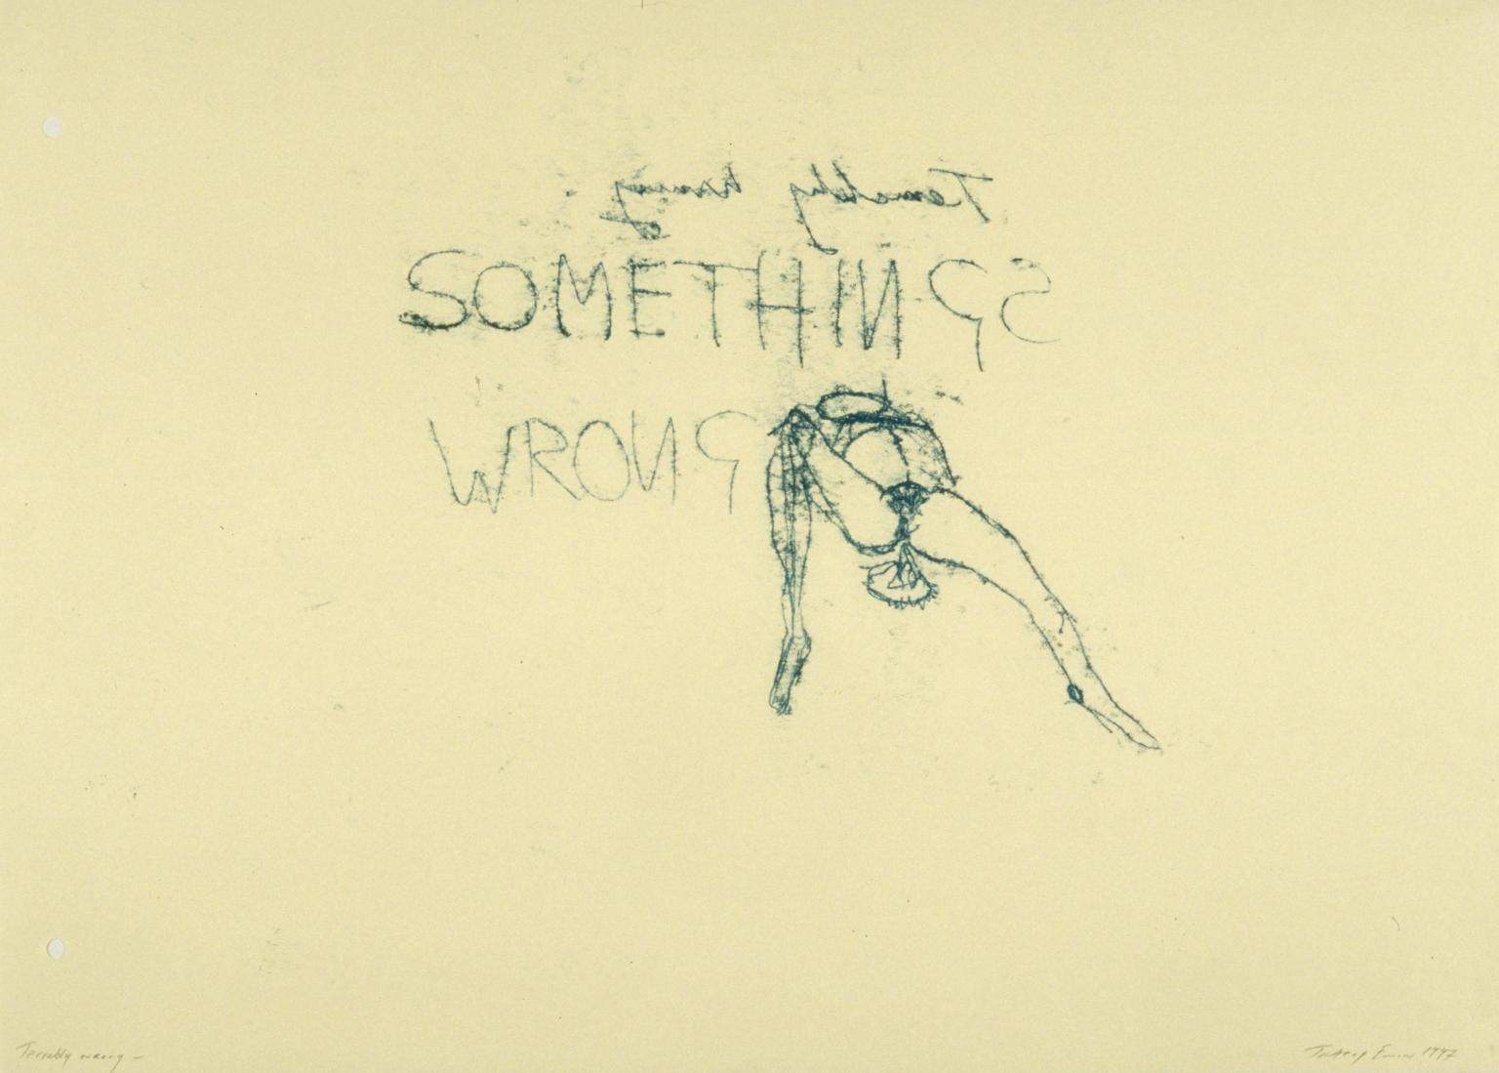
Figure five. Tracey Emin. (1977) Terribly Wrong. [Monoprint]

And the final piece of work I have picked to include within this exhibition is British contemporary artist Tracey Emin’s monoprint Terribly Wrong. Emin’s work could be considered extremely autobiographical. Her self-portraits emulate an almost confessional, honest quality. Emin’s piece Terribly Wrong is based on an abortion the artist had during 1994. Emin has stated that
For me, aggression, sex and beauty go together. Much of my work has been about memory, for example, but memories of violence and pain… Being an artist isn't just about making nice things, or people patting you on the back; it's some kind of communication, a message
(Quoted in Morgan, pp.59-60.)
This quote could help support the whole concept behind this exhibition I am trying to curate, art is about being able to communicate a message. The message I want this exhibition to have is that mental health issues are normal and should be more widely accepted and communicated about. The goal of the exhibition is to help eliminate the unhelpful stigma behind mental health issues and to celebrate the artists mentioned above for working towards this concept.
As the exhibition will be taking place in the Mission Gallery in Swansea, I have drawn out a diagram of where each piece will go in the building.
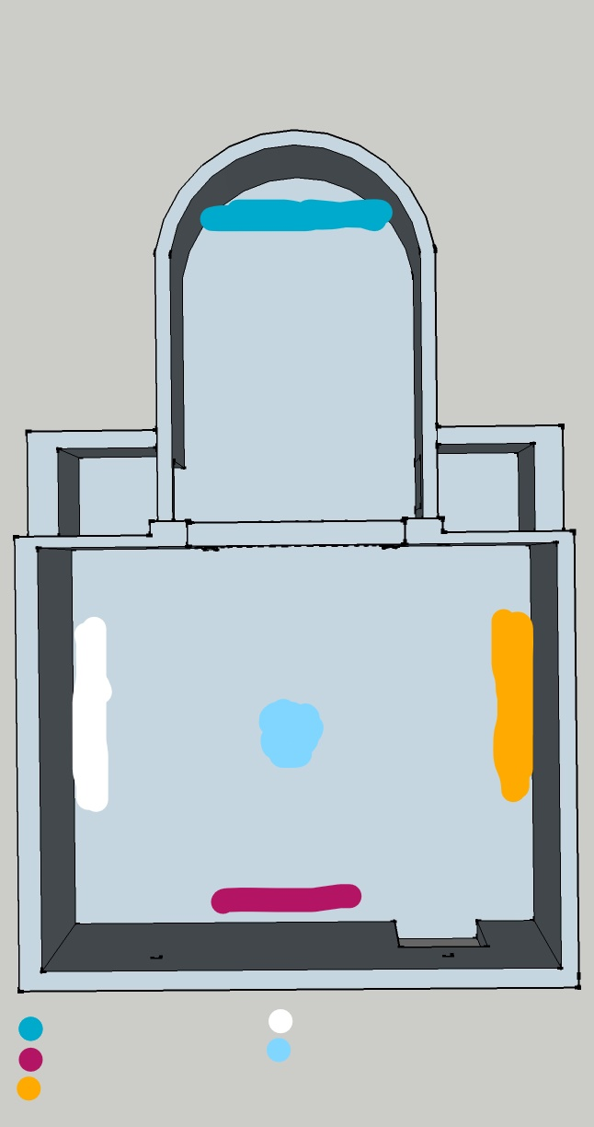
Key:
Pastel blue: Figure four: Anthony Gormley (1985) Untitled (For Francis). [Sculpture made of lead.]
Darker blue: Figure five. Tracey Emin. (1977) Terribly Wrong. [Monoprint]
White: Figure one: Francis Bacon. (1973) Self-portrait. [Oil on canvas]
Magenta: Figure Two: Yayoi Kusama. (1966) Self-Obliteration.
Orange: Figure three: Egon Schiele. (1911) Self-portrait with black vase and spread fingers. [Oil on canvas]

I have placed these pieces this way as I feel that each piece is facing opposite to its corresponding piece as I feel complimentary. Both the Bacon and Schiele pieces are similar as they both have a sense of distortion, similar painted mediums and colour schemes. Whereas Emin’s and Kusama’s pieces are both greyscale and include images of the female form. As Emin’s work could be considered to have the hardest hitting message behind it I have decided to place it at the end of the separate corridor room so viewers have their own space to contemplate in when viewing the work. Gormley’s sculpture in the middle of the room with its arms out reaching completes the exhibition space, aesthetically pleasing as it almost seems to welcome everyone who enters the room into the space.
.
Bibliography
Websites
https://www.england.nhs.uk/mental-health/

Books
- Rideal, L (2005) Insights. Self Portraits. London, England: National Portrait Gallery Publications
- Higgins, J (2013) Why It Does Not Have To Be In Focus: Modern Photography Explained. London, England: Thames and Hudson
- Berger, J (1980) About Looking. London, England: Bloomsbury
- Morris, F (2012) Yayoi Kasuma. London, England: Tate Publishing
- Schroder, K.A (2006) Egon Schiele: Eros and Passion. New York: Prestel
Interviews
Morgan, S (1997) The story of I: Interview with Tracey Emin. Frieze, issue 34. pp 56-61
Articles
Izenberg, G.N (2008) Egon Schiele: Expressionist Art and Masculine Crisis. pp 462-483
Accessed here: https://www.tandfonline.com/doi/pdf/10.2513/s07351690pi2603_11?needAccess=true

TedTalk
Gormely, A. (2012, June). Sculpted Space, Within and Without. [Video file]. Retrieved from: https://www.ted.com/talks/antony_gormley_sculpted_space_within_and_without

