  Component One:  What are the key skills required when working in the housekeeping team? 750 words (+/- 10%)  Contribution to Overall Module Assessment: 25% | Student No:
 | Module Title: | Operating Hotel Facilities
 | Module Code: | BMIH4006
 | Lecturer: | Ffion Cumberpatch
Mullins and Dossor, (2013) claim that housekeeping is the process of keeping a property clean, organised, and properly maintained in order to fulfil the requirements and expectations of visitors and to comply with health and safety laws, including guest rooms, public areas, and back-of-house spaces. Cleaning and sanitising rooms, replacing amenities, changing linens and towels, monitoring inventory, managing laundry services, and conducting preventative maintenance on equipment and fixtures are all part of the job. Good housekeeping is crucial to ensuring the overall success of a hotel or other hospitality business and maintaining a great visitor experience. This learning log will summarise the important abilities needed to work in the housekeeping team.
Firstly, attention to detail is a necessary ability for the cleaning crew. Housekeeping personnel, according to Raghubalan and Raghubalan (2016), must pay attention to the tiniest details when cleaning guest rooms, such as ensuring the curtains are properly hung or the pillows are properly set on the bed. This degree of detail is crucial to the whole experience of the guest, and a lack of it may result in unfavourable comments or complaints.
Secondly, effective communication is another crucial talent necessary in the housekeeping team, as mentioned by Ferdinand and Kitchin (2017). To ensure that jobs are accomplished properly and efficiently, housekeeping employees must interact with their colleagues. They must also communicate with visitors in order to give information and address any concerns that may emerge. Excellent customer service requires strong communication abilities.
Furthermore, working on the cleaning team requires a high level of employee involvement. Employees who are engaged and motivated, as Bridger (2018) points out, are more likely to perform effectively and contribute positively to the workplace. Housekeeping managers must guarantee that their teams are engaged and motivated to continually offer high-quality services. They may do this by delivering regular training, chances for personal and professional growth, and recognising and rewarding outstanding achievement.
Moreover, time management is another essential ability for the cleaning crew. Housekeeping personnel, as indicated by Mullins and Dossor (2013), must finish their responsibilities within a certain time range to guarantee that guest rooms are ready for new arrivals. They must be able to prioritise their work and finish things efficiently, which necessitates solid time management abilities. Quick (2020) emphasises the importance of time management in event management in the hotel business, and this ability is equally significant in the housekeeping crew.
Additionally, another important quality to have when working on the cleaning crew is flexibility. The hospitality sector, according to Casado (2012), is ever-changing, and housekeeping staff must be adaptive and able to respond to new scenarios. This implies they must be willing to work in a variety of jobs and accept new responsibilities as needed. This may entail modifying schedules or working hours to fit the demands of visitors, and flexibility is essential in ensuring that customers receive the finest service possible.
Similarly, as suggested by Jones (2010), providing housekeeping personnel with training is critical to ensuring that they have the knowledge and abilities to carry out their tasks properly. On-the-job training as well as continued professional development are included. Housekeeping personnel may learn about the newest cleaning technologies and practises, including how to utilise cleaning equipment, chemicals, and cleaning agents, with proper training. They can also learn how to handle specific guest requirements, such as using hypoallergenic bedding or removing specific objects from a room. Ongoing training can also help to keep employees motivated and engaged, leading to higher job satisfaction and better guest experiences.
Lastly, in the housekeeping crew, the ability to function as a team is essential. Cottrell (2019) discusses how team members must collaborate to reach a common purpose. Workers on the housekeeping crew must be able to collaborate efficiently in order to guarantee that the guest rooms are cleaned and kept to a high quality. Good communication skills, a desire to listen to others, and the capacity to collaborate to solve challenges are required.
To conclude, the abilities necessary to work on a cleaning crew are distinctive and critical to the hospitality business. Housekeeping personnel must have attention to detail, efficient communication, employee involvement, time management, flexibility, and collaboration. The academic materials included in this learning log emphasise the significance of these abilities in the housekeeping team and provide useful insight into how they may be cultivated and fostered in the workplace. The housekeeping crew is critical in the hotel sector, and its personnel must have the abilities necessary to give customers with a pleasant and happy stay.

Word Count | 751

Component Two:
Contribution to Overall Module Assessment: 25%
In this scenario – You have just been promoted to team leader for a floor within the hotel. A guest complains that on their arrival, their room had not been properly cleaned. Create an action plan and answer the following questions.

Problem | Why did it happen? | What are you going to do? | How will you prevent this from happening in the future? | What measures would you introduce to improve team effectiveness?
Complaint from guest. | Insufficient staffing | Firstly, I will apologize for the inconvenience and assure the guest that the issue will be resolved quickly. | If insufficient staffing is recognised as a problem, I would evaluate the housekeeping staff workload and determine whether it is necessary to hire additional staff, either temporarily or permanently, to alleviate the current staff workload. Moreover, I would collaborate with human resources to create job postings, screen and interview applicants, and select the most qualified candidates. In addition, I would ensure that new hires receive adequate training and are provided with the tools and resources necessary to perform their duties effectively. If additional staffing is not feasible due to budgetary constraints, I would consider alternative solutions such as redistributing responsibilities among the current staff, optimising schedules, and streamlining processes to increase productivity. I might, for instance, divide the workload into smaller tasks to make it more manageable or implement cross-training so that employees can perform a variety of tasks. | I would collaborate closely with the housekeeping staff to identify areas for improvement and provide them with the resources they need to work more efficiently.  Lastly, I would monitor the housekeeping staff's workload and output on a regular basis to ensure adequate staffing levels. If occupancy rates or demand for rooms were to fluctuate, I will adjust staffing levels accordingly to ensure that guests continue to receive superior service.
Complaint from guest. | Inadequate training | Furthermore, I will determine the scope of the cleaning issue by inspecting the room. | Firstly, I will examine the current training programme to identify any weaknesses or gaps. In addition, I will create a comprehensive training programme that covers cleaning procedures, customer service, and quality assurance. Also,  I will design training materials that are accessible and simple to comprehend for all employees. I will, similarly, ensure that all employees are up to date on the most recent procedures and standards by providing ongoing training. Lastly, I will perform routine performance evaluations to identify training requirements and areas for improvement. At the same time, I will provide employees with feedback and coaching to assist them in enhancing their skills and performance. | Inadequate training is a potential cause of customer complaints. To prevent this from occurring in the future, it is necessary to develop a comprehensive training programme that addresses all aspects of cleaning procedures, customer service, and quality control. All employees should be able to understand and access the training programme, and ongoing training should be provided to keep employees up to date on the most recent procedures and standards. To further enhance the effectiveness of a team, it is essential to establish a culture of continuous learning. This includes providing incentives for training course completion and encouraging employees to seek out training opportunities. Regular team-building exercises can also improve team communication, collaboration, and overall performance. This may include workshops, social events, and team-building exercises intended to foster a positive and collaborative workplace. Additionally, a mentoring programme can be implemented to pair new employees with experienced staff members who can provide guidance and support as they learn their job responsibilities. This would ensure that new employees are properly trained and capable of performing their duties effectively. In addition, a quality control programme should be implemented to ensure that all work is completed to the required standards, and employees' performance should be evaluated frequently.
Complaint from guest. | Lack of quality control | Moreover, I will reassign the guest to a room that has been cleaned properly or provide an upgrade if one is available. | As a team leader for a hotel floor, it is essential to maintain a high level of quality control in order to ensure that all rooms are cleaned to the required standard. Inconsistent service, unsatisfied guests, and negative reviews can result from insufficient quality control. There are multiple steps that can be taken to prevent this from occurring in the future.  The initial step is to create a comprehensive quality control programme that includes clear cleaning procedures and standards. This should include a checklist of all tasks that must be completed during the cleaning process and a review procedure to ensure that all tasks have been completed to the required standard. In addition, the programme should include routine room inspections to identify any issues and ensure that all work is completed to the required standard.  Secondly, it is essential to educate all employees on quality control procedures and standards. This should involve regular training sessions on topics like room inspection, cleaning techniques, and customer service. By ensuring that all employees are adequately trained, it is possible to reduce the likelihood of errors or omissions that could result in guest complaints.  Implementing a system of accountability is a crucial measure for preventing a lack of quality control. This should include regular performance evaluations to identify any problems and provide performance feedback to employees. In addition, there should be consequences for employees who do not meet the required standard, such as corrective action and retraining as needed.  To further enhance quality control, it is essential that staff and management maintain open lines of communication. This can include regular check-ins and meetings to discuss problems and identify areas for improvement. Staff members should also be encouraged to provide feedback on the quality control programme and make suggestions for enhancements or modifications.  Finally, it is essential to regularly monitor guest feedback and reviews in order to identify any issues with the provided service quality. This may include periodic surveys, social media monitoring, and review analysis to identify any recurring themes or issues that require attention. By proactively monitoring guest feedback, it is possible to identify potential issues before they become significant problems. | Creating a positive and collaborative work environment is a necessary first step. This can be done by fostering a culture of teamwork, where staff members feel valued, respected, and supported. Open communication is encouraged, and opportunities for staff members to share ideas and suggestions should be created. By doing so, employees are more likely to feel at ease and motivated, which can result in enhanced teamwork and increased output.  Secondly, it is essential to develop a comprehensive training programme to ensure that employees have the necessary skills and knowledge to perform their responsibilities effectively. There should be regular training sessions on customer service, cleaning procedures, quality control, and other pertinent topics. By providing regular training, employees can remain current with the most recent procedures and standards, which can result in improved performance and greater guest satisfaction.  Regular team-building exercises are an additional important measure that can be implemented to enhance team performance. This may consist of workshops, social events, and team-building exercises designed to enhance communication, collaboration, and overall team effectiveness. Regular team-building exercises can aid in boosting employee morale, fostering teamwork, and cultivating a positive and collaborative work environment.  Implementing a performance management system is also essential for assisting employees in identifying areas for improvement and establishing objectives for their personal and professional growth. By providing regular performance evaluations and feedback, employees can receive direction on how to improve their performance, leading to improved teamwork and increased productivity.
Complaint from the guest. | Communication breakdown | In addition, I will investigate the underlying cause of the cleaning problem and implement corrective measures to prevent it from occurring again. | In a hotel environment, a breakdown in communication can lead to misunderstandings, errors, and dissatisfied guests. To prevent this from occurring in the future, it is necessary to take multiple measures. Creating a culture of open communication must come first. Encouraging staff members to communicate openly and honestly can prevent misunderstandings and ensure that everyone is on the same page. Staff members can develop the necessary skills for communicating effectively with one another and with guests if they receive regular training on effective communication. In addition, the use of communication tools such as messaging apps and radios can aid in keeping everyone informed and up-to-date on any changes or updates. Lastly, regular team meetings and check-ins can help ensure that communication remains open and that any issues are promptly addressed. By taking these measures, a team leader can prevent communication breakdowns and foster a more productive and positive workplace. | To ensure that staff members comprehend and adhere to processes and procedures, it is crucial to establish clarity. This can help to reduce errors, improve consistency, and increase efficiency. By providing clear processes and procedures, staff members are able to perform their responsibilities effectively, which can lead to enhanced teamwork and productivity.  Providing opportunities for career advancement, such as training programmes, job rotations, and promotions, can improve employee retention and motivate employees to perform their duties efficiently. By offering staff members opportunities for career development, staff members are more likely to feel valued and motivated, which can lead to improved teamwork and increased productivity.
Complaint from the guest. | High occupancy rate | Lastly, ensure the customer is pleased with the resolution by following up with them. | First, it is essential to periodically check occupancy rates and alter worker numbers accordingly. By having the appropriate amount of employees on hand, service interruptions may be avoided and guests can be responded to quickly and effectively. Second, it can be advantageous to develop a complete training programme that addresses all parts of the job, such as customer service, cleaning techniques, and quality control. This will aid in ensuring that staff employees have the skills and information necessary to perform their tasks efficiently. Finally, having a contingency plan in place can assist in mitigating any problems that may develop during periods of high occupancy. This may involve having additional personnel on call, outsourcing specific jobs, or implementing technology to streamline service delivery. By taking these steps, a team leader can prevent high occupancy rates from having a negative effect on guest satisfaction and the hotel's overall reputation. | Developing a rewards and recognition programme is another effective way to boost team performance. By recognising and rewarding staff members who demonstrate excellence in their work, staff members are motivated to perform their responsibilities effectively, which can result in increased guest satisfaction and improved overall performance.

Component Three:
Contribution to Overall Module Assessment: 50%
Your task is to create and prepare a presentation following the detailed scenario provided below.

As the floor housekeeping manager and given the recent guest complaints you need to put together a basic training presentation for your colleagues within the housekeeping team to get the best out of them, ensure that brand standard is being achieved and that Health and Safety procedures are also being followed.

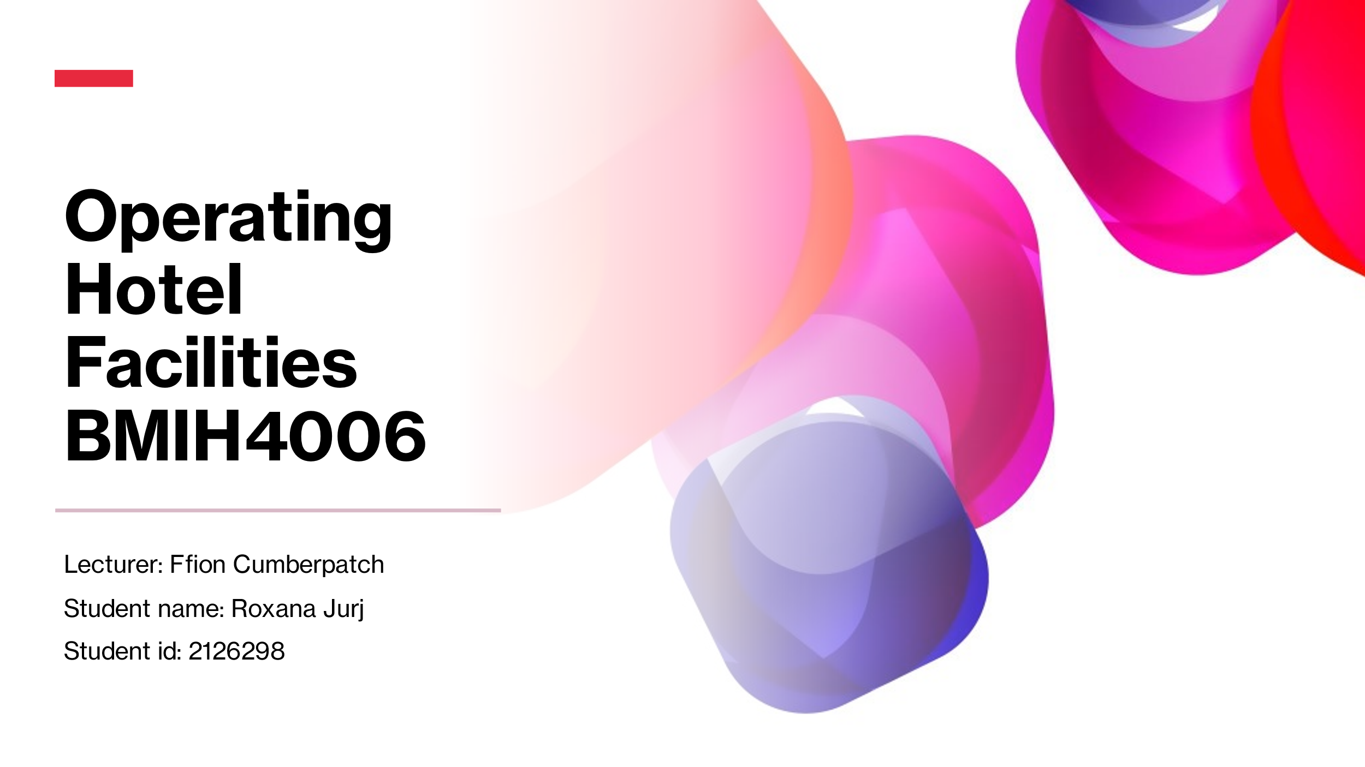

Training Notes: Hello everyone, my name is Roxana, and I am the housekeeping manager at Trinity Hotel. Today, we will be discussing how we can provide the best service to our guests, uphold the brand standards, and follow health and safety procedures.
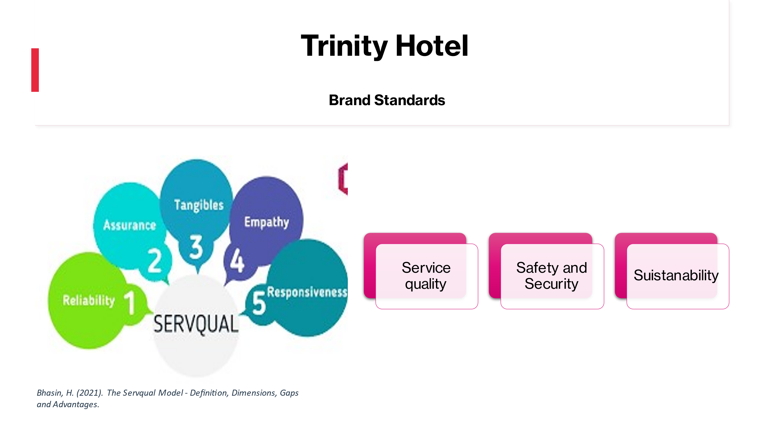

Training Notes: At Trinity Hotel, we are committed to providing our guests with a memorable experience. Our brand standards include “Cleanliness and tidiness in all areas of the hotel, Attention to detail in cleaning and presentation, Prompt and friendly service,” Therefore, to uphold these standards, we must ensure that every room and area of the hotel is clean, organized, and welcoming.
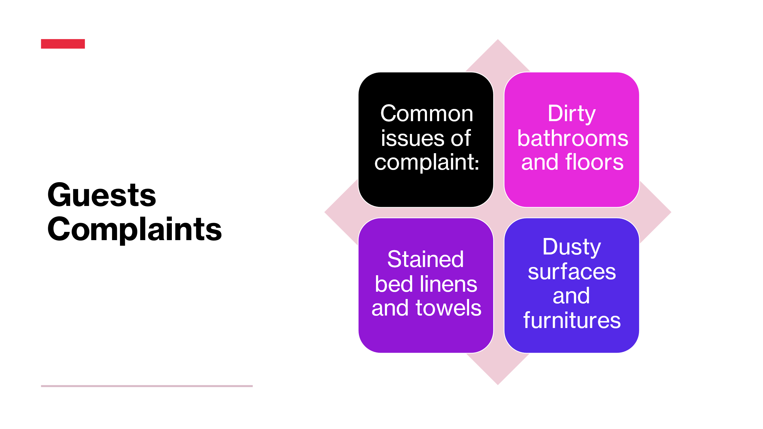

Training Notes: We have received recent complaints from our guests about the cleanliness and presentation of their rooms and common areas. This means that we need to improve our processes to ensure that we meet their expectations. Some common issues that guests complain about include dirty bathrooms and floors, stained bed linens and towels, dusty surfaces and furniture. By avoiding these issues, we can ensure that our guests have a positive experience at our hotel. In contrast, the hotel might suffer from reputation damage, financial losses, and the employees from low morale.
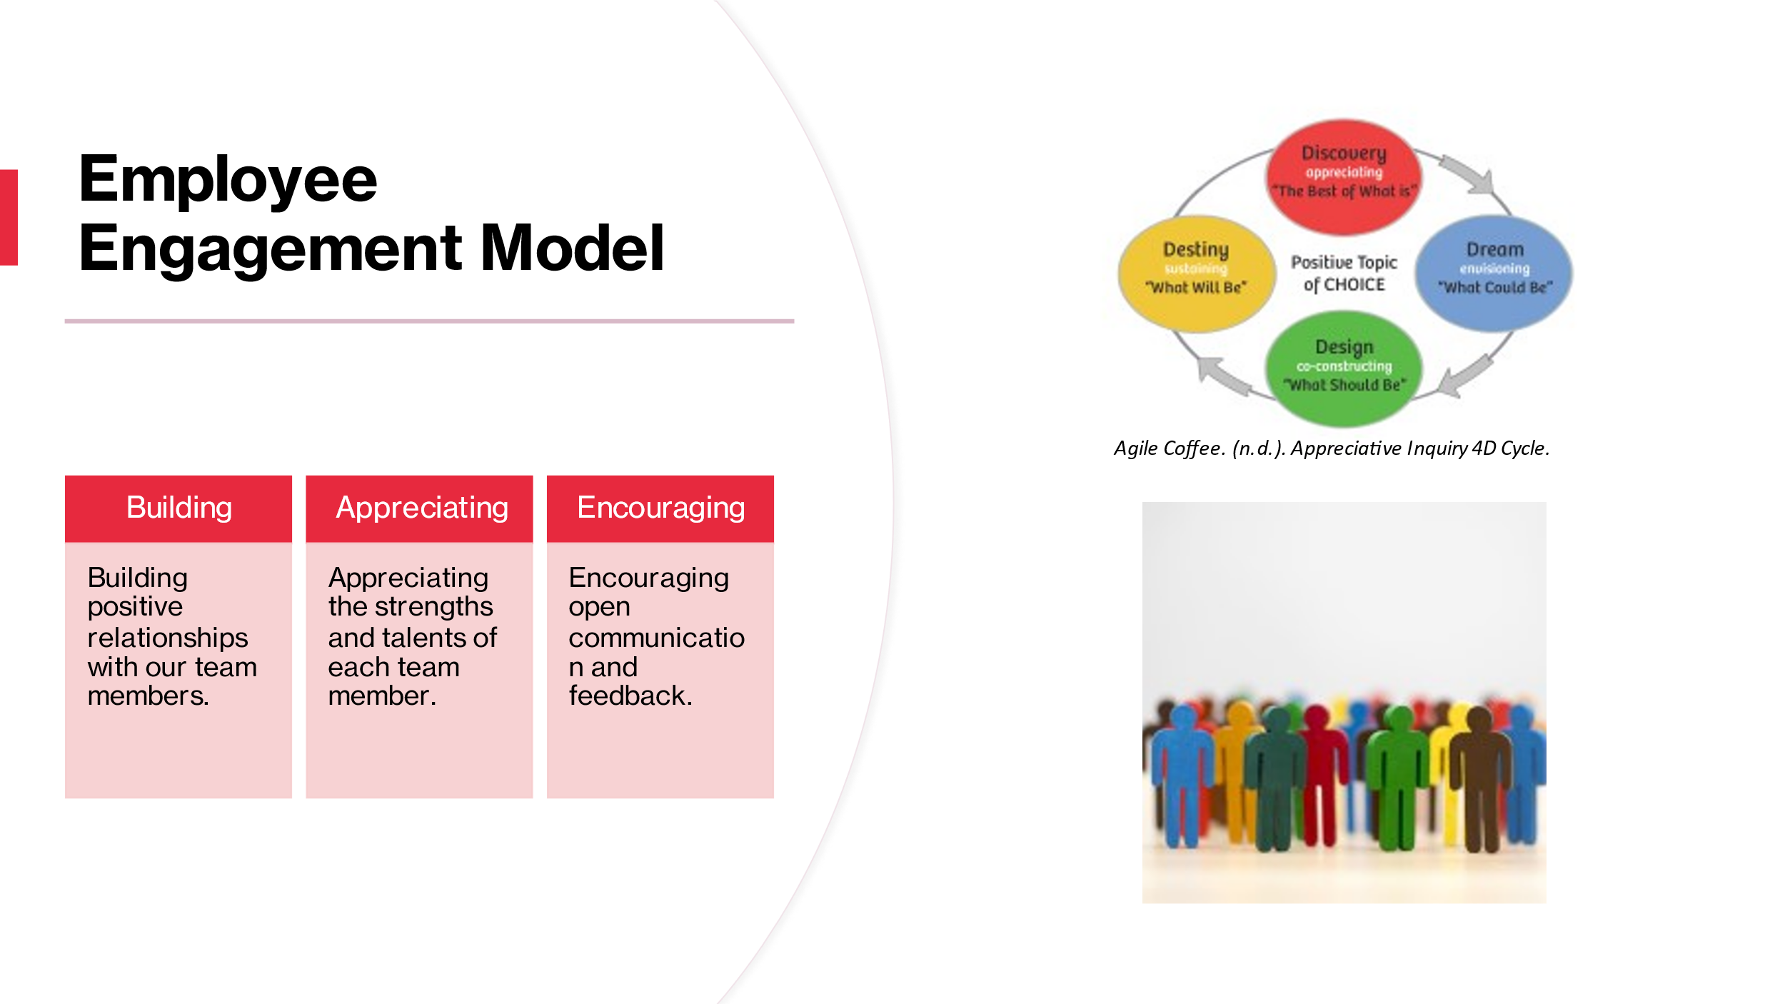

Training Notes: The success of any company, including ours, depends on the dedication of its staff. Those who feel like they have a stake in the success of the company are more likely to go above and beyond to help it succeed. When utilised in the hospitality industry, the Appreciative Inquiry methodology has been shown to increase employee engagement and consequently, the quality of service provided to visitors.The Appreciative Inquiry paradigm is a constructive method of organisational growth that places emphasis on strengthening relationships and recognising and celebrating individuals' contributions. Hotels may reach their goals and give outstanding service to their customers by focusing on the skills and talents of their team members, which is based on the idea that organisations grow in the direction of their positive focus.

The first step in introducing the Appreciative Inquiry methodology in a hotel is to foster trusting relationships with staff. To this end, it is important to foster a fun and welcoming workplace, encourage team-building activities, and highlight individual contributions.

The second step is to recognise and value everyone's unique skills and abilities on the team. Each staff member brings special skills and qualities to the table that are essential to the hotel's success. Hotels may foster a culture of positivity and support that helps team members realise their greatest potential by focusing on and building upon these strengths.

Step three is to promote candid dialogue and suggestions. A hotel, like any other business, relies heavily on effective communication in order to thrive. Hotels can increase the likelihood that their staff will be invested in the company's success, driven to work towards common goals, and able to provide constructive criticism by encouraging an environment of open dialogue. In order to accomplish this, it is important to encourage open communication on the team by offering regular chances for members to share their views and ideas, actively listening to recommendations and criticism, and providing constructive feedback.

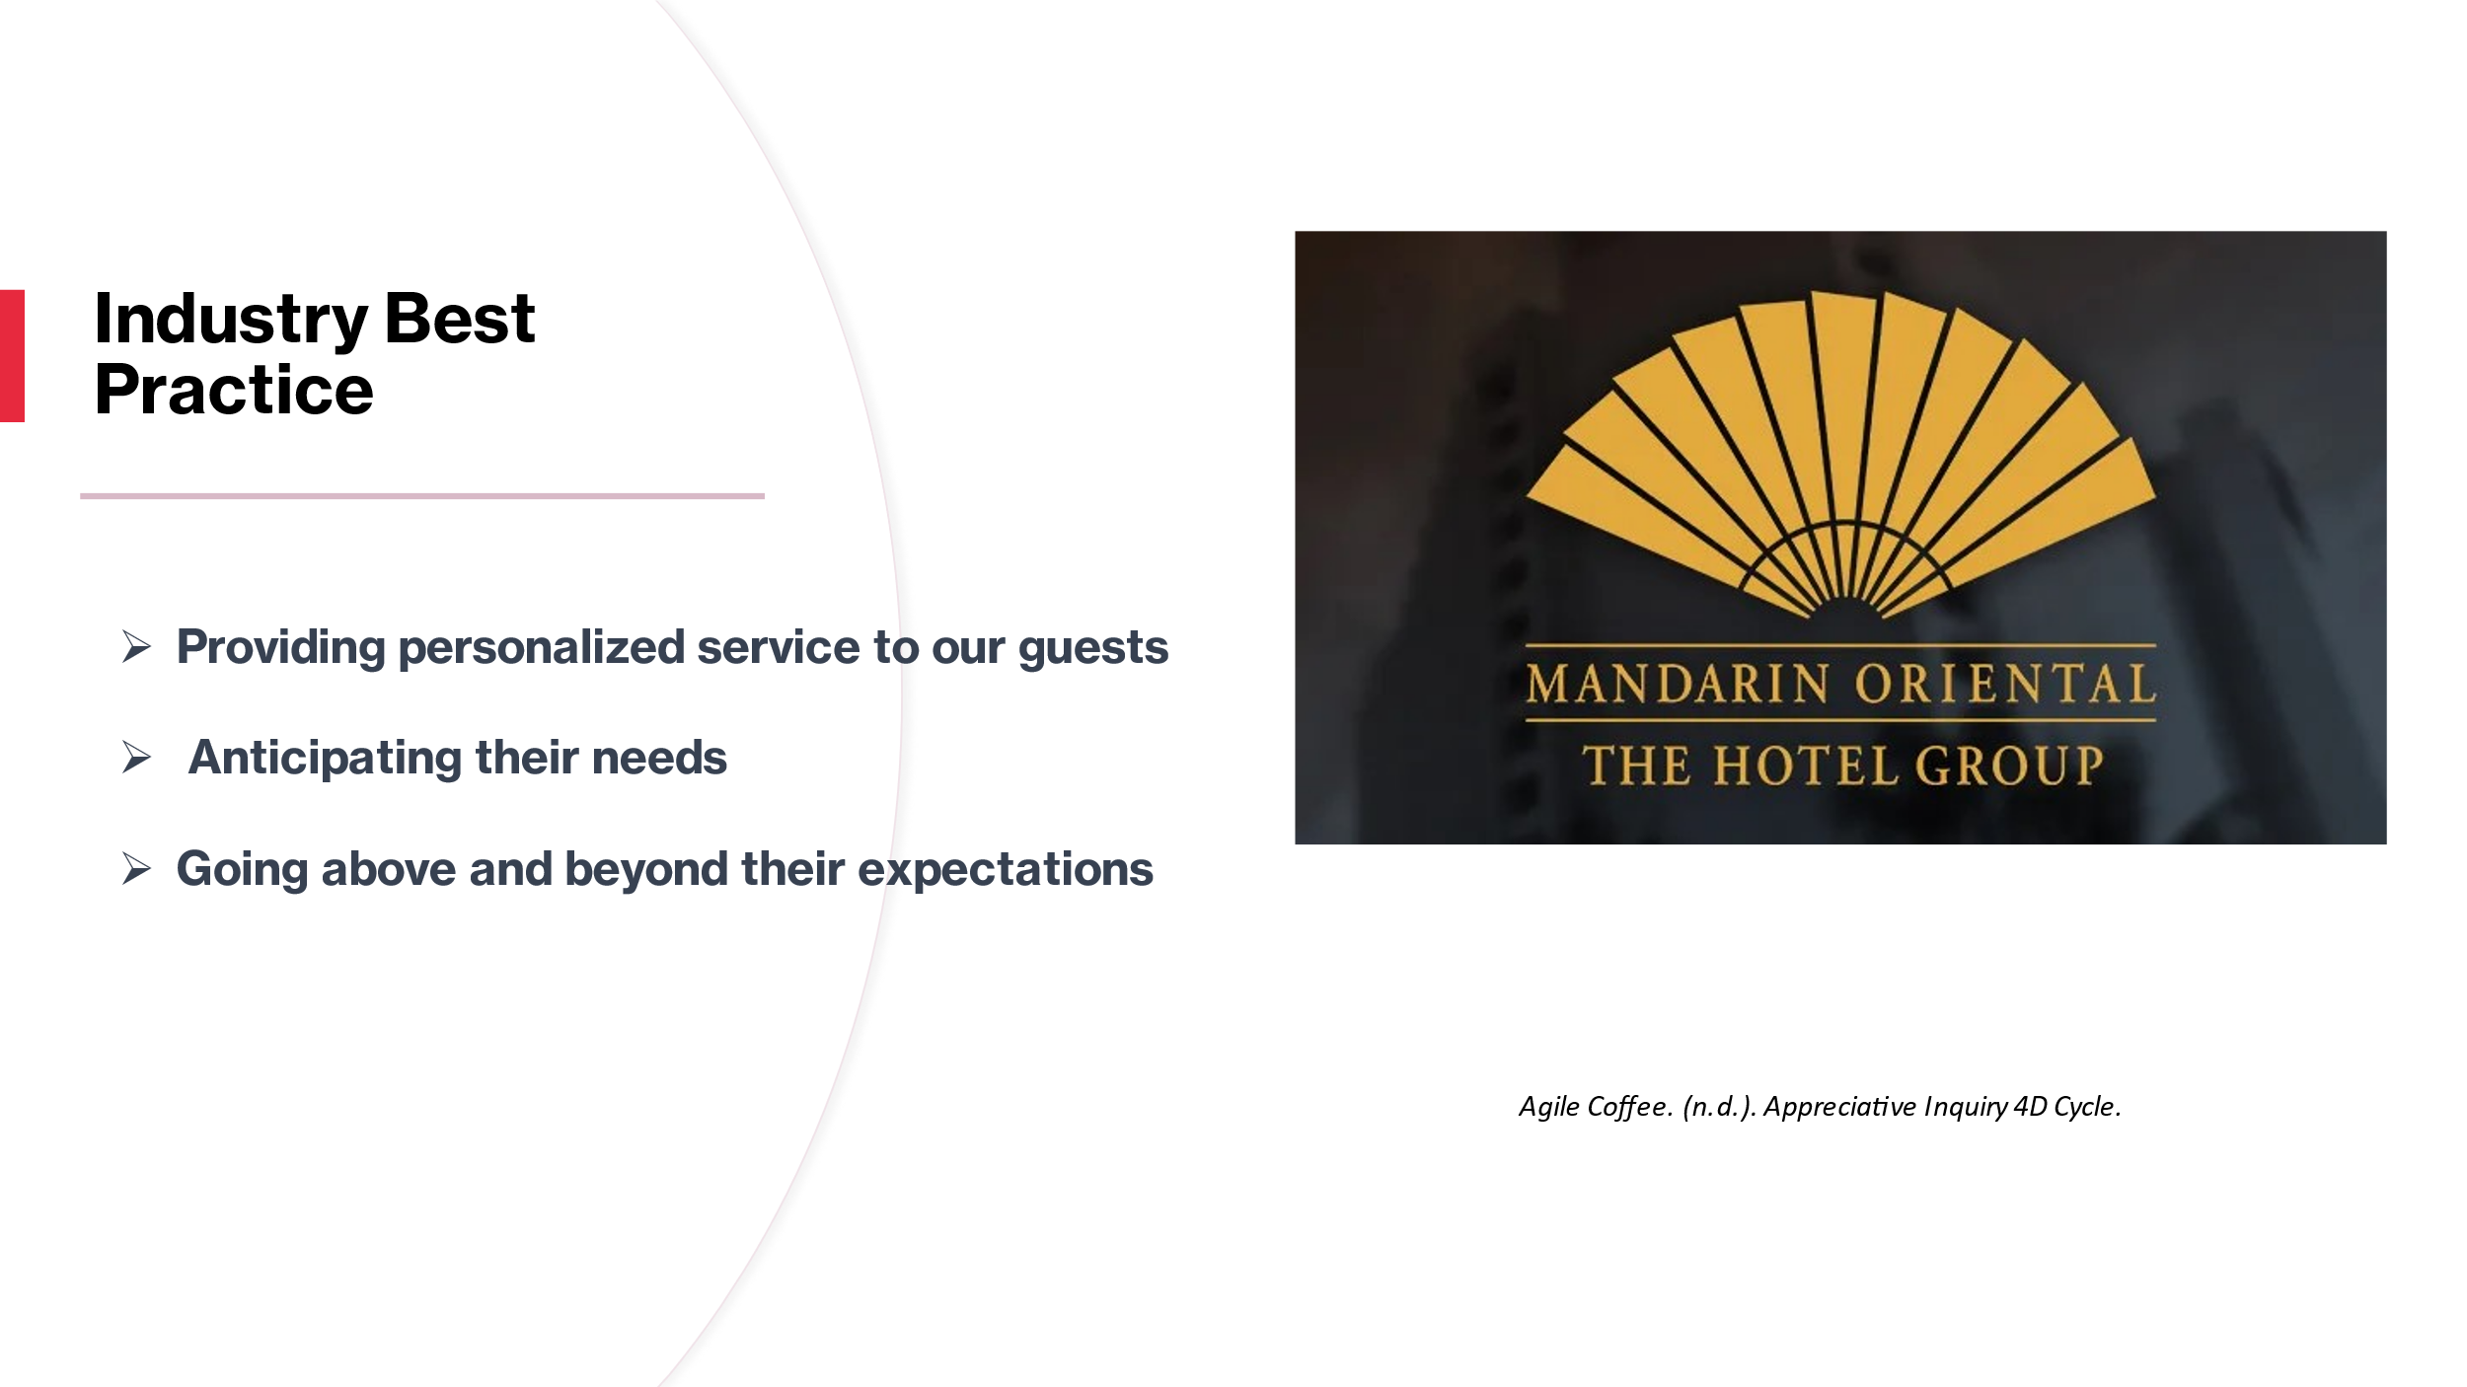

Training Notes: When it comes to housekeeping, the Mandarin Oriental Hotel Group is largely regarded as an industry leader. The hotel chain has set the bar high for others in the industry to follow due to its dedication to its guests and the quality of its service.

The Mandarin Oriental Hotel Group is known for its exceptional service and luxurious accommodations. The hotel staff makes an effort to get to know each guest and their specific requirements as soon as they check in. Everything from the ideal temperature for the room to the brand of tea they prefer is fair game. Providing guests with individualised attention helps the hotel stand out from the competition and increases the likelihood that they will return.

The Mandarin Oriental Hotel Group is known for going above and beyond in terms of service by consistently going above and beyond in terms of anticipating their customers' needs. Rather from merely responding to customers' needs, the hotel's staff takes the initiative to meet their needs. To illustrate, if a guest requests additional towels, the housekeeping team will stock the room with them before the guest's return. This kind of thoughtfulness and anticipation can greatly improve a guest's stay.

Last but not least, the Mandarin Oriental Hotel Group is renowned for providing exceptional service. This means that they aim to provide for their guests beyond what is expected of them. One such amenity is a personalised guided tour of the city or the gratis delivery of champagne and chocolates to the guest's room on the occasion of a special occasion. Going above and above for customers is a sure-fire way to earn rave reviews and future bookings for the hotel.

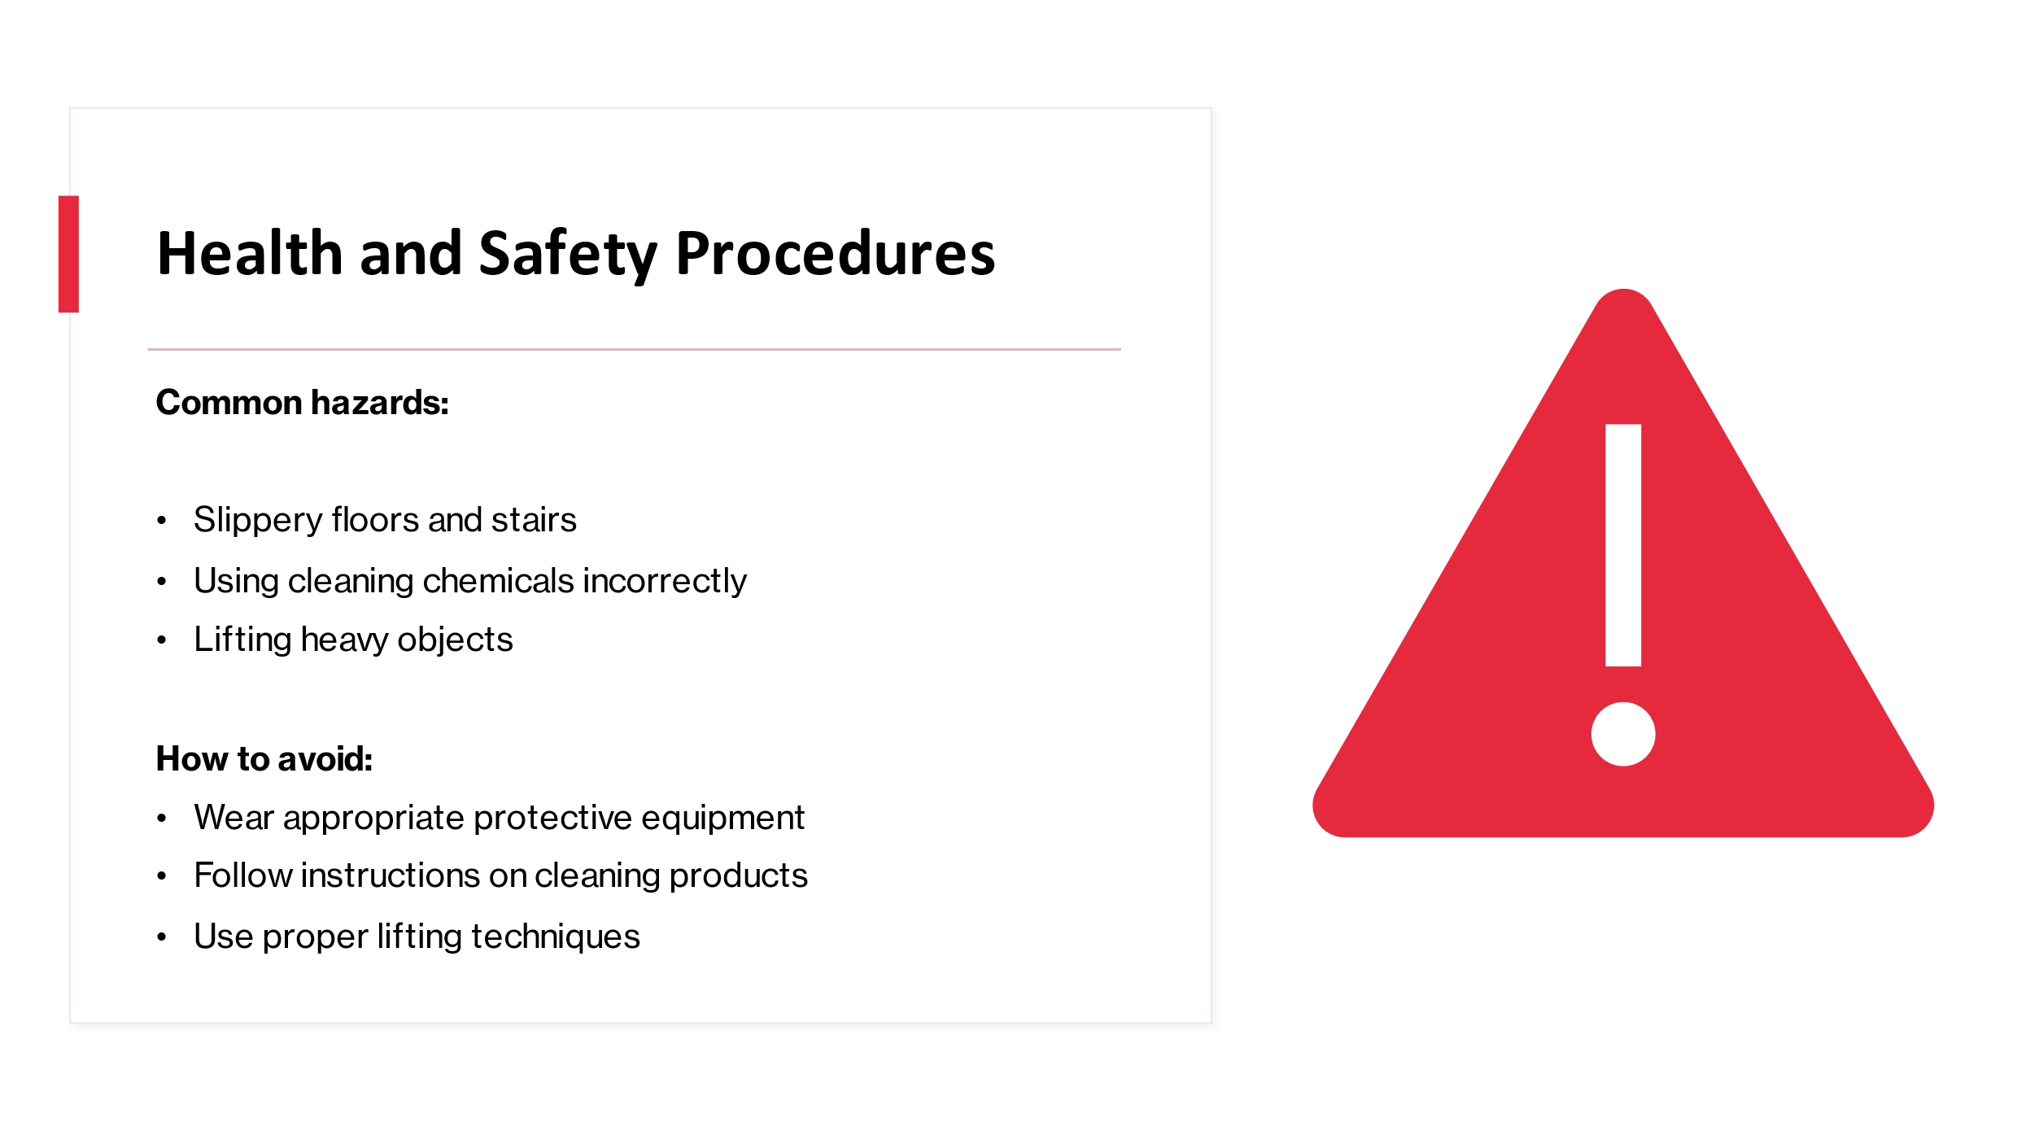

Training Notes: Keeping hotels safe and healthy for its visitors and employees is of the utmost importance. Accidents and injuries, which can be avoided with effective health and safety standards, can have major legal and financial ramifications for the hotel, if they occur.

Hotel guests sometimes suffer injuries from slip-and-fall accidents due to the wet, slick surfaces of floors and staircases. Hotels may reduce the likelihood of injuries like this by keeping all floors, especially those with heavy foot traffic, dry and clean. Anywhere there is a high probability of damp floors, such as entrances, mats should be used. Stairways should also have adequate lighting and handrails for safety.

Hotel guests should be beware of the dangers posed by the improper use of cleaning agents. If not utilised appropriately, cleaning chemicals might pose serious health risks. The use of chemicals requires the use of protective gear such as gloves and goggles to prevent injuries to workers. The cleaning products, as well as their dilution and application rates, should be used according to the directions provided by staff.

One other prevalent hazard in hotels is the need to lift big goods. In order to prevent strains and injuries, employees should be taught the correct way to lift objects. For example, you can avoid straining your back by bending your knees and maintaining your back straight while lifting, and by putting the weight of the lift in your legs rather than your back. Employees should not attempt to lift anything that is too heavy for them to carry without first consulting a supervisor.

Every member of staff has a responsibility to report accidents and injuries promptly and adhere to established protocols in the event of an incident. You should administer first aid if it's needed, alert the proper authorities, and fill out any mandatory incident reports. In addition, hotels should have a defined process for analysing accident reports and enacting safety upgrades to prevent similar incidents in the future.
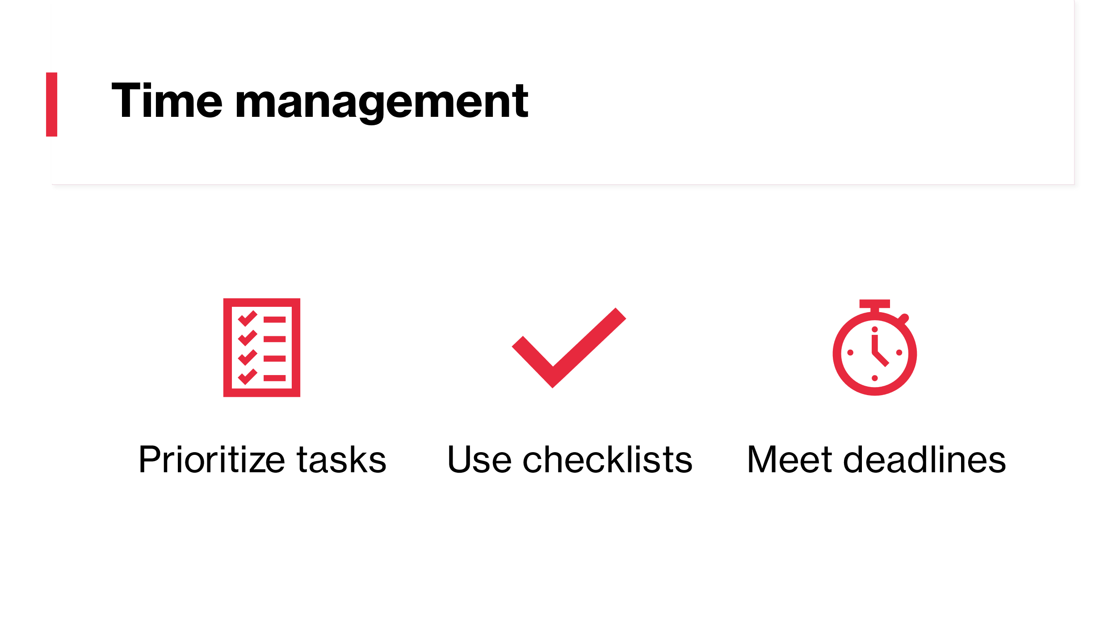

Training Notes: In the housekeeping department of a hotel, where employees are responsible for cleaning and maintaining multiple rooms and public areas, time management is crucial. Effective time management is necessary to ensure that the hotel is clean, organised, and ready to receive guests, given the number of jobs and deadlines that must be met. By prioritising tasks, utilising checklists, and working efficiently, employees can effectively manage their time and meet deadlines. This may involve performing high-priority chores first, such as cleaning and arranging guest rooms before check-in, utilising checklists to ensure that no jobs are neglected, and working efficiently by reducing interruptions and distractions. Good time management in the housekeeping staff can increase production, client pleasure, and ultimately the hotel's bottom line.
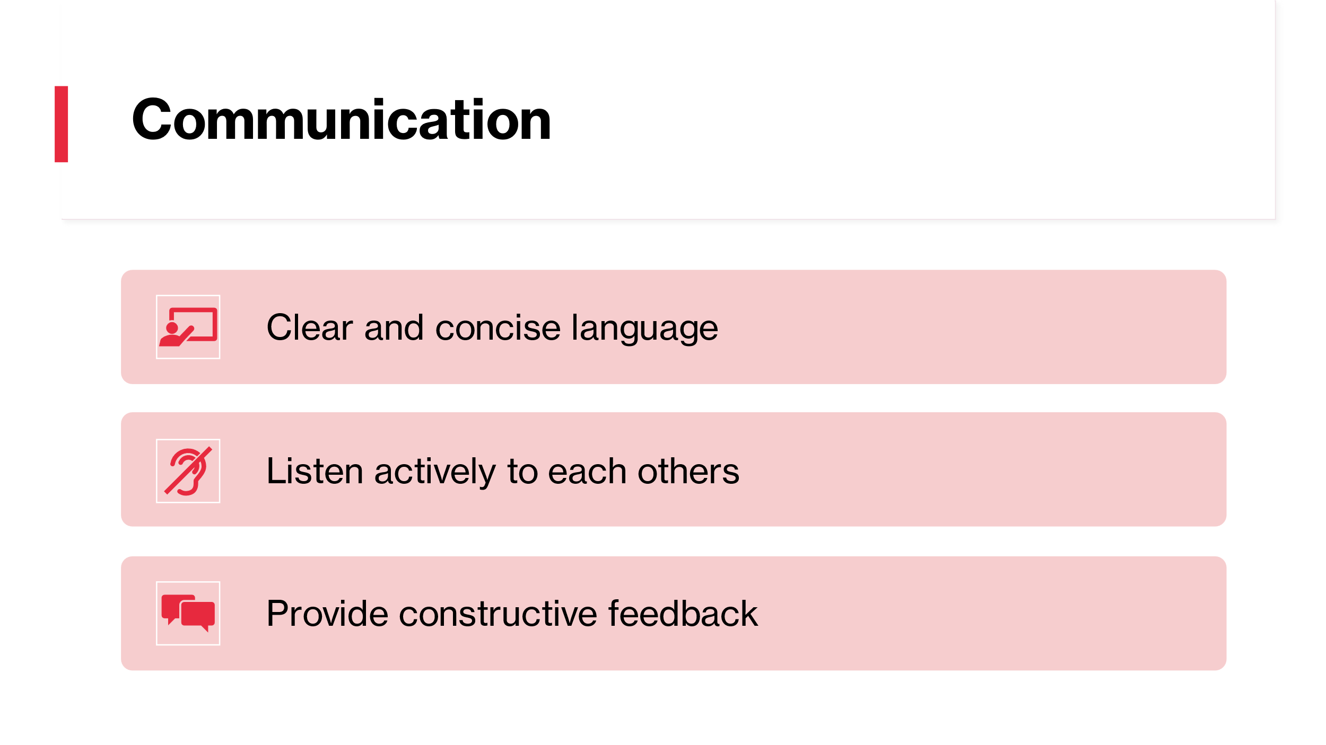

Training Notes: Efficient communication is essential to the success of a hotel's housekeeping staff. It is essential to use clear and precise language to ensure that everyone knows their roles and obligations. Equally crucial is active listening, which enables team members to comprehend each other's views and discuss any worries or challenges. Giving constructive feedback is also crucial since it can assist team members in improving their performance and achieving their objectives. Good communication can result in increased productivity, enhanced teamwork, and ultimately greater visitor pleasure.
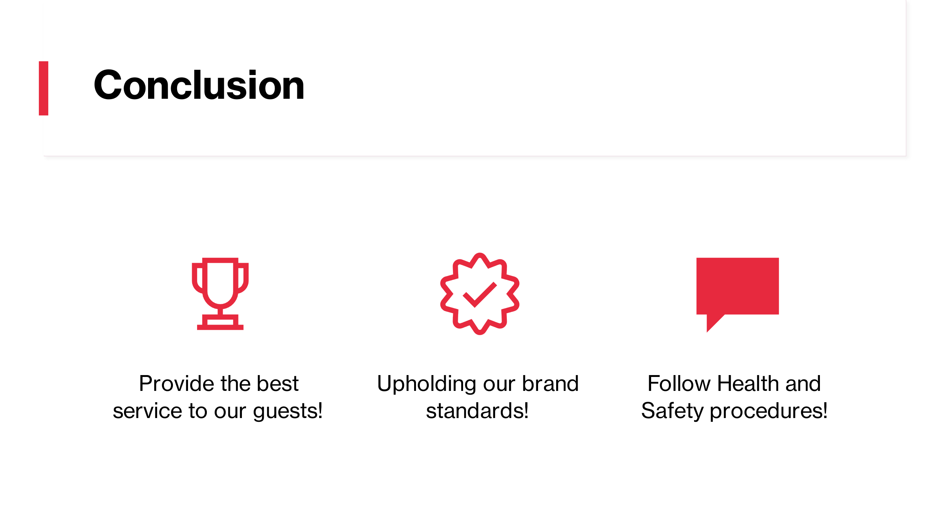

Training Notes: In conclusion, to ensure the success of the housekeeping team in a hotel, we need to prioritize providing exceptional service to our guests, maintaining our brand standards, and following health and safety procedures. To achieve this, we can use the Appreciative Inquiry model to build positive relationships with team members, appreciate their strengths and talents, and encourage open communication and feedback. We can also learn from industry best practices, use effective cleaning techniques, and manage our time efficiently to meet our goals.
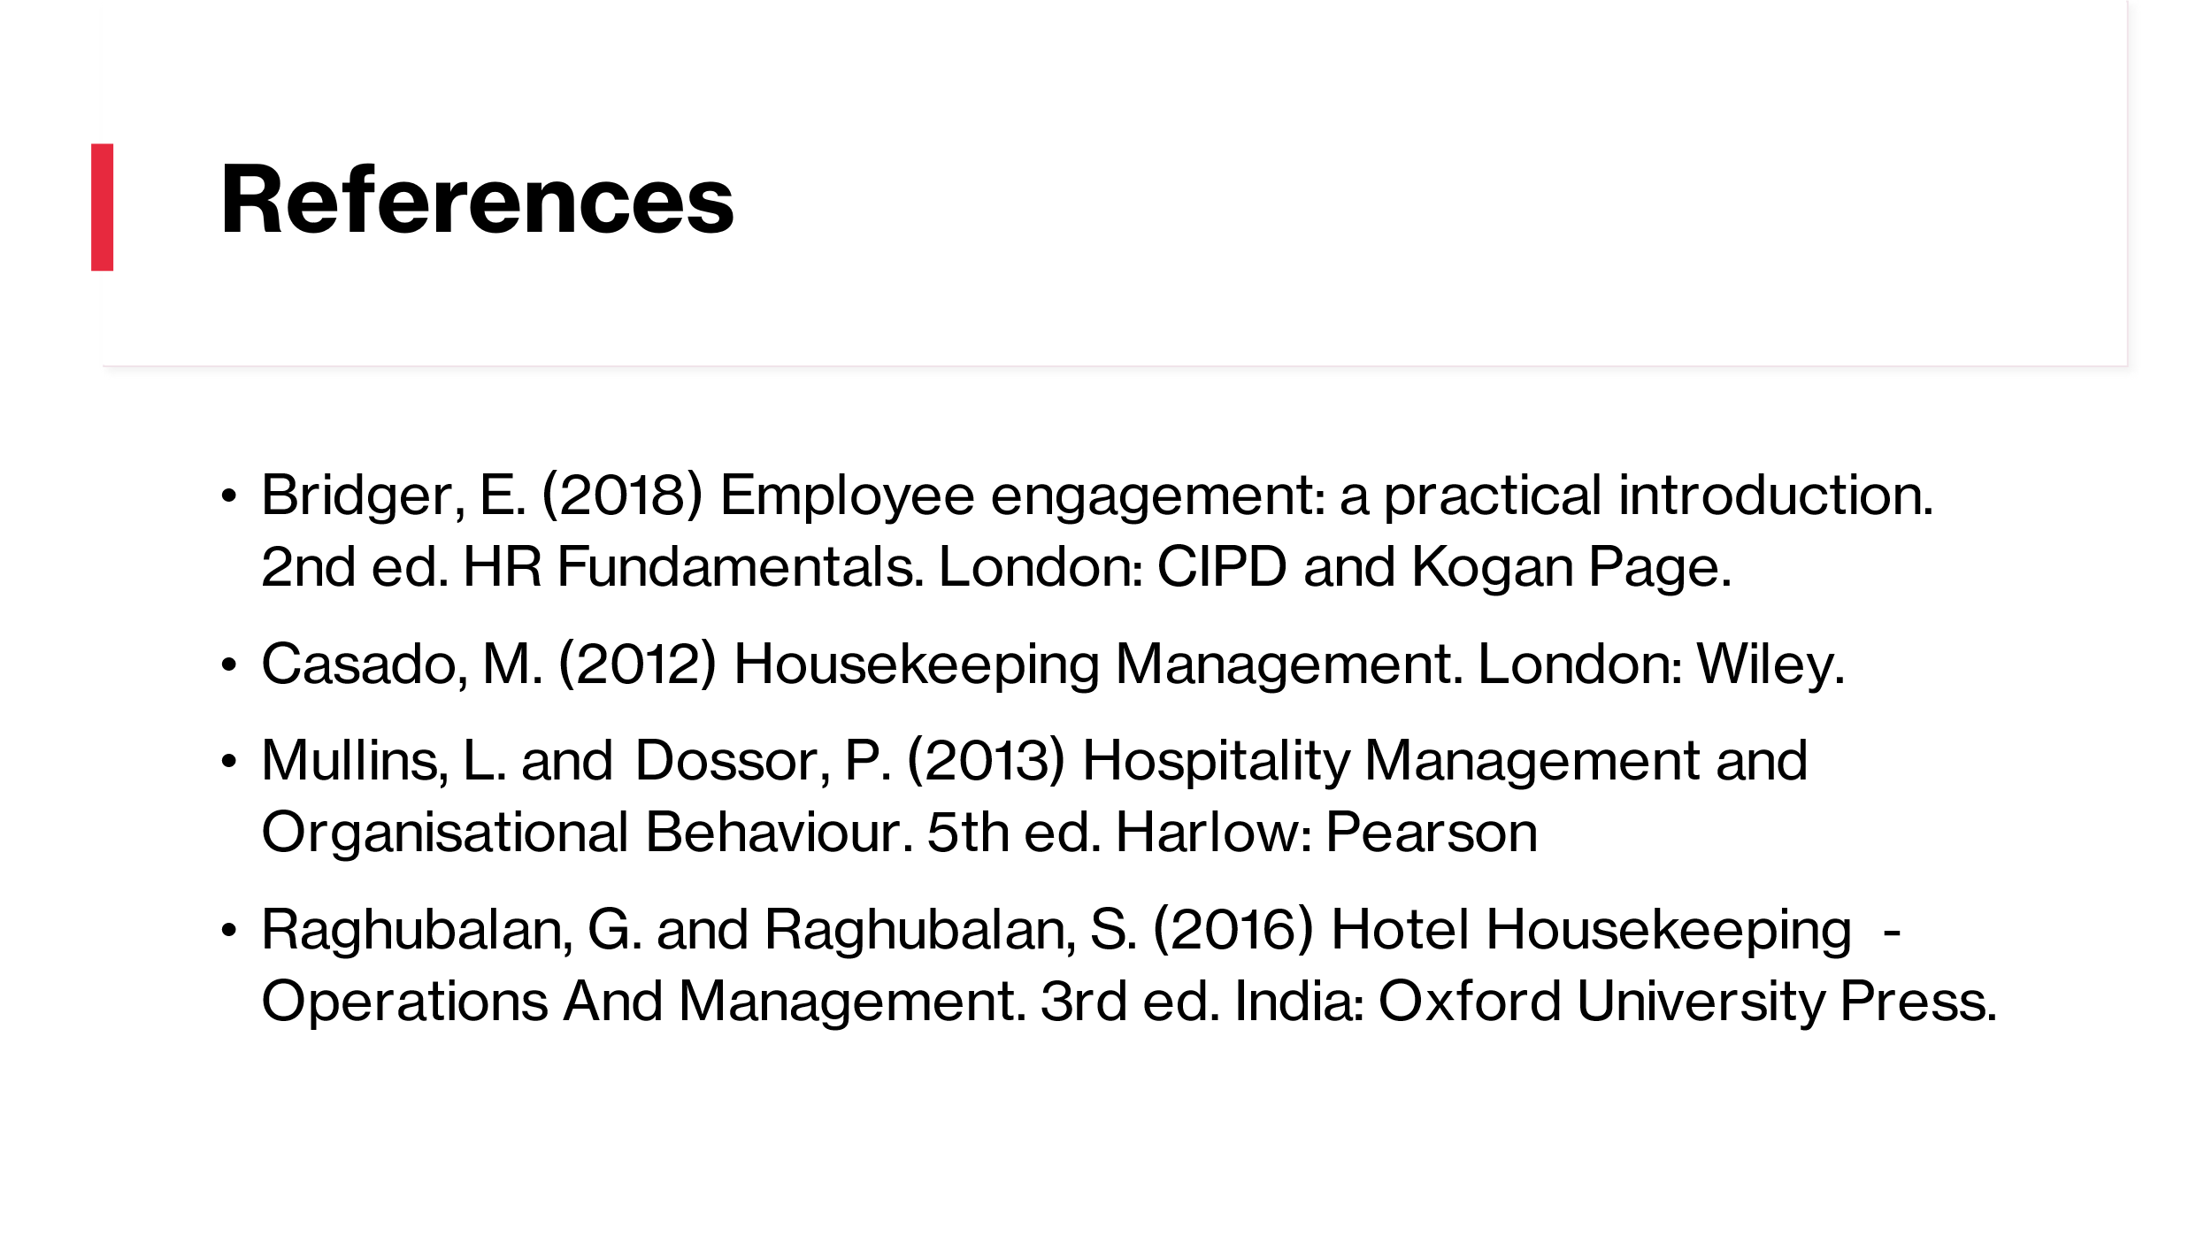

Training Notes:

References

Bridger, E. (2018) Employee engagement: a practical introduction. 2nd ed. HR Fundamentals. London: CIPD and Kogan Page.
Casado, M. (2012) Housekeeping Management. London: Wiley.
Cottrell, S. (2019) The Study Skills Handbook. 5th ed. London: Red Globe Press.
Ferdinand, N. and Kitchin, P. (2017) Events Management - An International Approach. 2nd ed. London: SAGE Publications Ltd.
Jones, T. (2010) Professional Management of Housekeeping Operations. London: Wile
Mullins, L. and Dossor, P. (2013) Hospitality Management and Organisational Behaviour. 5th ed. Harlow: Pearson.
Quick, L. (2020) Managing Events. Real Challenges, Real Outcomes. London: SAGE Publications Ltd.
Raghubalan, G. and Raghubalan, S. (2016) Hotel Housekeeping - Operations and Management. 3rd ed. India: Oxford University Press.

