LCHS4004 Introduction to public health, Component 1
Errol McCalla (2028568)
Dr Aishat Bakre
11 November, 2022
Incidence of Disease in Communities

Incidence of Disease in Communities
In the group discussion on 17th October, 2022 we looked at tuberculosis and the means of how to control and detect the disease to prevent its spread of the disease. Tuberculosis is an airborne infectious disease that has caused problems around the world for many years. Tuberculosis (TB) is caused by a type of bacterium called Mycobacterium tuberculosis.
The chart below shows the infection methods for TB;
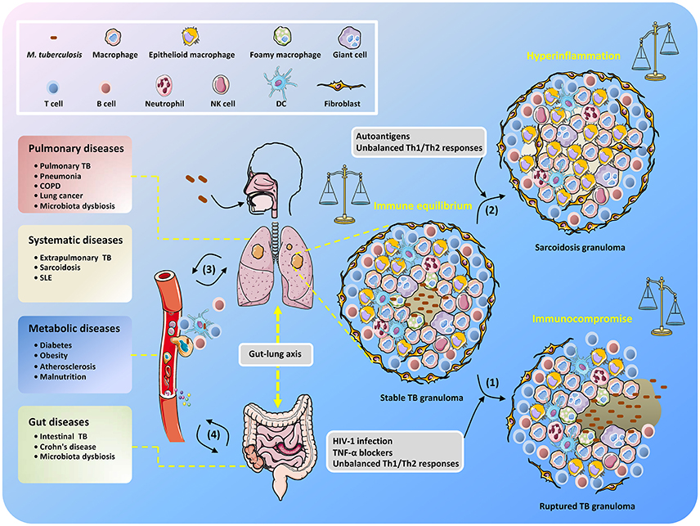

Source: Abella, V., Scotece, M., Conde, J., Pino, J., Gonzalez-Gay, M. A., Gomez-Reino, J. J., et al. (2017).
Signs of TB include coughing for a long period, coughing blood or mucus, and chest pains (Abella et al, 2017). The following report outlines strategies used in the incidence of tuberculosis and how to investigate, confirm and describe the disease as it was detected, determine the cause, and implement vaccines to control it.
Disease measurement is crucial to qualify a disease as an outbreak or not. Therefore, infectious disease measurement enables outbreak detection to generate alerts whenever observed data reaches a certain threshold or baseline (Gordon et al, 2018). There are four basic methods used for infectious disease outbreak detection (Mand1, Reis and Cassa, 2004):
- The syndrome grouping stage - data is acquired from approved sources and is used to assign each patient with a specific syndrome group like a gastrointestinal infection.
- The modelling stage – historic data for patients are analysed to establish
models from observed temporal and spatial patient distributions.
- The detection stage – the expected values are compared with observed
values to determine whether the adverse health event is occurring.
- The alert stage – thresholds are set to evaluate whether the case warrants
notifying public health authorities.
Historic data from a given region may be used to accomplish the first two stages.
When determining whether it is an outbreak or not, two variables need to be considered.
The incidence rate and prevalence rate. When the incidence rate is compared to the prevalence
rate and the resultant figure denotes a higher incidence than prevalence at a given place and time, an outbreak may be occurring (Mand1, Reis and Cassa, 2004).
Infectious diseases are best monitored using disease surveillance mechanisms (Agrebi, and Larbi, 2020.). The goal of disease surveillance is to monitor trends, identify outbreaks, and describe current burden and epidemiology of a disease (Gordon et al, 2018). The case definition is the first approach used in disease monitoring and it helps make sure that cases are counted the same way everywhere (Nicastri, et al 2020). Case definitions are based on the symptoms of the disease. For instance, in Tuberculosis, we can define the case by observing a prolonged cough lasting more than three weeks with usual phlegm, which may be bloody, weight loss, night sweats, tiredness, loss of appetite, fatigue and neck swellings (Kanchar and Swaminathan, 2019). The case definition is followed by information collection by conducting public health surveillance. Surveillance helps to calculate disease incidences, prevalence, hospitalizations and deaths (Mand1, Reis and Cassa 2004).
The next step is case reports. When data is collected, it is analyzed and then converted
into a form that can be visualized. Epidemiological data may be visualized by an epi curve that
shows what has happened in terms of the number of cases, hospitalizations, and deaths (Nicastri, et al 2020). Contact tracing may be the last step in disease monitoring. Health professionals talk to patients over time to follow a chain of infection and recovery rates. Data from contact tracing is summarised in online lists (CDC, 2020).
Infection control is crucial in reducing the transmission of infections from one person to
another. In healthcare, infection control entails a number of measures based on how the disease
is spread (Guardian, 2022). However, some of the ways that are used to control infections include hand washing; infection control standard, droplet, contact, and airborne precautions like wearing masks; quarantine of contacts, control of vectors of infection, prophylaxis of exposed individuals and decontamination (‘Population Control 2020). For the case of TB, the risk of an outbreak can be prevented by good ventilation, using natural light in the room as UV light kills off the bacteria, good hygiene like covering mouth and nose when coughing or sneezing, and ensuring that every child is vaccinated (by The BCG Bacille Calmette-Guérin) at birth (Lee et al, 2020).
The UK has various strategies and policies to maintain public health. Some of these strategies include public health programs such as European Union public health policy that has three strands: improving information for health development, reacting to threats to health, and tackling health determinants through disease prevention and health promotion (Kanchar and Swaminathan, 2019). Moreover, legal frameworks for the detection and control of communicable diseases in the UK and EU member states include restrictions on the movement of goods and people, and European surveillance and response system (‘Gordon et al, 2018).
According to a public health annual report (2021), public health has been able to strengthen partnerships through shared purpose both within and across organizations in local places. This has resulted in barriers being broken and enhancing of understanding each other’s work and inculcation of a feeling of health being everyone’s responsibility. For instance, the primary care network structure (PCN) has proven potential in promoting health and well-being in the community (Kanchar and Swaminathan, 2019). This is depicted by the contributions of the communities where individuals come to volunteer. Moreover, there has been massive involvement of local communities in national initiatives. The report recognizes that the progression of Covid 19 led to local organizations at all levels to get into stride and show the value of effective national strategy and local implementation. This can be seen through vaccine rollout and faster testing rates. The report concludes that. Partners, agencies and the wider society that have worked with public health on COVID-19 have a clear understanding of their pivotal role (CDC 2020).
The first step in a case that is suspected to be TB is to perform various tests followed by treatment. Early detection and application of preventive therapy for persons with TB are effective in the control and prevention of tuberculosis. Persons at increased risk of tuberculosis, and to whom the TB consequences may be severe, that is, the three adults whom they share a room with, should be screened for tuberculosis infection to identify those to whom prevention treatment can be administered. This is done concurrently with the isolation of cases to avoid further transmission to healthy individuals (CDC 2020).

References
Abella, V., Scotece, M., Conde, J., Pino, J., Gonzalez-Gay, M. A., Gomez-Reino, J. J., et al. (2017). Leptin in the interplay of inflammation, metabolism and immune system disorders. Nat. Rev. Rheumatol. 13, 100–109. DOI: 10.1038/nrrheum.2016.209
CDC (2020) Coronavirus Disease 2019 (COVID-19), Centers for Disease Control and Prevention. Available at: https://www.cdc.gov/coronavirus/2019-ncov/science/aboutepidemiology/monitoring-and-tracking.html (Accessed: 30 October 2022). ‘E94886_ch05.pdf’ (no date). Available at: https://www.euro.who.int/__data/assets/pdf_file/0003/138162/E94886_ch05.pdf (Accessed: 30 October 2022).
Guidelines for Preventing the Transmission of Tuberculosis in Health-Care Settings, with
‘Population Control (2020) Disease Prevention and Control, San Francisco Department of Public Health. Available at: https://www.sfcdcp.org/communicable-disease/infection-controlpractices/ (Accessed: 30 October 2022).
Gordon, J.H., LaMonte, M.J., Genco, R.J., Zhao, J., Cimato, T.R., Hovey, K.M. and Wactawski‐Wende, J., 2018. Association of clinical measures of periodontal disease with blood pressure and hypertension among postmenopausal women. Journal of periodontology, 89(10), pp.1193-1202.
Guardian (2022) [Online] UK vulnerable to major animal disease outbreaks, report finds. Available from < UK vulnerable to major animal disease outbreaks, report finds | Science | The Guardian> Accessed on 11th Nov, 2022.
Agrebi, S. and Larbi, A., 2020. Use of artificial intelligence in infectious diseases. In Artificial intelligence in precision health (pp. 415-438). Academic Press.
Mand1, K., Reis and Cassa (2004) Measuring Outbreak-Detection Performance By Using Controlled Feature Set Simulations. Available at: https://www.cdc.gov/mmwr/preview/mmwrhtml/su5301a26.htm (Accessed: 30 October 2022).
Public health annual report 2021: rising to the challenges of COVID-19 | Local Government Association (no date). Available at: https://www.local.gov.uk/publications/publichealth-annual-report-2021-rising-challenges-covid-19 (Accessed: 30 October 2022).
Nicastri, E., Petrosillo, N., Bartoli, T.A., Lepore, L., Mondi, A., Palmieri, F., D’Offizi, G., Marchioni, L., Murachelli, S., Ippolito, G. and Antinori, A., 2020. National Institute for the infectious diseases “L. Spallanzani”, IRCCS. Recommendations for COVID-19 clinical management. Infectious disease reports, 12(1), p.8543.
Kanchar, A. and Swaminathan, S., 2019. Tuberculosis control: WHO perspective and guidelines. The Indian Journal of Pediatrics, 86(8), pp.703-706.
Lee, Y., Raviglione, M.C. and Flahault, A., 2020. Use of digital technology to enhance tuberculosis control: scoping review. Journal of medical Internet research, 22(2), p.e15727.

