PROPERTIES OF A SINEWAVE

- We may describe a sinusoid in a number of ways. A sinewave and coswave are two specific forms of sinusoid.

- Sinewave : A sinusoid that starts from zero and moves in a positive direction from t=0.

- Coswave: Starts from 1 and moves in a negative direction from time t=0.
t
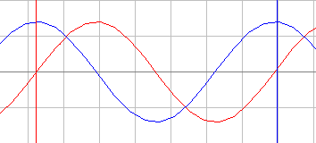
sinewave
y
coswave

- Information about sinusoids may be expressed in different ways e.g. in terms of an equation or drawn on diagrams as shown below.
- We may write y = sin (2πft) to represent a unit amplitude sinewave of frequency “f” Hz or we may alternatively show it on a diagram as shown below.
coswave
sinewave

- The circle is of unit radius, the length of the arrow represents the amplitude of the sinewave and the angle it makes with respect to the horizontal represents its time displacement from the t=0 origin i.e. its phase shift.
- THE COSWAVE IS ASSUMED TO BE AT THE SAME FREQUENCY AS THE SINEWAVE!

- In the case of a sinewave its phase shift is zero at t=0. A unit amplitude coswave is also shown.

- Its length is one but it is at an angle of 90 degrees to the horizontal ,zero reference.

- This is because a coswave is phase shifted by 90 degrees compared with a sinewave at t=0.

- The diagram doesn’t show us the frequency information about the sinewave and coswave but if we imagine, say, the sinewave arrow (phasor) rotating anticlockwise for one complete revolution then we can say that in that time the sinewave will have phase shifted one complete cycle on the
y = sin (2πft) curve.

- This means that we may replace the horizontal axis “t” with an angle θ and then express the sinewave as y = sin θ.

- We may then plot y = sin θ for values of θ from 0 to 360 degrees and get a graph of one complete cycle of a unit amplitude.

Exercise: Plot y = sin θ and cos θ for θ = 0 to 360 degrees in steps of 15 degrees.

MAKE SURE YOUR CALCULATOR IS SET TO DEGREES

y

θ̊
15 30 45

- From the graphs we can see that one complete cycle of waveform is completed at θ = 360 degrees. We may also consider representing the 0 to 360 rotation in another way i.e. in terms of radians.

Definition of the RADIAN

Consider the circle shown below:
The right hand circle is the same size as the left hand circle and therefore cuts the left circle on its circumference at a distance equal to the radius of the circle. The resulting angle made by the arrow is approximately 57.29˚. This angle is known as a radian.
If we divide 360 by this angle we find the result is
equal to 2π.
θ

Therefore there are 2π radians in 360˚ i.e. 2π^{c}
- We may therefore consider plotting our Sinusoids on a horizontal axis of radians where one complete cycle will end after 2π radians.

90 180 270 360º

0 π/2 π 3 π 2π^{c} 2

- Examples of both types of axis are shown above.

- Now the expression y = sin θ does not give any information about the frequency of the sinusoid. To include this information we may express the wave as :

- y = sin 2.π.f.t = sin (ω.t ) where ω = 2.π.f
ω = angular velocity.
Unit of ω = radians/sec i.e.
r.s⁻¹

- We may now represent our sinusoid on an x axis of time (t). We will also be able to plot the frequency information as well.

Exercise:
- Plot a 1/6 Hz sinewave over a time period of 12 second. You should see that it completes two cycles in this time. Use the graph paper provided.

DON’T FORGET TO CHANGE CALCULATOR TO RADIANS!
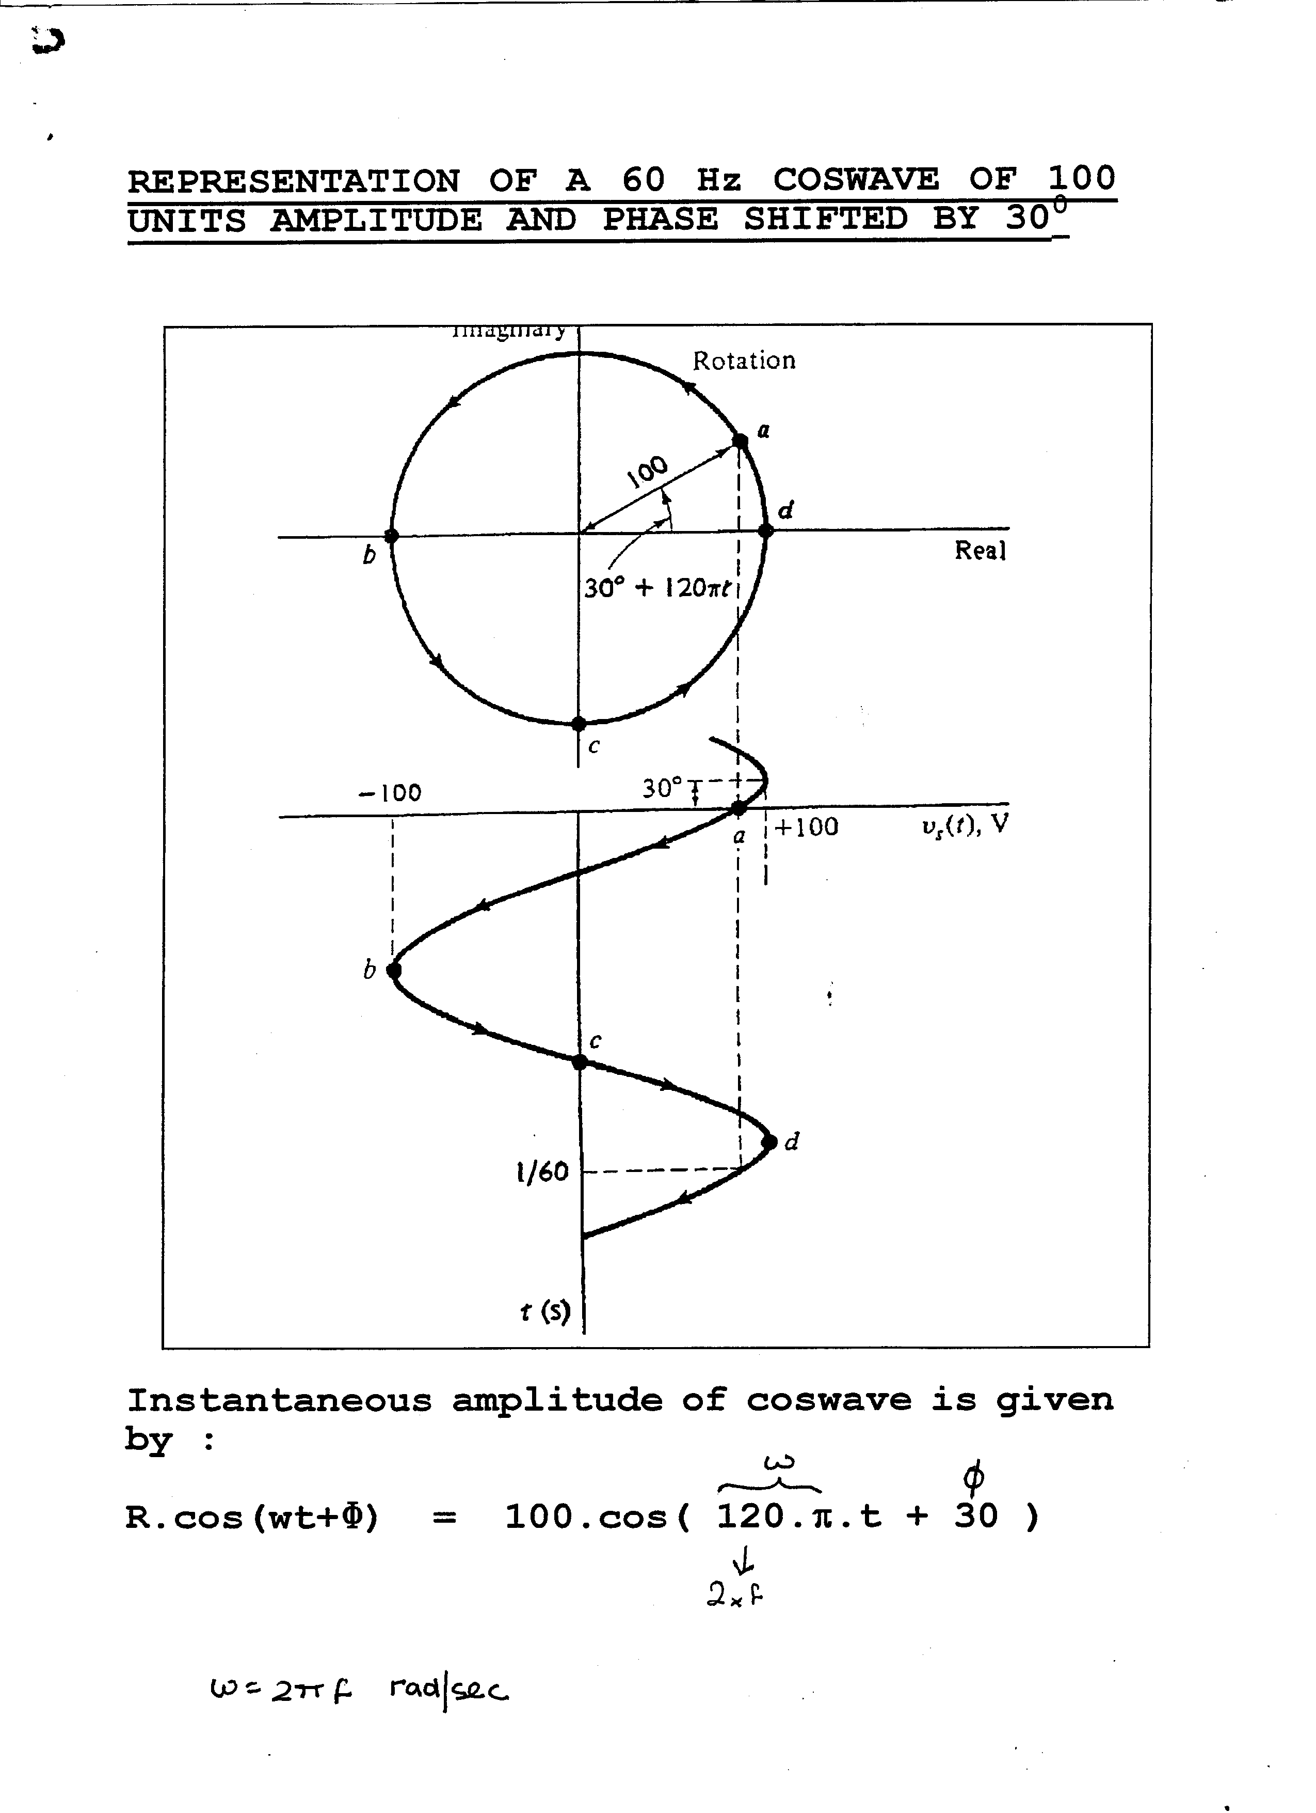RECAP : We may plot a sinusoid on either a time,phase or radian axis.

