Student name: Sofia Sacalus

Student number: 1907696

Module code: BMHP5014

Module name: Changemakers: Creativity and Value Creation

Lecturer name: Dr Azora Hurd

Assignment title: Project Outcomes Written Assignment

Introduction

The aim of the project is to identify the key points learned in this module from the four units, namely: Ideas and values, Creative solution, Mobilising support, and Evaluation.
Each unit has something to prove and learn. Some of the key points learned are self-confidence, being organized, being motivated, being creative, involving effective communication and how to communicate effectively, to have positive thinking, to analyse problems. Also, the units provide a picture of personal values and how they can be developed.
Finding creative solutions also offers a list of ideas and steps in solving problems and tasks, which evaluate and verify them. Mobilization and evaluation have an impact in making decisions and putting them into practice.
So, there follows the development of the ideas of all the units travelled.

Ideas and values
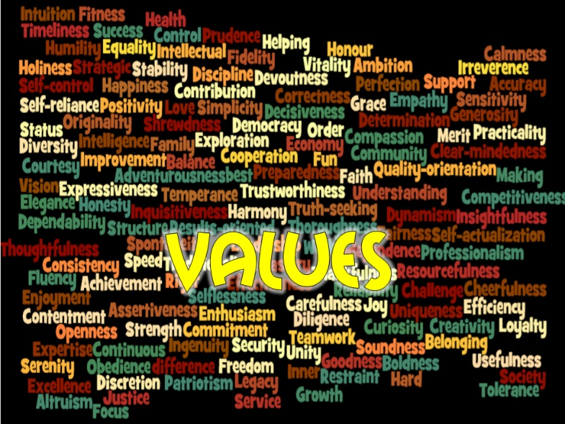
Overview
Values can be defined as themes, concepts, and orientations on the world. Also be interesting, preference, personal needs or living feelings.
Each person has different values, and they guide our behaviour. They decide what we believe for right, evil, or injustice. Values has permanent in nature. They represent a single faith that guides actions and judgment through objects and places. They come from social and cultural ways.
Understanding the themes and values
Workplace values influence the attitude and behaviour of the team. Values includes mutual respect, promises, personal responsibilities, or providing customer service.
It is important to identify the values in the workplace of colleagues so that they can be shared. Own values in the workplace are important in terms of how they work. Using owned principles to choose between what is right and wrong at work, and they help in making important decisions and especially choices. (Understanding Workplace Values: ― Finding the Best Cultural Fit, 2021)
- Workplace value
- Being accountable.
- Making a difference.
- Focusing on detail.
- Delivering quality.
- Honesty
Understand the values:
- Clarifying values is an integral part of personal growth.
- It is very important to know our plans and the direction in our lives, which is our path.
- Self-knowledge of our values and how to develop them.
- Knowing our core values or what is most important to us is extremely relevant for setting goals, setting priorities, and managing our time.
- You will have solid ideas about where you are going to commit blocks of our energy and our time. Small areas can be set aside from our programs.
- When we must make choices between activities, we will have our core values to guide us.
- When we clarify our values, we can also strengthen our value system and integrity and integrate ourselves into the zenitude with international expectations. (wikieducator.org,2011)

From this module, Creativity, and value creation, more precisely unity 1 Ideas and Values I learned to build my own creativity and recognize my own values, which I apparently did not recognize in myself. To develop a little concept of being creative in ideas the best example is the assignments we have in this course. To accomplish the tasks, we must read that then we get the essential idea of the text. To paraphrase a text, it takes a little creativity to express our ideas, of course they are not ours, but we cannot just to write an idea.

Creative solutions

People creativity is different in solving problems and tasks. They develop differently in each with disadvantages and folds. Sometimes, for a class of people, it is easy to be creative and come up with ideas for performing a task, work or in everyday life. On the other hand, another category of people finds it difficult to be creative when presenting their ideas or solving a task. That is why sometimes people get activities when they start a job, to test their creativity. who could tell a story? (Gupta et al., 2012)
To find solutions for daily problems it is necessary to be a creative person which evolves concepts that are not present in that problem and to know general knowledge to resolve the problem. An important step is to find the most creative solution and to identify and involve people which are creative and, to have good ideas. The adequacy of a solution is related to the background of the person or program that will complete the solution. The concession isolates the thought of the background.
From some research the evidence of a relationship between mindfulness and mental wandering is a difference when we speak about creativity. For example, attention deficit hyperactivity disorder scares people, which is known to be associated with the spirit of growth, tend to score higher on creative tests and report more creative achievements in their daily lives than people without ADHD. In addition, people with low latent inhibition, which is defined as the ability to filter previously irrelevant content from conscious consciousness, to achieve a higher score on creative tasks, would generate new and useful ideas, and creative achievements for life. Similarly, people with a conscious storyteller focus, which tends to suffer from distraction from irrelevant or peripheral stimuli, have found them to produce more and more creative production. These results, while indirect, suggest that a tendency towards mental wandering is beneficial for creativity. (Zedelius and Schooler, 2015)
From this Unit I had learned to identify my creative part. It is very useful to be creative, to create solutions in our working live. For some jobs it is essential to be a creative person to solve the problems of the company. Another thing learned is how to say my story, how to make my story interesting.

Mobilising support

Mobilisation support means all activities aimed at the mobility of individuals, groups, or organization without being a solution to a social problem in the family. Ask, convince, or encircle acts of force and influential authorities at the end of the order or at the chosen fair that makes the group profit for help.
Principles of mobilisation
Be responsible for the changes that will contribute.
Mobilization is the influence of people behaviour influencing the government, business, or civil society organization. Presidential phrases, these decrees on the other side of big companies. If you influence these decisions, you become co-responsible to some extent for the changes that decision makers accept.
Create the trust of the beneficiaries, the parties and the decides you are getting closer.
Recipients, partners, and rather that information needs to be trusted. Most of the rather individual sin - conscious or unconscious - to decide whether they take a person or an organization to serious. I like to vote to act on the principle of the building, it will facilitate communication with all documents and apartment reinforcements in sin and organization.
The best choices pour strategy.
The use of principles can be done by choice at the end of the conflict and supervised by changes beyond intervention.

What had I learned from Mobilising support in Unit 3?
I had learned to collaborate and be competitive in what I am doing. It is very important to be competitive in our lives because in this way we can be where we are planning. Also, I had learned to share my ideas, to be confidence and to prepare to become a winner.

Evaluation

Evaluation is a process that critically examines a program. The aim is to collect and analyse information about the activities, characteristics, and results of a program. Its objective is to judge a program, improve its effectiveness and/or inform programming decisions (Patton, 1987).
It is important to evaluate and adapt activities regularly to ensure they are as effective as possible. Evaluation can help to identify areas for improvement and ultimately achieve your goals more effectively. In addition, when you share your findings on what is becoming more effective, you are helping to advance environmental education.
The evaluation allows you to demonstrate the success or progress of the program. The information you collect allows you to better communicate the impact of the program with others, which is essential for public relations, staff morale and attract and retain support from current and potential financiers.
Ratings fall into one of two main categories: trainer and summative. Formative evaluations are conducted during the development and implementation of the program and are useful if you want guidance on how best to achieve your goals or improve the program. The evaluations should be completed once the programs are well established and will tell you how well the program is meeting its objectives.
Making evaluation an integral part of your program means that evaluation is part of everything you do. Design the program in mind, always collect data, and use this data to continually improve the program.
There are many benefits to developing and implementing such an evaluation system, including helping you:
- Better understand and meet the needs of the target audience
- The development of more achievable and measurable goals
- Track progress towards goals in a more efficient and effective way
- Learn more about evaluation
- Increase the productivity and efficiency of your program

From evaluation unit I had learned first how to evaluate my performance, my self which is very important. It is essential for our confidence to recognise our failure and how to improve myself. I had learned how to identify my skills and to create a plan for my ideas.

Conclusion

Going through these units in the Changemakers: Creativity and value creation module was not easy at all, sometimes putting me in difficulty, because creativity is not my strong point. But these units in quite a large number have helped me to develop my creative side to fulfil my tasks. They will also help me in my daily life because I have encountered a few points that I hit every day in real life.
Creativity is also an innate skill. Here we talk about those people who use their creativity every day, that is what they do and that is what they make a living from. A good example are painters, writers, emotional spikers and may be relevant examples. In health and social that creativity is essential when it comes to care for patients. A relevant example is an activity involving children or adults with problems. In such activity must be captured their attention, and then creativity and ideas are essential.

Reference list

- Change the Game Academy. (n.d.). Subsequent phases in mobilising support. [online] Available at: https://www.changethegameacademy.org/mobilisingsupport/module-1-why-mobilise-support-locally/ms-steps/the-steps-in-mobilising-support/?init_selection [Accessed 23 Mar. 2021].
- Gupta, N., Jang, Y., Mednick, S.C. and Huber, D.E. (2012). The Road Not Taken. Psychological Science, 23(3), pp.288–294.
- https://th.bing.com/th/id/R84836ee952bbf229686b8d67d4d826a2?rik=tMy0jNJprGAqvA&riu=http%3a%2f%2flivejobsglobal.com%2fContent%2fassets%2fimg%2fMobilization_header.jpg&ehk=%2bOLx62K5eiIytwCKp3%2bQiRH%2b8yFKUW%2fkuC7%2fD4i1uKg%3d&risl=&pid=ImgRaw [Accessed 23 Mar. 2021].
- https://images.squarespace-cdn.com/content/v1/55250058e4b0410f326fdb03/1431953236006-N38O271W32TKQU4GPBCK/ke17ZwdGBToddI8pDm48kPmLlvCIXgndBxNq9fzeZb1Zw-zPPgdn4jUwVcJE1ZvWQUxwkmyExglNqGp0IvTJZamWLI2zvYWH8K3-s_4yszcp2ryTI0HqTOaaUohrI8PIBNma9y6dPKVBlA697ZV8bG6HHuaYDzPGSzySBzrGfBs/values.png [Accessed 23 Mar. 2021].
- https://th.bing.com/th/id/OIP.nPgAo6Rt5kW9xRNxU_m7iwHaDV?w=317&h=157&c=7&o=5&dpr=1.5&pid=1.7 [Accessed 23 Mar. 2021].
- https://th.bing.com/th/id/OIP.FlPhdVFueMeRb8awWsclCAHaEK?pid=ImgDet&rs=1 [Accessed 17 Mar. 2021].
- iEduNote.com. 2021. Values: Definition, Characteristics, Importance, Types of Values. [online] Available at: <https://www.iedunote.com/values> [Accessed 9 March 2021].
- www.meera.snre.umich.edu. (n.d.). Evaluation: What is it and why do it? | Meera. [online] Available at: https://www.meera.snre.umich.edu/evaluation-what-it-and-why-do-it.
- Mindtools.com. 2021. Understanding Workplace Values: ― Finding the Best Cultural Fit. [online] Available at: <https://www.mindtools.com/pages/article/understanding-workplace-values.htm> [Accessed 9 March 2021].
- wikieducator.org., 2011. Life Skills Development/Module One/Unit 1: Values Education - WikiEducator. [online] Available at: https://wikieducator.org/Life_Skills_Development/Module_One/Unit_1:_Values_Education#Prioritizing_Your_Values [Accessed 17 Mar. 2021].
- Zedelius, C.M. and Schooler, J.W. (2015). Mind wandering “Ahas” versus mindful reasoning: alternative routes to creative solutions. Frontiers in Psychology, 6.

