

Reflective review of learning journey



Robert Rubint
1909138

13th of November 2019

Table of Contents
Introduction 2
Personal SMART Career Goal 3
SWOT 4
The Maslow’s Hierarchy of Needs 5
GO MAD 6
Learning Style 8
Honey and Mumford Learning Styles 8
VARK 9
Personal Development Plan 9
Conclusion 9
Bibliography……………………………………………………………………………………..12
Appendices……………………………………………………………………………………….14

Introduction
In the present highly competitive and fast-paced workplace, it is less complicated to keep up with the latest trends in the industry, hence increasing one’s knowledge to stay at the forefront of the in-demand skills in the market (Chinoperekweyi, 2017). For me, staying at the top of the latest career trends is a full-time job. So as to truly improve and enhance my life as a whole, it is critical to think about my personal development, both within and outside my career path. In my case, one of the importance of professional career development is achieving an awareness of my career trajectory. Since young age, I have had the passion for good quality food, and as such, that is why I have chosen to become a chef and ultimately own. However, I feel it is time to challenge myself and focus on something which reflects my ambition. In this regard, my smart goal is to open up my own restaurant. My focus is to achieve personal employment and career goals by focusing on the short term goal of becoming an accomplished chef and nutritionist. So as to amass a great background, I will focus on acquiring employment prior to establishing my own restaurant to acquire the experience needed to run one. Using theories and models of career development and personal enhancement, I will breakdown my career development plan.

Findings
Personal SMART Career Goal
A useful way of making a career development plan practical is ensuring that the goals set are more powerful to use within one’s life. The SMART (Doran, 1981) mnemonic is useful in making such decisions. While there is a myriad of variants, SMART translates to: S – Specific (or Significant), M - Measurable (or Meaningful), A – Attainable (or Action-oriented), R - Relevant (or Rewarding), and T – Time-bound (or Trackable). In my personal career development objective, my SMART Goal is to open my own hospitality restaurant by 2023. This goal is attainable and, as a consequence, a lot of preparation and determination will have to be completed to achieve it.
SWOT Analysis Related to Career Goal
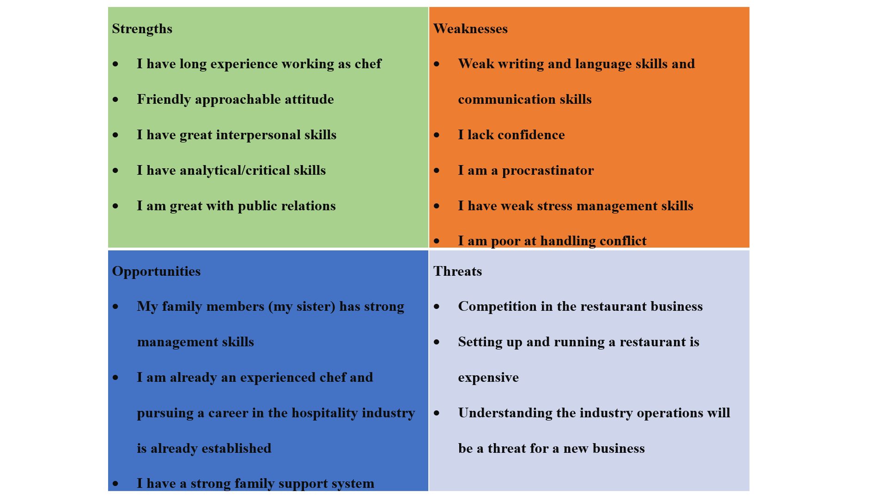
I will carry out a SWOT (Humphery, 1960-1970) (Strengths, Weaknesses, Opportunities and Threats) analysis to measure myself, make sure I am in the right way to achieve my goal. The personal SWOT will help me learn more about myselves and, hence, set for improvement. The following SWOT analysis is a tool for me and is based on my commitment to make positive changes which will propel me towards a new direction filled with new opportunities.

I will focus on using my strengths to the best of my ability to set my career up and running. I will also take every chance I have to take advantage of the opportunities available for my career
journey so as to make best of my restaurant business. In regard to the weaknesses, I will focus on turning them into my strengths by using personal conversion strategies. I will learn to be proficient in English writing and hence communication by taking an English learning course possibly. I will try to meditate more so as to change my procrastination habits and as I work hand in hand with my sister, I will achieve strong management skills which will place me in position to better manage conflict that might arise in the workplace.
In regard to the threats, most of them evolve around capital availability and countering the competition. Ideally, I will establish a unique niche in the restaurant business and concentrate on differentiating myself to the best of my ability. My focus will be to achieve a competitive edge in the restaurant business, which will ensure that I uniquely place my business in the market. I target on using the social media platform as the paradigm I will utilise most to market my brand and advertise my business. I will achieve my goal because, I am already taking up this coalification and I am learned how to convert my weakness to strength and my threat to opportunity.
The Maslow’s Hierarchy of Needs
The Maslow’s Hierarchy of Needs, just like the personal SWOT Analysis and the SMART Goal Model, is crucial to career developmental theory (Kenrick et al., 2010). This theory is based on work-related needs and argues that they follow the following format: the first are basic physiological needs (Robert, Wood and Smith, 2015). The basic psychological needs within my established career goal of owning a restaurant will be represented by my psychological achievement after setting up the restaurant. The second is safety needs, such as security of property, employment, resources, and family. My restaurant will explore these needs because I will use the family resources of human capital and the business will also ensure that wheare employed as a family. Level 3 of the hierarchy of needs includes love and belonging, whereby individuals start developing ad discovering their career paths. To achieve this level, I will have already set up my restaurant and won a market in the industry. Level 4 is esteem and it involves achieving a career status, which aligns with my ambition to achieve a competitive advantage in the market. The last level (level 5) is self-actualisation. Within my career development plan, this will be achieved when I open my own restaurant chain.
Relevant Career Development Theories in the Long-Runjkj
In the first section of my findings, I analysed various disciplines that my career goals relate to and how they will help me establish the path that I will follow in securing my career. There is a myriad of theories that will help me focus and make any needed adjustment to my career development plan in the long run.

Go Mad Thinking Framework

The Go M.A.D (Gilbert and Chakrovothy, 1999) (making difference) results and solution framework focuses on a particular thinking methodology which enables teams and people to more easily solve the problems they are facing and improve their productivity. When organisations embed and adopt this methodology as a shared toolkit/language, the results are dramatic. The personal responsibility aspect is integral to this framework when applied within a personal career development paradigm. I wish to make changes in my business mindset. Currently, I am viewing the restaurant goal as an opportunity from a theoretical perspective, but I need to shift this mentality effectively. Within my personal scope, I might need to take a business course just to improve my proficiency in business management and adapt to the practical business world.

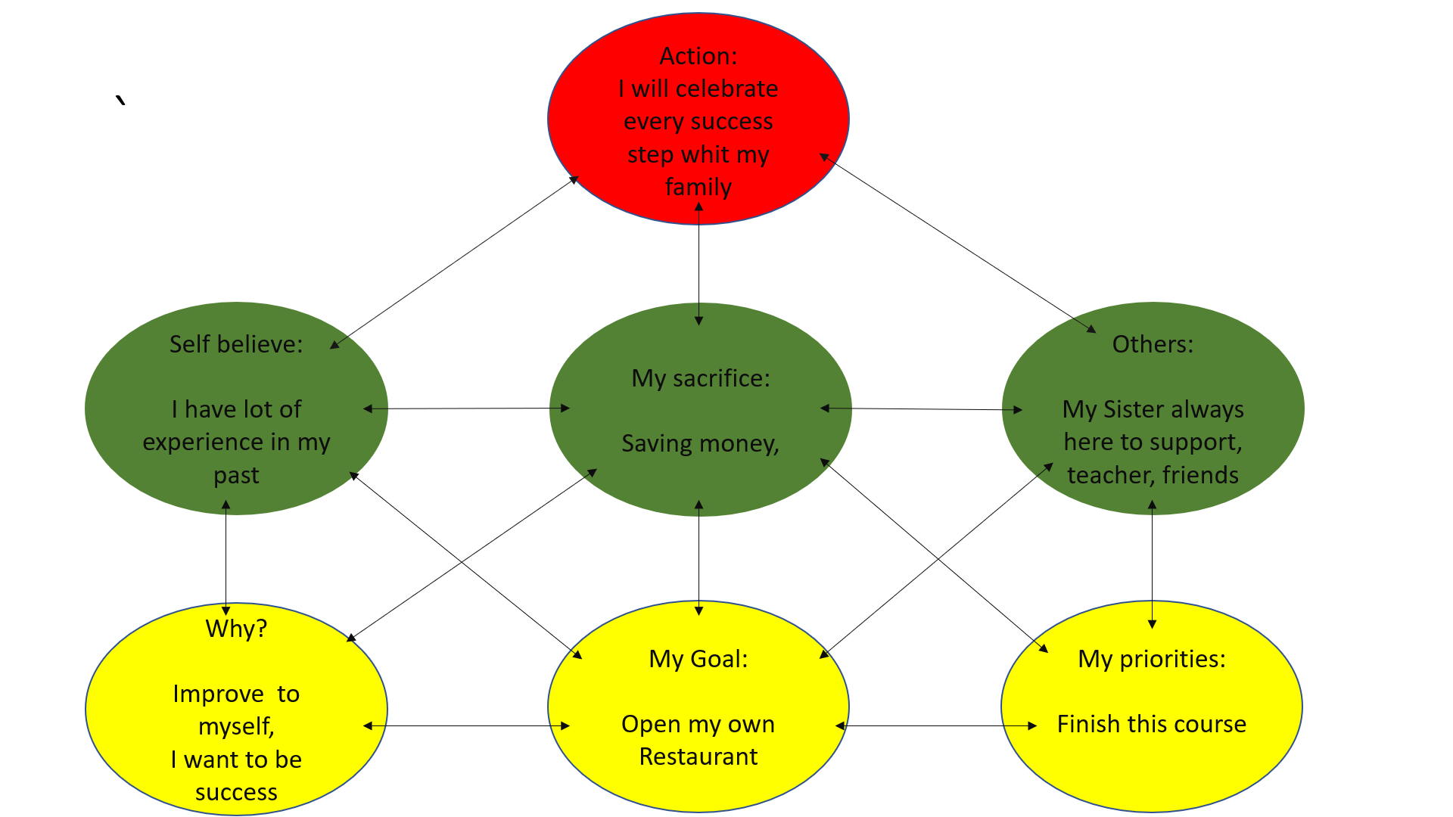
Personally, I will use the Go MAD Methodology to focus my career by diversifying my experience across the various relevant career development disciplines. I have learned that career development is a process by which an individual’s career identity if formed since their childhood and through a lifetime. There are myriads of career development theories but since not a single one of them is comprehensive, it is important for me as a career practitioner to be aware of the strengths, weaknesses, and potential biases within each discipline and then apply the go MAD framework to improve my capabilities. For instance, a number of the disciplines are limited in such the information on women, minorities, and socio-economic diversity is underreported. I will focus my career based on theories from four disciplines.
I will organise my experiences around being a chef and acquiring hospitality business management expertise. For instance, I will prefer going on internships that are specialising on hospitality management than those focusing on business management. Thirdly, the other discipline is the developmental psychology, which focuses on the life-course of an individual (Rothbart, Ahadi and Evans, 2016). My life course will involve beginning humbly as a learner in the hospitality business, slowly transitioning into the restaurant ownership business as my expertise grows. As I amass more capital, I will look forward to owning a line of restaurants attached to my brand. The fourth discipline is the sociology one, which focuses on occupational mobility. I will organise my career such that I can operate my restaurants remotely or open them in different locations.
Learning style
Is really important to know your self and know how you can learn. I carried out 2 learning style tests to beaver how can make my study years easier, and I can reflect this on my personal development plan.

Honey and Mumford Learning
The learning styles underlined by Honey and Mumford underline the concept of reflectors within the personal development spectrum. Reflectors are people who stand back and think about experiences and observe them from various angles. Within this capacity, I will collect data first hand as well as from others and I will think about this data thoroughly before making any conclusions (Honey and Mumford, 2006). According the learning test I am a Reflector. After opening the restaurant, I will collect information and data on how the business fared in the first quarter. I will then borrow data from similar restaurants and compare results. If there are any inconsistencies in performance, I will identify them and think about the best approaches I can use to counter any negative result. This might involve changing my social media approach completely.
Reflecting on the model proposed by Honey and Mumford, I have learned that personal development is an essential step and career direction for making yourself more appealing to those you work with in the identified industry.

VARK learning test
This learning style was developed in 1992 from Fleming and Milles. The base for this test, was everybody different and everyone collect information different way, someone listening (Auditory), others through communication (Visual) , somebody reading (Reading/Writing) and the last group who learn from experiences (Kinaesthetic). I am belonging a Reader/Writer group. I will go out and I will collect information from books, and I always write a list for my self in the future, and I will use this information in my personal development plan.

Personal Development Plan

I have three development objectives for my pdp. This first what I have chosen is my communication. The good communication skill is key point be come a good businessman. According to my Honey and Mumford test I am a reflector, I will go and seat in business ….. and I will take on English communication lessons. My biggest barrier will be a time, as I working most off the days or I am in University. Be in university is great opportunity to develop this skill, as we always communicate with my fellow classmates, and my teacher always here to support me. My speech will be come more fluent and my confidence will be growing with it.
The second will be the essay writing, as English my second languish, I am struggling sometimes with grammar and spelling. According my VARK test I am a reader/writer, which is help me develop this skill. I will read lot of books and take up English lessons. The time the biggest challenge again, as I live a busy lifestyle when I am at home, I am more like to watch tv, I will try to use this time ready books or articles. I will get support from my lecturer and feedbacks from her when she marks my work. I will write my reports quicker, my spelling and grammar enology grow.
The third will be a leadership skill. I am already taking on this coalification and I will continue study until I will have business degree. According to Honey and Mumford I have tendency to study, I am flexible and open minded. My barrier is will be my English languish skill, if my other two point in my pdp come better, will be have positive affection on my leadership skills to. I will measure my self when I am at work, I will be have better leader skills in the busy restaurant.
These will link to my learning style which is based on largely reflecting on what my business might need in the long-run. My reflection based on data will be phenomenal in pushing my restaurant business to the ultimate end of becoming a chain restaurant owner.

Conclusion

In the present day highly-competitive and fast-paced workplace, it is less complicated to keep up with the latest trends in the industry and hence increasing ones knowledge to stay at the forefront of the in-demand skills in the market. My SMART Goal is to open my own restaurant by 2023. The SWOT analysis conducted has identified my strengths and opportunities and, most importantly, my weaknesses and threats. My focus will be to concentrate on converting the threats to opportunities and weaknesses to strengths. I will base my career development on aligning it with the disciplines identified in my initial reflection of the disciplines relevant to my career goal. Additionally, the theories identified such as the Honey and Mumford learning styles will help me develop as a reflector who uses data and information to improve on weak areas of performance. I have two development objectives for my long-term career goal: to become a better manager and become a better informed decision maker. These will link to my learning style which is based on largely reflecting on what my business might need in the long-run.
Bibliography

Caspi, A. and Roberts, B. W., (2011). Personality development across the life course: The argument for change and continuity. Psychological Inquiry, 12(2), pp.49–66. \
Chinoperekweyi, J., (2017). Exceptionality without relapse. Notion Press.
Costa, P. T. Jr. and McCrae, R. R., (2014). Set like plaster? Evidence for the stability of adult personality. In T. F. Heatherton and J. L. Weinberger (Eds.), Can personality change? (pp. 21–40). Washington, DC: American Psychological Association.
Deckers, L. (2018). Motivation: biological, psychological, and environmental. London: Routledge Press.
Donnellan, M. B. and Robins, R. W., (2009). The development of personality across the lifespan. In P. J. Corr and G. Matthews (Eds.), The Cambridge handbook of personality psychology (pp. 191-204). New York, NY: Cambridge University Press.
Herr, E.L. and Cramer, S. H., (2016). Career guidance and counselling through the lifespan: systematic approaches. New York: HarperCollins.
Hettema, P.J. and Deary, I.J., (2013). Foundations of personality. Springer Science and Business Media, p.7.
Honey, P. and Mumford, A., (2006). Learning styles questionnaire: 80-item version. London, Maidenhead.
Kenrick, D. T., Griskevicius, V., Neuberg, S. L., and Schaller, M., (2010). Renovating the pyramid of needs: contemporary extensions built upon ancient foundations. Perspectives on Psychological Science, 5(3), pp.292–314.
Pope, M., (2009). Jesse Buttrick Davis (1871-1955): pioneer of vocational guidance in the schools. Career Development Quarterly, 57, pp.278-288.

Roberts, B. W. and Caspi, A., (2003). The cumulative continuity model of personality development: striking a balance between continuity and change in personality traits across the life course. In U. Staudinger and U. Lindenberger (Eds.), Understanding human development: life span psychology in exchange with other disciplines (pp. 183-214). Dodrecht: Kluwer.
Roberts, B. W. and DelVecchio, W. F., (2010). The rank-order consistency of personality traits from childhood to old age: a quantitative review of longitudinal studies. Psychological Bulletin, 126(1), pp.3–25.
Roberts, B. W., Wood, D., and Caspi, A., (2015). The development of personality traits in adulthood. In O. P. John, R. W. Robins, and L. A. Pervi (Eds.), Handbook of personality: theory and research (3rd ed., pp. 375-398). New York, NY: Guilford Press.
Roberts, B. W., Wood, D., and Smith, J. L., (2005). Evaluating five factor theory and social investment perspectives on personality trait development. Journal of Research in Personality,39, pp.166–184.
Rothbart, M. K., Ahadi, S. A., and Evans, D. E., (2016). Temperament and personality: origins and outcomes. Journal of Personality and Social Psychology, 78, pp.122–135.

Appendices


