Bone Ageing

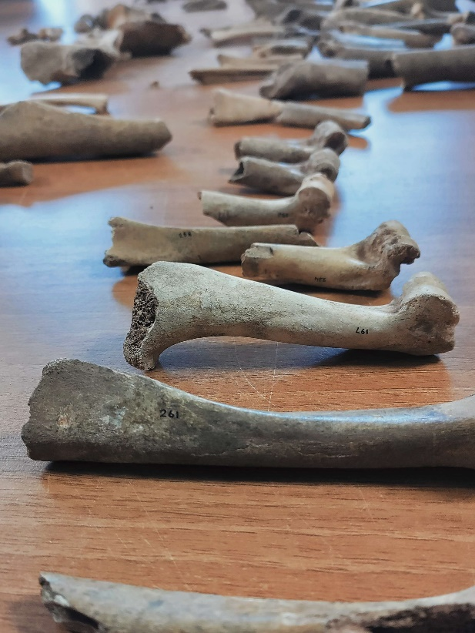
Figure 1. Harris, C (2023) Humerus [Photograph] Lampeter
Aging bones in an assemblage can be a useful tool for an archaeologist. Through determining the age of the bones present it is possible to gain insight into the human and animal interactions of the site as well as giving insight into the economic context of the area. Aging bones within an assemblage is a great way of gathering an understanding of an assemblage at an early stage of analysis (Baker and Worley, 2019). Not only is identifying the age at death of the animal bones present useful for discerning animal management and husbandry practices but also can allow for more accurate counting of individual specimens present.
Through determining the age at death of the bones present also allows for the improvement of determining the MNI of an assemblage. Noting the age of the bones allows for the elimination of potentially similar bones being marked as belonging to a single specimen.
It is possible to understand animal management through aging the animal bones present. This is due to the pattern of distribution of bone age within an assemblage. A pattern that differs from that which would be considered “natural” human interference and can highlight the animal management practices present. Understanding the number of juvenile or perinatal bones present compared to the number of adult bones can allow for understanding what type of animal management practices are present. For example, when presented with a collection of sheep and goat bones there may be evidence of a meat economy. That is if there are a large selection of juvenile bones present, as the optimum age of meat in sheep and goats is around 9months (Munsen, 2000). Aging animal bones for non-modern domesticates presents additional complications however for common European animals well documented practices allow for greater insight into past practices.
O’Connor expresses that there are three main ways of determining the age of bones. Through the analysis of cementum, through analysing the eruption rate of teeth and through examining the rates of fusion on a bone (O’Connor 2000, p.80).
Fusion allows for the age of the bones to be determined through examining rates of bone fusion at the proximal or distal ends. As bones grow the shape of them changes with fusion fully completing when the animal reaches adulthood. A juvenile animal will have very little fusion on either the proximal or distal end of the bone. As an animal ages the shape of the bone changes and fusion takes place. Examining the points of fusion on a bone is not always straight forward as it is not often that a full bone survives into the archaeological record resulting in bone fragments. However, fragmentation does not prevent determining the age of a bone as a partially fused bone may have a ‘loose end’ and therefore can be more easily snapped from the bone.
Ageing through examining the rates of fusion relies on understanding at which ages fusion begins on each animal bone and species and may present trouble when identifying animal bones of older species. It is also important to note that fusion can only be used to determine the age range of younger animals as fusion is completed in early adulthood (Baker and Worley, 2019). It is here that determining age through other means may present more reliable method of bone aging.

Reference list
Baker, P. and Worley, F. (2019). Animal Bones and Archaeology Recovery to archive Historic England Handbooks for Archaeology. [online] Swindon: Historic England. Available at: https://historicengland.org.uk/images-books/publications/animal-bones-and-archaeology/animal-bones-archaeology-handbook/ [Accessed 19 Feb. 2023].
Munson, P.J. (2000). Age-correlated Differential Destruction of Bones and its Effect on Archaeological Mortality Profiles of Domestic Sheep and Goats. Journal of Archaeological Science, [online] 27(5), pp.391–407. doi:https://doi.org/10.1006/jasc.1999.0463.
O’Connor, T.P. and O’Connor, T. (2000). The Archaeology of Animal Bones. 2nd ed. [online] Google Books, Stroud: Sutton Publishing LImited, pp.54–57. Available at: https://books.google.co.uk/books?id=kzVpgrMQcJsC&printsec=frontcover#v=onepage&q&f=false [Accessed 19 Feb. 2023].
‌

